**EEASVI : A Voice-Driven Solution for the Visually Impaired**

**Tushar Dhere1, Vishal Bodke2, Yash Bhusal3 , Nikhil Deore4 , Prof. D.S. Shingate5**

1,2,3,4,5Department of Information Technology Engineering, MET’s Institute of Engineering, Nashik, Maharashtra, India

---------------------------------------------------------------------***---------------------------------------------------------------------

**Abstract -** In the present scenario, everybody needs communication technology to connect with each other. Communication technologies are significant these days for the betterment of social and personal interaction. The combination of technologies with the internet makes communication easy. However, the person who is physically challenged suffered a lot to utilize this technology due to visual and physical difficulties. There are many technologies advancements have come though it is not possible to use like normal users. This paper aims at creating an email system that helps even new users or physically impaired people to use the system for communication without any previous practices. There is no use of keywords, only with the help of mouse actions and voice conversion the email system works. The person who is not literate can also send emails as it is based on speech recognition and text to speech. The system is completely based on responsive voice interaction to utilize the technology easy and hassle-free manner. The system is well designed to send the mails quickly. There are all the options available to send emails and perform all the functions for the email system.

***Key Words*:** Email, Internet, Voice, Speech recognition, physically challenged, Text to speech

**1. INTRODUCTION**

In a world where communication has become synonymous with digital interaction, email stands as one of the most prevalent mediums for exchanging information, ideas, and sentiments. However, for individuals with visual impairments, navigating through the digital realm can present significant challenges. Despite the strides made in accessibility technology, traditional email systems still pose barriers for the blind community, limiting their ability to independently engage in electronic correspondence.

Recognizing the need for inclusivity and innovation, the development of a voice-based email system tailored specifically for blind individuals emerges as a critical endeavor. This research paper explores the design, implementation, and potential impact of such a system in

enhancing the digital accessibility and autonomy of blind users.

At its core, this project seeks to bridge the gap between technology and accessibility by leveraging the power of voice recognition and synthesis technologies. By offering a seamless interface where users can dictate, listen to, and manage their emails through spoken commands, this system aims to empower blind individuals to communicate effectively in the digital sphere.

This paper delves into the technical intricacies of developing a voice-based email system, exploring the challenges encountered, the methodologies employed, and the solutions devised. Furthermore, it examines the potential social and psychological impacts of such a system on the lives of blind users, shedding light on the transformative potential of accessible technology.

Ultimately, the pursuit of a voice-based email system for blind individuals underscores the transformative power of technology when harnessed with empathy and purpose. Through collaborative efforts in research, design, and implementation, we endeavor to create a future where digital communication knows no bounds, ensuring that every voice is heard, regardless of sight.

**A. OBJECTIVE**

The objective of this research paper is to explore the development and implementation of a voice-based email system specifically designed to enhance accessibility for individuals with visual impairments. The study aims to investigate the challenges faced by blind individuals in accessing and managing emails through traditional interfaces and proposes a solution that leverages voice recognition technology. By analyzing the usability, efficiency, and overall user experience of the proposed voice-based email system, the research aims to contribute valuable insights into improving digital communication accessibility for the visually impaired community.

**2. LITERATURE SURVEY**

The paper [1] Voice Email Based on SMTP For Physically Handicapped was published in June 2021. This paper Presents a system that completely based on the voice response. There is no prior knowledge required to use this. Everything is automatically prompting the only thing is to give the responses of the voices to perform the actions.

The paper [2] Voice A Review on Voice based E-Mail System for Blind was published in June 2020. This Paper presents a system working on the voice controlling principles for the peoples with visual impairment to deliver a simple and easy access to email system. This framework will also helpful for individuals with other weaknesses alongside the visually impaired individuals

The paper [3] Algorithms and Techniques for Image to Sound Conversion for Helping the Visually Impaired People - Application Proposal was published in November 2017. This paper presents a system that transforms images acquired with a camera into sounds. The system is designed for the visually impaired people and will convert real time images into sounds, respecting a certain algorithm, to preserve the visual information, but not forgetting the limitations imposed by the human hearing system.

The paper [4] Camera based text and Product Label Reading for Blind People was published in July 2021. This paper present smart blind stick, aims to enhance the

quality of life for the blind community by enabling independent mobility. Utilizing ultrasonic sensors, the stick detects obstacles and communicates their distance through speech output. GPS technology is employed to pinpoint the user's precise location, with data relayed to caretakers via email. Additionally, a camera identifies obstacles and objects ahead, providing spoken descriptions to the user. Furthermore, the camera processes text on objects, converting it to speech, thus enabling users to access written information.

## 3. PROBLEM STATEMENT

The existing email systems predominantly rely on visual interfaces, presenting a significant challenge for blind individuals to access and manage their emails effectively. This disparity underscores the necessity for a voice-based email system tailored to the needs of the visually impaired community. The absence of such a solution inhibits blind individuals from independently engaging in email communication, hindering their access to vital information and participation in modern communication channels. Therefore, developing an intuitive and efficient voice-based email system specifically designed for blind users is imperative to bridge this accessibility gap and empower them with seamless email communication capabilities.

**4. PROPOSED METHODOLOGY**

There can be many proposed systems for the above problems. The present proposed system is completely based on the user’s accessibility and easiness of the email system. This system is completely useful for visually impaired peoples.

In this system two main Functionalities are used –

For login the face recognition is used with HAAR Cascade Algorithm - Haar cascade algorithm is a machine learning-based method for object detection. It uses Haar features, which are simple calculations based on the difference of pixel intensities in adjacent rectangular regions, to represent the characteristics of an object. It then applies a cascade of classifiers, each consisting of a set of Haar features, to scan the image at different scales and locations. [The cascade structure, trained using the AdaBoost algorithm, enables an efficient, hierarchical evaluation of features, reducing the computational load and accelerating the detection speed](https://medium.com/analytics-vidhya/haar-cascades-explained-38210e57970d)

For the voice interaction Google text – to – speech and speech to text functionalities are used in this the NLP (Natural Language Processing) is used - NLP stands for Natural Language Processing, which is a branch of Artificial Intelligence that deals with the interaction between computers and human languages. NLP enables machines to understand, analyze, generate, and manipulate natural language, such as text or speech. NLP has many applications in various domains, such as information retrieval, machine translation, sentiment analysis, chatbots, text summarization, and more

**5. PROPOSED SYSTEM ARCHITECTURE**

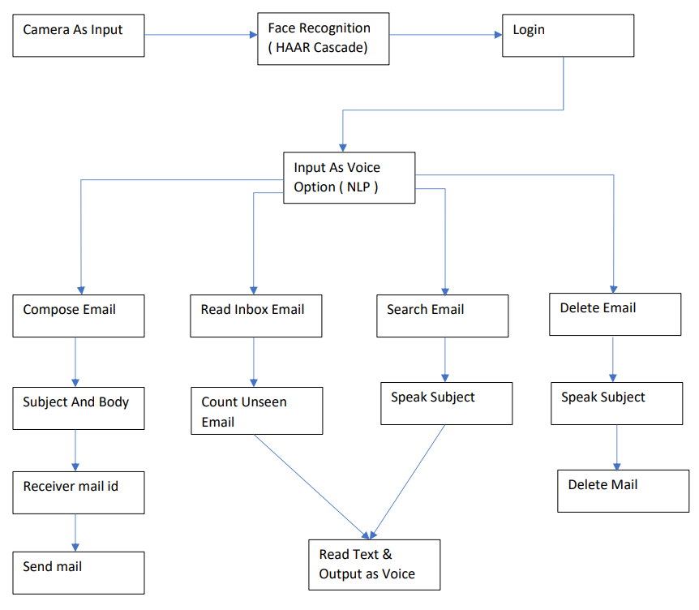

Fig 1 – System Architecture

proposed system architecture for an email management system that integrates face recognition and voice input functionalities. It begins with the user being identified through a camera using face recognition technology (HAAR Cascade). Once recognized, the user can log in. The system also accepts voice inputs, processed using NLP (Natural Language Processing), to compose, read, search, and delete emails.

**6. GUI and OUTPUT**

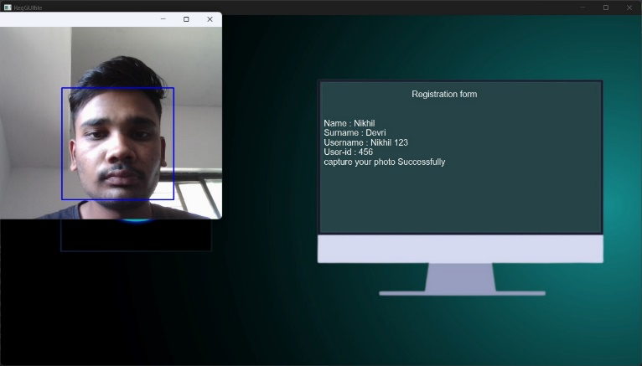

1. **Registration**

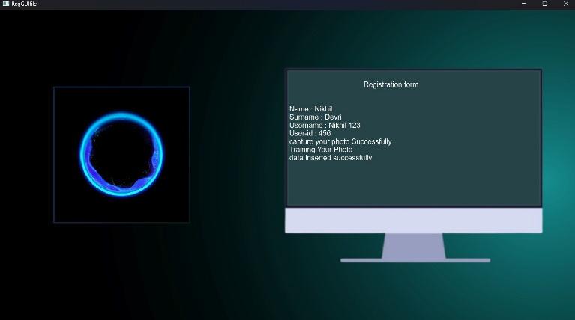

1. **Registration Successfully**

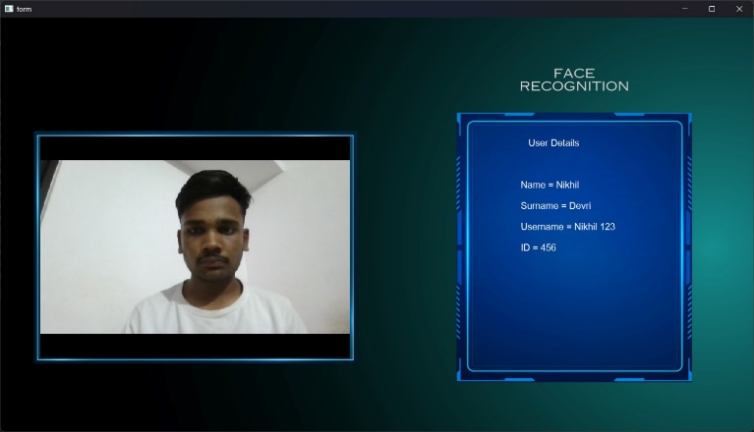

1. **Login Page**

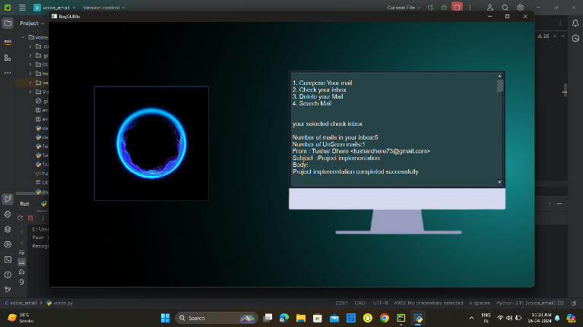

1. **Email Functionality**

**7. FUTURE WORK**

Moving forward, potential areas of focus for advancing the voice-based email system for blind individuals include exploring more sophisticated natural language processing algorithms to improve the system's accuracy in interpreting spoken commands and contextual understanding. Additionally, integrating machine learning techniques could enhance the system's ability to adapt to individual user preferences and speech patterns, thereby personalizing the user experience. Further research could also investigate the incorporation of multimodal feedback mechanisms, combining voice prompts with haptic or auditory cues to provide additional context and improve usability. Additionally, expanding the system's capabilities to support multi-language interfaces would enhance its accessibility to diverse user populations. Moreover, conducting longitudinal studies to assess the long-term usability and effectiveness of the system in real-world settings would provide valuable insights for iterative refinement and continuous improvement. Overall, these avenues of future work aim to advance the voice-based email system for blind individuals, ultimately fostering greater inclusivity and accessibility in digital communication platforms.

**8. CONCLUSION**

This research paper has outlined a methodology designed to address the unique challenges faced by visually impaired individuals in accessing and managing email content. The incorporation of accessibility features and intuitive interface design not only enhances usability but also empowers blind users to navigate and interact with their emails efficiently. Furthermore, the seamless integration with existing email platforms and continuous user feedback mechanisms ensure that the system remains responsive to evolving user needs and preferences. By deploying this voice-based email solution and providing comprehensive training and support resources, the research endeavors to bridge the accessibility gap and enable blind individuals to engage fully in email communication, thus promoting greater inclusivity and participation in the digital world.

**REFERENCES**

1 Sign Language interpreter DS Shingate, R Bajaj, Y Bhavar – International journal of innovation in engineering 2019.

2 P. Merkle, A. Smolic, K. Muller, and T. Wiegand, “Efficient prediction structures for Multiview video coding,” IEEE Trans. Circuits Syst. Video Technol., vol. 17, no. 11, pp. 1461-1473, Nov. 2007.

3 High Efficiency Video Coding, document Rec. ITU-T H.265, International Telecommunications Union Standard, April 2013.

4 G. J. Sullivan, J. M. Boyce, Y. Chen, J.-R. Ohm, C. A. Segall, and A. Vetro, “Standardized extensions of High Efficiency Video Coding (HEVC),” IEEE J. Sei. Topics Signal Process., vol. 7, no. 6, pp. 1001-1016, Dec. 2013.

5 P. Merkle, A. Smolic, K. Muller, and T. Wiegand, “Multi-view video plus depth representation and coding,” in Proc. IEEE Int. Conf. Image Process. (ICIP), vol. 1. Sep. 2007, pp. I-201-I-204.

6 P. Merkle et al., “The effects of Multiview depth video compression on Multiview rendering,” Signal Process., Image Common., vol. 24, nos. 1-2, pp. 73-88, Jan. 2009.

7 P. Merkle, C. Bartnik, K. Muller, D. Marpe, and T. Wiegand, “3D videos: Depth coding based on inter-component prediction of block partitions,” in Proc. Picture Coding Symp. (PCS), May 2012, pp. 149-152.3. van Leeuwen, J. (ed.)

8. K. Muller, P. Merkle, and T. Wiegand, “3-D video representation using depth maps,” Proc. IEEE, vol. 99, no. 4, pp. 643-656, Apr. 2011.