ENHANCING RECRUITMENT AND SELECTION PROCESSES: INSIGHTS FROM PNB METLIFE’S TALENT ACQUISITION

PRANJAL GUPTA
MBA FINAL YEAR, AMITY BUSINESS SCHOOL
AMITY UNIVERSITY, RAIPUR (C.G.)
EMAIL ID- pranjalgupta700@gmail.com

DR. IMRAN NADEEM SIDDIQUI
ASSISTANT PROFESSOR, AMITY BUSINESS SCHOOL
AMITY UNIVERSITY, RAIPUR (C.G.)
EMAIL ID- insiddiqui@rpr.amity.edu

ABSTRACT
This paper is on recruitment and selection process at PNB MetLife Insurance Company Limited. The process of identifying, screening, shortlisting, and choosing the best applicants to occupy the necessary vacant jobs is known as recruitment and selection. The primary objectives of this research are to determine how candidates are recruited, on what criteria the selection process is based, and what skill set is necessary for a certain position. The aim of this research is to investigate the PNB MetLife's recruitment and selection procedure and to investigate whether the procedure is simple to comprehend and use different methods that are used by the organisation. The study's research design is descriptive. Primary data have been collected for this project. 50 candidates make up the sample size for the questionnaire method used to acquire the data.
The data indicates that employee referrals (72%) are the dominant source for internal recruitment, and employment agencies (42%) lead in external recruitment. High satisfaction (88%) with the resume screening process and clear job descriptions (94%) reflect positively on organizational practices, while a strong awareness (94%) of referral schemes supports internal hiring strategies. Such insights offer valuable guidance for refining recruitment approaches and enhancing employee satisfaction, thereby fortifying organizational success. This project makes an effort to offer suggestions for improving recruitment efficiency and lowering hiring costs.

Keywords: Recruitment Process, Selection process, Interview, Job vacancy, Qualification and Skills

OBJECTIVES
- To study and analyse the Recruitment and Selection process followed at PNB MetLife.
- To analyse the satisfactory level of the employees about Recruitment and Selection procedure of an organization.
- To find out problem and issues associate with recruitment and selection procedure.
- To find out whether the recruitment and selection process is simple to understand and implement.
- To study the various sources of recruitment followed in PNB MetLife.

INTRODUCTION
In HRM, recruitment and selection play a crucial role in maximising employee strength to achieve the strategic goals and objectives of the company. To put it briefly, the process of identifying, screening, shortlisting, and choosing the most suitable candidates to fill the necessary positions available is known as recruitment and selection.
Recruitment and selection encompass a wide range of operations and has a very broad scope. Resources are the most precious asset of every organisation. Consequently, the most crucial component of recruitment is selecting the right employees. Every business has its own recruitment processes that are specific to its policies and procedures.
The scope of recruiting and selection includes the following operations:
- Dealing with the excess or shortage of resources.
- Analysing the recruitment policies, processes, and procedures of the organization.
- Identifying the areas, where there could be a scope of improvement.
- Choosing the best suitable process of recruitment for effective hiring of resources.

RECRUITMENT PROCESS:
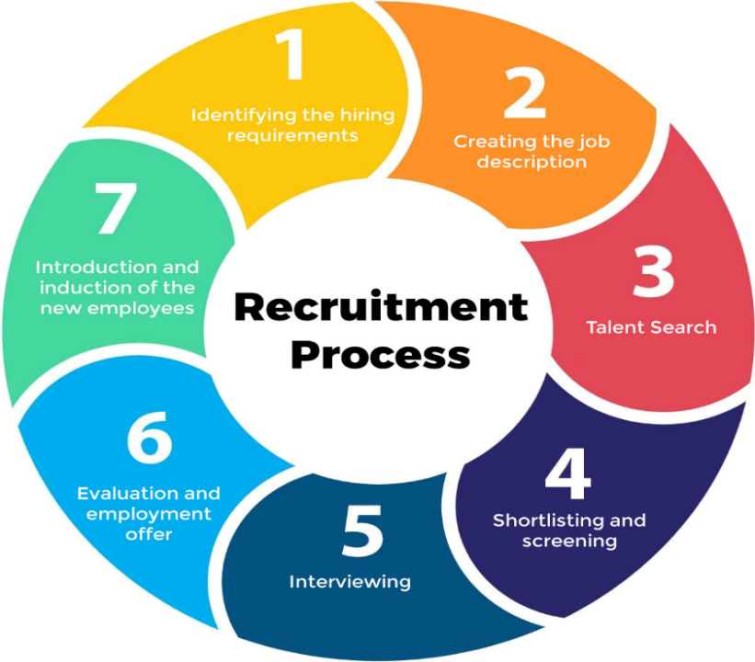

Every organization wants to be in secure and capable hands for the future. Therefore, one of the most crucial tasks for every organization is hiring the suitable talent. It is the whole process that begins with the identification of the needs of the company with respect to the job & resources and ends with employing a candidate in the company. The first things that spring to mind when we think of the recruitment process are tasks like analysing the requirements for a certain job, recruiting candidates for the job, screening applicants, and choosing the best applicant for the desired position of employment. Prior to recruiting candidates, the company must accurately carry out its virtual hiring strategies and forecast them in order to identify the precise number of employees it will need.
Step 1: Identify the Hiring Requirement
The recruitment process begins with identifying the need for a new hire. This involves understanding why the new position is necessary, whether it's due to company growth, a vacancy, or a specific project requiring additional expertise. Stakeholders define the job's purpose, essential qualifications, and key responsibilities. This stage also includes setting a timeline and budget for the hiring process. Clear identification of the requirement ensures that the recruitment process aligns with the company’s strategic goals and addresses specific business needs.
Step 2: Creating the Job Description
Once the hiring need is identified, the next step is to create a detailed job description. This document outlines the job title, duties, responsibilities, required qualifications, and desired skills. It also provides information about the company's culture, the department, and the position's reporting structure. A well-crafted job description is crucial as it serves as the foundation for attracting the right candidates and sets clear expectations for prospective employees.
Step 3: Talent Search
The talent search involves sourcing potential candidates using various methods. These can include internal databases, job boards, social media, recruitment agencies, and employee referrals. The aim is to reach a broad audience to attract diverse candidates. Networking events and industry-specific platforms can also be valuable in finding specialized talent. This stage is crucial for creating a pool of qualified candidates from which to select. Attracting job applicants for vacant positions is part of the search process. The sources can be broadly classified into two different categories: Both internal and external sources-
- Internal Sources
Internal sources of recruiting are those who hire employees from within the company by means of:-
- Promotions
- Transfers
- Former Employees
- Internal Advertisements (Job Posting)
- Employee Referrals
- Previous Applicants

- External Sources
Recruitment from outside the organization is referred to as "external sources of recruitment-
- Direct Recruitment
- Employment Exchanges
- Employment Agencies
- Advertisements
- Professional Associations
- Campus Recruitment
- Word of Mouth
Step 4: Shortlisting and Screening
After collecting applications, the next step is to shortlist and screen candidates. This involves reviewing resumes and cover letters to identify those who meet the minimum requirements. Screening can include initial phone interviews, skills assessments, and background checks. The goal is to narrow down the candidate pool to those who best match the job criteria, ensuring that only the most suitable candidates proceed to the next stages.
There are three steps in the recruitment screening process.
- Reviewing of Resumes and Cover Letters
Reviewing is the first step of screening candidates. Throughout this procedure, resumes are examined to make sure that the candidates' backgrounds, education, and work experiences align with the requirements of the position.
- Conducting Telephonic or Video Interview
The second round of candidate screening involves conducting phone or video interviews. In this form of recruitment, the hiring manager contacts the candidates by phone or video after screening the resumes. There are two positive impacts to this screening process: it helps to verify that the candidates are available and actively seeking employment. Additionally, it facilitates a rapid assessment of the candidate's attitude, ability for responding to questions during the interview, and communication abilities.
- Identifying the top candidates
The final phase of screening the resumes and candidates is to determine who the most qualified candidates are. During this procedure, just the most suitable resumes are selected, making the hiring manager's decision-making process easier.
Step 5: Interviewing
Interviewing is a critical step where selected candidates are assessed through face-to-face, virtual, or panel interviews. This stage evaluates not only their qualifications and experience but also their cultural fit within the organization. Structured interviews with standardized questions can help compare candidates more effectively. Behavioral and situational questions can provide insights into how candidates might perform in the role and interact with the team.
Step 6: Evaluation and Employment Offer
Following the interviews, the hiring team evaluates each candidate's performance and fit for the role. This involves discussing feedback from all interviewers and possibly conducting further reference checks. Once a decision is made, an employment offer is extended to the chosen candidate. The offer should include details on salary, benefits, job role, and other terms of employment. Effective negotiation ensures that both parties are satisfied with the terms.
Step 7: Introduction and Induction of New Employees
The final step is the introduction and induction of the new employee. This onboarding process helps new hires acclimate to the company culture and understand their responsibilities. It typically includes orientation sessions, training programs, and meetings with key team members. A well-structured induction ensures that new employees feel welcomed, supported, and prepared to contribute to their roles effectively from the outset.
Each of these steps is essential for a successful recruitment process, ensuring that the right talent is hired and integrated into the organization efficiently.

SELECTION PROCESS:
Selecting the right persons for the proper jobs is the process of employee selection. It is the process of aligning individual's qualifications and skills with organisational requirements. Only when there is effective matching can there be effective selection. By choosing the most suitable candidate for the necessary position, the company will have employees that perform well. Additionally, the organization will not encounter as many issues with employee turnover and absenteeism. The organization will also save time and money by choosing the best candidate for the required position. Candidates are thoroughly examined before being selected. Every candidate for the job is put through testing.
Although recruiting and selection are two stages of the hiring process, they must be distinguished from one another. Because it encourages more candidates to apply for jobs, recruitment is seen as a beneficial activity. It creates a pool of applicants. It is just sourcing of data.
It is necessary to fit the candidates in accordance with the qualifications after they are chosen for the required position. Fitting a chosen individual into the appropriate role or location is referred to as placement. Once the candidate is fitted into the job, the candidate is given the activities he has to perform and also talked about his duties. After that, the newly hired candidates receive orientation to get them acquainted and introduce them to the organization.

RECRUITMENT AND SELECTION AT PNB METLIFE:
Based Upon the job description and specifications, recruitment process is performed. The process of attracting in candidates who have an excellent possibility of getting the job is known as recruitment. Recruitment process starts with the drafting of advertisement for the required post mentioning the name of the post, qualifications required, place of posting etc. A nationwide distribution of the commercial is made available in all major newspapers. Advertisements are posted not only in print media but also in other media, such as online media. In the instance that the requirements related to recent graduates, placement agencies and educational institutions are given consideration. Employee references by are also encouraged. The HR division first screens the applications after they are received, using the minimum requirements and qualifications listed for the position. Applications for higher positions that have been examined by the HR division are forwarded to the appropriate divisional heads for further screening.
Depending on the nature or sensitivity of the level and the role, the selection process may include tests, interviews, group discussions, psychometric testing, or a combination of these. Tests have been used as means of elimination for technical roles, but not as means of elimination for other posts, such as management trainee. To make sure the chosen candidates fit well with the organization's culture, background checks are conducted on them. Offers of employment are extended to the shortlisted candidates, who are then requested to confirm their acceptance. When an applicant confirms their enrollment, the personnel and administration division prepares an appointment letter, which is delivered to them at the time of joining. The division of human resources is responsible for compensation offers, and the division of personnel and administration is in charge of salary administration.

REVIEW OF LITERATURE
Dr. Sayel (2018) states in "Impact of online recruitment on recruitment" that the goal of these studies is to compare e-recruitment with the traditional recruitment process and also discuss the benefits and drawbacks of e-recruitment. Additionally, the research aims to assess changes in recruitment strategies and practices, as well as the causes of e-recruitment tools, opportunities, and challenges for the organisation. The study concludes that e-recruitment demonstrated declining recruitment spends that were centred on web-based recruitment at the expense of traditional methods.
In their 2018 study, Tanja Koch and Charlene Gerber noted that social media's impact on recruiting and research Examine how social media affects South Africa's hiring procedures. This study offers fresh perspective on the influence of social media on hiring in South Africa. The goal of the study was to examine the effect that social media has had on hiring, particularly on the sourcing process. The results verify that social media has evolved into a crucial component of the hiring process; yet, recruiters must exercise caution to avoid becoming enthralled in a hype or frenzy around social media's use in hiring.
According to Chungyalpa W. (2016), the source of best practices and Emerging Trends in Recruitment and Selection, the study's goal is to examine the current trends in the recruitment and selection process as well as the recruitment and selection process itself. There are three sections in the paper. The study's conclusion examines how, in the past, businesses have mostly depended on prospective employees to identify vacant positions; yet, in the present, headhunting is an active HR department activity. Firm not only need to head hunt but also must retain existing employees. The entire recruitment and selection strategy has hanged and evolved to a new for where the onus lies on the fir to advertise attract and retain top talents.
The purpose of these studies is to learn about emotional intelligence and its significance in the HR process in order to use it as a tool in the recruitment and selection process to improve the manager's ability to make decisions. Pranav Kharbanda and Jyoti Sapramadan (2015) elaborated on the use of emotional intelligence in recruitment and selection. These studies' conclusion is that emotional intelligence has been considered a strong indicator of how an employee will perform on the job as well as an indicator of leadership behaviours.
Muhammad And Anosh Naqvi (2014) Analysed that recruitment and selection of HR department practices the objective of these study is the number of people of who are employed by a particular company procedure that effect the organizational in long term the ability of test with different reason that is mechanical (naturally good at understanding) verbal (something is connected with words) numerical (expressed in the numbers) spatial ( to describe the things that is related to that areas) a plan or an idea you suggest it for people to think about and to decides the decision about what is going to be done in the future HR organizational which enable to line managers.
The most important function of HRM, according to Alka, R. (2014), is recruiting and selection. An organization's foundation is firmly established through recruitment and selection processes. The primary aim is to draw in and assign an individual with sufficient and relevant skills and qualifications to the most suitable position. These days are tech aware. The organisation is able to attract and manage skilled workers with the use of online recruitment and selection processes. Understanding the purpose and methodology of the online hiring and selection process is the primary goal of this article. A large number of internet recruitment firms are also becoming well-known and trustworthy sources for hiring. In the article, a few of them are covered. The online recruiting and selection procedure that IBPS has implemented is the subject of particular attention. There are numerous ways in which using information technology in the recruitment and selection procedures benefits both the hiring manager and the candidates.
According to Dora, S. (2003), the process of anticipatory socialisation, which is sometimes referred to as pre-entry organisational socialisation, includes recruitment and selection activities. Graduates are vulnerable to these kinds of consequences because training is the initial stage of their socialisation through exposure to professional employers. It is believed that the first psychological contract between employers and graduates, as well as the development of reasonable career expectations, are influenced by the actions of employers. According to the current study, students in traditional professions were exposed to employers more through work activities, were more proactive in attending recruiting events, and had extensive familiarity with selection procedures at comparable study stages than students in emerging professions. Greater activity was in turn associated with expectations for a career, including varying levels of interest and dedication to the profession and career clarity.
According to Rod, D. (1995), a number of elements come together to make research and practice in selection and recruiting dynamic and at the forefront of the present demand for management excellence. As a body of knowledge, it has been reinforced by the necessity to demonstrate its value in the 1960s and 1970s. Today, there is a growing understanding that strong organisations in the future can be attributed to a combination of excellent recruitment and selection practices, training, appraisal systems, and organisational design/reengineering.

RESEARCH METHODOLOGY
The next stage in a formal research project is to identify the source from which the data must be gathered after the study's purpose has been clearly specified. The collection is an interesting aspect of the study achieving data effectively the information consist of two types of data.
Data collection:
a)Primary data: The next stage in a formal research project is to identify the source from which the data must be gathered after the study's purpose has been clearly specified.
1.Questionnaire: A structure of questionnaire was prepared and distributed among the employees and workers.
2.Interview: Interview conducted face-to-face with contractor labourers and employees.
3.Observation: By observing the working environment.
b)Secondary data: The data classified as secondary are those that have previously been gathered and subjected to statistical analysis. Published and unpublished statistics are the two basic categories into which secondary data sources can be divided. Various sources are available namely Books, Magazines, Research paper and Newspapers etc.
RESEARCH PLAN
Research Method Used | Quantitative
Research Design: | Descriptive
Analysis Technique Used | Through pie charts, Percentage
Table 1: Table showing the research plan carried out during my internship.

Research Design- The given table will talk about how I proceeded towards collecting, analysing my data. Data was collected from primary and secondary sources through questionnaire and journals and articles respectively. Sample size for the research is 50. I have used a random sampling method to identify the sample respondents. For the purpose of the study, I have used the questionnaire as a tool for data collection in a sample survey. In this method, questionnaire were distributed to the respondents and they were asked to answer questions in the questionnaire and also a personal interaction was done with the employees.
SAMPLING PLAN
Sampling Plan | Random sampling
Tools used for Data Collection | Questionnaire
Data Collection
Sample Size | 50
Table 2: Table showing the sampling plan of my data. I used questionnaire for primary data collection from 50 employees of PNB MetLife.
DATA ANALYSIS AND INTERPRETATIONS
Analysis Of Questionnaire:-
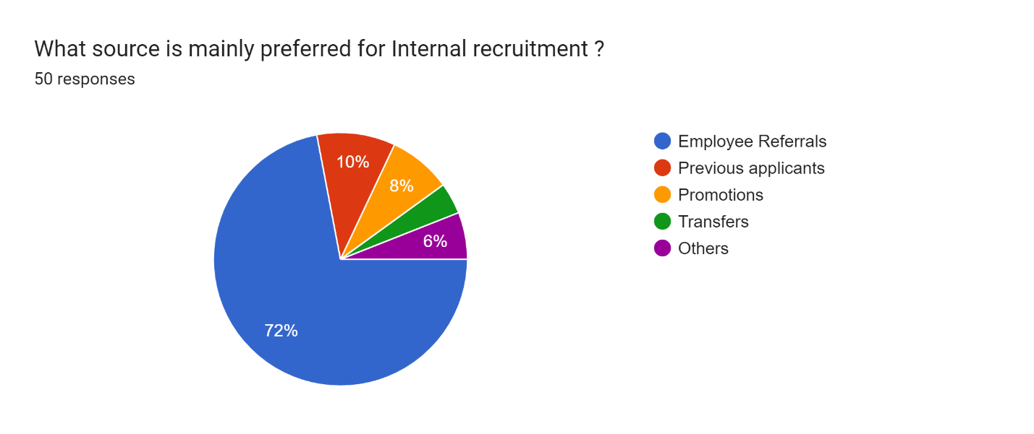
Interpretation: The pie chart shows that the most popular source for internal recruitment is employee referrals, at 72%. Previous applicants are the next most popular source at 10%, followed by Promotions at 8%. The remaining 10% includes Transfers and other sources.

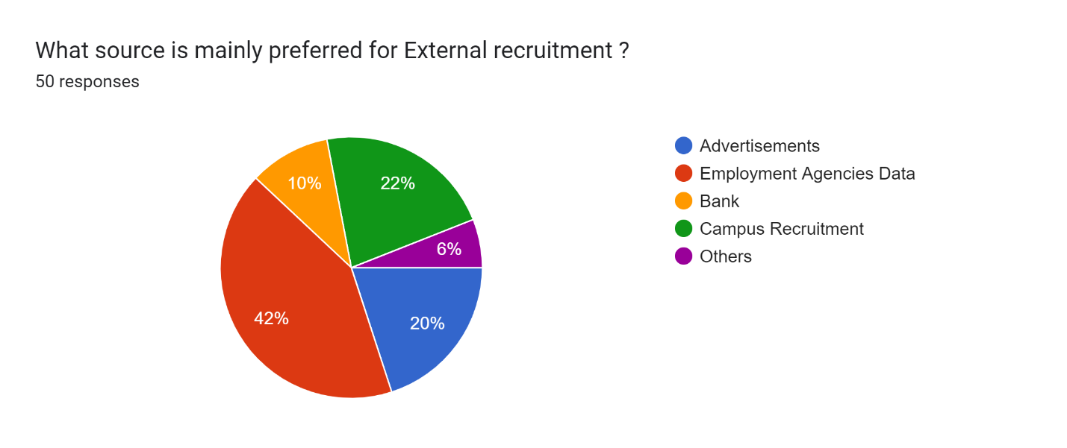
Interpretation: The pie chart shows that Employment agencies are the most preferred source for external recruitment, at 42%. Campus recruitment are the second most preferred source, at 22%. The remaining sources, which include advertisements, a bank, and others, account for 36%.
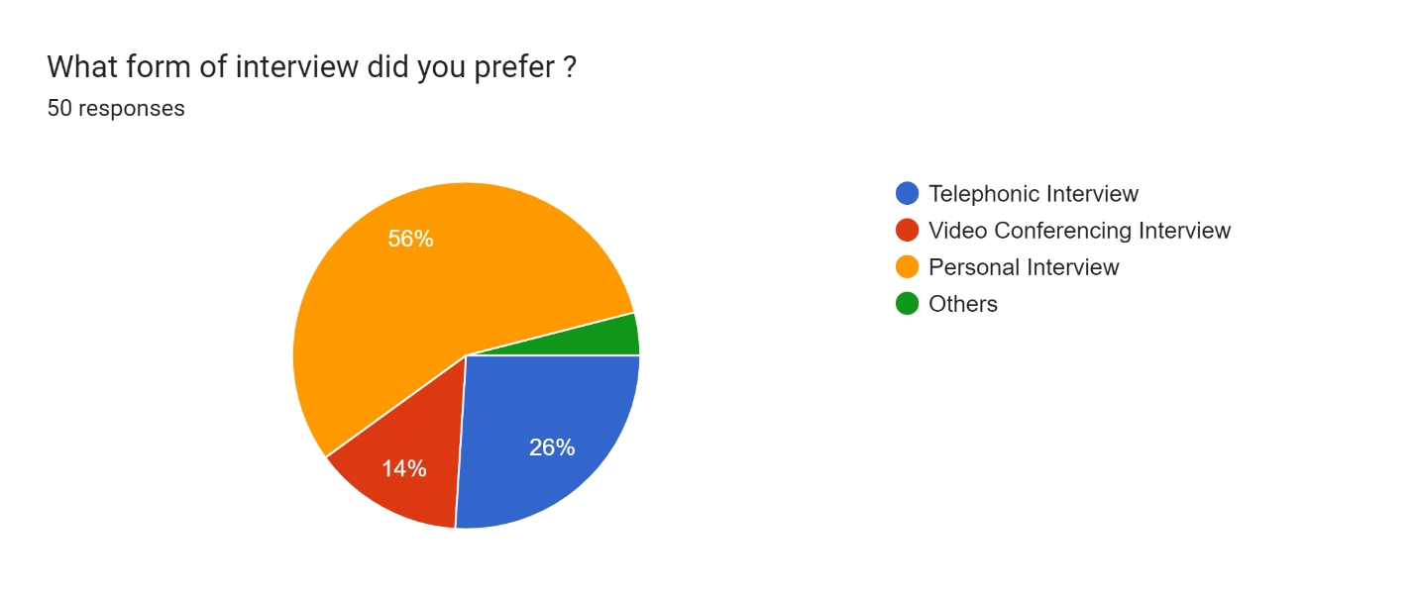
Interpretation: The pie chart shows that Personal interview are the most preferred method, at 56%. Telephonic interview is the second most preferred method, at 26%. In contrast, Video Conferencing interview and other methods are less preferred, at 14% and 4% respectively.

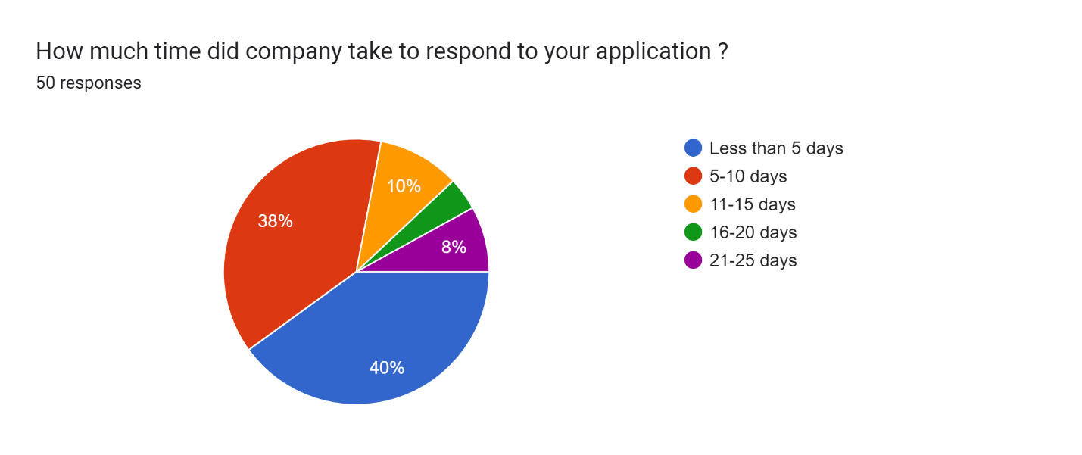Interpretation: The pie chart shows how long it takes companies to respond to job applications. The most common response time is less than 5 days, at 40%, with another significant portion (38%) taking 5-10 days. The remaining 22% of applicants wait 11-25 days for a response.
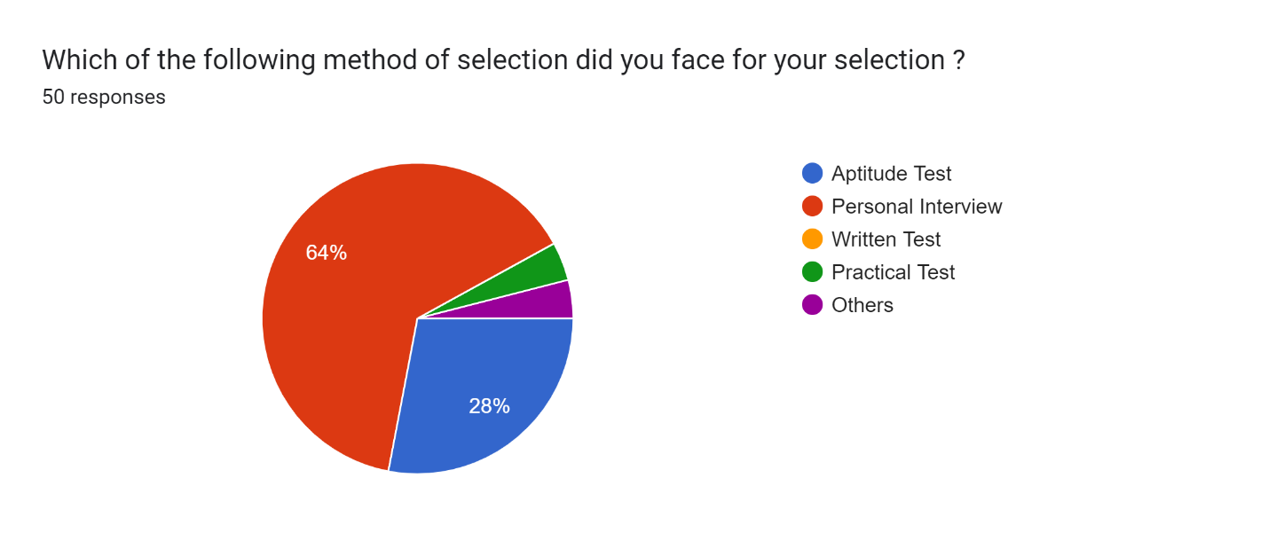
Interpretation: The pie chart shows the results of a survey on job selection methods. The most common method was the Personal Interview, chosen by 64% of respondents. The second most common method was the Aptitude Test, chosen by 28% of respondents. Written test, practical test, and other methods were all chosen by less than 8% of respondents.
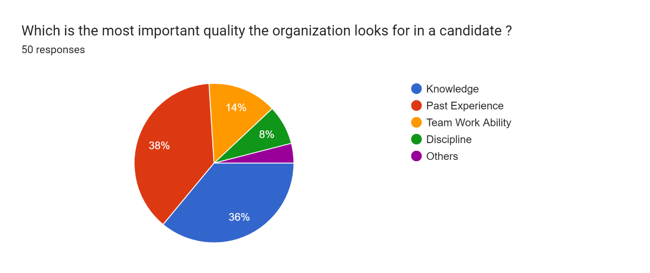
Interpretation: The pie chart shows that, according to the survey, the most important quality that organizations look for in a candidate is past experience (38%). This is followed by knowledge (36%), team work ability (14%), and discipline (8%). Other qualities account for the remaining 4%.
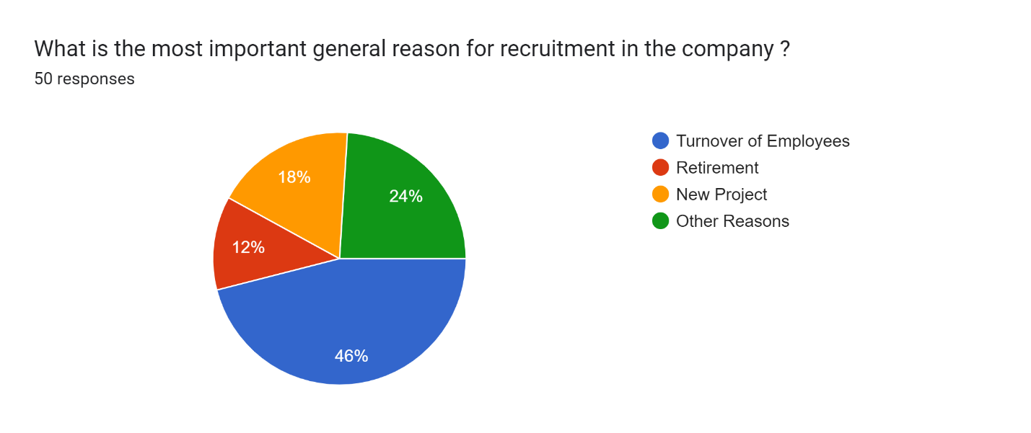
Interpretation: The pie chart shows that the most common reason for recruitment in the company is turnover of employees, at 46%. This is followed by other reasons for recruitment (24%), new project (18%), and retirement (12%). In other words, the company hires most often to replace employees who have left the company.

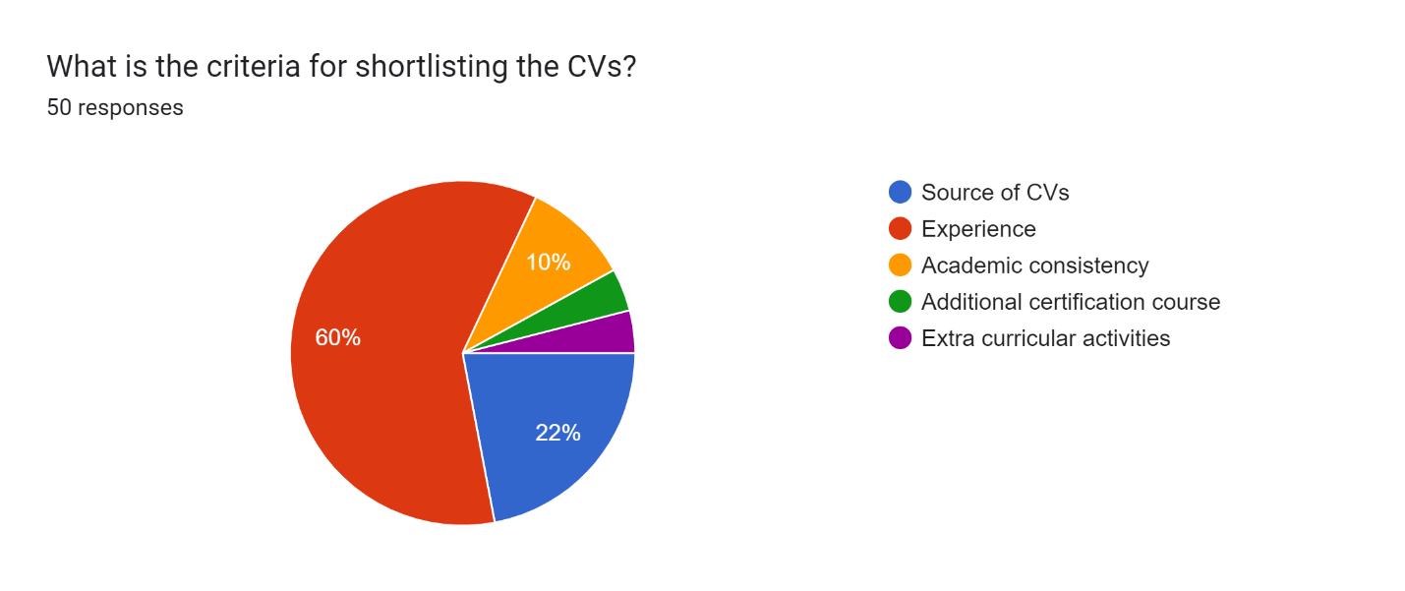
Interpretation: The pie chart shows the criteria used to shortlist CVs. The most important factor is experience, at 60%. Source of CVs is the second most important factor, at 22%, followed by academic consistency, at 10%. Overall, the pie chart suggests that experience is the most important factor when it comes to shortlisting CVs.
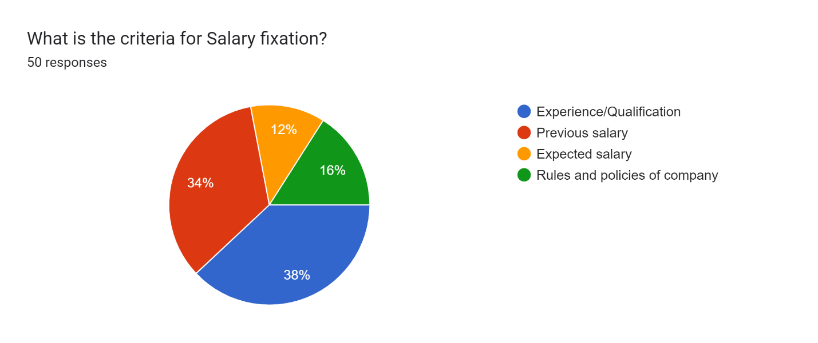
Interpretation: The pie chart shows that according to the survey, the most important factors considered when fixing salary are experience and qualification (38%), followed by previous salary (34%), rules and policies of company (16%), and expected salary (12%). This suggests that a combination of a candidate's experience and qualifications, along with the company's guidelines and the candidate's salary history, are all important factors in determining salary.
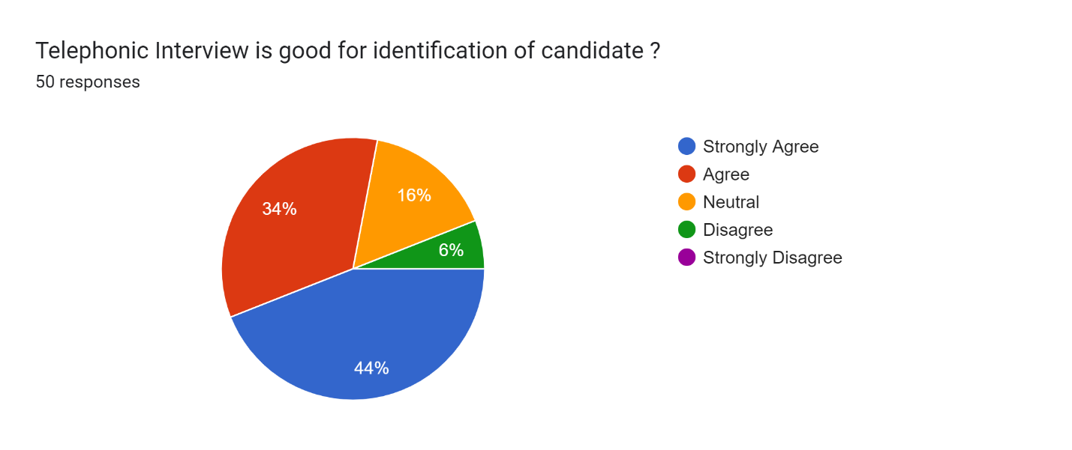
Interpretation: The pie chart shows the results of a survey on whether telephone interviews are good for identifying candidates. The two largest slices, are "Strongly Agree" (44%) and "Agree" (34%), indicating that a majority of respondents believe telephone interviews are a good way to identify candidates. The remaining 22% is split between "Neutral" (16%), "Disagree" (6%). Overall, the survey suggests that telephone interviews are a well-regarded method for identifying candidates. ​​​
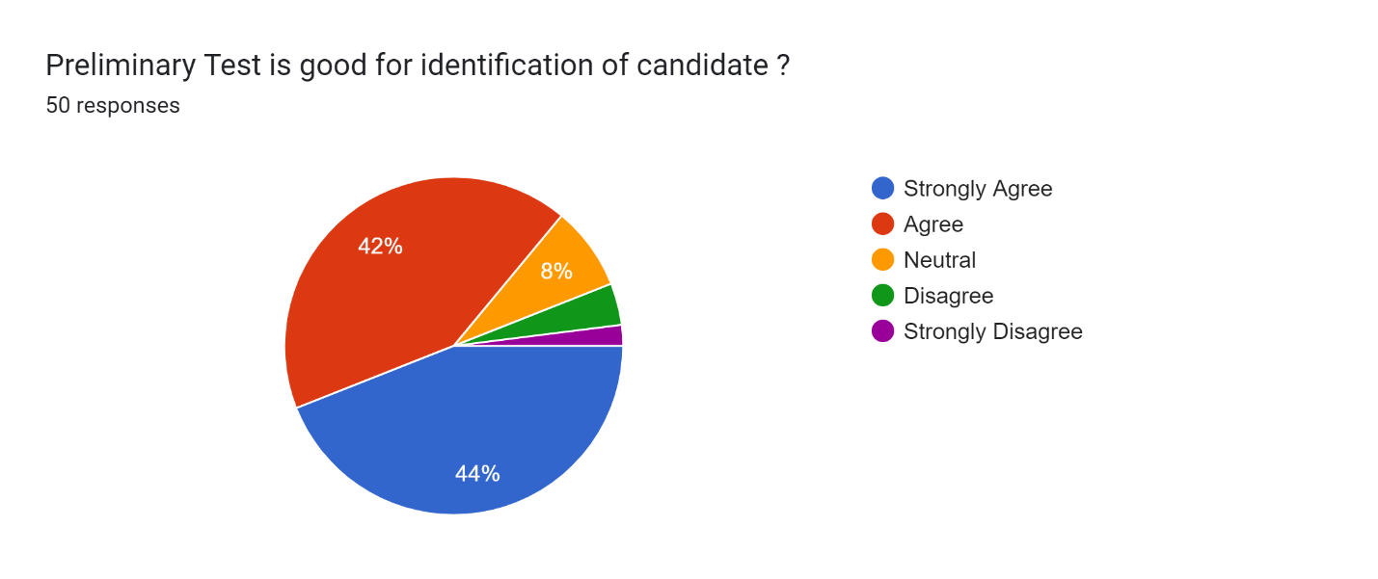
Interpretation: The pie chart shows the results of a survey on whether a preliminary test is good for candidate identification. 86% of respondents agree (42% agree + 22% strongly agree) that a preliminary test is good for this purpose. The remaining 14% of respondents disagree (8% neutral + 4% disagree + 2% strongly disagree). Overall, the survey suggests that a preliminary test is a well-regarded method for identifying candidates.

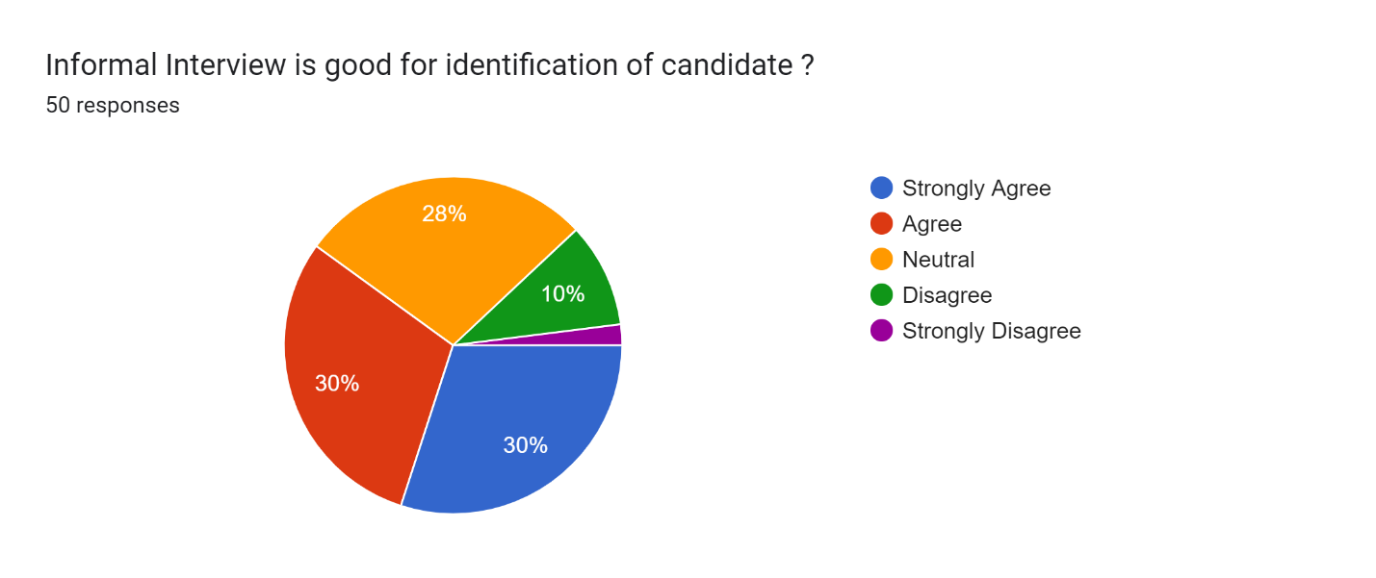
Interpretation: The pie chart shows the results of a survey on informal interviews being good for identifying candidates. 60% of respondents agree (30% strongly agree + 30% agree) that informal interviews are good for this purpose. The remaining 40% of respondents disagree (28% neutral, 10% disagree, and 2% strongly disagree). Overall, the survey suggests that informal interviews are a somewhat favored method for identifying candidates.
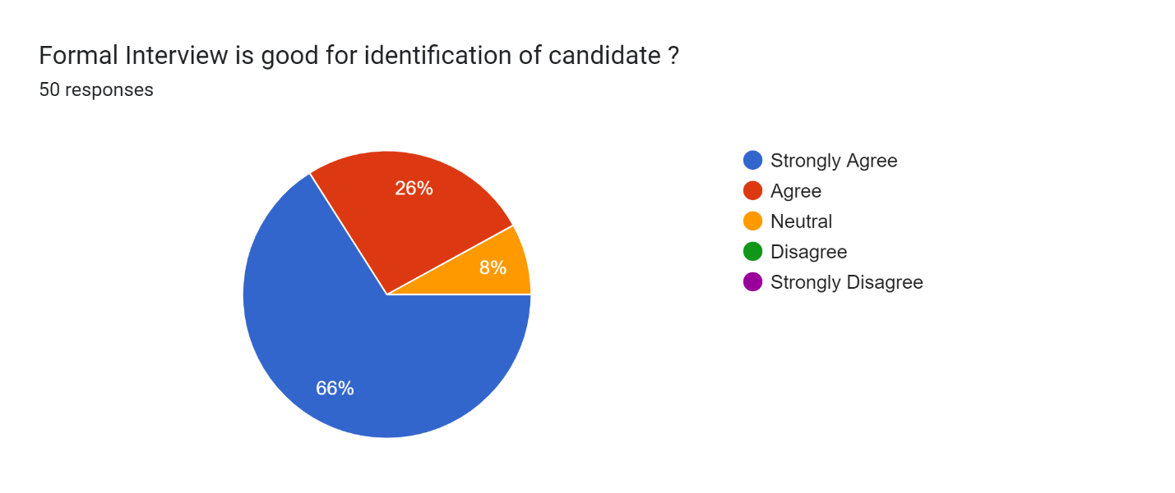
Interpretation: The pie chart shows the results of a survey on formal interviews being good for identifying candidates. 92% of respondents agree (66% strongly agree + 26% agree) that formal interviews are good for this purpose. The remaining 8% of respondents are neutral. Overall, the survey suggests that formal interviews are a well-regarded method for identifying candidates.

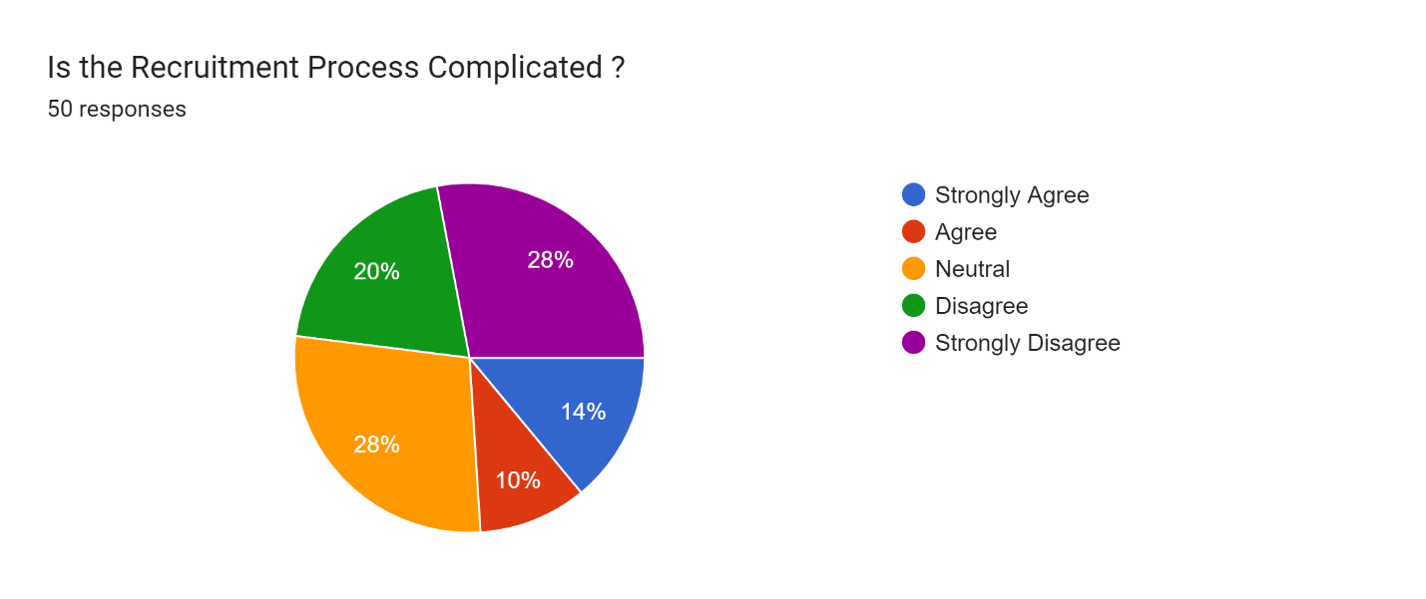
Interpretation: The pie chart shows that opinions are divided on whether the recruitment process is complicated. 48% of respondents disagree (28% strongly disagree + 20% disagree) and another 28% are neutral that the process is complicated. In contrast, 14% strongly agree and 10% agree.

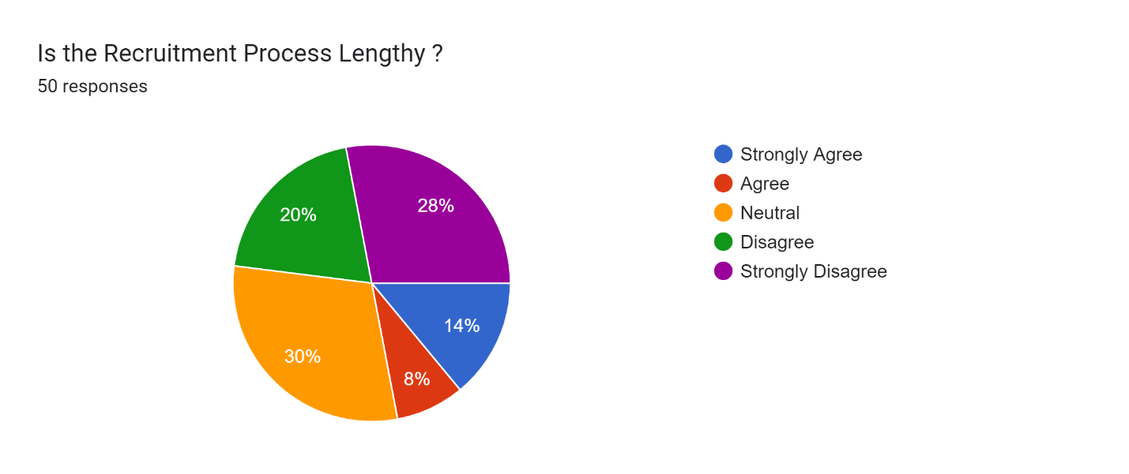
Interpretation: The pie chart shows that most people who responded to the survey don’t find the recruitment process lengthy. 30% of respondents said they are neutral (neither agree nor disagree) and another 28% strongly disagreed and 20% disagree. In contrast, only 14% said they strongly agree and 8% agreed that the recruitment process is lengthy. Overall, the chart suggests that more people find the recruitment process to be efficient than lengthy.

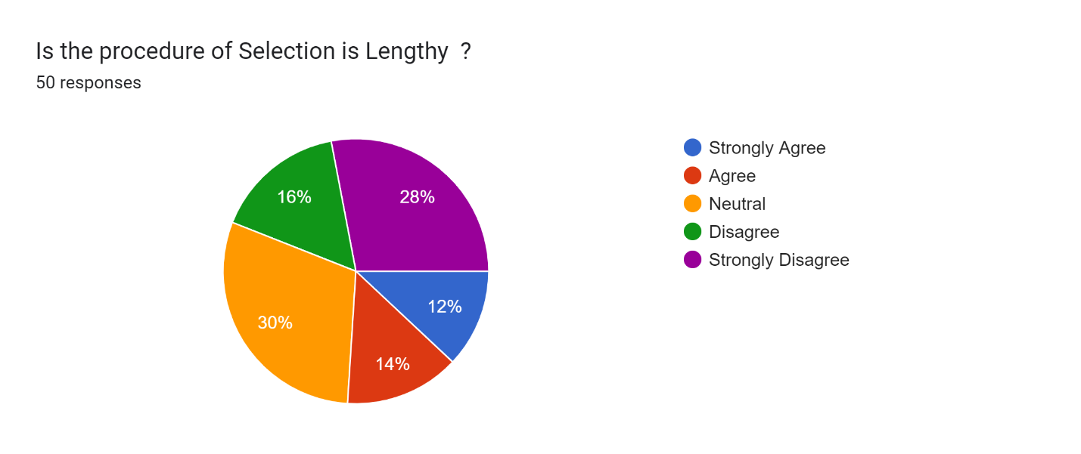
Interpretation: The pie chart shows mixed opinions on whether the selection process is lengthy. Around 30% of respondents are neutral and another 28% strongly disagree and 16% disagree. In contrast, only 14% agree and 12% strongly agree. Overall, a significant number of people find the selection process to be lengthy.
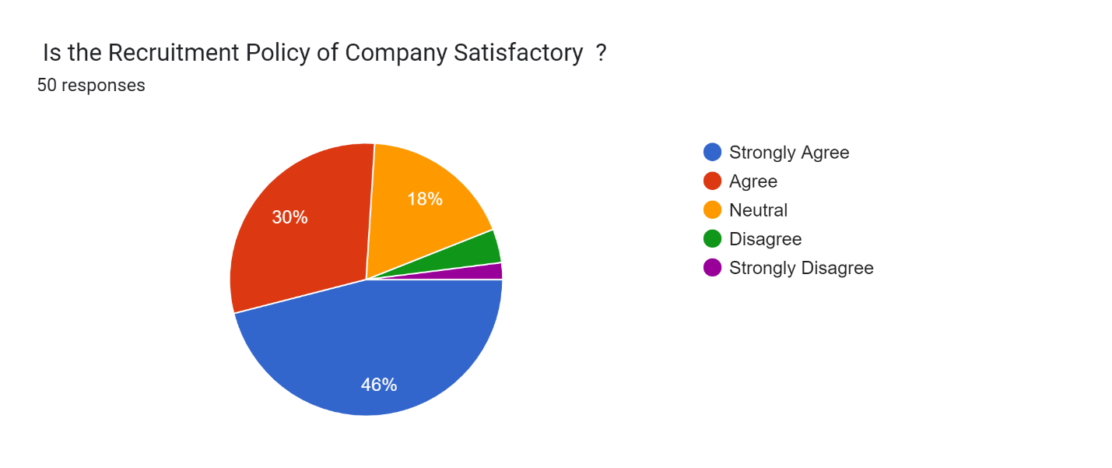
Interpretation: The pie chart shows that a majority of respondents, 46%, strongly agree about the company's recruitment policy satisfactory and 30% agree and another 18% are neutral that the policy is satisfactory. In contrast, 2% strongly disagree and another 4% disagree.

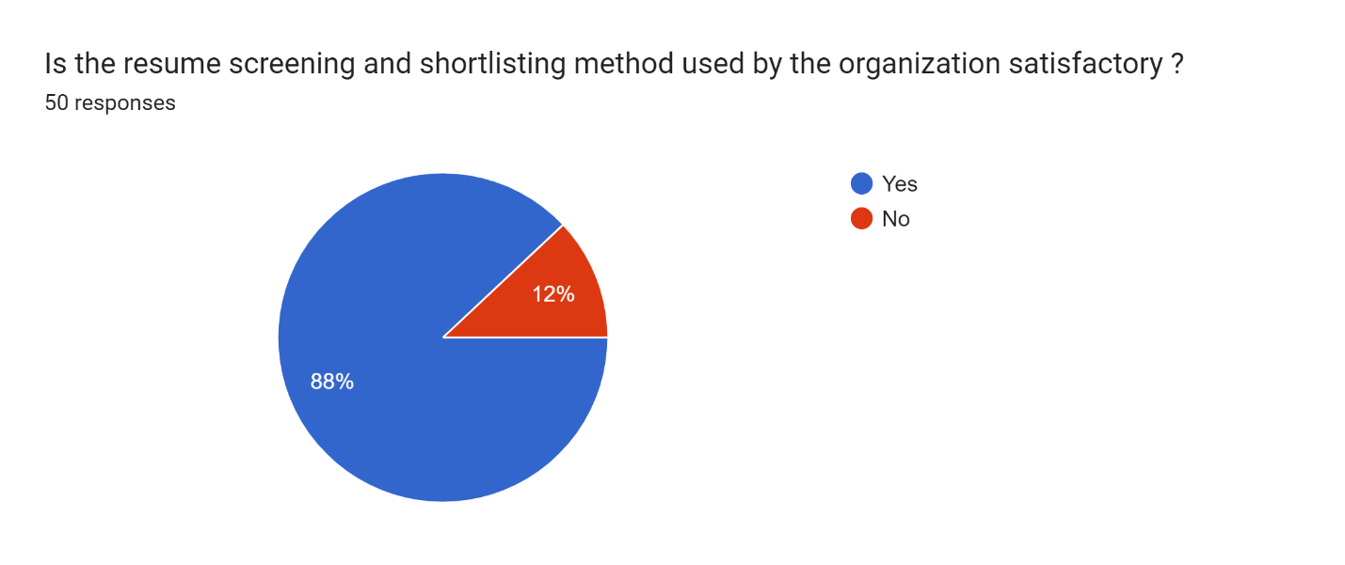
Interpretation: The pie chart shows the results of a survey on how satisfied respondents were with the resume screening and shortlisting process used by an organization. The vast majority of respondents, 88%, were satisfied. Only 12% of respondents were not satisfied.
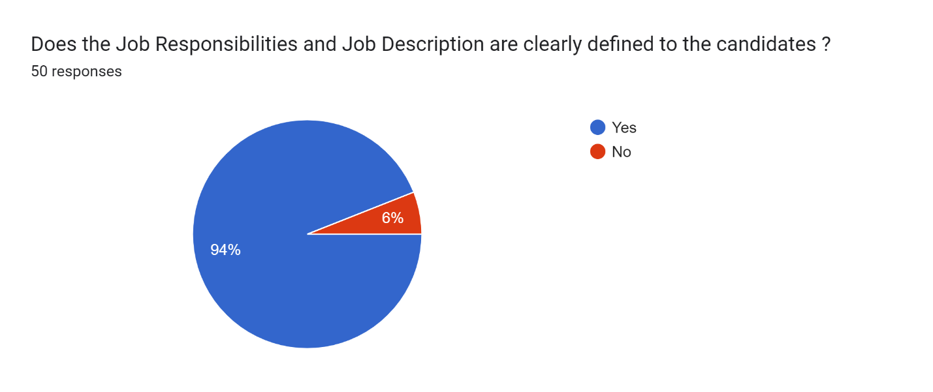
Interpretation: The pie chart shows that in a survey on job descriptions, 94% of respondents believe that the job responsibilities and job description are clearly defined for the candidates. Only 6% of respondents believe they are not clearly defined.

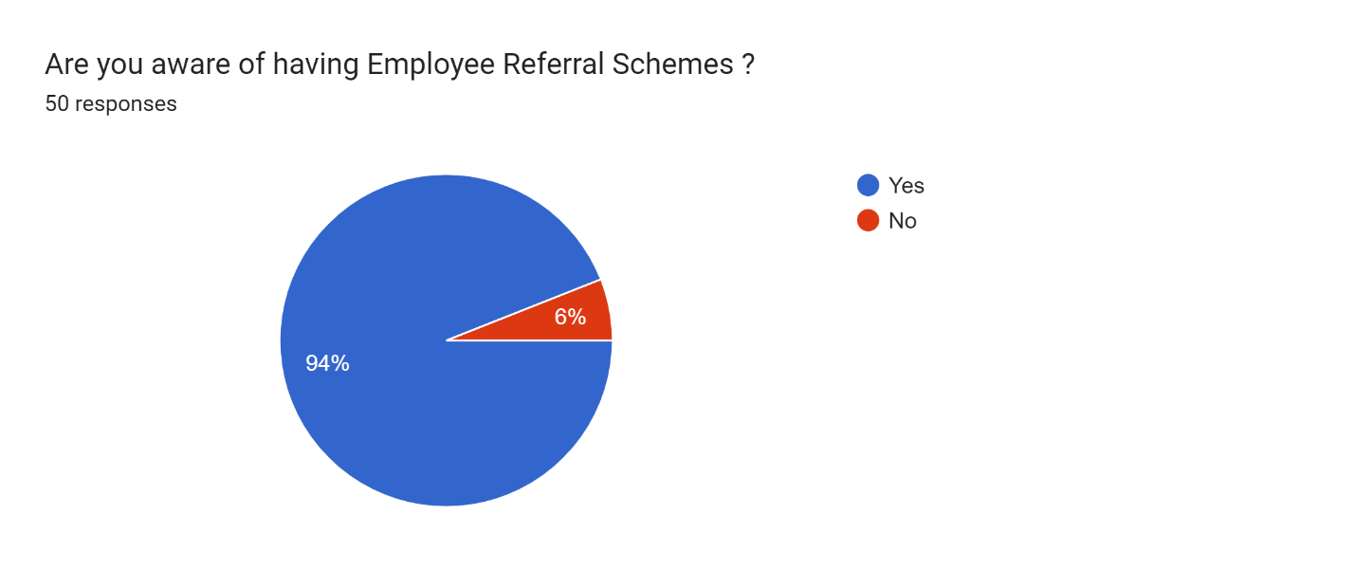
Interpretation: The pie chart shows that awareness of employee referral schemes is very high among employees. 94% of respondents are aware that their company has a scheme, with only 6% unaware.

FINDINGS
The findings from the analysis of questionnaire, including pie charts are listed as follows: -
- Employee referrals are the most popular source for internal recruitment (72%), followed by previous applicants (10%), promotions (8%), and other sources (10%).
- Employment agencies (42%) are the most preferred source for external recruitment, followed by campus recruitment (22%), with advertisements, banks, and others making up the remaining 36%.
- Personal interviews (56%) are the most preferred method, followed by telephonic interviews (26%), with video conferencing (14%) and other methods (4%) being less preferred.
- Most companies respond to job applications within 5 days (40%) or 5-10 days (38%), with 22% taking 11-25 days.
- Personal interviews (64%) are the most common job selection method, followed by aptitude tests (28%), with written tests, practical tests, and other methods each under 8%.
- Organization prioritize past experience (38%) and knowledge (36%) in candidates, followed by teamwork ability (14%) and discipline (8%), with other qualities at 4%.
- The primary reason for recruitment in the company is employee turnover (46%), followed by other reasons (24%), new projects (18%), and retirement (12%).
- Experience (60%) dominates as the primary criterion for shortlisting CVs, followed by CV source (22%) and academic consistency (10%), indicating its paramount importance in the selection process.
- Experience and qualifications (38%) are key in salary determination, followed by previous salary (34%), company policies (16%), and expected salary (12%), emphasizing their importance in setting salaries.
- 88% of respondents were satisfied with the organization's resume screening and shortlisting process, while only 12% were not satisfied, indicating high overall satisfaction.
- 94% of respondents perceive job responsibilities and descriptions as clearly defined, with only 6% indicating otherwise.
- High awareness of employee referral schemes among employees, with 94% aware of their company's scheme and only 6% unaware.

CONCLUSION
Recruitment is essential to effective Human Resources Management. It serves as the nerve centre of the organization's whole HR department. The level of skill of new hires drawn in by the recruitment process has a significant impact on the effectiveness of numerous other HR initiatives, including training and selection. Achieving good organizational performance and reducing employee turnover depend on effective recruitment. As of now PNB MetLife has a team of effective human resource which is efficiently managing the organization at its best.
In PNB MetLife, both internal & external source of recruitment are used. Internal recruitment is predominantly driven by employee referrals, while employment agencies are favoured for external hiring. Personal interviews are the preferred method for both screening and selection, highlighting their importance in the recruitment process. Companies prioritize past experience and knowledge when evaluating candidates, and experience significantly influences CV shortlisting and salary determination. The prompt response to job applications and high satisfaction with resume screening indicate efficient processes. Additionally, clear job descriptions and strong awareness of employee referral schemes reflect effective communication within organizations. High satisfaction rates with hiring processes and role clarity underscore organizational efficacy. These findings underscore the need for tailored recruitment strategies aligned with organizational goals to attract and retain talent effectively. Such insights offer valuable guidance for refining recruitment approaches and enhancing employee satisfaction, thereby fortifying organizational success.
Thus, through the analysis and the interpretations of the data it can be concluded that the employees are much satisfied and happy with the organization.
REFERENCES
1) Dr. Sayel (2018) Impact Of Online Recruitment On Recruitment www.mcm.ac.ae
2) Tanjakoch And Charlene Gerber (2018) The Impact Of Social Media On Recruitment. www.sajhrm.co.za
3) Chungyalpa w (2016) Best Practices And Emerging Trends In Recruitment And Selection. www.omicsonline.org
4)Pranav Kharbanda And Jyoti Sapramadan (2015) Emotional Intelligence In Recruitment And Selection
5) Muhammad And Hamad Anam Batool (2014) Impact Of Recruitment And Selection Of Hr Department Practices. www.iiste.org
6) Alka, R. (2014), Kalindi College, Department of Commerce, University of Delhi, Delhi , India, Indian Streams Research Journal, Vol. (4), No. 5. http://jgateplus.com/search/index
7) Dora s (2003), Anticipatory Socialization: The Effect of Recruitment and Selection Experiences on Career expectations, Career Development International, Vol. (8), No. 4, pp. 182-197. http://search.proquest.com
8) Rod, D. (1995), Recruitment and Selection: A Perspective for the Twenty-First Century, The International Journal of Career Management, Vol. (7), No. 1, pp. 3. http://jgateplus.com/search/index
9) Gupta Shashi K.; Human Resource Management; Kalyani Publications
10) Chhabra T.N.; Human Resource Management ; Dhanpat Rai & Co. Pvt Ltd
11) Aswathappa K.; Human Resource And Personnel Management; Tata McGraw –Hill Publishing Company Limited

