**TESTING LIFE CYCLE OF ELECTRICAL LOADS USING DOWN COUNTER**

Mrs. Kalpana S, Ajay kumar S, Divya M, Karthik G.D, Mrs. Kalpana S.

Department of Electrical and

Electronics engineering

PES Institute of Technology and Management

Shivamogga, India

-------------------------------------------------------------------***-----------------------------------------------------------------------

**Abstract *-*** ***As the lifespan of electrical loads can affect their reliability and efficiency, accuracy of life cycle testing becomes crucial. This paper demonstrates the development of a down counter-based system for monitoring and evaluating the life cycle of electrical loads. Tracking the operational cycles using an Arduino Mega 2560 as the primary controller helps to seamlessly ensure precise measurement of load performance and durability. Real-time system data provides useful information on the endurance of electrical parts and helps in predictive maintenance and failure analysis. The proposed method improves testing effectiveness while reducing human input, thus making it ideal for industrial use which often demands high precision. The system can also be designed to test many loads at the same time, which increases scalability. This approach has been shown to provide tremendously valuable information on how to best optimize electrical devices and components in different environments for maximal utility.***

***Key Words*:** ***Life cycle testing, Electrical loads, Down counter, Arduino Mega 2560, Reliability,***

**I. INTRODUCTION**

The long-term efficiency of electrical loads is dependent on their durability and reliability. Why? A down counter, controlled by an Arduino Mega 2560, is utilized to monitor the operational lifespan of electrical components in this project. It is designed to simulate continuous on-off cycles, especially for loads such as bulbs so that they can be tested for their durability. An automated switching mechanism manages the load, and the down counter keeps track of the number of cycles that have been completed. By utilizing this method, it is possible to identify failure patterns, efficiency, and longevity, which are crucial metrics for product quality improvement.

**II. LITERATURE SURVEY**

This section highlights significant studies that have contributed to the development and advancement of life cycle testing for electrical loads. These studies cover automation, the integration of microcontroller-based systems, and innovative approaches to improve testing efficiency, accuracy, and scalability. Below is a detailed discussion of these key studies

**1. Smith et al. (2018):**

Smith et al. investigated the automation of LED life cycle testing to improve testing accuracy and reliability. Their methodology relied on developing an automated system capable of monitoring ON/OFF cycles without manual intervention. The study employed sensors to detect light output and down counters to track operational cycles, ensuring consistent testing conditions. By automating the process, they were able to eliminate human errors, increase efficiency, and provide real-time data on LED performance under repetitive stress

**2. Zhang and Liu (2020):**

Zhang and Liu explored the application of down counters in automated testing setups, emphasizing their role in tracking ON/OFF cycles during life cycle testing of electrical loads. Their approach involved integrating down counters with relay circuits to automate the repetitive switching process. This setup was designed to monitor the durability and reliability of loads while providing precise cycle counts. Their methodology proved effective in reducing the complexity of testing systems and enhancing the accuracy of durability assessments

**3.Gupta and Sharma (2017):**

Gupta and Sharma focused on relay-based scalability in testing systems for electrical loads. They developed a methodology that used relay modules to control the ON/OFF operations of multiple loads simultaneously. Their system allowed for the testing of several devices under varying operational conditions, highlighting its scalability and adaptability for industrial applications. The study demonstrated that relay-based systems could improve efficiency and maintain precise control over testing processes, making them suitable for large-scale testing environments

**III. SCOPE OF PROJECT**

* This study is dedicated to the development and application of an automated system for the lifecycle test of electrical loads like bulbs by using a down counter.
* In this way, the exact control of operation cycles is ensured, and it becomes possible to evaluate the reliability, and performance of the load.
* The objective is to eliminate the manual systems and to introduce instead automatic, which is reliable as well as fast in quality testing process
* The scope extends to industrial and domestic applications.

**IV. PROBLEM DEFINITION**

* The performance of electrical loads, similarly to light bulbs, needs to be tested and monitored in relation to time.
* Its aging and durability must be evaluated.
* Testing procedures are prone to mistakes and do not offer any efficiency or precision for monitoring operational cycles.
* An automated system that can accurately track the lifetime of electrical loads within a simulated failure environment pattern is essential.
* The absence of such automated equipment renders the challenge of efficiently assessing the reliability of various components extremely difficult.
* A down counter modern method of performing an automated test system helps us overcome these barriers.

**V. OBJECTIVE OF THE PROJECT**

* Determining the durability and reliability of electrical loads by repetitive   ON/OFF cycles.
* Measuring the total number of operational cycles the load sustained before failure.
* Automating the life cycle testing process to enhance the precision and efficiency.
* Analyzing energy consumption and performance stability of electrical loads under various conditions.
* Developing a cost-effective and user-friendly.

**VI. METHODOLOGY**

* **System Design and Conceptualization**

Certain criteria have to be met to ensure that the whole system functions properly. The constituents of the system design’s architecture include an Arduino Mega 2560, a relay module, a down counter, a keypad 4x4 for data input, and a digital output unit, which on their own can accomplish life cycle testing of electric loads such as bulbs and guarantee dependable and repeatable outcomes.

Equally critical is the knowledge of each segment of the system. The primary controller, an Arduino Mega 2560, manages the entire procedure. It is fully responsible for communication with the relay module, which is meant for powering the load on and off, controlling the data input via the keypad, and sending status messages through the digital screen. It is Arduino programmed, so when the load completes a cycle, the down counter is decremented by one, enabling control and monitoring of the undertaking.

It is the physical switch that controls the load of electricity in this relay module. The ability to handle the current and voltage ratings of the electrical load makes it essential. By interacting with the Arduino Mega 2560, the relay can be programmed to switch on or off the load as per protocol specifications.

The user inputs the necessary test parameters, including the number of cycles required, load on and off times, and any remaining time between cycles via the interface. The system relies on this input to maintain user-defined conditions. The digital display shows the current status of the test, including the number of cycles that have been completed and the remaining cycles in real-time.

In conclusion, the load's number of cycles is determined by the down counter. As per the user's input, it'll decrease with each load change that is turned on and off. By providing feedback to this counter, the system allows users to monitor the progress of the test.

* **Cycle Execution and Down Counter**

Once initiated, the device constantly switches the bulb ON and OFF in line with the entered dependency. Each cycle includes a predefined-ON period accompanied by an OFF period. The countdown decreases the depend after each whole cycle, making sure a correct countdown shows. The device operates mechanically till both the dampers reach 0 or the bulb fails.

* **Failure Detection and Alert Mechanism**

The LDR sensor video display units the mild emitted through the bulb. If the LDR does now no longer stumble on mild while the bulb is switched ON, the device identifies it as a failure. At this point, the Arduino stops similarly switching, and the buzzer is activated to signify a failure. The virtual show indicates the ultimate hit depends earlier than failure.

* **Completion of Testing Process**

If the bulb completes all cycles successfully, the device stops mechanically whilst the down counter reaches 0. The person can then reset the device and begin a brand new take a look at with a clean enter cycle depend.

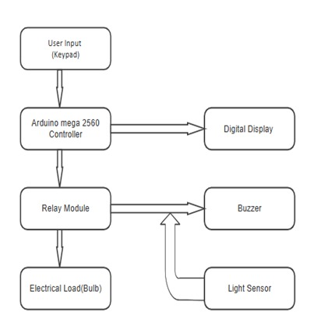**VII. BLOCK DIAGRAM**

**Figure 1. Block diagram**

First, the input is given by the user through the keyboard, and the input is taken into the Arduino Mega 2560 Controller. Now this input in the Arduino will enter the relay module, which controls the electric load. This load value is also displayed on the digital display, which also shows the cycle counter and status. Now in this relay mode, it shows the electric load and also the buzzer, and for that buzzer, there is a light sensor.

**VIII. CIRCUIT DIAGRAM**

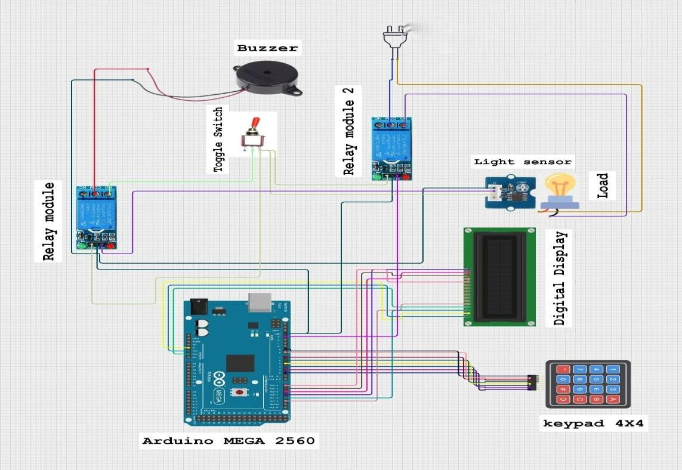

**Figure 2. Circuit diagram**

**IX. HARDWARE DESCRIPTION**

The "Testing Life Cycle of Electrical Loads Using Down Counter" machine accommodates numerous key hardware additives operating cohesively to make sure the correct execution of the take a look at cycles. The number one hardware consists of the Arduino Mega 2560, relay module, keypad, virtual display, and electrical load. Each factor performs a wonderful role withinside the machine, permitting green operation and unique testing. Below is an in-depth description of the hardware elements involved.

* Arduino Mega 2560
* Relay Module
* Keypad (4x4 Matrix)
* Digital Display
* Electrical Load (Bulb)
* Electric Buzzer
* Toggle Switch
* Light Sensor(LCD)

**X. WORKING**

The operation of the electrical loads life cycle testing system or automation of testing revolves around the automated control of individual components for testing the on-off repetition cycling performance of the bulb. The process initiates when the user toggles the switch which sends a signal to the Arduino Mega 2560, thus commencing the cycle.

As soon as the signal is received, the Arduino sends control signals to the relay which powers the bulb on and subsequently turned on. The LDR or Light Dependent Resistor is placed in a position to receive that emitted light. When the bulb is ‘ON,’ the LDR is active and therefore light will be present, hence the resistance will fall. This change is detected by the Arduino and the buzzer is kept in “OFF” mode, so it does not sound which is a healthy status for the bulb.

The Arduino, after powering the bulb for a set count of cycles will command the relay to toggle the bulb into the ‘OFF’ state. The absence of threshold light will be detected by the LDR, and the resistance will rise. The Arduino after this action will sound the buzzer indicating the bulb is “OFF". The system infinitely repeats the action of turning the lightbulb on and off, with the Arduino acting as the host and manually controlling each phase according to the set parameters.

The down counter monitors the count of completed cycles. Every time the light bulb is switched on or off the down counter decrements the cycle count. Cycle number is then displayed on a digital display so that the user can monitor the progress of the test in real time. This automatic cycle proceeds until the set number of cycles, which was predetermined by the user, is reached. The system uses on/off cycles to monitor the lightbulb’s life cycle, and during the test, the user is informed whenever the system turns the lightbulb off through an audible noise. This allows users to confirm whether the monitoring element of system and down counter, which is there to make sure accurate testing processes are done without missing cycles, is functioning properly.

With the use Relay, LDR, toggle switch, and Arduino, the system automates the testing of the lightbulb which guarantees that the lightbulb is placed under the same conditions for a long time and sustained stresses and conditions of real-world usage.

**XI. CONCLUSION**

The birth, life, and death process of the Arduino Mega 2560 powered by a relay module, a light-dependent resistor (LDR), a buzzer, and the use of a down counter were targeted during testing of the system. Combining software and hardware can result in a successful conduct of a great number of tasks. The central purpose to investigate the reliability and lifetime estimate of bulbs, e.g. , was achieved by a solid and fully automatic system which helped in real-time monitoring and giving feedback.

The excellent performance of the system is depicted in the case where the device operates as intended thus correctly counting the operational cycles, e.g., a bulb state gets changed from "ON" to "OFF". Being in the down counter, the latter meticulously displayed the number of cycles, thus, this allowed the system to monitor the bulb’s performance very accurately.

The relay module managed the bulb’s switching effectively while the LDR continually monitored the light intensity to determine if the bulb was working correctly. The buzzer was the one to give the immediate signal in case the bulb was switched off or it failed to perform well.

The automation of the system saved a lot of time and labor as it diminished the continuous human control and made the testing sector more productive, allowing the tests to run for a longer period of time. Furthermore, it was also a very accurate and repeatable way of life cycle testing, which is important in assessing the silliness and reliability of the electrical parts. The cooperation of all those gadgets- the Arduino Mega 2560, a relay, an LDR, a buzzer, and a down counter- was found to be quite perfect on the whole, in connection with its completion and transmitting the right signals.

On the whole, this testing system was the best measuring instrument in the cycle of life of electric loads. The project realized its aim by showing the durability of the bulb through a fully automated life cycle test. The system may be even improved with the help of newer sensors, better user interfaces, or a scalable test environment for different types of electrical loads. However, it currently provides a practical and reliable solution for life cycle testing, which is suitable for both industrial and educational applications.

**XII. FUTURE SCOPE**

This type of testing system in the life cycle realm is already being automated and becomes knowledgeable on how to deal with the difficulties of the eco-design process, but there are still many ways to improve it in the future. All the possible ways to make it even more improving are given below:

**1. Testing Multiple Bulbs at Once**

The current system in use is a single bulb endeavor. Later on, many tasks will be performed simultaneously by the system. The product will be much faster, and it will be able to test different brands or bulb types in a bundle and with the help of this system, the work will be very efficient.

**2. Adding Different Types of Electrical Loads**

This present system is a brand-specific one. But we can have a similar kind of testing facility for fans, motors, or LEDs. It is this tiny alteration that makes it stand as the life cycle testing fruit, which can be utilized for various kinds of appliances. With this one system, the changes of a product can be detected quickly, and the issue can be fixed before the breakdown occurs.

**3. Storing and Analyzing Test Data**

The company currently doesn't have a way of recording test results. The company can upgrade to having a system where it can store cycle data on an SD card, or it can be sent the data to a computer to be analyzed. This will help engineers to track failure patterns and thus improve product quality.

**4. Using a More Advanced Failure Detection System**

Instead of having only an on-off function, we can have the future system do tasks like brightness measurement, power consumption, and heat detection to know better how the product performs throughout its life.

**5. Connecting to the Internet (IoT Integration)**

Connecting to the Internet through Wi-Fi or Bluetooth, the system can transmit data to a distant device which can be a mobile application or store it in a cloud. Users can observe the test, and this will be an important advantage for industrial tests.

**6. Expanding to Large-Scale Industrial Use**

It is advisable to scale up this system to be used in testing laboratories for industries dealing with many electrical loads that need to be run continuously. Automation has to be enhanced by companies to get the product quality better and the testing time shorter.

**XIII. REFERENCES**

* Smith etal. (2018). Automation in LED life cycle testing.
* Zhang & Liu. (2020). Down counters in automated testing.
* Gupta & Sharma. (2017). Relay-based scalability in testing.
* Kumar etal. (2019). Arduino based industrial testing.
* Arduino Official Documentation. (2024). Arduino Mega 2560 Board. Retrieved from https://www.arduino.cc/en/Main/ArduinoBoardMega2560
* Ray, C. S. (2016). Arduino Programming in 24 Hours. Sams Publishing.
* Xing, L., & Wang, M. (2019). Relay Control Systems For Embedded Applications. Journal of Electrical Engineering, 75(4), 45-52.
* Sharma, D., & Agarwal, P. (2020). Electrical Load Testing and Monitoring. International Journal of Electrical Engineering & Technology, 12(3), 100-110.
* Makino, M., & Takeda, Y. (2017). Arduino-Based Relay Systems for Automation. Journal of Automation and Control, 58(2), 119-125.
* Khader, H. M., & Al-Akaidi, M. (2021). Arduino for Industrial Applications: Design and Implementation. Springer.
* Suryawanshi, S. S., & Shelar, R. P. (2019). Down-Counter Circuits for Accurate Load Cycle Measurement. Electronics & Communication Engineering Journal, 10(2), 33-40.
* National Instruments. (2022). Relay Modules and Their Use in Automation Systems. Retrieved from https://www.ni.com/en-us/innovations/relay-modules.html
* Electrical Safety Foundation International (ESFI). (2023). Testing Electrical Devices and Components for Safety and Durability. Retrieved from https://www.esfi.org
* Arduino Project Hub. (2024). How to Use a Light Dependent Resistor (LDR) with Arduino. Retrieved from https://create.arduino.cc/projecthub
* Ross, M. (2015). Practical Applications of Electrical Load Testing in Modern Industries. Industrial Automation Journal, 22(4), 50-57.

**XIV. BIOGRAPHIES**

|  |  |
| --- | --- |
|  | 1Ajay Kumar S  Department of Electrical & Electronics Engineering  PES Institute of Technology & Management  NH 206, Sagar Road, Shivamogga, Karnataka - 577204  *[ajayk263629@gmail.Com](mailto:ajayk263629@gmail.Com)* |
|  | 2Divya M  Department of Electrical & Electronics Engineering  PES Institute of Technology & Management  NH 206, Sagar Road, Shivamogga, Karnataka - 577204  [*divyam4826@gmail.Com*](mailto:divyam4826@gmail.Com) |
|  | 3Karthik G.D  Department of Electrical & Electronics Engineering  PES Institute of Technology & Management  NH 206, Sagar Road, Shivamogga, Karnataka - 577204  [*karthikgd12@gmail.Com*](mailto:karthikgd12@gmail.Com) |