A Research paper on Electric scooter battery ejection system

Stalin Britto, Abhishek Hande, Devesh Ratnakar, Mayur Dhanawade, Vishwas Pudale
Department of Mechanical Engineering
Faculty of Mechanical Engineering
IETES Bharat college of engineering Badlapur, Maharashtra India

Abstract – As we see growth in Electric
Vehicles Industry we face a big challenge in
Maintaining the safety of electric vehicles. As
Specially the safety of the Lithium battery
Used in it. In this paper we have tried as an idea to tackle this problem of fire catching in electric scooters by a Ejecting the battery by mannually pulling lever attached to front of the chassis of the electric scooter.

This paper focuses on reviewing the hazards
Caused in an electric scooter by the lithium
Ion battery which occurs due to various
Reasons like overcharging the battery
Mechanical damage, physical damage Overuse

In this paper we have tried to design a system Attacthed to the chassis of the electric scooter by designing additional parts which will help
to eject the battery from the electric scooter
with the help of a lever attached to it.

Keywords Electric scooter, battery ejection ,mechanical lever.

- Introduction
As we are shifting towards green energies and stop using fossil fuels the amount of electric vehicles is going to increase in demand. This will also lead to increase in fire accidents which occurs in this type of vehicles as we use lithium cells which is flammable.
Now currently in market there are two types of electric scooter which consist of a fixed battery and one is a portable battery, In this paper we have tried to

introduced a new type of safety system where we can eject the battery installed in it buy simply pulling a lever attached to the chassis of the scooter when it catches fire. The battery ejection system typically consists of a release mechanism that allows battery to be detached from the scooter frame. This ejection system is an important factor which helps to protect the other parts of the scooter when it catches fire.

  - Problem Defination
When the battery of the scooter catches fire sometimes it ejects smokes or some time it catches flames so the driver of the vehicle loses his vehicle. Which is dangerous to the driver also the surroundings of the vehicle, the problem is we cannot remove the battery when it catches fire or emits smokes because there is no such thing designed in the vehicle which can remove the bettery from the vehicle. We have noticed that when an scooter catches fire the front side of the scooter is a safe spot here we can install an lever which the driver of the vehicle can pull immediatedly when the battery catches fire which ejects the battery from the scooter.

  - Objective
1. To create a safety system for an electric scooter for the battery
2. To prevent the electric scooter from catching fire
3. Drivers safety

Main component

  - stainless steel wire rope cable 6x37 made of 6 strands consisted of multiple wire consisted together
  - stainless steel cable supporting rod

  - lithium ion Electric battery

1.6 supporting cable holder from where the cable is to be passed

1.7 Assembly of electric scooter with battery and frame with pulling mechanism

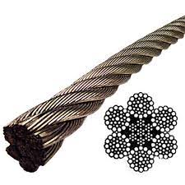

Fig 1.3 stainless steel wire rope cable 6x37 made of 6 strands consisted of multiple wire consisted together for improved flexibility

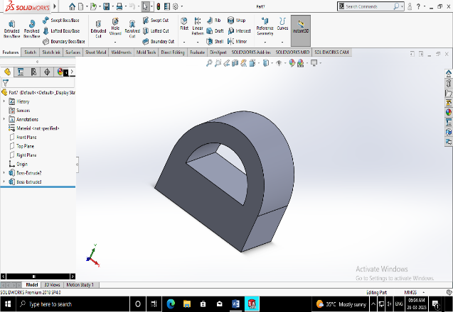

Fig 1.6 supporting cable holder from where the cable is to be passed

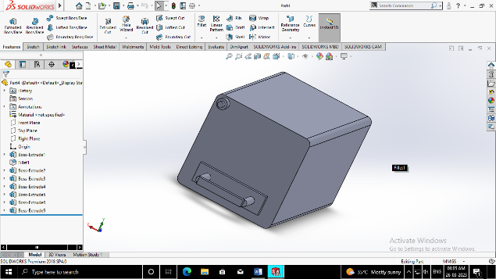

Fig 1.5 lithium ion Electric battery

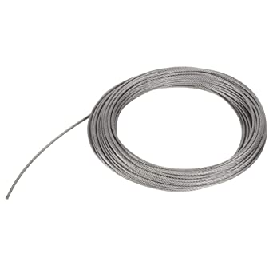

Fig 1.3 stainless steel cable supporting rod

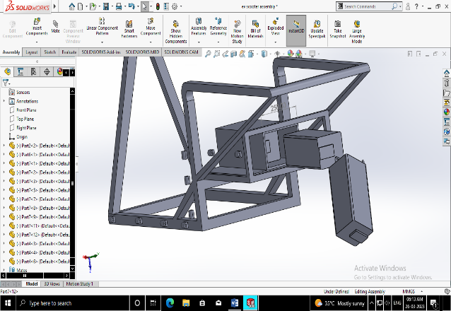
Fig1.7 This figure shows how the battery can be pulled out of the frame

Fig 1.4 stainless steel cable supporting rod

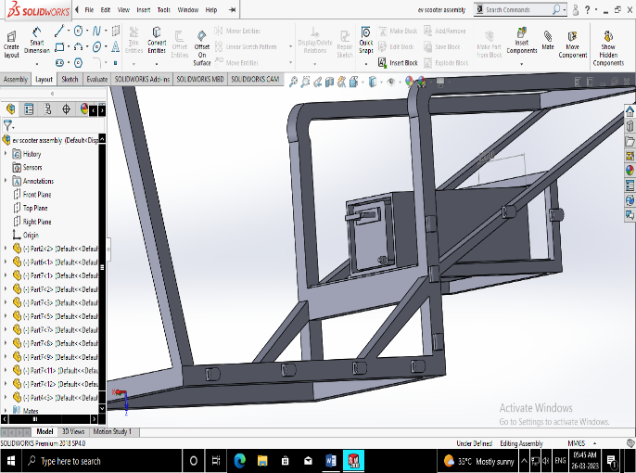

Fig 1.9 Assembly of electric scooter with battery and frame with pulling mechanism

In this mechanism we can see that the battery is covered in the shell and wire is drawn from the supporting rods attached to the body the idea is to pass a cable from the rods which will pull the battery from the back side of the chassis of the scooter.

Our Methodology

In this system that we created, the stainless steel cable wire will be passed from the supporting rods and it will be attached to the battery by nuts and bolt when the lever is pulled from the front part it will throw the battery from the frame outside the frame when the battery will caught fire the design we created is just an idea and is not a final product it is a prototype this idea is needed to be convert in manufacturing stage for testing . The lever attached tot the frame will be at the front part of the scooter.

Advantage
- Scooter safety
- Driver safety
- Physical damage of driver can be avoided
- No motors used
- Doesn’t add much weight overall of the vehicle

Future scope

- It can reduce the number of fire accidents caused in the scooters

- This can help in use of electric two wheelers in the market

Advantage
- Adding more safety to the electric scooter
- Reducing no. of fires

- The fear that is created in customers of electric scooters catching fires can be reduced

Acknowledegement

We would like to take this opportunity to express deep regard and profound gratitude to Prof Vishwas Pudale for this guidance, encouragement and valuable feedback throughout work.

We would also give our sincere gratitude to IETES BHARAT COLLEGE OF ENGINEERING for providing us platform where we learned to innovate this idea in the right direction.

References
https://www.safetyandhealthmagazine.com/articles/23309-e-bike-and-e-scooter-batteries-can-catch-fire-association-warns#:~:text=Keep%20batteries%20at%20room%20temperature,from%20liquids%20and%20young%20children.

