ADOPTING NEW MATERIALS AND CONSTRUCTION TECHNOLOGIES BEFITTING ARCHITECTURAL AND ENVIRONMENTAL ASPECTS

Abstract: Building Structures are designed and erected with consideration for architectural and environmental problem, as with the unique rates of construction material brought on by the circumstances of contemporary material culture. The interesting features of the outside and inside appearance of these structures are also taken into notice. It should be noted that the abstract approach to opting for the technologies for the factual structure of these particulars aids in determining the needed structural and company’s work, as well as redundant creative means of architectural eloquence. It's also suggested environment safety is one of the primary values for the comfort of living, together with architectural expressiveness. This study aims to identify the antecedents of arising technology relinquishment in construction market. Many of the new construction materials covered and the construction technologies were linked with determinants and barriers to the relinquishment of arising technologies in the construction assiduity. Construction technologies are estimated grounded on several factors, including original availability, affordability, energy effectiveness, structural stability, quality, speed, cost-effectiveness, environmental benevolence, and felicity for high-rise construction.

Keywords: Adoption, Construction, barriers, Innovative Technology, Factors

Introduction

A suitable and high-quality response to the architectural and ecological establishments in the design, construction, and operation of a domestic structure is presently the identifying point of a high position of comfort for living [1]. The individuality and distinctness of the specified product are expressed in the consummately chosen architectural style of the facades and innards. The degree of comprehensive system integration and study of variables impacting the comfort and environmental safety of the living terrain, both inside the building and its surroundings, is inversely significant [2]. The course of action of evolving materials for the construction of this order is directly told by how well their characteristics match the climatic conditions and demands placed on them, as well as how precisely they match the technological production process for those materials, the class of the product design, and other factors. The design and construction study in the area of material at the current stage of rising urbanization because it enables us to connect the design and ecological aspects [3]. Hence, there's a need to reanalyze alternative technologies for construction that can be fluently espoused in the country and reduce the construction cost significantly.

The Ministry of Urban Development unleashed the “Model Building Byelaws” in 2016 to maximize public health and safety by checking construction work and sustentation [46]. Under the Pradhan Mantri Awas Yojana- Housing for All(Urban) action, the Ministry of Housing and Urban Affairs( MoHUA) of the Government of India has established a technology sub-mission to grease the relinquishment of Innovative and environmentally friendly technologies for expedited and high- quality casing construction. It encourages the discovery of ideas and designs according to indigenous requirements and conditions [4]. It encourages the discovery and relinquishment of international best practices that are acclimatized to the circumstances and terrain of the regional area. The submission supports the establishment of systems for assessing and accepting products in the structure assiduity (MoHUPA, 2017) [5].

Need of Interpretation

The article intends to offer recommendations for enhancing the construction that is supported by ameliorated materials, taking into account its architectural and environmental features. The study's aims are shown in conformity with the aim, and they're to look at trends in contemporary designs and construction to bring about a high standing of solace. The purpose is to evolve theoretically the idea of harmonizing integration in the exterior and interior design of the structure, promoting sustainable architecture, and innovative structure materials. The study focuses on the ideas of adding new inventive materials and construction approaches for fabricating structures that combine practicality and aesthetics with architectural features. The contemporary styles of construction primarily involve the manufacture of constructions in factories, with implicit benefits similar to faster construction, minor construction faults, reductions in energy use and waste [6], and offer significant potential to minimize construction waste [7]and construction safety pitfalls [8].

Methodology

This study employs a methodical review process to achieve the study aims Methodical review is an attempt that helps to conclude by minimizing bias, hence space planning analysis and an intertwined multifaceted system for probing the issues of the design and construction of contemporary building structures are part of the methodology. The practical approach that makes it possible to demonstrate how building materials contribute to construction is vital. The theoretical underpinnings of the study are the scientific studies of contemporary structures, innovative materials and technologies, and the issues with" green" and sustainable architecture conducted by other researchers. The identification of effective technologies, and prostrating with the barriers it would help to ameliorate the time and cost performance of construction systems leading towards the enhanced chances of aesthetics of the design. An expansive literature review is developed to achieve the aims of the study keeping into consideration the studies conducted for specific materials and technologies.

Selection criteria adopting Modern building material for construction building materials for modern building systems

Recent years have seen a notable advancement in modern materials research. Together with the current technology wave, new building materials are also being created. Ancient Romans would not have believed their eyes if they had seen the advancements in construction as they had laid many of the groundwork principles for materials and methods [9]. New building materials are currently available that are truly innovative. Building materials are more advanced synthetic materials that are being developed that are stronger, lighter, and more environmentally friendly. These technological developments inspire completely new and environmentally friendly designs. When cement fractures, it is a much more serious issue in a place with fluctuating temperatures. Although it is undoubtedly significant, aesthetic is not the only consideration. If the crack is not fixed, water will seep deeper into the cement, widening the gap and compromising the building's structural stability [10].

What if, however, concrete could repair itself? In addition to eliminating environmental harm by replacing damaged materials, it would be able to save big investments only on repairs and restoration work. The building sector has consistently undergone innovation throughout history.

We may observe how the development of technology has affected the construction sector, from the steel used in skyscrapers and bridges to the sturdy concrete utilized in historic buildings. Certain materials change over time, while others are brand-new to the market [11]. Disasters, escalating building prices, and the need to meet demand in the construction sectors prompted the development of fresh, creative solutions. Some of the newest innovative building materials will be covered in this article [12].
Our construction company is continually innovating new building materials because it is mostly driven by unstoppable technology and expertise [13]. Our preferences and desire to reach new heights constantly drive us to delve too deeply and farther into both existing and new territories. Innovation isn't always about developing brand-new technologies or materials; rather, it's about enhancing what we already have, modernizing conventional thinking, and experimenting with it. Using waste materials creatively, using basic building materials in a more deliberate way that adheres to the principle of sustainability, or using them in a more designated or expressive way are all examples of this in architecture [14].
The building procedures are impacted by the new building materials. They meet ecological standards and requirements and offer improved structural protection and energy efficiency [15].
After thorough peer review procedures, the original research papers and review papers accepted for this article address a wide range of subjects that deal with crucial concerns in the development and application of smart materials for building design and construction. Innovative building materials that will lower construction costs without sacrificing quality will be addressed in this article.
Maintaining focus and playing a substantial part in environmental protection is achieved by having a thorough understanding of the market trends for new building materials.
Hydroceramic is a future material, as it is efficient and innovative. Hydroceramic has become one of the coolest building materials to change construction by incorporating an innovative cooling system into the current building structure. Further advancements in this area could render air conditioners obsolete and add a new component to the list of materials required to construct a structure [15].
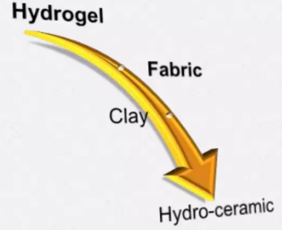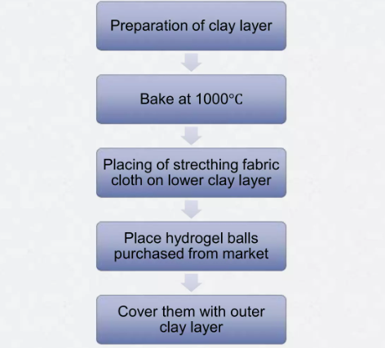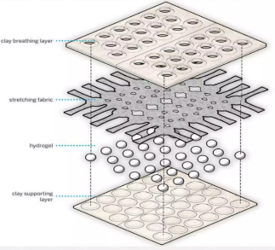
Fig 1: Material Component of Hrdroceramic Fig 2: Fabrication Process [source: https://iaac.net/project/hydroceramic/]

Researchers at RMIT created lighter, more energy-efficient bricks made of cigarette butts to lessen the environmental impact of cigarette butts. In other words, creatively repurposing garbage in an environmentally responsible way. The project's principal investigator, Dr. Abbas Mohajerani, and his team found that injecting fired-clay bricks with merely 1% of cigarette waste can significantly reduce environmental pollution [16]. Amount of cigarette butts added is 2.5% of the total weight of the clay brick.

Table no:1 Compaction and Composition of CB’s (Source: Gokulnath, M. et al. [17])
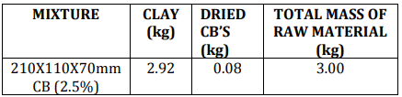

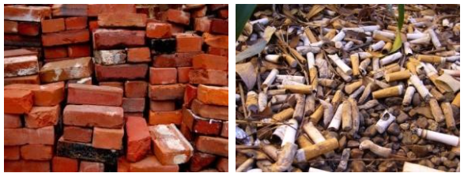
Fig 3: Cigarette butts Bricks Fig 4: Cigarette butts
A group of scientists from Illinois has created a type of "Martian concrete" that might be used to construct buildings on the surface of the red planet. [18]. In addition, water is not needed to create the new martian concrete. This critical advantage can truly aid the development of structures on Mars given the limited availability of water as a source. Sulphur is heated to a liquid at 240 degrees Celsius to form the martian concrete. As it cools, we get Martian concrete, which uses the soil from Mars as an aggregate. The research team believes that martian soil and sulphur should be combined in a 1:1 ratio [19]. Northwestern University researchers Lin Wan, Roman Wendner, and Gianluca Cusatis developed a building material that blends Martian soil with molten sulphur and says it may be used to construct an entire settlement on Mars [18].

Table 2: Major element composition of Martian Concrete [19].
Major element composition % by Wt.
Silicon dioxide (SiO2) | (SiO2) 34.5–44
Titanium dioxide (TiO2) | 3–4
Aluminum oxide (Al2O3) | 18.5–23.5
Ferric oxide (Fe2O3) | 9–12
Iron oxide (FeO) | 2.5–3.5
Magnesium oxide (MgO) | 2.5–3.5
Calcium oxide (CaO) | 5–6
Sodium oxide (Na2O) | 2–2.5
Potassium oxide (K2O) | 0.5–0.6
Manganese oxide (MnO) | 0.2–0.3
Diphosphorus pentoxide (P2O5) | 0.7–0.9

(a)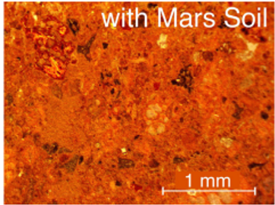 (b)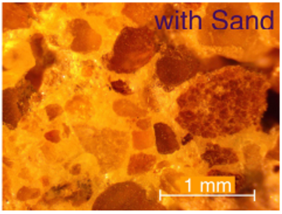
Fig. 5. Microscopy study of sulfur concrete on 1 mm scale with compositions of (a) 50% sulfur and 50% Martian soil simulant (b) 25% sulphur and 75% regular sand and a maximum particle size of 1 mm [19].
Light-absorbing and light-emitting cement have been developed by Dr. José Carlos Rubio Valos of the UMSNH in Morelia. There are a lot of possible applications and uses for this novel light-generating cement. [20].
Bricks now come with pollution voids! The Breathe Brick, created by assistant professor Carmen Trudell at Cal Poly's college of architecture and environmental design, filters the air before it is released. [21]. The novel material is intended to be a component of the typical ventilation system of a building. With specialized bricks on the outside and regular insulation within, it features a two-layer facade system.
Table No 3: Mix Proportion of Breathe Bricks [22]
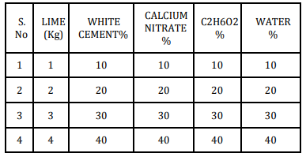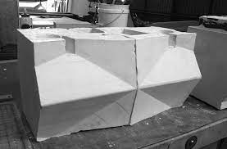
Fig 6: Breathe brick with faceted surface [22]
Self-healing concrete has been developed by Dutch civil engineer Dr. Schlangen at Delft University. He divided a piece of concrete in half, put the pieces back together, then heated the concrete in a microwave to show the material's efficacy during his presentation. The melted substance comes together once it has cooled [23]. Using a notched specimen, C. Kang et al. assessed the self-healing capabilities of concrete containing fly ash and fiber to enhance healing performance by comparing the flexural load and the flexural stiffness before and after the crack [24].
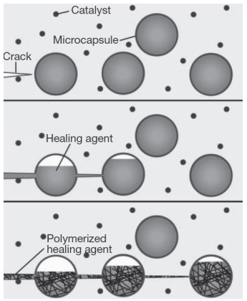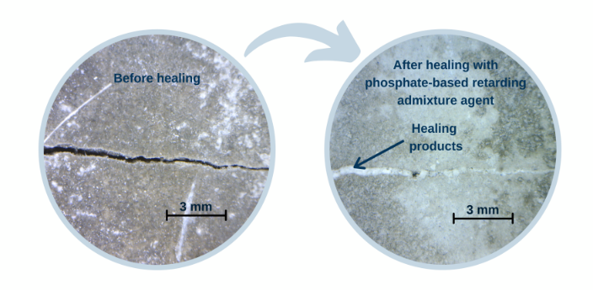
Fig 7: The mechanism of crack healing [25]. (White et al., 2001). Fig 8: Self-healing Concrete [25]. (White et al., 2001).

In terms of the ability of cementitious materials to self-heal, N. Shaheen et al. published results on the usage of limestone powder as a carrier medium to immobilize Bacillus subtilis [26].
Using high thermal mass materials and air cavities, S. Hao et al. suggested a heat recovery wall system that may effectively recover gas heat from heating stoves while lowering users' exposure to indoor air pollution. They performed on-site experimental testing to look at the thermal performance and surface temperature dispersion of this particular wall system design [27].
Lightweight concrete and autoclaved aerated blocks have been popular in recent years as wall materials, however because of their low density, their specific heat is significantly lower than that of other materials. Because of this, even though they transport heat slowly, substantially less energy is required to raise the temperature in comparison to materials with higher densities. This is thought to be the cause of the higher Energy used Intensity EUI values of 431 and 429 kWh/m2/yr, respectively [28].
Table 4: Features of AAC blocks [28]
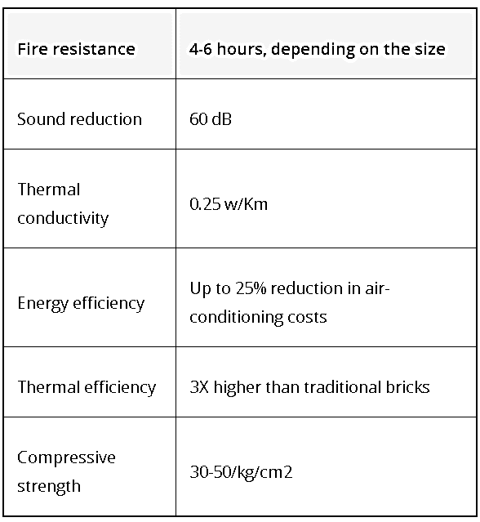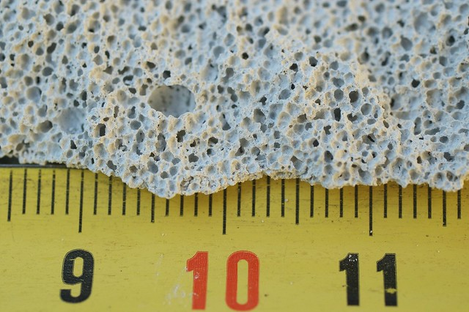
Fig9: AAC Blocks Source: https://www.magicbricks.com/blog/aac-blocks/129206.html
In terms of performance, laterite bricks (404 kWh/m2/yr) and clay-burned bricks (402 kWh/m2/yr) are seen to be significantly more efficient, with a difference of only 2 kWh/m2/yr. While it should be remembered that fly ash leeches when exposed to water and is only utilized for building internal walls, fly ash has a far higher Energy used Intensity (EUI) than Laterite and Clay burned.

Table 5. Properties of the Natural Laterite and Sand [29].
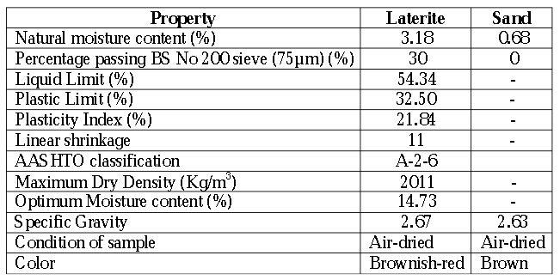
Hence, depending on the material's availability, a designer considering using just one type of material for walls should think about employing either laterite or clay burned [29].
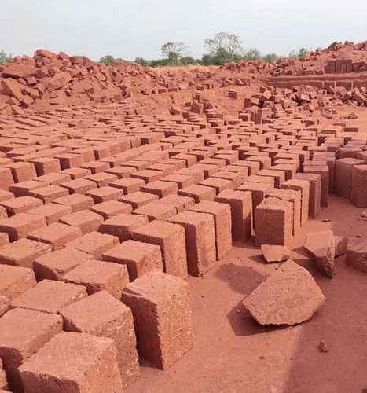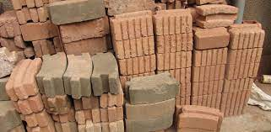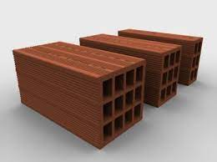
Fig 10: Laterite and Clay Burned Bricks
Factors Influencing the Adoption of Emerging Technologies
The decision to deploy a technology is a function of a variety of influences. The advancement of productivity, quality, and safety in the construction industry has historically been credited to the introduction of novel new technologies. The following factors adhere a part to comprehend the procedures, information sources, and crucial success elements that businesses rely on when investing in new technology. It offers an adoption model that has been thoroughly examined in terms of vendor tactics and visitor behaviour at two equipment exposure.
The selection to use a technology involves an array of factors.
Result Desired ( Appropriate)
Decision Stage for
Alternatives for replaceable material
Collection of Information material
Construction Firm

Stage of Construction
Potential of Material
Technology Knowledge
Examination of Material
Side

Technology Implementation
Knowledge Transfer
Stimulus to Action
Vendor Side

Trade Show to promote in Market
Environment

Fig 11: Array of factors Adoption of Emerging Technologies

Administrative Dimensions
According to Ghobakhloo, et al [30] "Company Size" can be defined by turnover or the number of employees because it may represent one of the most important factors in determining whether or not new technologies are adopted. In contrast to smaller businesses, (Lippert & Govindarajulu) [31] found that larger construction firms have a higher propensity to adopt new technology. This is because small businesses with few employees might not think it is important to prioritize safety-related issues.
Working Environment
Jones et al., state that a leader of a corporation makes the most welcoming environment and adaptable framework for embracing new technology within any firm. Employees of that corporation may be more amenable to change initiatives if they believe that their company has an open culture and believe in implementing new technology [32]. The author Abdullah et al. [33], mentioned in a report, a corporation’s strong working culture affects employees’ attitudes regarding the implementation of safety technology. The use of new technology may not be mandated by a boss, but employees with good safety awareness will support it.
Cost-effective
Naqvi et al. discusses using new technology across the board in the construction sector lowers material prices and there is need to hire more unskilled foreign labour [34]. Automation adoption can reduce reliance on temporary foreign labour and speed up the completion of labor-intensive tasks. Modern technology makes construction processes safer for all workers from a safety perspective [35].
Construction Time and Work Progression
Jiang, et al, [36]. states the use of developing technologies could shorten the duration of the construction process and speed up operations, promoting worker safety and health.
Applying new technology in the construction industry can expedite high-precision testing, monitoring, and control of materials without delaying exposure to outside heat stress Jiang, et al. [36]. It is preferred to use controlled prefabrication or machine installation rather than having the employees handle any materials or other operations since it preserves and guarantees higher finishes and quality. Word of Gonsalves, et al. article in 2021 [37] states that automation and robots could be used to address health and safety concerns in the construction industry and can lessen overexertion injuries brought on by repetitive action and strong forces.
Operational Restriction
Sagini et al illustrates about the complexity of the structural joints and connections between building components is one of the concerns or aims that the majority of businesses would enhance with the help of developing technologies. Building information modeling (BIM) is a new construction technology that enhances quality management, safety, effectiveness, and efficiency while enabling effective data management [38].
Governmental New Rules and Standards
Government assistance is crucial in policies, attitudes, rules, and external spending rather than an organization's capacity. The adoption of emerging technology for safety purposes will be influenced by standards regulations, such as new laws and regulations, health and safety laws, and waste disposal laws, as noted in Sagini et al,[38]. According to Abd Shukor et al. [39] the government can dedicate more safety practices in the construction industry to audits and inspections. Furthermore Lippert & Govindarajulu[31] illustrates that rules and policies should be involved if emerging technology's technical standards need to be implemented.
Competition Advantages in Construction Market
Rajapathirana et al. discerns that an organization's decision to implement emerging technology is often driven by competitive pressure. The effort to encourage the adoption of emerging technology in an organization will most likely be facilitated by increased competitive pressure, which will act as a catalyst. A competitive advantage is also known as competitive pressure [40]. Aguilar & Hewage [41] discovered that IT adoption can solve safety problems in monitoring modules, which frequently come into contact with heavy machinery, power tools, and other things.

Project Conditio & Geographical Location of Project
Project Characteristics
Task Productivity Quality
Project Cost, Safety Time
Construction

Technology
Durability, Site Performance
Versality, Capacity, Control
Maturity, Brand, Reliability
Attributes

Firm
Company Size
Technology Policy, Company Culture
Need, Goal, Cost Reduction
Characteristics

Individual
Relationship with Vendor, Responsibility to take Risk, Innovativeness, Self response to motivate
Attributes

Vendors
Guaranty, Warranty, training, Maintenance, Offer, Relationship & Motivation Program, Attachment to the Firm
Attributes

Fig 12: Categories of variables in new technologies

Innovative Organizational Culture
Noraini, et al, investigated, one trait that strongly influences the acceptance or adoption of new technologies is an innovative environment. The definition of an innovative culture adopts new technologies significantly more quickly than its peers. Organizational variables, such as a creative culture, might affect a company's readiness to adopt and test new technology [42].
Usability Index
Chuah et al. states that one can presume that a technology's effectiveness and functionality are beliefs that influence a potential user's mindset and indicate their intent to use and purchase. It describes a technology that can benefit a person more in terms of effectiveness. A person who uses a certain technology, however, will increase the efficacy and efficiency of their work [43].

Conclusion
From the sixteenth through the nineteenth to the twenty-first centuries, there have surely been advancements in the choice of materials used in construction [29].While materials used after the 19th century were processed from recycled materials or through intricate industrial processes to achieve the appropriate strength and quality, materials used before the 19th century underwent no chemical processing at all. This alone demonstrates the evolution of the building business. The goal of sustainable construction is to satisfy current demands for homes, workplaces, and infrastructure without compromising the ability of future generations to satisfy their demands.
This article aims to serve as a learning guide for providing the most recent information on smart building materials using advanced materials science. It will provide fresh insight into the many modern building design, structural engineering, and construction techniques. This study will be an invaluable resource for the students' specialized research projects and thesis papers. The article provides pertinent and practical knowledge to advance the usage of advanced materials in smart buildings. Energy-efficient designs and greener materials are becoming more popular in the building sector.
On the other side, the firms and contractors doing the work need to be more knowledgeable about the latest technology and materials. This will make it easier to benefit from all of the advantages, including using smart technology and professional workmanship. Also, a deeper comprehension of why each workplace should prioritize innovative technology to create a better atmosphere. Since the process of building intelligent projects has recently come under scrutiny, contractors should make the construction work easier by utilizing cutting-edge technology because it is safer than using manual labour to complete the project's structural stage from start to finish.
The adoption of new technologies holds the promise of the future, from climate action and improved health to more democratic and inclusive societies, and via this study, knowledge of some of the intelligent materials used in the building sector is shared. The question of how to fully leverage on the current technological revolution to close gaps impeding truly inclusive and sustainable development is one that has to be asked.
Reference
- Akadiri PO, Chinyio EA, Olomolaiye PO. Design of A Sustainable Building: A Conceptual Framework for Implementing Sustainability in the Building Sector. Buildings. 2012; 2(2):126-152. https://doi.org/10.3390/buildings2020126
- Petkar, Sanket. (2014). Environmental Impact of Construction Materials and Practices. 10.13140/RG.2.1.2581.0001.
- Simon Elias Bibri, John Krogstie, Mattias Kärrholm, 2020, Compact city planning and development: Emerging practices and strategies for achieving the goals of sustainability,Developments in the Built Environment,Volume 4,100021,ISSN 2666-1659,
- Ministry of Housing and Urban Affairs (MoHUA) (2019) Shortlisting of Proven Technologies for Participation in Bidding for Construction of Light House Projects. Ministry of Housing and Urban Affairs Government of India
- Ministry of Housing & Urban Poverty Alleviation (MoHUPA) (2013). Scheme Guidelines for Affordable Housing in Partnership. Ministry of Housing & Urban Poverty Alleviation, Government of India.
- Modern methods of house building. (2003). Postnote, London
- Waste and resource programme (2007). Current practices and future potential in modern methods of construction. Banbur, Oxon: WRAP
- Strukova Z. (2009). Specific perception of safety risks of construction projects. In Innovative approach to modelling of intelligent structural elements in construction, Kosice: TUKE

- https://www.futurelearn.com/info/courses/rome/0/steps/27618

- Safiuddin M, Kaish ABMA, Woon C-O, Raman SN. Early-Age Cracking in Concrete: Causes, Consequences, Remedial Measures, and Recommendations. Applied Sciences. 2018; 8(10):1730. https://doi.org/10.3390/app8101730
- Szolomicki J, Golasz-Szolomicka H. Technological Advances and Trends in Modern High-Rise Buildings. Buildings. 2019; 9(9):193. https://doi.org/10.3390/buildings9090193

- https://proest.com/construction/tips/innovative-materials/
- https://restorationnationtx.com/innovation
- I. Gibson, D.W. Rosen, B. StuckerAdditive Manufacturing Technologies: Rapid Prototyping to Direct Digital ManufacturingSpringer, Berlin (2009)
- https://www.energy.gov/eere/buildings/articles/chapter-6-materials
- Mohajerani, Abbas & Hui, Siu & Shen, Cary & Suntovski, James & Rodwell, Glen & Kurmus, Halenur & Hana, Marven & Rahman, Md Tareq. (2020). Implementation of Recycling Cigarette Butts in Lightweight Bricks and a Proposal for Ending the Littering of Cigarette Butts in Our Cities. Materials. 13. 4023. 10.3390/ma13184023.
- Gokulnath, M., Krishnan, P. H., Jayashree, S., Caroline, J. J., & Prakash, N. A. (2019). Utilisation of cigarette butts in clay bricks. Int Res J Eng Technol, 6(3), 3240-3242.
- https://www.dezeen.com/2016/01/07/scientists-develop-martian-concrete-for-building-architecture-in-outer-space/
- Allen, C. C., Morris, R. V., Lindstrom, D. J., Lindstrom, M. M., & Lockwood, J. P. (1997, March). JSC Mars-1-Martian regolith simulant. In Conference Paper, (Vol. 28).
- https://www.constructiondive.com/news/new-light-emitting-cement-could-revamp-highway-construction/418987/
- https://www.archdaily.com/771767/this-innovative-brick-sucks-pollution-from-the-air-like-a-vacuum-cleaner
- Manibalu, M. B., Sakthipriya, M. C., & Manikandan, M. R. (2021). Study on Breathe Bricks.
- https://www.academia.edu/41079217/Construction_techniques
- Kang, Choonghyun & Huh, Jungwon & Tran, Huy & Kwak, Kiseok. (2018). Evaluation of Self-Healing Performance of PE and PVA Concrete Using Flexural Test. Advances in Materials Science and Engineering. 2018. 10.1155/2018/6386280.
- White, S. R., Sottos, N. R., Geubelle, P. H., Moore, J. S., Kessler, M., Sriram, S. R., ... & Viswanathan, S. (2001). Autonomic healing of polymer composites. Nature, 409(6822), 794.
- Shaheen, Nafeesa & Khushnood, Rao & Din, Siraj-Ud-Din. (2018). Bioimmobilized Limestone Powder for Autonomous Healing of Cementitious Systems: A Feasibility Study. Advances in Materials Science and Engineering. 18. 10.1155/2018/7049121.
- Donglu Shi, Julian Wang, Wen Deng, "Smart Building and Construction Materials", Advances in Materials Science and Engineering, vol. 2019, Article ID 2432915, 2 pages, 2019. https://doi.org/10.1155/2019/2432915
- Leon M. De Souza, Omkar Phadtare, Jaydeep Pawar, Pravin Kurtikar, Sherwin Oliveira, Prachi Dessai, 2021, Analysis of Materials in Terms of Energy Performance Used in Ancient and Modern Architecture, International Journal of Engineering Research & Technology (IJERT) ICETCE – 2021 (Volume 09 – Issue 14),
- Shakir, Alaa & Mohammed, Ali. (2013). Manufacturing of Bricks in the Past, in the Present and in the Future: A state of the Art Review. International Journal of Advances in Applied Sciences. 2. 10.11591/ijaas.v2i3.1751.
- Ghobakhloo, M., Arias-Aranda, D., & Benitez-Amado, J. (2011). Information technology implementation success within SMEs in developing countries: An interactive model. In the POMS 22nd Annual Conference: Operations Management: The Enabling link: Reno, NV, USA.
- Lippert, S.K., & Govindarajulu, C. (2006). Technological, organizational, and environmental antecedents to web services adoption. Communications of the IIMA, 6(1), 2-14.
- Jones, R. A., Jimmieson, N. L., & Griffiths, A. (2005). The impact of organizational culture and reshaping capabilities on change implementation success: The mediating role of readiness for change. Journal of Management Studies, 42(2), 361-386
- Abdullah, N. H., Shamsuddin, A., Wahab, E., and Hamid, N. A. A. (2014). The relationship between organizational culture and product innovativeness. Procedia Social and Behavioral Sciences, 129, 140-147.
- Naqvi, R., Soomro, T.R., Alzoubi, H.M., Ghazal, T.M., & Alshurideh, M.T. (2021, June). The nexus between big data and decision-making: A study of big data techniques and technologies. In The International Conference on Artificial Intelligence and Computer Vision. Springer, Cham.
- Rugiero, A. (2016). Robotics in construction. Worcester Polytechnic Institute
- Jiang, S.H., Skibniewski, M.J., & Yuan, Y.B. (2011). Ultra-wideband applications in industry: A critical review. Journal of Civil Engineering Management, 437-444.
- Gonsalves, Nihar & Ogunseiju, Omobolanle & Akanmu, Abiola & Nnaji, Chukwuma. (2021). Assessment of a passive wearable robot for reducing low back dIsorders during rebar work. Journal of Information Technology in Construction. 26. 936-952. 10.36680/j.itcon.2021.050.
- Sagini, N. A., Dianga, S. O., & Mbiti, T. K. (2016). Investigating Factors that Influence the Rate of Adoption of Innovative Construction Technologies in Kenya. International Journal of Engineering Research & Technology, 5(01), 843-849.
- Abd Shukor, A.S., Mohammad, M.F. Mahbub, R., & Ismail, F. (2011). Supply chain integration in industrialized building system in the Malaysian construction industry. The Built & Human Environment Review, 4(1)
- Rajapathirana, R. J., & Hui, Y. (2018). Relationship between innovation capability, innovation type, and firm performance. Journal of Innovation & Knowledge, 3(1), 44-55.
- Aguilar, G.E., & Hewage, K.N. (2013). IT-based system for construction safety management and monitoring. Automation in Construction, 35, 217-228
- Noraini, M. N., Mahizer, H., & Norazilawati, A. (2016). The influence of demographic factors on personal innovativeness towards technology acceptance. Malaysian Online Journal of Educational Technology, 4(1), 68-76.
- Chuah, S.H, Rauschnabel, P.A, Krey, N., Nguyen, B., Ramayah, T., & Lade, S. (2016). Wearable technologies: The role of usefulness and visibility in smartwatch adoption. Computers in Human Behavior, 65, 276-284

