A STUDY ON CHANGES IN THE PREDICTION OF BIGDATA ANALYTICS ON CONSUMER BEHAVIOUR (INFLUENCED BY PSCHOLOGICAL TRAITS AND SOCIAL MEDIA)

Ananthi Christina R

ABSTRACT:

The purpose of the study is to analyse how do consumer behaviour could be predicted with the big data available. Have an overall view and an understanding on the available openings and opportunity that Bigdata help us in predicting the consumer behaviour. The bigdata might be helpful in the understanding of decision-making process in the field of marketing for the consumer. The prediction what we have based on the theory and the results may differ widely under the sky of bigdata and there might be a change of mindset with the consumers over a period. The information collected might me at one stage, over a period of research which might alter within the intellect set of the buyer due to social media impact might happen. Psychological traits may also influence the Consumer Behaviour which also affects the outcome from Bigdata available. The research is based on whether this event is true, whether this alter will influence the information collected earlier and the decision made on the consumer behaviour which may or may not give the exact analytical result. The data collected could be limited by its substandard, inferior quality and valuelessness. The data collection made may be with the past data but must be in the context with the revolution to understand the consumer behaviour.

KEYWORDS: Big data, Consumer Behaviour, Marketing decisions, Marketing Analytics, Psychological traits.

INTRODUCTION:

It has been expressed that the era of Huge Information begun on the figure at which the esteem of putting away data dropped beneath the esteem of erasing it. One needs presently not take that articulating to be motivated at the brand unused reasserts and assortments of data units to be had to marketers. Such data is an expanding number of to be had due to the reality more prominent intuitive with clients are taking locale in social media, online and on cell contraptions in which all developments may be without issues recorded. Buyers have risen as an “incessant generator of each organized, value-based data in expansion to cutting-edge unstructured behavioural information”. Huge Data are regularly characterised by 3 V’s: volume, velocity and variety Volume alludes back to the “bigness” property, while velocity says back to the charge at which the virtual forms make Huge Information indeed greater. Assortment alludes to unused groups and styles of actualities. Variety alludes to modern designs and styles of facts. These are as often as possible realities that are not within the square shape suitable for customary factual analysis, and that still regularly incorporate words, pictures, video, or other non-numeric client output. In publicizing, the essential driving constrain of the side interest in Enormous Information is the capability convenience of it for illuminating advertising decisions and executing promoting campaigns. A few creators have cautioned that Huge Information client analytics has altogether changed over the way publicizing is performed nowadays (Hofacker et al., 2016) .

BIGDATA AND CONSUMER BEHAVIOUR

The development of huge information and progresses in enormous data analytics driven to the creation of Google Trends a device and source for examining huge information on web looks over the globe. Such patterns are positive for the fashion industry within the UK which is encountering significant instability. Google Trends may be a great case of how enormous information can be abused and envisioned in a user-friendly fashion. The term huge information itself battles to discover a widespread definition and it can cruel diverse things to diverse individuals. Nowadays, the definition of huge information has advanced and presently incorporates 5Vs, with extra Vs being veracity (which accounts for the quality of the information) and value (which accounts for analytics on information).Information quality is another imperative thought, and Google Trends looks for to progress the quality of its information by excluding searches made by exceptionally few individuals, copy looks, and extraordinary characters The inspirations for this inquire about (and its significance) stems from a few existing ponders. Firstly, notes that the reason of enormous information use is presently moving from checking towards determining, and in this manner, demonstrating the significance of predictive analytics and determining for long run. Besides, the increment in ‘research shopping’, hereby buyers are seen getting to data via one channel and obtaining through another channel. Thirdly, as points out, organisations are fascinated by what is likely to happen following and determining may be a device which can give this data. In any case, the development of big information brings almost it possess challenges for creating precise estimates Fourthly, state that drift estimating is imperative for companies to be able to distinguish changes within the environment and set up guards to hold. They make more productive and marketing decisions and been able to forecast the Consumer Behaviour accurately, but the forecast failed in finding a single univariate model. (Silva et al., 2019)

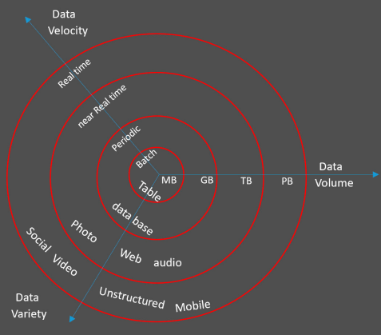
Figure 1(Silva et al., 2019)

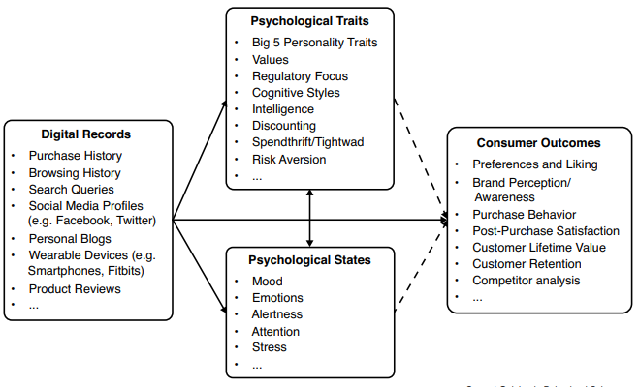

Figure 2 (Matz & Netzer, 2017)

CONSUMER BEHAVIOUR AND PSYCHOLOGICAL TRAITS

Traditional approaches incorporate broad customer overviews, focus groups interviews, perception thinks about and constrained scope auxiliary information such as scanner board information through phone and face-to-face discussions as well as perceptions Whereas the laid-out approaches can create important client information, they are not as it were costly and time-consuming – and thus troublesome to scale – but moreover inclined to various well set up response biases.
Psychological characteristics play a vital part in understanding and anticipating buyer behaviour. In any case, promoting analysts have long recognized that they cannot account for the total variation in consumer behaviour This is, often since psychological characteristics do not work in a vacuum, but instep is communicated in a
certain context, these characteristics are regularly impacted by situational factors.

RQ1. Does Psychological traits influence the behaviour of the consumer?
For case, customers who are in a positive temperament utilize more heuristic – instead of efficient – data handling and assess items and brands more favourably for an outline on the impact of disposition on customer conduct. Subsequently marketers can advantage from paying near consideration to and capitalize on customers’ mental states.(Matz & Netzer, 2017)
RQ2. Can the Psychological traits affect the bigdata analytics result?

MARKETING ANALYTICS FOR CONSUMER BEHAVIOR

The improvement of way better analytical tools and approaches in later a long time has given commerce pioneers critical modern decision-making capability. However, whereas progressed analytics give the capacity to extend growth and marketing return on investment (MROI), organizations appear nearly paralyzed by the choices on offer. As a result, trade pioneers tend to depend on fair one arranging and performance-management approach. They quickly find that indeed the foremost progressed single methodology has limits.(Bhandari et al., n.d.)
RQ3. Do the Marketing analytics provide better prediction results of consumer behaviour?
Making better decisions could be done by
1.Identifying the best analytical approaches.
marketing-mix modelling (MMM).(Bhandari et al., n.d.; Gupta et al., 2021)
2. Heuristics such as reach, cost, quality (RCQ).
RCQ brings all touchpoints back to the same unit of estimation so they can be more effortlessly compared. It is moderately direct to execute, regularly with small more than an Exceed expectations model.(Bhandari et al., n.d.; Hogenboom et al., n.d.)
3. Developing approaches such as attribution modelling.
Integrate capabilities to create experiences and coordinates approach, which incorporates pulling in coordinate reaction information and bits of knowledge, decreases the predispositions.(Bhandari et al., n.d.; Gillett et al., 2016)

CHANGES IN BIGDATA BY SOCIAL MEDIA
By simple definition, the social media alludes to exercises, practices, and behaviour among communities of individuals who assemble online to share information, information, and suppositions utilizing conversational media (Web based applications) Nowadays, a web page may be a need for the marketing blend of a company, and the social media substance is considered as King. Through the social media, viral promoting is created, which refers to the methodology of encouraging the guests of web page to share information published on Web, to their companions, so that, they can illuminate more people for an item or occasion, through photographs, recordings, etc.
RQ4. Does social media influence the consumer behaviour?
RQ5. Does the social media influence affect the analytics of data?
Social media has effect on the observational learning, according to which, consumers observe others behaviour, and learn indirectly from others encounters. Agreeing to psychology, individuals tend to remember more visual components, that’s why social media substance is assumed to remain longer in buyers’ intellect.(Jashari et al., n.d.) The changes in consumer behaviour and suppositions due to the move from an open to a commercial broadcaster within the setting of broadcasting universal media occasions. Despite positive alter in customer behaviour, there was a negative alter in customer opinion. Based on media occasions and broadcaster hypotheses, distinguished generalisable discoveries for all such moves.(Ioanăs, 2014; Joshi et al., n.d.)
ETHICS IN BIGDATA AND MARKETING RESEARCH
As the collection of unstructured information gets to be more financially practical and shifts in consumer utilization of innovation make a much more extensive run of information accessible, there is an incentive for associations to gather as much information as possible. Yet, fair since consumers are willing to supply information it does not cruel that it utilizes is free from security implications (Boyd, 2010).(Nunan et al., 2013)

For numerous segments the capacity to gather information and turn it into understanding incorporates a key part in creating more imaginative and fruitful items and administrations. Be that as it may, for advertise investigate the significance of get to be instrumental to the capacity to convey the item. The history of showcasing action gives us with numerous cases of circumstances where controllers have reacted reactively to open discernments of over-zealous, or unscrupulous, showcasing movement.

Ethics and advertise inquire about stay grounded in a demonstrate of the innovation that is at chances with the multi-device, socially based selection that is likely to create the premise of future web development. For illustration, 82% of web clients over the age of 15 presently utilize social organizing destinations. Enormous information presents a merging of both specialized and key capabilities that gives noteworthy potential for organizations of all sizes to create esteem from the information they store.(Nunan et al., 2013)

RQ6. Does ethical research of bigdata is in the field of marketing?

Huge information can help associations, analysts and moral customers get it the morals around shopper conduct and items. The openings to interface different sorts of information are energizing but must be research-question-led to dodge burrowing for non-existent causal joins. The strategies and get to information are still a boundary but open get to be key to understanding this. Enormous information will likely as it were help in filling within the subtle elements of our information on moral utilization and on items, but this may as it helped our choice making.(Kumar Chintakayala & Young, n.d.)

METHODOLOGY

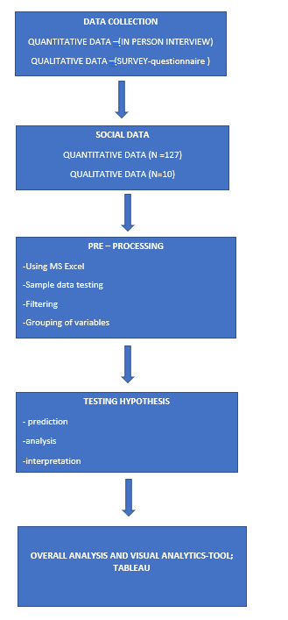
The research was done using two forms of data. One with the primary and the other with the secondary data. Primary data includes the questionnaire that was generated and sent for survey. The secondary data was the literature review that has been done for the research purpose regarding the bigdata changes on consumer behavior, added to that the psychological traits and the social media influence that influences the consumer behavior prediction using bigdata. The primary data collection was done with a questionnaire that has a maximum of 12 questions that was quantitative research. The primary data also had qualitative research conducted among 10 selected individuals who responded via the questionnaire to check the value of data for further research purposes. All the questions for primary data collection were made simpler, understandable and the questionnaire was tested for clarity with a minimum sample of and then for the further quantitative survey.

The questionnaire was developed from google forms and then the link was sent across through emails and social media. The responses of the participants were recorded automatically. The data collected from the research was analyzed
Figure 3: Data Analysis Process
and then displayed with numerical values using arithmetic average and then using charts and tables. The further analysis of research was done using data analytics algorithm for the prediction of research results. The sample size for the research was taken to be 150 out of which 141 people responded i.e., 95% of the sample participants. The highest were from the age group of (21- 30) which forms 52.4% of survey results. The responses from female were at 74.8 % which means most of the participants were female. Most of the participants are working professionals and are employed. This accounts to the demographic results of the research that has been conducted for analyzing the changes in the prediction of bigdata analytics on consumer behavior (influenced by psychological traits and social media) for the quantitative data. The qualitative data included 10 individuals who already participated in the quantitative research. The data individuals of 50% of age group (31-40) and 40% from the age group of (21-30).80 % of the participants were female and 60 % of them were employed. The qualitative research was to enhance how the data has been considered from the consumer.

RQ1  RQ2  RQ3  RQ4  RQ5 | Does Psychological traits influence the behaviour of the consumer?  Can the Psychological traits affect the bigdata analytics result?  Do the Marketing analytics provide better prediction results of consumer behaviour?  Does social media influence the consumer behaviour?  Does the social media influence affect the analytics of data?

EMPIRICAL ANALYSIS :

RQ1 Does Psychological traits influence the behaviour of the consumer?

A study has done whether the psychological traits influence the consumer behaviour taking the metrics of their current emotion and their buying behaviour based on the mood or emotion.
So, this metrics will give a prediction whether the psychological traits affect the consumer behaviour. A chi square test has been done in Ms Excel to show the significance between emotion and the consumer behaviour.
H0: There is no significant difference between emotion and the buying behaviour based on their emotion.
H1: There is significant difference between emotion and the buying behaviour based on their emotion.

If P value >0.05 Accept H0, Reject H1
If P value < 0.05 Reject H0, Accept H1
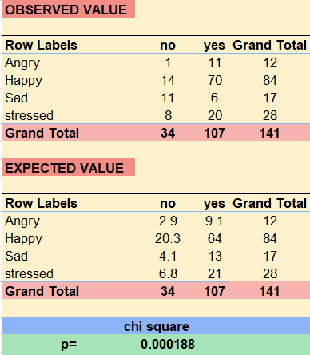
Figure 4 :Emotion Vs Consumer behaviour
Hence, there is significant relationship between emotion or mood that is currently observed, and the buying behaviour based on their emotion and therefore the psychological traits influence the behaviour of the consumer.
RQ2 Can the Psychological traits affect the bigdata analytics result?
New idea in the field of digital marketing that emerged recently is to use the psychological traits and predict the consumer behaviour. This focuses on taking note of traits like face book likes and inferring the personality and emotions of the consumer. It also put into account the expression and attitudes of the consumer. There are several tools that could predict the psychological traits to analyse the consumer behaviour in the marketing technology(Matz & Netzer, 2017)
As psychological trait influences the consumer behaviour this can influence the data analytics too as there is change of emotion and the consumer behaviour go hand in hand. Thus, reducing the rate of prediction of big data analytics which makes the data void. If the huge population change occurs with respect to emotion and their behaviour the result in the analytics might also get affected.

RQ3 Do the Marketing analytics provide better prediction results of consumer behaviour?
Through qualitative research from the count of 10 individuals only 4 responded by reading and understanding the questions given in the survey. The other respondents
Figure 5: Randomness of results
randomly selected the options given and then submitted the form. From this inference we could assume that the data collected is not a factual data and then the prediction results may not have a decision making for the market.
In this case, the predictions about the impact of this marketing mix factor will be biased. (Wedel & Kannan, 2016)
RQ4 Does social media influence the consumer behaviour?
The data collected from the participants show that there is huge influence of Instagram in buying the recommended products and the services offered.
H0: There is no significant difference between the social platform that is often used and the influence of media in buying products.
H1: There is significant difference between the social platform that is often used and the influence of media in buying products.
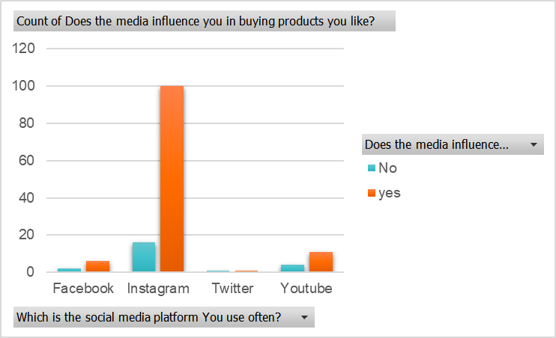

Figure 6 :Highest influencer of social media -Instagram
If P value >0.05 Accept H0, Reject H1
If P value < 0.05 Reject H0, Accept H1
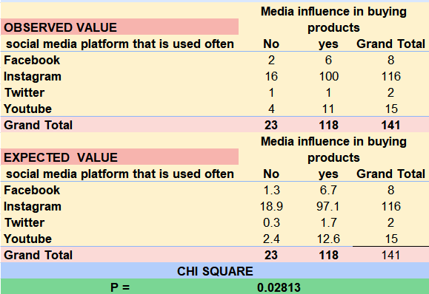

Figure 7 :Social media platform that is used often Vs Media Influence in buying products

P value is less than 0.05 and hence there is a significant difference between the social platform that is often used and the influence of media in buying products.
Participants are highly influenced by Instagram and then you tube, there is influence with the social media and the consumer behaviour as they see the visuals that is also added to the psychological trait consumers are influenced a lot and then the behaviour changes with the influence and recommendations from the media. social media substance is considered as King. Agreeing to psychology, individuals tend to remember more visual components, that’s why social media substance is assumed to remain longer in buyers’ intellect

RQ5 Does the social media influence affect the analytics of data?
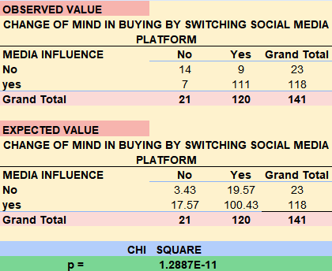

Figure 8: Social media influence Vs change of mind by Switching to another platform

H0: There is no significant difference between media influence and the change of mind in buying by switching social media.
H1: There is significant difference between media influence and the change of mind in buying by switching social media.
If P value >0.05 Accept H0, Reject H1
If P value < 0.05 Reject H0, Accept H1
P value is very much smaller than 0 so accept H1, which indicates there is a huge significance between the media influence and the change in the behaviour by switching different social media platforms.
From this it could be inferred that there is a change of mindset among the consumers with respect to the medium that is influenced by them. If the analysis of consumer behaviour is done with the bigdata available based on the social media influences, it might affect the accurate prediction of marketing analytics and could affect the consumer decision making.
CONCLUSION:
From the study that done to understand whether there is an influence in the consumer behaviour by social media and Psychological traits, the study says that there is an influence and the data that is collected prior to the influence might differ from the data after the influence of the customer, therefore this might affect the prediction model as there is vast change in the Bigdata collected. Hence the study says that there might be a change in the prediction model as the data collected changes with respect to social media and psychological traits.

REFERENCES:
Bhandari, R., Singer, M., & van der Scheer, H. (n.d.). Using marketing analytics to drive superior growth.
Gillett, N. P., Shiogama, H., Funke, B., Hegerl, G., Knutti, R., Matthes, K., Santer, B. D., Stone, D., & Tebaldi, C. (2016). The Detection and Attribution Model Intercomparison Project (DAMIP v1.0) contribution to CMIP6. Geoscientific Model Development, 9(10), 3685–3697. https://doi.org/10.5194/gmd-9-3685-2016
Gupta, S., India, W., Pandey, S., & Chhajed, S. (2021). Marketing Mix Modeling (MMM)-Concepts and Model Interpretation. Article in International Journal of Engineering and Technical Research. https://doi.org/10.17577/IJERTV10IS060396
Hofacker, C. F., Malthouse, E. C., & Sultan, F. (2016). Big Data and consumer behavior: imminent opportunities. Journal of Consumer Marketing, 33(2), 89–97. https://doi.org/10.1108/JCM-04-2015-1399
Hogenboom, A., Niewenhuijse, E., Hogenboom, F., & Frasincar, F. (n.d.). RCQ-ACS: RDF Chain Query Optimization Using an Ant Colony System. http://daml.org/2003/09/factbook/factbook-ont#
Ioanăs, E. (2014). Social Media and its Impact on Consumers Behavior. In International Journal of Economic Practices and Theories (Vol. 4, Issue 2). www.ijept.org
Jashari, F., Trinidad, J., & Rao, S. (n.d.). The impact of social media on consumer behavior-Case study Kosovo Related papers C ARUL JOT HI AND A MOHMADRAJ GAFFOOR: IMPACT OF SOCIAL MEDIA IN ONLINE SHOPPIN…. www.scientificpapers.org
Joshi, J. B. D., Institute of Electrical and Electronics Engineers, & IEEE Computer Society. (n.d.). Proceedings, 2016 IEEE International Conference on Big Data : Dec 05-Dec 08, 2015, Washington D.C., USA.
Kumar Chintakayala, P., & Young, C. W. (n.d.). Chintakayala and Young Using big data to understand consumer behaviour on ethical issues. www.cdrc.ac.uk.
Matz, S. C., & Netzer, O. (2017). Using Big Data as a window into consumers’ psychology. In Current Opinion in Behavioral Sciences (Vol. 18, pp. 7–12). Elsevier Ltd. https://doi.org/10.1016/j.cobeha.2017.05.009
Nunan, D., Domenico, D., & Domenico, M. di. (2013). Market research & the ethics of big data. In International Journal of Market Research (Vol. 55, Issue 4).
Silva, E. S., Hassani, H., Madsen, D. Ø., & Gee, L. (2019). Googling fashion: Forecasting fashion consumer behaviour using Google Trends. Social Sciences, 8(4). https://doi.org/10.3390/socsci8040111
Wedel, M., & Kannan, P. K. (2016). Marketing analytics for data-rich environments. Journal of Marketing, 80(6), 97–121. https://doi.org/10.1509/jm.15.0413

