College Recommendation System

Prajesh Dhande
Department of Information Technology
G H Raisoni College of Engineering, Nagpur
dhandeprajesh2002@gmail.com

Prajwal Rathod
Department of Information Technology
G H Raisoni College of Engineering, Nagpur
1382prajwalrathod@gmail.com
Parth Mandhare
Department of Information Technology
G H Raisoni College of Engineering, Nagpur
parthmandhare12@gmail.com

Prof. Sonali Guhe
Asst. Prof Dept of Information Technology
G H Raisoni College of Engineering, Nagpur
sonali.guhe@raisoni.net

Abstract-

The first step towards receiving a proper education, developing our skills, and realizing our objectives and aspirations is choosing a good and reputable college to complete our higher education after HSC. For every student, choosing the right college is crucial. Sometimes, choosing a college can be challenging for students because of things like inadequate guidance. They look up universities online where they may learn more about them, but this requires a lot of manual work; therefore, this project will be beneficial to the students in reducing their workload.
This project aims to assist the student in selecting a college based on their requirements and grades that will enable them to achieve their goals. The students will initially be required to enter some fundamental information, such as their area of interest and scores from the entrance exam.

Keywords- recommendation, college, filtering, students, database, data, HSC, training, system.

Introduction
In today’s world with growing technologies, there are many tools build to reduce the human work and help them work efficiently. College admissions is also done in online manner where students need to fill the online registration form, provide a list of colleges where he/she wants to get admission. It requires a lot of manual work like comparing colleges with each other, getting their going through their prospectus and all. So in order to make the work of student easier we are developing a recommendation system that will be proved essential to the students while shortlisting the colleges.
This project will predict a list of colleges where student can get admitted based on the entrance exam scores and the field the student wants to go. The project uses machine learning algorithms and techniques for training the data and working on it. A database of colleges with their cut-offs is internally provided to the system, the colleges will be predicted that are present in the database only.

Literature Survey
In “College Recommendation System” by Vinit jain, Jenish Kevadia, Mohak Gupta and Prof. Krishnanjali Shinde , the authors have introduced a system to predict a list of colleges for students after completing SSC. The authors have designed a system using algorithms like Naïve Bayesian and Decision Trees to solve the given input problem. The provided system works good for SSC students but it does not provide such functionality for students of other or higher streams.
In “Institute Recommendation System Using ML”, the authors Asmita Orse, Nikhil Suryawanshi , Harsh Shrivastav, Pratik Bajpai, Prof. Megha Patil have designed a system to help SSC pass student find the colleges. They have used techniques such as collaborative filtering, content based filtering, hybrid recommendations, knowledge based recommendations, demographic recommendations to built the module. Their system is also restricted to students of SSC only, the system is unable to provide the colleges for HSC or any other stream students.
This proposed system is made for students, parents as well as any entity who aims at searching top engineering colleges. Recommender System helps the students by reducing the number of searches and comparison he/she will need to do for shortlisting the colleges. Recommendation techniques mostly uses data mining and machine learning algorithm for providing required output. The system aims on providing a list of colleges to the students based on their provided information filtered by the data they are providing. College Recommendation System is a user-friendly web based application that is easy to use and handle. The system is been tested before implementing and is providing 89% accurate results.

Proposed Work
Currently there are systems available that provides solutions to the students who have completed their SSC, for students who want to pursue post-graduation, but there is no such system for HSC completed students. Our aim through this system is to guide the student for choosing right career decision. The system is built with a variety of filters that helps to provide accurate results as per the students’ requirement.
The major goal of the proposed effort is to give students a list of institutions depending on their entrance exam results. A clearly defined algorithm is created in order to provide the system the proper functionality. This model basically focuses on engineering colleges and the data is also provided for the same. The system will ask the student to enter his/her entrance exam score and the field of interest in which the student wants to get admitted to. The system will then compare the data such as college cut-off and student’s scores and provide a list of colleges that best matches the provided criteria.
The list will majorly focus on the cut-off and the field of the student, but the results will also be filtered with various factors like caste, minority and region of the student. This list of college will prove useful to the student and can be used by the student while filling the registration form for college selection rounds, without doing much manual work, searching, comparing and all.

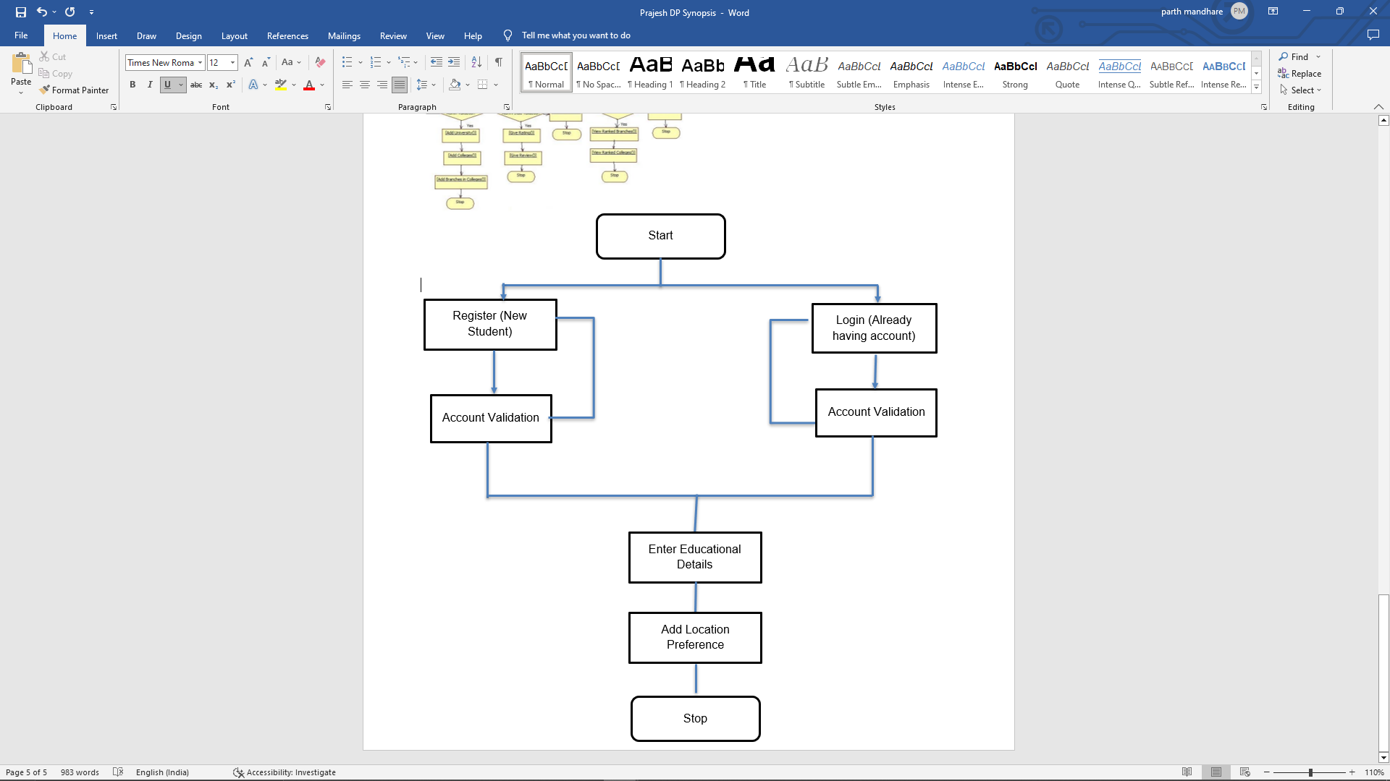
fig 1: User interface
No
Yes
Yes
No

- Process:
In the first phase we will work on constructing the frontend and backend of the system. After completing the first phase we will be working on the dataset that will contain all the engineering colleges, their cut-off, city-state where they are located, user registration details, login details and all the useful information required to the system. The data will be trained thoroughly and tested by giving various scenarios, the results will be observed and changes if required will be made accordingly.

- Algorithms:
The algorithms used for building the system includes K Nearest Neighbour, Feature Weighted K-Nearest Neighbour, Matrix Factorization, Content-based filtering, Collaborative filtering algorithms. The algorithms are used for data preparation, feature selection, feature weighting, training the data, model validation, recommendation. The above algorithms will help the system to give more accurate results.

- Steps involved in training and building the model:
- Data preparation:
The first step is to prepare the data by collecting relevant information about the colleges and universities. This information can include factors like location, program offerings, admission requirements, student demographics, and more.
- Feature selection:
The next step is to select the features that are most relevant to the recommendation task. These features can be selected based on their correlation with the target variable (i.e., the fields that students are likely to prefer).
- Feature weighting:
Once the relevant features have been selected, they can be weighted based on their importance to the recommendation task. This can be done using various techniques, such as mutual information or correlation analysis.
- Training data:
The data is then split into training and testing sets, with the training set used to train the FW-KNN model. During training, the FW-KNN algorithm calculates the distance between each data point (i.e., each student's preferences) and its k-nearest neighbours (i.e., colleges that are similar to the student's preferences). The weights assigned to each feature are used to adjust the distance metric.
- Model validation:
After the model is trained, it is validated using the testing set to evaluate its performance. This is done by comparing the predicted colleges with the actual colleges that the students eventually attend.
- Recommendation:
Once the model is validated, it can be used to make recommendations to new students based on their preferences. The FW-KNN algorithm calculates the distance between the student's preferences and the data available in the training set, taking into account the feature weights. The k-nearest neighbours (i.e., the colleges that are most similar to the student's preferences) are then recommended to the student.

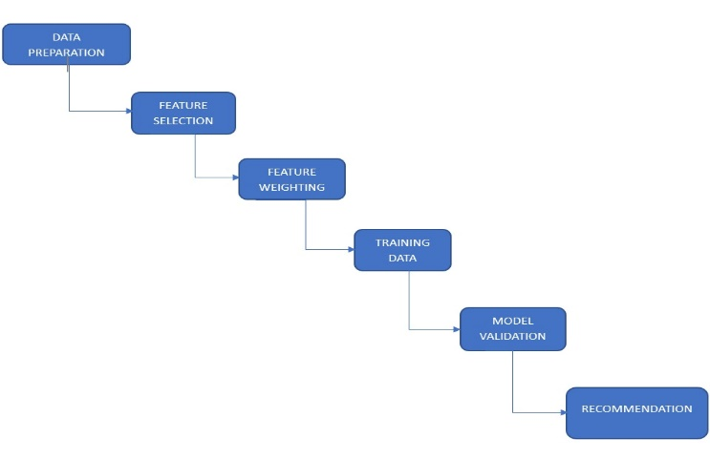
fig 2: Steps included in training and building the model

- Methodology:
The suggested recommendation system gives HSC students advice on how to get accepted to the best colleges. The system is designed with a number of filters that will filter the data in accordance with the needs of the students and provide the appropriate results.
The key elements that are used to make up the proposed recommendation system are: data collection (to gather data from various sources), data cleaning, data transformation, feature collection (to extract pertinent features from the data and create user and item profiles), data integration, data reduction, feature engineering, and recommendation engine (uses collaborative filtering and content-based filtering techniques to generate personalized recommendations for each student).

- Data collection:
The initial step would be to gather important project data. This might contain information about schools and universities such location, size, rating, majors offered, and tuition prices, as well as information about students like academic achievement, extracurricular activities, and personal preferences.
- Data cleaning:
The data that has been gathered has the potential to include inaccuracies, discrepancies, gaps, or anomalies that require attention. To guarantee the precision and comprehensiveness of the data, it may be necessary to utilize data cleaning methods, such as eliminating duplicates, filling in missing values, and managing outliers.
- Data transformation:
The data may need to be changed to make it more suited for analysis. For example, categorical variables may need to be encoded as numerical values or scaled to a common range. To extract meaningful information, feature engineering approaches such as establishing new variables based on existing ones can also be used.
- Data integration:
To generate a complete dataset, many data sources may need to be merged. Data integration entails addressing any data discrepancies or redundancies and combining data sources into an unified dataset.
- Data reduction:
The dataset might include a vast number of variables, many of which are irrelevant to the study. To minimise the number of variables while retaining the most critical information, data reduction techniques such as feature selection or dimensionality reduction can be used.
- Data splitting:
The final stage in data preparation is to separate the dataset into training, validation, and testing sets. This is done to assess the recommendation system's performance and minimise overfitting.

- Future Scope
This system will be beneficial to students in a number of ways because there is currently no system that can assist students in narrowing down their choices of engineering colleges. At the moment, the system only works for engineering college admission, but in the future, we will expand the system by adding more streams and more features to make it useful for other students as well.

- Conclusion
A user-friendly web programme called College Recommendation System will reduce students' workload and make it simpler for them to select the right college. The system will offer a list of colleges from which the student may choose the institution to which he or she wishes to be admitted. To get the intended results, we have employed a variety of data mining and machine learning methods in the project. The suggested work serves as a valuable guide for the learner.

References
- Sheetal Girase, Varsha Naik, Debajyoti Mukhopadhyay, “A User-friendly College Recommending System using User-profiling and Matrix Factorization Technique”, DOI: 10.1109/CCAA.2017.8229779, 2017.
- Akshar Panchal, Kushal Gosar, Homil Parmar, Rohini Nair, “College Recommendation System using Data Mining and Natural Language Processing”, 2018.
- Asmita Orse, Nikhil Suryawanshi, Harsh Shrivastav, Pratik Bajpai, Prof. Megha Patil, “Institute Recommendation System Using ML”, ISSN: 2321-9653, 2022.
- Mr. Y. Subba Reddy and Prof. P. Govindarajulu, “College Recommender system using student’ preferences/voting: A system development with empirical study”, 2018.
- Udhayakumar S, Harisai V, “College Recommendation System For Students Using Datamining With Collaborative Filtering Algorithm–2”, ISSN: 2582-5208 , 2021.
- Vinit Jain, Mohak Gupta, Jenish Kevadia, Prof. Krishnanjalin Shinde, “College Recommendation System”, ISSN: 2278-0181, 2017.
- Jadhav Sayali Pramod , Patil Durga Ananda , Kamble Sonali Arun, Shinde Sumit Sahebrao, “College Recommendation System using Machine Learning”, -ISSN: 2395-0056, Mar 2020.
- “Developing and Evaluating a University Recommender System”, Mehdi Elahi, Alain Starke, Nabil El loini, Anna Alexander Lambrix, 2022.
- Vidish Sharma, Tarun Trehan, Rahul Chanana, Suma Dawn, “StudieMe: College Recommendation System”, DOI: 10.1109/RDCAPE47089.2019.8979030, 2019.
- “A Recommendation System for Selecting the Appropriate Undergraduate Program at Higher Education Institutions Using Graduate Student Data”, Yara Zayed, Yasmeen Salman, Ahmad Hasasneh, https://doi.org/10.3390/app122412525, 2022.

