CORN LEAF DISEASE DETECTION

KOWSALYA R  Department of Computer Science  KIT- Kalaignarkarunanidhi Institute of technology, Coimbtore, India kit.23.19bcs027@gmail.com | Dr. S. SANTHI  Professor of the Department of Computer Science  KIT- Kalaignarkarunanidhi Institute of technology, Coimbtore, India  ssanthi.kit@gmail.com | HARI SHANKAR R  Computer Science and Engineering  KIT- Kalaignarkarunanidhi Institute of technology, Coimbtore, India  kit.23.19bcs015@gmail.com

BALA YOKESH MANI A
Department of Computer Science
KIT- Kalaignarkarunanidhi Institute of technology, Coimbtore, India kit.23.19bcs027@gmail.com

Abstract

The agricultural productivity is the major sector of Indian economy. The rate of misdiagnosis is extremely high, and conventional approaches for identifying crop diseases are ineffective in terms of both time and money. Accurate disease diagnosis also improves economic loss and decreases the effectiveness of agricultural output. The deep neural networks technology have shown promising results in the early phases of machine learning, allowing researchers to improve the precision of object detection and identification systems. The major goal of the research was to locate and classify maize leaf diseases using appropriate deep-learning-based architectures. We employ an open source dataset known as the Corn leaf infection dataset in trials where we must discriminate between healthy and diseased leaves as well as where specific areas of the leaf are affected. We used a VGG block model for our classification problem, keeping the number of parameters low to achieve rapid convergence while maintaining good accuracy. To locate the contaminated area in the maize leaf, we applied the cutting-edge deep learning model VGG 16. To show the effectiveness of our suggested solution, we run several end-to-end tests and analyze the results. The outcomes demonstrate that the proposed model performs rather well given the available data. Our model achieves mean average detection precision of 55.30% and a classification accuracy of 95.25 percent. Words like CNN, classification, object detection, VGG 16, corn leaf, maize leaf, and plant disease are used frequently.

- INTRODUCTION

One among the major factors affecting a nation's economic strength is how well its agricultural sector performs. Maintaining the health of any crop is essential to guaranteeing its quality and productivity since crops might contract a variety of diseases. Studying agricultural ailments is essential for scientific endeavors and research because crops are one of the primary sources of sustenance. Recent research has shown how quickly diseases can affect plants. Corn is one of many different varieties of basic foods. Corn production ranks among the highest in the world, after that of wheat and rice. Besides being a popular cereal, maize is used to make ethanol, animal feed, corn syrup, and corn starch, among other things. Corn diseases can infect a variety of plant sections, including the leaf, stem, rhizomes, and even the entire plant. The most frequent corn leaf infections include brown spots, northern leaf blight, common rust maize disease, and grey leaf spots. The symptoms of corn leaf infections might vary. In contrast to plant pathologists or other specialists, farmers typically have more difficulty identifying illnesses in the maize leaf. To address these problems, conventional techniques including chemical analysis of the contaminated area, imaging, and spectroscopy have been utilized; however, they have not proven successful in producing precise, timely, or cost-effective solutions.

Since the birth of the era of machine learning and artificial intelligence, the deep convolutional neural network(CNN) has achieved tremendous advances in computer vision. For a certain sample of input data, a class label is predicted in a classification task. The goal of detection, on the other hand, is to identify noteworthy aspects of a picture concerning the background. As demonstrated, both our classification system and detection method can distinguish between healthy and diseased maize leaves, as well as the location of the infection. On the dataset of maize leaf diseases, we proposed two improved deep convolutional neural network models that achieve great classification accuracy with a limited number of parameters and a high mean Average Precision (MAP). The binary classifier that we suggested, the VGG block model, has a 95% accuracy rate.

- RELATED WORKS
The application of computer vision technologies in various industries, including agriculture, has increased significantly during the past few years. Keeping an eye on the health of crops as they grow is crucial in today's agricultural production if you want to increase crop output efficiency. As a result, there are many different convolutional neural network architectures available. A few of the more well-known ones are VGG16, VGG19, Google Net, ResNet, Dense Net, etc. These architectures are also used to detect plant diseases. Alehegn's study used imaging and machine learning to categorize the diseases that affect corn leaves. Researchers are focusing on digital image analysis methods based on texture, color, and morphological aspects to differentiate between healthy and diseased leaves on maize. For four classes, including healthy leaves, common rust, leaf blight, and leaf spot, a total of 800 photos were gathered. Each of the 200 images in each class is given a total of 22 characteristics, and K-nearest neighbors (KNN) and artificial neural networks (ANN) classifiers are then used to analyze the data. According to their analysis, ANN performs better than KNN and obtains 94.4% accuracy. Mohanty et al. (2016) trained a deep convolutional neural network to recognize 14 crop species and 26 diseases using a public dataset that includes 54,306 photos of healthy and disease . The trained model achieves an accuracy of 99.35% on a held-out test set. They employed transfer learning and training from scratch mechanisms and used the Alex Net and Google Net architectures. Liu and Wang suggest a modified YOLOv3 algorithm to identify pest insects and diseases affecting tomatoes (2020). Multi-scale feature identification based on image pyramids, object bounding box dimension clustering, and multi-scale training are used to enhance this network. Their collection consists of 146,912 bounding boxes and 15,000 photos representing 12 distinct diseases. With a MAP of 92.39%, the suggested YOLOv3 model surpasses SSD, Faster R-CNN. Strong robustness is present in the upgraded YOLOv3 network for the detection of various item sizes and various image resolutions in a challenging environment.

- CONCEPTUAL BACKGROUND

EXISTING SYSTEM
In the previous study, only two types of diseases are being focused on. ie. Blight, common rust however other major disease types are not covered yet.
PROPOSED SYSTEM
Our system implements it with an updated new dataset which covers 4 classes of diseases such as
1. Blight
The eventual death of plant parts including leaves, branches, twigs, or floral organs is a sign of blight. [1] As a result, many illnesses that primarily display this symptom are referred to as blights.
2. Common rust
The first appearing after silking in maize is frequently Puccinia Sorghi. Chlorotic spots on the leaf are the first early sign of the disease. Golden-brown pustules or bumps on the plant tissue's surface are the most prominent symptoms of this plant infection. [5] These lumps are urediniospores, which can infect further plants by spreading to them.
3. Gray Leaf Spot
Small, spherical lesions with a yellow halo are the first signs of grey leaf spots on leaves. Before the start of the fungal sporulation, these initial lesions may be brown or tan. Due to its resemblance to eyespot and common rust, the first sickness can be challenging to distinguish from grey leaf spots at this point. The lesions normally start on the lower leaves and migrate higher on the plant throughout the season, but as they get older, they enlarge into rectangular, narrow, brown to grey dots.
4. Healthy (no disease)
Maize production now blooming that of wheat or rice, it has become a staple meal in many parts of the world. Apart from direct human consumption, maize is used to produce corn ethanol, animal feed, and other maize-based goods such as corn syrup and starch.

VI. CLASSIFICATION MODEL
- DATA ACQUISITION: The dataset used in this experiment is a subset of a Plant Village dataset hosted on Kaggle. It has roughly 217,000 photos divided into 38 different categories of both healthy and ill plant photographs. From this dataset, images of corn plants were chosen for the experiment as it includes a large number of images in four categories. The data required for this diagnosis are mostly from medical research papers. One such place to find datasets is Kaggle. Jupiter Notebook is a no-setup, configurable Jupiter Notebook environment provided by Kaggle.

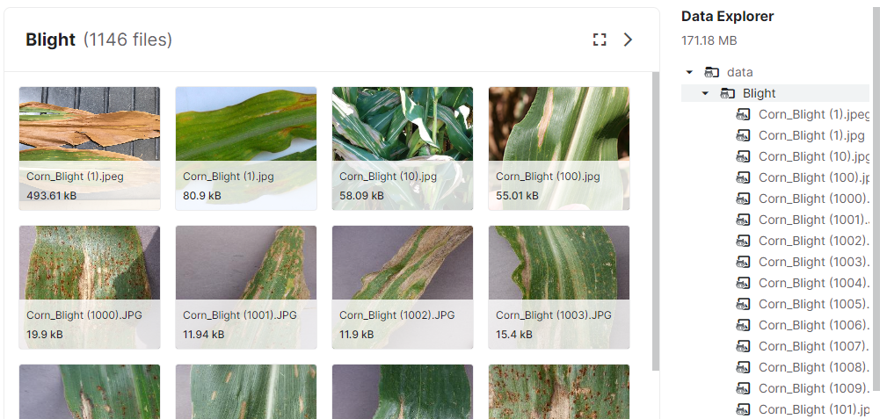
Unhealthy leaf uploaded in google drive

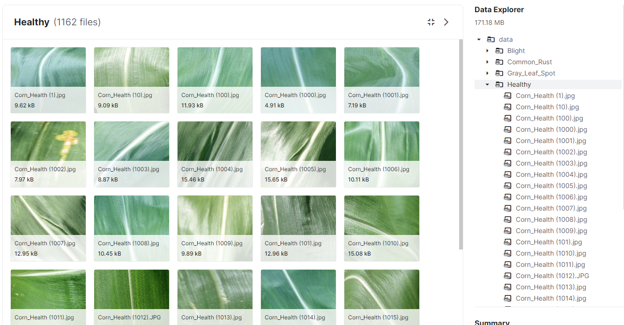
Healthy leaf uploaded in google drive
- DATA PROCESS
Pre-processing often comprises removing low-frequency historical noise, adjusting the character particle intensity, eliminating reflections, and cropping areas of the image. Image pre-processing is the approach to enhancing statistics. During the section on amassing the snapshots for the dataset, snapshots with smaller decisions and dimensions of less than 500 pixels were not taken into consideration as a valid pixels for the dataset. In that way, it changed into ensuring that snapshots include all of the wanted statistics for characteristic studying.
Once we had labeled the data, the data in the datasets are arranged according to the id. This will make the first part of the data frame healthy images and the second part blight, grey leaf images. 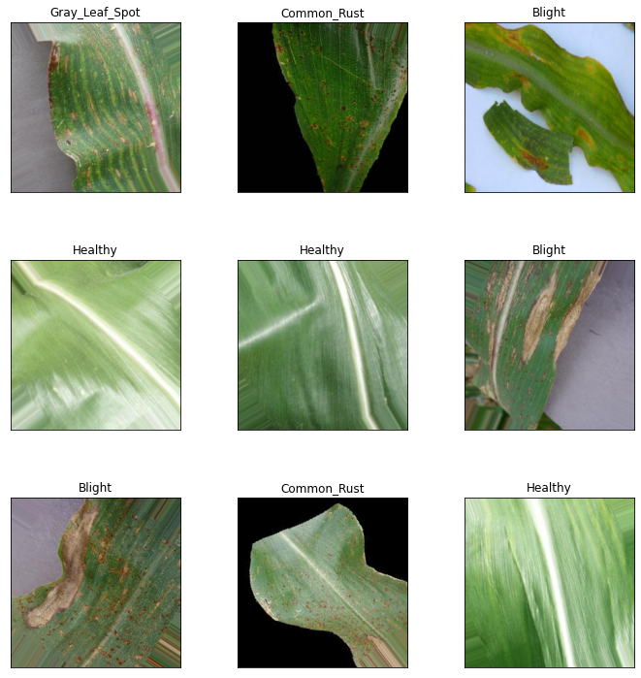
Head of the data frame without seeding.

Now the data frame is visualized as a histogram using matplotlib to get an idea of the data present in the data frame. It is always advised to visualize the cleaned data before utilizing it. In the histogram of title frequency, we consider the id in the x-axis and the number of images in the y-axis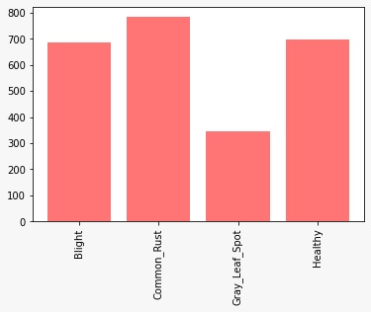
Dataset labeling

- MODEL TRAINING
The model considered for this dataset is VGG16. VGG16 is a CNN model that has 19 layers. In VGG16, one can give the input at one end which will go through several convolutional and pooling layers. This model will return a set of feature maps that are reduced in size to the original image. By flattening these maps, a feature vector is created that may be fed to a sequence of fully connected linear layers to generate a probability distribution of class course.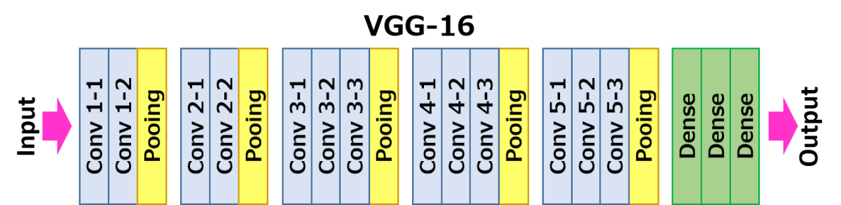
An epoch consists of one or more batches The parameter weight is a pre-trained model that is used. VGG16 is pre-trained on ImageNet. To exclude the fully connected head we add the parameter include top which should be made false. This code would be used when performing transfer learning via fine-tuning To feed input to the model we use Input() function which contains shape() as an argument. Shape() has three arguments for itself, those are, size x size x dimension. Here size = 64, dimension = 3
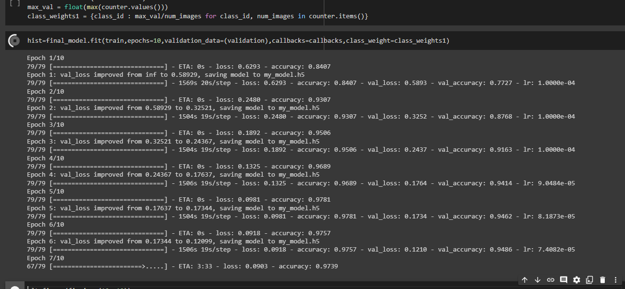 Model training till the number of epochs.
- EVALUATION PHASE
In this module, once the VGG16 model is trained we check the accuracy and the loss that occurred during the training. We use to evaluate() method which returns two parameters, one is accuracy and the other is lost.
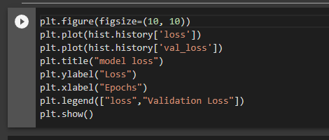
Finding Loss and Accuracy of the Model
Now to visualize the trained model we use a confusion matrix. A confusion matrix is a method to calculate the quality of the output on the iris of the data

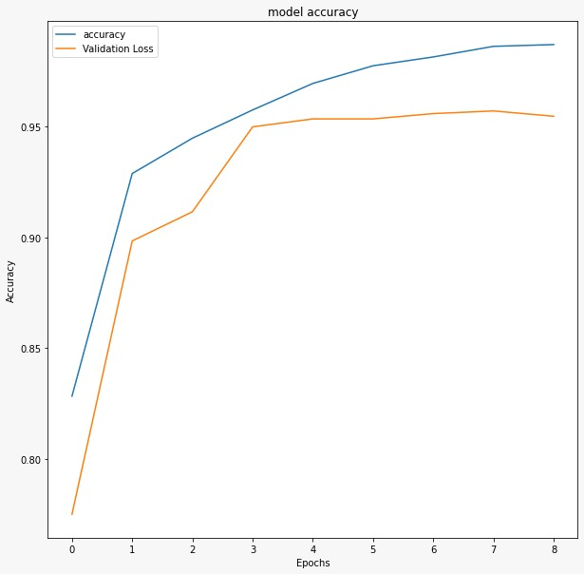
Accuracy chart for the trained model

V. Results, Analysis, Discussion
Even during the presence of various models that are trained with X-ray of leaf datasets, Corn leaf is promised to be revolutionary to diagnose Corn leaf disease patients. As the actual accuracy can be a bit less than the expected accuracy of 0.91, the system used to implement the project will be the major reason. As the model was not trained with larger datasets.
● Accuracy
● Recall
● Precision
● F1 score
● ROC curve
It is concluded that considering the F1 score is a major parameter to calculate the effectiveness of the model. The F1 score works best for unevenly distributed data. Still, F1-score gives more of the precision value than the recall value.
The system has been developed and the performance has been evaluated successfully. The system works well as per the expectations. Once the seller sells the products through the system, they need to edit the available quantity after the sales because successful sales and transportation time cannot be defined by the system. The system only provides a forum to market the cultivated products of farmers throughout the world. Our system is working well and the objectives of the project have been achieved.
VI. Conclusion And Future Work
Findings of the trials in this current study allow us to conclude such as deep features taken from several CNNs and fusing the features to create a more complex feature set to increase classification accuracy for maize plant diseases. Based on the comparative analysis, we may conclude that the methodology utilized in this paper, which produced a classification accuracy score of 98.56%, performs better in comparison to the accuracy scores reported in the literature. Additionally, integrating the feature sets of CNNs with small parameters to extract features results in more reliable models that beat CNNs with bigger parameters. As part of future work, we can use the same method to categorize additional corn illnesses, and other plant diseases using digital photos. Additionally, we can experiment with other augmentation methods and different CNN configurations for feature extraction.
References
- Platform for Intergovernmental Science and Policy on Biodiversity and Ecosystem Services. (Mar. 29, 2016). Report of the Fourth Session Plenary of the Intergovernmental Science-Policy Platform on Biodiversity and Ecosystem Services. [Online]. See https://seea.un.org/content/reportplenary-intergovernmental-sciencepolicy-platform biodiversity-and-ecosystem-services
- "Threat to future global food security from climate change and ozone air pollution," A. P. K. Tai, M. V. Martin, and C. L. Heald, Nature Climate Change, vol. 4, no. 9, September 2014, pp. 817-821.
- R. N. Strange and P. R. Scott, ‘‘Plant disease: A threat to global food security,’’ Annu. Rev. Phytopathol., vol. 43, pp. 83–116, Jul. 2005.
- Smallholders, Food Security, and the Environment, Int. Fund Agricult. Develop., Rome, Italy, 2013, p. 29.
- [5] C. A. Harvey, Z. L. Rakotobe, N. S. Rao, R. Dave, H. Razafimahatratra, R. H. Rabarijohn, H. Rajaofara, and J. L. MacKinnon, ''Extreme vulnerability of smallholder farmers to agricultural risks and climate change in Madagascar,'' Phil. Trans. Roy. Soc. B, Biol. Sci., vol. 369, no. 1639, Apr. 2014, Art. no. 20130089.
- R. Perroy, ‘‘World population prospects,’’ United Nations, vol. 1, no. 6042, pp. 92–587, 2015.
- L. Deng and D. Yu, ‘‘Deep learning: Methods and applications,’’ Found. Trends Signal Process., vol. 7, nos. 3–4, pp. 197–387, Jun. 2014.
- R. Hu, S. Zhang, P. Wang, G. Xu, D. Wang, and Y. Qian, ‘‘The identification of corn leaf diseases based on transfer learning and data augmentation,’’ in Proc. 3rd Int. Conf. Comput. Sci. Softw. Eng., May 2020, pp. 58–65.
- S. Sladojevic, M. Arsenovic, A. Anderla, D. Culibrk, and D. Stefanovic, ‘‘Deep neural networks based recognition of plant diseases by leaf image classification,’’ Comput. Intell. Neurosci., vol. 2016, pp. 1–11, May 2016.
- T. O’Shea and J. Hoydis, ‘‘An introduction to deep learning for the physical layer,’’ IEEE Trans. Cognit. Commun. Netw., vol. 3, no. 4, pp. 563–575, Dec. 2017.
- G. Aceto, D. Ciuonzo, A. Montieri, and A. Pescapé, ‘‘Mobile encrypted traffic classification using deep learning: Experimental evaluation, lessons learned, and challenges,’’ IEEE Trans. Netw. Service Manage., vol. 16, no. 2, pp. 445–458, Jun. 2019.
- E. L. da Rocha, L. Rodrigues, and J. F. Mari, ‘‘Maize leaf disease classification using convolutional neural networks and hyperparameter optimization,’’ in Proc. Anais do XVI Workshop Visão Computacional. (SBC), 2020, pp. 104–110.
- M. Agarwal, V. K. Bohat, M. D. Ansari, A. Sinha, S. K. Gupta, and D. Garg, ''A convolution neural network-based approach to detect the disease in the corn crop,'' in Proc. IEEE 9th Int. Conf. Adv. Comput. (IACC), Dec. 2019, pp. 176–181.
- A. Waheed, M. Goyal, D. Gupta, A. Khanna, A. E. Hassanien, and H. M. Pandey, ‘‘An optimized dense convolutional neural network model for disease recognition and classification in corn leaf,’’ Comput. Electron. Agricult., vol. 175, Aug. 2020, Art. no. 105456.
- ] Y. Zhao, L. Liu, C. Xie, R. Wang, F. Wang, Y. Bu, and S. Zhang, ‘‘An effective automatic system deployed in agricultural Internet of Things using multi-context fusion network towards crop disease recognition in the wild,’’ Appl. Soft Comput., vol. 89, Apr. 2020, Art. no. 106128.
- F. Saeed, M. A. Khan, M. Sharif, M. Mittal, L. M. Goyal, and S. Roy, ''Deep neural network features fusion and selection based on PLS regression with an application for crop diseases classification,'' Appl. Soft Comput., vol. 103, May 2021, Art. no. 107164.
- Y. LeCun, L. Bottou, Y. Bengio, and P. Haffner, ''Gradient-based learning applied to document recognition,'' Proc. IEEE, vol. 86, no. 11, pp. 2278–2324, Nov. 1998.
- A. F. Agarap, ‘‘Deep learning using rectified linear units (ReLU),’’ 2018, arXiv:1803.08375.
- L. Torrey and J. Shavlik, ‘‘Transfer learning,’’ in Handbook of Research on Machine Learning Applications and Trends: Algorithms, Methods, and Techniques. Hershey, PA, USA: IGI Global, 2010, pp. 242–264.
- J. Deng, W. Dong, R. Socher, L.-J. Li, K. Li, and L. Fei-Fei, ‘‘ImageNet: A large-scale hierarchical image database,’’ in Proc. IEEE Conf. Comput. Vis. Pattern Recognit., Jun. 2009, pp. 248–255.
- Tan and Q. Le, ‘‘EfficientNet: Rethinking model scaling for convolutional neural networks,’’ in Proc. Int. Conf. Mach. Learn., 2019, pp. 6105–6114.
- F. Iandola, M. Moskewicz, S. Karayev, R. Girshick, T. Darrell, and K. Keutzer, ‘‘DenseNet: Implementing efficient ConvNet descriptor pyramids,’’ 2014, arXiv:1404.1869.
- Plant Village Dataset. Accessed: Jul. 9, 2021. [Online]. Available: https://www.kaggle.com/saroz014/plant-diseases
- D. P. Kingma and J. Ba, ‘‘Adam: A method for stochastic optimization,’’ 2014, arXiv:1412.6980.

