Intelligent Sales Prediction Using SVM Algorithm

Mrs. E. Padma¹, Dhivyabrabha M², Kavin Kumar G³, Kaviya V N⁴, Mahalakshmi R⁵
¹Assistant Professor, Department of Computer Science and Engineering, Nandha Engineering College, Erode-52.
^{2,3,4, 5}UG Student, Department of Computer Science and Engineering, Nandha Engineering College, Erode-52.
Email id: dhivya12102001@gmail.com¹,kavingkumar161@gmail.com²,kaviyanatarajkumar@gmail.com³, maharam2702@gmail.com⁴

Abstract — The Analysis report proposes a solution that grants businesses complete visibility into their inventory and streamlines sales operations from the distribution center to the store. It is used to determine the balance of existing materials when it is demanded to know the stock balance, control the levels of materials, and daily movement of the materials. Data is gathered from the web application and processed to form a group of charts called a dashboard. This dashboard helps to analyze the sales and performance of every product report. Analysis report deals with the organization’s requirements, performance analysis, sales, and financial problems, and solving them, in addition, to saving all the materials information, and process in a private system database. The quality of wood used in the furniture and performance analysis of furniture based on design are represented in form of charts for a better understanding of the user. Admin can view their financial and sales reports by daily, weekly, monthly, and yearly trends. This Furniture Web Application System is created for the convenience of the customers, of this specific shop. It is not only for users but also convenient for the owner to sell their products online along with analytics reports using machine learning techniques. To analyze reports, the system uses Support Vector Machine (SVM), a supervised machine learning technique.
Keywords—furniture, machine learning, analysis report

- INTRODUCTION
In the competitive furniture inventories market of today, having an online platform where products can be sold is essential for retailers. The final version of the website includes a front end for customers and a back end for store owners to efficiently manage the site. Additionally, sales and transaction reports, product reports, order reports, and stock reports are all available as part of this website's analysis reports.
In this paper, data analytics is implemented with machine learning techniques. It provides design decisions, competitive analysis along with database
rudiments. The topmost non-discriminatory of this paper is to build a website that is both professional and cost-effective. To achieve this goal, the e-commerce system will be developed using an open-source solution called osCommerce. Data analytics is used in various domains in this ultramodern era. Data gathered from various areas like customer, product, purchase, and stock details are made into a graph with the use of a machine learning algorithm. With this technique, users can fluently analyze reports from the admin side. These analytic reports help increase organization sales and acquire further furniture market customers, eventually increasing the store's growth.

- LITERATURE SURVEY

- Exploring the Effectiveness of SVM through Performance Analysis
Machine learning refers to the analysis of algorithms that can improve automatically by learning from experience. In supervised learning, the algorithm uses classified training data to learn and can then make predictions for new, unseen data. Using a kernel trick technique, this algorithm transforms the data and identifies the optimal boundary between issues. The kernel trick is a method used in machine learning to form highly linear data from non-linear at this point, it becomes easier to classify. It allows algorithms to efficiently perform calculations on the data in the multi-scale space without using the data points coordination. This function manipulates the dot product among the transformed points in the feature space, which can be used to make predictions and classify new data points. The kernel trick is commonly used in support vector machines and other classification algorithms.

- Optimizing Material Usage through Cutting Stock Problem
The objective of this problem is to minimize material usage and optimize resource utilization in product design, manufacturing, and application. The genetic annealing algorithm can be utilized to optimize the stock-cutting process for fingerboard furniture. Cutting stock problem is used to minimize material waste with the use of mathematical calculations that arises from the application industry. The cutting stock problem is an established minimalist problem in the field of operations research and production management. It is a problem that arises when a manufacturer needs to produce a certain number of pieces of a product from a fixed number of raw materials, typically a roll or a sheet of material such as wood, metal, or fabric. The goal of this problem is to determine the optimal cutting pattern for the raw material so that it minimizes waste and maximizes the number of pieces produced.
- Material Application and Innovation
Various materials were utilized in the creation of furniture during different periods. This paper discusses the usage of traditional and modern materials in modern furniture design. Materials reflect the level of productive force development and social-artistic characteristics at a given time. Modern furniture design is based on advanced technology, production efficiency, design, and functionality. Contemporary furniture is developed with an emphasis on practicality, multi- functionality, comfort, health, and decoration.

- Effective Furniture Financial Allocation
The Furniture financial allocation is to determine the fabrication expense of furniture being manufactured. To automate the furniture budgeting process, a workflow-based information system has been designed and developed. In furniture companies, financial management is a critical assignment that relies on the ability to quickly respond to customer requests for manufacturing. Well-prepared budget management helps to know the company’s resources, business development, and financial crises of the company enhancing the furniture website experience for the consumers. Furthermore, the furniture budgeting process has been enhanced in the following ways:
  - Optimization and improvement of business processes.
  - Increased productivity through resource minimization and efficient resource allocation.
  - Manufacturing time and cost estimation improvement.
  - Business process covering improvement.

- Online Customer Experience
The expanding e-commerce landscape has contributed to a rise in online shopping, and this trend has been reflected in the furniture industry. With the steady rise of e-commerce, people have become more receptive to online shopping. As a result, the furniture industry has taken notice and has begun to focus on online retail. This study provides practical recommendations for enhancing the furniture website experience for furniture consumers. Many studies have shown that customer reviews have a significant impact on providing consumers with better products and the likelihood of repeat purchases. Furniture companies are placing increased emphasis on online retail. In a modern and increasingly aggressive business, perfecting the e- shopping web application is crucial for business organizations to offer unique products and advanced customer services. The overall consumer expectation is personalized feedback to any interaction between customers and the company, making the online consumer experience a critical concept in the area of e-commerce.
- Exploring Furniture Design
Furniture design plays a crucial role in the creation of intelligent homes. To achieve this, it is necessary to explore and develop new furniture pieces by analyzing design trends and emerging technologies that can bring these ideas to life. Furniture design is a critical area of study as it directly relates to the needs and requirements of humans. According to the Data Mining Survey, design is crucial in improving the quality of life for consumers. Visual Data Mining is used to identify current design trends and future tendencies for furniture. This process involves various categories such as production, customization, algorithms, adjustable or ductile and modular furniture, human- centered design, and smart or contemporary furniture.
- Integrated Energy and Environment Management
Continuous increases in energy costs, manufacturing units, including which are involved in energy moderate industries like the furnishings industry, require powerful methods for reducing their fuel consumption. Additionally, there exist several profit-making and territory reasons for companies to consider implementing environmental management initiatives. These initiatives include system implementation, business ventures, rules and

regulation development, energy, and nature auditing, activity scheduling, system enhancement, verifying system development, and maintenance review. It is essential to implement a joint preservation of environmental resources management system in many furniture industrial companies. The main consumption of essential energy in the wood-based industry, which specifies the construction of wood furniture and finished products, was miniature but offered possible ways for power reduction. Energy overhead in energy-less industrial companies like furniture industries is often considered fixed overheads, although they can be easily managed as a cost category.

- Exploring the Aesthetics of Furniture
Furniture style is a crucial aspect of indoor decoration in the real world as it represents the distinct visual characteristics of furniture. Unlike traditional grouping methods, furniture design classification focuses on categorizing various pieces of furniture based on their appearance style rather than their functional structure, such as a bed, desk, etc. Furniture product is a blend of practicability and desirability, and their varieties, colors, and patterns or designs widely determine the optical impact of interior decoration. In these latest years, with the enhancement of human living methods, the furniture market has seen a development of various feature enhancements, making it challenging for people to choose furniture that is both functionally and aesthetically appropriate. Therefore, automatic furniture style classification has become an important development direction in computer vision technology and artificial intelligence domains. By using various advanced machine learning algorithms, it is possible to automatically classify furniture styles based on their visual features such as color, shape, and texture. This can greatly help consumers in their furniture selection process by providing them with more accurate and efficient recommendations based on their preferences. Additionally, furniture companies can also benefit from automated style classification by improving their product recommendation systems and marketing strategies.

- Improving Sales Performance with Machine Learning
Machine learning is indeed a powerful tool that can be used to improve sales performance in many ways. In particular, it can be utilized to predict
the status of a sale in a particular business, which can help salespeople prioritize their efforts and focus on the leads that are most likely to convert. It can eventually be used to analyze shoppers’ feedback along with their sentiments, which supports businesses to identify places for additional improvement in their products or services. Additionally, machine learning can be used to optimize pricing strategies by analyzing sales data and adjusting prices accordingly. By leveraging the power of machine learning, businesses can gain a competitive edge and achieve greater success in their sales efforts. By analyzing customer data such as browsing history, search queries, and purchase history, machine learning algorithms can generate insights that help e-commerce businesses better understand their customers' preferences and needs. Based on these insights, businesses can personalize the customer experience, such as by recommending products that are relevant to the customer's interests, displaying targeted ads, or providing customized promotions. This personalization can increase customer engagement, satisfaction, and loyalty, leading to improved sales performance.

- Recommendation Engines
traditional recommendation engines may struggle with understanding the artistic view of furniture and other visually-oriented products. However, there are techniques and algorithms that have been developed specifically for image-based recommendation engines. Additionally, some recommendation engines use a combination of image analysis and customer behavior data to make personalized recommendations. While recommendation engines are great for more statistical analysis and relationships, something different is needed to improve success on sites that require analysis are more artistic concepts. Machine learning (ML) is a broad spectrum of solutions, and it is starting to be applied to design issues that can improve business, both on the internet and in retail. Over the past few years, there has been a notable rise in the trend of home shopping. Recommendation engines for direct sell, cross-sell and up-sell, are critical for helping customers quickly find objects to buy. The typical recommendation engine uses statistical analysis and clustering to suggest most customers who like A will like B. Art is more subtle. To add to the complexity, with many vendors for each product such as chairs, couches, or tables, and each site potentially using multiple vendors, trying to find enough data for accurate clustering is difficult. Online purchasing is the perfect market for

incorporating design knowledge within machine learning and AI-based solutions.

- SYSTEM DESIGN
System design describes the architecture involved in the system along with its component parts and their future interaction with one another.

- USECASE DIAGRAM

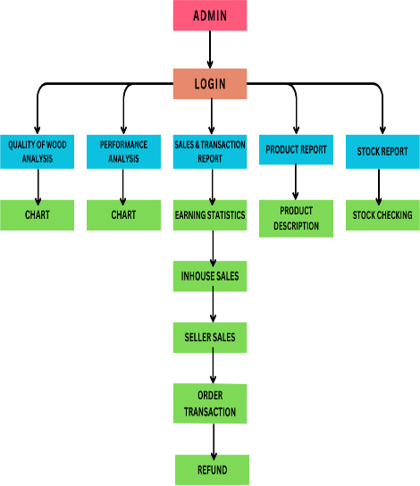

Fig2 : Dataflow Diagram
- METHODOLOGY
The methodology specifies the procedures or techniques that are used to point out, choose, procedure, and examine information about the specific topic. This project involves creating an analytical report with a set of methods by following data analytics and machine learning techniques. Data gathering is the first requirement in this system. This is done by collecting data about the consumers buying a product from the furniture shop web application. The purchased product details are sent to the executive portal then data is stored in the backend.

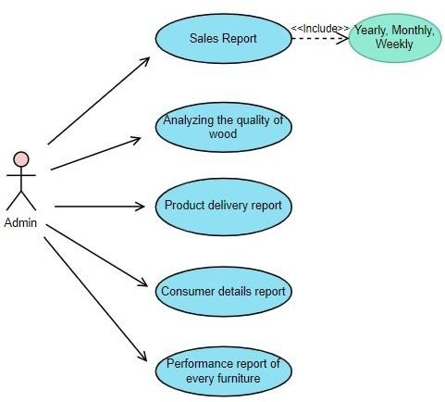
Fig1 : Usecase Diagram

- DATAFLOW DIAGRAM
After storing data it is processed under machine learning techniques to plot graphs in the form of line and bar charts in the Earning statistics section. The support vector machines algorithm is the machine learning technique used in this project. Support Vector Machines (SVM) algorithm can be used in furniture report analysis to classify and predict the performance of furniture based on various parameters. Reports are used to analyze the sales and stock details weekly, monthly, and yearly wise. This method helps in understanding how the furniture shop is growing over the past years. The generated report also identifies the details of the products, stocks available, order id, refund, and customer details to verify the billing and payment process. The furniture production system takes into account the quality of wood used in the manufacturing process, as well as the analysis of performance based on the design. After the system has been in use for a period, it should be evaluated to identify areas of improvement. This may involve gathering feedback from stakeholders and analyzing system usage data. Based on the feedback, the
system can be improved and updated as needed in the future.

- IMPLEMENTATION

- Sales and Transaction Report
Sales and Transaction report enables observing sales invoices transactions within the selected time period. The report on transaction details provides a comprehensive overview of specific details, such as work order information, transaction history, the number of materials used, unit cost of both labor and materials and other relevant information. It provides detailed reports on revenue, profit, and loss. Reports provide valuable information which ensures transparency and fairness on the website. This would include the total amount of revenue generated by the website during a specific period of time. It also includes details about the customers who made purchases on the website, such as their names, contact information and purchasing history. Tracking customer behavior and preferences can be accomplished by utilizing this information. Transaction Details include information about individual transactions, such as the date and time of the sale, the item purchased, the price, and any applicable discounts or promotions.

- Product Report
Product Sales would provide a breakdown of sales by individual products or categories of products. This information can help identify which products are the most popular and profitable. Detailed information about a particular product or group of products is provided by it. Product information includes basic information about the product such as its id, name, description, and any relevant features or specifications. The report can be used by an organization to track inventory, analyze sales performance, or evaluate the profitability of a product line.

- Order Report
An order report is a document that provides detailed information about the orders placed by customers. It also shows the status of the order, such as whether it has been shipped or is still pending. By analyzing order data, businesses can make informed decisions about pricing strategies, inventory management, and customer service efforts. An order report can help businesses track sales performance, monitor inventory levels, and identify opportunities for growth. The key functionality of this type of
the report is that it can be filtered by period and can work toward the growth of the organization.

- Stock Report
A stock report provides detailed information about the inventory levels of an organization. The report shows the current stock levels for each product, including the quantity on hand, on order, and back-ordered. It also shows the movement of stock in and out of inventory, including the quantity received, sold, or returned. Stock reports also include information about the age of stock, such as how long each item has been in inventory. By analyzing stock data, businesses can make informed decisions about ordering, pricing, and promotion strategies, as well as identify potential issues such as overstocking or slow- moving inventory.

- Quality of wood analysis
The wood quality analysis involves evaluating the properties of wood to determine its suitability for various applications, such as furniture making, construction, or manufacturing. The quality of the wood is analyzed in form of charts for a better understanding. Overall, a wood quality analysis can help ensure that the wood being used is suitable for its intended application and meets the desired quality standards. This can lead to better performance and durability of finished products and greater customer satisfaction.

- Performance Analysis based on Design Performance analysis based on design
involves evaluating the performance of a product or system based on its design features. Performance analysis of the furniture is represented in form of charts. The charts consist of parameters like quality, durability, comfort, cost efficiency, and the rating provided by the customer. Performance analysis ensures that a product is durable and meets the desired aesthetic and functional standards. This can lead to better customer satisfaction, improved sales, and increased profitability.

- RESULT ANALYSIS
Our paper explains Analytical reports for sales by weekly, monthly, and yearly trends. It also represents order reports and stock reports. This process is done by SVM algorithm so that Admin can analyze the reports within a modern dashboard.

Fig 1 : Earning Statistics

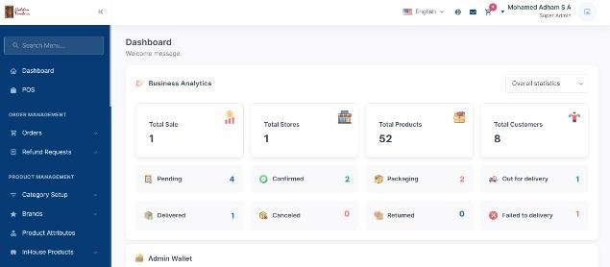

Fig 2 : Admin Wallet

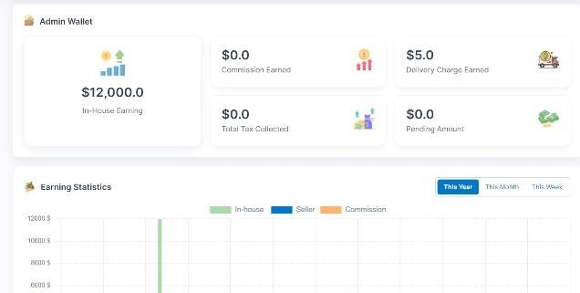

Fig 3 : Order Report

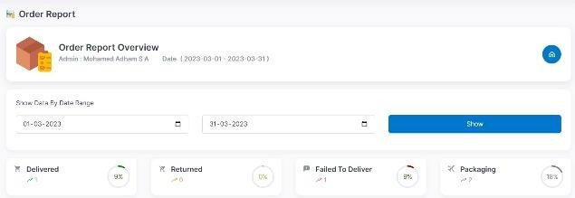

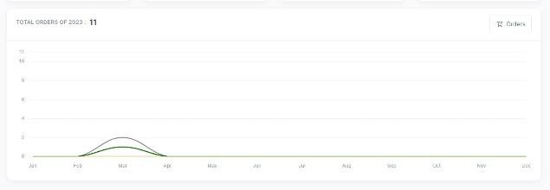

- CONCLUSION
Analyzing the sales and product details through bills and documents is complicated for the admin to manage reports. This system helps to understand the reports in an easy way with a modern dashboard and helps to overcome disadvantages in traditional analyzing methods. This dashboard works under SVM (support vector machine) algorithm. It can plot the charts by getting information from the user-purchased products. Finally, our system is implemented to analyze the reports which support the growth of the organization in a gradual manner. The analytical reports help in better customer understanding, enhanced sales, and elevated profit.
- REFERENCE
- A. David Teich, “Design Is Merging With Machine Learning In Home Décor”, Published by Forbs magazine, April 2022.
- David Raffo, and Feng TIAN, “A Review of the State of the Art”, Published by Institute of Electrical and Electronics Engineers, July 2018.
- J.C. Vidal, M. Lama, A. Bugarin, and S. Barr, “Workflow-based information system for furniture budgeting”, Published by Institute of Electrical and Electronics Engineers, January 2009.
- Jin Wang, Lufang Zhang, and Xiaojian Liu, “Material application and innovation in furniture design”, Published by Institute of Electrical and Electronics Engineers, January 2009.
- Milun Babic, Dubravka Jelic, Davor Koncalovic, and Vladimir Vukasinovic, “Integrating Energy and Environmental Management in Wood Furniture Industry”, Published by The Scientific World Journal, January 2014.
- Qi Yue, Lewen Gao, “Genetic annealing algorithm for cutting stock problem in furniture industry”, Published by Institute of Electrical and Electronics Engineers, January 2009.
- Sunitha Cheriyan, Shaniba Ibrahim, Saju Mohanan, Susan Treesa, “Intelligent Sales Prediction Using Machine Learning Techniques”, Published by Institute of Electrical and Electronics Engineers, March 2019.
- S. Suresh, S. P. Raja, and S. Saravanan, “Performance Analysis of Wooden Furniture using Support Vector Machine Algorithm”, The International Journal of Next-Generation Computing (IJNGC), November 2021.
- S. Zhang, J. Zhu, G. Wang, S. Reng, and H. Yan, “Furniture online consumer experience: A literature review”, Published in Scholarly Journal, February 2022.
- Zhenhen hu, Yonggang wen, and Luoqi liu, Jianguo jiang, richang hong, and meng wang, Shuicheng yan”, Visual Classification of Furniture Styles”, Published by ACM Transactions on Intelligent Systems and Technology, June 2017.

