Design and Comparative Analysis of Ladder Frame Truck Chassis
Supreet Mahadeokar¹, Akansha Patel², Aneesh Ahmad³
¹Department of mechanical engineering, Baderia Global nature care sangathan’s group of institutions, Jabalpur
² Department of mechanical engineering, Baderia Global nature care sangathan’s group of institutions, Jabalpur ³Department of mechanical engineering, Baderia Global nature care sangathan’s group of institutions, Jabalpur
---------------------------------------------------------------------***---------------------------------------------------------------------
Abstract - This research paper titled "Design and Analysis of Chassis" aims to investigate the mechanical behavior of three different materials namely Steel alloy302, Steel alloy4130, and AA 7068 on different cross-sectional shapes of a ladder frame chassis - C, I, and Box (Hollow). The design of the chassis is created using Solid Works 2013 software, and static analysis is conducted using Ansys software R18.0. The results obtained from the analysis provide information on the total deformation, equivalent strain, and equivalent stress of each material on different cross-sectional shapes.
For the C type cross-section, it is observed that Steel alloy302 and Steel alloy4130 have higher total deformation and equivalent strain compared to AA 7068. However, the equivalent stress is higher for AA 7068. For the I type cross-section, Steel alloy4130 shows the highest total deformation and equivalent strain, while AA 7068 exhibits the highest equivalent stress. Finally, for the Box (Hollow) type cross-section, the total deformation and equivalent strain are highest for Steel alloy4130, and the equivalent stress is highest for Steel alloy302.
These results provide valuable insights into the behaviour of different materials on different cross-sectional shapes of a ladder frame chassis. The findings can be utilized to optimize the design of the chassis for better performance and durability. The study emphasizes the importance of material selection and cross-sectional shape in the design of a chassis for various applications.
Key Words: Chassis, SOLIDWORKS Modelling, Static Analysis
1.INTRODUCTION
This document is a template. An electronic copy can be downloaded from the conference website. For questions on paper guidelines, please contact the conference publications committee as indicated on the conference website. Information about final paper submission is available from the conference website.
The design and analysis of a chassis is a crucial component in the development of any vehicle. A well-designed chassis not only provides structural integrity and support but also influences the vehicle's performance and handling. In this research paper, we focus on the design and analysis of three different materials used in three different cross-sectional shapes of a ladder frame chassis: Steel alloy 302, Steel alloy 4130, and AA 7068. The ladder frame chassis is widely used in off-road vehicles, racing cars, and heavy-duty trucks due to its strength and durability.
To carry out the analysis, a 3D model of the chassis was designed using SolidWorks 2013 software. The model was then imported into Ansys software R18.0 for static analysis. Three different cross-sectional shapes were analyzed, including C type, I type, and box (hollow) type. The total deformation, equivalent strain, and equivalent stress of each material were calculated for each cross-sectional shape.
Steel alloy 302, Steel alloy 4130, and AA 7068 were chosen for this study due to their popularity in the automotive industry and their diverse properties. Steel alloy 302 is a corrosion-resistant, austenitic alloy with high strength and excellent toughness. Steel alloy 4130 is a low-alloy steel with high strength and excellent weldability. AA 7068 is a high-strength aluminum alloy with excellent fatigue resistance and fracture toughness.
The results of this study can help in the selection of appropriate materials and cross-sectional shapes for ladder frame chassis design. It provides insights into the behaviour of different materials under static loads and can aid in the optimization of the chassis design for improved performance and safety. The use of advanced software tools for analysis ensures accurate results and reduces the need for physical testing, saving time and cost in the design process.
In conclusion, this research paper presents a comprehensive analysis of the design and analysis of ladder frame chassis using three different materials on three different cross-sectional shapes. The results obtained from this study can be utilized in the design of ladder frame chassis for various applications in the automotive industry

2. OBJECTIVE
The objective of this research paper titled "Design and Comparative Analysis of Truck Chassis" is to evaluate the performance of different materials, namely Steel alloy302, Steel alloy4130, and AA 7068, on various sections of a truck chassis, namely I-section, C-section, and box (hollow) section. The research aims to analyze the static behavior of the chassis design prepared on SolidWorks 2013 and evaluate the stress and deformation characteristics of each material and section using ANSYS software R18.0. The study seeks to compare the results obtained for each material and section and identify the most suitable material and section for the truck chassis. This study is expected to contribute to the development of more efficient and effective truck chassis design and construction, resulting in better performance, safety, and sustainability in the transportation industry

3.Properties of Material
TABLE 1
PROPERTY | STEEL ALLOY 302 | STEEL ALLOY 4130 | AA 7068
_{Mass Density (gm/cm}³₎ | 7.790 | 7.798 | 2.85
_{Yield Strength (MPa)} | 340 | 910 | 590
Ultimate Tensile Strength (MPa) | 590 | 1030 | 641
_{Poisson’s Ratio} | 0.33 | 0.27-0.30 | 0.23
_{Shear Modulus (GPa)} | 78 | 80 | 76
_{Young’s Modulus (GPa)} | 210 | 205 | 73.1

4.Methodology
Step-1.The literature review is conducted to gather information on the truck chassis, its design, and material selection. Relevant articles, research papers, and books are studied to understand the current practices and challenges in truck chassis design.
Step-2.Design:
The design of the truck chassis is prepared using Solidworks 2013 software. Three different cross-sectional shapes (I, C, and box/hollow sections) are considered, and the design is prepared accordingly. The design is based on the standard truck chassis dimensions and specifications.
Step-3.
Material
Three different materials are selected for the analysis: Steel alloy302, Steel alloy4130, and AA 7068. These materials are selected based on their properties and availability.
Step-4.Static analysis:
The designed chassis models are imported into Ansys software R18.0 for static analysis. The analysis is performed using finite element method (FEM) to determine the stress, strain, and deformation in the chassis models. The boundary conditions and loads are applied as per the standard truck chassis specifications.
Step-5.Results:
The results of the static analysis are obtained in the form of total deformation, equivalent strain, and equivalent stress for each material and cross-sectional shape. The results are compared and analyzed to determine the most suitable material and cross-section shape for the truck chassis.
Step-6.
Discussionandconclusion:
The results are discussed and analyzed to draw conclusions about the most suitable material and cross-sectional shape for the truck chassis. The limitations of the study and scope for future research are also discussed.
In summary, this research paper includes a literature review, chassis design, material selection, static analysis, and result comparison. The study aims to provide insights into the design and analysis of truck chassis using different materials and cross-sectional shapes
5.Specification of Chassis
Eicher-E2 (modelno.11.10) Truck Chassis is used for the study.
TABLE 2 Dimensions of side bar chassis 210x76x6.
Front over hanging | 938mm
Rear over hanging | 1620mm
Wheel base | 3800mm
Length of chassis | 6355mm
Width of chassis | 2250mm
Distance between two reaction | 3800mm

6.MODELLING OF CHASSIS

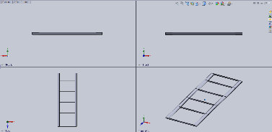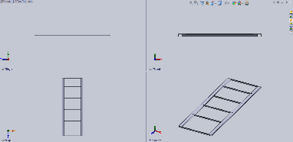
Figure 1 C-section Figure2 I-section

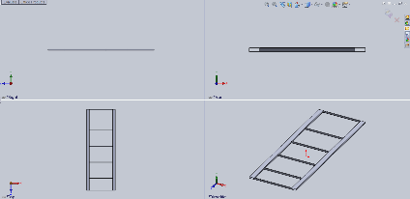
Figure 3 BOX-section

7.FINITE ELEMENT OF CHASSIS
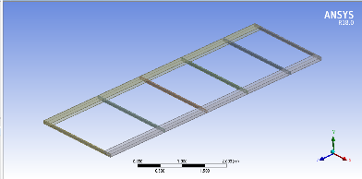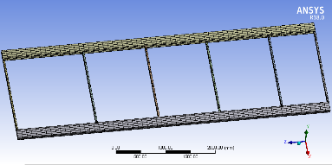
Figure 4 Model import to Figure 5 Meshing of
ANSYS Workbench Chassis frame

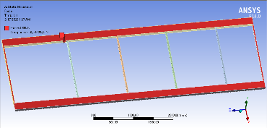
Figure 6 Load Applied to
Ladder frame

8.STRUCTURAL ANALYSIS OF LADDER FRAME

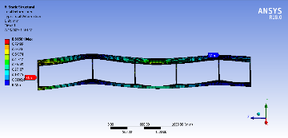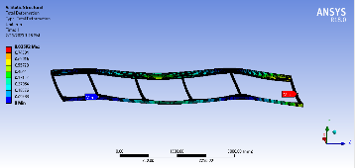

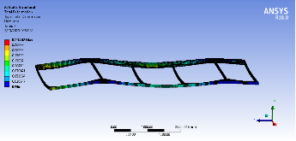
Figure 7 Total Deformation in C section in Steel Alloy 302, Steel Alloy 4130 and AA 7068

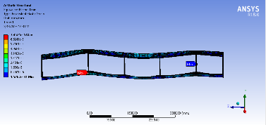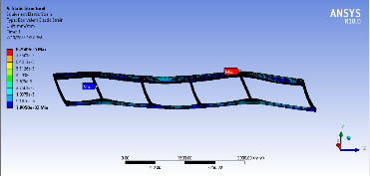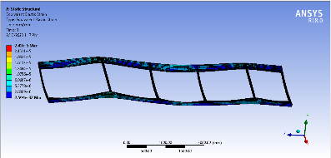
Figure 8 Equivalent strain in C section in Steel Alloy 302, Steel Alloy 4130 and AA 7068

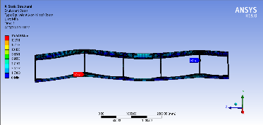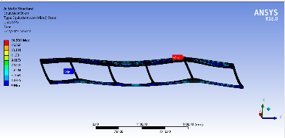
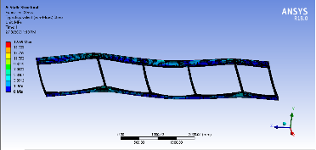
Figure 9 Equivalent stress in C section in Steel Alloy 302, Steel Alloy 4130 and AA 7068

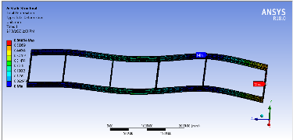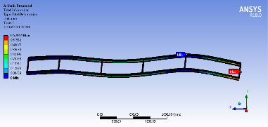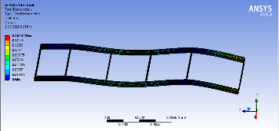
Figure 10 Total Deformation in I section in Steel Alloy 302, Steel Alloy 4130 and AA 7068

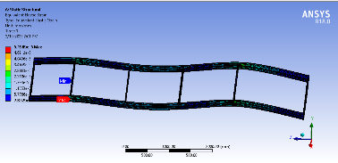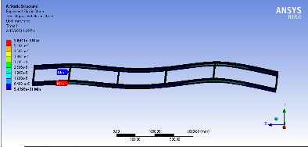
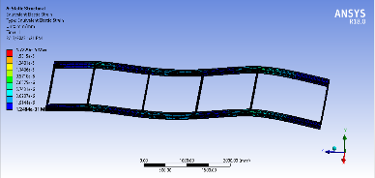
Figure 11 Equivalent strain in I section in Steel Alloy 302, Steel Alloy 4130 and AA 7068

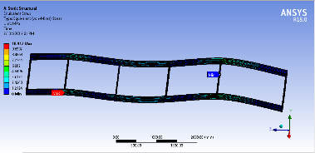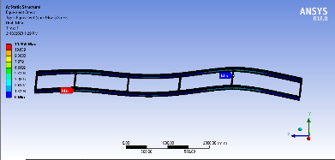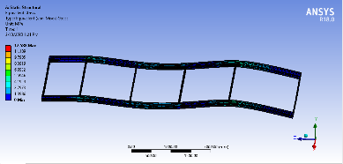
Figure 12 Equivalent stress in I section in Steel Alloy 302, Steel Alloy 4130 and AA 7068

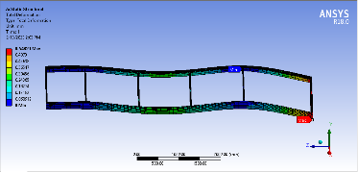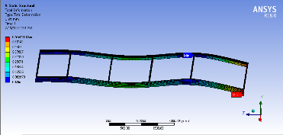
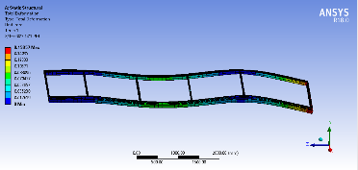
Figure 13 Total Deformation in Box(hollow) section in Steel Alloy 302, Steel Alloy 4130 and AA 7068

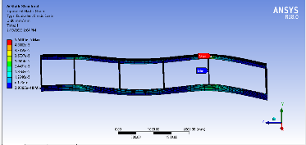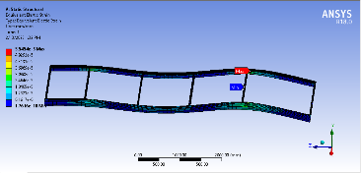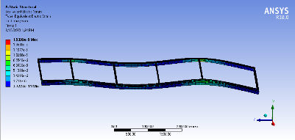
Figure 14 Equivalent strain in Box(hollow) section in Steel Alloy 302, Steel Alloy 4130 and AA 7068

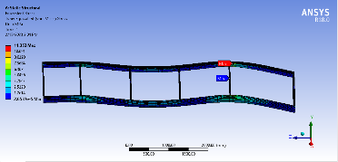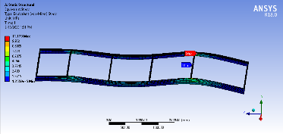
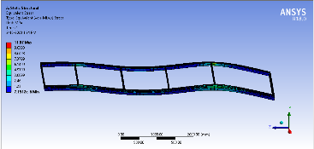
Figure 15 Equivalent stress in Box(hollow) section in Steel Alloy 302, Steel Alloy 4130 and AA 7068

9. RESULTS
_{Material} | _{Total deformation (mm)} | _{Equivalent Strain (MPa)} | _{Equivalent Stress (MPa)}
_{Steel alloy 302} | 0.81561 | 74.521 | 15.649
_{Steel alloy 4130} | 0.83592 | 82.689 | 16.951
_{AA 7068} | 0.23442 | 24.2 | 17.69
TABLE 3 Result of C section ladder frame

TABLE 4 Result of I section ladder frame
_{Material} | _{Total deformation (mm)} | _{Equivalent Strain (MPa)} | _{Equivalent Stress (MPa)}
_{Steel alloy 302} | 0.56654 | 51.989 | 10.912
_{Steel alloy 4130} | 0.5795 | 58.411 | 11.968
_{AA 7068} | 0.16232 | 17.229 | 12.588

TABLE 5 Result of Box section ladder frame
_{Material} | _{Total deformation (mm)} | _{Equivalent Strain (MPa)} | _{Equivalent Stress (MPa)}
_{Steel alloy 302} | 0.54821 | 55.105 | 11.353
_{Steel alloy 4130} | 0.56411 | 55545 | 11.173
_{AA 7068} | 0.15857 | 15.399 | 11.07

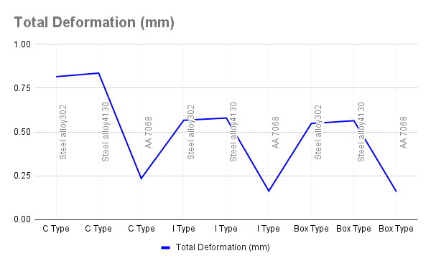
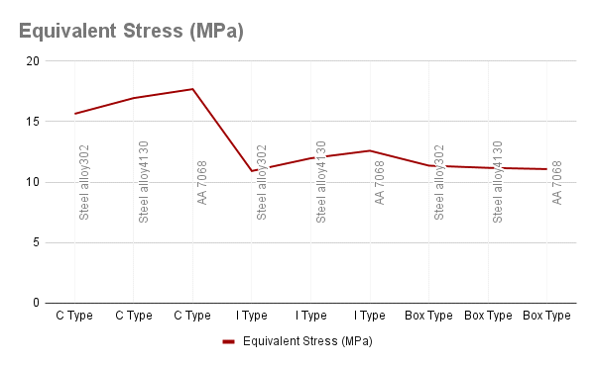
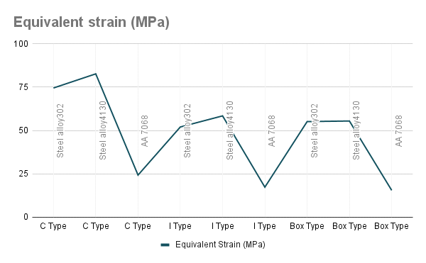

10. CONCLUSIONS

1.The results show that Steel alloy4130 has the highest equivalent stress and strain values for all three cross-section types, indicating its superior strength and toughness compared to Steel alloy302 and AA 7068. This suggests that Steel alloy4130 may be the most suitable material for heavy-duty truck chassis designs where durability and longevity are critical design factors.
2.The I type cross-section ladder frame has the highest equivalent stress and strain values for all three materials tested, indicating that this cross-section type provides the best structural performance and strength for the truck chassis design. This may be due to the I type cross-section's ability to distribute loads evenly across its top and bottom flanges, which helps to minimize stress concentrations and improve overall strength.
3.The box (hollow) type cross-section ladder frame shows good equivalent stress and strain values for all three materials tested, and may be a viable alternative to the I type cross-section for truck chassis designs where weight reduction is a critical factor. The hollow section reduces weight while maintaining good strength and stiffness, which can improve overall fuel efficiency and payload capacity.
4.The C type cross-section ladder frame shows the lowest equivalent stress and strain values for all three materials tested, suggesting that it may not be the best choice for heavy-duty truck chassis designs where strength and durability are critical factors. However, it may be suitable for lighter-duty truck designs where weight reduction is a critical design factor.
5.It is important to note that the results obtained from the static analysis performed using SolidWorks 2013 and Ansys software R18.0 are based on assumptions and simplifications made during the analysis. Therefore, further testing and validation may be required to confirm the suitability of the chosen material and cross-section type for a specific truck chassis design.
6.Overall, the results suggest that the choice of material and cross-section type can have a significant impact on the strength, durability, and weight of the truck chassis design. Therefore, careful consideration should be given to these factors during the design process to ensure the optimal combination of performance and efficiency.
REFERENCES
- Rai K, Mahadeokar S, Mehre A, Patel A. DESIGN & COMPARATIVE ANALYSIS OF TRUCK CHASSIS.
- Mishra S, Mittal S, Singh SP, Choudhary S, Kumar A. Weight Optimization of Chassis of an Automotive Vehicle using ANSYS.
- Raj VY, Yob MS, Ab Latif MJ, Kurdi O, Kassim MS, Izhar MM. Design And Analysis Of Four-point Bending Test Rig For Ladder Frame. Journal of Applied Science and Engineering. 2022 Jun;26(3):323-9.
- Tin CT, Tun HM. Buckling analysis on various material profiles for truck chassis of ladder frame type. Journal of Engineering Researcher and Lecturer. 2022 Nov 1;1(1):25-9.
- Nandan RG, Shashank SK, Irwin D. A Journal on “Design and Optimization of Vehicle Chassis for Harsh Road Conditions”.
- Nandhakumar S, Seenivasan S, Saalih AM, Saifudheen M. Weight optimization and structural analysis of an electric bus chassis frame. Materials Today: Proceedings. 2021 Jan 1;37:1824-7.
- Gurjar M, Deshmukh S, Goswami S, Mathankar V, Shrivastava S. Design and Durability Analysis of Ladder Chassis Frame. Available at SSRN 3372318. 2019 Mar 30.
- Agrawal MT, Patel A. A Review on Design and Analysis of Ladder Chassis.
- Kumar, A.H. and Deepanjali, V., 2016. Design & analysis of automobile chassis. International journal of engineering science and innovative technology (ijesit), 5(1), pp.187-196.
- Agarwal A. Design optimization of heavy motor vehicle chassis (Doctoral dissertation).
- Contractor AR, Rathod GP, Patel TM. Design and analysis of ladder frame chassis considering support at contact region of leaf spring and chassis frame. IOSR Journal of Mechanical and Civil Engineering (IOSR-JMCE). 2015 Mar;12(2):63-71.
- Patil KY, Deore ER. Stress analysis of ladder chassis with various cross sections. IOSR Journal of Mechanical and Civil Engineering (IOSR-JMCE). 2015 Jul;12(4):111-6.
- Francis V, Rai RK, Singh AK, Singh PK, Yadav H. Structural analysis of ladder chassis frame for jeep using Ansys. International Journal of Modern engineering research. 2014 Apr;4(4).

