Design of Brake Disc for ATV Vehicle
Sunil Chaugule, Krushna Lohar, Pranav Suryawanshi, Chetan Patil, Shreyas Patil
Vishwakarma Institute of Technology, Pune-411037

Abstract -- Vehicle's braking system is its most crucial safety component. Braking system's primary function is to precisely slow down a car in a variety of conditions. In this condition kinetic energy acquired by vehicle converted into heat energy by the friction between brake disc and calliper. The brake disc of a car is perhaps the part that is used the most after the tyre. The disc must withstand high levels of friction, heat, and clamping force from the brake calliper. This paper consists of design calculation of braking rotor and done the CAD design on SOLIDWORKS 2021 using calculation of braking force, braking torque. FEA Analysis done on the disc with the help of ANSYS 2021.
Keywords: Braking system, Thermal Analysis, FEA, ANSYS-21, SOLIDWORKS-21.

- INTRODUCTION
Every vehicle's control and safety are centred on its braking system. Our main task was to come with braking mechanism that is quite simple, optimized and reliable. Brakes are crucial for manoeuvring a vehicle in accordance with the driver's intentions, in addition to acting as a device for slowing down the vehicle. This is accomplished via several force-transmitting components that translate, magnify, and apply the force offset from the center line of the wheels, creating a torsional moment that is directed in the opposite direction from the direction of motion. [1]. Braking system classified into mechanical, hydraulic and pneumatic based on source of force applied and drum type and disc-type based on geometry.
Hydraulic brakes respond quickly, have more force production capacity, smaller in size, less weight, independent of the power source and provide better feedback [2]. The operating principle of braking system is the conversion of a vehicle's kinetic energy into thermal energy because of frictional resistance.
Drum brake is particularly use for rear wheels of big vehicles and passenger cars. However, compared to disc brakes, drum brake components are more complicated and offer little room for high performance adjustment.
High performance brake assembly is necessary for all racing vehicles, including formula cars and off-road buggies like all-terrain vehicle (ATV). [3] Since these vehicles must operate in harsh environments, included components be strong and resilient.
Custom disc is added to the system to reduce weight and produce the desired output. The goal of brake rotor design is to create a disc that can survive strong clamping force, heavy wear, and extremely high temperatures.
Disc-type rotors are incredibly effective in dissipating heat. The heat produced by the friction increases the temperature of the disc and the calliper pads. Because it causes the disc material to creep, the temperature increase is not ideal. Heating of brake oil is a further detrimental temperature effect that must be avoided. The area of contact between a disc and the environment is larger. Additionally, it has holes or vanes to create more turbulence in the medium around it. [4] This rise in heat transfer coefficient, which is brought on by the increase in turbulence, aids in cooling the disc more quickly. This gives disc-type rotors an edge over drum-type systems in terms of thermal dissipation. This paper consists of all the design calculation required for design of brake disc.
- SELECTION OF MATERIAL FOR BRAKE DISC
Brake Rotor experiences heavy wear due to strong clamping forces and heat produced by friction. Rotor’s material needs to be highly durable and thermally stable and strong resistance to wear.
Creep is a phenomenon that explains how greater temperatures affect disc material. When choosing a material, the thermal stability becomes a crucial factor because it will lessen the strange behaviour of metal at higher temperatures. [5] Additionally, the material must swiftly release heat. Other brake components won't become too hot because of this. Temperature has a critical role in braking performance; for high-performance race cars, a too-low temperature is also undesirable. The brake discs utilised in these cars are made of high strength aluminium alloys and carbon-carbon composite. [6]
Wear and corrosion resistance of chosen material can be improved by heat treatment. A material with great wear resistance will prevent pitting corrosion and scratching of disc under intense pressure from pads. Since brake pads are formed of granular material, which wears out in the form of microscopic particles. In this regard, the ease of removal of such particles gives disc breaks an additional advantage over drum brakes. Below Table.1 describes the properties of 3 materials that we have used for material selection.
Table 1 Properties of materials
Material | Elastic Modulus  (MPa) | Poisson’s Ratio | Tensile Strength  (MPa) | Yield Strength  (N/m²)
AISI 321 | 192990 | 0.27 | 619 | 2.344217
AISI 420 | 200000 | 0.275 | 1630 | 350
AISI 410 | 200000 | 0.275 | 450 | 290
AISI 410 is readily available on the market, highly resistant to wear and corrosion, and ready for heat treatment. Being magnetic is an additional benefit of grade 410. The magnetic disc may be quickly and easily clamped on the magnetic chuck. Surface finishing is made simpler by using 410 grade since grinding equipment is frequently equipped with an electromagnetic chuck [6]. Owing to above reasoning AISI 410 was selected as a material brake disc.
- DESIGN CONSIDERATION
The amount of mounting space is a major design factor for brake discs. The space restriction for braking discs is determined by the type of wheel chosen. Below Fig.1 describes the flowchart of step-by-step procedure for design consideration.
Calculation of amount of mounting space in rim

Calliper Size and available Clearance

Maximum amount of braking torque supplied to disc

Calculation of thickness which depends upon material

Fig.1 Flowchart of design consideration procedure
It is crucial for a BAJA vehicle's wheel to endure rough terrain and dangers. The 10" diameter DWT rims were chosen as wheels due to their light weight and excellent construction. After considering the calliper size and available clearance space, the highest permitted disc size for the current BAJA vehicle was 7" in diameter.
.
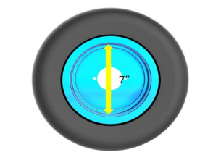
Fig.2 Space available in rim
A set fixed distance between calliper pads regulates the thickness of the braking disc. Therefore, the thickness depends on the material's thermal diffusivity, heat transfer coefficient, and thermal stability. The FEA also offers a straightforward but efficient way for optimising disc thickness.

- DESIGN CALCULATION OF BRAKE DISC
Calculating stopping distance and disc dimensions requires the following information:
Table No.2 Prerequisite data for calculation
Sr. No. | Parameter |  | Value
1 | Mass of Vehicle | (m) | 220 Kg
2 | Weight of vehicle | (w) | 2156 N
3 | Wheelbase (b) |  | 1.35m
4 | C.G. (h) |  | 0.556m
5 | Weight distribution Ratio |  | 40: 60
6 | Diameter of Tyre (m) |  | 0.2921
7 | Static Weight | Front | 88 Kg
 | Distribution | Rear | 132 Kg

- Dynamic weight transfer
When a car travelling at a given speed comes to an abrupt stop, the front suspension jounces while the rear springs re-bound. This is because a portion of the weight from the rear axle is transmitted to the front axle, adding up to the gross front axle weight. Dynamic weight transfer is the term for this. The dynamic weight transfer value is given by the following expression:
$$W_{t}=\frac{h*w*μ}{b}$$
$$W_{t}=532.771N$$
Here,
$W_{t}$ – Dynamic weight transfer
h- Height of CG from ground
m- Mass of vehicle in kg
b- Wheelbase
$μ$ = coefficient of friction between tyre and road, 0.6
The dynamic weight transfer of current vehicle is 36.211 kg.
Table 3 lists the weight distribution in front and rear after dynamic weight transfer.

Table.3 Dynamic weight transfer
Particulars | Static weight, Nm | Dynamic weight, Nm
Front ($R_{f}$) | 862.400 | 1395.172
Rear ($R_{r}$) | 1293.600 | 760.828

- Deacceleration of vehicle
Deacceleration of vehicle can be calculated by the formula:
$$\left(\frac{w}{g}\right)a= μ(R_{f}+R_{r})$$
$$a= μg$$
Here, a = deacceleration of vehicle
Require braking force and torque
$$F_{b}=m*a$$
$$F_{b}=1293.6 N$$
Require braking force on front wheel, $F_{bf}$
$$F_{bf}= R_{f}*μ$$
$$F_{bf}=837.103 N$$
Require braking force on front wheel, $F_{br}$
$$F_{br}= R_{r}*μ$$
$$F_{br}=456.4968 N$$
Require Torque on front and rear wheel
R = Wheel radii = 0.2921 m
$$τ_{f}=F_{bf}*R=244.517 Nm$$
On each wheel, $τ_{f}=\frac{244.517}{2}=122.258 Nm$… (1)
$τ_{r}=F_{br}*R=133.34 Nm$…. (2)

- Clamping force
The force that a brake calliper applies to a disc is known as the clamping force. This clamping force, which is normal of the disc surface, leads to the development of the frictional force. The following expression provides the force.
$$F_{c}= μ_{1}*F_{d}*M.L*H.L*2$$
Here,
$F_{c}$- Total clamping force
$F_{d}$- Force applied by driver, 300N
M.L- Mechanical leverage, 5
H.L.- Hydraulic leverage
$μ_{1}$ = coefficient of friction between brake pad & brake disc, 0.4
For finding hydraulic leverage,
H.L. = $\frac{A_{1}}{A_{2}}$
$A_{1}$= surface area of brake calliper
$A_{2}$ = Area of Tandon Master Cylinder (TMC)
$$A_{1}=\frac{π}{4}* D_{1}^{2}$$
$$A_{1}=6.605*{10}^{-4} m^{2}$$
Here, $D_{1}$ = Bore diameter of Calliper, 29mm
$$A_{2}=\frac{π}{4}* D_{2}^{2}$$
$$A_{1}=285.9*{10}^{-6} m^{2}$$
Here, $D_{1}$ = Bore diameter of TMC, 19.05mm
Now,
$$H.L. = \frac{A_{1}}{A_{2}}$$
$$H.L. =2.310$$
Now, the Clamping force,
$$F_{c}= F_{d}*M.L*H.L*2$$
$$F_{c}=2772 N$$
- Rotor effective radius
Rotor outer radius = 170 mm
Rotor inner radius = 60 mm
Re = $\frac{rotor outer radius}{2}-\frac{rotor inner radius}{2}$
Re = 61.8 mm = 0.0618 mm

- DISC BRAKE CAD MODEL
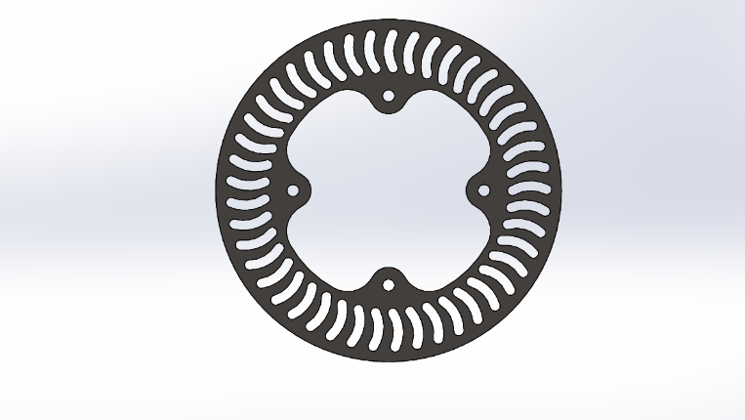
Fig.4 CAD model of Brake Disc
- Brake torque requirement
Dynamic weight transfer and wheel size affect the necessary braking torque. It is used to determine the braking disc's diameter. The formula below calculates the necessary braking torque:
$$T_{b}=F_{c}*R_{e}$$
Here,
$T_{b}$- Braking torque
$R_{e}$- Effective radii
Hence, the applied braking torque for front and rear wheel is same and equal to 171.31 Nm.
- CALCULATION OF STOPPING DISTANCE
- Stopping distance
The stopping distance is calculated from the moment the driver applies the brakes until the moment the vehicle comes to a complete stop [5].
$$S_{total}=V_{tr}\left(t_{r}+t_{a}+\frac{t_{b}}{2}\right)+\frac{V_{1}^{2}}{2*a_{max}}-\frac{a_{max}*t_{b}^{2}}{24}$$
Also, $\frac{V_{tr}}{a}=t_{s}$
Here,
$V_{tr}$- Initial vehicle velocity
$t_{r}$- Driver reaction time
$t_{a}$- brake system application time
$t_{s}$- braking time
a: deceleration
$S_{total}$ = stopping distance
Now,
$V_{tr}$= 40 km/hr
$t_{r}$= 1 Sec.
$t_{r}$= 0.25 Sec.
$t_{r}$= 0.3 Sec.
a=µ*g = 0.7*9.81
Therefore,
$$S_{total}=11.11\left(1+0.25+\frac{0.3}{2}\right)+\frac{{11.11}^{2}}{2*6.867}-\frac{11.11*{0.3}^{2}}{24}$$
$$S_{total}=15.554+8.9873-0.02575$$
$$S_{total}=24.5155m$$

- Stopping time
It is the amount of time needed for a vehicle to fully stop after using the brakes [5].
Total time = $t_{r}+t_{a}+\frac{t_{b}}{2}+\frac{V_{r}}{2*a_{max}}$
Total time = 2.2089 second

- FEA ANALYSIS
With the increase in the torque supplied by transmission the diameter of the brake disc has increased considerably. We have done the thermal analysis on the brake disc to ensure that the brake pads are not worn out.
Initial vehicle speed: 50kmph = 13.85 m/s
Mass of vehicle: 260 kg
Total kinetic energy to be absorbed by rotors: $\frac{1}{2}×mv^{2}=\frac{1}{2}×240×{11.11}^{2}=14811.85 J$
Braking power = kinetic energy/braking time = 14811.58/1.4 = 10733 W
Total brake bias = 66:34
Heat flux = Brake Power / area in contact =
1850600 W/m²
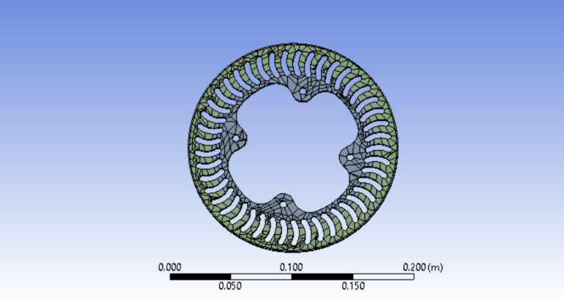
Fig.5 Meshing of Brake Disc
Fig.5 shows the meshing done on the brake disc consist of 8484 Nodes and 848 Elements in which resolution is taken as 2 in ANSYS 21 R2.
BOUNDARY CONDITIONS:
1. Convection Heat transfer Coefficient: 22484 W/m²°C
2. Ambient Temperature: 22 °C
3. Heat flux: 1850600 W/m²
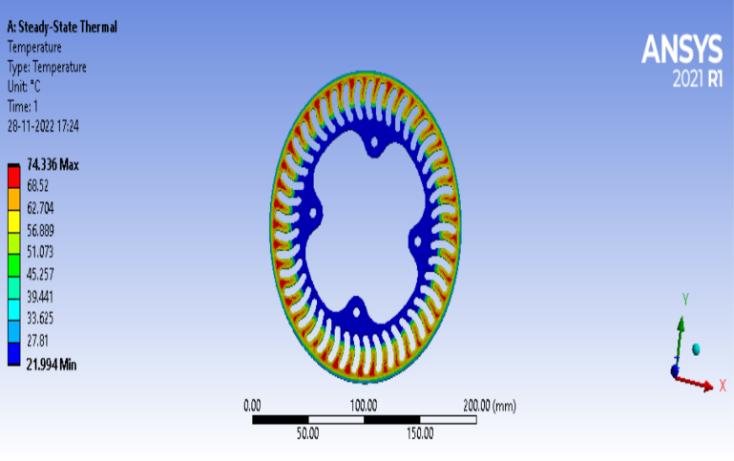
Fig.No.6 Thermal Analysis of Brake Disc
From Fig. 6 reveals that the maximum temperature reached during working is around 74⁰C. which is less than 150⁰C as specified by the manufacturer of brake calliper.
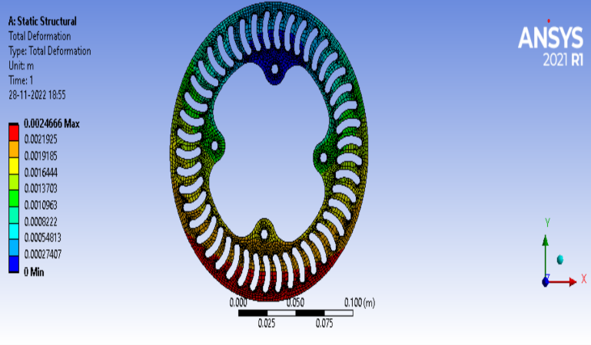
Fig.7 Total deformation of brake disc
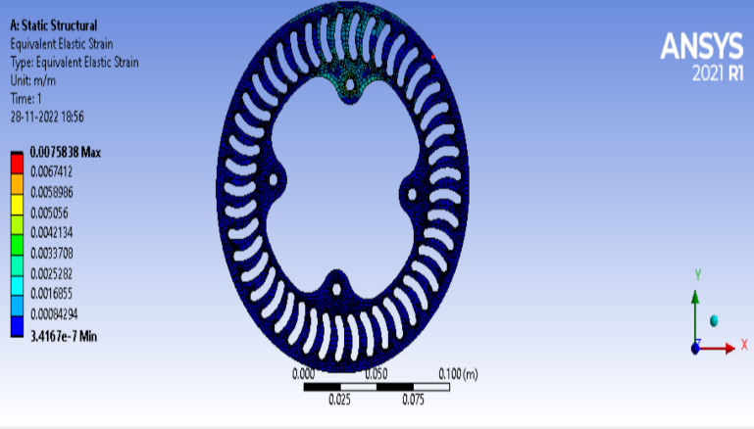
Fig.8 Strain Analysis of brake disc
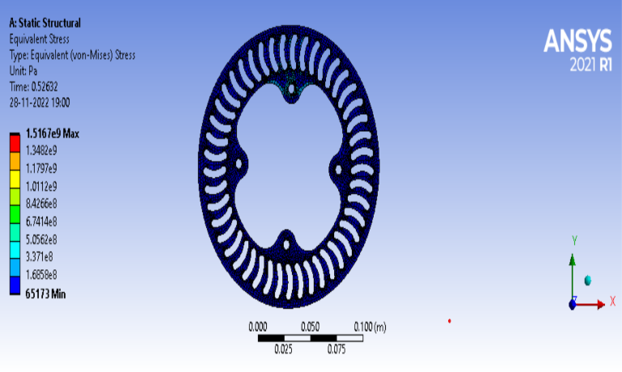
Fig.No.9 Equivalent Stress analysis of brake disc
Total deformation and equivalent stress are found to be 0.00246 m and 1.516-e9 Pa respectively which are within permissible limits from functional requirement and material considerations.
- RESULT
Below are the conclusions drawn from design and specs.
- Calculated stopping distance = 24.5155 m
- Calculated stopping time = 2.20 seconds.
Referring equation (1), (2) and table.4. It is found that required torque value are lower than applied torque and it is given in below table.5
Table.5 Required and applied torque values
 | Required torque | Applied torque
Front | 122.258 Nm | 171 Nm
Rear | 133.34 Nm | 171 Nm

The design of the brake disc is greatly influenced by the wheel, dynamic weight transfer, brake callipers, and master cylinder choices. The goal of creating a robust and long-lasting brake rotor was accomplished.

- CONCLUSION
Using all design calculation of brake disc and its analysis, the brake disc satisfies the design specifications after being installed in the vehicle. By using FEA analysis, we tested it by considering real conditions on it and got that brake disc can sustain and maintain its temperature. As a result, we may conclude that the basic goal of creating the brake rotor for the safe vehicle braking was met which serves as the foundation for design of other allied braking system components such as brake callipers and pads.

REFERENCES
- J Walker, “The Physics of Racing Braking System”, StopTech Braking System 2005.
- Milliken and Milliken, Race Car Vehicle Dynamics, 1995.
- C. Smith, “Tune to Win”, AERO publishers Inc, 1978
- Taxis Janson, Bachelors Thesis, Braking system design of 2013 Bearcats BAJA Team
- Rudolf Limpert, Brake design and Safety, Society of Automotive Engineers, 2011
- V.D. Kodgire, ‘Material Science and Metallurgy’. 1978
- Fei Gao1, Gang Xiao, Yuanming Zhang,(2009), Semisimilarity design of motorcycle-hydraulic-disk brake: strategy and Application”, pp-576-579
- Grieve D. G., Barton D. C., Crolla D. A.,Buckingham J. T. (1998), Design of a lightweight automotive brake disc using finite element and Taguchi techniques, Proc. Instn. Mech. Engrs., Vol. 212, No 4, 245-254.
- Swapnil R. Abhang, D. P. Bhaskar “Design and Analysis of Disc Brake” , International Journal of Engineering Trends and Technology Feb 2014.
- K Sowjanya, S Suresh “Structural Analysis of Disc Brake Rotor” , International Journal of Computer Trends and Technology (IJCTT) – volume 4 Issue 7– July 2013.
- Hozaan Najmi et al 2021 IOP Conf. Ser.: Mater. Sci. Eng. 1116 012146

