AUTONOMUS FIRE FIGHTING ROBOT

L. SURYA PRAKASH REDDY
Department of Computer Science and Engineering,
Kalasalingam Academy of Research and Education,
Virudhnagar, Tamil nadu ,India
9920004433@klu.ac.in

P. SIVA KUMAR
Department of Computer Science and Engineering,
Kalasalingam Academy of Research and Education,
Virudhnagar, Tamil nadu, India
9920004388@klu.ac.in

P. SASI KUMAR
Department of Computer Science and Engineering,
Kalasalingam Academy of Research and Education,
Virudhnagar, Tamilnadu,
9920004437@klu.ac.in

K. CHAKRADHAR
Department of Computer Science and Engineering,
Kalasalingam Academy of Research and Education,
Virudhnagar, Tamil nadu ,India
9920004446@klu.ac.in

Dr.K.Maharajan
Department of Computer Science and Engineering,
Kalasalingam Academy of Research and Education,
Virudhnaga Tamil nadu, India .
k.maharajan@klu.ac.in

ABSTRACT

Robots now take the place of people in situations where their lives are in danger thanks to technology. We want to create a robot that can spot flames and put them out. Disasters can be avoided with little risk to human life by developing and deploying an autonomous robot that is capable of spotting and putting out fires. In this study, we present an autonomous robot that can locate indoor fires and move toward them so they can be put out using carbon dioxide.

I. INTRODUCTION

In order to reduce fire-related injuries and increase robot efficacy, people are most frequently searching for fire fighting robots. Smoke and fire (thermal) reflections can provide hints as to the direction of the fire's spread to the robot. The project's goal is to

develop a robotic fire-extinguishing vehicle that can be controlled remotely and manually. The project's main goal is to create and implement a firefighting robot that can either be operated automatically or manually. We can detect fire, smoke, or any other obstructions in its way with the robot's sensor-equipped equipment. Compared to water, the suggested vehicle's gas spray can put out fires more quickly.
II. LITERATURE SURVEY
A. Paper [1] - "Firefighting Robot Implementation Methods"
Author - Mrs. Bhavna K. Pancholi, Miss. Kena Patel
The robot shown here is an embedded, real-time gadget. The software utilised to implement this kind of robot is written in C. The robot monitors the surroundings in automatic mode to find fire accidents. Infrared (IR) sensors are used by this robot, and the output of the electrical sensors is supplied to an amplifier transistor. Later, this signal is routed into the microphone controller's INpin. The microprocessor runs the motors and activates the actuators when a fire is detected. On the frame is a water reservoir with a 10 rpm DC pump motor. The hose's end is placed on the robot's head, and it is connected to the water reservoir.
B. Paper [3] - “Design and implementation of remote controllers for rescue robots used at fire sites.”
Author – Ho Kang, Young-Duk Kim, Duk-Han San, Young Sun Ryuh
This concept uses 2 different sorts of remote controls: one is an ultramobile personal computer, and the other is a joystick personal platform. Even though these 2 systems differ, they have the same architecture. At the fire station, the rescue robot and its complete remote control system are installed. Using a fire station as a base of operations allows the controller and robot to communicate. The utilisation of distinct wireless channels is necessary for speedy data transmission. In addition, there is less signal interference on these distinct wireless channels. This robot is primarily equipped with a camera for visual display, an LED to direct the evacuation path, and many other sensors to monitor the concentration of dangerous chemicals in the atmosphere. The data have been gathered and will be forwarded.
C. Paper [3] – “Automatic fire extinguisher robot”
Author – B. Swetha Sampath
According to the strength of the fire, the robot is programmed to move in that direction. The AT mega micro controller is used. Robots are covered in sheets of calcium silicate to withstand extreme temperatures. The DC voltage is boosted and then transformed into AC using a DC to AC converter.
The fire extinguisher's water pump is powered by the resulting AC voltage. The Obstacle Avoider and Motion Sensor were utilised to identify people and move in the direction of the fire's intensity using a high dynamic range camera. The robot sounds the alarm to alert the rescuer when it senses a human signal.
D. Paper[4] – “Fire Extinguishing Robot Using IoT”
Author - Prof. Sankalp Mehta , Sujata Tupale , Shilpa Kappalguddi, Sangharsha Madvanna , Rakshanda Patil .
the fire-fighting robot that uses IoT to detect flames. The proposed system's main function is to use an Android application to control the robot. In the designated area, the robot will patrol. The Node MCU and the firefighting robot are wirelessly linked. If a node detects a fire, it will send a message to the Central Node MCU, which will tell fire safety personnel, activate robots to carry out firefighting tasks, and activate the pump to put out the fire.
III. STATEMENT OF PROBLEM
The issue with the current approach is that injuries and fatalities from fires are primarily caused by exposure to the tumultuous and dangerous environment surrounding a fire, rather than by the fire itself. In order to effectively guide rescue efforts and develop workable counterplans, it is imperative to have access to accurate real-time information on the conditions directly at the fire site. Unfortunately, access to and sight in the areas used for combating fires are sometimes hampered by obstructions, dilapidated buildings, and smoke, hazardous gases, or dust. Therefore, the fire scene is an information-poor environment due to a lack of information on the location of the fire, the firefighters, and the victims, and the search and rescue opportunities are now unthinkable due to a lack of situational conditions and real-time information for targeted decision making. The accidents happen due to this.

HYPOTHESIS:

The legal framework for fire fighting robot is a good step in the right direction for the development of the Indian fire fighting setup since it is well-suited and ready for it.

STUDY OBJECTIVE:

The suggested model can manoeuvre the robot to the site of a fire accident and use an ultrasonic sensor to measure object distance and determine the presence of a fire. To regulate the robot's mobility, it has motor drivers and gear motors. When a fire is detected, the robot moves toward the burning area after communicating with its microcontroller (an Arduino MEGA). The fire extinguisher is attached on the robotic vehicle, which is then operated via wireless communication to put out the fire automatically.

IV.METHODOLOGY

As soon as possible, we must check that each component is linked, and we must provide power via an external device. When an object is present, the robot uses a flame sensor to begin turning 360 degrees while still being motionless at first. In the event that the object is outside of the range, it moves on and checks once more to see if it is there. In order to move to the object precisely, the signal is sensed by one of the five channel flame sensors, and the robot advances if it signals to the centre sensor. Once the flame has been detected, the device moves a certain distance before checking the distance again and moving closer to the flame-related object. Following its arrival, it starts a water pump or fire extinguisher to spray water on the burning object.

A. DESIGN

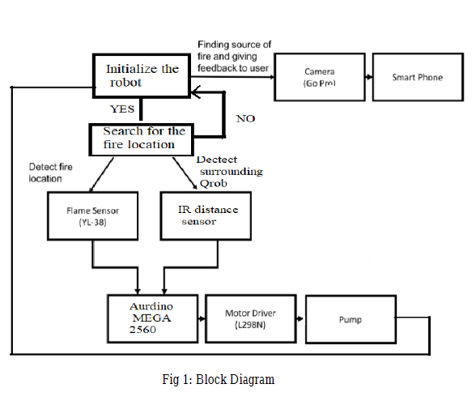
B.HARDWARE IMPLEMENTATION

The Arduino Mega2560, which controls all other components, is a key component of this robot. It is made up of various different types of sensors. As seen in Fig. 1, an Arduino board is utilised as a microcontroller in conjunction with other parts. The DC motor is moved by means of a motor driver. Additionally, it has an IR distance sensor and a flame sensor as part of the system input. To put out fires, a fire extinguisher is installed on the robot.

C. WORKING FLOWCHART

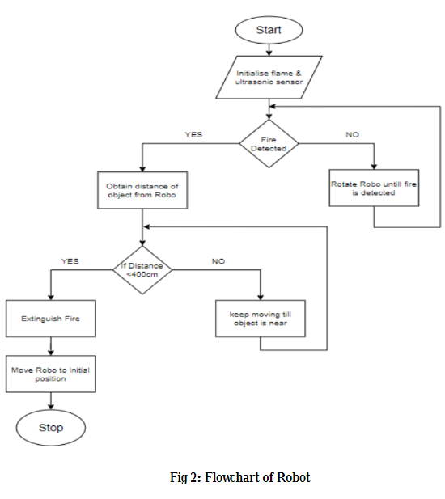

V. RESULTS AND DISCUSSION

VI. CONCLUSION

This project outlines a real-time firefighting robot that runs at a constant speed, locates fires, and then puts them out using a pumping mechanism. Along with having a small body and a light structure, it includes beneficial features like the capacity to automatically detect the position of fire. Due to its compact form, the robot can be employed in places with narrow entrances or in tight quarters. The technique may be effective for preventing an epidemic and fortifying fire fighters. Longer distance remote control operation allows the operator to put out fires. The camera can be used by operators to keep an eye on the surrounding conditions while fighting a fire. According to the outcomes of the trial, the robot can detect smokes and

Fire Fighting Robot”, 2007 IEEE.

