Farming Resource Management System
Assistant Prof. Ganesh Patidar¹ and
Mahendiali Vijapura² , Shubham Shukla³ , Jaineel Shah⁴ , Adarsh Rathod⁵

Department of information technology1 ,Parul institute of engineering & technology2 , Vadodara 3 ,Gujarat, India – 391760
----------------------------------------------***--------------------------------------------------
Abstract
Most of the day-to-day activities are done using mobile apps, even for farmers. From better assessment of land management to quality yield, mobile applications have provided many benefits to farmers. Farmers use different types of apps to check crop health throughout the crop cycle. Some of the mobile apps are developed to help the farmers in many ways like gardening, crop management etc. Some of the mobile framework apps also inform the farmers about weather forecasts, agricultural field opportunities, expert suggestions, question answers etc. Some apps also offer details related to soil quality, fertiliser usage etc. Here we are adding all these features and some new features like equipment and other farming resources and personal guides etc.

Keywords: Android, Farmer produce, weather forecasting, transportation, equipment, Resources.

Introduction
To provide a platform for farmers to easily sell produce from farms at better prices, pool or share transportation to take produce to markets, and help farmers take precautionary measures based on the weather forecast. Many farmers are not able to rent a tractor in normal quantities or they do not find a tractor easily. In another case, farmers sometimes do not know about the price of a tractor; so it is very easy for the tractor provider to deceive the farmers and cheat them by taking extra money from them.In India, there are so many farmers who can't afford farming instruments for those farms. Some Farmers Have Ability to Farm but Don't Have Large Land. Some Farmers Don't Have Any Knowledge How to Use It to Increase productivity.To create a mobile application where farmers can rent tractors and other machinery related to agriculture using their mobile phones at regular rates. Create an interface between farmers who want to hire and those who want to rent equipment. Save time and money for farmers. The Tools Rental app can easily overcome such problems for the farmers where they easily find the tractor and other mechanisms for their use.This moulding tool rental system was very user friendly. This application contains complete and up-to-date device data. Users can access the application by entering their username and password. Users can access this application at any time. We primarily suggest this article for disadvantaged farmers. As a result, they cannot purchase all types of devices. As a result, we strive to provide low-cost rental services.

A Survey on Mobile Agricultural Apps

The Food and Agriculture Restoration Management Involving Networked Groups (EC FARMING) network was established in order to bring together the many stakeholders who would be concerned about responding to widespread radioactive contamination of the food chain and to develop practical strategies for preserving agricultural production and a reliable food supply. Since 2001, stakeholder panels have regularly met as part of the network in the UK, Finland, Belgium, France, and Greece to discuss, debate, and share viewpoints on the acceptability, limitations, and impacts of different countermeasure alternatives and approaches. This article's goals are to highlight the major FARMING project successes from 2000 to 2004, to call attention to the many issues encountered, and to discuss how challenging it is to include stakeholders in off-site emergency and long-term recovery [1].

The Internet of Things (IoT), a technology with enormous promise, provides reliable and efficient solutions for the modernisation of many different industries. With the least amount of human involvement possible, IoT-based solutions are being developed to automate and monitor agricultural activities. The essay discusses several different technological aspects of IoT in agriculture. There is a description of the main components of IoT-based smart agriculture. The presentation of network technologies used in IoT-based agriculture has addressed the network architecture and layers, network topologies, and protocols in detail. It was also shown how to combine IoT-based agricultural systems with relevant technologies like cloud computing, large data storage, and analytics. IoT farm security issues were also discussed. A list of developing smartphone and sensor-based farm management applications was also provided. Finally, a number of available success examples are provided along with the laws and policies enacted by various nations to standardise IoT-based agriculture. Finally, a few unsolved research issues and difficulties in IoT agriculture were presented [2].

An overview of recent works on the issue is used to assess agriculture in the information society. Information technology (IT) utilization in agriculture is expected to undergo substantial changes with the growth of the future network society. The economic justification that applying inexpensive externally manufactured inputs and streamlining farming practises were more effective ways to cut agricultural expenses than IT can be used to explain why farmers have only used it sparingly up to this point. Due to limitations on chemicals and particular manufacturing techniques, this condition is anticipated to change. Information technology will become more crucial as a result of the requirements for food documentation, the need for higher precision in the use of pesticides and the care of farm animals. Governments and the food sector will impose restrictions and limitations. Farming operations will need IT solutions that offer real-time decision support on broadband wireless internet connections. In the reimagined agricultural extension service of the future Network Agriculture, email and chat applications enhanced with photographs, videos, and sounds will become crucial components [3].

Demand for food, energy, and water (FEW) is anticipated to more than double as the world's population increases from 7.3 billion people now to an estimated 10 billion by 2050. Undoubtedly, the demand for FEW resources that will result from such population growth will provide a significant problem for civilization. A difficulty made more difficult by humanity's need to meet an increase in resource consumption while leaving a smaller ecological imprint. As a response to this significant problem, this paper suggests a system designed to maximise the use of water, energy, and fertiliser for agricultural crops. It is an automated smart irrigation system that plans irrigation based on real-time information from wireless sensor networks. The test site consists of a wireless network that keeps an eye on sensors placed in the root zones of crops and all around the test site that measure soil moisture, temperature, sunlight, humidity, and fertiliser levels. An access point (AP) utilising the ZigBee protocol manages the wireless transmission and acquisition of data from the sensor. The algorithm was created automatically and programmed into a programmable microcontroller to control irrigation time based on soil temperature and moisture criteria. An energy storage tank and a solar photovoltaic (PV) panel work together to totally meet the system's energy requirements. This prototype's experimental data will be refined and modelled in order to study the profile of food production as a function of energy and water consumption. It will also make an effort to comprehend how adverse weather affects food production. In an effort to develop a more sustainable strategy to meet the anticipated rise in demand, this holistic approach will investigate the relationships between water and energy resources and crop output for many basic crops [4].

The professional competency of their staff is a difficulty for agricultural organisations all around the world. To improve the skills and general performance of extension workers, extension organisations must prioritise planning, training, and human resource management. The training requirements for agricultural employees in the Indian state of Himachal Pradesh with relation to organic farming are examined in this research. 65 employees from the 10 districts of the Himachal Pradesh State Department of Agriculture (HSDPA) were chosen randomly from the pool of applicants. The information is based on self-reported ratings that were gathered using a standardised instrument that included ten different areas of organic farming. A list of developing smartphone and sensor-based farm management applications was also provided. domestic farming, biodynamic farming, biological pest control methods, biorational management techniques, biofertilizer technology, recordkeeping/certification standards, and sorting, packaging, and filing of ecological products for sale. Most extension workers stated that they did not need any training in crop rotation, green manuring, or vermicomposting. Age, education, or prior work experience did not significantly correlate with the training needs that were indicated. In order to increase the likelihood that organic farming will be accepted and successfully implemented among farmers in Himachal Pradesh, the training of HSDPA agricultural extension workers could concentrate on enhancing their knowledge in the seven skill areas of organic farming that have been identified [5].

Every aspect of a regular man's life has been altered by Internet of Things (IoT) technology, which has made everything smart and intelligent. IoT stands for the self-configuring network made up of a network of devices. With the advancement of IoT Intelligent Smart Farming technologies, agricultural production is changing day by day by becoming more efficient, cost-effective, and waste-free. The purpose of this study is to create a new Internet of Things (IoT)-based smart agricultural tool that will help farmers get real-time data (temperature, soil moisture) for effective environmental monitoring. This will allow them to engage in smart farming and increase their overall yield and output quality. The agricultural stick that is proposed in this study integrates Arduino technology, a breadboard that has a variety of sensors mixed in, and online real-time data access through Thingspeak.com. The proposed device has undergone testing on actual agricultural fields and has data charge accuracy of more than 98% [6].

The Indian economy is based on agriculture, which employs 70% of the country's entire population. Agriculture is the backbone of the Indian economy. Regarding the adoption of technology, agriculture is still a developing industry. Information on numerous government agriculture programmes is now available online via websites and mobile applications thanks to advances in technology and internet services. Farmers, however, are not aware of numerous agricultural information and programmes because of digital illiteracy in rural areas. Indian farmers will be able to access several government programmes through this mobile app. This service will be offered in local dialects, English, Marathi, and possibly additional languages as needed. Farmers will have access to the programmes via text, audio, and video. Farmers in India had little discretion over the marketplaces and consumers of their produce for a very long time. The majority of states in the nation require that agricultural produce be marketed and sold through state-owned mandis, retail locations where intermediaries put pressure on farmers to raise profits. In such a scenario, technologically advanced Indian farmers may sell their goods to consumers. So, yeah, it is the solution. We have developed a method to assist farmers in their native tongue and meet their needs [7].

This software programme is primarily for the sustainable growth of farmers and is made possible by the Internet of Things (IoT), a promising technology. When choosing the right fertilizer, insecticide, and timing for particular farming tasks, farmers are frequently perplexed. This application can help you prevent this issue. Each type of crop's fertilizer regimen will be recorded. Farmers will receive weather notifications if a particular crop exceeds its ideal temperature range, herbicide application alerts, disease pesticide schedules, and fertilizer application alerts based on the current harvest date. Based on soil type, geolocation will be used to provide crop suggestions, and farmers will receive real-time national crop rates to maximize their gains. For effective and seamless management, this system combines GPS with contemporary Internet and mobile communication systems. The introduction, theory, and analysis of DBMS, as well as the application of smartphones in agriculture, are presented in this review article. This booklet was created to provide a brief overview of some of the typical issues that farmers in the nation encounter. This initiative intends to introduce the 21st century to the 70% of people who revere the planet [8].

It is suggested to use an innovative method to offer fertilizer advice in precision agriculture. The approach is centred on approximating the profit function through the use of artificial neural networks-based decision support systems. The suggested method is explained, and its application to simulated real-world data is demonstrated. According to experimental findings, the suggested technique can be used for site-specific crop management [9].

Precision agriculture is a modern strategy that examines and optimizes the growth and development of crops using digital technologies. The use of this cutting-edge approach is the application of fertilizers at various levels, further mixing is easily achievable in the fields, and its optimization is easily done for various crops grown. Precision farming technology first arose in the middle of the 1980s. Currently, several nations throughout the world use this practice for a variety of crops. Sensors, GPS, software, and remote sensing are just a few of the technologies used in precision agriculture that have the potential to significantly boost crop yield. Field data gathering, yield evaluation, remote sensing, quality mapping, variable fertilizer delivery, and heat mapping are all applications of precision agriculture. The techniques and technology utilized by precision agriculture to boost crop output are covered in this chapter [10].

MethodoLogy

SDLC Model: Incremental Model

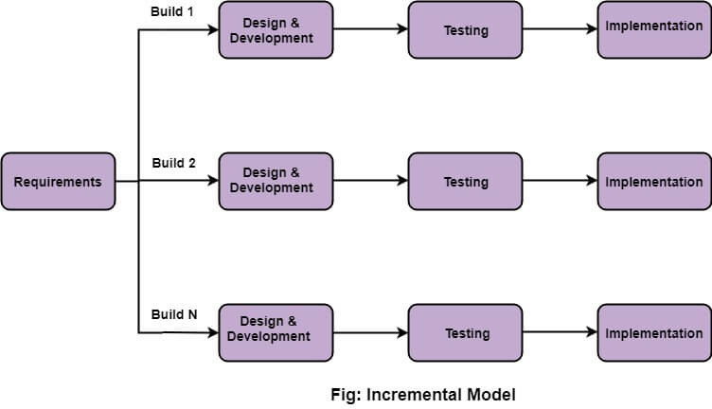
Incremental Model is a process of software development where requirements are divided into multiple standalone modules of the software development cycle. In this model, each module goes through the requirements, design, implementation and testing phases. Every subsequent release of the module adds function to the previous release. The process continues until the complete system is achieved.
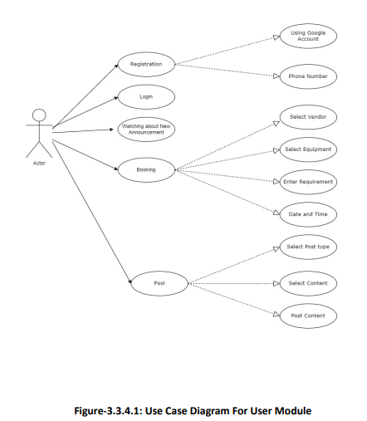
We employ a variety of actors, outside entities (or "roles"), and related use cases as indicated in the use case diagram to model system functionality. Use case diagrams are another tool used to demonstrate the actions, services, and functions that the systems will carry out. The graphic depicts the use case diagram for the Smart Farm project.

4.3 SNAPSHOTS
SIGNUP PAGE LOGIN PAGE

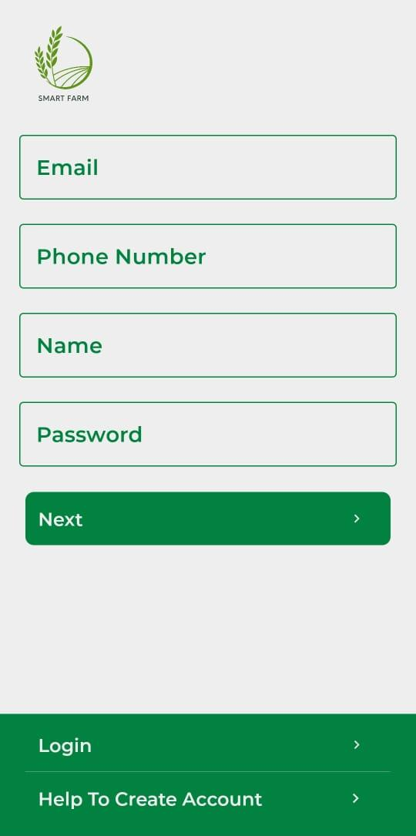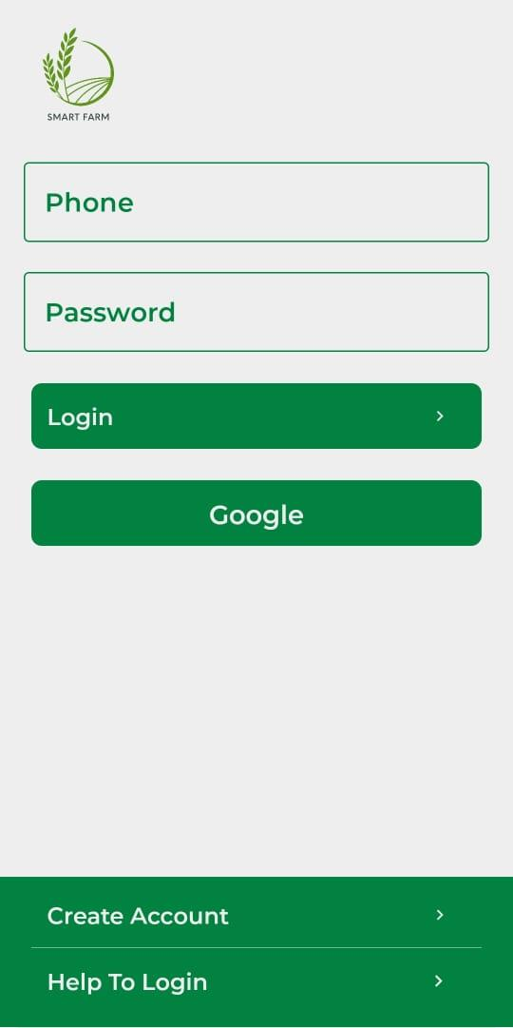
(Figure: Signup Page) (Figure: Login Page)

INSTRUMENT PAGE INSTRUMENT DETAILS PAGE
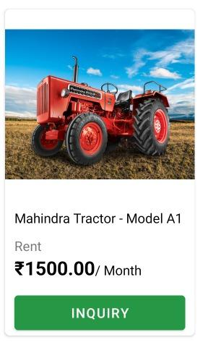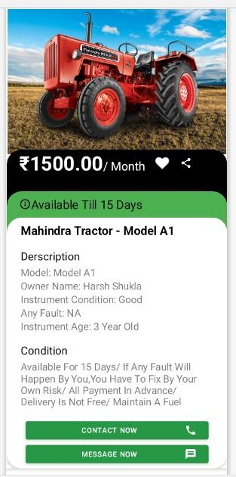
(Figure: Instrument Page) (Figure: Instrument Detail Page)
FERTILIZER PAGE FERTILIZER DETAILS PAGE
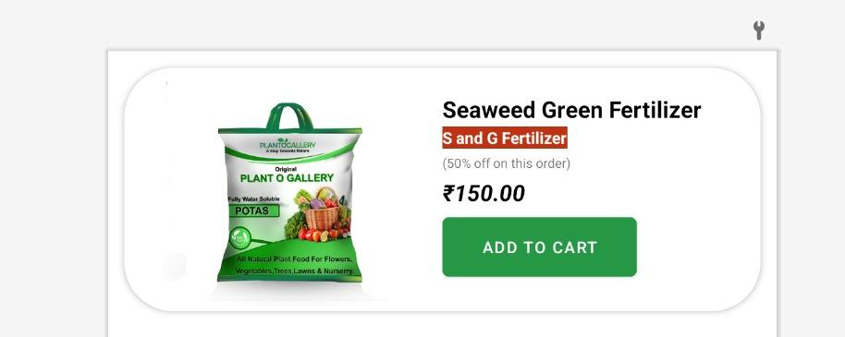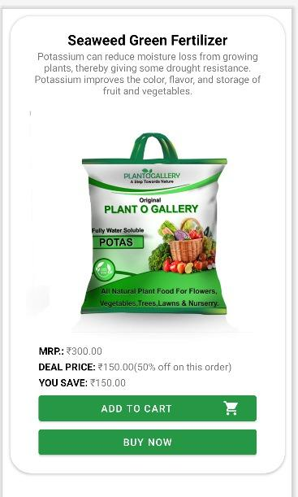
(Figure: Fertilizer Page) (Figure-4.3.6: Fertilizer Details Page)

POST UPLOAD PAGE HOME PAGE

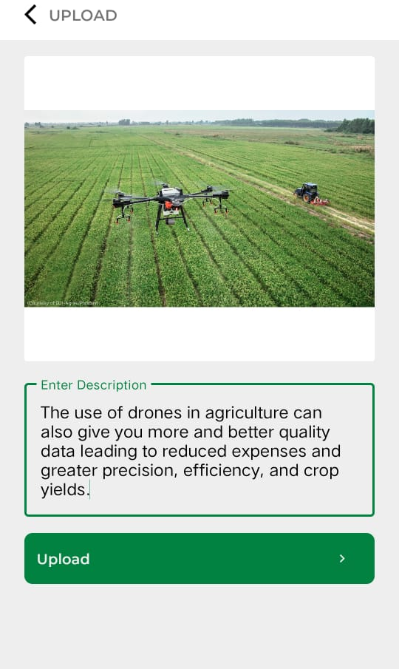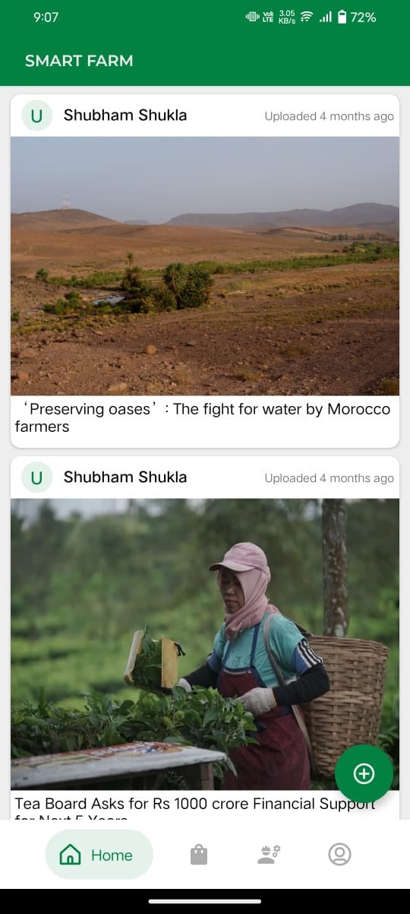

(Figure: Post Upload Page) (Figure: Home Page)

PROFILE PAGE POST BUTTON
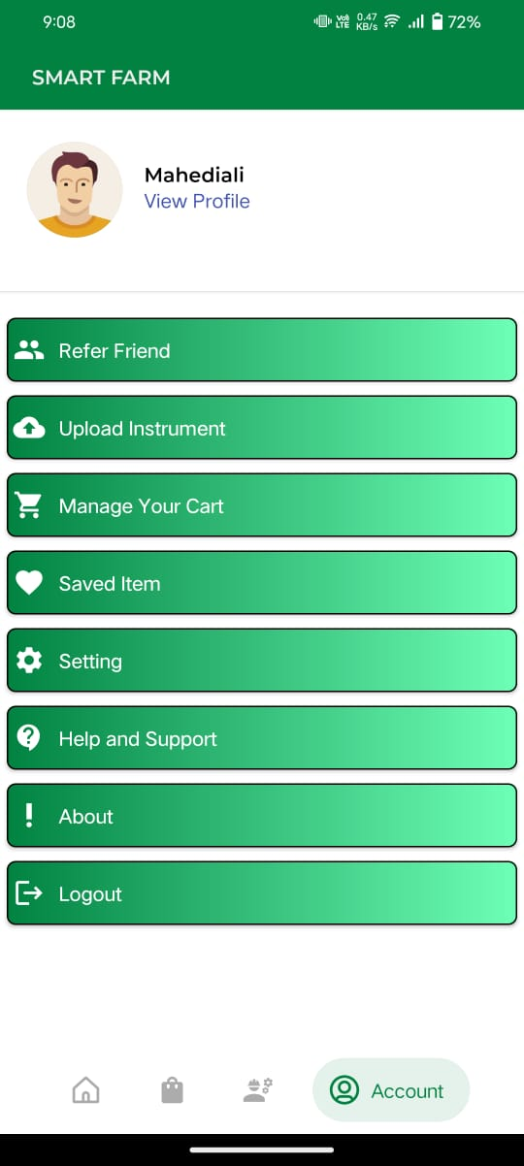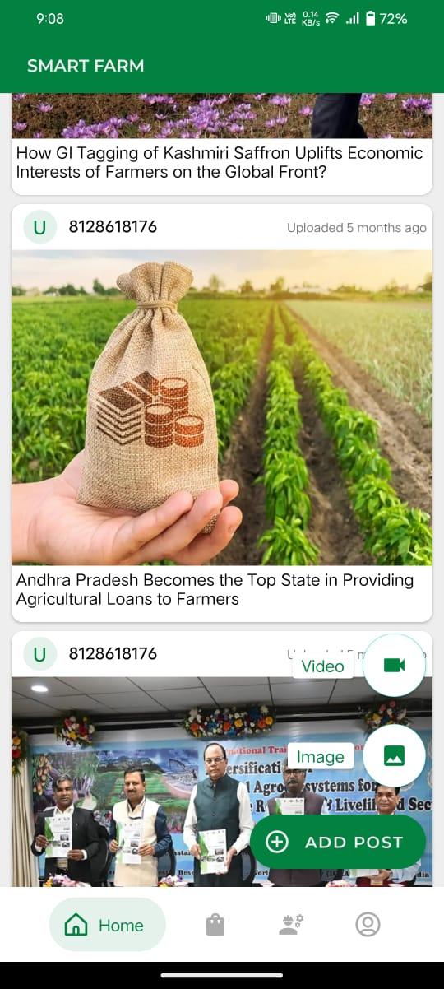
(Figure: Profile Page) (Figure: Post Upload Button)

Limitation/Drawbacks Of Existing System

Smart farming needs constant internet access. The rural part of most developing countries does not meet this requirement. Also, the internet connection is slow. Smart farming tools require farmers to understand the technology and learn how to use it. This poses a significant obstacle to the widespread adoption of sustainable agriculture practices. Excessive use of chemicals by machines reduces soil fertility. Lack of practical knowledge farmers cannot manage the equipment properly. Although the maintenance cost is very high. The device can harm the environment if it is used excessively. Although it has many drawbacks and difficulties, it functions well. The autonomous agricultural vehicle is also a requirement to use the technology. Enhance the test systems. A robot machine couldn't alter their culture; instead, we must take control of their system. Since most farmers lack literacy, they are unable to handle modern machinery.

Conclusion

We have determined that by launching the project known as the "tractor rental app," the problem's first introduction is fully avoided. And the Android app helps to accomplish the aim. Using our technological skills, we first conducted a problem analysis and identified the issue farmers have while renting tractors and agricultural equipment for a variety of farming reasons. We then discussed and recommended an Android application as a potential solution to the issue. As we work on the answer, there have been a number of issues for which we are doing research. For example, we are learning more about the numerous agricultural tools that farmers use in order to efficiently meet their needs. To make the software simple for farmers to use, we utilised Hindi. If the farmer adheres to the application's usage ethics, he is permitted to utilise it. Because it doesn't exist in real form, this software was created collaboratively and is thus ecologically friendly. We developed this project using principles of software engineering. We made advantage of java programming languages and algorithmic techniques. We used the software development life cycle to create our project. We gained important collaboration skills after completing all of these duties and procedures.

References

- Kim S., Seo G. and Kang C., “Cost Minimising Farm Machinery Selection for Rice Farming”,Department of Architectural Engineering, vol 44, issue no. 19, 2021, pp. 27-51.

- Farooq M., Riaz S., Abid A., Abid K. and Naeem M.,”A Survey on the Role of IoT in Agriculture for the Implementation of Smart Farming”, Department of Computer Science, University of Management and Technology, vol. 7, issue no. 19, 2019, pp. 156237-156271.

- Krunal B., Khoshant L. “Tractor Hiring Application for Farmers”, International Research Journal of Engineering and Technology (IRJET), vol 44, issue no. 19, 2021, pp. 27-51.

- Muhammad A.“Toward Making the Fields Talk: Internet - of - Things (IoT) - Based Smart Agriculture”, Department of Electrical Engineering, University of the Punjab, vol. 7, issue no. 19, 2019, pp. 129551-129583.

- Vengatesan D., Govind D., Dr. Ramesh K. “Technological Needs of Farm Women in Varied Farming Systems of Tamil Nadu”,International Journal of Innovative Technology and Exploring Engineering, vol 91, issue no. 1,2019, pp.662-665.

- Shin, G., “A Study on the Land Boundary Dispute and Land Boundary Demarcation Suit”Faculty of Agriculture, Annamalai University, vol 19, issue 2, 2017, pp.139-151.

- R. Shukla, “E-Connect Kisan”, Chonnam National University, Department of Architectural Engineering, IIM Gandhinagar, vol 51, issue no. 13,2016, pp.62-66

- Seung-Yeosu S. , Chang-Ho K. , “E- Agro Android Application”, National Academy of Agricultural Science Korea Department of Bio-Mechatronic Engineering, vol 7, issue no. 2,2014, pp.1508-1511

- S. Jung, M. Thesis, “Neural network-based software for fertiliser optimization in precious farming”, Chonnam National University, Department of Architectural Engineering, vol 16, issue no. 331, 2011, pp.166-198.
- Shekhar B. , “Precision Farming and Its Application”, Department of Architectural Engineering, IIT Kharagpur,vol 91, issue no. 1,2012, pp.72-78.

