Influences of Residual Stresses during Self-Piercing Rivet process
on Aluminum sheets using Aluminum Rivets
Ravi Sivalingam¹, Arun Tom Mathew²
¹Department of Design and Automation,SMEC,VIT Vellore
² Department of Design and Automation,SMEC,VIT Vellore
---------------------------------------------------------------------***---------------------------------------------------------------------
Abstract - Finite Element Analysis of Self-Piercing Rivet (SPR) forming process using a CAE tool LS-DYNA 971 software. In this software simulation was carried out to understand the simulation of elastic-plastic behavior of aluminum rivet. It was carried out under non-linear condition to investigate the SPR forming process. Aluminum rivet becomes favorable compare to steel regards to some improvement for increasing efficiency in automobile fuel economy and weight reduction. Also wide range of aluminum automotive product such as doors, bumpers, face bars fenders seat frames and roof panels have been produced. In manufacturing industry to minimization of response times and costs and maximization of the efficiency and quality SPR is a major role in product design and development. The major role of Residual Stress in the Self-Piercing Rivet having good response during compression mode in the rivet site and the results are clarified and clearly in this part of analysis.

Key Words: LS-DYNA Residual stress FEA, Simulation, Self-Piercing Aluminum Rivet

1.INTRODUCTION ( Size 11, Times New roman)

Piercing a rivet in to the sheet metal by applying forging force on rivet through punch without predrilled hole is called self-piercing rivet (SPR). This topic was chosen why because in Automotive Vehicle manufacturing industries facing problem in joining two different material without changing the mechanical, chemical and thermal properties. So this Self-Piercing Riveting method is important in the Automotive Society. This methods is adopted particularly because of the light weight, properties are not changing after joining, more than two layer can be joined easily and also joining quickly. Based on the material various metals were tested in many researcher. Therefore this analysis we chosen aluminum Rivet AA 7075 as a Self-Piercing Rivet material for furthermore analysis of residual stresses. Finally the analysis they discussed many areas example in Finite Element area there we considered the meshing of all the component in the assembly. In the assembly the sequence method was followed and FE techniques was adopted and simulated. In the conclusion the results were predicted and plotted. Ultimately the residual stresses were predicted in the rivet and the sheet metal. Next the images were captured in unsymmetrical manner and placed for display. condition of symmetry that only normal stresses act on the
Piercing a rivet in to the sheet metal by applying forging force on rivet through punch without predrilled hole is called self-piercing rivet (SPR). This topic was chosen why because in Automotive Vehicle manufacturing industries facing problem in joining two different material without changing the mechanical, chemical and thermal properties. So this Self-Piercing Riveting method is important in the Automotive Society. This methods is adopted particularly because of the light weight, properties are not changing after joining, more than two layer can be joined easily and also joining quickly. Based on the material various metals were tested in many researcher. Therefore this analysis we chosen aluminum Rivet AA 7075 as a Self-Piercing Rivet material for furthermore analysis of residual stresses. Finally the analysis they discussed many areas example in Finite Element area there we considered the meshing of all the component in the assembly. In the assembly the sequence method was followed and FE techniques was adopted and simulated. In the conclusion the results were predicted and plotted. Ultimately the residual stresses were predicted in the rivet and the sheet metal. Next the images were captured in unsymmetrical manner and placed for display. Condition of symmetry that only normal stresses act on the SPR.

2. Body of Paper
The body of the broadside consists of add up to sections that present the main outcomes. These sectors should be organized to best existent the material.
It is often central to refer back (or forward) to vague sections. Such locations are made by designating the slice number, for case, “In Sec. 2 we exposed…” or “Section 2.1 contained a portrayal….” If the word Segment, Reference, Equation, or Figure starts a judgment, it is implied out. When occurring in the intermediate of a sentence, these disputes are abbreviated Sec., Ref., Eq., and Fig.
At the first manifestation of an contraction, spell it out followed by the acronym in additions, e.g., charge-coupled diode (CCD).

Table -1: Sample Table format

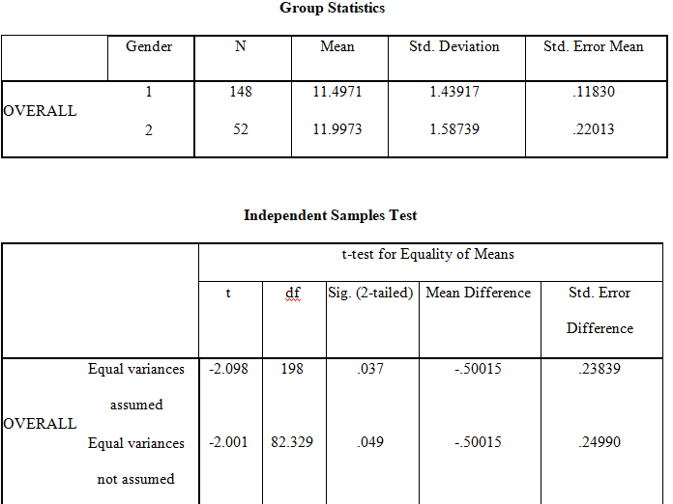

ISJEM sample model format ,Define acronyms and acronyms the first spell they are used in the writing, even after they have been well-defined in the abstract. Shortenings such as IEEE, SI, MKS, CGS, sc, dc, and rems do not have to be demarcated. Do not use condensations in the title or bonces without they are unavoidable.


Fig -1: Figure

Charts
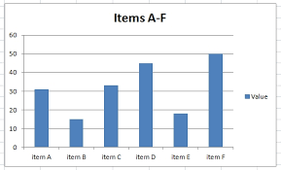
3. CONCLUSIONS

The online variety of the dimensions will be offered in LNCS Online. Members of establishments subscribing to the Sermon Notes in Computer Science successions have entree to all the pdfs of all the available publications. Non-subscribers can only read as far as the abstracts. If they try to go ready there this point, they are routinely asked, whether they would like to order the pdf, and are given directions as to how to do so.

ACKNOWLEDGEMENT

The caption should be dried as a 3rd level header and should not be dispersed a number.

REFERENCES

1. Maldonado, M., Chang, C.-C.K., Gravano, L., Paepcke, A.: The Stanford Digital Library Metadata Style. Int. J. Digit. Libr. 1 (1997) 108–121
2. Bruce, K.B., Carcelle, L., Pierce, B.C.: Linking Object Encodings. In: Abadi, M., Ito, T. (eds.): Notional Aspects of CPU Software. Lecture Notes in Computer Science, Vol. 1281. Springer-Verlag, Berlin Heidelberg New York (1997) 415–438
3. van Leeuwen, J. (ed.): Computer Skill Today. Recent Trends and Developments. Lecture Proceedings in Supercomputer Science, Vol. 1000. Springer-Verlag, Berlin Heidelberg New York (1995)
4. Michalewicz, Z.: Genetic Systems + Data Structures = Evolution Programs. 3rd edn. Springer-Verlag, Berlin Heidelberg New York (1996)

BIOGRAPHIES (Optional not mandatory )
1’st Author  Photo | Description about the author1  (in 5-6 lines)

