Counterfeit Merchandise Identification Using Blockchain
Mr. M. Venkatesh¹, M. Harshitha², M. Venkata Susmitha³, P. Mounika⁴,
K. Naga Durga Bhavani⁵
¹ Assistant Professor, Department of Electronics and communication Engineering
Vasireddy Venkatadri institute of Technology Engineering College, Nambur - 522508, Andhra Pradesh, India.

^{2,3,4,5} UG Students, Department of ECE
Vasireddy Venkatadri institute of Technology Engineering College, Nambur - 522508, Andhra Pradesh, India.
-------------------------------------------------------------***----------------------------------------------------------
Abstract - As a result of a lack of openness, supply chain management frequently confronted issues such as service duplication, poor collaboration between divisions, and a lack of uniformity. Item duplicating is something which is extremely normal now-a-days and its exceptionally difficult to distinguish a fake item by simply checking it out forgers cause critical difficulties for authentic firms yet unreasonably many individuals have no clue about the whole measure of fake things effect on brands there are a few strategies concocted in the past to pull off this issue of item falsifying the most well-known strategies are utilizing radio frequency identification (RFID) labels, computerized reasoning QR code based frameworks and so forth however every one of them had many weaknesses for example the QR code can be duplicated from a certified item and put on a fake item, computerized reasoning purposes CNN and AI which needs high computational power etc. This undertaking is to further develop identification of fake items by following its store network history this is accomplished with block chain innovation which guarantees the recognizable proof and detectability of genuine items all through the store network block chain based framework makes all that decentralized that might be gotten to by a few gatherings simultaneously one of its fundamental benefits is that the recorded information is challenging changing without the assent of every interested individual which makes the information incredibly secure and safeguard from all weaknesses. This paper present’s framework planned utilizing blockchain innovation for discovery of fake items.

Keywords: Blockchain, Counterfeit (Fake) product, QR code, Supply Chain, Transaction history.

1. INTRODUCTION

Product counterfeiting happens when an item is offered perceiving a tendency to be another item it is buyer extortion and regularly characterized as tricky strategic policies that make shoppers experience monetary or different misfortunes as per the confirmation arrangement supplier’s affiliation reports it costs the Indian economy INR 1 trillion consistently fake episode are expanding by 20 in the middle of between 2018-20 [1]. Fake merchandise incorporates fake purses clothing beauty care products and hardware it adversely affects the economy as well as on residents too for instance unfortunate beauty care products can influence skin and cause skin sicknesses and rashes fake electronic parts can cause glitch in contraptions and can prompt horrible circumstances and disasters low quality garments shoes when worn can cause distress consequently this issue requires discovering some answer for the offer of fake items.

Another consequence of counterfeiting is that a company’s reputation suffers that numerous clients are dumbfounded that the item they are holding is a thump they will blame the veritable organization assuming the thump of item neglects to perform appropriately falls to pieces quickly. client request reward either as a discount or another item and they search it out straightforwardly from the genuine organization a ton of impacted organizations might end up in a situation where they are managing a troubled client who is grumbling about the terrible nature of the thing and the client care delegate is uninformed that the thing being referred to is a fake organization are gotten between a predicament endeavoring to abstain from with nothing to do and exertion managing unfortunate impersonations of their merchandise while yet attempting to keep their clients satisfied the damage brought about by forgers reaches out past client connections due to the ways of behaving of forgers.
Blockchain is a distributed, decentralized technology with a database that stores data in blocks connected by chains. When new data is added to databases, it is connected to the existing data in a chain by connecting to the block that already exists. Every time new data is added as a new block to already existing data, no user can make any changes to it. Therefore, the data in the blockchain cannot be deleted or altered, ensuring data security and protection. Blockchain based system contributes to the solution to the issue of phony goods.

2. BLOCKCHAIN

Blockchain is a collection of blocks that are interconnected and store data. It is difficult to change the data as each block has a timestamp, transaction data and its own hash as well as the previous block's hash. Blockchain is a distributed platform. It ensures that each new block added to the blockchain is the only true version agreed upon by all nodes. Through decentralization, it denotes the collective maintenance of a technical solution that maintains a continuous log file as a reliable database. [2][3][4]
A Decentralized technology that is distributed among computers in a computer network is known as a blockchain. A blockchain stores data in the form of blocks and chains, similar to a database. Bitcoin, a cryptocurrency, is one of the most successful real-world applications of blockchain. Blockchain records transactions using a more secure and protected method. Blockchain guarantees the safety of our data. Typical databases and blockchain databases are nearly identical. The only difference between the two methods of data storage is the structure of the data in databases. While a typical database stores data as it is supplied by the user, a blockchain stores data in blocks that are connected by a chain. Hashing is the technology behind block and chain. When a block is completely filled, a new block is linked to it, and the new information is stored in a new block. The process continues as new data continue to come in. Each block has its own capacities and information. Blockchain gives us a distributed, decentralized, and un editable database, which is one of its main benefits. Therefore, the blockchain does not provide us with the capability to modify our existing data.

2.1 Working of Blockchain

As was mentioned earlier, the primary objective of blockchain is to make recorded data un editable. The operation of the blockchain can be described in roughly five steps, which are as follows:
- When a user or client enters data, the transaction blockchain must verify the user.
- A new block is created with transaction data stored after authentication is completed.
- Every computer network node receives a portion of the newly created block.
- After the authorized nodes verify the transaction, information is added to existing blocks using chaining mechanisms after they verify the transaction.
- Once more, updates are spread throughout the network.
As a response, the transaction information is now kept in blockchain databases. The stages are also depicted in the Figure 1.
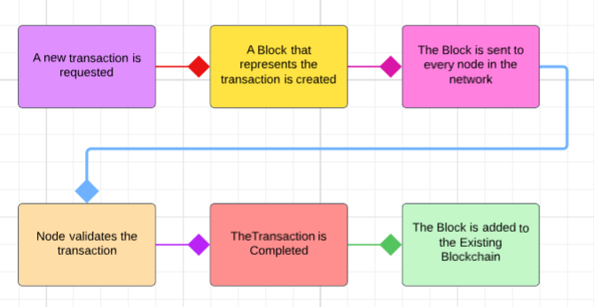
Figure 1: Working of Blockchain
2.2 Benefits of Blockchain
Blockchain uses its own consensus algorithms rather than any centralized authority as an arbitrator to add data records to its database. Blockchain is a highly reliable open-source database. The characteristics of Blockchain technology are outlined in greater detail below. Figure 2 depicts Blockchain's characteristics [5].
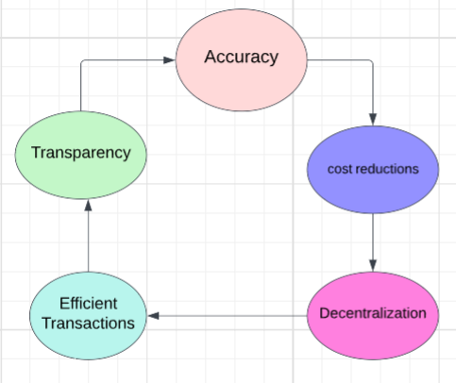
Figure 2: Features of Blockchain

- Accuracy: Since the blockchain is known to be a distributed system, its database is spread out among the various computer network nodes. This implies that the client never comes to be aware from where the data set of blockchain is coming. Because of this, humans are less involved in the technology, which reduces human error and reduces computational error by blockchain technology, which improves accuracy.

- Cost Reduction: Due to the fact that it removes the involvement of third parties like banks, blockchain greatly reduces transaction costs. For instance, whenever business owners accept credit card payments, the bank will deduct a small portion of the service fee. Nonetheless, there will be no or very low transaction fees because the blockchain lacks a central authority.

- Decentralization: As we probably are aware from the above meaning of blockchain that blockchain is a decentralized disseminated framework. Therefore, the blockchain database is distributed across numerous computers in computer networks and has multiple copies. Therefore, every computer must update its blockchain to reflect the new block whenever it is added to the database. As a result, tampering with blockchain becomes more difficult. Even if a hacker attempted to alter the blockchain, only that copy would be affected; the other copies would remain unchanged. As a result, the blockchain's decentralization feature contributes to data security.

- Effective Dealings: Blockchain transactions are not controlled by a central authority and they are decentralized. As we are aware, authorities conduct transactions during business hours. If we initiate a transaction on Friday, it will take three days to complete; however, the blockchain operates 24 hours a day, seven days a week, and the transaction will be completed in less than ten minutes. Blockchain also completes cross-border trades in about the same amount of time, whereas other authorities take longer because of time zones and other factors. As a result, Blockchain offers an effective method for transactions.

- Transparency: Since the majority of blockchains are open-source software, they provide transparency. As a result, it will enable us to review the code and offer suggestions for enhancing blockchain technology. in this way blockchain is totally straightforward to the client. If the majority of network users agree, the suggestions will be implemented.

3. LITERATURE SURVEY
The survey focused on identifying the origins of counterfeiting and its impact on society. There are various methods to detect counterfeit products using artificial intelligence, QR codes, machine learning and blockchain.
Shaik's techniques included giving a product public and private key as a QR code, and the application to read the QR code with cryptographic functions to crack the QR code. In addition, the manufacturer should operate a server to receive requests and to compare the identity of the buyer and the article number. In order to decrypt the ciphertext of the item code embedded in the QR code, the scanning software must have cryptographic capabilities [6]. According to Benatia and Baudry et .al explains traceability-CPS-based supply chain management architecture consists of multiple layers that combine to create a traceability-CPS. In addition, the proposed architecture allows for supply chain monitoring and data analysis to improve the product. Quality and safety. The proposed method calculates the most frequently occurring sets of items in the product transaction database. This collection of items is then used as a legitimate product trail and can be used to identify anomalous product behavior [7].
Khalil and Doss et.al suggest using an RFID-based device to minimize counterfeiting. This method allows customers to refer to the tag attached to an item in the store to confirm its authenticity. RFID-based anti-counterfeiting and anti-theft systems are well suited for large-scale retail applications. The proposed system is lightweight and can be implemented with inexpensive passive RFID bands. The anti-counterfeiting algorithm developed by Tran and Hong’s is used. This technology is resistant to DOS attacks [8]. Daud and Vu et.al Focus on AI application design. It consists of three main components: the data collection, the recognition models, and the learned model. Machine learning based anti-counterfeiting tool to detect counterfeit products. The two necessary steps are model building and logo recognition. Faster R-CNN achieves high accuracy while training at a low rate [9].
In a blockchain-based system, data is stored on each node, and then the nodes exchange information with each other over the network. Each node stores all data in the blockchain. The node checks the received transactions and inserts them into the new block based on its blockchain data and attempts to acquire the rights of the new block. Ethereum as the blockchain backend operating system. Store relevant product sales information on the blockchain, accessible to all. It is profitable [10]. It offers blockchain technology for exchanging information. This information is under the control of the owner, making it difficult for third parties to intervene. Users always know what data is being collected about them and how it is being used. The blockchain contains sender, amount, recipient, transaction ID, product ID and metadata [11].
The limitations of existing systems are that brands use QR codes on products to prove their validity of the product. However, the QR code can be copied and used to identify counterfeit products [6]. In an RFID-based system, cheap RFID tags can be used for self-identification of products, but due to cloning of RFID tags, this method is not suitable [12]. In AI and machine learning applications, CNN takes more time and storage space. It requires training and they are tested before actual distribution. The AI ​​does not detect attacks where the counterfeiter removes the legal label from the original and reapplies it to a counterfeit or expired product [13]. Customers, suppliers and resellers are not authorized to verify the integrity of the product.
4. PROPOSED SYSTEM
Global counterfeiting has a significant impact on businesses, manufacturers, and consumers. It has an impact on the organization's influence. India isn't excluded. The proposed framework is focused on customer items, and it helps track the items by keeping up with the item and the store network honesty by utilizing Blockchain. Customers can now use blockchain and a QR code to follow the entire product's history from the manufacturer to the end user. We need to develop a full-fledged application system that will assist us in identifying counterfeit products as the global prevalence of counterfeit goods grows. In this paper, the proposed framework is that it will store the store network of the item and keep the historical backdrop of responsibility for items. so that when customers buy this product, they can see all of the information about it and decide if it is authentic or not. We will add product-specific information and verify the products using QR codes. Additionally, a system that prevents anyone from altering the product's data must be used for its storage; blockchain technology can accomplish this. We therefore use QR codes and the blockchain in this proposed system to identify counterfeit goods.
4.1 Model of the System
The proposed system will be a decentralized application implemented using the Ethereum chain as the main blockchain to keep all records. Ganache, a personal piece of software, is used to implement the blockchain for the proposed system. The blockchain network used to keep track of and manage transactions was developed by Ganache. We need to use ganache software that helps us implement blockchain in order to use the Ethereum blockchain. Meta mask is an extension for the web browser that connects the blockchain to the page. The web page was built with node.js, and the solidity programming language was used to build blockchain smart contracts as shown in Figure 3.
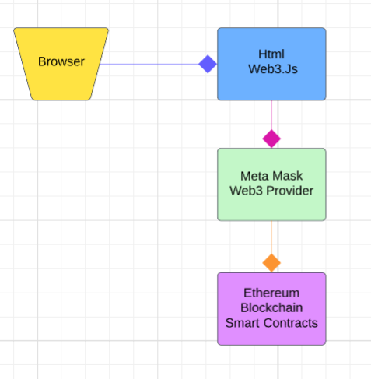 Web3 Provider
Figure 3: System Model of Proposed System
4.2 Tools Requirement

Ganache: Ganache is a set of software for creating your own Ethereum blockchain. Your blockchain will be added to the network with this tool. It makes it possible to interact with your smart contracts in the Ethereum blockchain by stimulating it.

Meta mask: Meta mask is an extension for the web browser that enables users to use their Ethereum blockchain wallet and serves as an interface between the browser and the blockchain.

Suite Truffle: Truffle is a framework for creating an environment for writing blockchain-based smart contracts.

Nodejs: A framework called Nodejs is used to build the website's pages.

Solidity: Solidity is a language for programming. In blockchain, it is used to write smart contracts. Solidity is an object-oriented, high-level language for implementing smart contracts. Smart contracts are programs which govern the behaviour of accounts within the Ethereum state. Solidity is a curly-bracket language designed to target the Ethereum Virtual Machine (EVM). It is influenced by C++, Python and JavaScript. You can find more details about which languages Solidity has been inspired by in the language influences section.
.
4.3 Flow of proposed system
The system is keeping track of the product's ownership status, which includes a QR code, the product's manufacturer, the current owner, and the product's ownership history. The main objective of this proposed system is to preserve the originality of the product by helping the customer track the product's supply chain history. The system gives customers the capability to trace the history of an entire product from the manufacturer to the customer using the blockchain. This blockchain-based anti-counterfeiting system consists of three roles, the builder role, the agent role and the customer role. The flow is depicted in the Figure 4.
Stage 1: Procedure for Product Registration: The product's initial owner will be the manufacturer. Therefore, the manufacturer will add the product to the blockchain's database and include a QR code for adding new product data to the blockchain.
Stage 2: Chains of distributors: The manufacturer will ship the product to the distributor in the subsequent step. The distributor will scan the QR code when he receives the product and add a new chain containing his network information, product ownership, time stamp, and date.
Stage 3: Retailer chains: The retailer receives the product from the distributor at this point, scans the product's assigned QR code with a QR code scanner, and then adds the product's owner information to a new chain on the network.
Stage 4: Final User: The customer will take the product at the end of the chain, upload the QR code to the website, and will be able to obtain all product information from the manufacturer to the final retailer. And when he got the details, he could decide whether or not to buy the product.
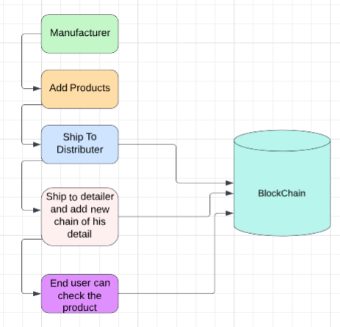
Figure 4: Block Diagram of Proposed System

5. RESULTS AND DISCUSSION
With the proposed system, both suppliers and manufacturers can interact with the system to add their own blocks to the blockchain that contain transaction details without changing the blocks of other parties. Solidity is used to write the contracts for the manufacturer and supplier block. Ganache has been used for local testing because the code is running on a local network. The Trufflee-config.js file is used to set up the host "127.0.0.1" and port 7545. Truffle is then used to compile and distribute the contracts. For deployment, migration files are created. We can deploy contracts on an Ethereum blockchain network with the assistance of migration files.
React is used to create the interface. The Web3.js library, which is used to send ether, confirm transactions, and read and write smart contract data, is used to enable interaction with the Ethereum blockchain. MetaMask is a wallet for interacting with the Ethereum blockchain that is installed on a browser. This makes it possible to access the Ethereum wallet through a browser. The MetaMask is used to import accounts from ganache. They must use their MetaMask wallet account, which is connected via Web3.js, to confirm the transactions in order to add blocks for suppliers and manufacturers. The end user can then verify the product's integrity by scanning the QR code to check the supply chain. Figure 5 illustrates the three types of accounts: manufacturer, supplier, and customer. Figure 6 depicts how the manufacturer uses the MetaMask Wallet to connect to his Ethereum account.

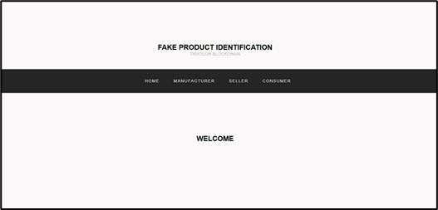

Figure 5: Landing page.

The manufacturer logs into their account using their username and password, as shown in Figure 7. Figure 8 depicts the Blockchain database where the credentials are kept. The address and login information for manufacturers and suppliers are stored in a blockchain centralized database.

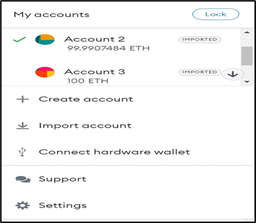

Figure 6: Connecting Ethereum using MetaMask

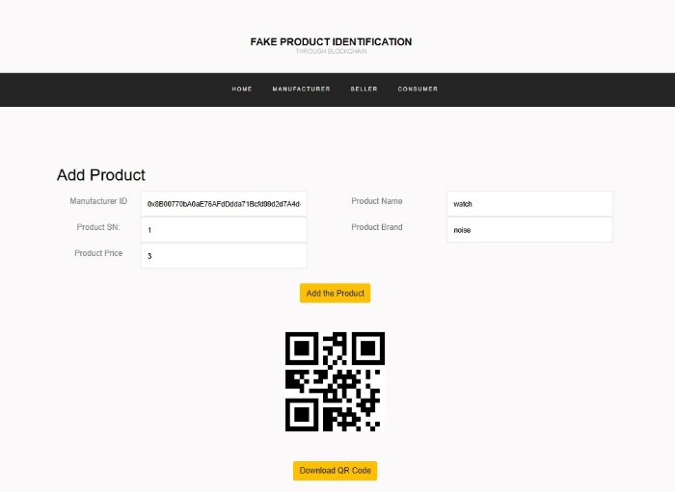
Figure 7: Manufacturer Login page
The details are stored into Blockchain server where the credentials are kept. The address and login information for manufacturers and suppliers are stored in a blockchain decentralized database.
After logging into his account, as depicted in Figure 7, the manufacturer generates the product's QR code and assigns a unique serial number. When a product is transported to other locations, this QR code is applied to it. In addition, the manufacturer enters additional information about the product, such as its name, current address, which indicates where it originated, and destination. The manufacturer adds all of the filled-in information to the blockchain by clicking the "add product" button and download the QR code for further uses.
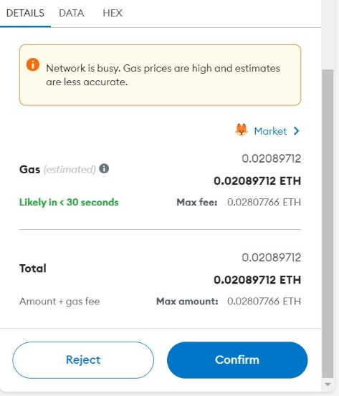
Figure 8: Completing the transaction with MetaMask wallet
As shown in Figure 8, a MetaMask approval popup appears, asking for affirmation. The block that contains all of the details is added to the blockchain after it is confirmed, and the details are successfully stored there. The supplied must connect his MetaMask wallet and log into his account, as shown in Figure 9, once the product reaches its destination. When the supplies are finished, a screen prompts them to enter the product's necessary information. This time, rather than creating the QR code, the supplier selects "scan QR" and scans the code. Figure 10 depicts how the supplier adds the block after entering the necessary product information and logging out to confirm his transaction through the MetaMask wallet.

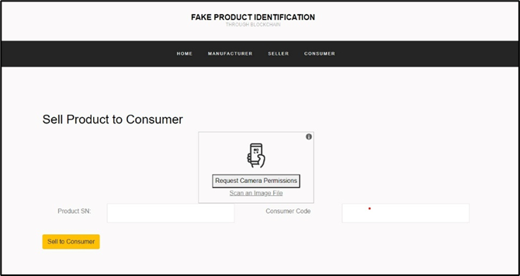

Figure 9: Supplier Login page.

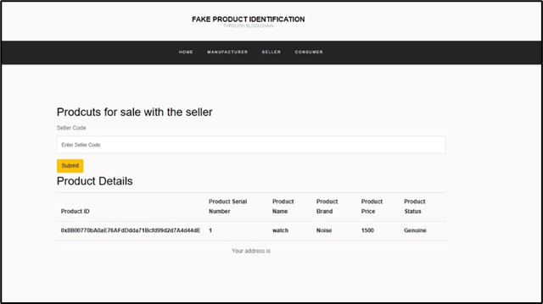

Figure 10: Supplier can check status of the product.
The other providers involved also access your accounts and add your blocks to the blockchain. Once the product reaches the customer, you can check the entire supply chain history of the product by visiting the same page, scanning the QR code as shown in Figure 10, and so on. The product ID, its name, its brand, its status, its address in relation to the companies involved, its Ethereum account address, the timestamp of adding the block and any additional comment if added are displayed in. Supply Chain History. If a customer buys the product by following the QR scan in the supply chain history, the customer will know that the product is not genuine if the last location does not match the place of purchase. The customer is made aware of counterfeiting after it comes to the conclusion that the QR code was copied as shown in Figure 11.
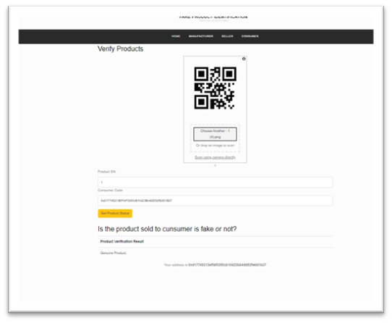
Figure 11: Customer page to check Supply chain history of the product.

- CONCLUSION
As a decentralized system, blockchain prevents local suppliers from interfering with product verification or counterfeiting in the proposed system. Product details can be stored in Blockchain by suppliers and manufacturers. Blockchain's properties, such as tamper-resistance, data consistency, and confidentiality, ensure the data's security and privacy on the network. The customer checks the authenticity of the product by looking at the product's supply chain history. The quality of the products that customers purchase can be assured. Companies will have an easier time demonstrating to customers that they will not purchase counterfeit goods thanks to the proposed system, which has the potential to effectively reduce the rate of counterfeiting of branded goods. In actuality, this system will contribute to the improvement of the economy and the reduction of corruption by fostering trust and positive relationships between manufacturers and customers. To prevent fraud in the banking, healthcare, voting, online shopping, and other areas, additional systems can be developed.

- References
[1] ASPA, The state of counterfeiting in india 2021.
[2] Y. Lu, Journal of Management Analytics 5, 1 (2018).
[3] F. Casino, T.K. Dasaklis, C. Patsakis, Telematics Informatics 36, 55 (2019)
[4] M. Peck, IEEE Spectrum 54, 26 (2017)
[5] J. Ma, S.Y. Lin, X. Chen, H.M. Sun, Y.C. Chen, H. Wang, IEEE Access 8, 77642 (2020).
[6] C. Shaik, Computer Science & Engineering: An International Journal (CSEIJ) 11 (2021)
[7] M.A. Benatia, D. Baudry, A. Louis, Journal of Ambient Intelligence and Humanized Computing pp. 1–10 (2020).
[8] G. Khalil, R. Doss, M. Chowdhury, IEEE Access 8, 47952 (2020).
[9] E. Daoud, D. Vu, H. Nguyen, M. Gaedke, Improving Fake Product Detection Using Ai-Based Technology, in 18th International Conference e-Society (2020)
[10] J. Ma, S.Y. Lin, X. Chen, H.M. Sun, Y.C. Chen, H. Wang, IEEE Access 8, 77642 (2020).
[11] M. Nakasumi, Information sharing for supply chain management based on block chain technology, in 2017 IEEE 19th conference on business informatics (CBI) (IEEE, 2017), Vol. 1, pp.140–149.
[12] S. Chen, R. Shi, Z. Ren, J. Yan, Y. Shi, J. Zhang, A blockchain-based supply chain quality management framework, in 2017 IEEE 14th International Conference on e-Business Engineering (ICEBE) (IEEE, 2017), pp. 172–176.
[13] E. Daoud, D. Vu, H. Nguyen, M. Gaedke, Improving Fake Product Detection Using Ai-Based Technology, in 18th International Conference e-Society (2020).

