Design and Implementation of a Wireless Bluetooth-Controlled Robotic Arm with a Wi-Fi Camera and Wheels
Khaja Arman Ahmed¹, Syed Mujtaba Hussain², B. Lokanath³
^{1,2,3}Student, Department of Mechanical Engineering, Vardhaman College of Engineering, Hyderabad, Telangana
---------------------------------------------------------------------***---------------------------------------------------------------------
ABSTRACT: This research paper is about the design and implementation of a robotic arm system called Wheely-Cam Bot, equipped with DC motor wheels, Wi-Fi camera, ultrasonic sensor, and controlled by Arduino Uno using a Bluetooth module. The Wheely-Cam Bot is designed to perform remote operations with agility and mobility. The Wheely-Cam Bot employs a rack and pinion mechanism for the robotic arm, and an L298 motor driver board is used to control the DC motors through the Arduino Uno. The DC motor wheels enable the Wheely-Cam Bot to move in any direction, while the Wi-Fi camera provides live video streaming and remote monitoring capabilities. The Arduino Uno-based Bluetooth module provides wireless communication and control of the Wheely-Cam Bot from a remote device such as a smartphone or tablet. The system is designed to be modular and expandable, allowing for the addition of new features and functionalities.
To ensure safety, an Ultrasonic Distance Sensor Module - HC-SR04 is installed, which can detect obstacles in front of the Wheely-Cam Bot, thus stopping the robot in its tracks. The Wheely-Cam Bot has potential applications in various fields such as surveillance, inspection, and exploration. The experimental results demonstrate the Wheely-Cam Bot's capabilities in performing a range of tasks, making it suitable for use in fields such as surveillance, inspection, and exploration. The aim is to provide a cost-effective solution that can assist in tasks such as inspecting pipelines, performing maintenance tasks in nuclear power plants, or carrying out surveillance and reconnaissance in difficult terrains.
KEYWORDS: Wheely-Cam Bot, Rack and Pinion Mechanism. Arduino Microprocessor, WiFi camera, Ultrasonic Sensor-HC-SR04.
- INTRODUCTION

Robotics research and development has become a fascinating and quickly expanding sector in engineering and technology. In order to do a certain task, a robot is a sophisticated system that integrates a number of subsystems, including sensors, actuators, controllers, and power sources. Robots are perfect for carrying out jobs that are risky, repetitive, or need for great precision and accuracy since they may be programmed to work autonomously or under human direction.
In recent years, the development of robotic systems has enabled the automation of various tasks, making them more efficient, accurate, and safe. One such system is the Wheely-Cam Bot, a robotic arm system equipped with wheels and various sensors for monitoring the environment. This project aims to develop a Wheely-Cam Bot with the capability of being wirelessly controlled.
The Wheely-Cam Bot is designed to move smoothly and accurately with the help of the DC motors powered wheels. A rack and pinion mechanism are utilized to provide the robotic arm with the ability to move and grasp objects with precision. The system is controlled using an Arduino Uno microcontroller board, which is connected to an HC-05 Bluetooth module, enabling wireless operation.
The use-case of this project is vast, and the Wheely-Cam Bot has numerous applications. One of the significant applications of this system is in the field of surveillance. The Wi-Fi camera attached to the system provides real-time monitoring, making it ideal for security purposes. The Ultrasonic Distance Sensor Module - HC-SR04, incorporated into the system, allows the robot to detect objects in front of it, making it a safety feature for various applications.

The design of the Wheely-Cam Bot is modular, which allows additional sensors and functionalities to be added to the system, making it adaptable for various use cases. This system's primary objective is to develop a versatile robotic arm system that can perform various tasks

efficiently and accurately, making it an ideal choice for surveillance, inspection, and exploration. The project's experimental results demonstrate the Wheely-Cam Bot's capabilities, making it a suitable choice for various applications.

- PROJECT OVERVIEW

- Robotics Definition:

In his play R.U.R (Rossum's Universal Robots), written in 1921, Czechoslovakian playwright Karel Capek used the term "robot" for the first time in English. Robots were once considered "forced labour," which is another phrase for slave labour, although their definition has since been expanded in the contemporary sense. The robot is described as "a reprogrammable and multifunctional manipulator designed to move material, parts, tools, and specialised devices through variable programmed motions for the performance of the variety of tasks" by The Robotics International Division of The Society of Manufacturing Engineers (RI/SME). The three keywords listed above, which are "reprogrammable," "multifunctional," and "able to move material, components, or objects," demonstrate three qualities of a robot.
Hence, a versatile device designed to operate and convert equipment or devices across a track that has been programmed to carry out particular duties is what is meant by a robot, especially an industrial robot. A machine must include at least three essential components in order to be considered a modern robot system:
1) Manipulator, A mechanical device that carries out the movements is called a manipulator. A robot's manipulator typically comprises of a wrist and sleeve (main frame). This manipulator's purpose is to provide the robot the ability to precisely attain a given position.
2) Actuator, is a source of power for the manipulator. Hydraulic systems, pneumatic systems, DC motors, AC motors, stepper motors, and several other drivers can all be used as actuators on a robot.
3) Processor. Is the robot's "brain," which stores and processes each robot movement's sequence. The processor typically enables the robot to carry out a number of activities that have been programmed/set for it.

- Arduino UNO

The Arduino Uno is an open-source microcontroller board based on the ATmega328P microcontroller,
which features 14 digital input/output pins, six analog inputs, a USB connection, power jack, and an ICSP header. It can be programmed using the Arduino Integrated Development Environment (IDE) to control a wide range of electronic devices and sensors.

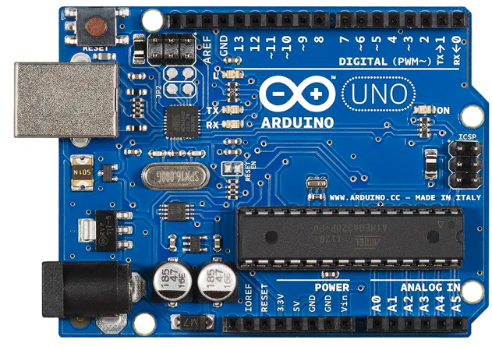

Fig. 1. Arduino UNO
The Mega2560 Arduino can be powered by an external power source or by a USB connection, and the power source is selected automatically. It can supply between 6V and 20V of power. The pin release voltage will be less than 5V if the input voltage is less than 7V. The voltage regulator IC will get extremely hot and unsafe for the board when the input voltage is higher than 12V. Hence, 7V to 12V is the ideal input voltage range.
- HC-05 Bluetooth Transceiver Module
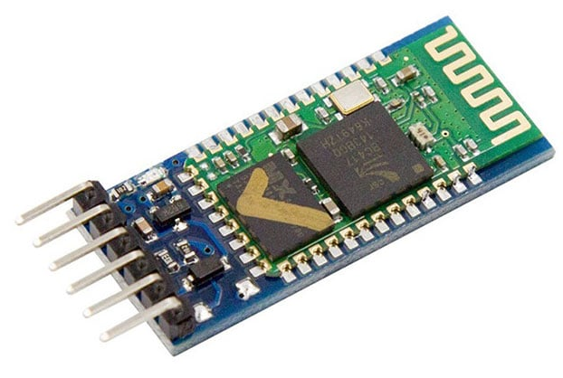
Fig. 2. HC-05 Bluetooth Transceiver Module
A highly integrated device, the HC-05 Bluetooth transceiver module enables wireless serial communication through Bluetooth technology. It runs on the 2.4 GHz frequency band with a transmission range of up to 10 metres. The module includes an integrated antenna, a power supply regulator, and a UART interface enabling simple microcontroller integration, such as with the Arduino. It is suited for a variety of Bluetooth-required applications since it may be set up in master or slave mode.

D. L298 Motor Driver Board
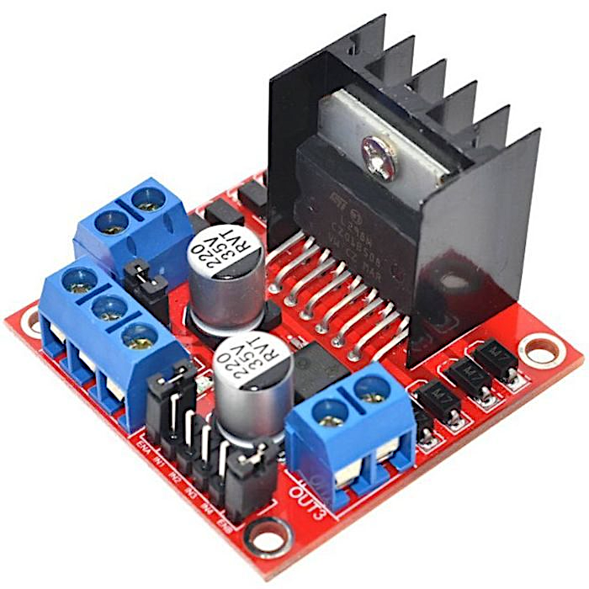
Fig. 3. L298 Motor Driver Board
The L298 Motor Driver Board is an electronic circuit that can control the direction and speed of two DC motors or one stepper motor. It works by using pulse-width modulation (PWM) to regulate the power delivered to the motors. The board can handle high currents and voltages, up to 2 amps and 35 volts, respectively. It has a variety of input pins for controlling the motor speed and direction, and can be interfaced with microcontrollers such as Arduino. Overall, the L298 Motor Driver Board is a versatile and powerful tool for controlling motors in a wide range of applications.
E. Ultrasonic Distance Sensor Module - HC-SR04
The Ultrasonic Distance Sensor Module, also known as HC-SR04, is an electronic device that measures distance using ultrasonic waves. It works by emitting a high-frequency sound wave and then detecting the time it takes for the wave to bounce back from an object. Based on the time delay, the module can calculate the distance to the object with high accuracy.
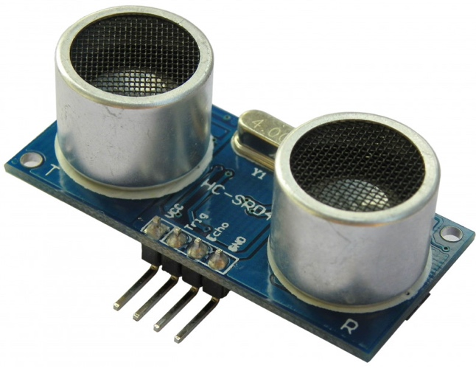
Fig. 4. Module - HC-SR04

The HC-SR04 sensor module is easy to use and has a wide range of applications, such as in robotics, automation, and distance measurement systems. It operates at a frequency of 40kHz and has a range of up to 4 meters. Overall, the HC-SR04 is a reliable and cost-effective distance sensing solution.
F. Wi-Fi Camera TP-link Tapo CP200
Used as an auxiliary sensor to provide visual feedback for the arm's movements and a safety feature to prevent collisions.
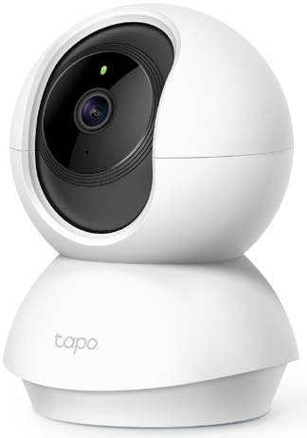

Fig. 5. Wi-Fi Camera TP-link Tapo CP200

Live Camera Feed, 1080p resolution and night vision capabilities, wide viewing angle of 114 degrees, and it can be adjusted manually to tilt up or down and pan left or right.
The camera can be used to help the robotic arm navigate its environment. By analyzing the visual data, the robotic arm can determine its position and orientation relative to objects in its environment.

III. THE MECHANICAL ARM
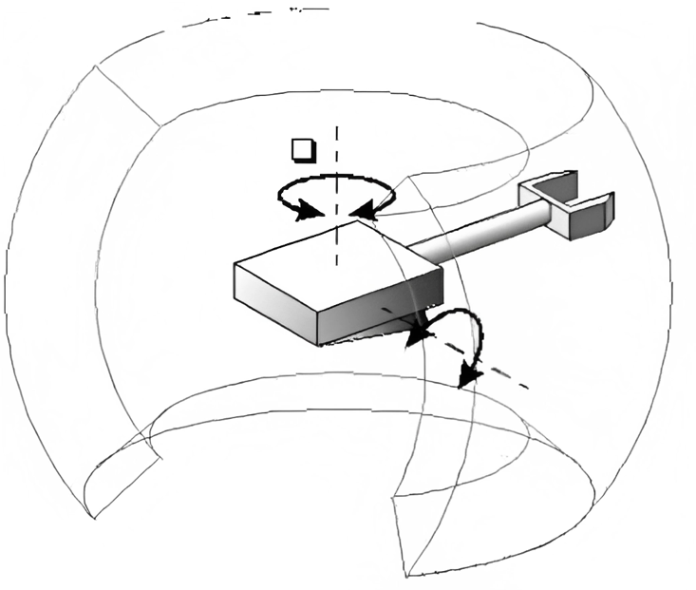

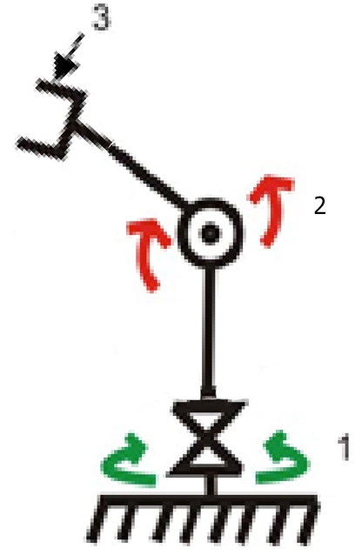

Fig. 6. Design for the degree of freedom angle on the robotic arm

A robotic arm designed in our work have three degrees of freedom (3 DOF). An illustration of the movement, system configuration in the form of the number of degrees of freedom can be seen in Figure 6.

The three degrees of freedom of a robotic arm could be defined as follows:

Base movement: The first degree of freedom allows the robotic arm to rotate horizontally around a base. This movement allows the arm to cover a wide range of workspace and provides flexibility in positioning the arm.

Shoulder movement: The second degree of freedom allows the arm to move up and down vertically. This movement is achieved by a joint at the base of the arm that connects to the shoulder joint.

Gripping mechanism movement: The third degree of freedom allows the claw grip to open and close. This movement is achieved by a joint or actuator connecting the claw grip to the arm.

By combining these three degrees of freedom, the robotic arm can move in a wide range of positions and orientations in 3D space and manipulate objects through its gripping mechanism. The movement of the robotic arm and the claw grip is typically controlled by a computer or a microcontroller, which receives input from sensors and feedback systems to ensure precise and accurate movement of the claw grip.

The end effector of a robotic arm with 3 degrees of freedom can be a simple gripper or a suction cup, depending on the task requirements. The gripping mechanism can be actuated by various methods, such as electric motors, pneumatic systems, or hydraulic systems.

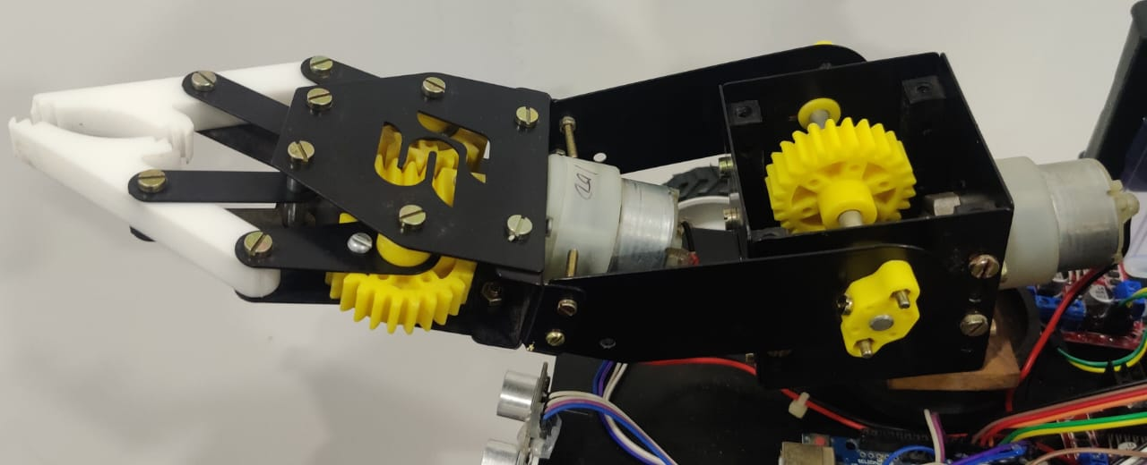

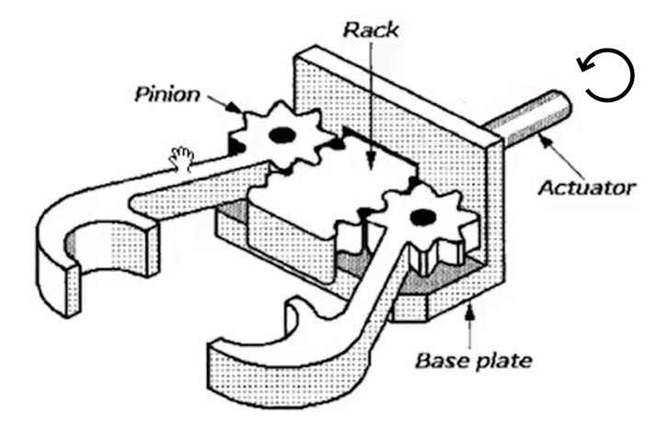

Fig. 7 The Rack and Pinion mechanism used in the arm and end affector.

The excellent amount of precision and control offered by a rack and pinion system in a robotic arm is one of its benefits. There is a direct connection between the movement of the motor and the movement of the arm or joint because the motion of the rack is directly related to the rotation of the pinion. This enables accurate placement and movement as well as easy programming and control of the arm.

The rack and pinion mechanism's purpose is to change rotational motion into linear motion or the other way around. The pinion is a tiny gear that meshes with the rack, which is a flat or toothed bar. The rack is moved linearly along its axis while the pinion spins.

Several types of racks, such as spur racks, helical racks, and straight racks, are employed in rack and pinion devices. Spur racks are utilised in applications that call for fast speed and minimum noise, and they feature straight teeth. Angled teeth on helical racks offer a smoother, quieter operation. For applications requiring exact linear motion, straight racks are employed.

Types of pinions: The pinion can also come in different types, including spur pinions, helical pinions, and worm pinions. Spur pinions have straight teeth and are used for high-speed applications. Helical pinions have angled teeth and provide a smoother and quieter operation. Worm pinions are used for high torque applications.

Advantages: Rack and pinion mechanisms have several advantages, including high precision, efficiency, and load carrying capacity. They also have a relatively simple design and can be used in a wide range of applications.

Applications: Rack and pinion mechanisms are used in various applications, including automotive steering systems, industrial machinery, robotics, and linear motion systems.

Maintenance: Regular maintenance is essential to ensure the proper functioning of the rack and pinion mechanism. This includes lubrication of the gear teeth, regular inspection for wear and damage, and replacement of worn components.

Limitations: Rack and pinion mechanisms have some limitations, including potential for wear and backlash in the gear teeth, limited speed range, and difficulty in handling heavy loads. Additionally, they require precise alignment and adjustment to function properly

IV. DESIGN METHODS
A. Tools
Tools used in the design of hardware:
1) Microcontroller Arduino Uno as a data processor and robot controllers.
2) Wireless communications HC-05 Bluetooth Transceiver Module as sender and recipient of the data instructions.
4) 3 Battery Packs each containing 3 cells (each cell 1200 mAh), total 10800 mAh.
5) DC motors as actuators driving the rotation.
7) An Ultra-Sonic Module - HC-SR04 sensor as the detection object.
8) L298 Motor Driver as a driver of motors.
9) The components of electronics, cables, and connectors.
B. Software
The supporting softwares used in our work are:
1) The Arduino IDE is used to create the program in the microcontroller.
2) Adobe Photoshop for editing.
C. Hardware design
The general description of the system can be observed on block diagram in Figure 8.

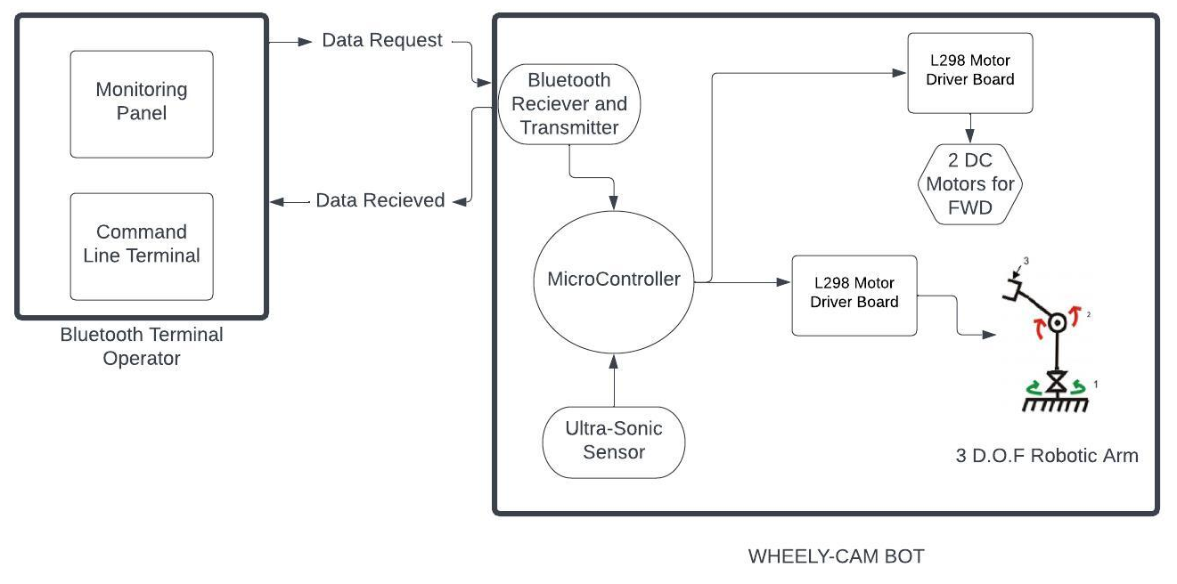Fig. 8. The System Block Diagram

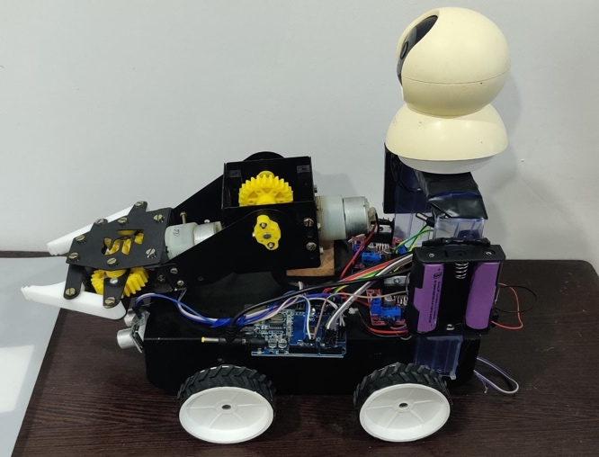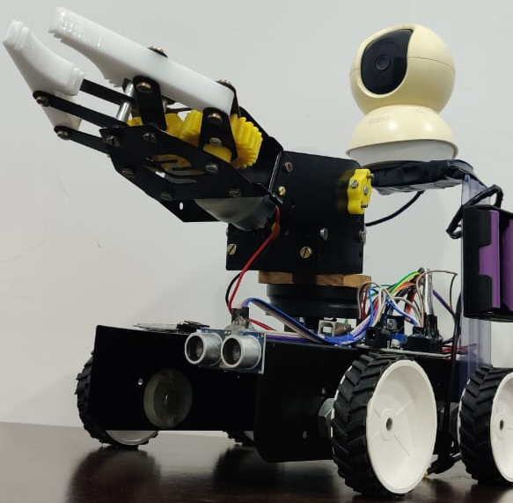
Fig. 9. The Side and Front View of the Wheely-Cam Bot.

RESULTS AND DISCUSSION
A. Design Realisation
Realisation of the RWD Robot with the addition of a robotic arm to move objects can be seen in Figure 9, while Table 1 showed the robot specifications.
TABLE I. The Robot Specifications
SL NO. | Specifications | Value
1 | Height | 34 cm
2 | Length | 25 cm
3 | Width | 23 cm
4 | Weight | 2.1 kg
5 | One Battery Cell | 3.7 VDC 1 A
6 | Total battery capacity | 10,800 mAh
7 | Object Sensor Type | Module - HC-SR04
8 | Movement Type | RWD
9 | Arm Robot Type | 3 D.O.F
B. Realisation and testing on the remote control for the arm robot
The command functions from the remote-control Bluetooth Terminal to the robot currently can only be indicated by the Command given on the terminal. The division of these functions are as follows:
a) The Command ‘B’ functioned to move the robot reverse.
b) The Command ‘F’ functioned to move the robot forward.
c) The Command ‘L’ functioned to move the robot to the left.
d) The Command ‘R’ functioned to move the robot to the right.
e) The Command ‘Y’ functioned to drive the motor to rotate the robotic arm to the right and ‘X’ functioned to rotate the robotic arm to the left.

g) The Command ‘U’ functioned to drive the motor to move the robotic arm upwards and ‘D’ for functioned to drive the motor to move the robotic arm downwards.
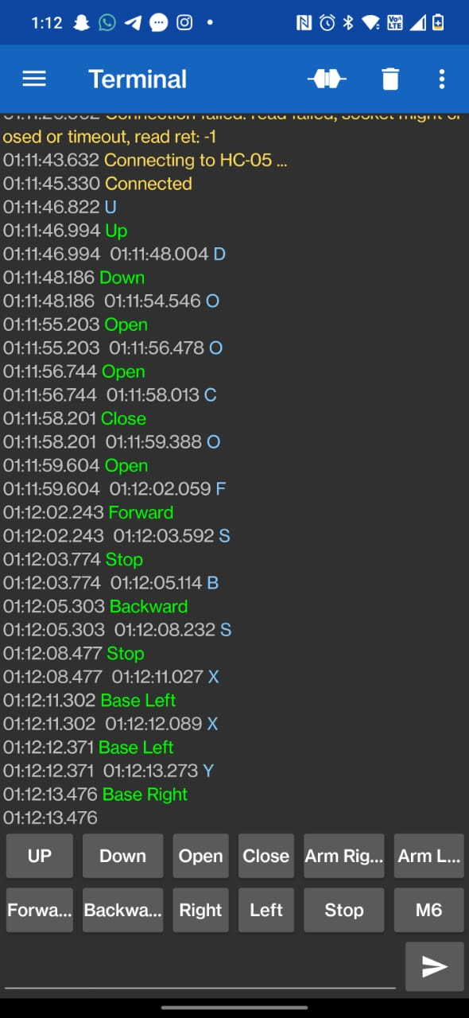
Fig. 10. The Bluetooth Terminal on Smart-Phone
h) The Command ‘O’ functioned to drive the motor to make the robotic arm gripper to open and ‘C’ functioned to drive the motor to make the robotic arm gripper to close.

VI. CONCLUSIONS
The conclusions of the work are as follows:
1. The Three Degree of Freedom (3 DOF) has enabled the robotic arm to perform the designed movements very well. Furthermore, the mobile robot successfully follows the command from each input on the terminal remote control to move the robotic arm.
2. The mobile robot and the robotic arm movement can successfully be done and it is able to pick and place objects upto 1,4 kg.
3. The rack and pinion mechanism provides a simple and efficient means of translating rotary motion into linear motion, allowing the arm to move up and down.
4. With the Wi-Fi camera, users can remotely view the arm's movements and activities, making it possible to operate the arm from a distance.

REFERENCES

B. Alit Swamardika, N. Budiastra, N. Setiawan, N. Indra, “Design of Mobile Robot with Robotic Arm Utilising Microcontroller and Wireless Communication” International Journal of Engineering and Technology · April 2017

- M. A. Qassem, I. Abuhadrous and H. Elaydi, "Modeling and Simulation of 5 DOF educational robot arm", Advanced Computer Control (ICACC) 2010 2nd International Conference on, vol. 5, pp. 569-574, 2010, March.

- S. Kurbanhusen Mustafa, G. Yang, S. Huat Yeo, W. Lin and M. Chen, "Self-calibration of a biologically inspired 7 DOF cable-driven robotic arm", Mechatronics IEEE/ASME Transactions on, vol. 13, no. 1, pp. 66-75, 2008.

- Rajgure, S. D., Aakash, D. C., Ajit, N. B., Suraj, A. B., and Swaroop, S. C. (2018). A Review on Design and Development of Pick and Place Robotic Arm. Journal of Mechanical and Civil Engineering. 74-78.

- M. A. Qassem, I. Abuhadrous and H. Elaydi, "Modeling and Simulation of 5 DOF educational robot arm", Advanced Computer Control (ICACC) 2010 2nd International Conference on, vol. 5, pp. 569-574, 2010, March.

- K. Kruthika, B. M. Kiran Kumar and S. Lakshminarayanan, "Design and development of a robotic arm," 2016 International Conference on Circuits, Controls, Communications and Computing (I4C), Bangalore, India, 2016, pp. 1-4, doi: 10.1109/CIMCA.2016.8053274.

- Dias, M. B., Mills-Tettey, G. A. and Nanayakkara, T, (2005). Robotics, education, and sustainable development. Retrieved from https://www.ri.cmu.edu/pub_files/pub4/dias_m_bernardine_2005_1/dias_m_bernardine_2005_1.pdf

Books:
- B. Siciliano, Robotics, London:Springer, 2009.

- Craig, J. J. (2005). Introduction to robotics: Mechanics and control. Pearson, USA.

Internet:
- https://en.wikipedia.org/wiki/Robotic_arm

- https://en.wikipedia.org/wiki/Arduino_Uno

- https://docs.arduino.cc/learn/starting-guide/the-arduino-software-ide

- https://www.intel.com/content/www/us/en/robotics/robotic-arm.html

- https://howtorobot.com/expert-insight/robotic-arms

- https://www.universal-robots.com/in/blog/robotic-arm-design/

