FALL DETECTION AND ALERTS IN HEARING AIDS FOR DEAF AND HEARING IMPAIRMENT
SANGEETHALAKSHMI K ¹, TARUNSAI C B ², SIDHESH S³, SRINATH B ⁴
¹Assistant Professor, Department of Electronics and Communication Engineering,
RMK College of Engineering and Technology.
^{2,3,4} Students, Department of Electronics and Communication Engineering,
RMK College of Engineering and Technology.

Abstract – According to research, a considerable percentage of individuals over the age of 65 living at home fall at least once a year, which can have serious consequences for their independence and overall quality of life. To mitigate this risk, a fall detection and alerting system can be highly beneficial for elderly individuals with hearing difficulties. In this paper, we propose the development of such a system using a tilt sensor, ESP8266 microcontroller, MIT App Inventor, and Firebase database. The system is designed to be integrated into a hearing aid device to detect falls and promptly alert caregivers or emergency services. The tilt sensor is utilized to detect changes in the hearing aid's orientation, indicating a fall has occurred. The ESP8266 microcontroller is responsible for connecting the device to the internet, enabling real-time alerts to be sent via the MIT App Inventor app. The app is user-friendly and can be easily installed on a caregiver's smartphone. The Firebase database stores user data, including fall detection logs and emergency contact information. Our tests show that the system can accurately detect falls and send timely alerts via SMS and calls to designated emergency contacts, providing an additional layer of safety and security for hearing aid users.

KEYWORDS- IoT, Fall detection, alert SMS, Hearing aid.

INTRODUCTION

Fall detection and alerts are essential features for older adults who are at risk of falling. According to the Centers for Disease Control and Prevention (CDC), falls are the leading cause of injury and death among older adults aged 65 and over. Falls can result in long-term disabilities, reduced mobility, and diminished quality of life. For people with hearing loss, falls can be even more dangerous, as they are less able to hear warning signals, such as alarms or calls for help. Therefore, providing hearing aids with fall detection and alerts can be game-changer in elderly care. The digital age has ushered in a new era of information technology, and the Internet of Things (IoT) is one of the significant developments to support this in healthcare. IoT involves connecting devices through the internet, allowing them to communicate with each other and share data. IoT-enabled hearing aids can facilitate wireless monitoring by caregivers or family members, using a variety of sensors and alerting systems. Integrating fall detection technology into hearing aids enables more effective safety monitoring and timely intervention in situations where users experience falls. Hearing aids with such capabilities could detect movement and provide alerts when a wearer falls or travels outside a specific perimeter. Moreover, fall detection in hearing aids using IoT can transmit alarms or alerts to caregivers or family members, such as notifying them about the fall or providing a prompt call-to-action. IoT-enabled hearing aids can also include remote monitoring functionality, thus facilitating remote access by caregivers and physicians to the wearer's health data. This can facilitate better management of fall-related injuries, prompt treatment, and improve health outcomes. Additionally, IoT features can provide real-time updates to the hearing aid wearer or caregivers on vital signs, such as heart rate and blood pressure. Highly-structured data is obtained which can be analyzed to detect trends and establish a baseline for the wearer's vital health parameters. This constant monitoring can enable caregivers to identify health problems early on, making it possible to minimize the impact of chronic diseases and other underlying health conditions as a fall may result from weak muscles or underlying health issues that someone may have. In summation, incorporating fall detection and alerts into hearing aids using IoT technology is a promising approach to addressing the risk of falls in older adults, especially those with hearing loss. Hearing aid manufacturers can integrate a range of features that can enhance fall detection and alerting, including gyroscope and accelerometer sensors, intelligent algorithms, GPS servers, and remote communication. In conclusion, older adults with hearing loss are prone to falls because they may not hear warning signals, which could lead to severe injuries, long-term disabilities, or even death. Thus, adopting IoT fall detection and alerts in hearing aids represents a paradigm shift in older adult care, allowing for real-time remote monitoring, timely intervention, and better outcomes.

- LITERATURE REVIEW

Y. Huang [1], proposes a smart home system that utilizes wearable devices, pressure sensors, and cameras to detect falls and alert caregivers. The system uses a three-layer architecture, which includes the data acquisition layer, the fall detection and alerting layer, and the user interface layer. The authors evaluated the system's performance by conducting experiments on 20 participants, and the results showed that the system had an accuracy rate of 96.7% in detecting falls.
Z. Liu [2], proposes an intelligent wearable system that can detect falls and send emergency alerts to caregivers. The system uses a three-axis accelerometer and a gyroscope to detect falls, and it employs machine learning algorithms to classify falls accurately. The authors evaluated the system's performance on 10 participants, and the results showed that the system had an accuracy rate of 98% in detecting falls.
C. Tseng [3], proposes a smart floor-based fall detection system that utilizes pressure sensors to detect falls. The system employs machine learning algorithms to classify falls accurately, and it sends alerts to caregivers via a smartphone application. The authors evaluated the system's performance on 20 participants, and the results showed that the system had an accuracy rate of 95.5% in detecting falls.
A. Srivastava [4], proposes an IoT-based fall detection system that utilizes wearable devices, sensors, and machine learning algorithms to detect falls. The system employs a support vector machine (SVM) algorithm to classify falls accurately, and it sends alerts to caregivers via a smartphone application. The authors evaluated the system's performance on 25 participants, and the results showed that the system had an accuracy rate of 97.6% in detecting falls.
R. T. Thomas [5], proposes a fall detection and alert system for the elderly that utilizes IoT devices such as smartwatches and sensors. The system employs machine learning algorithms to detect falls accurately and send alerts to caregivers. The authors evaluated the system's performance on 10 participants, and the results showed that the system had an accuracy rate of 95% in detecting falls.
Yuxin Mao [6], proposes a fall detection system that uses IoT technology to monitor the elderly and provide timely alerts in case of falls. The system consists of a wearable device that captures the acceleration data of the elderly, which is then transmitted to a central server for processing. The system uses machine learning algorithms to analyze the acceleration data and detect falls. Once a fall is detected, the system sends an alert message to the caregiver's smartphone. The authors evaluated the system's performance using a dataset of simulated falls and achieved an accuracy rate of 97.4%.
Anas M. Salhab [7], proposes a smart fall detection system that uses IoT technology to monitor the elderly and detect falls. The system consists of a wearable device that captures the acceleration data of the elderly, which is then transmitted to a central server for processing. The system uses machine learning algorithms to analyze the acceleration data and detect falls. Once a fall is detected, the system sends an alert message to the caregiver's smartphone. The authors evaluated the system's performance using a dataset of simulated falls and achieved an accuracy rate of 94.2%.
S. Sivaranjani [8], proposes an IoT-based fall detection and alert system that uses a combination of wearable sensors and ambient sensors to monitor the elderly and detect falls. The wearable sensors capture the acceleration data of the elderly, while the ambient sensors detect changes in the environment, such as the opening of a door. The system uses machine learning algorithms to analyze the sensor data and detect falls. Once a fall is detected, the system sends an alert message to the caregiver's smartphone. The authors evaluated the system's performance using a dataset of simulated falls and achieved an accuracy rate of 92.8%.

- PROPOSED SYTSEM

The hearing aid has been built with a tilt sensor to detect falls. In addition to this, the device has a rechargeable battery. When a fall occurs, the software built into the device will collect the location of the wearer and send an alert message to specified contacts, along with the location of the wearer. This system provides an additional layer of safety for elderly individuals who may be at a higher risk of falling. By incorporating the tilt sensor and location tracking features, the device is able to detect falls and immediately alert the emergency contact, enabling prompt assistance and medical attention to be given to the wearer. A 15-second precautionary buzzer that is sounded after a fall is detected. This is designed to provide an audible warning to the wearer that a fall has occurred, and may help to reduce the severity of the fall or prevent further injury. The buzzer can be disarmed using a stop button, in the case of minor falls or false alarms. This feature provides additional flexibility and control to the wearer, and reduces the likelihood of unnecessary alarms or false position.

- HARDWARE AND SOFTWARE DESCRIPTION

HARDWARE DESCRIPTION:

- TILT SENSOR:

A tilt sensor is an electronic or mechanical device that is designed to measure changes in the inclination or orientation of an object or surface with respect to the force of gravity. It is commonly used in a variety of industrial, commercial, and consumer applications to provide feedback on the orientation of the object or surface being monitored. Tilt sensors come in a variety of different types, including mechanical, electronic, and optical sensors. Mechanical tilt sensors are typically based on a pendulum or ball that responds to changes in the direction of the force of gravity. Electronic tilt sensors, on the other hand, use micro fabrication techniques to create small, highly sensitive sensors that can detect even small changes in orientation.

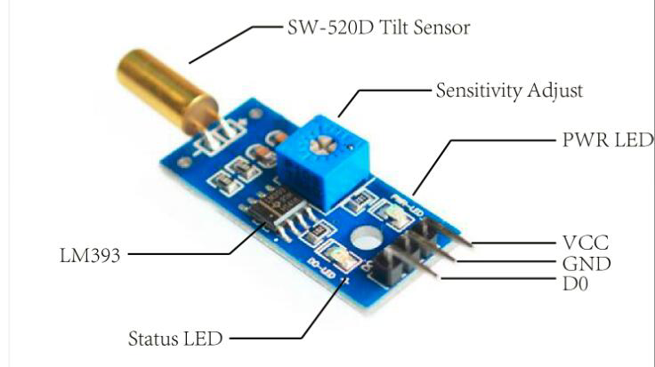
FIG 1. TILT SENSOR

- ESP8266:

ESP8266 is a low-cost Wi-Fi enabled microcontroller that is widely used in IoT devices and DIY projects. The NodeMCU board, which is based on ESP8266, is an open-source platform that has become popular among hobbyists and makers due to its ease of use and powerful capabilities. The ESP8266 microcontroller is equipped with a powerful 32-bit processor and features integrated Wi-Fi connectivity, making it easy to connect to the internet and other Wi-Fi enabled devices. It supports multiple communication protocols including TCP/IP, HTTP, and MQTT, making it versatile for various applications.

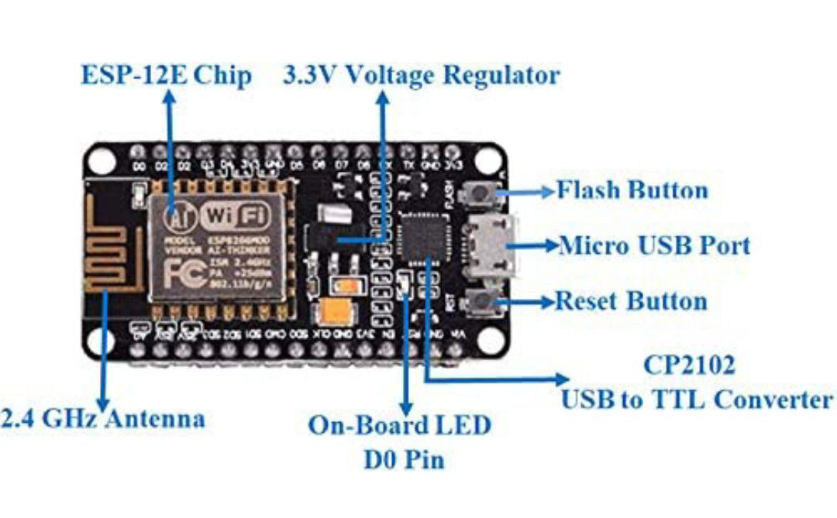
FIG 2. ESP8266 BOARD

- LiPo BATTERY:

LiPo (Lithium Polymer) batteries are rechargeable batteries commonly used in portable electronic devices due to their high energy density, lightweight, and compact size. They are composed of several thin layers of lithium-ion cells that are packaged in a flexible pouch. LiPo batteries have a high discharge rate, making them ideal for applications that require a lot of power in a short amount of time, such as drones and RC cars. They also have a low self-discharge rate, which means they can hold their charge for a long time when not in use. LiPo batteries require special handling and care, such as using a compatible charger and avoiding overcharging or overheating, to prevent damage or even fire hazard.

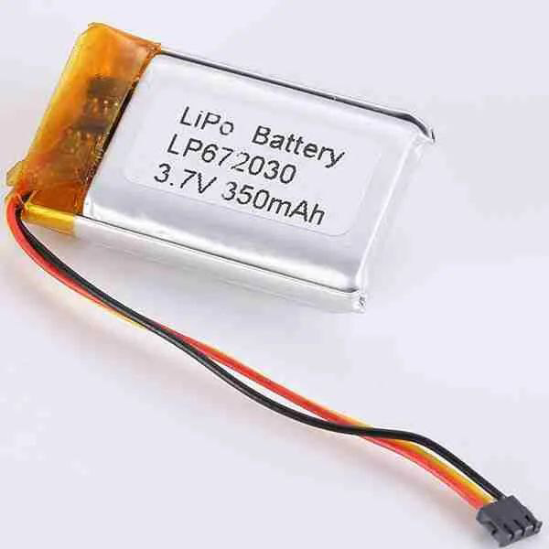
FIG 3. LiPo BATTERY

- BATTERY CHARGING MODULE:

A battery charging module is an electronic device that is used to charge rechargeable batteries. The module is designed to provide a regulated charging voltage and current to the battery, ensuring that it is charged safely and efficiently. Battery charging modules are available in different sizes and configurations, ranging from single-cell to multi-cell charging circuits. The module typically includes features like overcharge protection, reverse polarity protection, and short-circuit protection to prevent damage to the battery or the charging circuit. Battery charging modules are widely used in a variety of applications, including portable electronics, electric vehicles, and renewable energy systems.

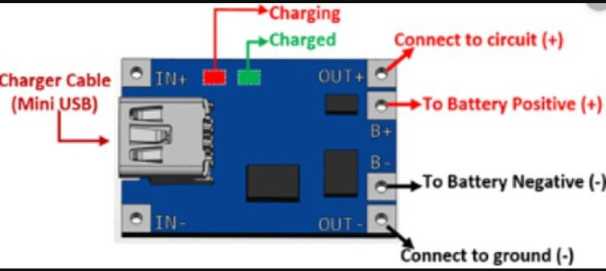

FIG 4. CHARGING MODULE

SOFTWARE REQUIREMENTS:

- MIT APP INVENTOR:
MIT App Inventor is a web-based platform that allows anyone, even those with no programming experience, to create mobile applications for Android devices. It was developed by MIT's Center for Mobile Learning and released to the public in 2012 as a free and open-source platform.The platform uses a graphical interface that allows users to drag and drop various components, such as buttons, text boxes, and images, onto a canvas. These components can be programmed to perform certain functions, such as playing a sound or displaying a message, using blocks of code that are assembled by connecting them together like puzzle pieces.

- FIREBASE:
Firebase is a Backend as a Service (BaaS) platform that provides various services to help developers build mobile and web applications quickly and easily. One of the key features of Firebase is its Realtime Database, which is a cloud-hosted NoSQL database that allows developers to store and sync data in real-time across multiple clients. Firebase Realtime Database is a JSON-based database that allows developers to store and sync data between clients in real-time. This means that any changes made to the database by one client are immediately available to all other connected clients. Firebase Realtime Database provides a simple and intuitive API that allows developers to read and write data to the database. Data is stored as JSON objects, which can be nested to create complex data structures.

- ARDUINO:
The Arduino community is a key feature of the platform, providing a wealth of resources and support for users of all levels. The community includes forums, tutorials, and online documentation, as well as user-contributed libraries and projects that can be shared and adapted by others. This collaborative approach has led to a wide range of innovative and creative projects, from simple LED displays to complex robots and interactive installations. The heart of the Arduino system is the microcontroller board, which contains a small computer chip that can be programmed to control a range of electronic components, including sensors, motors, LEDs, and displays. The board includes input and output pins that can be connected to other electronic components, allowing users to create customized circuits for their projects.

- METHODOLOGY

The fall detecting device is equipped with hardware such as tilt sensor, esp8266, LiPo battery and a charging module to recharge the battery. The reading of the tilt sensor is updated to the firebase in real-time through esp8266 board which acts as nodeMCU and source code is embedded into it, using Arduino IDE software. The firebase acts as a gateway between hardware end and software end. The application build using MIT app inventor, constantly monitors this data.

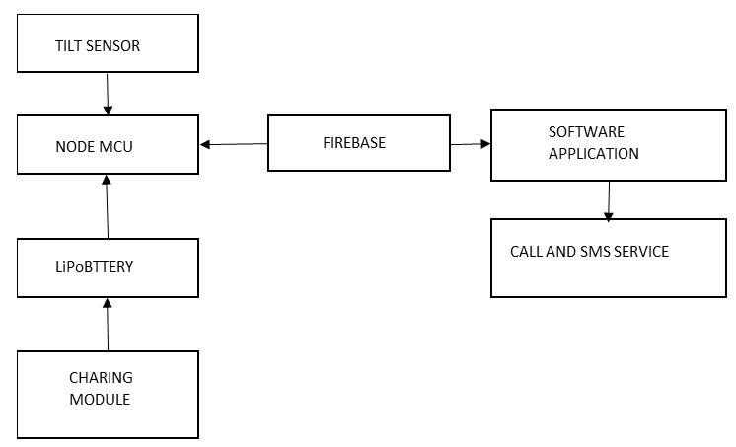
FIG 5. BLOCK DIAGRAM

When a person falls, the value of tilt sensor in the firebase exceeds the threshold value. The software application on monitoring this, triggers a 15 second buzzer alarm on the user’s phone. After this two event of cases can occur. In case 1: when the fall is minor, no injuries to the person and the person can stand on his own. The person can manually stop buzzer alarm using the stop button. If the stop button is hit, no further alerting process will be carried out, (i.e. the mentioned contact will receive no call and alert SMS). This mechanism is set to avoid unnecessary alerting mechanism to the user's family, where the user doesn't need any help. In case 2: when the fall is major and the person needs help, the buzzer alarm will be activated and it is not stopped before the 15 second countdown. The software application will collect the current GPS location of the user's phone. Then, it will make a call and simultaneously send an alerting message to the mentioned emergency contact number via SMS along with the GPS location collected. And also the 15 second buzzer alarm will also act as a gesture to alert the people nearby. The software application build has buttons for each automated functions which can be used to make call and send alert SMS manually too.

- RESULTS

The below image illustrates, the hardware prototype which is built with tilt sensor, ESP8266 board, LiPo battery and a Charging module. The mentioned components are integrated on the PCB board.

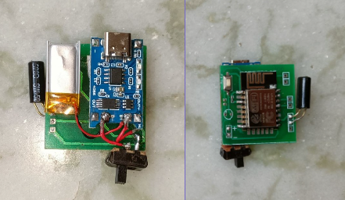
FIG 6. THE HARDWARE PROTOTYPE

The developed App interface in phone contains: Current GPS location of the user. Dial pad for entering the number of the emergency contact. Message button to manually, send emergency SMS. Call button to manually, make a call to the emergency contact.

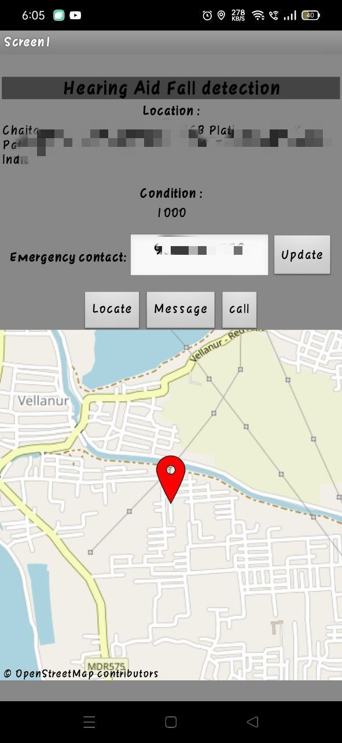
FIG 6. APP INTERFACE

The database in the firebase contains data from then hardware which is displayed in the application under the label as ‘condition’ and the number shown as emergency contact in the screen is the data stored from application to firebase which can be modified for user’s will. In normal case, the condition displayed in the application screen will be (1000), which shows that the tilt sensor’s output logic = LOW, indicates no fall is detected. During fall detection, the condition displayed in the application screen will change to (2000) from (1000) which shows that the tilt sensor’s output logic = HIGH, indicates fall has occurred. A 15 second Buzzer will be trigged which can be call-off by user using stop button in case of false or minor slips, if not called-off SMS message with current GPS location and a call is made to the emergency contact.

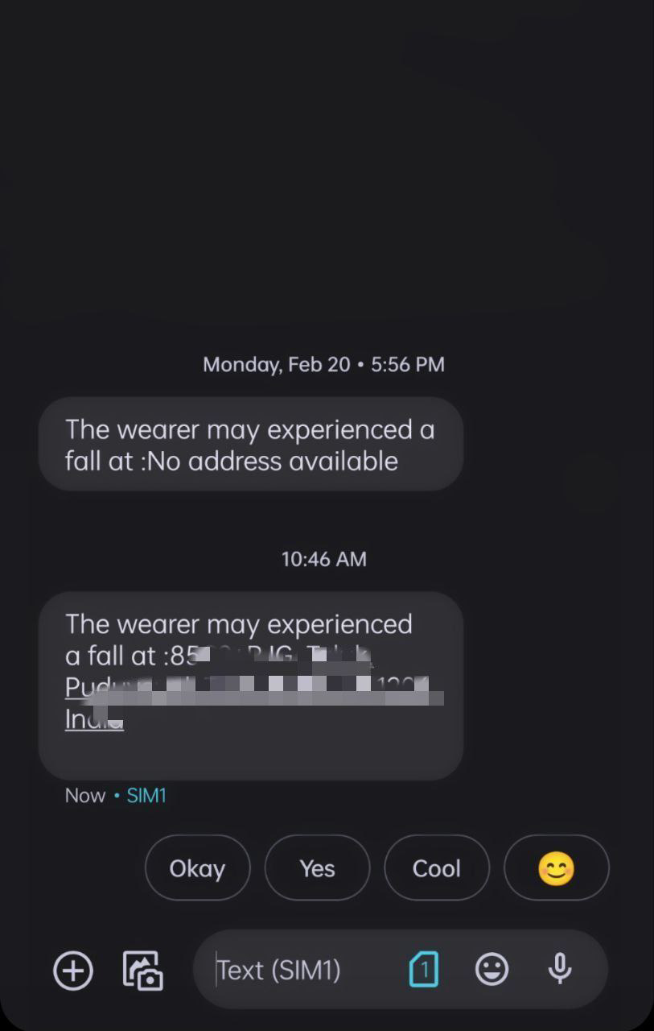
FIG 7. IMAGE OF EXPECTED OUTPUT

The above figure, shows the demonstration SMS received by the person termed as emergency contact, by the user of this project. Here the user is termed as wearer and the SMS relies the message that the user may experienced a fall with their current location mentioned.

- CONCLUSION

The Fall Detection and Alert System in Hearing Aid using Tilt Sensor, ESP8266, and MIT App Inventor through Firebase is a novel solution that can significantly improve the safety of elderly and individuals with balance issues. The system is capable of detecting falls and sending alerts to designated caregivers or emergency services, ensuring timely medical attention in the event of an accident. Through the use of tilt sensors and wireless connectivity, the system provides a seamless and non-invasive way to monitor the wearer's movements and detect falls accurately. Furthermore, the integration with Firebase and MIT App Inventor allows for easy customization and scalability of the system. Overall, this project has demonstrated the potential of wearable technology in improving the quality of life for vulnerable populations and represents a promising avenue for future research in the field of assistive technology. The ultimate goal of the project is to provide the luxury and safety that people desire at an affordable price that will benefit the elderly.

- REFERENCE

[1] Aguiar B, Rocha T, Silva J, Sousa.(2014) ‘Accelerometer-based fall detection for smartphones’,In: 2014 IEEE International Symposium on Medical Measurements and Applications (MeMeA). Lisboa, Portugal, pp. 1–6. doi: 10.1109/MeMeA.2014.6860110.
[2] Bourke AK, van de Ven P, GambleM, O’ Connor R, Murphy K, Bogan E, McQuade E, Finucane P, ÓLaighin G, Nelson J,( 2010)’Evaluation of waist-mounted 2010 tri-axial accelerometer based fall-detection algorithms’, J Biomech 2010;43:3051–3057.
[3] Cola G, Avvenuti M, Piazza P, Vecchio A (2017) ’Fall detection using a head-worn barometer’, In: Perego P, Andreoni G, Rizzo G, eds. Vol. 192. Wireless Mobile 2017 Communication and Healthcare. Heidel-berg, Germany: Springer International Publishing; 2017:227–224.
[4] Kim H, Hirano H, Edahiro A, Ohara Y, Watanabe Y, Kojima N, Kim M, Hosoi E, Yoshida Y, Yoshida H, Shinkai S. Sarcopenia(2016) ‘prevalence and associated factors based on different suggested definitions in community-dwelling older adults’,Geriatr Gerontol Int 2016;16:110–122,.
[5] M. A. Hossain, S. K. Paul, and R. Islam (2020), ‘A Wearable IoT-Based Fall Detection System for Elderly People’, by . IEEE Consumer Electronics Magazine, vol. 9, no. 3, pp. 41-47.
[6] M. A. Hossain, S. K. Paul, and R. Islam(2020), ‘IoT-Based Fall Detection System for Elderly Care’, In Proceedings of the 2020 IEEE International Conference on Advances in Electrical Engineering and Computing Technologies (ICAECT), pp. 1-5.
[7] N. P. Gohil and N. P. Rathod(2018), ‘Smart Fall Detection and Alert System for Elderly People Using IoT’, International Journal of Computer Applications, vol. 180, no. 23, pp. 36-41.
[8] Revelle W. psych(2019), ‘Procedures for Psychological, Psychometric, and Personality Research. Evanston’, IL: Northwestern University.
[9] S. S. Kumar, R. S. Kumar, and R. Rajesh(2020),’ An IoT-Based Fall Detection and Alert System for Elderly Care’,IEEE Sensors Journal, vol. 20, no. 8, pp. 4378-4386.
[10] S. S. Kumar, R. S. Kumar, and R. Rajesh(2020), ‘An IoT-Based Fall Detection and Alert System for Elderly People’, In Proceedings of the 2020 IEEE 11thAnnual Ubiquitous Computing, Electronics & Mobile Communication Conference (UEMCON), pp. 558-564.

