Camera Vision Based Animal Beat Back System for Agriculture using Machine Learning
¹ Harishankar A, ²Karthikeyan M, ²Dhanasekhar B, ³Charan N, ⁴Jeeva K

¹Assistant Professor, Department of Computer Science Engineering, Adhiyamaan College of Engineering(Autonomous),Hosur, India
^{2,3,4} Student, Department of Computer Science Engineering., Adhiyamaan College of Engineering(Autonomous),Hosur, India

Abstract- Crop raiding by animals has become one of the most common human animal disputes as a result of human encroachment of wildlife habitats and deforestation. Farmers has tried many ways for preventing animals raid from lighting fire crackers to maintain a watch on the field through the night but none of these were effective. Nevertheless, some of the traditional methods have environmental pollution effects on both humans and ungulates, while others are very expensive with high maintenance costs, with limited reliability and limited effectiveness. In this project, we develop a system, that combines Computer Vision using DCNN for detecting and recognizing animal species, and specific ultrasound emission (i.e., different for each species) for repelling them. The edge computing device activates the camera, then executes its DCNN software to identify the target, and if an animal is detected, it sends back a message to the Animal Repelling Module including the type of ultrasound to be generated according to the category of the animal.

- INTRODUCTION
Agriculture is undergoing a fourth revolution triggered by the exponentially increasing use of information and communication technology (ICT) in agriculture. Autonomous, robotic vehicles have been developed for farming purposes, such as mechanical weeding, application of fertilizer, or harvesting of fruits. Virtual fence technologies allow cattle herd management based on remote-sensing signals and sensors or actuators attached to the livestock. Taken together, these technical improvements constitute a technical revolution that will generate disruptive changes in agricultural practices. This trend holds for farming not only in developed countries but also in developing countries, where deployments in ICT (e.g., use of mobile phones, access to the Internet) are being adopted at a rapid pace and could become the game-changers in the future (e.g., in the form of seasonal drought forecasts, climate-smart agriculture).
- LITERATURE SURVEY
[1] Zachary J.Ruff, Damon B.Lesmeister, Cara L.Appel, Christopher M.Sullivan[2021] The aim of this project is automated identification of animal sounds using Convolutional Neural Networks. [2]R. Nikhil; B.S. Anisha; Ramakanth Kumar P.[2020]. The aim of this project is crop prediction helps the farmers to grow suitable crops depending on the soil parameters by the use of machine learning techniques and it also helps in prevention of the intruders like wild animals into the field.[3]L. G. C. Vithakshana; W.G.D.M. Samankula [2021]. The aim of this project is an IoT based acoustic classification system was designed using Convolutional Neural Networks (CNN), which is beneficial for those who are interested in monitoring ecosystems such as animal scientists, zoologists, and environmentalists.
- PROPOSED SYSTEM
AI Computer Vision based DCNN for detecting animal species, and specific ultrasound emission (i.e., different for each species) for repelling them .design, deployment and assessment of an intelligent smart agriculture repelling and monitoring IoT system based on embedded edge AI, to detect and recognize the different kinds of animal, as well as generate ultrasonic signals tailored to each species of the animal .This combined technology used can help farmers and agronomists in their decision making and management process .Deep learning in the form of Convolutional Neural Networks (CNNs) to perform the animal recognition.
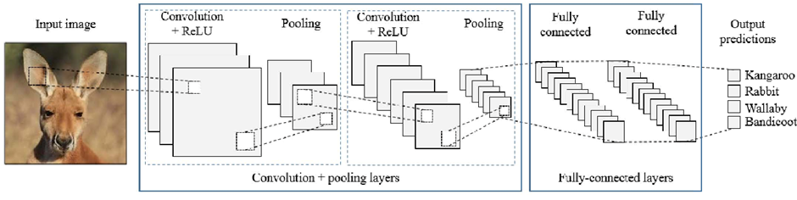
- WORKING
In this project, deep convolution neural network-based classification algorithm is devised to detect animals both in video and images. Proposed approach is a classification model based on different features and classifiers. The different features like color, gabor and LBP are extracted from the segmented animal images.Possibilities of fusing the features for improving the performance of the classification have also been explored. Classification of animals is accomplished using CNN and symbolic classifiers. Initially, features are extracted from images/frames using blink app pre-trained convolution neural network.
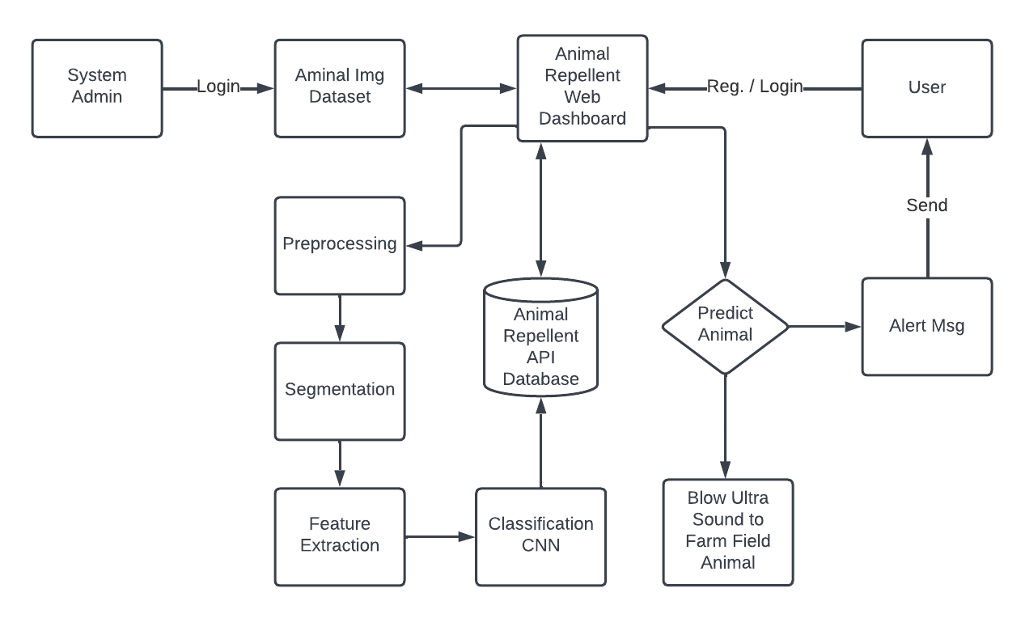

- CONCLUSION
Agricultural farm security is widely needed technology nowadays. In order to accomplish this, a vision-based system is proposed and implemented using Python and Open CV and developed an Animal Repellent System to blow out the animals. The proposed CNN was evaluated on the created animal database. The overall performances were obtained using different number of training images and test images .The obtained experimental results of the performed experiments show that the proposed CNN gives the best recognition rate for a greater number of input training images (accuracy of about 98 %).

- REFERENCE
[1] M. De Clercq, A. Vats, and A. Biel, ``Agriculture 4.0: The future of farmingtechnology,'' in Proc. World Government Summit, Dubai, UAE, 2018,pp. 11-13.
[2] Y. Liu, X. Ma, L. Shu, G. P. Hancke, and A. M. Abu-Mahfouz, ``Fromindustry 4.0 to agriculture 4.0: Current status, enabling technologies,and research challenges,'' IEEE Trans. Ind. Informat., vol. 17, no. 6,pp. 4324334, Jun. 2021.
[3] M. S. Farooq, S. Riaz, A. Abid, K. Abid, and M. A. Naeem, ``A surveyon the role of IoT in agriculture for the implementation of smart farming,''IEEE Access, vol. 7, pp. 156237-156271, 2019.
[4] K. Kirkpatrick, ``Technologizing agriculture,'' Commun. ACM, vol. 62,no. 2, pp. 14-16, Jan. 2019.
[5] A. Farooq, J. Hu, and X. Jia, ``Analysis of spectral bands and spatialresolutions for weed classification via deep convolutional neural network,''IEEE Geosci. Remote Sens. Lett., vol. 16, no. 2, pp. 183-187,Feb. 2018.
[6] M. Apollonio, S. Ciuti, L. Pedrotti, and P. Banti, ``Ungulates and theirmanagement in Italy,'' in European Ungulates and Their Managementin the 21th Century. Cambridge, U.K.: Cambridge Univ. Press, 2010,pp. 475-505.
[7] A. Amici, F. Serrani, C. M. Rossi, and R. Primi, ``Increase in crop damagecaused by wild boar (Sus scrofa L.): The `refuge effect,''' AgronomySustain. Develop., vol. 32, no. 3, pp. 683-692, Jul. 2012.
[8] S. Giordano, I. Seitanidis, M. Ojo, D. Adami, and F. Vignoli, ``IoT solutionsfor crop protection against wild animal attacks,'' in Proc. IEEE Int.Conf. Environ. Eng. (EE), Mar. 2018, pp. 1-5.
[9] M. O. Ojo, D. Adami, and S. Giordano, ``Network performance evaluationof a LoRa-based IoT system for crop protection against ungulates,'' inProc. IEEE 25th Int.Workshop Comput. Aided Modeling Design Commun.Links Netw. (CAMAD), Sep. 2020, pp. 1-6.
[10] H. E. Heefner and R. S. Heffner, ``Auditory perception,'' in Farm Animalsand the Environment, C. Phillips and D. Piggins, Eds. Wallingford, U.K.:CAB International, 1992.
[11] https://www.indiatimes.com/news/india/in-the-battle-between-man-vs-wild-highways-railway- lines-emerge-as-new-challenges-375504.html
[12]https://adventuresinmachinelearning.com/neural-networks-tutorial/

