STUDY OF BATTERY CHARGING AND DISCHARGING CHARACTERISTICS OF DIFFERENT BATTERIES ON DIFFERENT LOADS

A Report of Major Project-II
Submitted towards the partial fulfilment of the requirement for the award
of the degree of
Master of Technology in Engineering Systems

SUBMITTED BY

MEHER KUMAR
M.TECH.(VIII-SEM) PART TIME
ROLL NO. 1906417
COURSE NUMBER PEE 300

DEPARTMENT OF ELECTRICAL ENGINEERING
FACULTY OF ENGINEERING
DAYALBAGH EDUCATIONAL INSTITUTE
(DEEMED TO BE UNIVERSITY)
DAYALBAGH , AGRA-282005
MAY-2022

(i)|Page

CERTIFICATE

This is to certify that Mr. Meher Kumar has carried out the project work presented in this report entitled “ STUDY OF BATTERY CHARGING AND DISCHARGING CHARACTERISTICS OF DIFFERENT BATTERIES ON DFFERENT LOADS ” for the award of Master of Technology in Engineering Systems From Faculty of Engineering, Dayalbagh Educational Institute, Agra, under my supervision. The thesis embodies results of original work and studies carried out by student himself and the contents of the thesis do not form the award of any other degree to the candidate or to anybody else.

SUPERVISOR

Dr. G. S. Sailesh Babu
Prof. and Head
Department of Footwear Technology
Faculty of Engineering
Dayalbagh Educational Institute
Dayalbagh, Agra-282005

 HEAD OF DEPARTMENT
Dr.KEDRI JANARDANA 
Electrical Engineering Department Faculty of Engineering
Faculty of Engineering Dayalbagh Educational Institute
Dayalbagh Educational Institute (Deemed to be University)
(Deemed to be University)
Dayalbagh, Agra-282005

(ii)|Page

DECLARATION

I hereby declare that the project work entitled ““ STUDY OF BATTERY CHARGING AND DISCHARGING CHARACTERISTICS OF DIFFERENT BATTERIES ON DFFERENT LOADS ”” submitted to the Dayalbagh Educational Institute (Deemed to be University), Agra , is a record of the original work done by me under the guidance of Dr. G S Shailesh Babu , and the project work is submitted in the partial fulfilment of the requirements for the award of the degree of Master of Technology in Engineering Systems . The results embodied in the report have not been submitted to any other University or Institute for the award of any degree.




(iii)|Page

ACKNOWLEDGEMENTS

I would like to express my gratitude to my project guide Dr. G S Shailesh Babu, Department of Electrical Engineering , Dayalbagh Educational Institute (D.E.I), Prof. and Head, Agra for his pain staking whole hearted efforts and the valuable guidance at each stage of the development of project.

I would also like to thanks Prof. V.SOAMI DAS, Dean, Faculty of Engineering, D.E.I for providing the facilities during the work .

I would also like to thanks Prof. A.K.Saxena, Head of the Electrical Department and Prof. K Janardan , Coordinator M.Tech., Faculty of Engineering, for his valuable suggestions during the progress of the project work.
Finally, I am thankful to my near and dear ones related to this project.



(iv)|Page
ABSTRACT

Earlier Lead Acid batteries were available and used widely since Lithium Ion batteries were not discovered .The Lead Acid are still used since they have low cost of initial investment and have low specific energy and are capable of high discharge rates . When Lithium Ion batteries came into practice , they were found to be having light weight , able to provide constant power ,are temperature tolerant and charging is fast and safe .Though Lead Acid battery are cheap in initial investment but lithium Ion battery although costly requires less investment and service .
Since nowdays both batteries intermixed charging is used . The mobile charging is done in car itself. The car charged from lead acid or lithium ion depends upon type of battery used . Whereas mobile has lithium ion battery . So when mobile charging is done in car , there is intermixing of two batteries. And so a study forcasing the characteristics nature in regards to charging and discharging regimes i.e state of charge and current naturehood during these period is envitable . So now we are charging Lithium Ion battery with Lead Acid or Lithium Ion or vice –versa .So due to this at times , we observe that there is too much delay in charging . So it becomes evident to check the Charging and Discharging characteristics of both Lead Acid and Lithium Ion batteries separately and also through their series-parallel combinations to discover the malfunctioning in it in order to raise the points so that further more work could be done in this respect . By studying the nature both through the display and waveforms , we are able to demonstrate the peculiarities and able to derive the basic inbuilt in their charging and discharging patterns . Thus we are getting much better throughput in understanding .
“Batteries with good characteristics will help the user to operate their devices safely .A good battery has to be dependable and reliable on load varying working conditions .A rectified Battery management system not only possess good energy density but it also not affected by the temperature variations developed in working environment .So an attempt is made to survey the SOC and current characteristics to understand their limitations .

(v)|Page

LIST OF FIGURES
Figure No. | Title | Page No.
Figure 1.1 | GRAPH BETWEEN STATE OF CHARGE AND CHARGE EFFICIENCY | 7
Figure 1.2 | GRAPH BETWEEN CHARGING CURRENT AND CHARGE EFFICIENCY | 8
Figure 1.3 | LEAD ACID BATTERY CHARGE CHARACTERISTICS TAKING CASE THAT CHARGING IS NON CONTINUOUS AND PEAK VOLTAGE HIGHER | 8
Figure 1.4 | LEAD ACID BATTERY CHARGE CHARACTERISTICS ATKING CASE THAT CHARGING IS CONTINUOUS AND PEAK VOLTAGE LOWER | 9
Figure 1.5 | CHARGE CURVE OF LITHIUM –ION BATTERY | 9
Figure 1.6 | DISCHARGE CURVE OF LITHIUM –ION BATTERY | 10
Figure 3.1.1 | DC VOLTAGE SOURCE DETAIL FOR LEAD ACID BATTERY CHARGING | 18
Figure 3.1.2 | DETAIL SPECIFICATION OF LEAD ACID | 19
Figure 3.1.3 | CIRCUIT DIAGRAM OF LEAD ACID BATTERY CHARGING FOR 425 SECONDS | 20
Figure 3.1.4 | SOC & CURRENT WAVEFORM OF LEAD ACID BATTERY CHARGING FOR 425 SECONDS | 20
Figure 3.2.1 | DC VOLTAGE SOURCE DETAIL FOR LITHIUM ION BATTERY CHARGING | 22
Figure 3.2.2 | DETAILS SPECIFICATION OF LITHIUM ION BATTERY | 22
Figure 3.2.3 | CIRCUIT DIAGRAM OF LITHIUM ION BATTERY CHARGING FOR 425 SECONDS | 23
Figure 3.2.4 | SOC & CURRENT WAVEFORM OF LITHIUM ION BATTERY CHARGING FOR 425 SECONDS | 23
Figure 3.3.1 | DC VOLTAGE SOURCE DETAIL FOR LEAD ACID & LEAD ACID BATTERY SERIES CHARGING | 25  (vi)|Page
Figure 3.3.2 | DETAIL SPECIFICATION OF BOTH LEAD ACID BATTERY IN SERIES | 25
Figure 3.3.3 | CIRCUIT DIAGRAM OF LEAD ACID BATTERY & LEAD ACID BATTERY SERIES CHARGING FOR 1 HOUR | 26
Figure 3.3.4 | SOC & CURRENT WAVEFORM OF LEAD ACID BATTERY SERIES CHARGING FOR 1 HOUR | 26
Figure 3.4.1 | DETAIL SPECIFICATION OF LITHIUM ION BATTERY CONNECTED IN SERIES WITH LEAD ACID BATTERY | 28
Figure 3. 4.2 | DETAIL SPECIFICATION OF LEAD ACID BATTERY CONNECTED IN SERIES WITH LITHIUM ION BATTERY | 28
Figure 3.4.3 | CIRCUIT DIAGRAM OF LEAD ACID BATTERY SERIES CHARGING WITH LITHIUM ION BATTERY FOR 1 HOUR | 29
Figure 3.4.4 | SOC & CURRENT WAVEFORM OF LEAD ACID BATTERY SERIES CHARGING WITH LITHIUM ION BATTERY FOR 1 HOUR | 29
Figure 3.5.1 | DC VOLTAGE SOURCE DETAIL FOR LITHIUM ION BATTERY SERIES CHARGING | 31
Figure 3.5.2 | DETAIL SPECIFICATION OF BOTH LITHIUM ION BATTERY FOR SERIES CHARGING | 31
Figure 3.5.3 | CIRCUIT DIAGRAM OF CHARGING OF LITHIUM ION BATTERY CONNECTED IN SERIES WITH LITHIUM ION BATTERY FOR 1 HOUR | 32
Figure 3.5.4 | SOC AND CURRENT WAVEFORM OF CHARGING OF LITHIUM ION BATTERY CONNECTED IN SERIES WITH LITHIUM ION BATTERY FOR 1 HOUR | 32
Figure 3.6.1 | DC VOLTAGE SOURCE DETAIL FOR LEAD ACID BATTERY CONNECTED TO LEAD ACID BATTERY FOR PARALLEL CHARGING | 34
Figure3.6.2 | DETAIL SPECIFICATION OF BOTH LEAD ACID BATTERY FOR PARALLEL CHARGING | 34 (vii)|Page
Figure3. 6.3 | CIRCUIT DIAGRAM OF BOTH LEAD ACID BATTERY PARALLEL CHARGING FOR 1 HOUR | 35
Figure 3.6.4 | SOC & CURRENT WAVEFORM OF LEAD ACID BATTERY CONNECTED IN PARALLEL FOR CHARGING FOR 1 HOUR | 35
Figure 3.7.1 | DETAIL SPECIFICATION OF LEAD ACID BATTERY | 37
Figure 3.7.2 | DETAIL SPECIFICATION OF LITHIUM ION BATTERY | 37
Figure 3.7.3 | CIRCUIT DIAGRAM OF LEAD ACID & LITHIUM ION BATTERY PARALLEL CHARGING FOR 1 HOUR | 38
Figure 3.7.4 | SOC & CURRENT WAVEFORM OF LEAD ACID & LITHIUM ION BATTERY PARALLEL CHARGING FOR 1 HOUR | 38
Figure 3.8.1 | CIRCUIT DIAGRAM OF LITHIUM ION & LITHIUM ION BATTERY PARALLEL CHARGING FOR 1 HOUR | 40
Figure 3.8.2 | SOC & CURRENT WAVEFORM OF LITHIUM ION & LITHIUM ION BATTERY PARALLEL CHARGING FOR 1 HOUR | 40
Figure 3.9.1 | CIRCUIT DIAGRAM OF DISCHARGE OF LEAD ACID BATTERY WITH 72 OHMS RESISTANCE FOR 500 HOURS | 42
Figure 3.9.2 | SOC & CURRENT WAVEFORM OF LEAD ACID BATTERY DISCHARGE FOR 500 HOURS | 42
Figure 3.9.3(a) | CIRCUIT DIAGRAM OF DISCHARGE OF LEAD ACID BATTERY WITH LOAD AS STEP SIGNAL FOR 25 HOURS | 43
Figure3. 9.3(b)&3.9.3(c) | STEP SIGNAL WAVEFORM & DETAIL | 43-44
Figure3. 9.4 | SOC & CURRENT WAVEFORM OF DISCHARGE OF LEAD ACID BATTERY CONNECTED TO STEP SIGNAL FOR 25 HOURS | 44
Figure3. 9.5 | CIRCUIT DIAGRAM OF LEAD ACID BATTERY DISCHARGE CONNECTED TO LOAD OF STEP SIGNAL WITH RAMP START PROVIDED BY SIGNAL BUILDER FOR 250 HOURS | 45  (viii)|Page
Figure3. 9.6 | IMAGE OF STEP SIGNAL WITH RAMP START DEVELOPED IN SIGNAL BUILDER | 45
Figure3. 9.7 | SOC & CURRENT WAVEFORM OF LEAD ACID BATTERY DISCHARGE CONNECTED TO LOAD OF STEP SIGNAL WITH RAMP START FOR 250 HOURS | 46
Figure 3.10.1 | CIRCUIT DIAGRAM OF DISCHARGE OF LITHIUM ION BATTERY WITH LOAD RESISTANCE 72 OHMS FOR 500 HOURS | 48
Figure 3.10.2 | SOC & CURRENT WAVEFORM OF LITHIUM ION BATTERY DISCHARGE FOR 500 HOURS | 48
Figure 3.10.3(a) | CIRCUIT DIAGRAM OF DISCHARGE OF LITHIUM ION BATTERY WITH LOAD AS STEP SIGNAL FOR 25 HOURS | 49
Figure 3.10.3(b) | IMAGE SHOWING DETAILS OF STEP SIGNAL | 49
Figure 3.10.3(c) | SOC & CURRENT WAVEFORM OF DISCHARGE OF LITHIUM ION BATTERY CONNECTED TO STEP SIGNAL FOR 25 HOURS | 50
Figure 3.10.4(a) | IMAGE OF STEP SIGNAL WITH RAMP START DEVELOPED IN SIGNAL BUILDER | 50
Figure 3.10.4(b) | CIRCUIT DIAGRAM OF DISCHARGE OF LITHIUM ION BATTERY WITH LOAD AS STEP SIGNAL WITH RAMP START FOR 20 HOURS | 51
Figure3. 10.4(c) | SOC & CURRENT WAVEFORM OF DISCHARGE OF LITHIUM ION BATTERY CONNECTED TO LOAD AS STEP SIGNAL WITH RAMP START FOR 20 HOURS | 51
Figure 3.11.1(a) | CIRCUIT DIAGRAM OF DISCHARGE OF LEAD ACID-LEAD ACID SERIES BATTERY WITH LOAD AS 72 OHM RESISTANCE FOR 500 HOURS | 53 (ix)|Page
Figure 3.11.1(b) | SOC & CURRENT WAVEFORM OF DISCHARGE OF LEAD ACID-LEAD ACID SERIES BATTERY CONNECTED TO LOAD RESISTANCE OF 72 OHMS FOR 500 HOURS | 53
Figure3. 11.2(a) | CIRCUIT DIAGRAM OF DISCHARGE OF LEAD ACID-LEAD ACID SERIES BATTERY WITH LOAD AS STEP SIGNAL WITH RAMP START FOR 500 HOURS | 54
Figure 3.11.2(b) | SOC & CURRENT WAVEFORM OF OF DISCHARGE OF LEAD ACID-LEAD ACID SERIES BATTERY WITH LOAD AS STEP SIGNAL WITH RAMP START FOR 500 HOURS | 54
Figure3. 11.3(a) | CIRCUIT DIAGRAM OF DISCHARGE OF LEAD ACID-LEAD ACID SERIES BATTERY WITH LOAD AS STEP SIGNAL WITH RAMP START DEVELOPED BY SIGNAL BUILDER FOR 500 HOURS | 55
Figure 3.11.3(b) | SOC & CURRENT WAVEFORM OF DISCHARGE OF LEAD ACID-LEAD ACID SERIES BATTERY WITH LOAD AS STEP SIGNAL WITH RAMP START DEVELOPED BY SIGNAL BUILDER FOR 500 HOURS | 55
Figure 3.12.1(a) | CIRCUIT DIAGRAM OF DISCHARGE OF LEAD ACID-LITHIUM ION ACID SERIES BATTERY WITH LOAD RESISTANCE OF 72 OHMS FOR 500 HOURS | 57
Figure 3.12.1(b) | WAVEFORM OF DISCHARGE OF LEAD ACID-LITHIUM ION ACID SERIES BATTERY WITH LOAD RESISTANCE OF 72 OHMS FOR 500 HOURS | 57
Figure 3.12.1(c) | SOC & CURRENT WAVEFORM OF DISCHARGE OF LEAD ACID-LITHIUM ION ACID SERIES BATTERY WITH LOAD AS STEP SIGNAL FOR 500 HOURS | 58 (x)|Page
Figure 3.12.1(d) | SOC & CURRENT WAVEFORM OF DISCHARGE OF LEAD ACID-LITHIUM ION ACID SERIES BATTERY WITH LOAD AS STEP SIGNAL WITH RAMP START FOR 500 HOURS | 58
Figure 3.13.1(a) | CIRCUIT DIAGRAM OF DISCHARGE OF LITHIUM ION-LITHIUM ION ACID SERIES BATTERY WITH LOAD RESISTANCE OF 72 OHMS FOR 500 HOURS | 60
Figure 3.13.1(b) | SOC & CURRENT WAVEFORM OF DISCHARGE OF LITHIUM ION-LITHIUM ION ACID SERIES BATTERY WITH LOAD RESISTANCE OF 72 OHMS FOR 500 HOURS | 60
Figure 3.13.1(c) | SOC & CURRENT WAVEFORM OF DISCHARGE OF LITHIUM ION-LITHIUM ION ACID SERIES BATTERY WITH LOAD AS STEP SIGNAL FOR 500 HOURS | 61
Figure 3.13.1(d) | SOC & CURRENT WAVEFORM OF DISCHARGE OF LITHIUM ION-LITHIUM ION ACID SERIES BATTERY WITH LOAD AS STEP SIGNAL WITH RAMP START FOR 500 HOURS | 61
Figure 3.14.1(a) | CIRCUIT DIAGRAM OF DISCHARGE OF PARALLEL CONNECTED LEAD ACID-LEAD ACID ACID BATTERY WITH LOAD RESISTANCE OF 72 OHMS FOR 500 HOURS | 63
Figure 3.14.1(b) | SOC & CURRENT WAVEFORM OF DISCHARGE OF PARALLEL CONNECTED LEAD ACID-LEAD ACID ACID BATTERY WITH LOAD RESISTANCE OF 72 OHMS FOR 500 HOURS | 63
Figure 3.14.1(c)&13.1(d) | DETAIL OF LEAD ACID BATTERY & STEP SIGNAL | 64 (xi)|Page
Figure 3.14.2(a) | CIRCUIT DIAGRAM OF DISCHARGE OF PARALLEL CONNECTED LEAD ACID-LEAD ACID ACID BATTERY WITH LOAD AS STEP SIGNAL FOR 500 HOURS | 65
Figure 3.14.2(b) | SOC & CURRENT WAVEFORM OF DISCHARGE OF PARALLEL CONNECTED LEAD ACID-LEAD ACID ACID BATTERY WITH LOAD AS STEP SIGNAL FOR 500 HOURS | 65
Figure 3.14.3(a) | CIRCUIT DIAGRAM OF DISCHARGE OF PARALLEL CONNECTED LEAD ACID- LEAD ACID BATTERY WITH LOAD AS STEP SIGNAL WITH RAMP START DEVELOPED BY SIGNAL BUILDER FOR 500 HOURS | 66
Figure3. 14.3(b) | SOC & CURRENT WAVEFORM OF DISCHARGE OF PARALLEL CONNECTED LEAD ACID-LEAD ACID BATTERY WITH LOAD AS STEP SIGNAL WITH RAMP START DEVELOPED BY SIGNAL BUILDER FOR 500 HOURS | 66
Figure 3.15.1(a) | CIRCUIT DIAGRAM OF DISCHARGE OF PARALLEL CONNECTED LEAD ACID-LITHIUM ION BATTERY WITH LOAD RESISTANCE 72 OHMS FOR 470 HOURS | 68
Figure 3.15.1(b) | SOC & CURRENT WAVEFORM OF DISCHARGE OF PARALLEL CONNECTED LEAD ACID-LITHIUM ION BATTERY WITH LOAD RESISTANCE 72 OHMS FOR 470 HOURS | 68
Figure 3.15.2(a) | CIRCUIT DIAGRAM OF DISCHARGE OF PARALLEL CONNECTED LEAD ACID-LITHIUM ION BATTERY WITH LOAD AS STEP SIGNAL FOR 140 HOURS | 69
Figure 3.15.2(b) | SOC & CURRENT WAVEFORM OF DISCHARGE OF PARALLEL CONNECTED LEAD ACID-LITHIUM ION BATTERY WITH LOAD AS STEP SIGNAL FOR 140 HOURS | 69 (xii)|Page
Figure 3.15.3(a) | CIRCUIT DIAGRAM OF DISCHARGE OF PARALLEL CONNECTED LEAD ACID-LITHIUM ION BATTERY WITH LOAD AS STEP SIGNAL WITH RAMP START FOR 200 HOURS | 70
Figure 3.15.3(b) | SOC & CURRENT WAVEFORM OF DISCHARGE OF PARALLEL CONNECTED LEAD ACID-LITHIUM ION BATTERY WITH LOAD AS STEP SIGNAL WITH RAMP START FOR 200 HOURS | 70
Figure 3.16.1(a) | CIRCUIT DIAGRAM OF DISCHARGE OF PARALLEL CONNECTED LITHIUM ION-LITHIUM ION BATTERY WITH LOAD AS 72 OHMS FOR 500 HOURS | 72
Figure 3.16.1(b) | SOC & CURRENT WAVEFORM OF DISCHARGE OF PARALLEL CONNECTED LITHIUM ION-LITHIUM ION BATTERY WITH LOAD AS 72 OHMS FOR 500 HOURS | 72
Figure 3.16.2(a) | CIRCUIT DIAGRAM OF DISCHARGE OF PARALLEL CONNECTED LITHIUM ION-LITHIUM ION BATTERY WITH LOAD AS STEP SIGNAL FOR 6 HOURS | 73
Figure 3.16.2(b) | SOC & CURRENT WAVEFORM OF DISCHARGE OF PARALLEL CONNECTED LITHIUM ION-LITHIUM ION BATTERY WITH LOAD AS STEP SIGNAL FOR 6 HOURS | 73
Figure 3.16.3(a) | CIRCUIT DIAGRAM OF DISCHARGE OF PARALLEL CONNECTED LITHIUM ION-LITHIUM ION BATTERY WITH LOAD AS STEP SIGNAL WITH RAMP START FOR 80 HOURS | 74
Figure 3.16.3(b) | SOC & CURRENT WAVEFORM OF DISCHARGE OF PARALLEL CONNECTED LITHIUM ION-LITHIUM ION BATTERY WITH LOAD AS STEP SIGNAL WITH RAMP START FOR 80 HOURS | 74 (xiii)|Page
Figure 3.17.1(a) | PV-ARRAY DETAILS | 76
Figure 3.17.1(b) | PROGRAM FOR MATLAB FUNCTION OF DUTY CYCLE | 77
Figure 3.17.2(a) | CIRCUIT DIAGRAM OF PV-ARRAY CONNECTED TO LEAD ACID BATTERY WITH A BUCK CONVERTER CONNECTED TO INVERTER WHICH FURTHER CONNECTED TO RECTIFIER & BOOST CONVERTER TO A LEAD ACID BATTERY | 78
Figure 3.17.2(b) | DETAILS OF LEAD ACID BATTERY CONNECTED TO PV-ARRAY THROUGH BUCK CONVERTER | 79
Figure 3.17.2(c) | SOC , CURRENT & VOLTAGE CHARACTERISTICS OF LEAD ACID BATTERY CONNECTED TO PV-ARRAY THROUGH A BUCK CONVERTER | 79
Figure 3.17.2(d) | DETAIL OF LEAD ACID BATTERY CONNECTED TO OUTPUT AS LOAD | 80
Figure 3.17.2(e) | SOC , CURRENT & VOLTAGE CHARACTERISTICS OF LEAD ACID BATTERY CONNECTED TO OUTPUT AS LOAD | 80
Figure 3.17.3(a) | CIRCUIT DIAGRAM OF PV ARRAY CONNECTED TO LEAD ACID BATTERY WITH A BUCK CONVERTER WHICH IS FURTHER CONNECTED TO INVERTER WHICH IN TURN CONNECTED TO RECTIFIER & BOOST CONVERTER TO A LITHIUM ION BATTERY | 81
Figure 3.17.3(b) | DETAIL OF LEAD ACID BATTERY CONNECTED TO PV-ARRAY THROUGH A BUCK CONVERTER | 82
Figure 3.17.3(c) | SOC , CURRENT & VOLTAGE CHARACTERISTICS OF LEAD ACID BATTERY CONNECTED TO PV-ARRAY THROUGH A BUCK CONVERTER | 82 (xiv)|Page
Figure 3.17.3(d) | DETAIL OF LITHIUM ION BATTERY CONNECTED TO OUTPUT AS LOAD | 83
Figure 3.17.3(e) | SOC , CURRENT & VOLTAGE CHARACTERISTICS OF LITHIUM ION BATTERY CONNECTED TO OUTPUT AS LOAD | 83
Figure 3.18.1(a) | CIRCUIT DIAGRAM OF PV ARRAY CONNECTED TO LITHIUM ION BATTERY WITH A BUCK CONVERTER WHICH IS FURTHER CONNECTED TO INVERTER WHICH IN TURN CONNECTED TO RECTIFIER & BOOST CONVERTER TO A LITHIUM ION BATTERY | 85
Figure 3.18.1(b) | DETAIL OF LITHIUM ION BATTERY CONNECTED TO CONNECTED TO PV-ARRAY THROUGH A BUCK CONVERTER | 86
Figure 3.18.1(c) | SOC , CURRENT & VOLTAGE CHARACTERISTICS OF LITHIUM ION BATTERY CONNECTED TO PV-ARRAY THROUGH A BUCK CONVERTER | 86
Figure 3.18.1(d) | DETAIL OF LITHIUM ION BATTERY CONNECTED TO CONNECTED TO OUTPUT AS LOAD | 87
Figure 3.18.1(e) | SOC , CURRENT & VOLTAGE CHARACTERISTICS OF LITHIUM ION BATTERY CONNECTED TO OUTPUT AS LOAD | 87
Figure 3.18.1(f) | CIRCUIT DIAGRAM OF PV ARRAY CONNECTED TO LITHIUM ION BATTERY WITH A BUCK CONVERTER WHICH IS FURTHER CONNECTED TO INVERTER WHICH IN TURN CONNECTED TO RECTIFIER & BOOST CONVERTER TO A LEAD ACID BATTERY | 88
Figure 3.18.1(g) | DETAIL OF LITHIUM ION BATTERY CONNECTED TO CONNECTED TO PV-ARRAY THROUGH A BUCK CONVERTER | 89 (xv)|Page
Figure 3.18.1(h) | SOC , CURRENT & VOLTAGE CHARACTERISTICS OF LITHIUM ION BATTERY CONNECTED TO PV-ARRAY THROUGH A BUCK CONVERTER | 89
Figure 3.18.1(i) | DETAIL OF LEAD ACID BATTERY CONNECTED TO CONNECTED TO OUTPUT AS LOAD | 90
Figure 3.18.1(j) | SOC , CURRENT & VOLTAGE CHARACTERISTICS OF LEAD ACID BATTERY CONNECTED TO OUTPUT AS LOAD | 90
(xvi)|Page

LIST OF TABLES

Table No. Title Page No.

3.1 Simulation result of Battery Charging 95
3.2 Simulation result of Battery Discharging 95

(xvii)|Page

CONTENTS
Page No
CERTIFICATE i
DECLARATION II
ACKNOWLEDGEMENT iii
ABSTRACT iv
LIST OF FIGURES v to xv
LIST OF TABLES xvi
TABLE OF CONTENTS xvii to xx
CHAPTER 1: INTRODUCTION 1
1.1General 1
1.2Types of Batteries 1
1.2.1 Primary Batteries 1
1.2.2 Secondary Batteries 1
1.3 Types of Secondary Batteries 2-3
1.4 Details of Lead Acid battery 3-5
1.5 Details of Lithium-Ion Battery 5-6
1.6 MATLAB 6
1.6.1 Simulink 6
1.6.2 Simscape 6
1.7 Battery Performance Parameters 7-9
1.7.1 SOC 7-10
1.7.2 Depth of Discharge 7-10
1.7.3 Charging and Discharging rates 7-10
1.8 Outline of the Report 10
(xviii)|Page

CHAPTER 2: LITERATURE REVIEW 11
2.1 General 11
2.1.1 Primary Batteries 11
2.1.1(a)Dry Cell(Leclanche Cell) 11
2.1.1(b) Lithium Cells 12
2.1.2 Secondary Cells(or)Accumulator batteries 13
2.1.2 (a)Lead Storage battery 13-15
2.1.3 Fuel Cell 15-17
CHAPTER 3 RESULT AND DISCUSSION 18-94
3.1 Lead Acid Battery Charging 18-20
3.2 Lithium –Ion Battery Charging 21-23
3.3 Lead Acid-Lead Acid Series Battery Charging 24-26
3.4 Lithium Ion -Lead Acid Series Battery Charging 27-29
3.5 Lithium Ion -Lithium Ion Series Battery Charging 30-32
3.6 Lead Acid -Lead Acid Parallel Battery Charging 33-35
3.7 Lead Acid -Lithium Ion Parallel Battery Charging 36-38
3.8 Lithium Ion - Lithium Ion Parallel Battery Charging 39-40
3.9 Lead Acid Battery Discharge 41-46
3.10 Lithium Ion Battery Discharge 47-51
3.11 Lead Acid-Lead Acid Series Battery Discharge 52-55
3.12 Lead Acid-Lithium Ion Series Battery Discharge 56-58
3.13 Lithium Ion -Lithium Ion Series Battery Discharge 59-61
3.14 Lead Acid Battery Parallel Discharge 62-66
(xix)|Page

3.15 Lead Acid-Lithium Ion Battery Battery Parallel Discharge 67-70
3.16 Lithium Ion -Lithium Ion Battery Battery Parallel Discharge 71-74

3.17 PV Array connected to lead acid battery with 75-83
a buck converter which is further connected to inverter which
in turn connected to rectifier & boost converter to a lead acid or
lithium ion battery
3.18 PV Array connected to lithium ion battery 84-90
with a buck converter which is further connected to inverter which
in turn connected to rectifier & boost converter to a lithium ion or
lead acid battery
3.19 Analysis of Lead Acid Battery Charging 91
3.20 Analysis of Lithium –Ion Battery Charging 91
3.21 Analysis of Lead Acid-Lead Acid Series Battery Charging 91
3.22 Analysis of Lead Acid-Lithium Ion Series Battery Charging 91
3.23 Analysis of Lithium Ion -Lithium Ion Series Battery Charging 91
3.24 Analysis of Lead Acid-Lead Acid Parallel Battery Charging 91
3.25 Analysis of Lead Acid-Lithium Ion Parallel Battery Charging 92
3.26 Analysis of Lithium Ion -Lithium Ion Parallel Battery Charging 92
3.27 Analysis of Lead Acid discharge 92
3.28 Analysis of Lithium Ion Discharge 92
3.29 Analysis of Lead Acid- Lead Acid Series Discharge 92
(xx)|Page

3.30 Analysis of Lead Acid - Lithium Ion Series Discharge 92
3.31 Analysis of Lithium Ion - Lithium Ion Series Discharge 93
3.32 Analysis of Lead Acid – Lead Acid Parallel Discharge 93

3.33 Analysis of Lead Acid – Lithium Ion Parallel Discharge 93
3.34 Analysis of Lithium Ion – Lithium Ion Parallel Discharge 93
3.35 Analysis of PV array connected to lead acid battery with 93-81
a buck converter which is further connected to inverter which
in turn connected to rectifier & boost converter to a lead acid
or lithium ion battery.

3.36 Analysis of PV array connected to lead acid battery with 94
a buck converter which is further connected to inverter which
in turn connected to rectifier & boost converter to a lead acid or
lithium ion battery .
CHAPTER 4 SUMMARY AND CONCLUSIONS 96-97
4.1 Summary 96
4.2 Conclusions 96-97
CHAPTER 5 FUTURE SCOPE 98
REFERENCE 99

(xxi)|Page

CHAPTER 1
INTRODUCTION

1.1General:-
A battery can be defined as; it is a combination of one or more electrochemical cells that are capable of converting stored chemical energy into electrical energy. A battery is a device, which consists of a various voltaic cells. Each voltaic cell consists of two half cells connected in series by a conductive electrolyte holding anions and cat ions. One half-cell includes electrolyte and the electrode to which anions move, i.e. the anode or negative electrode; the other half-cell includes electrolyte and the electrode to which cat ions move, i.e. the cathode or positive electrode.
In the redox reaction that powers the battery, reduction occurs to cations at the cathode, while oxidation occurs to anions at the anode. The electrodes do not touch one another but are electrically connected by the electrolyte. Mostly the half cells have different electrolytes. All things considered every half-cell is enclosed in a container and a separator that is porous to ions but not the bulk of the electrolytes prevent mixing.
1.2 Types of Batteries
1.2.1 Primary Batteries:
As the name indicates these batteries are meant for single usage. Once these batteries are used they cannot be recharged as the devices are not easily reversible and active materials may not return to their original forms. Battery manufacturers recommend against recharge of primary cells.
Some of the examples for the disposable batteries are the normal AA, AAA batteries which we use in wall clocks, television remote etc. Other name for these batteries is disposable batteries.
1.2.2 Secondary Batteries:
Secondary batteries are also called as rechargeable batteries. These batteries can be used and recharges simultaneously. They are usually assembled with active materials with active in the discharged state. Rechargeable batteries are recharged by applying electric current, which reverses the chemical reactions that occur during discharge. Chargers are devices which supply the required current.
Some examples for these rechargeable batteries are the batteries used in mobile phones, MP3 players etc. Devices such as hearing aids and wristwatches use miniature cells and in places such as telephone exchanges or computer data centre’s, larger batteries are used.

1.3 Types of Secondary Batteries:-
Types of Secondary (rechargeable) Batteries include (A) SMF (B) Lead Acid (C) Li and (D) Nicd .
A) SMF Battery:
SMF is a sealed maintenance free battery, designed to offer reliable, consistent and low maintenance power for UPS applications. These batteries can be subject to deep cycle applications and minimum maintenance in rural and power deficit areas. These batteries are available from 12V.
In today’s informative world, one can’t overlook the requirement for battery systems are designed to recover crucial qualified data and information and run basic instrumentations for desired durations. Batteries are required to deliver instant power. Unreliable and inferior batteries can result in the loss of data and equipment shutdowns that can cost companies considerable financial losses. Subsequently, the UPS segments calls for the utilization of a reliable and proven battery system.

- Lithium (Li) Battery:
We all use it in portable devices such as cell phone, a laptop computer or a power tool. The lithium battery has been one of the greatest achievements in portable power in the last decade; with use of lithium batteries we have been able to shift from black and white mobile to color mobiles with additional features like GPS, email alerts etc. These are the high energy density potential devices for higher capacities. And relatively low self-discharge batteries. Also Special cells can provide very high current to applications such as power tools.

- Nickel Cadmium (Nicd) Battery:
The Nickel Cadmium batteries have the advantage of being recharged many times and possess a relatively constant potential during discharge and have more electrical and physical withstanding capacity. This battery uses nickel oxide for cathode, a cadmium compound for anode and potassium hydroxide solution as its electrolyte.

When the battery is charged, the chemical composition of the cathode is transformed and the nickel hydroxide changes to NIOOH. In the anode, formation of Cadmium ions take place from Cadmium Hydroxide. When battery is discharged, the cadmium reacts with NiOOH to form back nickel hydroxide and Cadmium Hydroxide.
Cd + 2H2O + 2NiOOH —> 2Ni(OH)2 + Cd(OH)2

- Lead Acid Battery:
Lead Acid batteries are widely used in automobiles, inverters, backup power systems etc. Unlike tubular and maintenance free batteries, Lead Acid batteries require proper care and maintenance to prolong its life. The Lead Acid battery consists of a series of plates kept immersed in sulphuric acid solution. The plates have grids on which the active material is attached. The plates are divided into positive and negative plates. The positive plates hold pure lead as the active material while lead oxide is attached on the negative plates.
A completely charged battery can discharge its current when connected to a load. During the process of discharge, the sulphuric acid combines with the active materials on the positive and negative plates resulting in the formation of Lead sulphate. Water is the single most important step in maintaining a Lead Acid battery. The frequency of water depends on usage, charge method and operating temperature. During process, the hydrogen atoms from the sulphuric acid react with oxygen to form water.
This results in the release of electrons from the positive plates which will be accepted by the negative plates. This leads to the formation of an electric potential across the battery. The electrolyte in the Lead Acid battery is a mixture of Sulphuric acid and water which has a specific gravity. Specific gravity is the weight of the acid-water mixture compared to equal volume of water. The specific gravity of pure ions free water is 1.
1.4 DETAILS OF LEAD ACID BATTERY:-
The lead-acid batteries provide the best value for power and energy per kilowatt-hour; have the longest life cycle and a large environmental advantage in that they are recycled at an extraordinarily high rate. No other chemistry can touch the infrastructure that exists for collecting, transporting and recycling lead-acid batteries.
The rechargeable and secondary batteries category includes lead acid batteries. Despite the battery's low energy-to-volume and energy-to-weight ratios, it can deliver higher surge currents. This refers to the fact that lead acid cells have a high power-to-weight ratio.
These are the batteries that transform chemical energy into electrical energy by using lead peroxide and sponge lead. Because of the elevated cell voltage levels and low cost, these are commonly used in substations and power systems.

Types of Lead Acid Battery
Sealed Type – This type of lead-acid battery is merely a variation on the flooded type. About the fact that no one has access to each cell in the battery, the internal architecture is nearly identical to that of a flooded form. The biggest difference with this form is that there is a sufficient volume of acid to allow for a smooth flow of chemical reactions during the battery's existence.
VRLA Form – Also known as a sealed type of battery, these are known as Valve Controlled Lead Acid batteries. At the point of charging, the value controlling process allows for the stable evolution of O2 and H2 gases.
AGM Type – This is an Absorbed Glass Matte battery, which allows the electrolyte to be stopped at the plate material. This type of battery improves the discharge and charging processes' performance. These are mostly used in motorsports and engine start-up applications.
Gel Type – This is a wet type of lead-acid battery in which the electrolyte in the cell is silica-based, causing the material to stiffen. As compared to other forms, the recharge voltage values of the cell are small, and it also has more sensitivity.
Lead Acid Battery Chemical Reaction:-
The chemical reaction in the battery occurs primarily during the discharging and recharging processes, and it is described as follows:
When the battery is fully charged, the anode and cathode are PbO2 and Pb, respectively. As these are associated with resistance, the battery is discharged, and the electrons are charged in the opposite direction. The H2 ions pass into the anode and fuse together to form an atom. It reacts with PbO2 to produce PbSO4, which is white in color.
Similar to the sulfate ion, the sulfate ion moves into the cathode, where it is converted into SO4. It becomes lead sulfate as it reacts with the lead cathode.
PbSO4 + 2H = PbO + H2O
PbO + H2SO4 = PbSO4 + 2H2O
PbO2 + H2SO4 + 2H = PbSO4 + 2H2O
The cathode and anodes are connected to the negative and positive edges of the DC supply during the recharging process. The positive H2 ions pass into the cathode, gaining two electrons and becoming an H2 atom. It forms lead and sulphuric acid after a chemical reaction with lead sulfate.
Lead Acid Battery Life:-
The optimum operating temperature for a lead acid battery is 250 degrees Celsius, or 770 degrees Fahrenheit. Longevity is shortened as the temperature spectrum widens. According to the law, any 80°C rise in temperature decreases the battery's half-life. A performance-operated battery with a 250C operating temperature has a lead acid battery life of ten years. And it only has a 5-year life span when maintained at 330 degrees Celsius.
Applications:-
Used in electric motors , Submarines ,Nuclear submarines.
1.5 DETAILS OF LITHIUM – ION BATTERY:-
Lithium –Ion batteries are now popular in majority of electronic portable devices like Mobile phone, Laptop, Digital Camera, etc due to their long lasting power efficiency. These are the most popular rechargeable batteries with advantages like best energy density, negligible charge loss and no memory effect. Li-Ion battery uses Lithium ions as the charge carriers which move from the negative electrode to the positive electrode during discharge and back when charging. During charging, the external current from the charger applies an over voltage than that in the battery. This forces the current to pass in the reverse direction from the positive to the negative electrode where the lithium ions get embedded in the porous electrode material through a process called Intercalation. The Li- Ions pass through the non aqueous electrolyte and a separator diaphragm. The electrode material is intercalated lithium compound.
The negative electrode of the Li-Ion battery is made up of carbon and the positive electrode is a metal oxide. The most commonly used material in the negative electrode is Graphite while that in the positive electrode may be Lithium cobalt oxide, Lithium ion phosphate or Lithium manganese oxide. Lithium salt in an organic solvent is used as the electrolyte. The electrolyte is typically a mixture of organic carbonates like Ethylene carbonate or Diethyl carbonate containing lithium ions. The electrolyte uses anion salts like Lithium hexa fluoro phosphate, Lithium hexa fluoro arsenate monohydrate, Lithium per chlorate, Lithium hexa fluoro borate etc. Depending upon the salt used, the voltage, capacity and life of the battery varies. Pure lithium reacts with water vigorously to form lithium hydroxide and hydrogen ions. So the electrolyte used is non aqueous organic solvent. The electrochemical role of the electrodes charge between anode and cathode depends on the direction of current flow.
Li Ion Battery Reaction:-
In the Li-Ion battery, both the electrodes can accept and release lithium ions. During the Intercalation process, the lithium ions move into the electrode. During the reverse process called de intercalation, the lithium ions move back. During discharging, the positive lithium ions will be extracted from the negative electrodes and inserted into the positive electrode. During the charging process, the reverse movement of lithium ions takes place.
Advantages of Lithium – Ion Battery:-
- Light weight compared to other batteries of similar size
- Available in different shape including Flat shape
- High open circuit voltage that increases the power transfer at low current
- Very low self discharge rate of 5-10% per month. Self discharge is around 30% in NiCd and NiMh batteries.
- Eco-friendly battery without any free lithium metal .

Disadvantages of Li-Ion Battery:
- The deposits inside the electrolyte over time will inhibit the flow of charge. This increases the internal resistance of the battery and the cell’s capacity to deliver current gradually decreases.
- High charging and high temperature may leads to capacity loss
- When overheated, Li-Ion battery may suffer thermal run away and cell rupture.
Applications :-
- Lithium Ion batteries find a massive range of applications right from smart watches to renewable energy storage systems to electric vehicles.
- The upcoming innovations in Lithium Ion batteries include factors which can help the battery tolerate fast charging, offer higher capacity and increased safety.

1.6 MATLAB:
Matlab is a high-level language with interactive environment which enables to performing computationally intensive tasks faster than with traditional programming languages such ac C , C++ and FORTRAIN . It has various componenets to support simulation of various complex electrical and power electronics systems .

1.6.1 Simulink:
Simulink is a plateform for multidomain simulation and Model-Based Design for dynamic systems . It provides an interactive graphical environment and a customizable set of block libraries and can be extended for specialized applications . Simulink library Information inserts a table that lists library links in the current model , system , or block .

1.6.2 Simscape:
Simscape extends Simulink with tools for modelling and simulating basic electrical circuits and detailed electrical power systems. These tools facilitate modelling of the generation ,
Transmission , distribution , and consumption of electrical power , as well as its conversion into mechanical power . Sim Power System is well suited for the development of complex , self-contained power systems and power utility applications .

1.7 Battery Performance Parameters:-
The Performance Parameters of Battery are SOC(State of Charge) ,Depth of Discharge and Charging and Discharging rates .

1.7.1 SOC :-
It gives the ratio of the amount of energy presently stored in the battery to the
Nominal rated capacity . It is the fraction of the battery capacity that has been used over the total available from the battery .

1.7.2 Depth of Discharge :- The Depth of Discharge of a battery determines the fraction of power that can be withdrawn from the battery .

1.7.3 Charging and Discharging rates :- The charging rate , in Amps , is given in the amount of charge added to the battery per unit time . The charge /discharge rate may be specified directly by giving the current .
The discharging rate is determined by the amount of time it takes to fully discharge the battery .

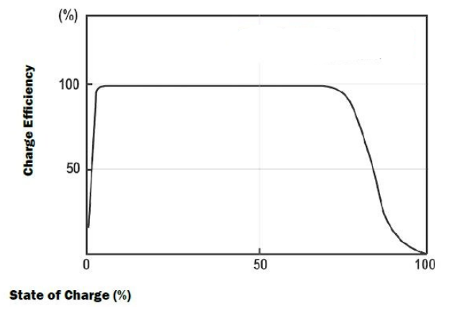
Figure 1.1 :- Graph between State of charge and charge Efficiency

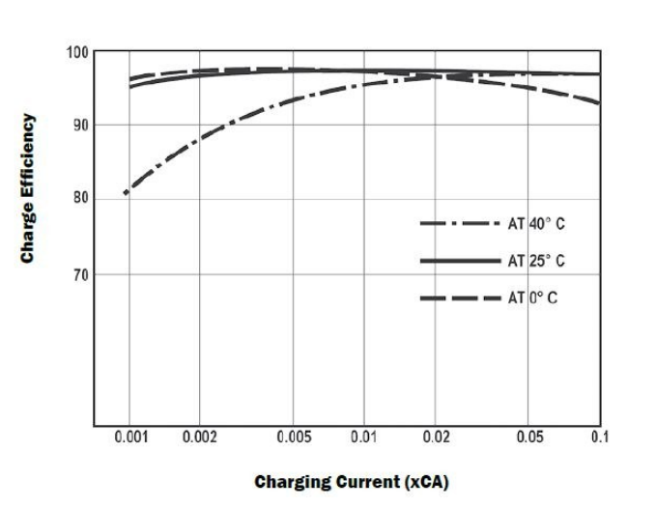
Figure 1.2 :- Graph between Charging current & Charge Efficiency

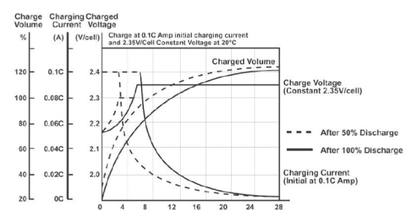

Figure 1.3:-Lead Acid battery charge characteristics taking case that charging is non continuous and peak voltage higher .

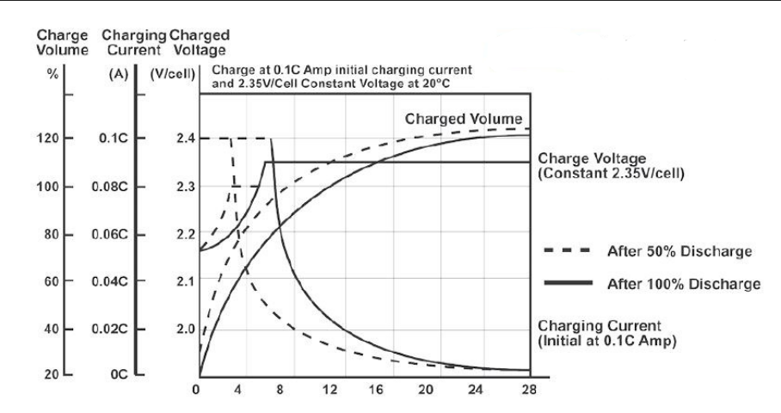
Figure 1.4 :-Lead Acid battery charge characteristics taking case that charging is continuous and peak voltage lower .

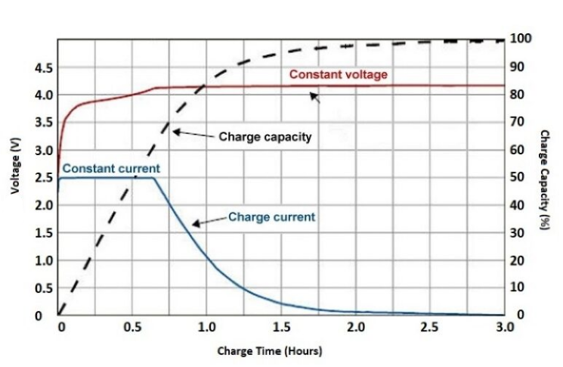

Figure 1.5 :- Charge curve of Lithium –Ion Battery

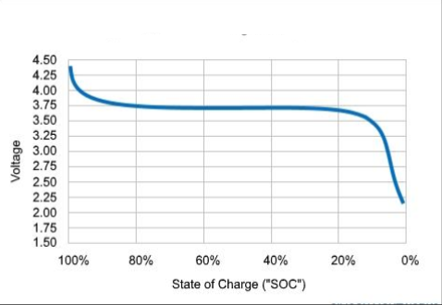
Figure 1.6 :-Discharge curve of Lithium–Ion Battery

1.8 Outline of the Report:-
The report consiste of discussing the Analysis ,modelling and simulation of various Series –Parallel combination of Lead-acid and Lithium-Ion battery spread over six chapters as given below:
Chapter 1 :- Introduces Batteries and its application and classification of batteries , modelling and performance parameters .
Chapter 2 :- Presents literature review on the background of types of batteries and their characteristics and objective of study .
Chapter 3:- Presents simulation results and discussion of Lead- acid and Lithium –Ion battery for the desired load .
Chapter 4:- Deals with summary and conclusion .
Chapter 5:- Deals with future scope of work .

CHAPTER 2
LITERATURE REVIEW
________________________________________________________________________________
2.1 General :
A battery is a storage device used for the storage of chemical energy and for the transformation of chemical energy into electrical energy . Battery consists of group of two or more electric cells connected together electrically in series. Battery acts as a portable source of electrical energy.
Batteries are of 3 types:-
- Primary Batteries (or) Primary Cells
- Secondary Batteries (or) Secondary Cells
- Fuel Cells (or) Flow Batteries

2.1.1 Primary Batteries (or) Primary Cells :-
Primary cells are those cells in which the chemical reaction occurs only once and the cell becomes dead after sometime and it cannot be used again. These batteries are used as source of DC power e.g. Dry cell (Leclanche Cell) and Mercury cell .
Requirements of Primary cell:
- It should satisfy the requirements .
- It must be convenient to use.
- Cost of discharge should be low.
- Stand-by power is desirable.
2.1.1(a) Dry cell (Leclanche Cell) :-
It consists of a cylindrical Zinc container that acts as an anode. A graphite rod placed in the centre acts as a cathode. The space between anode and cathode is packed with the paste of NH4Cl and ZnCl2 and the graphite rod is surrounded by powdered MnO2 and carbon . The cell is called dry cell because of the absence of any liquid phase, even the electrolyte consists of NH4Cl ,ZnCl2 and MnO2 to which starch is added to make a thick paste which prevents leakage. The graphite rod is fitted with a metal cap and the cylinder is sealed at the top with a pitch.
Zn2+ + 2NH3 + 2 Cl- ◊ [Zn(NH3)2Cl2]
The net cell reaction is
Zn(s)+2MnO2(s)+H2O → Zn2++ Mn2O3+ 2OH-
2 NH4Cl + 2 OH- → 2NH3 + Cl- +2 H2O
Zn2+ + 2NH3 + 2 Cl- → [Zn(NH3)2Cl2]
Advantages:
1) These cells have voltage ranging from 1.25v to 1.50v.
2) Primary cells are used in the torches,radios,transistors,watches etc.
3) Price is low.
Disadvantages:
These cells does not have a long life, because the acidic NH4Cl corrodes the container even when the cell is not in use.

2.1.1(b) Lithium cells :-
Lithium Cells are Primary cells in which lithium acts as anode and cathode may differ. Lithium metal is used as anode because of its light weight, high standard oxidation potential(>3v) and good conductivity. As the reactivity of lithium in aqueous solution is more, Lithium cells use non aqueous solvents as electrolyte. Lithium cells are classified into two categories:
a) Lithium cells with solid cathodes
b) Lithium cells with liquid cathodes
a) Lithium cells with solid cathode:
The electrolyte in these systems is a solid electrolyte . The most widely used cell is Lithium-Manganese dioxide cell . MnO2 should be heated to over 3000C to remove water before keeping it in the cathode, there by the efficiency of the cell is increased.
Anode: Lithium metal
Cathode: MnO2 as an active material
Electrolyte: LiBF4 salt in a solution of propylene carbonate and dimethoxy ethane.

Net reaction: Li + MnO2 → Li MnO2
Reactions:
At Anode : Li → Li+ +e-
At Cathode : e-+ MnO2 → MnO2-
Net reaction: Li + MnO2 → Li MnO2
Applications:
1) The coin type cells are used in watches and calculators.
2) Cylindrical cells are used in fully automatic cameras.
(b) Lithium cells with Liquid cathode:
Lithium- Sulphur dioxide cell is an example of liquid cathode. The co-solvents used are acrylonitrile or propylene carbonate (or) mixture of the two with SO2 in 50% by volume.
Cell reaction: 2Li + 2SO2 → LiS2O4
Uses:
1) They are used for military and space application.
2) In Medicinal devices like neuro-stimulators drug delivery system lithium batteries are widely used.
3) They are also used in electric circuit boards for supplying fixed voltage for memory protection and standby functions.
2.1.2 Secondary Cells (or) Accumulator batteries :-
These cells can be recharged by passing an electric current through them and can be used again and again.eg: Lead storage battery, Nickel-Cadmium battery, Lithium-ion cell battery.
Secondary cells are widely used in cars,trains,motors,electric clocks, power stations, laboratories, emergency lights, telephone exchange, digital cameras, laptops etc.These are reversible cells, they behave as galvanic cell while discharging and as electrolytic cell while charging. To improve the performance of battery for commercial purpose, the anodes and cathodes with very small separation to conserve space are used.Current discharge should be high at low temperature. It should have less variation in voltage during discharge.

2.1.2(a) Lead storage battery:
It should be reliable.
It should have tolerance to shock, temperature etc.
It should have number of charging and discharging cycles before failure of battery (Cycle life)
Lead –acid battery:If a number of cells are connected in series, the arrangement is called a battery. The lead storage battery is one of the most common batteries that is used in the automobiles. A 12 V lead storage battery is generally used, which consists of six cells each providing 2 V. Each cell consists of a lead anode and a grid of lead packed with lead oxide as the cathode. These electrodes are arranged alternately, separated by a thin wooden piece and suspended in dil. H2SO4 (38%), which acts as an electrolyte .Hence it is called Lead-acid battery.

Anode: Pb
Cathode:PbO2
Electrolyte: H2SO4(20.22%)EMF=2V

2.1.2(b) Lead storage battery:-
To increase the current output of each cell, the cathode and the anode plates are
joined together, keeping them in alternate positions. The cells are connected parallel to each other (anode to anode and cathode to cathode).When battery produces current, the reactions at the electrodes are as follows:
At anode: Pb → Pb+2 + 2e-
Pb (s) + SO4 (aq.) → PbSO4 (s)
At cathode:
PbO2 (s) + SO4 (aq.) + 4H+ (aq.) + 2e– → PbSO4 (s) + 2H2O
Therefore, overall reaction is
Pb (s) + PbO2 (s) + 4H2SO4 (aq.) → 2PbSO4 (s) + 2H2O
During discharging the battery, H2SO4 is consumed, and as a result, the density of H2SO4 falls; when it falls below 1.20 g/cm3, the battery needs recharging. In Discharging, the cell acts as a voltoic cell where oxidation of lead occurs. During recharging, the cell is operated like an electrolytic cell, i.e. electrical energy is supplied to it from an external source. The electrode reactions are the reverse of those that occur during discharge.
PbSO4 (s) + 2e– ◊Pb (s) + SO4– – (aq.)
PbSO4 (s) + 2H2O → PbO2 (s) + 2H2SO4 + 2e–
2PbSO4 (s) + 2H2O → Pb (s) + PbO2 (s) + 2H2SO4 (aq.)
During this process, lead is deposited at the cathode, PbO2 is formed at the anode and H2SO4 is regenerated in the cell.
Advantages:-
Lead acid batteries are used for supplying current to railways, hospitals, automobiles, power stations, telephone exchange, UPS (stand-by supplies). Other advantages are its rechargeability, portability and Its relatively constant potential & low cost.
Disadvantages:
Use of Conc.H2SO4 is dangerous, Use of lead battery is fragile.
- Nickel–cadmium cell (Nicad cell):-
It is rechargeable secondary cell. It consists of cadmium as the negative electrode(anode) and NiO2 acting as a positive electrode (cathode).
Potassium hydroxide(KOH) is used as an electrolyte. The cell reaction during charging and discharging are as follows.
Anode: Cd
Cathode: NiO(OH)
Electrolyte: KOH
EMF=1.4V
Cd(S) + 2OH- (Aq) → Cd(OH)2 (s) + 2e-
At Anode
Cd(S) + 2OH- (Aq) → Cd(OH)2 (s) + 2e-
At Cathode
NiO(OH) (s) + 2H2O + 2e- →2 Ni(OH)2+ OH-(aq)
Overall reaction:
Cd(s) + 2 Ni(OH) + 2H2O ◊ Cd(OH)2 (s) + 2 Ni(OH)2(s)
Advantages and uses:-
The Nickel-Cadmium cell has small size and high rate charge/discharge capacity, which makes it very useful. It has also very low internal resistance and wide temperature range (up to 70°C) . It produces a potential about 1.4 volt and has longer life than lead storage cell. These cells are used in electronic calculators, electronic flash units, transistors etc.Ni- Cd cells are widely used in medical instrumentation and in emergency lighting, toys etc.
2.1.3 Fuel Cell :
Definition : A Fuel cell is an electrochemical cell which converts chemical energy contained in readily available fuel oxidant system into electrical energy.
Principle: The basic principle of the fuel cell is same as that of electrochemical cell. The only difference is that the fuel & oxidant are stored outside the cell. Fuel and Oxidant are supplied continuously and separately to the electrodes at which they undergo redox reactions.Fuel cells are capable of supplying current as long as reactants are replenished.
Fuel + Oxidant → Oxidation Products + electricity
eg : 1) H2 -O2 fuel cell
2) Propane -O2 fuel cell
3) CH3OH-O2 fuel cell
A. Hydrogen – Oxygen fuel cell : -
One of the most successful fuel cell is H2 –O2 fuel cell . The cell consists of two inert porous electrodes made of graphite impregnated with finely divided ‘Pt’ (or) Ni (or) Pd – Ag alloy and a solution of 2.5% KOH as electrolyte. The following reactions takes place.
Cell Reaction
At anode : 2H2 (g) + 4OH- → 4H2O + 4e-
At Cathode : O2 (g) + 2H2O + 4e- → 4OH-
Net Reaction : 2H2 (g) + O2 (g) → 2H2O
EMF cell = 1.23V
- A large no of these cells connected in series form a fuel-cell battery.
A large no of these cells connected in series form a fuel-cell battery. In the production of electricity by this method, the byproducts are heat,CO2,water, which will not cause pollution of the environment.

Applications:
- These are used as auxiliary energy source in space vehicles, submarines and other military vehicles. The product water produced is a valuable source of fresh water for astronauts. Fuel cell is preferred in spacecraft because of its lightness.
- Initial cost of fuel cell is high.
Advantages:
- 1) Fuel cells have high efficiency. It is nearly 70% while other sources have efficiency 15-20% (gasoline engine) and 30-35%(diesel engine).
- 2) The efficiency of the fuel cell does not depend on the size of the power plant.
- 3) Maintenance cost is very low.
- 4) Fuel cells are more efficient in producing the mechanical power to drive the vehicles and require less energy consumption.Disadvantages:1) Initial cost of fuel cell is high.2) Life time of fuel cell is not known accurately.3)There is a problem of durability and storage of large amount of hydrogen
GENERAL APPLICATIONS
Emergency power - Lithium cells, water activated batteriesStandby, power Lead acid Medical implants , long life, watches, calculators, memory back up, wireless peripherals: Button and coin cells
The Primary cells have high energy density and slow in discharge and easy to use .There are no fluids in the cells hence it is also called as dry cells . It has high internal resistence . It has an irreversible chemical reaction .While the secondary cells have smaller energy density . These are made up of wet cells (flooded and liquid cells )and molten salts (liquid cells with different composition). It has a low internal resistance . It has a reversible chemical reaction .

CHAPTER 3
RESULT & DISCUSSION:-
3.1 LEAD ACID BATTERY CHARGING:
Circuit diagram of Lead Acid battery charging is shown in figure and design parameters are also shown below .Simulation results are shown both in display and waveform basis .

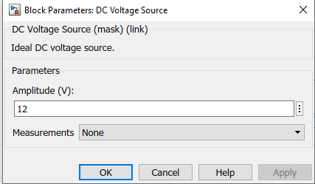
Figure 3.1.1 :- DC VOLTAGE SOURCE FOR LEAD ACID BATTERY CHARGING
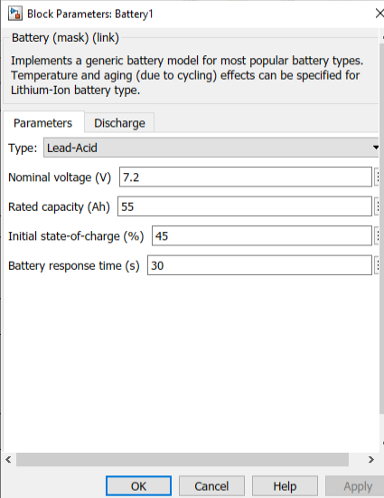
Figure 3.1.2:- DETAIL SPECIFICATION OF LEAD ACID BATTERY
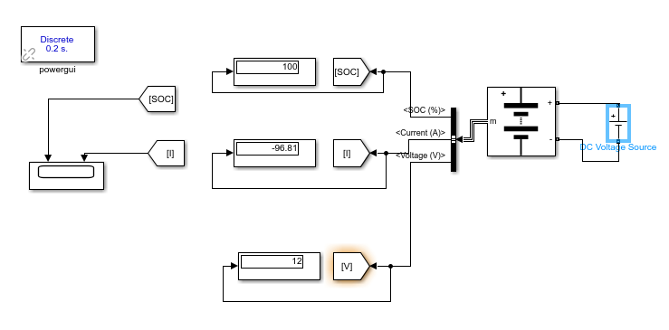
Figure 3.1.3 :- CIRCUIT DIAGRAM OF LEAD-ACID BATTERY CHARGING FOR 425 SECONDS

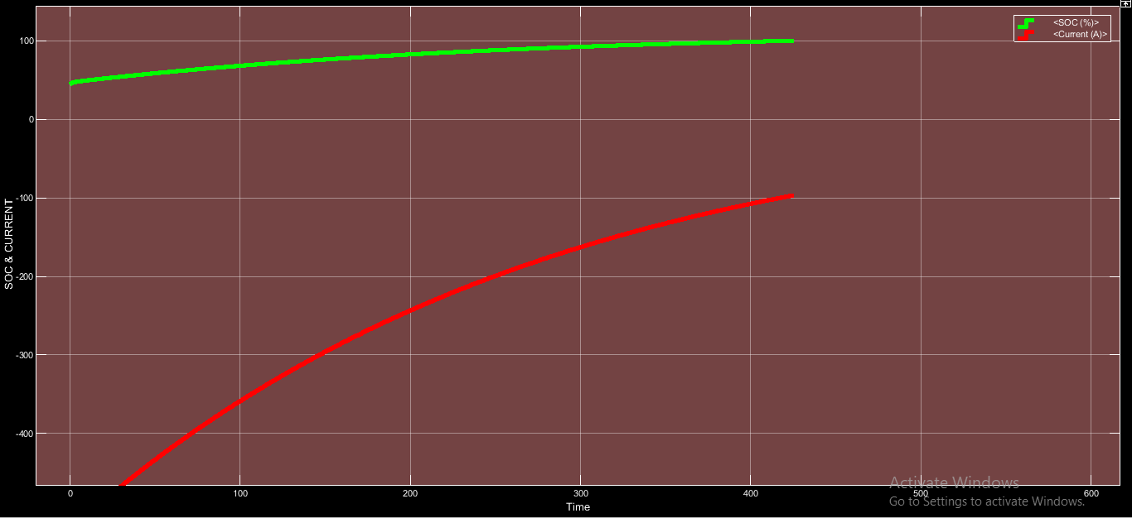Figure 3.1.4:- SOC & CURRENT WAVEFORM OF LEAD ACID BATTERY CHARGING FOR 425 SECONDS

3.2 LITHIUM ION BATTERY CHARGING:
Circuit diagram of Lithium Ion charging is shown in figure and design parameters are also shown below .Simulation results are shown both in display and waveform basis .

Figure 3.2.1:- DC VOLTAGE SOURCE

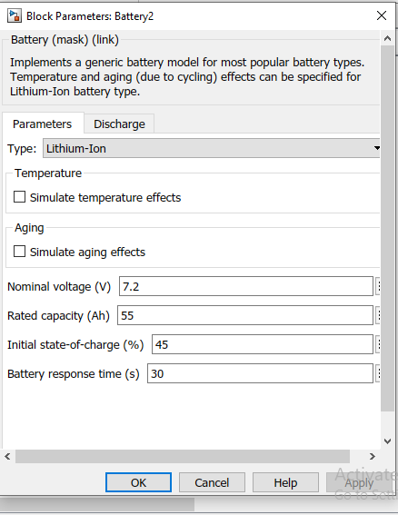
Figure 3.2.2:- DETAIL SPECIFICATION OF LITHIUM ION BATTERY
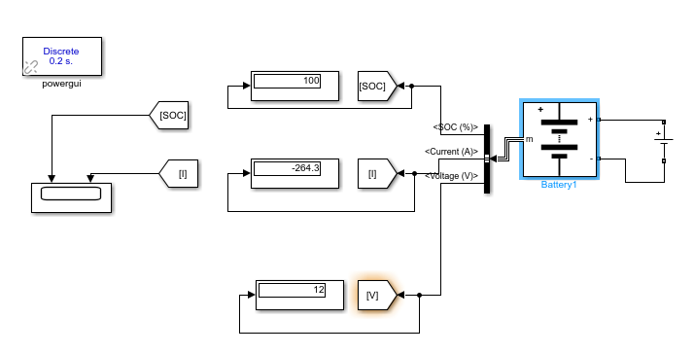
Figure 3.2.3 :- CIRCUIT DIAGRAM OF LITHIUM ION BATTERY CHARGING FOR 425 SECONDS

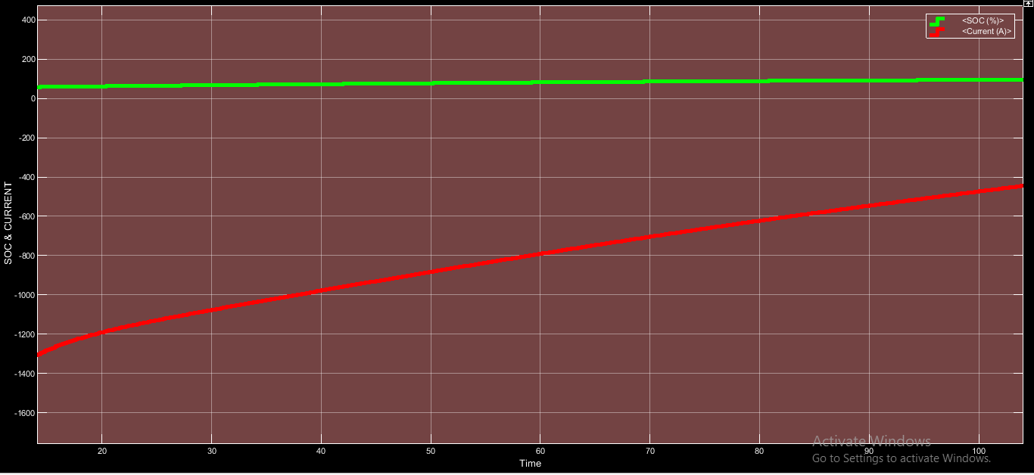
Figure 3.2.4:- SOC & CURRENT WAVEFORM OF LITHIUM ION BATTERY CHARGING FOR 135 SECONDS

3.3 LEAD ACID- LEAD ACID SERIES BATTERY CHARGING :
Circuit diagram of Lead Acid-Lead Acid series battery charging is shown in figure and design parameters are also shown below .Simulation results are shown both in display and waveform basis .

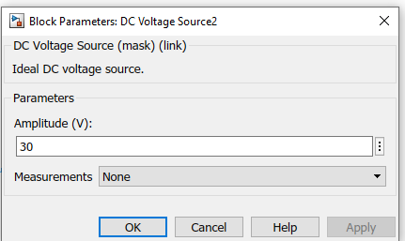
Figure 3.3.1:- DC VOLTAGE SOURCE DETAIL FOR LEAD-ACID & LEAD-ACID SERIES CHARGING

FIGURE 3. 3.2:- DETAIL SPECIFICATION OF BOTH LEAD-ACID BATTERIES CONNECTED IN SERIES
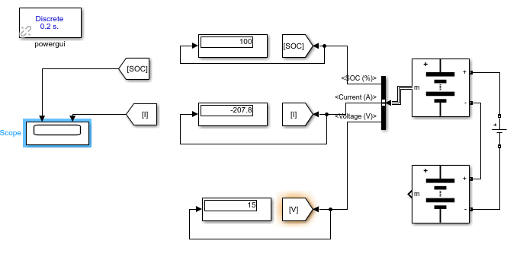FIGURE 3.3.3:- CIRCUIT DIAGRAM OF LEAD-ACID & LEAD-ACID BATTERY SERIES CHARGING FOR 1 HOUR

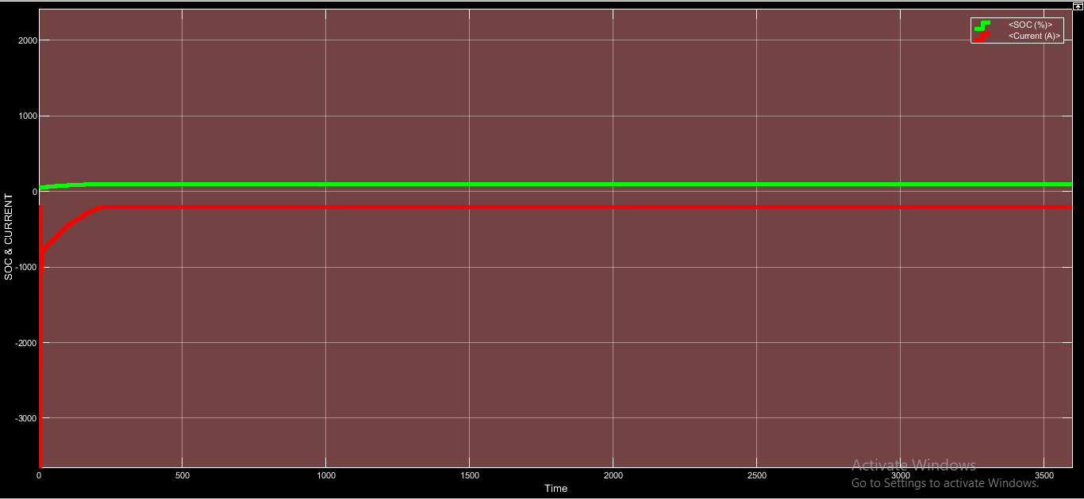
Figure3. 3.4:- SOC & CURRENT WAVEFORMM OF LEAD ACID & LEAD ACID BATTERY SERIES CHARGING

3.4 LITHIUM ION-LEAD ACID SERIES BATTERY CHARGING :
Circuit diagram of Lithium Ion-Lead Acid Series battery charging is shown in figure and design parameters are also shown below .Simulation results are shown both in display and waveform basis .

FIGURE 3. 4.1:- DETAIL SPECIFICATION OF LITHIUM ION BATTERY CONNECTED IN SERIES WITH LEAD ACID BATTERY

FIGURE3. 4.2:- DETAIL SPECIFICATION OF LEAD ACID BATTERY CONNECTED IN SERIES WITH LITHIUM ION BATTERY

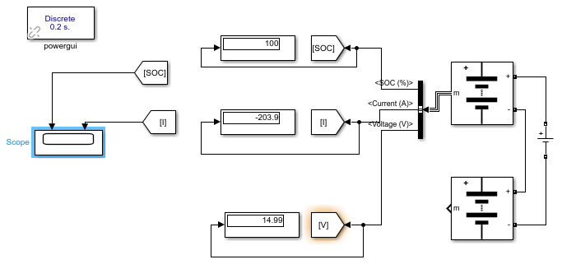
FIGURE 3.4.3:-CIRCUIT DIAGRAM OF LEAD ACID BATTERY CONNECTED IN SERIES WITH LITHIUM ION BATTERY FOR 1 HOUR

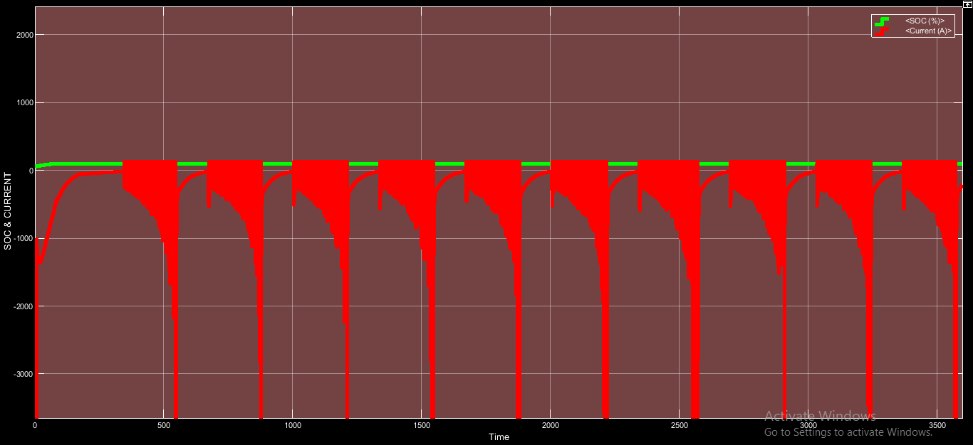FIGURE 3.4.4:-SOC & CURRENT WAVEFORM OF LEAD ACID BATTERY CONNECTED SERIESWITHLITHIUM ION BATTERY FOR 1 HOUR

3.5 LITHIUM ION-LITHIUM ION SERIES CHARGING:
Circuit diagram of Lithium Ion-Lithium-Ion battery charging is shown in figure and design parameters are also shown below .Simulation results are shown both in display and waveform basis .

Figure 3.5.1:- DC VOLTAGE SOURCE DETAIL FOR LITHIUM ION BATTERY SERIES CHARGING
Figure 3.5.2:-DETAIL SPECIFICATION OF BOTH LITHIUM ION BATTERY FOR SERIES CHARGING

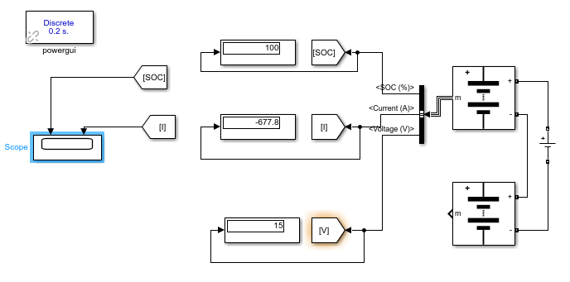
FIGURE 3.5.3:-CIRCUIT DIAGRAM OF LITHIUM ION BATTERY CONNECTED IN SERIES WITH LITHIUM ION BATTERY FOR 1 HOUR

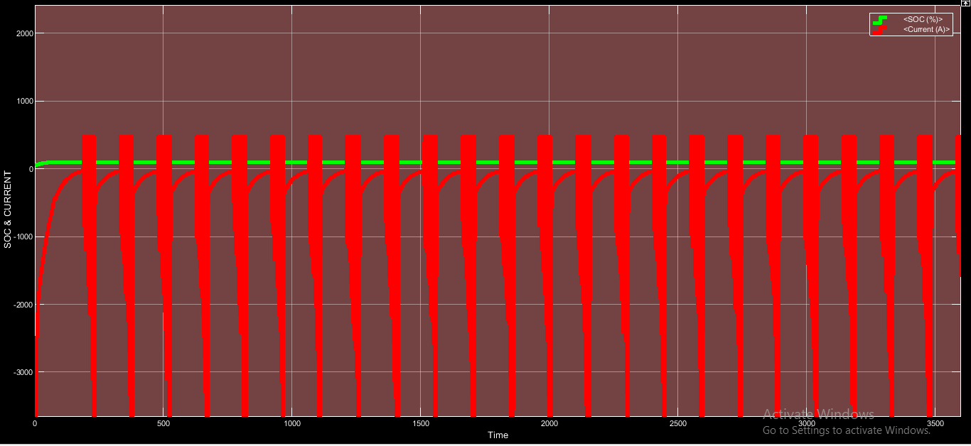
FIGURE3. 5.4:-SOC & CURRENT WAVEFORM OF LITHIUM ION BATTERY CONNECTED SERIESWITHLITHIUM ION BATTERY FOR 1 HOUR

3.6 LEAD ACID-LEAD ACID BATTERY PARALLEL CHARGING:
Circuit diagram of Lead Acid battery charging is shown in figure and design parameters are also shown below .Simulation results are shown both in display and waveform basis .

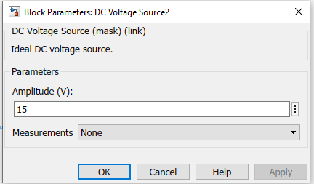
Figure3. 6.1:- DC VOLTAGE SOURCE DETAIL FOR LEAD ACID & LEAD ACID BATTERY PARALLEL CHARGING

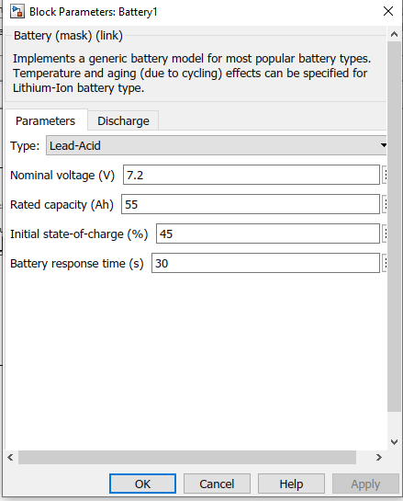
Figure 3.6.2:- DETAIL SPECIFICATION OF BOTH LEAD ACID BATTERY FOR PARALLEL CHARGING

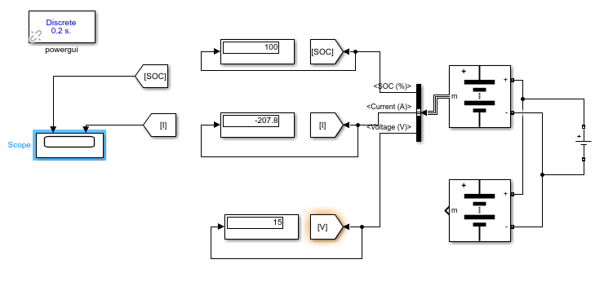
Figure 3.6.3:-CIRCUIT DIAGRAM OF BOTH LEAD ACID BATTERY FOR PARALLEL CHARGING FOR 1 HOUR
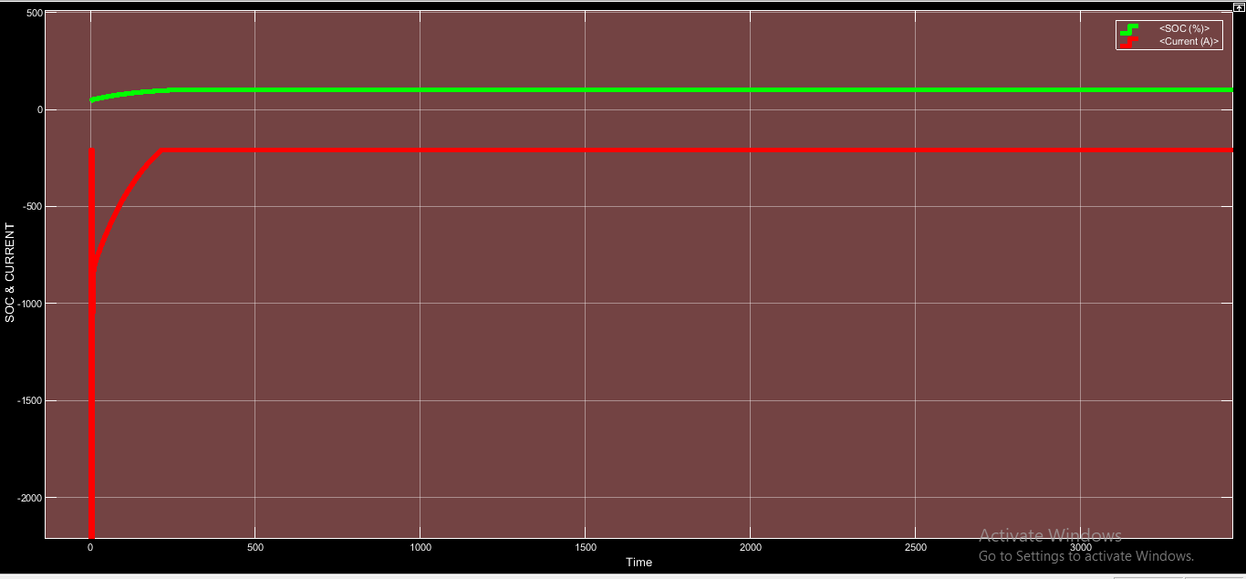
Figure 3. 6.4:- SOC & CURRENT WAVEFORM OF BOTH LEAD ACID BATTERY CONNECTED IN PARALLEL FOR CHARGING FOR 1 HOUR

3.7 LEAD ACID-LITHIUM ION BATTERY PARALLEL CHARGING:
Circuit diagra of Lead Acid-Lithium Ion battery Parallel charging is shown in figure and design parameters are also shown below .Simulation results are shown both in display and waveform basis .

Figure3. 7.1:- DETAIL SPECIFICATION OF LEAD ACID BATTERY
Figure 3.7.2:- DETAIL SPECIFICATION OF LITHIUM ION BATTERY
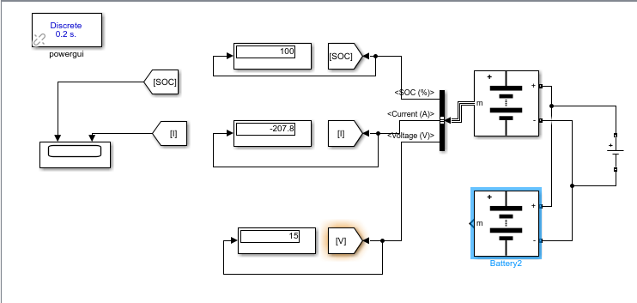
Figure 3.7.3:-CIRCUIT DIAGRAM OF LEAD ACID BATTERY & LITHIUM ION BATTERY PARALLEL CHARGING FOR I HOUR
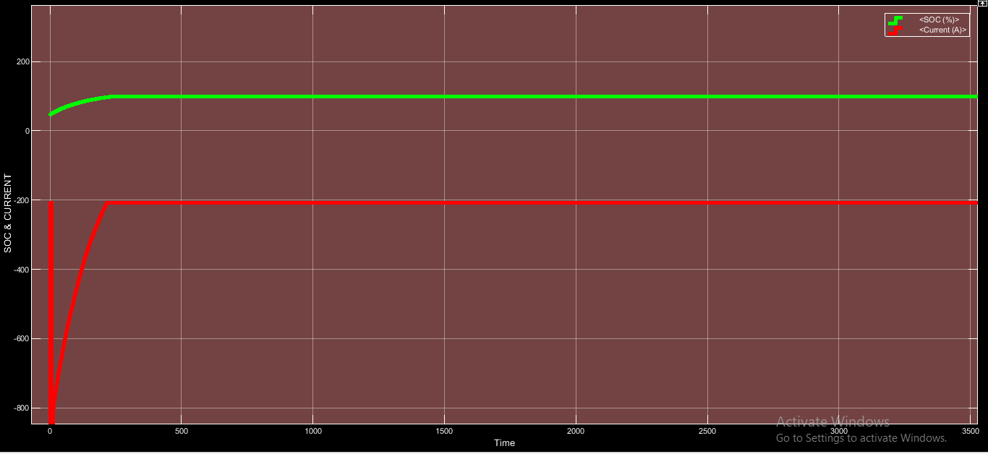
Figure 3. 7.4:-SOC & CURRENT WAVEFORM OF LEAD ACID BATTERY & LITHIUM ION BATTERY FOR PARALLEL CHARGING FOR 1 HOUR

3.8 LITHIUM ION-LITHIUM ION BATTERY PARALLEL CHARGING:
Circuit diagra of Lithium Ion-Lithium Ion battery Parallel charging is shown in figure and design parameters are also shown below .Simulation results are shown both in display and waveform basis .

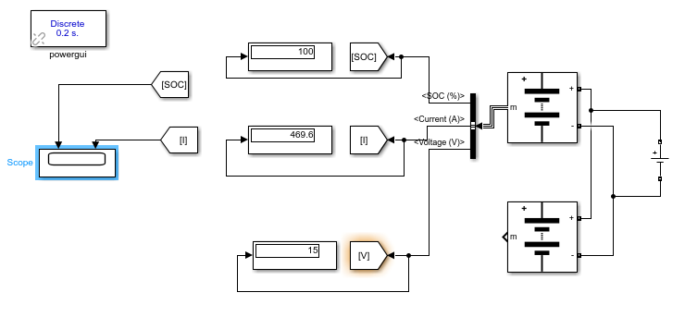

Figure 3.8.1:-CIRCUIT DIAGRAM OF LITHIUM ION BATTERY & LITHIUM ION BATTERY PARALLEL CHARGING FOR I HOUR

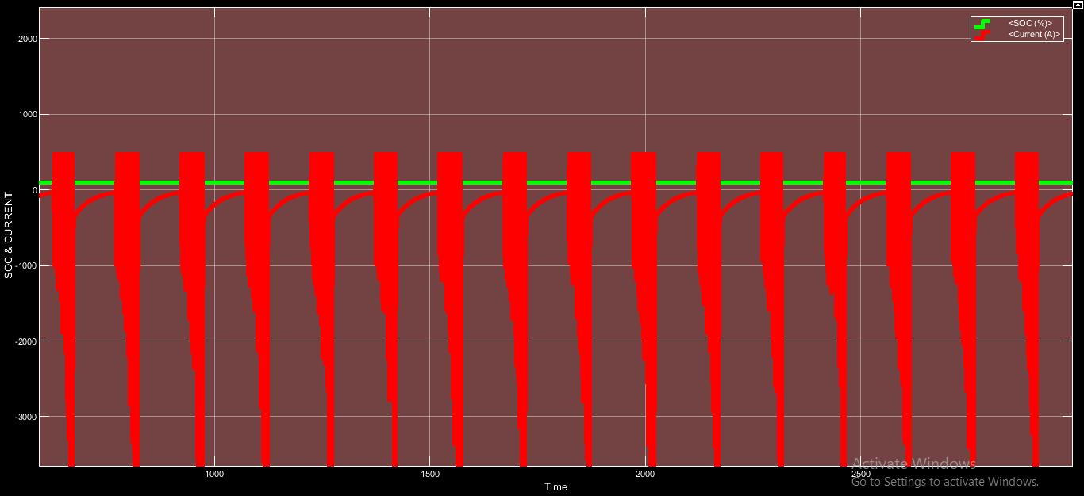
Figure 3.8.2:-SOC & CURRENT WAVEFORM OF LITHIUM ION BATTERY & LITHIUM ION BATTERY FOR PARALLEL CHARGING FOR 1 HOUR

3.9 LEAD ACID BATTERY DISCHARGE:
Circuit diagra of Lead Acid battery discharge is shown in figure and design parameters are also shown below .Simulation results are shown both in display and waveform basis .
Initially the battery charging is taken as 100% and nominal voltage of battery is taken as 7.2 volt .

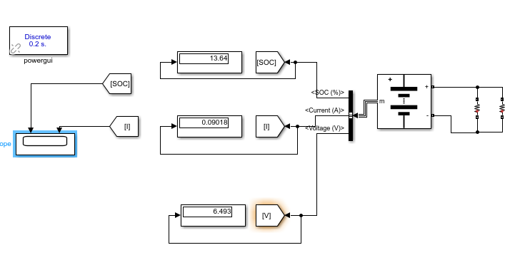
Figure3. 9.1:- CIRCUIT DIAGRAM OF DISCHARGE OF LEAD ACID BATTERY WITH LOAD RESISTANCE 72 OHMS FOR 500 HOURS

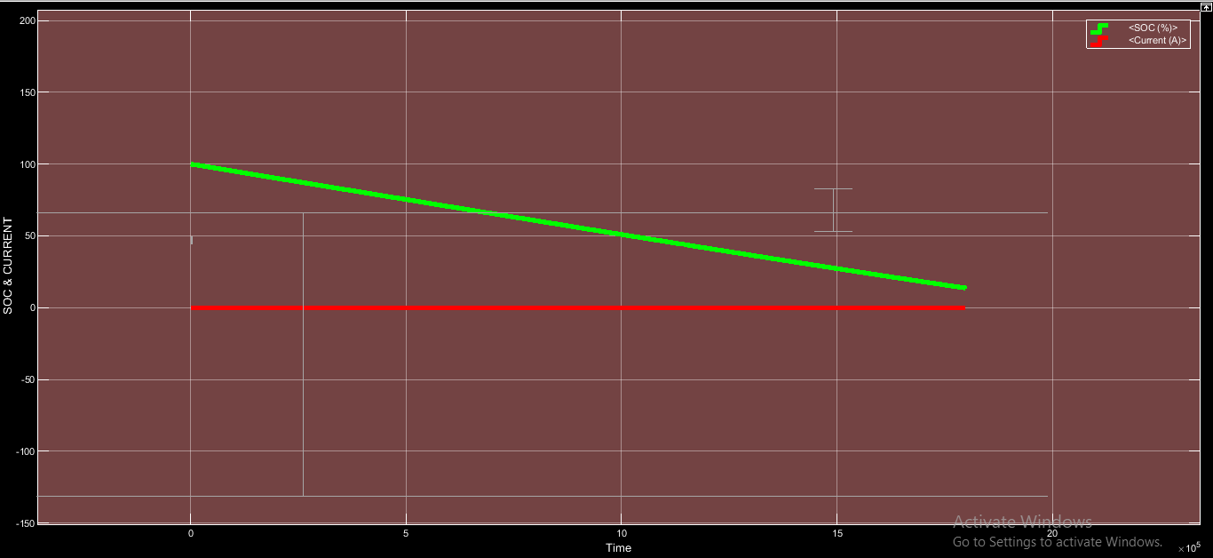
Figure 3.9.2:- SOC & CURRENT WAVEFORM OF LEAD ACID BATTERY DISCHARGE FOR 500 HOURS
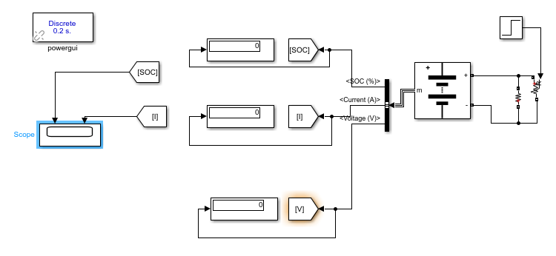

Figure 3.9.3(a):- CIRCUIT DIAGRAM OF DISCHARGE OF LEAD ACID BATTERY WITH LOAD AS STEP SIGNAL FOR 25 HOURS
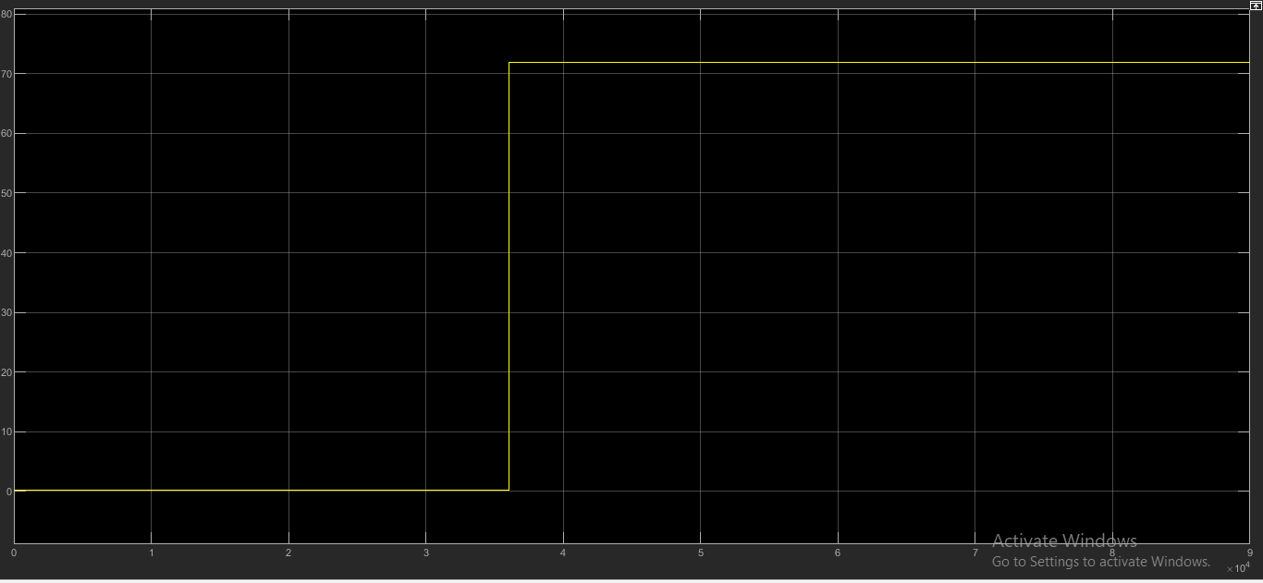
Figure3. 9.3(b):- FIGURE SHOWING STEP SIGNAL
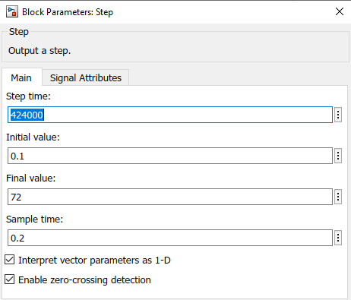
Figure 3.9.3(c):- IMAGE SHOWING DETAILS OF STEP SIGNAL

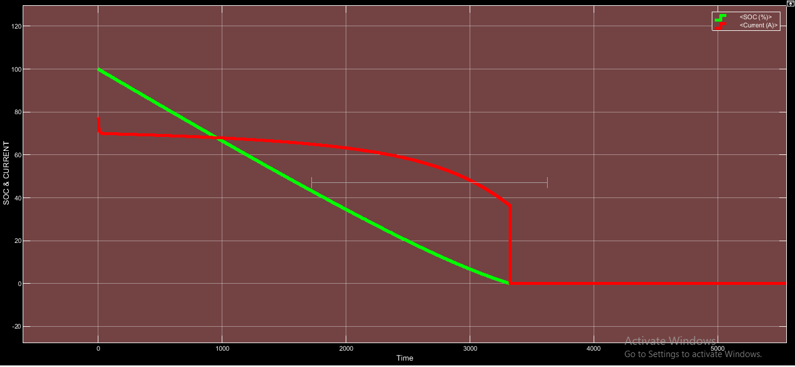
Figure 3. 9.4:- SOC & CURRENT WAVEFORM OF DISCHARGE OF LEAD ACID BATTERY CONNECTED TO STEP SIGNAL FOR 25 HOURS

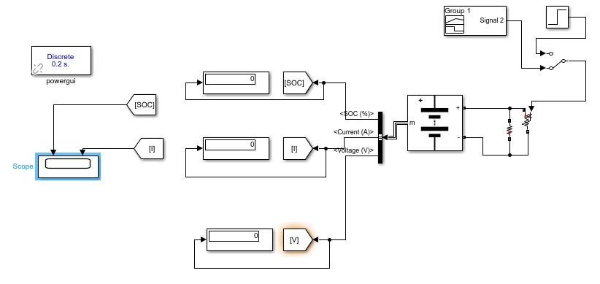
Figure 3.9.5:- CIRCUIT DIAGRAM OF LEAD ACID BATTERY DISCHARGE CONNECTED TO LOAD OF STEP SIGNAL WITH RAMP START PROVIDED BY SIGNAL BUILDER FOR 250 HOURS

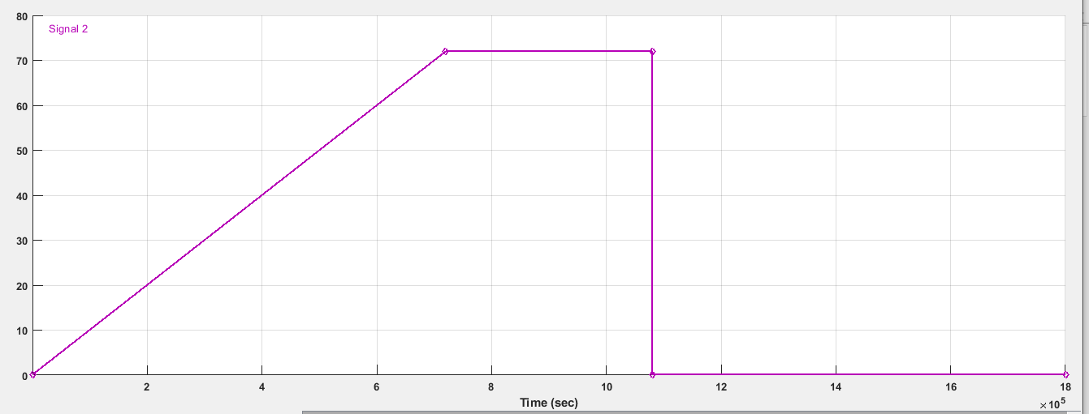
Figure3. 9.6:- IMAGE OF STEP SIGNAL WITH RAMP START DEVELOPED IN SIGNAL BUILDER
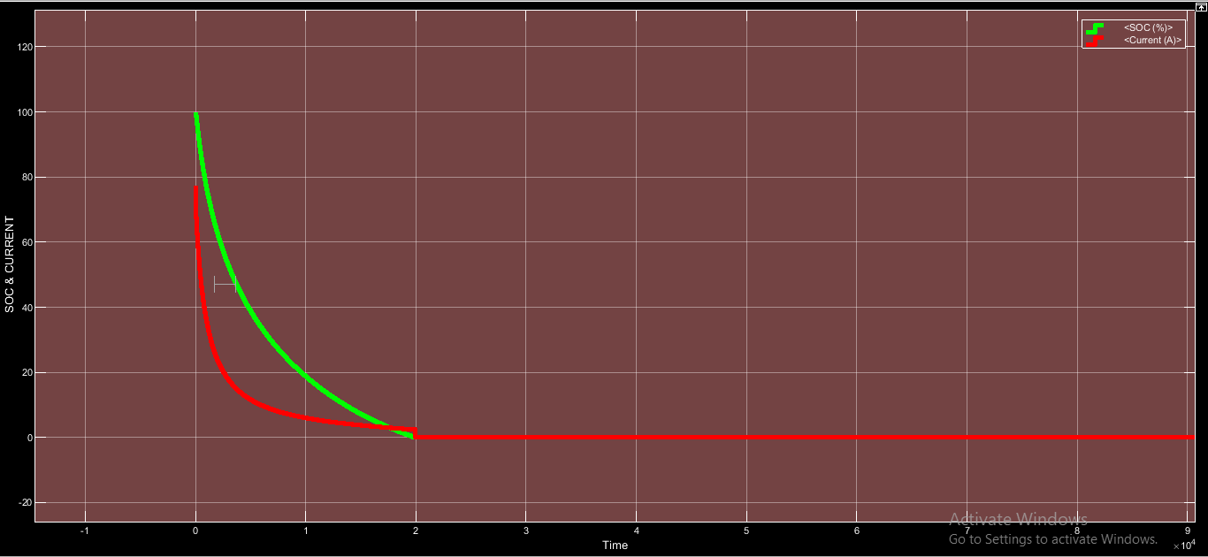
Figure3. 9.7:- SOC & CURRENT WAVEFORM OF LEAD ACID BATTERY DISCHARGE CONNECTED TO LOAD OF STEP SIGNAL WITH RAMP START FOR 250 HOURS

3.10 LITHIUM ION BATTERY DISCHARGE:
Circuit diagra of Lithium Ion battery discharge is shown in figure and design parameters are also shown below .Simulation results are shown both in display and waveform basis .

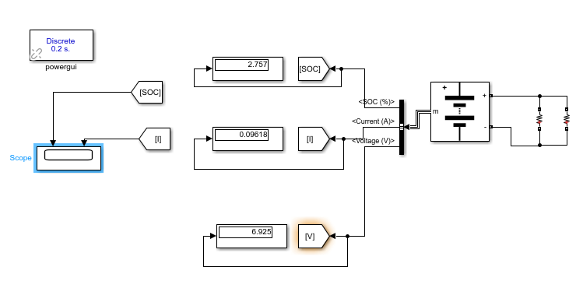
Figure 3.10.1:- CIRCUIT DIAGRAM OF DISCHARGE OF LITHIUM ION BATTERY WITH LOAD RESISTANCE 72 OHMS FOR 500 HOURS
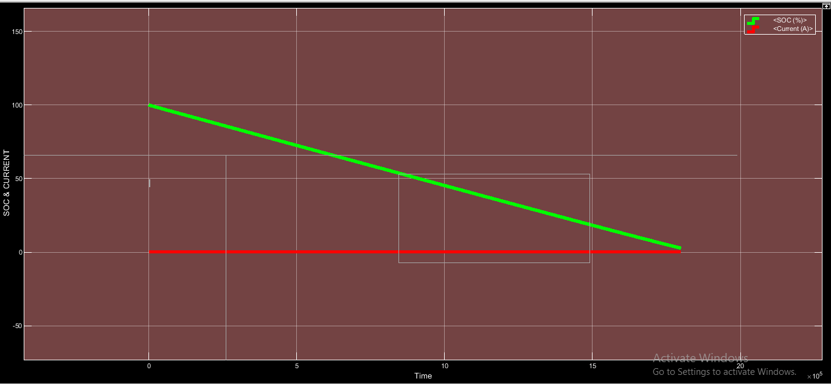
Figure 3.10.2:- SOC & CURRENT WAVEFORM OF LITHIUM ION BATTERY DISCHARGE FOR 500 HOURS

Figure 3.10.3(a):- CIRCUIT DIAGRAM OF DISCHARGE OF LITHIUM ION BATTERY WITH LOAD AS STEP SIGNAL FOR 25 HOURS
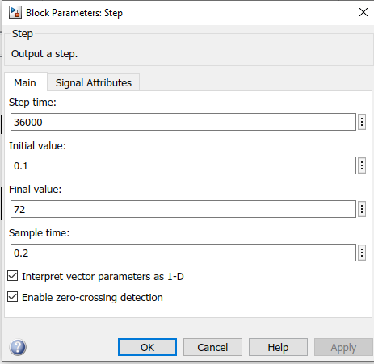
Figure 3.10.3(b):- IMAGE SHOWING DETAILS OF STEP SIGNAL

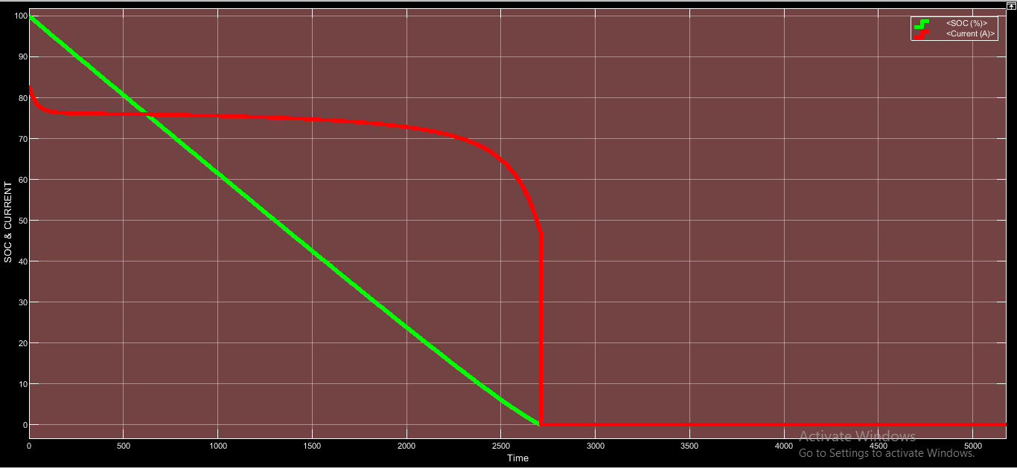
Figure 3.10.3(c):- SOC & CURRENT WAVEFORM OF DISCHARGE OF LITHIUM ION BATTERY CONNECTED TO STEP SIGNAL FOR 25 HOURS

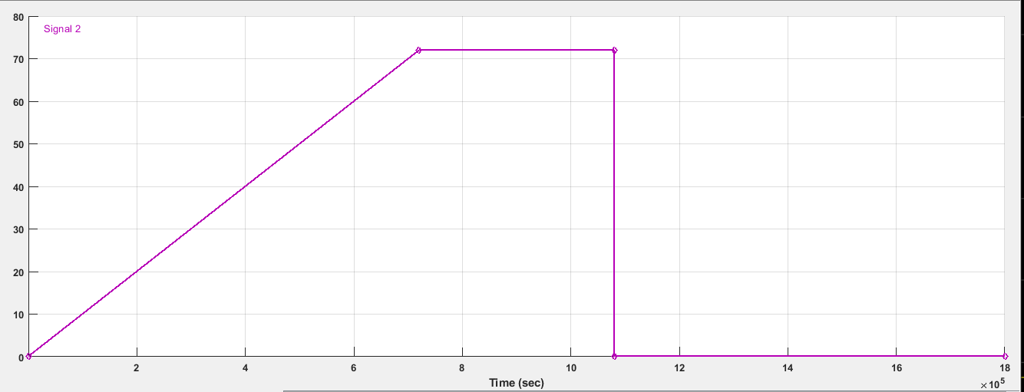
Figure 3.10.4(a):- IMAGE OF STEP SIGNAL WITH RAMP START DEVELOPED IN SIGNAL BUILDER

Figure 3.10.4(b):- CIRCUIT DIAGRAM OF DISCHARGE OF LITHIUM ION BATTERY WITH LOAD AS STEP SIGNAL WITH RAMP START FOR 20 HOURS
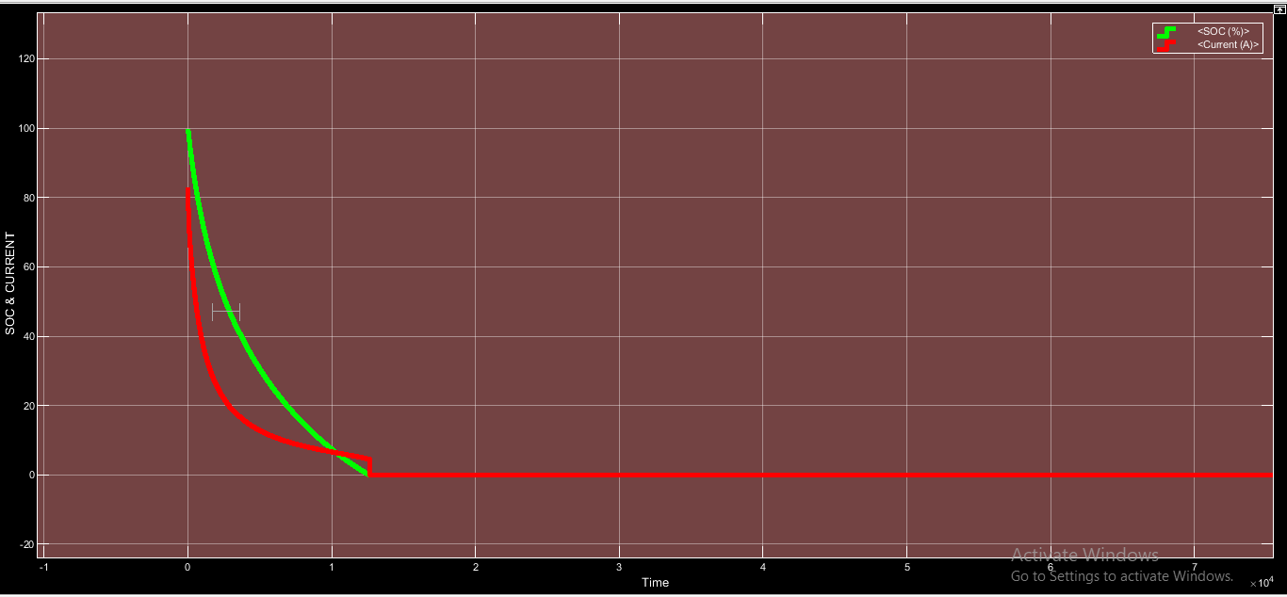
Figure3. 10.4(c):- SOC & CURRENT WAVEFORM OF DISCHARGE OF LITHIUM ION BATTERY CONNECTED TO LOAD AS STEP SIGNAL WITH RAMP START FOR 20 HOURS

3.11 LEAD ACID-LEAD ACID SERIES BATTERY DISCHARGE:
Circuit diagra of Lead Acid-Lead Acid series battery discharge is shown in figure and design parameters are also shown below .Simulation results are shown both in display and waveform basis .

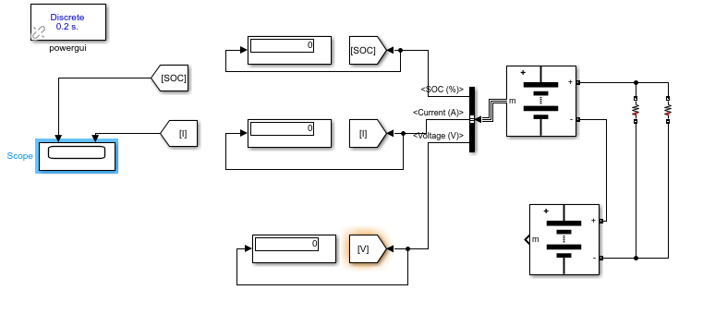
Figure 3.11.1(a):- CIRCUIT DIAGRAM OF DISCHARGE OF LEAD ACID-LEAD ACID SERIES BATTERY WITH LOAD AS 72 OHM RESISTANCE FOR 500 HOURS

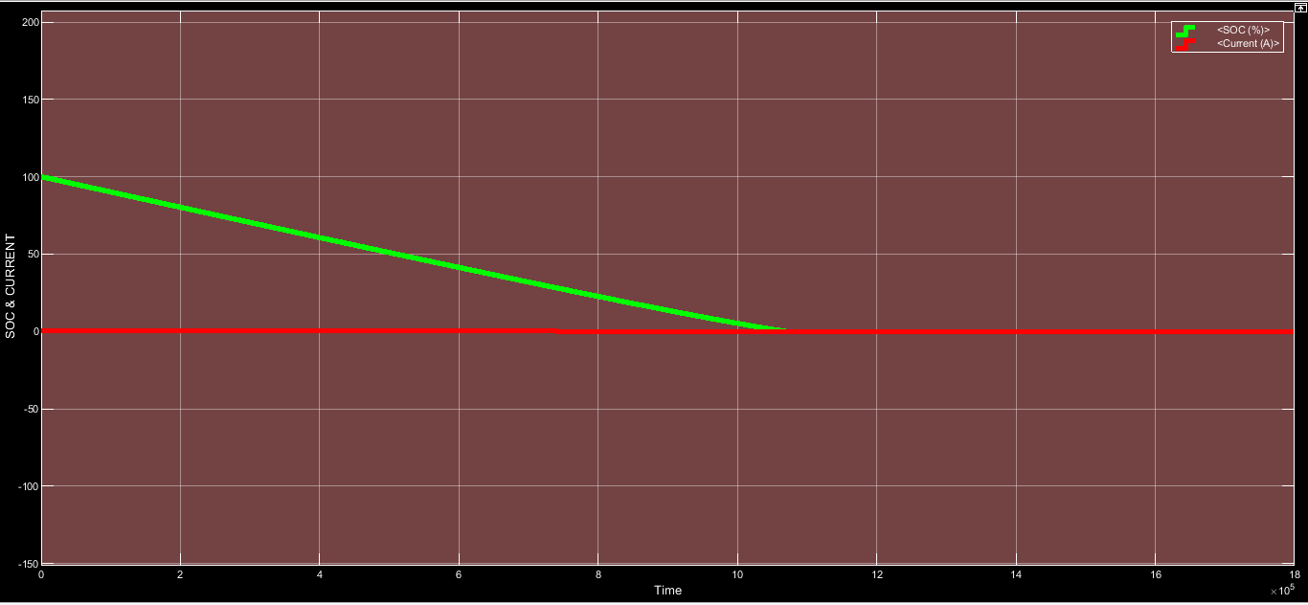
Figure3. 11.1(b):- SOC & CURRENT WAVEFORM OF DISCHARGE OF LEAD ACID-LEAD ACID SERIES BATTERY CONNECTED TO LOAD RESISTANCE OF 72 OHMS FOR 500 HOURS

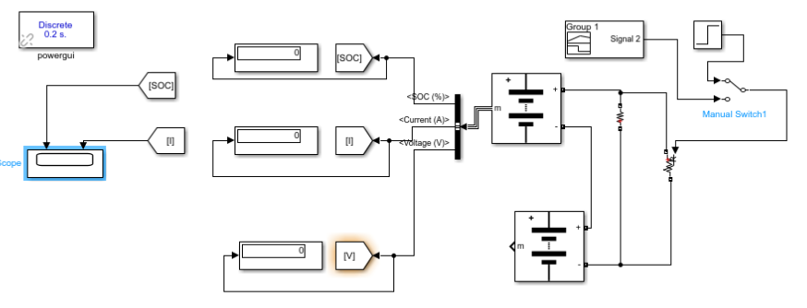
Figure 3.11.2(a):- CIRCUIT DIAGRAM OF DISCHARGE OF LEAD ACID-LEAD ACID SERIES BATTERY WITH LOAD AS STEP SIGNAL WITH RAMP START FOR 500 HOURS

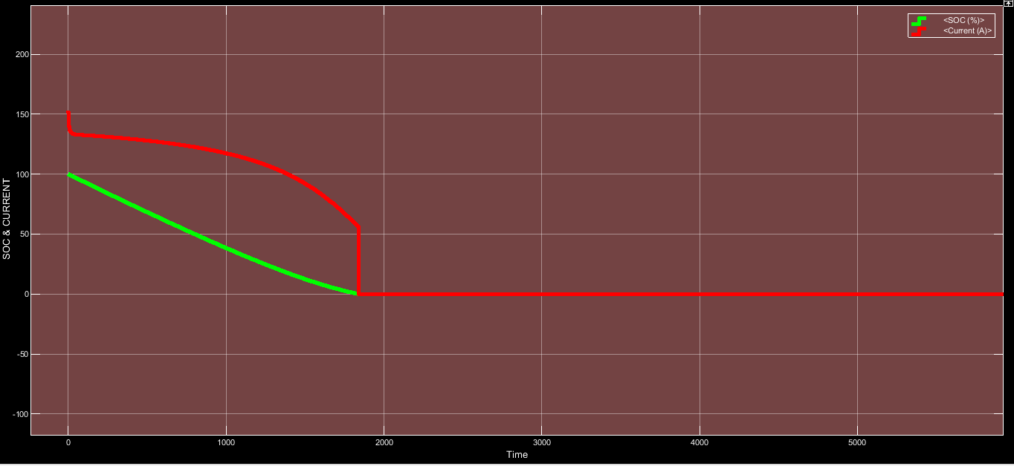
Figure3. 11.2(b):-SOC & CURRENT WAVEFORM OF OF DISCHARGE OF LEAD ACID-LEAD ACID SERIES BATTERY WITH LOAD AS STEP SIGNAL WITH RAMP START FOR 500 HOURS

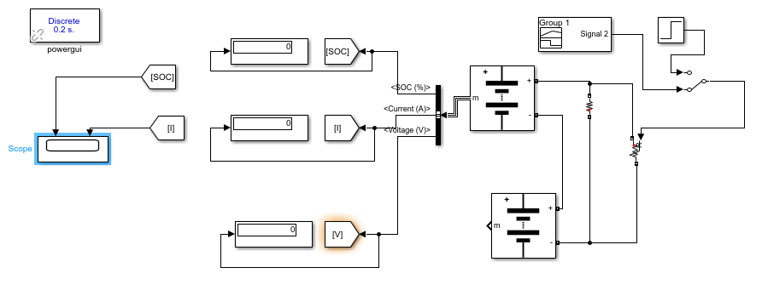
Figure3. 11.3(a):- CIRCUIT DIAGRAM OF DISCHARGE OF LEAD ACID-LEAD ACID SERIES BATTERY WITH LOAD AS STEP SIGNAL WITH RAMP START DEVELOPED BY SIGNAL BUILDER FOR 500 HOURS

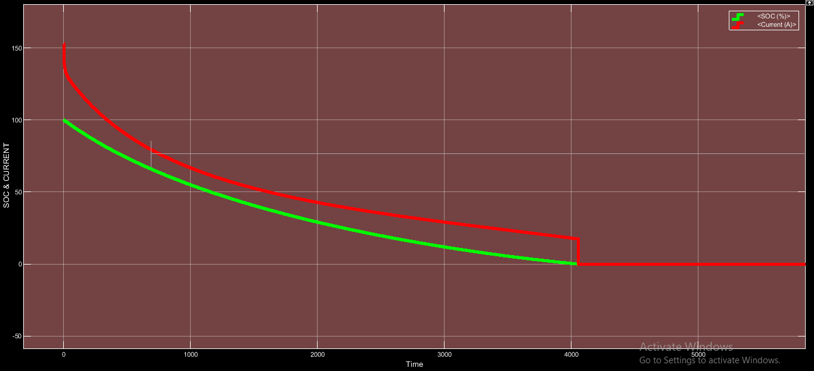
Figure 3.11.3(b):- SOC & CURRENT WAVEFORM OF DISCHARGE OF LEAD ACID-LEAD ACID SERIES BATTERY WITH LOAD AS STEP SIGNAL WITH RAMP START DEVELOPED BY SIGNAL BUILDER FOR 500 HOURS

3.12 LEAD ACID-LITHIUM ION SERIES BATTERY DISCHARGE:
Circuit diagra of Lead Acid-Lithium Ion series battery discharge is shown in figure and design parameters are also shown below .Simulation results are shown both in display and waveform basis .

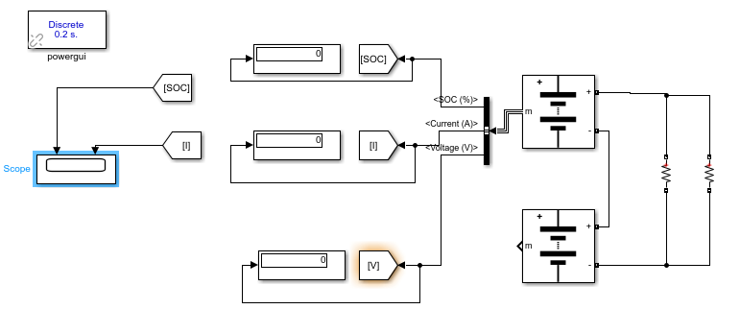
Figure 3.12.1(a):- CIRCUIT DIAGRAM OF DISCHARGE OF LEAD ACID-LITHIUM ION ACID SERIES BATTERY WITH LOAD RESISTANCE OF 72 OHMS FOR 500 HOURS

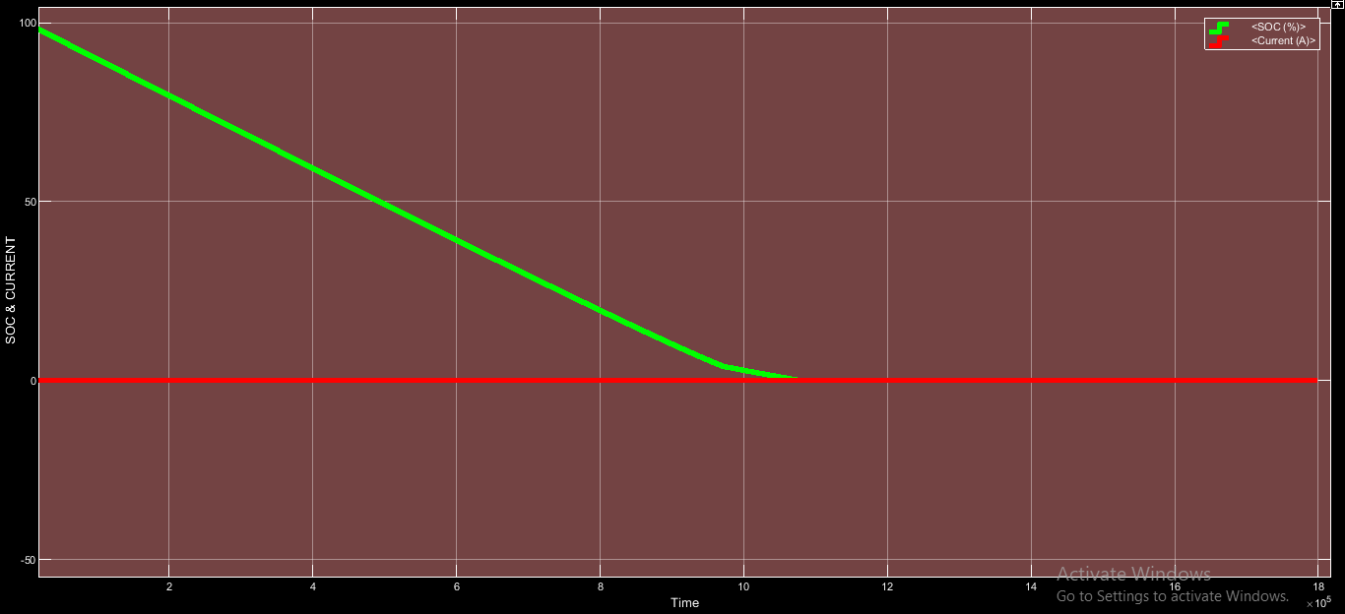
Figure 3.12.1(b):- WAVEFORM OF DISCHARGE OF LEAD ACID-LITHIUM ION ACID SERIES BATTERY WITH LOAD RESISTANCE OF 72 OHMS FOR 500 HOURS

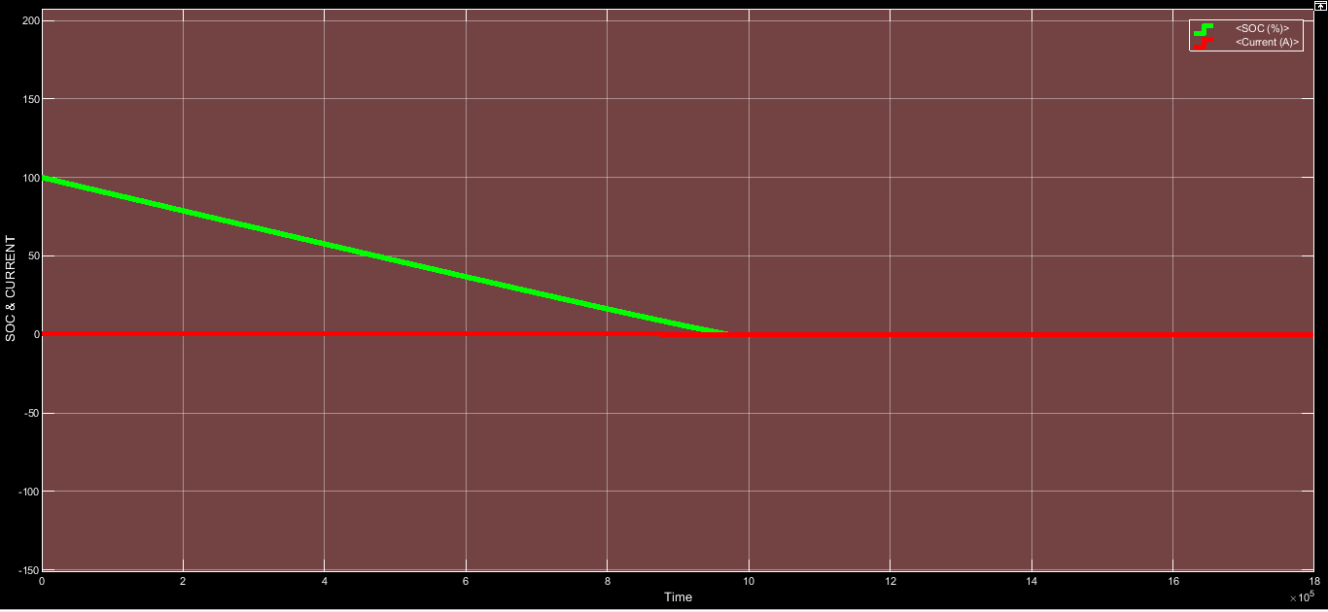
Figure 3.12.1(c):- SOC & CURRENT WAVEFORM OF DISCHARGE OF LEAD ACID-LITHIUM ION ACID SERIES BATTERY WITH LOAD AS STEP SIGNAL FOR 500 HOURS

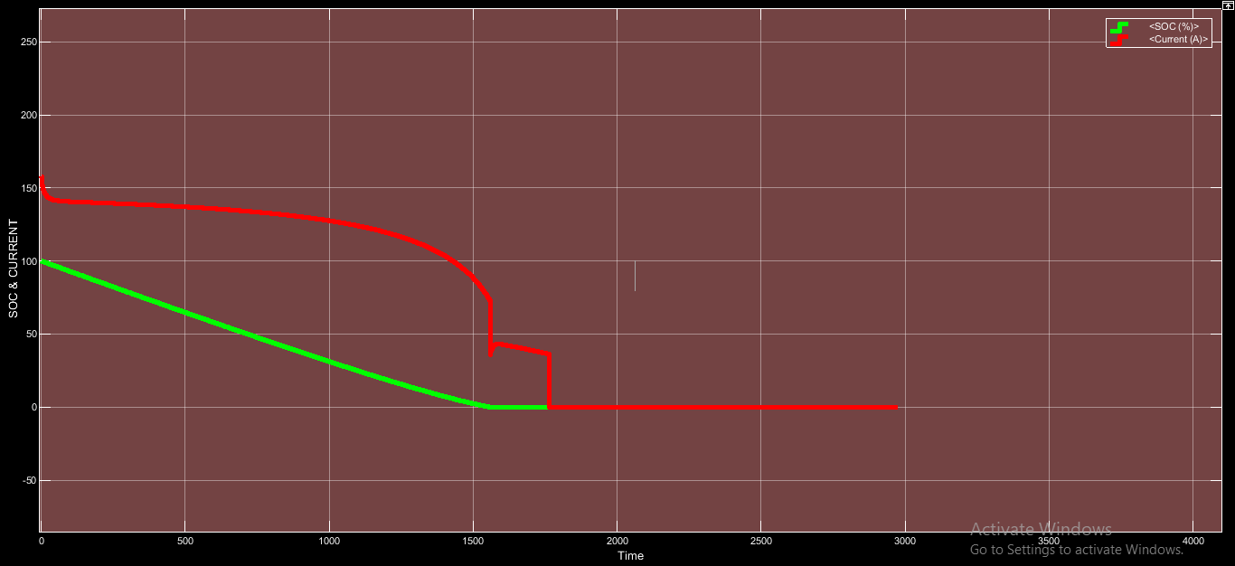
Figure 3.12.1(d):- SOC & CURRENT WAVEFORM OF DISCHARGE OF LEAD ACID-LITHIUM ION ACID SERIES BATTERY WITH LOAD AS STEP SIGNAL WITH RAMP START FOR 500 HOURS

3.13 LITHIUM ION-LITHIUM ION SERIES BATTERY DISCHARGE:
Circuit diagra of Lithium Ion-Lithium Ion Series battery discharge is shown in figure and design parameters are also shown below .Simulation results are shown both in display and waveform basis .

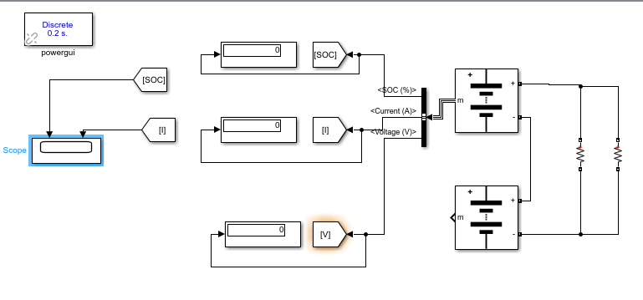
Figure 3.13.1(a):- CIRCUIT DIAGRAM OF DISCHARGE OF LITHIUM ION-LITHIUM ION ACID SERIES BATTERY WITH LOAD RESISTANCE OF 72 OHMS FOR 500 HOURS

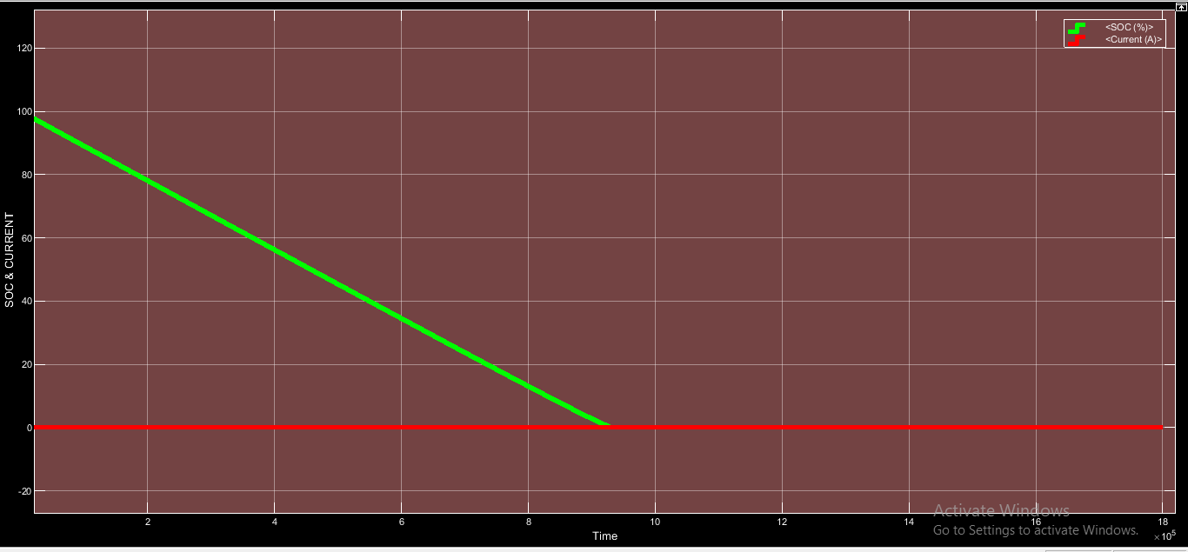
Figure 3.13.1(b):- SOC & CURRENT WAVEFORM OF DISCHARGE OF LITHIUM ION-LITHIUM ION ACID SERIES BATTERY WITH LOAD RESISTANCE OF 72 OHMS FOR 500 HOURS

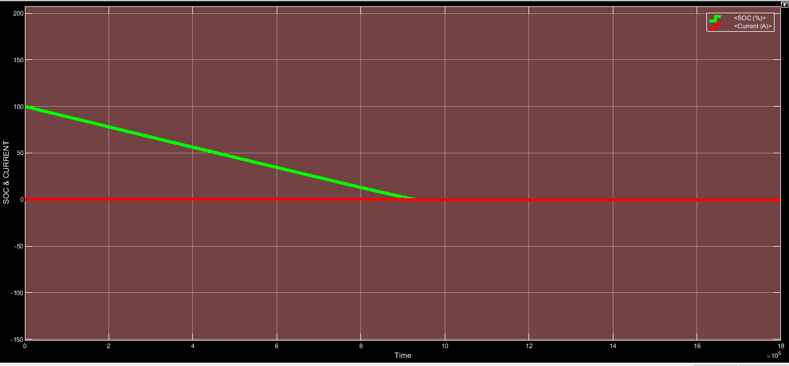
Figure 3.13.1(c):- SOC & CURRENT WAVEFORM OF DISCHARGE OF LITHIUM ION-LITHIUM ION ACID SERIES BATTERY WITH LOAD AS STEP SIGNAL FOR 500 HOURS

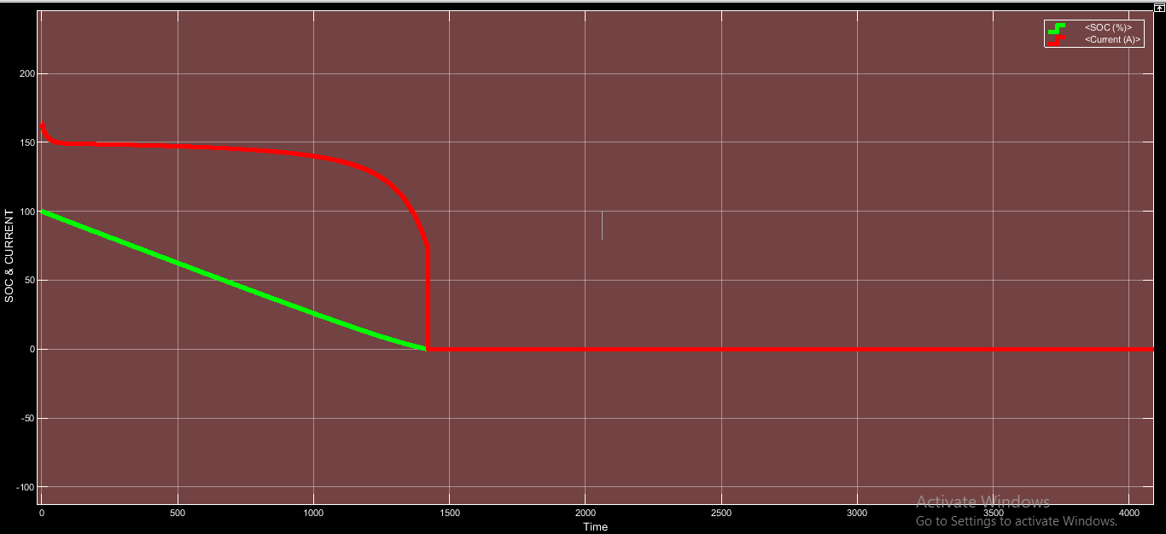
Figure 3.13.1(d):- SOC & CURRENT WAVEFORM OF DISCHARGE OF LITHIUM ION-LITHIUM ION ACID SERIES BATTERY WITH LOAD AS STEP SIGNAL WITH RAMP START FOR 500 HOURS

3.14 LEAD ACID BATTERY PARALLEL DISCHARGE:
Circuit diagra of Lead Acid battery Parallel discharge is shown in figure and design parameters are also shown below .Simulation results are shown both in display and waveform basis .

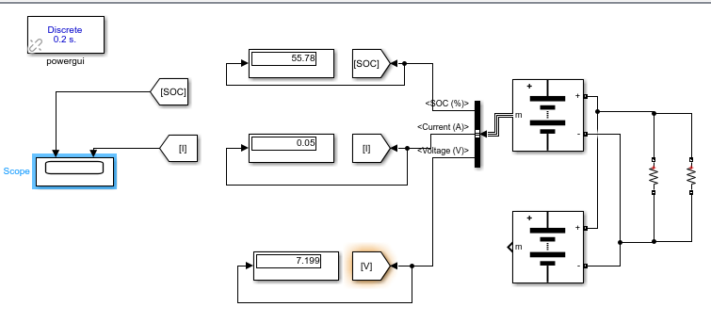
Figure 3.14.1(a):- CIRCUIT DIAGRAM OF DISCHARGE OF PARALLEL CONNECTED LEAD ACID-LEAD ACID ACID BATTERY WITH LOAD RESISTANCE OF 72 OHMS FOR 500 HOURS

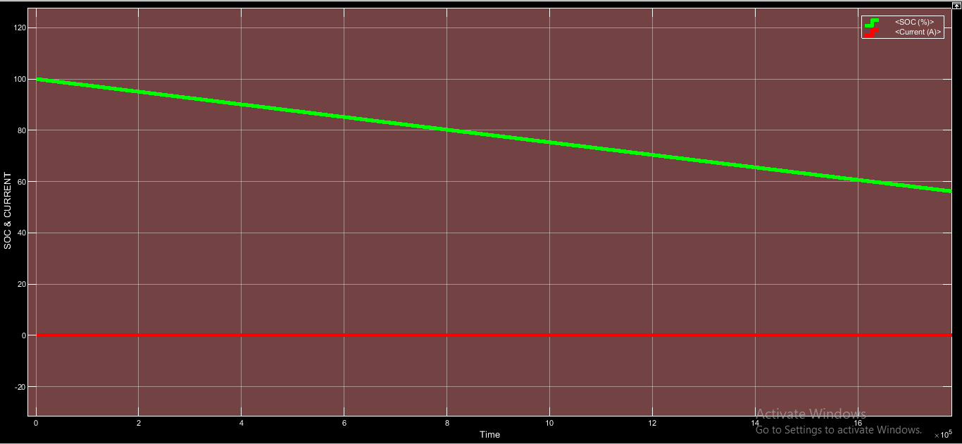
Figure 3.14.1(b):- SOC & CURRENT WAVEFORM OF DISCHARGE OF PARALLEL CONNECTED LEAD ACID-LEAD ACID ACID BATTERY WITH LOAD RESISTANCE OF 72 OHMS FOR 500 HOURS

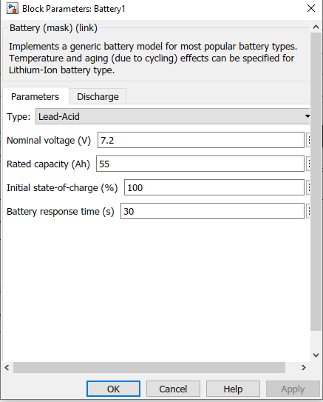
Figure 3.14.1(c):- DETAIL OF LEAD ACID BATTERY
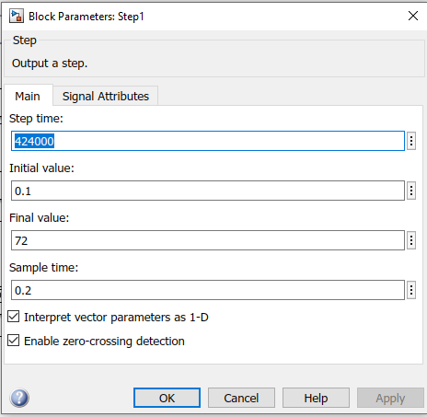
Figure 3.14.1(d):- IMAGE SHOWING DETAIL OF STEP SIGNAL

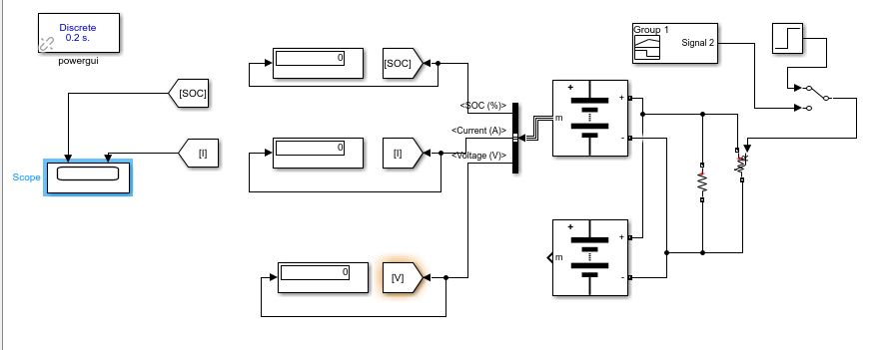
Figure 3.14.2(a):- CIRCUIT DIAGRAM OF DISCHARGE OF PARALLEL CONNECTED LEAD ACID-LEAD ACID ACID BATTERY WITH LOAD AS STEP SIGNAL FOR 500 HOURS
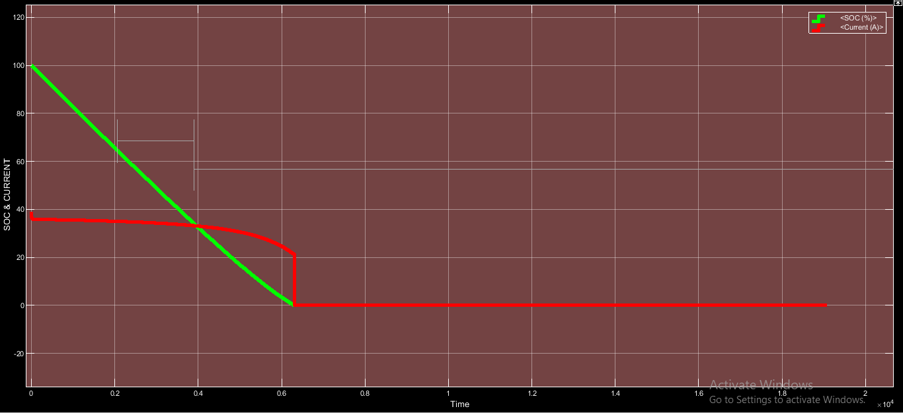
Figure 3.14.2(b):- SOC & CURRENT WAVEFORM OF DISCHARGE OF PARALLEL CONNECTED LEAD ACID-LEAD ACID ACID BATTERY WITH LOAD AS STEP SIGNAL FOR 500 HOURS
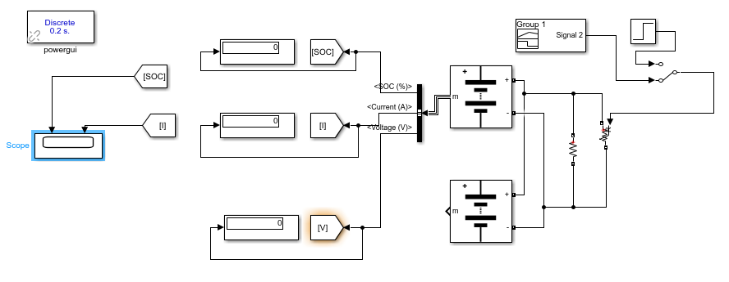
Figure 3.14.3(a):- CIRCUIT DIAGRAM OF DISCHARGE OF PARALLEL CONNECTED LEAD ACID- LEAD ACID BATTERY WITH LOAD AS STEP SIGNAL WITH RAMP START DEVELOPED BY SIGNAL BUILDER FOR 500 HOURS

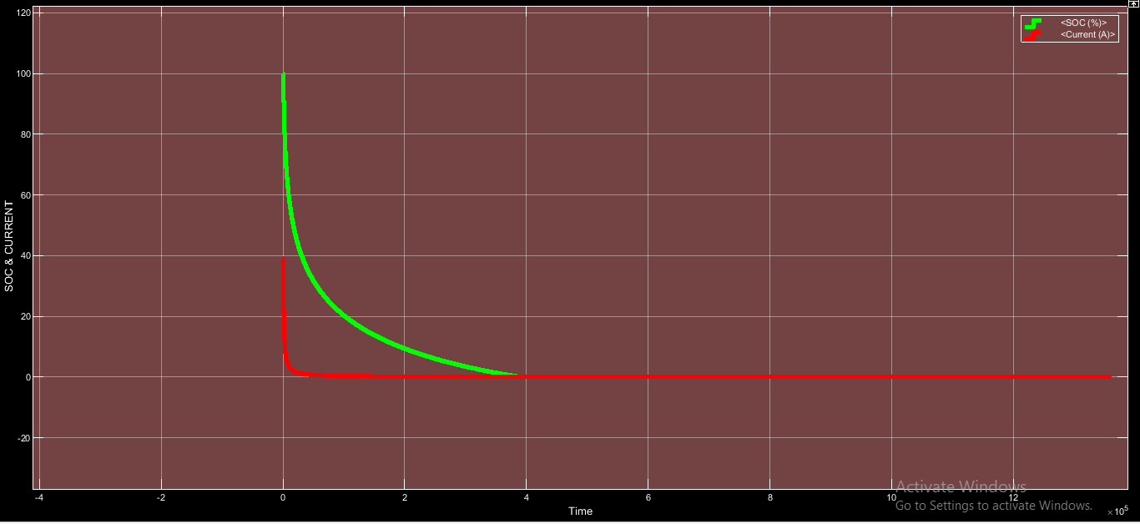
Figure 3.14.3(b):- SOC & CURRENT WAVEFORM OF DISCHARGE OF PARALLEL CONNECTED LEAD ACID-LEAD ACID BATTERY WITH LOAD AS STEP SIGNAL WITH RAMP START DEVELOPED BY SIGNAL BUILDER FOR 500 HOURS

3.15 LEAD ACID-LITHIUM ION BATTERY PARALLEL DISCHARGE:
Circuit diagra of Lead Acid- Lithium Ion battery parallel discharge is shown in figure and design parameters are also shown below .Simulation results are shown both in display and waveform basis .

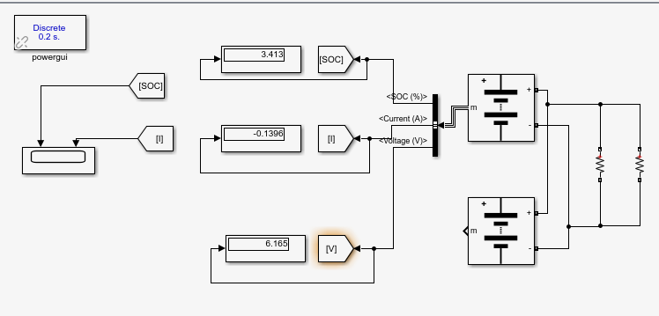
Figure 3.15.1(a):- CIRCUIT DIAGRAM OF DISCHARGE OF PARALLEL CONNECTED LEAD ACID-LITHIUM ION BATTERY WITH LOAD RESISTANCE 72 OHMS FOR 470 HOURS

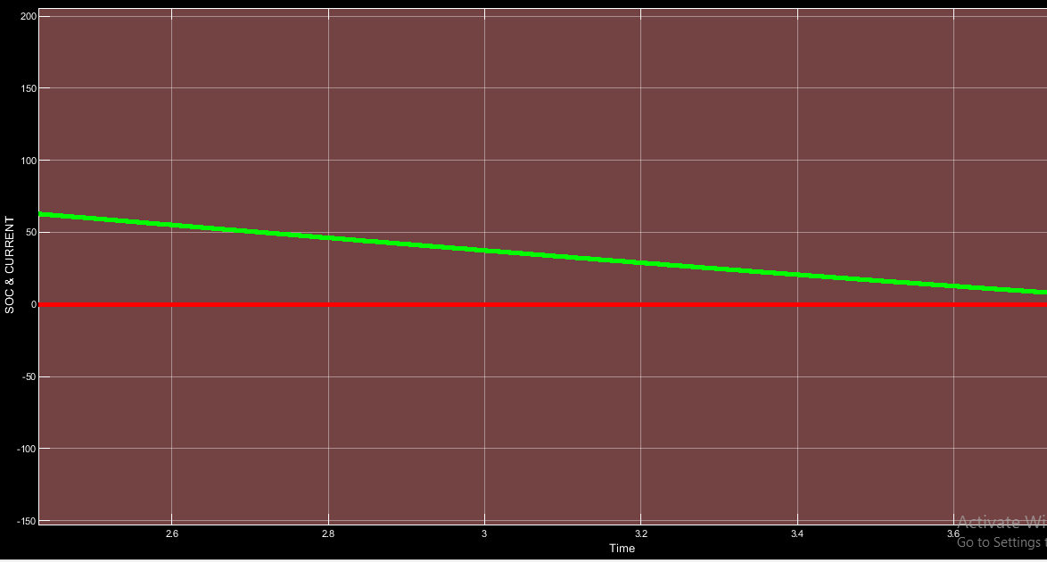
Figure 3.15.1(b):- SOC & CURRENT WAVEFORM OF DISCHARGE OF PARALLEL CONNECTED LEAD ACID-LITHIUM ION BATTERY WITH LOAD RESISTANCE 72 OHMS FOR 470 HOURS
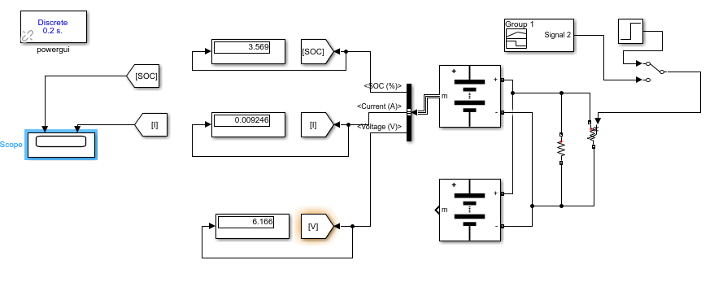
Figure 3.15.2(a):- CIRCUIT DIAGRAM OF DISCHARGE OF PARALLEL CONNECTED LEAD ACID-LITHIUM ION BATTERY WITH LOAD AS STEP SIGNAL FOR 140 HOURS

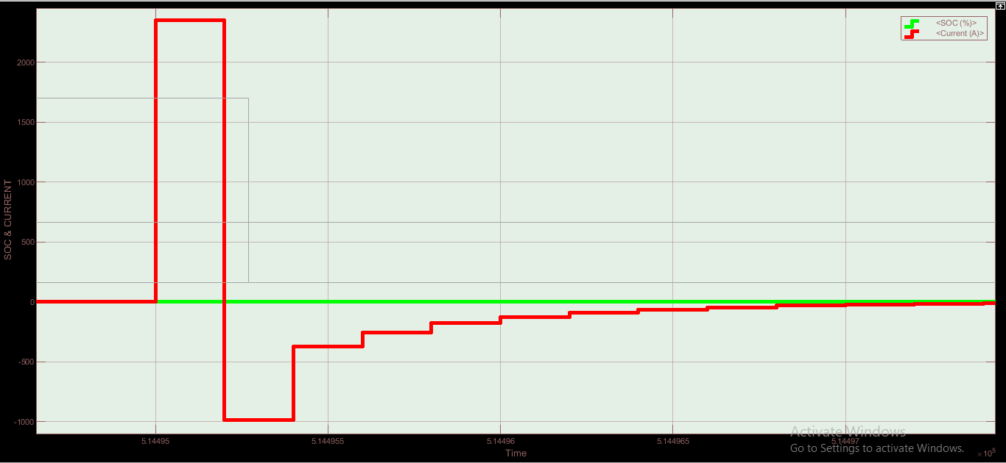
Figure 3.15.2(b):- SOC & CURRENT WAVEFORM OF DISCHARGE OF PARALLEL CONNECTED LEAD ACID-LITHIUM ION BATTERY WITH LOAD AS STEP SIGNAL FOR 140 HOURS

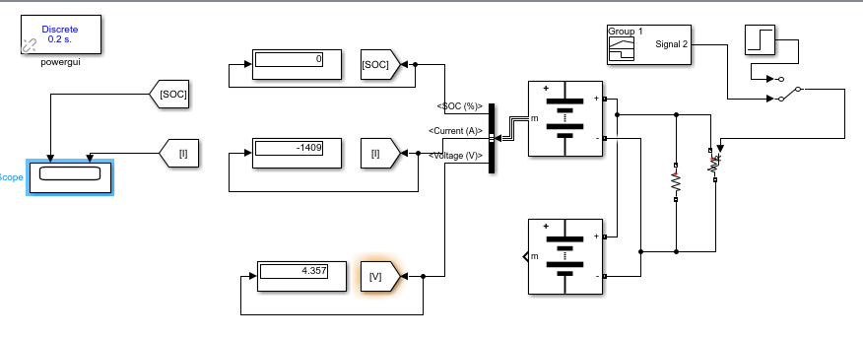
Figure 3.15.3(a):- CIRCUIT DIAGRAM OF DISCHARGE OF PARALLEL CONNECTED LEAD ACID-LITHIUM ION BATTERY WITH LOAD AS STEP SIGNAL WITH RAMP START FOR 200 HOURS

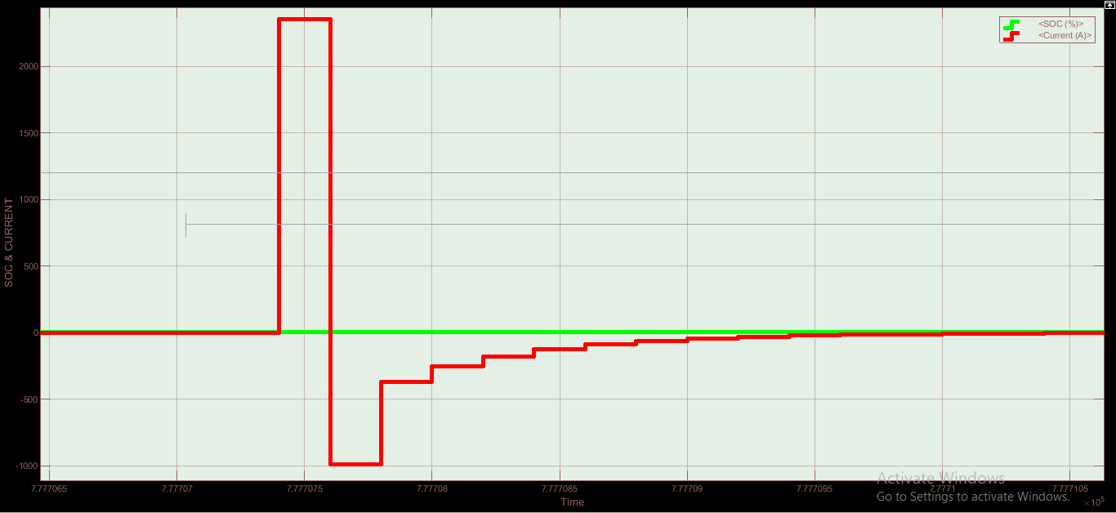
Figure 3.15.3(b):- SOC & CURRENT WAVEFORM OF DISCHARGE OF PARALLEL CONNECTED LEAD ACID-LITHIUM ION BATTERY WITH LOAD AS STEP SIGNAL WITH RAMP START FOR 200 HOURS

3.16 LITHIUM ION-LITHIUM ION BATTERY PARALLEL DISCHARGE:
Circuit diagra of Lithium Ionm-Lithium Ion battery Parallel discharge is shown in figure and design parameters are also shown below .Simulation results are shown both in display and waveform basis .

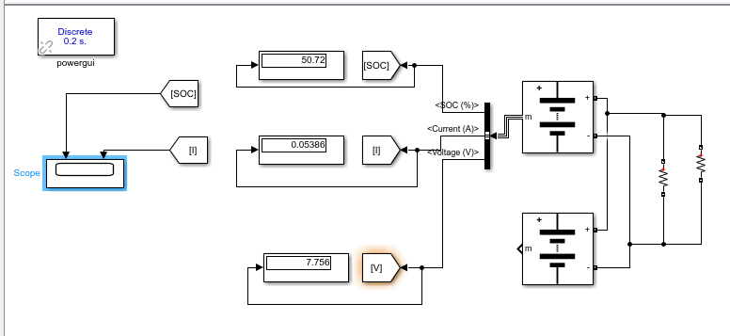
Figure 3.16.1(a):- CIRCUIT DIAGRAM OF DISCHARGE OF PARALLEL CONNECTED LITHIUM ION-LITHIUM ION BATTERY WITH LOAD AS 72 OHMS FOR 500 HOURS

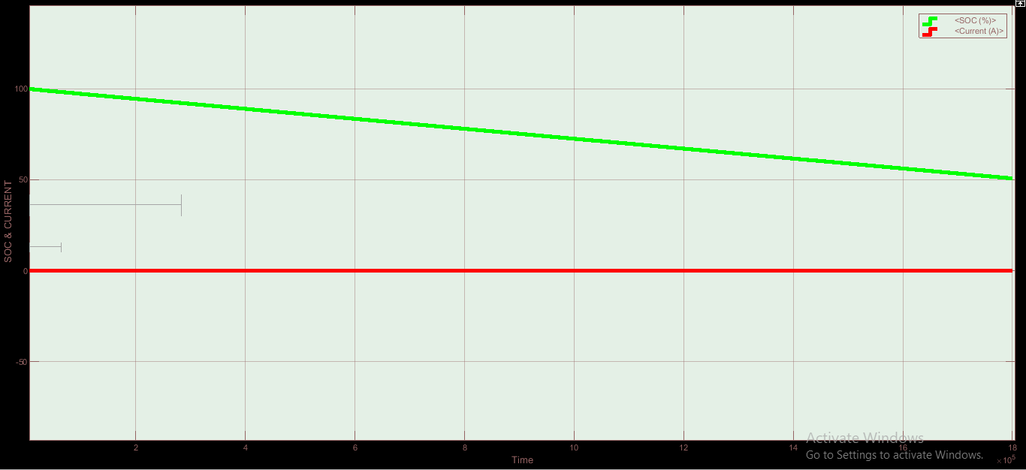
Figure 3.16.1(b):- SOC & CURRENT WAVEFORM OF DISCHARGE OF PARALLEL CONNECTED LITHIUM ION-LITHIUM ION BATTERY WITH LOAD AS 72 OHMS FOR 500 HOURS

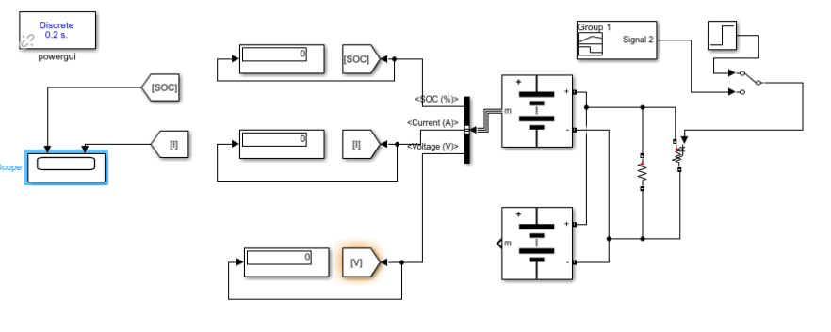
Figure 3.16.2(a):- CIRCUIT DIAGRAM OF DISCHARGE OF PARALLEL CONNECTED LITHIUM ION-LITHIUM ION BATTERY WITH LOAD AS STEP SIGNAL FOR 6 HOURS

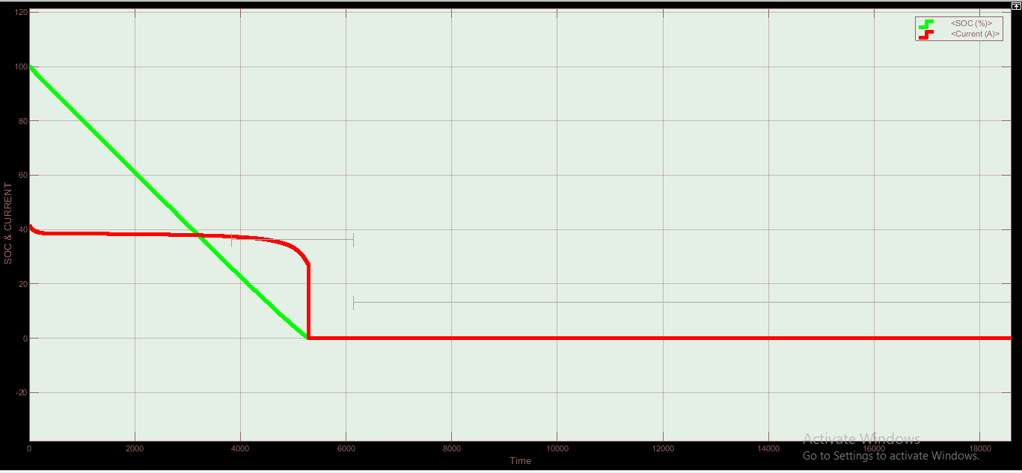
Figure 3.16.2(b):- SOC & CURRENT WAVEFORM OF DISCHARGE OF PARALLEL CONNECTED LITHIUM ION-LITHIUM ION BATTERY WITH LOAD AS STEP SIGNAL FOR 6 HOURS

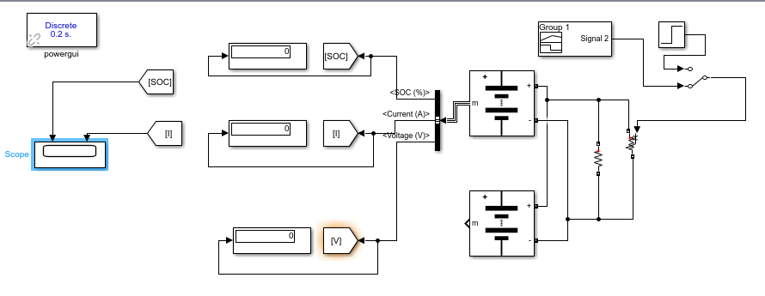
Figure 3.16.3(a):- CIRCUIT DIAGRAM OF DISCHARGE OF PARALLEL CONNECTED LITHIUM ION-LITHIUM ION BATTERY WITH LOAD AS STEP SIGNAL WITH RAMP START FOR 80 HOURS

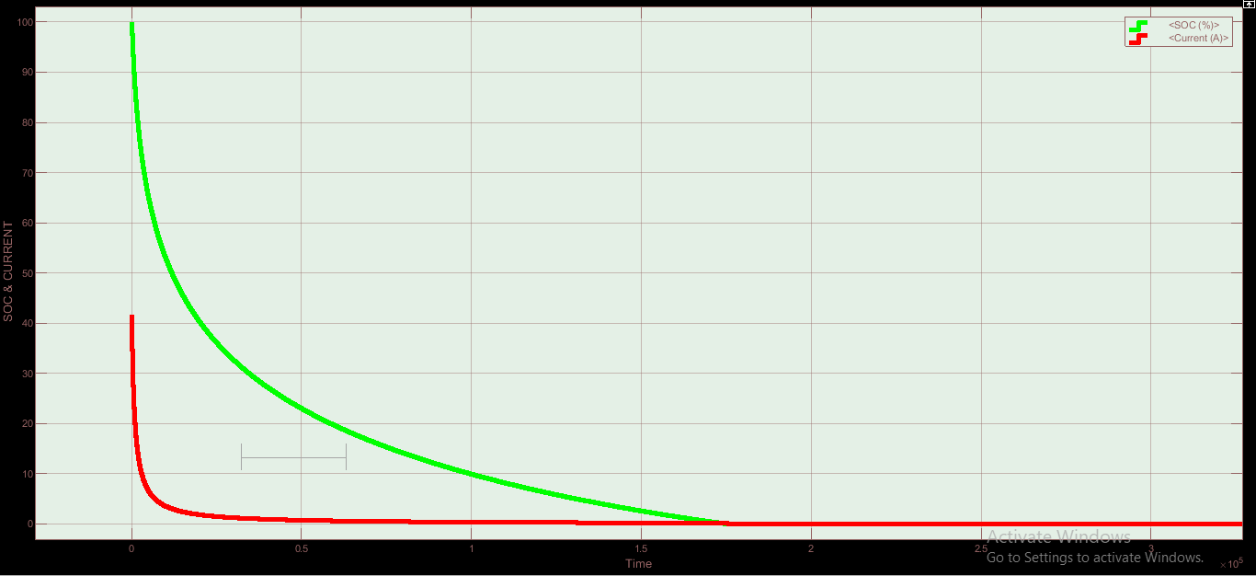
Figure 3.16.3(b):- SOC & CURRENT WAVEFORM OF DISCHARGE OF PARALLEL CONNECTED LITHIUM ION-LITHIUM ION BATTERY WITH LOAD AS STEP SIGNAL WITH RAMP START FOR 80 HOURS

3.17 PV ARRAY IS CONNECTED TO LEAD ACID OR LITHIUM BATTERY WITH A BUCK CONVERTER WHICH IS FURTHER CONNECTED TO INVERTER WHICH IN TURN CONNECTED TO RECTIFIER & BOOST CONVERTER TO A LEAD ACID OR LITHIUM ION BATTERY

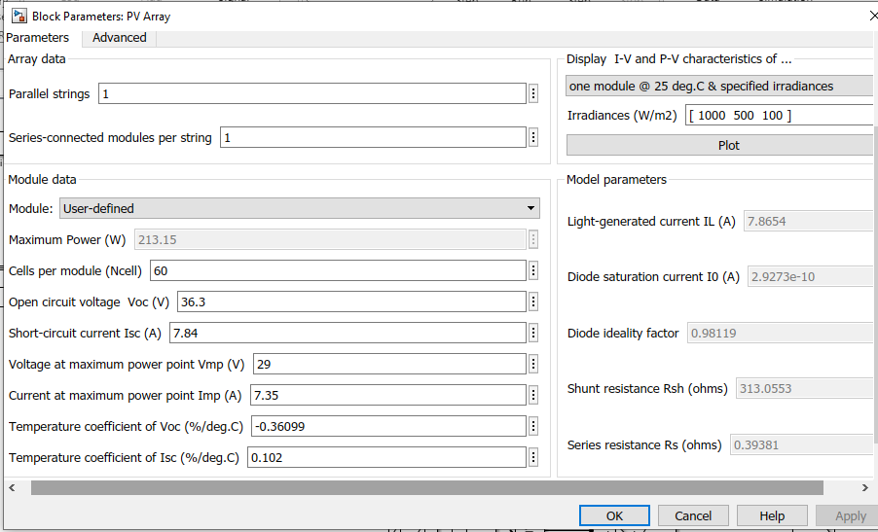
Figure 3.17.1(a) PV-ARRAY DETAILS
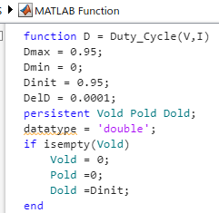

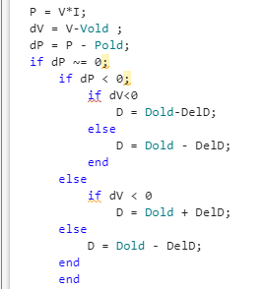
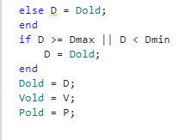
Figure 3.17.1(b):- MATLAB FUNCTION FOR DUTY CYCLE

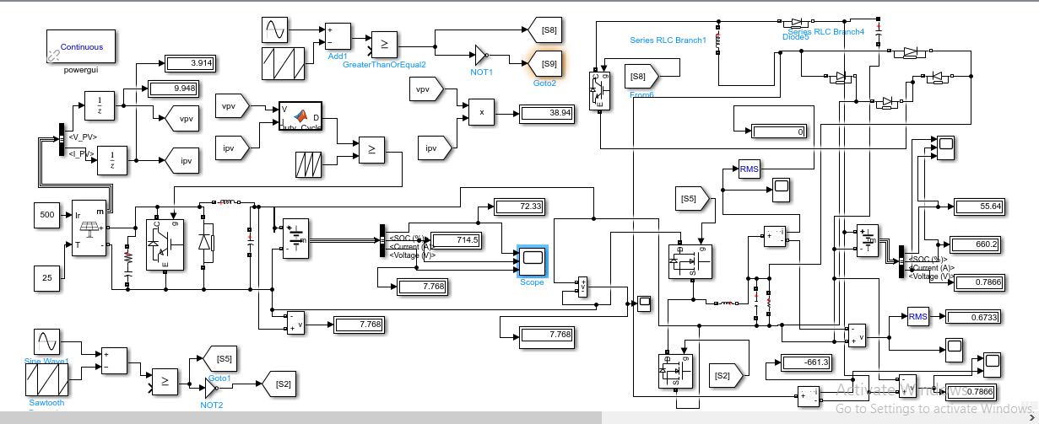
Figure 3.17.2(a):- CIRCUIT DIAGRAM OF PV ARRAY CONNECTED TO LEAD ACID BATTERY WITH A BUCK CONVERTER WHICH IS FURTHER CONNECTED TO INVERTER WHICH IN TURN CONNECTED TO RECTIFIER & BOOST CONVERTER TO A LEAD ACID BATTERY

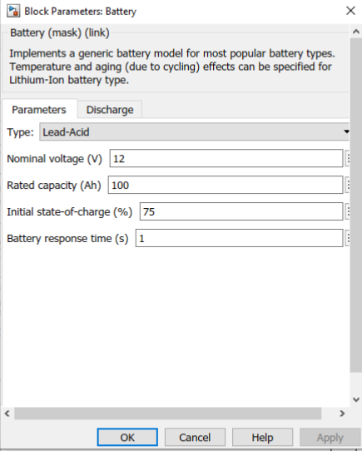
Figure3. 17.2(b):- DETAIL OF LEAD ACID BATTERY CONNECTED TO PV-ARRAY THROUGH A BUCK CONVERTER

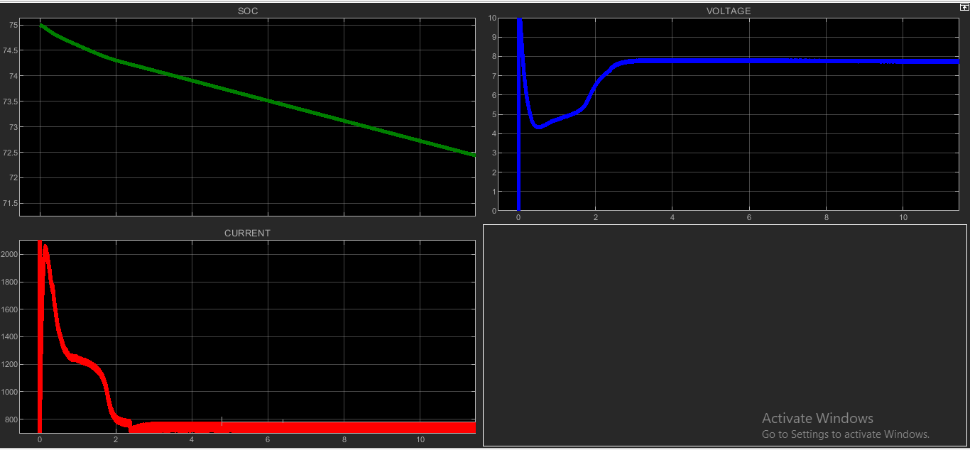
Figure 3.17.2(c):- SOC , CURRENT & VOLTAGE CHARACTERISTICS OF LEAD ACID BATTERY CONNECTED TO PV-ARRAY THROUGH A BUCK CONVERTER

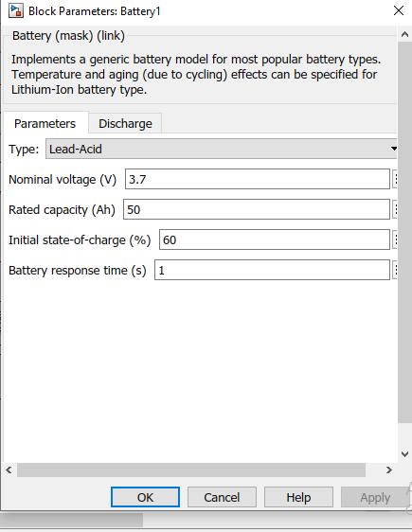
Figure3. 17.2(d):- DETAIL OF LEAD ACID BATTERY CONNECTED TO OUTPUT AS LOAD

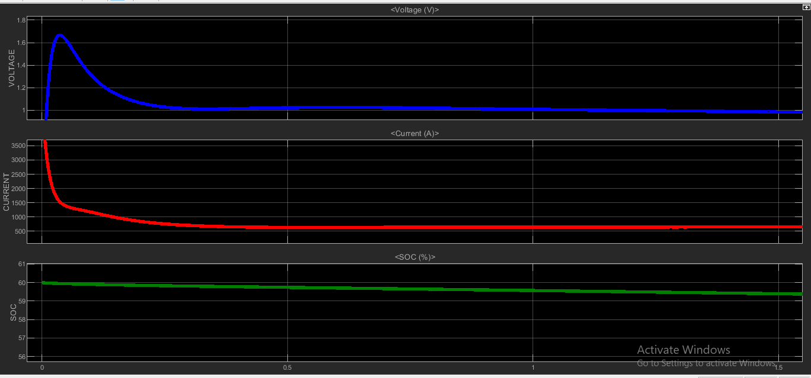
Figure 3.17.2(e):- SOC , CURRENT & VOLTAGE CHARACTERISTICS OF LEAD ACID BATTERY CONNECTED TO OUTPUT AS LOAD

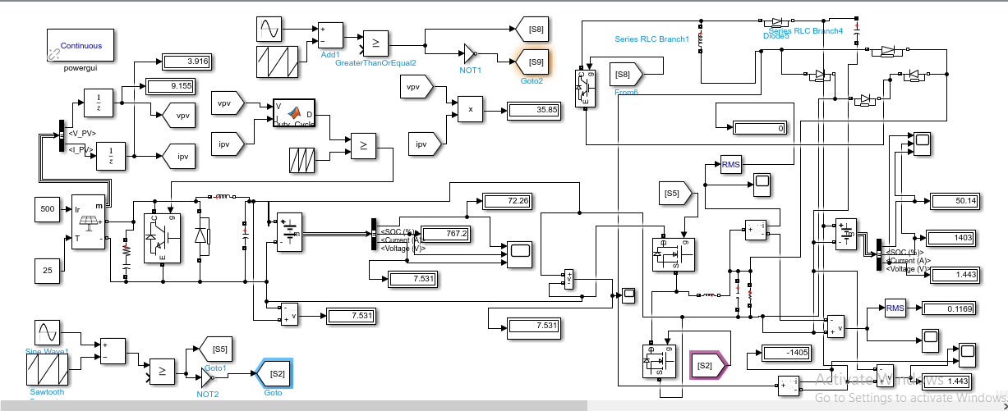
Figure3.17.3(a):- CIRCUIT DIAGRAM OF PV ARRAY CONNECTED TO LEAD ACID BATTERY WITH A BUCK CONVERTER WHICH IS FURTHER CONNECTED TO INVERTER WHICH IN TURN CONNECTED TO RECTIFIER & BOOST CONVERTER TO A LITHIUM ION BATTERY

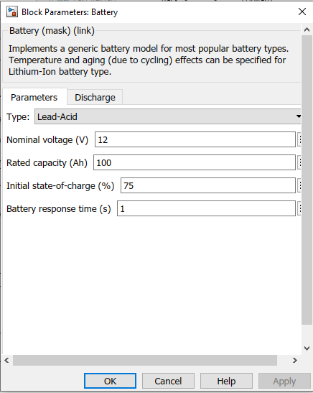
Figure3.17.3(b):- DETAIL OF LEAD ACID BATTERY CONNECTED TO PV-ARRAY THROUGH A BUCK CONVERTER
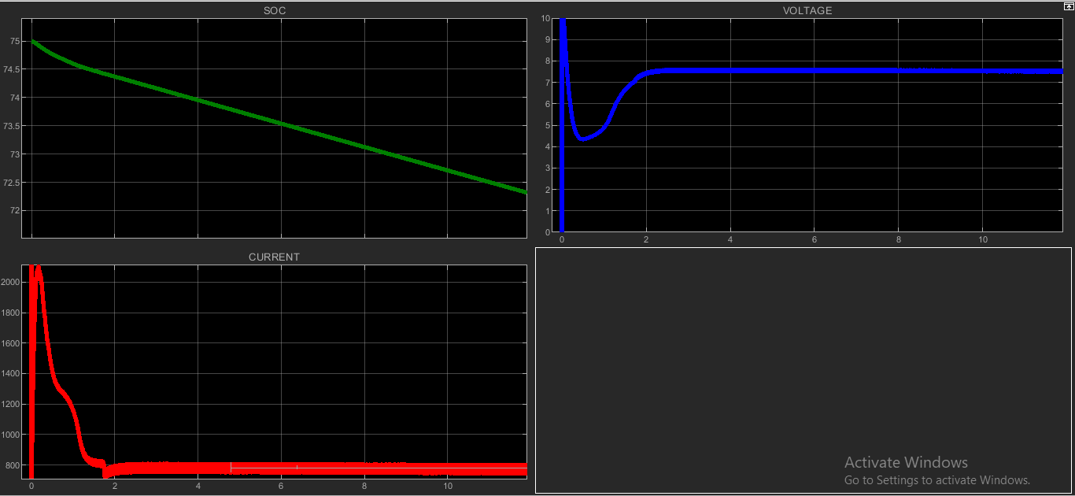
Figure3. 17.3(c):- SOC , CURRENT & VOLTAGE CHARACTERISTICS OF LEAD ACID BATTERY CONNECTED TO PV-ARRAY THROUGH A BUCK CONVERTER
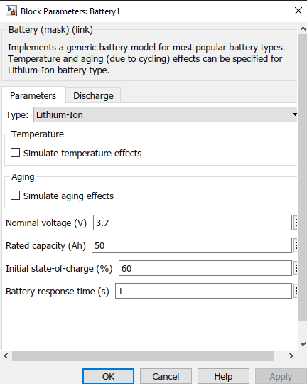Figure3.17.3(d):- DETAIL OF LITHIUM ION BATTERY CONNECTED TO OUTPUT AS LOAD
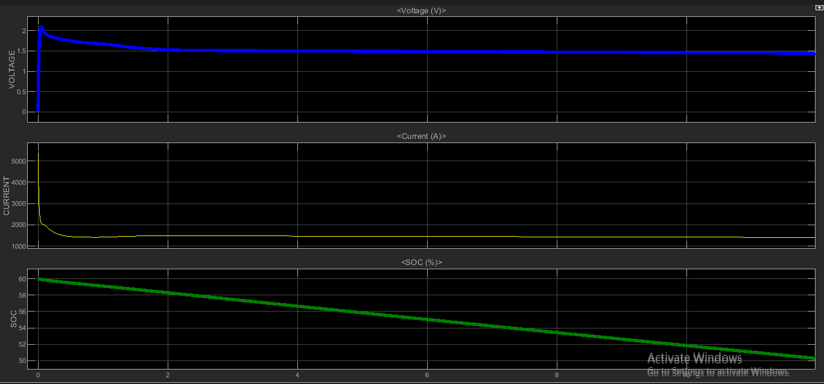
Figure3. 17.3(e):- SOC , CURRENT & VOLTAGE CHARACTERISTICS OF LITHIUM ION BATTERY CONNECTED TO OUTPUT AS LOAD

3.18 PV ARRAY CONNECTED TO LITHIUM ION BATTERY WITH A BUCK CONVERTER WHICH IS FURTHER CONNECTED TO INVERTER WHICH IN TURN CONNECTED TO RECTIFIER & BOOST CONVERTER TO A LITHIUM ION BATTERY OR LEAD ACID BATTERY

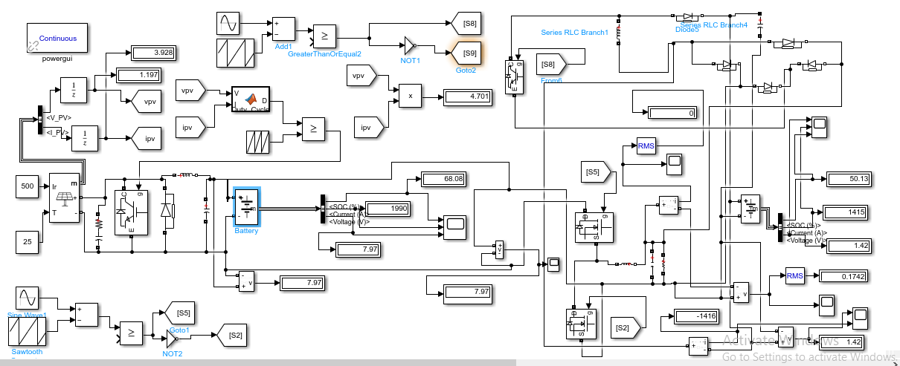
Figure3.18.1(a):- CIRCUIT DIAGRAM OF PV ARRAY CONNECTED TO LITHIUM ION BATTERY WITH A BUCK CONVERTER WHICH IS FURTHER CONNECTED TO INVERTER WHICH IN TURN CONNECTED TO RECTIFIER & BOOST CONVERTER TO A LITHIUM ION BATTERY

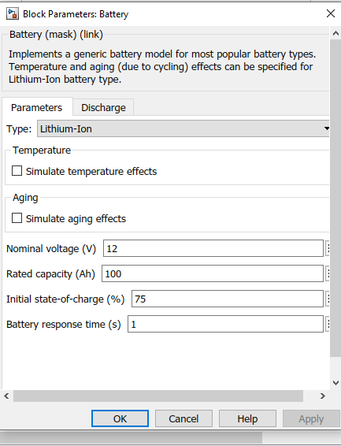
Figure3.18.1(b):- DETAIL OF LITHIUM ION BATTERY CONNECTED TO CONNECTED TO PV-ARRAY THROUGH A BUCK CONVERTER
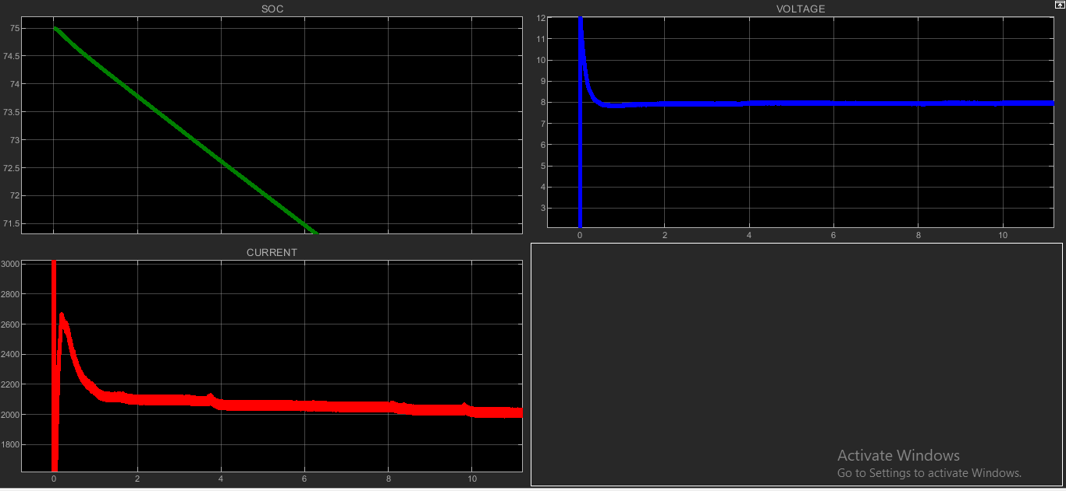Figure3.18.1(c):- SOC , CURRENT & VOLTAGE CHARACTERISTICS OF LITHIUM ION BATTERY CONNECTED TO PV-ARRAY THROUGH A BUCK CONVERTER
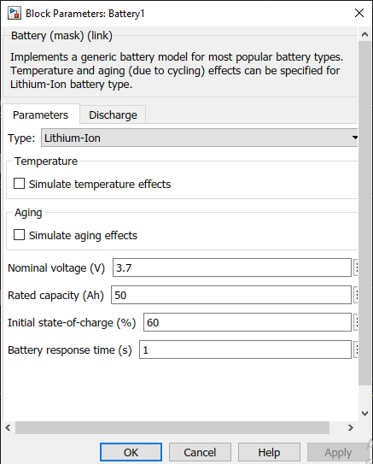
Figure 3.18.1(d):- DETAIL OF LITHIUM ION BATTERY CONNECTED TO CONNECTED TO OUTPUT AS LOAD

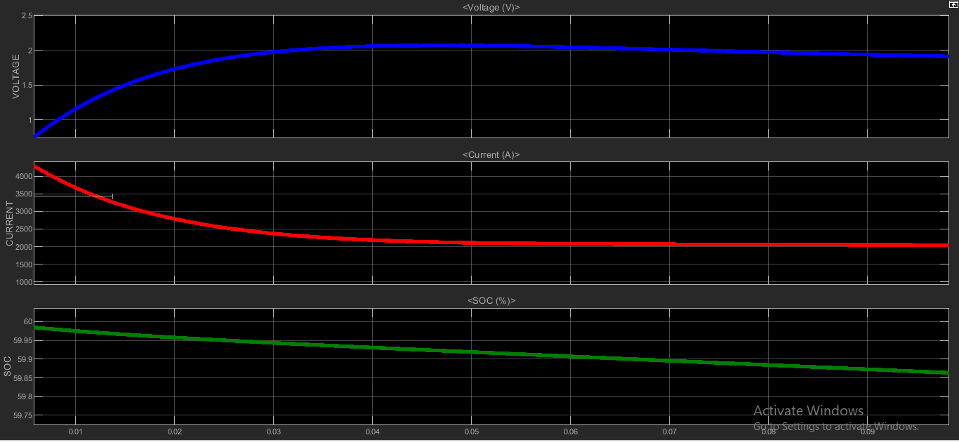
Figure 3.18.1(e):- SOC , CURRENT & VOLTAGE CHARACTERISTICS OF LITHIUM ION BATTERY CONNECTED TO OUTPUT AS LOAD

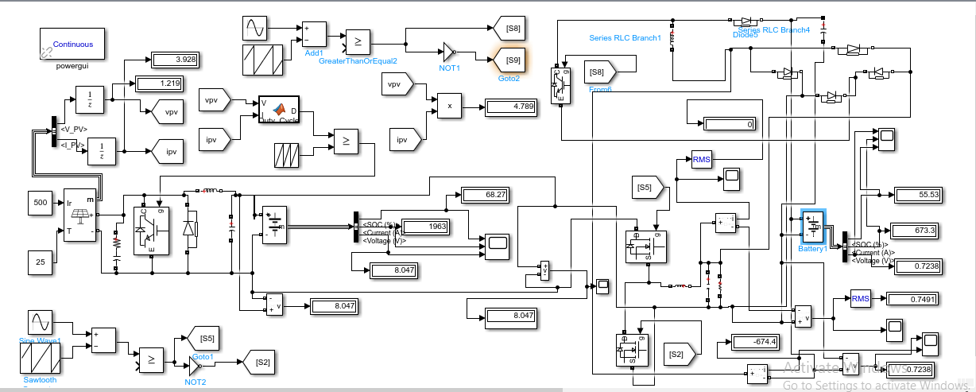
Figure3.18.1(f):- CIRCUIT DIAGRAM OF PV ARRAY CONNECTED TO LITHIUM ION BATTERY WITH A BUCK CONVERTER WHICH IS FURTHER CONNECTED TO INVERTER WHICH IN TURN CONNECTED TO RECTIFIER & BOOST CONVERTER TO A LEAD ACID BATTERY

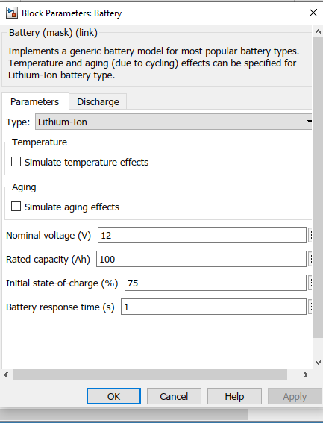
Figure 3.18.1(g):- DETAIL OF LITHIUM ION BATTERY CONNECTED TO CONNECTED TO PV-ARRAY THROUGH A BUCK CONVERTER
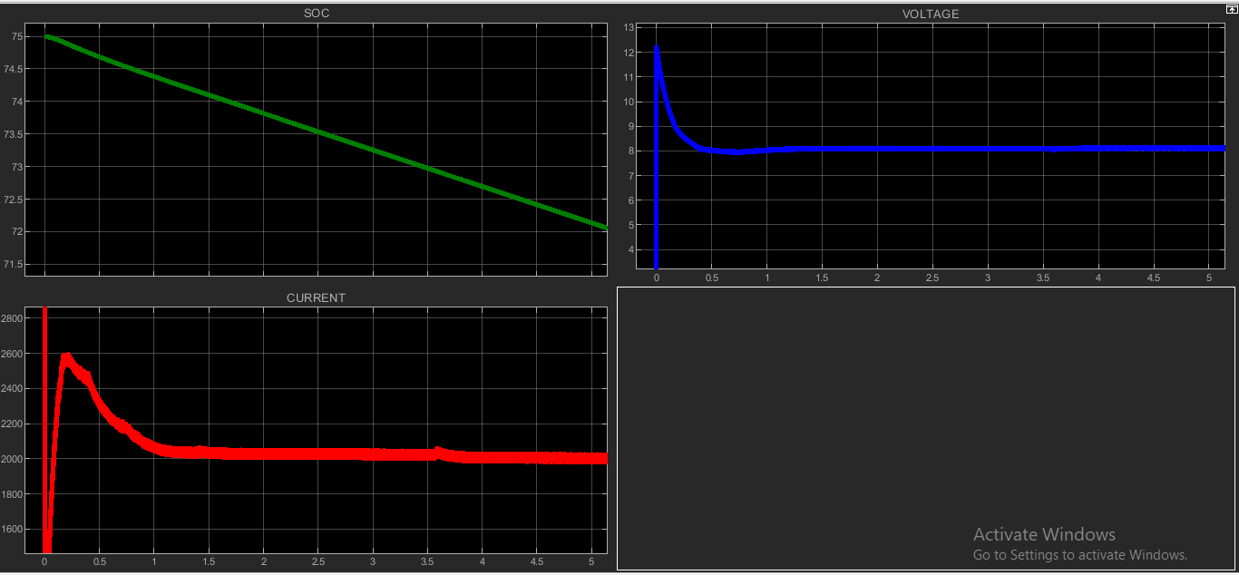
Figure 3.18.1(h):- SOC , CURRENT & VOLTAGE CHARACTERISTICS OF LITHIUM ION BATTERY CONNECTED TO PV-ARRAY THROUGH A BUCK CONVERTER

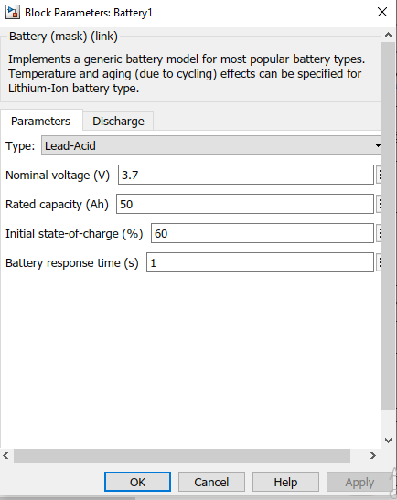
Figure 3.18.1(i):- DETAIL OF LEAD ACID BATTERY CONNECTED TO CONNECTED TO OUTPUT AS LOAD
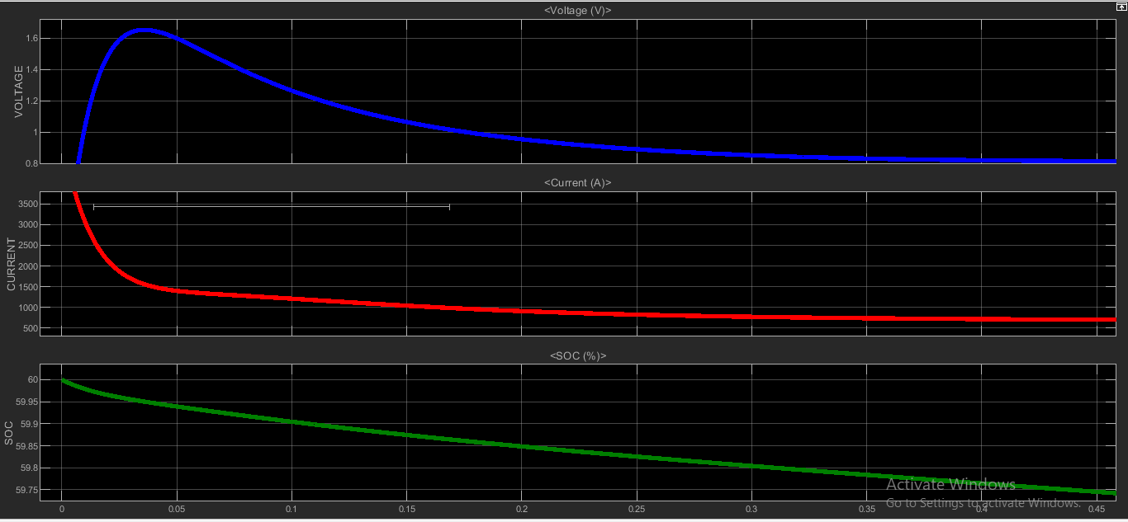
Figure 3.18.1(j):- SOC , CURRENT & VOLTAGE CHARACTERISTICS OF LEAD ACID BATTERY CONNECTED TO OUTPUT AS LOAD

3.19 ANALYSIS OF LEAD ACID BATTERY CHARGING :-
Initially the SOC & nominal voltage of Lead Acid battery taken as 45% and 7.2 volt . The SOC reaches to 100% and charging current becomes -96.81 milli Ampere within a period of 425 seconds .The charging current was more initially and reduced by time i.e with 24 volt DC source for charging lead acid battery of initial voltage of 7.2 volt , the charging currenr reduces exponentially .
3.20 ANALYSIS OF LITHIUM ION BATTERY CHARGING :-
Initially the SOC & nominal voltage of Lithium Ion battery taken as 45% and 7.2 volt . The SOC reaches to 100% and charging current becomes -264.3 milli Ampere within a period of 425 seconds .The charging current was more initially and reduced by time i.e with 24 volt DC source for charging lead acid battery of initial voltage of 7.2 volt , the charging currenr reduces somewhat linearly .
3.21 ANALYSIS OF LEAD ACID –LEAD ACID SERIES BATTERY CHARGING :-
Initially the SOC & nominal voltage of both Lead Acid battery taken as 45% and 7.2 volt . The SOC reaches to 100% and charging current becomes -207.8 milli Ampere within a period of 1 hour as observed . .The charging current was more initially and reduced to constant i.e with 30 volt DC source for charging lead acid battery of initial voltage of 7.2 volt , the charging currenr becomes constant.
3.22 ANALYSIS OF LEAD ACID –LITHIUM ION SERIES BATTERY CHARGING :-
Initially the SOC & nominal voltage of Lead Acid & lithium ion battery taken as 45% and 7.2 volt . The SOC reaches to 100% and charging current becomes -203.9 milli Ampere within a period of 1 hour as observed . The charging current was more initially and reduced to constant i.e with 30 volt DC source for charging lead acid battery of initial voltage of 7.2 volt , the charging current initially increases & in a short time reduces and then after a small interval of regular 500 seconds , it further increases and then reduces again and this continues .
3.23 ANALYSIS OF LITHIUM ION –LITHIUM ION SERIES BATTERY CHARGING :-
Initially the SOC & nominal voltage of both lithium ion battery taken as 45% and 7.2 volt . The SOC reaches to 100% and charging current becomes -677.8 milli Ampere within a period of 1 hour as observed . The charging current was more initially and reduced to constant i.e with 30 volt DC source for charging lead acid battery of initial voltage of 7.2 volt , the charging current initially increases & in a short time reduces and then after a small interval of regular 200 seconds , it further increases and then reduces again and this continues .
3.24 ANALYSIS OF LEAD ACID –LEAD ACID PARALLEL BATTERY CHARGING :-
Initially the SOC & nominal voltage of both lead acid & lead acid battery taken as 45% and 7.2 volt . The SOC reaches to 100% and charging current becomes -207.8 milli Ampere within a period of 1 hour as observed . The charging current was more initially and reduced to constant i.e with 15 volt DC source for charging lead acid battery of initial voltage of 7.2 volt , the charging current initially increases & then reduces and this reduced current maintains constant throughout .
3.25 ANALYSIS OF LEAD ACID –LITHIUM ION PARALLEL BATTERY CHARGING :-
Initially the SOC & nominal voltage of both lead acid & lead acid battery taken as 45% and 7.2 volt . The SOC reaches to 100% and charging current becomes -207.8 milli Ampere within a period of 1 hour as observed . The charging current was more initially and reduced to constant i.e with 15 volt DC source for charging lead acid battery of initial voltage of 7.2 volt , the charging current initially increases & then reduces and this reduced current maintains constant throughout i.e the behavior is same as for leadacid-lead acid parallel battery charging .
3.26 ANALYSIS OF LITHIUM ION –LITHIUM ION PARALLEL BATTERY CHARGING :-
Initially the SOC & nominal voltage of both lead acid & lead acid battery taken as 45% and 7.2 volt . The SOC reaches to 100% and charging current becomes 469.6 milli Ampere within a period of 1 hour as observed i.e with 15 volt DC source for charging lead acid battery of initial voltage of 7.2 volt , the charging current initially very low & then reduces and this reduced current maintains constant throughout .
3.27 ANALYSIS OF LEAD ACID DISCHARGE:-
For a period of 500 hour , the lead acid discharges from 100% to 13.64% and low discharge current develops and voltage reduces to 6.49 volt from 7.2 volt when 72 ohms resistance is connected at load & with step load , the current reduces in step and the for step signal with ramp start load , the the current purely reduces exponentially and then becomes constant .
3.28 ANALYSIS OF LITHIUM ION DISCHARGE:-
For a period of 500 hour , the lead acid discharges from 100% to 2.757% and low discharge current develops and voltage reduces to 6.925 volt when 72 ohms resistance is connected at load & with step load , the current reduces in step with little curvature and finally becomes cvonstant and the for step signal with ramp start load , the current purely reduces exponentially and then becomes constant .
3.29 ANALYSIS OF LEAD ACID-LEAD ACID SERIES DISCHARGE:-
The soc reduces from 100% to 0% within a period of 300 hours & current almost remains constant for 72 ohms resistance at load . For step , the current reduces in a step format and finally becomes constant & SOC reduces to 0% in nearly 1800 seconds . For step with ramp start , the soc reduces to 0 % in 4000 seconds & current droops exponentially with a step end and finally becomes constant .
3.30 ANALYSIS OF LEAD ACID-LITHIUM ION SERIES DISCHARGE:-
The soc reduces from 100% to 0% within a period of 300 hours & current remains constant throughput for 72 ohms resistance at load .For step , the SOC reduces to 0% in 250 hours & current constant throughput . For step
The SOC reduces to 0% in 250 hours and current constant throughput .Fopr step with ramp start , the soc reduces to 0 % in 1200 seconds & current reduces to nearly zero in a step format with a curvature in 1750 seconds .
3.31 ANALYSIS OF LITHIUM ION-LITHIUM ION SERIES DISCHARGE:-
The soc reduces from 100% to 0% within a period of 250 hours & current remains low constant throughput for 72 ohms resistance at load .For step , the SOC reduces to 0% in 250 hours & current constant throughput . For step , The SOC reduces to 0% in 250 hours and current remains low throughput .Fopr step with ramp start , the soc reduces to 0 % in 1400 seconds & current reduces to nearly zero , becomes constant at it , in a step format with a curvature in 1400 seconds .
3.32 ANALYSIS OF LEAD ACID –LEAD ACID PARALLEL DISCHARGE :-
The SOC REDUCES TO 58% in 500 hours and current remains low constant throughput for 72 ohms resistance at load .For step load , the the SOC reduces to 0 in 170 hours & reduces in a step format to a low constant current . For step load with ramp start , the SOC reduces exponentially to zero in 110 hours and current remains constant low.
3.33 ANALYSIS OF LEAD ACID –LITHIUM ION PARALLEL DISCHARGE :-
The SOC reduces to 3.413% in 470 hours and current remains low constant throughput for 72 ohms resistance at load .For step load , the the SOC reduces to 0 & current first increases & then continuously decreases in step format to low current in 165 hours . For step with ramp start load also , the same is observed .
3.34 ANALYSIS OF LITHIUM ION-LITHIUM ION PARALLEL DISCHARGE:-
The SOC reduces to 50.72% in 500 hours and current remains low constant throughput for 72 ohms resistance at load .For step load , the the SOC reduces to 0 in 140 hours & current reduces in step format to finally constant zero current in . For step with ramp start load also , the SOC reduces to zero in 40 hours & current droops to zero and becomes constant throughput .
3.35 ANALYSIS OF PV ARRAY CONNECTED TO LEAD ACID BATTERY WITH A BUCK CONVERTER WHICH IS FURTHER CONNECTED TO INVERTER WHICH IN TURN CONNECTED TO RECTIFIER & BOOST CONVERTER TO A LEAD ACID BATTERY OR LITHIUM ION BATTERY:-
FOR INPUT LEAD ACID BATTERY TO PV ARRAY AND BUCK CONVERTER:-The SOC reduces from 75% to 72.5 % in 11 seconds. The voltage begins with the spike at peak voltage 10 volt and then becomes constant at 8 volt and current begins with spike and then reduces to 800 milli ampere and becomes constant .
FOR OUTPUT LEAD ACID BATTERY AS LOAD:-The SOC reduces from 60% initial charging to 30% in 1.5 seconds . The voltage begins with a spike at 16 volt and reduces to 1 volt .The current begins with a spike & reduces to 100 milli ampere constant current .
FOR OUTPUT LITHIUM ION BATTERY AS LOAD:-
The SOC reduces from 60% initial charging to 52% in 12 seconds . The voltage begins with a spike at 16 volt and reduces to 1.5 volt .The current begins with a spike & reduces to 1300 milli ampere constant current .

3.36 ANALYSIS OF PV ARRAY CONNECTED TO LITHIUM ION BATTERY WITH A BUCK CONVERTER WHICH IS FURTHER CONNECTED TO INVERTER WHICH IN TURN CONNECTED TO RECTIFIER & BOOST CONVERTER TO A LITHIUM ION BATTERY OR LEAD ACID BATTERY :-
FOR INPUT LITHIUM ION BATTERY TO PV ARRAY AND BUCK CONVERTER:-
The SOC reduces from 75% to 70 % in 6 seconds. The voltage begins with the spike at peak voltage 10 volt and then becomes constant at 8 volt and current begins with spike and then reduces to 2000 milli ampere and becomes constant .
FOR OUTPUT LEAD ACID BATTERY AS LOAD:-
The SOC reduces from 75% to 58 % in 0.1 seconds. The voltage reduces from 1.8 volt to 0.8 volt & current then reduces from 2000 milli ampere to 800 milli ampereand becomes constant .
FOR OUTPUT LITHIUM ION BATTERY AS LOAD:-
The SOC reduces from 75% to 58 % in 0.45 seconds. The voltage increases exponentially to1.8volt & droops down to 0.8 volt & current begins with a spike, reaches above 5000 milli ampere and then reduces from to 800 milli ampere and becomes constant .

TABLE 3.1 SIMULATION RESULT OF BATTERY CHARGING
CHARGING OF BATTERIES WITH INITIAL STATE OF CHARGE = 45%
LEAD ACID BATTERY | 425 SECONDS | 100%
LITHIUM ION BATTERY | 100 SECONDS | 100%
LEAD ACID-LEAD ACID SERIES BATTERY CHARGING | 140 SECONDS | 100%
LITHIUMION –LEAD ACID SERIES BATTERY CHARGING | 70 SECONDS | 100%
LITHIUMION-LITHIUMION SERIES BATTERY CHARGING | 60 SECONDS | 100%
LEAD ACID-LEAD ACID PARALLEL BATTERY CHARGING | 225 SECONDS | 100%
LEADACID-LITHIUMION PARALLEL BATTERY CHARGING | 250 SECONDS | 100%
LITHIUMION-LITHIUMION PARALLEL BATTERY CHARGING | 80 SECONDS | 100%

TABLE 3.2 SIMULATION RESULT OF BATTERY DISCHARGING
DISCHARGING OF BATTERIES WITH INITIAL STATE OF CHARGE = 100% WITH LOAD AS 72 OHM RESISTANCE
LEAD ACID BATTERY | 500 HOURS | 13.64%
LITHIUM ION BATTERY | 500 HOURS | 2.757%
LEAD ACID-LEAD ACID SERIES BATTERY DISCHARGING | 275 HOURS | 0%
LITHIUMION –LEAD ACID SERIES BATTERY DISCHARGING | 300 HOURS | 0%
LITHIUMION-LITHIUMION SERIES BATTERY DISCHARGING | 250 HOURS | 0%
LEAD ACID-LEAD ACID PARALLEL BATTERY DISCHARGING | 500 HOURS | 55.78%
LEADACID-LITHIUMION PARALLEL  BATTERY DISCHARGING | 470 HOURS | 3.413%
LITHIUMION-LITHIUMION PARALLEL  BATTERY DISCHARGING | 500 HOURS | 50.72%

CHAPTER 4
SUMMARY & CONCLUSION
4.1 Summary:
The analysis and design of batteries charging and discharging have been carried out for various performances parameters of voltages and loads. For charging , the fixed voltage source of 12 volt for 7.2v battery and fixed voltage source of 24 volt for series charging is used . The loads vary from purely resistive load or step load to step load with ramp at start . Namely Lead Acid , Lithium Ion and their series and parallel combination have been designed to delever output characteristics with fixed DC voltage source for charging and and also outputs of Discharging of batteries studied with load variations seen through display and waveform characteristics .This work was carried out with the help of Matlab-Simulink . The result of simulation are presented for comparison . These design concepts are validated through simulation in the matlab and the results are presented for analysis of various batteries.
4.2 Conclusion:
The depth of discharge and battery capacity is strongly affected by the discharge rate of the battery . The battery capacity degrades due to sulfation and shedding of extra material .The degradation of battery capacity depends most strongly on the interrelationship between the following parameters :-
- The charging/discharging regime which the battery has experienced
2. The exposure to prolonged periods of low discharge .
3. The average temperature of the battery over it’s lifetime .
Reducing internal resistance improves battery output , enhances energy efficiency which in turn leads to higher reliability .The specific energy density for lead acid is 30-50 Wh/Kg and for lithium ion , it is 100-135 Wh/Kg with Manganese as salt . The cycle life with 80% discharge for lead acid is 200-300 hours and for lithium ion , it is 1000-2000hours with phosphate as salt .The internal resistance of Lead acid with 12 volt battery pack is less than 100 milli ohm where as for lithium ion battery , it is 25-50 milli ohm per cell . The initial state of charge of both batteries set at 45% and it is found that Lead acid battery takes 425 seconds to full charge while Lithium Ion Battery takes 100 seconds to full charge . So charging of Lithium IonBbattery is fastest . With initial state set to full charge , it was found that Lead Acid Battery discharge to 13.64% in 500 hours while Lithium Ion Battery in the same period discharge to 2.757% with load resistance set at 72 ohms in both cases . While lead acid charging through simulation ,it is seen that initially the charging current is high and the charging current reduces exponentially with time onwards . Theoritically if lead acid battery is being discharged very quickly , then the discharge current is high but practically if discharged for long period of 500 hours with load resistance nearly 100 ohms , the discharge current is constant . while in Lthium Ion Charging ,the charging current develops constant current algorithm and it is observed , unlike Lead Acid , where charging current decreases exponentially , here in Lithium Ion Battery , the current deduces to constant naturehood in a very short period of time duration .Even seen in Lithium Ion also like in Lead Acid that discharging for 500 hours results to constancy in current characteristics .

.

CHAPTER 5
FUTURE SCOPE

Lead acid battery is used in every type of vehicle because they have proven to be very cost effective method for storing sufficient power and energy .They are inexpensive and simple to manufacture . Due to growth in automobile and Unterruptible Power Source (UPS) , there is potential increase in the market of these batteries . But lead and sulphuric acid which are two main components can poison solid and ground water and so are threat to human health and the environment .While lead acid can take 10 hours to charge , the lithium ion takes 3 hours and few minutes to charge , depending on the size of the battery ,The lithium ion accepts a faster rate of current , charges quickly than lead acid batteries .The solid state Lithium battery is a new development and steps forward from current Lithium Ion Batteries . The Solid State Batteries combine the performance of conventional Lithium Ion and Lithium polymer with higher safety for use in different applications . It promises lower cost , more power ,longer range , faster charging times ,greater flexibility and improved safety . Solid state batteries can have energy density of upto 350 watt-hours per kg and even higher as compared to 100-360 Whr/kg of conventional lithium ion batteries .So Solid state batteries can secure our future challenging needs .

REFRENCES
[1]Tenno, R. Tenno and T. Suntio, "Battery impedance and its relationship to battery characteristics," 24th Annual International Telecommunications Energy Conference, 2002, pp. 176-183, doi: 10.1109/INTLEC.2002.1048653.
[2]Lakshmi Kp and Pruthvija .B,” Review on Battery Technology and its Challenges”, International Journal of Scientific and Engineering Research 11(9):1706 , September 2020

[3]Max Langridge and Luke Edwards, “Future batteries, coming soon: Charge in seconds, last months and power over the air”, July 2018.
[4]Kularatna, Nihal. “Rechargeable Batteries and Their Management. Instrumentation & Measurement
Magazine”, IEEE. 14. 20 - 33. 10.1109/MIM.2011.5735252, 2011.

[5]Geoffrey J. Maya, *, Alistair Davidsonb, Boris Monahovc, “Lead batteries for utility energy
storage: A review”, Journal of Energy Storage 15-145–157, 2018.
[6] Jilei Liu a, Chaohe Xu b, Zhen Chen a, Shibing Ni c, Ze Xiang Shen, “Progress in aqueous rechargeable batteries,” Advanced Research evolving science, 2468-0257. October 2017.
[7] Syed Murtaza Ali Shah Bukhari, Junaid Maqsood, “Comparison of Characteristics - Lead Acid, Nickel Based, Lead Crystal and Lithium Based Batteries,” 17th UKSIM-AMSS International Conference on Modelling and Simulation, DOI 10.1109/UKSim.2015.69, 2015.
[8]X. Chen, W. Shen, T, Z. Cao and A. Kapoor, "An overview of lithium-ion batteries for electric vehicles," 10th International Power & Energy Conference (IPEC), Ho Chi Minh City, pp. 230-235. doi: 10.1109/ASSCC.2012.6523269, 2012.
[9] P. G. Horkos, E. Yammine and N. Karami, "Review on different charging techniques of lead-acid
batteries," 2015 Third International Conference on Technological Advances in Electrical, Electronics and Computer Engineering (TAEECE), Beirut, pp. 27-32. doi:10.1109/TAEECE.2015.7113595, 2015
[10]David Sandoval, “Disadvantages of Lead acid battery”, https://itstillruns.com/disadvantages-lead-acid-batteries-8158723.html.
[11] Da Deng, “Li-ion batteries: basics, progress, and challenges,” Energy Science and Engineering 2015; 3(5):385–418, doi: 10.1002/ese3.95, August 2015.

