A Frequency Divider in Folded MCML with Complementary N- And P-Type Flip-Flops by Controlling Input of Flipflop
R. Kiran Kumar¹, K. Vyshnavi², M. Nandini², K. R. Udayasree Raghavi²
Assistant Professor, Electronics & Communication Engineering, Madanapalle Institute of Technology and Sciences, Madanapalle, India. Mail: royalkiran406@gmail.com.
UG Scholars, Electronics & Communication Engineering, Madanapalle Institute of Technology and Sciences, Madanapalle, AP, India. Mail:19691a04n8@mits.ac.in, 19691a04p0@mits.ac.in, 19691a04m0@mits.ac.in.

Abstract- There has been a significant increase in the use of microcircuits devices over the past several years, which is one of the most significant breakthroughs in integrated system technology. Computers and other electronic devices frequently employ registers for a variety of reasons in our digital environment. A static frequency divider built on FMCML (i.e., Folded MOS Current Mode Logic) is provided in this study along with various modifications that cut down on power and delay. A modeling approach is provided to examine how power consumption and propagation delay depend on bias currents. The research projects show that the FMCML behaves similarly for both proposed and existing circuits.
Keywords: Static Frequency Divider, FMCML (i.e., Folded MOS Current Mode Logic), power consumption, propagation delay, Tanner EDA.

Introduction
MCML (i.e., MOS Current Mode Logic) is the most desired technique in the digital circuit which can be employed across a wide range of applications ranging from mixed signal circuits having higher accuracy to integrated systems that can function with very high speed. This is due to its extremely low switch1`ing noise capabilities and inherent durability [1-5].The frequency divider is a crucial component of the diverse MCML digital circuits. It is frequently necessary in extremely fast subsystems of SerDes, time-interleaved analog-to-digital converters, clock generators, and PLL-based frequency synthesizers [6-10]. The enormous decrease of the power supply in the newly created deeply scaled technologies is one of the most pressing concerns that classical MCML, despite its advantages, must be addressed. Indeed, the low voltage environment severely restricts the ability to stack many transistors used in the typical MCML, rendering it inappropriate for supply voltages lower than 1V.
- Problem Statement
The assumption of quasi-steady-state phasors for voltages and currents forms the foundation of the traditional power system model for transient stability analysis. The frequency necessary to define all phasors and system parameters must be constant and equal to its nominal value. This is the fundamental premise upon which such a model is constructed. This concept is suitable if primary and secondary frequency regulators are used to manage the system frequency using solely the synchronous machines' rotor speed fluctuations. However, in recent years, there has been a rise in the expectation that frequency control will be provided by more and more things than synchronous machines.
- Objectives of the work
The following lists our project’s goals.
- To make use of FMCML in order to decrease power consumption and propagation latency.
- To examine how the bias currents' influence on propagation delay and power consumption are there throughout the simulation conduct.
- To show that the FMCML behaves in a consistent manner for both the proposed and existing circuits.
- To efficiently administer the inputs of FF by using the complementary circuitries and related variations in the frequency divider,
- To use Tanner EDA's 45nm technology to fabricate and simulate the design to validate the performance.

- Literature Review
This part will be giving with the existing works and ideas pertaining to the current work that is being proposed revolving around identified research arena.
Various design strategies were also offered, but they only work well if the value of gate fan-in is more than 3. These strategies normally permit a minimized supply voltage that is less than the one required by the triple tail MCML and the FMCML (i.e., Folded MCML). In particular, the method known as MTCML (i.e., Multiple-Tail Current Mode Logic) [20] offers a shallow depth (depending upon the another folding type than that utilized in the FMCML that was used in [11]) and can cut the number of stacked stages in half or more. However, if the value of gate fan-in is more than 3, it generally could not attain the reduced supply voltage which is as low as the one utilized in the MCML inverter. The innovative multi-folded MCML, on the other hand, may operate with a minimum supply voltage as low as that of an MCML inverter and generalizes the FMCML method independent of the gate fan-in [21].
[22] Using a CML (i.e., Current Mode Logic) circuit, a storage element may be built. The always ON load PMOSFETs in the CML D FF that is folded by having better-switching action circuitry cause dissipation of static categorical power. In this study, a positive edge triggered LPRR DFF (i.e., Low Power Rail to Rail D Flip-Flop) utilizing Rail to Rail D latch mechanism was presented to lessen this static power dissipation. Using the gpdk45 MOSFET prototypes of the Cadence Virtuoso Specter simulating tool by supplying power at the rate of 1 V in a 45 nm tech, the drafting of the CML D Latch that’s Folded, Rail-Rail D Latch containing distinctive buffer, CML D FF that’s Folded by having enhanced switching action, and the devised LPRR DFF arrangements were applied, synthesized, and assessed.
[23] This study presents a LFSR (i.e., Linear Feedback Shift Register) created with MCML (i.e., MOS Current Mode Logic). Based on the three MCML D-Latch design techniques (low power MCML tri-state buffers, switch-based MCML tri-state buffers, and standard MCML style), three distinct implementations of LFSR were achieved. In terms of power use and power supply switching current, the study investigated several MCML-based LFSR implementations. Also, a comparison of the MCML-based and CMOS-based LFSRs was conducted.
[24] Although NTC (i.e., Near-Threshold Computing) suffers from a sizable performance loss and an increased susceptibility to voltage noise, it was an efficient method for enhancing a CMOS microprocessor's energy efficiency. Inherently quick and low-noise, MOS current-mode logic (MCML), a differential logic family, maintains a minimal voltage swing and a constant current. Due to these characteristics, MCML was an obvious choice to construct an NTC processor; nevertheless, MCML has a high static power that was unaffected by the clock frequency or the amount of switching activity, which would cause an excessive energy consumption in a large-scale IC. The suggested processor demonstrates three times the performance, two times the energy consumption, and ten times the reduction in voltage noise when compared to an eight-core static CMOS processor working in the near-threshold zone. It also dissipates power at a level that was compared with other methods.
- Preliminaries
The requirement for abruptly higher speed yet lower power operating VLSI circuitries has increased a lot owing to the raise in the transmission rates of this age communication entities [25]. Despite the noticeable improvement imparted by the scaling for these techs of CMOS, the utilizations-specific speed and power necessities can’t be fulfilled by the traditional circuitries of CMOS at once. Also, the considerable supply noise was found to be created because of these traditional circuitries. MCML- MOS Current Mode Logic is nothing but a logic way that could fulfill the requirement of raised speed cum lower power utilization when contrasted against the conventional CMOS circuitries once the frequencies were at peak [30]. The advantages of conventional ECL- Emitter Coupled Logic such as dt/ di noise reduction, noise decline of common node, and raised speed alongside absence of necessity of bipolar transistors could be preserved in this MCML.
In the recent days, the multiplying tools were found to be deployed with the help of both the MCML [] and CMOS logic ways for the sake of enhancing the performance. Ever since the last few years, the most performance research arena was related to logic that are capable of reversible and in numerous of techs such as reduced power CMOS, optical estimating, nanotech, reversible logics were utilized. With the drafting of these logic that’s reversible, the depth of the circuitries, count of garbage outcomes, and quantum cost could be lessened. These FFs could be categorized into the following:
- JK- Jack Kilby FF
- D- Data FF
- SR- Set Reset FF
- T- Toggle FF
These FMCMLs were found to utilize the complementary behavior of the CMOS tech with the help of nMOS distinctive sets at the top state that’s was supposed to be attached to current mirror and a pMOS distinctive set for the bottom most state in the stack. Thus, the minimization of lesser supply voltage was allowed by it.
Frequency dividers that were of static nature were identified as the cascade of DIV2 levels, deployed as TFFs- Toggle Flip-Flops by containing input T fixed to one as indicated in the below fig. 1, for the sake of toggling at each edge of rising clock. With reference to the logic manner of MCML, these kinds of actions were readily acquired with the help of DFFs and the input to the outcome that’s inverted get attached in feedback as seen in the following fig. 2:
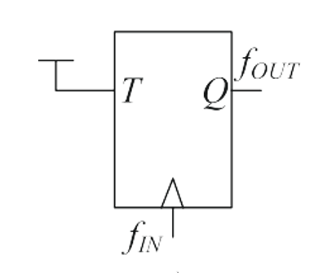
Fig. 1 Frequency divider of Static nature oriented on TFF
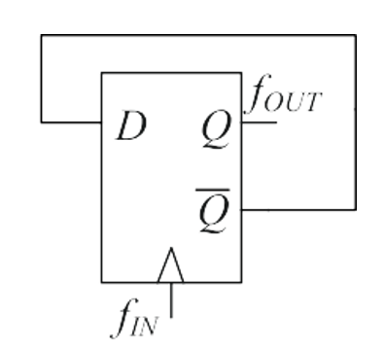
Fig. 2 Frequency divider of Static nature oriented on DFF
In the instance of FMCML deployment, DFF is relying on the setting of master-slave and the schema of sole D-categorical latch, that’s major constructing block as indicated in the below fig. 3. For $2^{N}$ divider, these DFFs were found to be used by having every DFF attached to the clock input of the following one. By referring to the above said fig. 3., this needs non-suitable inter-attachment intermediary to the input of pMOS distinctive set and the outcome of an nMOS distinctive set.
Furthermore, one could say that with the CMOS tech of deeper sub micrometer, $|VTH|$ was lesser than that of 0.35 Volts, an appropriate magnitude of $V_{SW}$ is around 600 m-Volts, the least $V_{OV}$ could be around 50 m-Volts, and it’s was possible to acquire a minimum of 300 m-Volts for $V_{CM,imax, n-type}$, that’s lesser than that of $V_{CM,o, n-type}.$The common redressal to this issue is the utilization of an origin follower as a shifter to the state intermediary to these DFFs. Nonetheless, it’s found to raise the consumption of power, and the origin follower power could yield in a portion of the total power utilization towards the peak speedy performance.

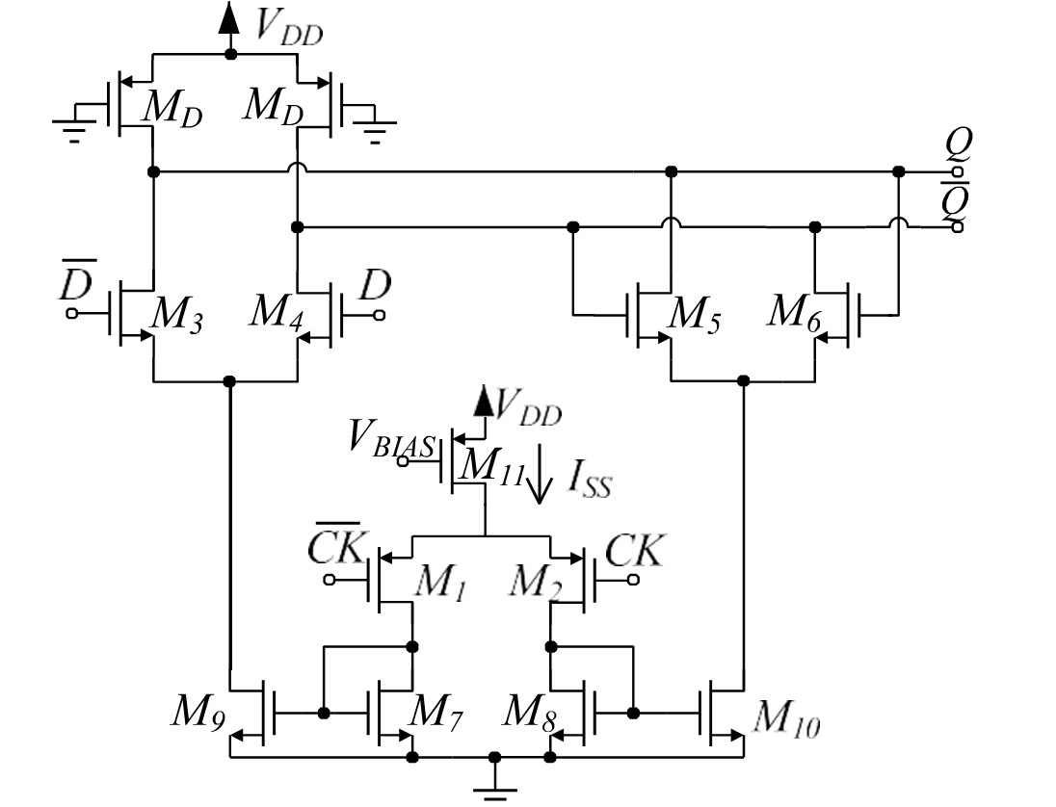
Fig. 3 FMCML D-latch containing pMOS input at the bottom state (referring to n-type).

Typically, the highest toggle frequency of TFF caused by the propagation delay of clock-to-outcome, t CKO, of the latch used to determine the DFF fixes the speed fulfilment of a static frequency divider. Actually, the slave latch's tcko is equal to the DFF's overall t CKO with respect to the obvious master-slave DFF. The least input clock signal time are required to be higher than 2tcko because the said divider's core depends on unitary feedback categorical DFF, as shown previously in Figure 2 and as the fundamental cell of the divider needs to process appropriately. Actually, beginning from edge of one clock, the need to guarantee the period $t_{CKO}$ of the slave latch towards the steady intervening outcome exist to make it the outcome of the DFF, and the newer master latch input simultaneously.

- Working Methodology
In this work, we propose a unique methodology in which the output and input common-mode states of every block of DIV2- Divide-by-2 are facilitated to be compatible with the alternation of complementary DFF levels of FMCML, thereby, restraining the supplementary level intermediary to them. In this devised methodology, we are proposing the common redressals to the literature encountered issue by the utilization of an origin follower as a shifter to the state intermediary to these DFFs. Thus, further consequences of total power utilization towards the peak speedy performance were also regularized through our novel frequency divider methodology.
The schematic level representation of both the FFs have been shown in the following fig. 4 and fig. 5 respectively over below.

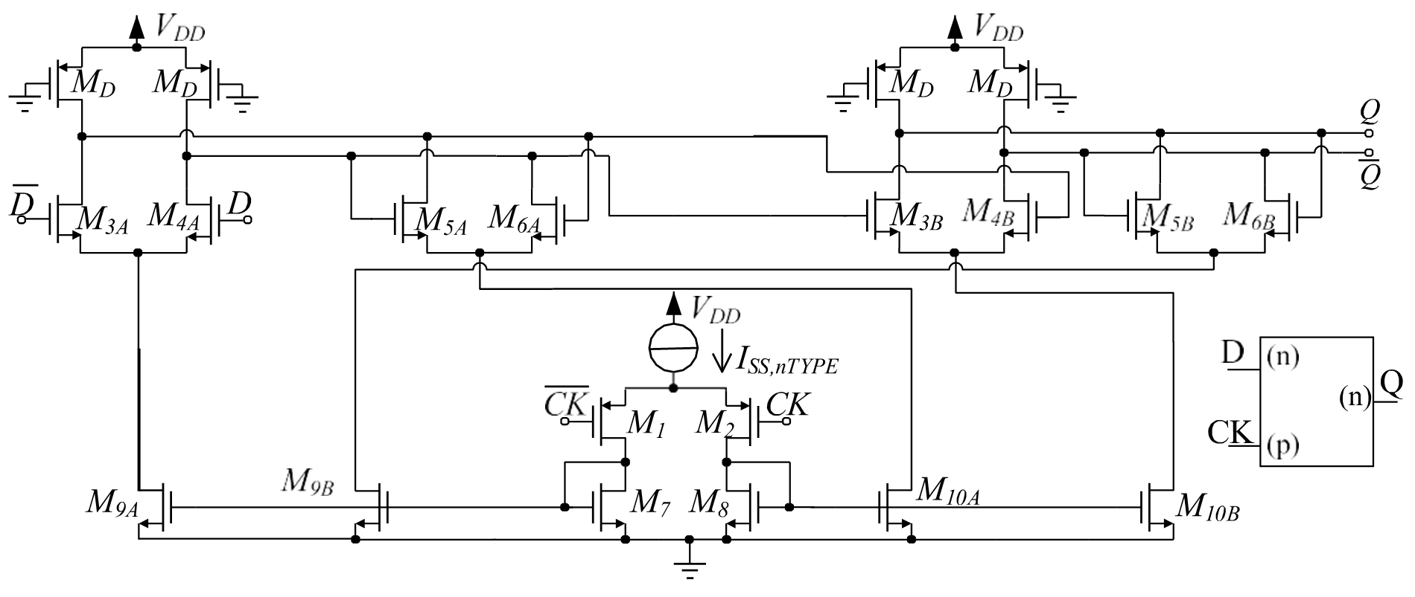
Fig. 4 Structure of n-typed D categorical FF in FMCML logic manner
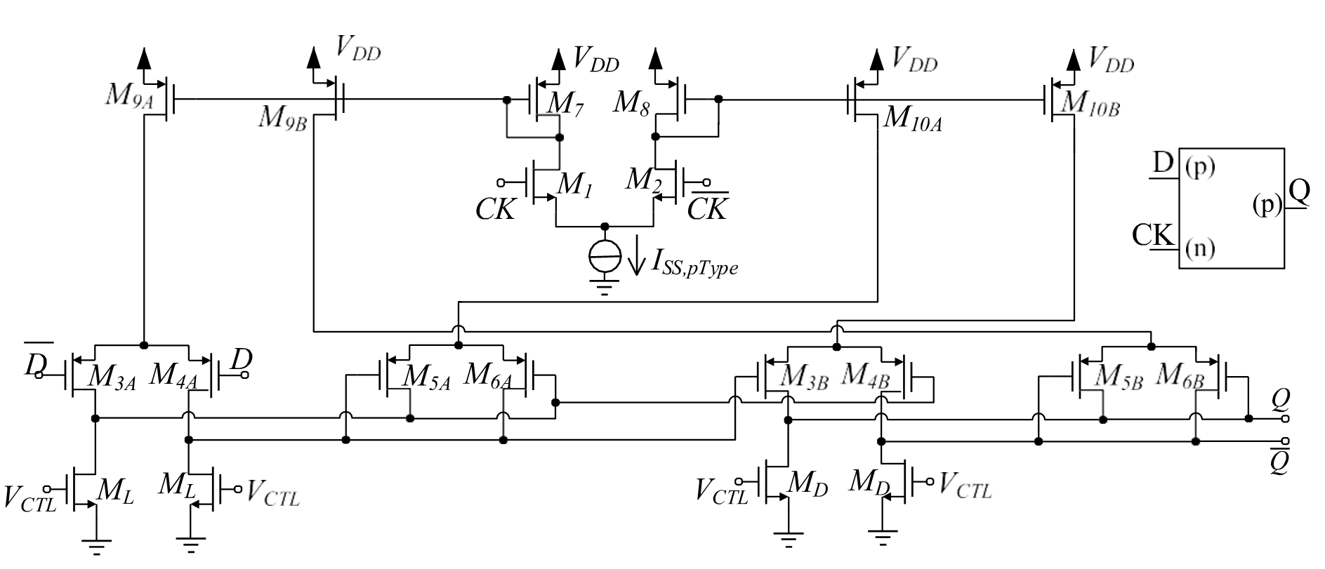
Fig. 5 Structure of n p-typed D categorical FF in FMCML logic manner
The p-typed FF in the inventive frequency divider arrangement, which considers the case of frequency division by 16, comprises of the input "D" to the transistor provided by pMOS in addition to the input of the clock being fed to the transistor provided by nMOS. In contrast, the n-typed FF comprises of input "D" to the transistor provided by nMOS and along with the clock input being provided by pMOS to the transistor.
With the help of the utilized constructing blocks, we can identify a $2^{N}$ obvious frequency dividing tool with the merger of them, as exhibited in the following fig. 6. Then, we present the schematic of our devised FMCML frequency dividing tool containing needed modification as shown in the following fig. 7

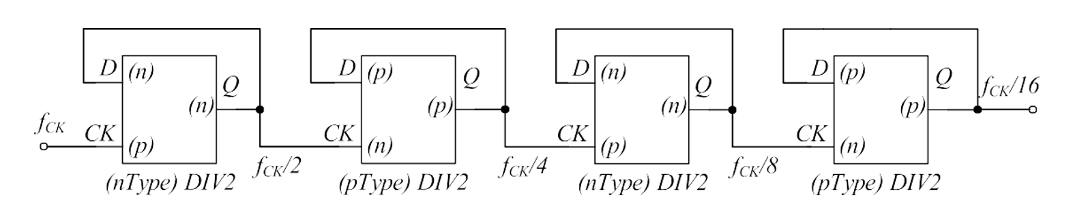
Fig. 6 Devised arrangement for the deployment of a frequency divider by 16

Advantages of Proposed Methodology
The advantages of our proposed methodology are given below.
- Minimum Power dissipation by controlling input of flipflop
- Lesser delay is achieved by forward biasing the load transistors
Applications of Proposed Methodology
The applications of our proposed methodology are listed below:
- Clock generators
- PLL based frequency synthesizers
- Analog to digital converters by incorporating time
- Extremely fast analog/RF
- Various digital applications

- Simulation Results and Discussion
The simulation schematic will be given below by making use of Tanner Tool and technique with 45 nm dimension. All the circuitry schematics have been generated by using the Tanner as briefed in the preceded section of the work. Then, we show the variation carrying schematic representation in the following fig. 7:
Finally, we show the outcome of the devised Frequency dividing tool administering the FF input in the following fig. 8, that showed the delay-based superiority contributing to the lesser power utilization in the circuitry as a whole.

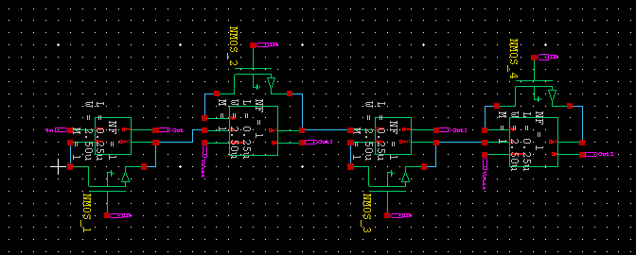
Fig. 7 Simulation Perspective schematic representation of devised frequency divider with variations in FMCML by administering input of flipflop
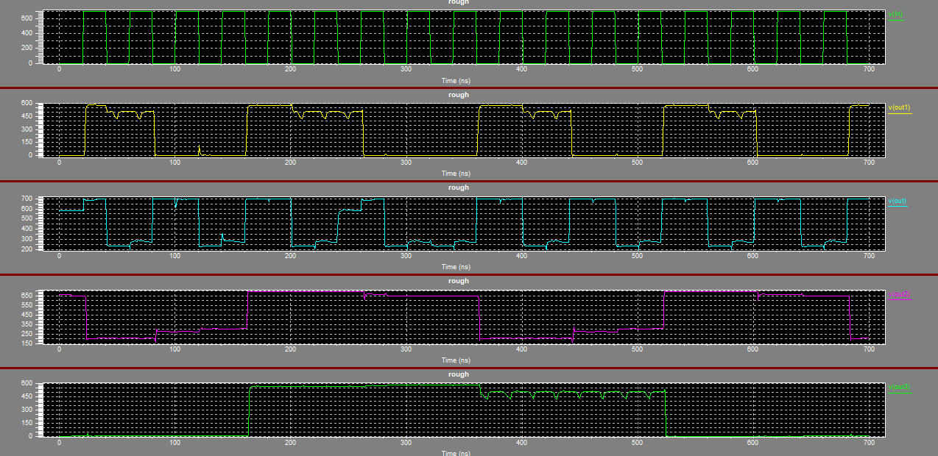
Fig. 8 Output of proposed frequency divider in FMCML

- Conclusion and Future Work
In this research work, a complementary p-type and n-type flip flop frequency divider by 16 in folded MCML was suggested. Flip flop input is controlled. The suggested circuit may function with Deep Sub-micron technology as the scale of the transistors was steadily reduced. Utilizing flip flops of the complementary variety also results in less common mode interference and power loss. This too employs a constant current source to control the clock. This also helps to cut down on propagation latency.
Due to these benefits, they are being mostly employed in radio applications, clock generators, phase-locked loop circuits, and high frequency applications. As a futuristic work, we desire to validate the performance of power utilization and we also desire to make the comparison study a comprehensive one by adding on more parameters for comparison.
VIII References
1. Alioto, M., et al., Design strategies for source coupled logic gates. 2003. 50(5): p. 640-654.
2. Alioto, M. and G. Palumbo, Model and design of bipolar and MOS current-mode logic: CML, ECL and SCL digital circuits. 2006: Springer Science & Business Media.
3. Yektaei, M. and M.J.I.T.o.V.L.S.I.S. Ghaznavi-Ghoushchi, PDP and TPD flexible MCML and MTCML ultralow-power and high-speed structures for wireless and wireline applications. 2020. 28(8): p. 1782-1795.
4. Rafiee, M., M.B.J.I.J.o.C.T. Ghaznavi‐Ghoushchi,and Applications, Low‐voltage and high‐speed stand‐alone multiple‐input complex gates for error correction coding applications. 2021. 49(4): p. 921-937.
5. Srivastava, P., et al., Robust circuit implementation of 4-bit 4-tube CNFET based ALU at 16-nm technology node. 2021. 109(1): p. 127-134.
6. Yazdi, A., M.M.J.I.t.o.m.t. Green, and techniques, A 40-Gb/s Full-Rate 2: 1 MUX in 0.18-$\mu {\hbox {m}} $ CMOS. 2011. 59(11): p. 2879-2887.
7. Lin, C.-S., et al., A 5.5-GHz 1-mW full-modulus-range programmable frequency divider in 90-nm CMOS process. 2011. 58(9): p. 550-554.
8. Won, H., et al., A 0.87 W transceiver IC for 100 gigabit Ethernet in 40 nm CMOS. 2014. 50(2): p. 399-413.
9. Feng, C., et al., A 40 GHz 65 nm CMOS phase-locked loop with optimized shunt-peaked buffer. 2014. 25(1): p. 34-36.
10. Lee, J., et al., Design of 56 Gb/s NRZ and PAM4 SerDes transceivers in CMOS technologies. 2015. 50(9): p. 2061-2073.
11. Yang, K. and A.J.I.T.o.S.G. Walid, Outage-storage tradeoff in frequency regulation for smart grid with renewables. 2013. 4(1): p. 245-252.
12. Stroe, D.I., et al., Selection and performance-degradation modeling of limo 2/li 4 ti 5 o 12 and lifepo 4/c battery cells as suitable energy storage systems for grid integration with wind power plants: An example for the primary frequency regulation service. 2014. 5(1): p. 90-101.
13. Miao, L., et al., Coordinated control strategy of wind turbine generator and energy storage equipment for frequency support. 2015. 51(4): p. 2732-2742.
14. Anaya-Lara, O., et al., Contribution of DFIG-based wind farms to power system short-term frequency regulation. 2006. 153(2): p. 164-170.
15. Ramtharan, G., N. Jenkins, and J.J.I.R.P.G. Ekanayake, Frequency support from doubly fed induction generator wind turbines. 2007. 1(1): p. 3-9.
16. Mauricio, J.M., et al., Frequency regulation contribution through variable-speed wind energy conversion systems. 2009. 24(1): p. 173-180.
17. Bevrani, H., A. Ghosh, and G.J.I.R.P.G. Ledwich, Renewable energy sources and frequency regulation: survey and new perspectives. 2010. 4(5): p. 438-457.
18. Moutis, P., et al., DC switch driven active power output control of photovoltaic inverters for the provision of frequency regulation. 2015. 6(4): p. 1485-1493.
19. Guan, M., et al., Synchronous generator emulation control strategy for voltage source converter (VSC) stations. 2015. 30(6): p. 3093-3101.
20. Ghaznavi-Ghoushchi, M. and S.J.M.j. Ejtahed, MTCML: Analysis, design and optimization of an alternative shallow-depth multiple-tail current mode logic. 2017. 67: p. 57-70.
21. Palumbo, G., G.J.I.T.o.C. Scotti, and S.I.R. Papers, A multi-folded MCML for ultra-low-voltage high-performance in deeply scaled CMOS. 2020. 67(12): p. 4696-4706.
22. Mutukuri, S. and K.S. Pande. Low power rail to rail D flip-flop using current mode logic structure. in 2020 4th International Conference on Electronics, Materials Engineering & Nano-Technology (IEMENTech). 2020. IEEE.
23. Agarwal, S., et al. Design of MCML-based LFSR for low power and mixed signal applications. in 2015 Annual IEEE India Conference (INDICON). 2015. IEEE.
24. Bai, Y., et al. Architecting a MOS current mode logic (MCML) processor for fast, low noise and energy-efficient computing in the near-threshold regime. in 2015 33rd IEEE International Conference on Computer Design (ICCD). 2015. IEEE.
25. Reyserhove, H. and W. Dehaene, Efficient VLSI Design Flow, in Efficient Design of Variation-Resilient Ultra-Low Energy Digital Processors. 2019, Springer. p. 53-85.
26. Savidis, I., S. Kose, and E.G.J.I.J.o.S.-S.C. Friedman, Power noise in TSV-based 3-D integrated circuits. 2012. 48(2): p. 587-597.
27. Joice, J.P., et al., Design of Filter Using MOS Current Mode Logic. 2016. 5(1): p. 72-78.

