ERGONOMICS STUDY IN AGRICULTURAL WORK BY USING ERGONOMIC TOOL - REBA
Mr. Sethuramalingam P ^{*1}, Ms. Anugeetha Shine ^{*2}
^{*1}Postgraduate student, Department of Industrial Safety Engineering, Bannari Amman Institute of Technology, Erode, Tamil Nadu, India
^{*2}Assistant Professor, Department of Food Technology, Bannari Amman Institute of Technology, Erode, Tamil Nadu, India

ABSTRACT
Safety is a state of mind, if you have a positive attitude you will have a fewer accident. There are various factors (physical, chemical, biological, psychological) influencing workers and the work place. One of the predominant factors that has a bad influence on human being is the ergonomic risks. These ergonomic risks are often noticed in most of all workers. Agriculture involves several harmful diseases. Among the non-fatal ones, musculoskeletal disorders (MSDs) are the most prevalent, as they have reached epidemic proportions. The main aim of this investigation is to systematically review the major risk factors regarding MSDs as well as evaluate the existing ergonomic interventions. In this paper the ergonomics risk assessment and posture analysis are carried out for 23 agricultural workers. Risk level for the working posture of those workers calculated and certain suggestions were given to eliminate the ergonomic hazards experienced by the workers.
Keywords: Safety, bad influence, ergonomic risks, spinning and knitting mill, assessment
- INTRODUCTION
Agriculture provides food, raw materials for other industries and employment opportunities. As a consequence, given the key role of agriculture in global economy, safety and health of its employees are regarded to be of major importance. However, rural occupation involves a considerable number of harmful illnesses. Epidemiological studies have identified several health problems such as cancers, respiratory and pesticide-caused diseases, hearing loss and musculoskeletal disorders (MSDs) [17–19]. The most widespread and alarming non-lethal disease among farmers is considered to be the MSDs [20]. Manual operations such as harvesting and pruning are very common, in developing countries [21]. These tasks involve working in awkward postures, prolonged and repetitive trunk bending, kneeling, heavy carrying and lifting, which constitute the main risk factors for the pathogenesis of MSDs [22,23]. Nowadays, mechanization in agriculture covers most farming operations as a means to lessen intensive manual labour, optimize timeliness of the tasks and increase productivity [24]. Nevertheless, in many cases, the introduction of machinery did not eliminate the health problems of workers. Operators of the agricultural machines, for example, are exposed to engine fumes, harvesting dust and whole-body vibration (WBV) effects [21].
The vibrations, which are generated due to the engine operation and ground roughness, are transferred to the operator as a result of the body’s contact with the seat, the cabin floor and handling operating tools [34]. WBV exposures regarding on-road vehicles are principally along the vertical axis (z). On the other hand, concerning the off-road vehicles, WBV is developed not only along z axis, but along the fore-aft (x) and lateral (y) axes [35] as well. Long-term high-level vibration can result in degenerative changes of joints, especially of lumbar spine [36]. Such multi-axial exposures of WBV can increase the rotational forces and shear in the spine as well as enlarge the muscle loads for the purpose of counterbalancing the head and torso inertia. Moreover, the long-lasting working period can lead to the impairment of the soft tissues of the neck and low back. These injuries are known as “precursor of musculoskeletal injuries” [37]
Farming involves a wide range of manual activities that vary depending on the type of farming, climate, and location. Here are some common manual activities in farming:
Planting: This involves preparing the soil and manually placing seeds or seedlings in the ground.
Weeding: This is the process of removing unwanted plants from the cultivated area. It is essential for crop growth and yield.
Irrigation: This involves manually watering the crops to ensure they have enough moisture to grow.
Harvesting: This is the process of collecting mature crops from the fields, which can involve manual labor such as cutting and threshing.
Pruning: This is the process of cutting off unwanted parts of plants to promote healthy growth and improve yield.
Fertilizing: This involves manually applying fertilizers or organic manure to the soil to improve soil fertility and promote plant growth.
Pest control: This involves manually removing pests such as insects and rodents from the crops to prevent damage and ensure healthy growth.
Land preparation: This involves clearing land and preparing it for planting by removing obstacles such as rocks and stumps.
Crop rotation: This involves manually rotating crops to maintain soil fertility and improve yield.
Livestock management: This involves manually caring for animals such as cows, chickens, and pigs, including feeding, cleaning, and milking.
- METHODOLOGY
- Identification of different activities carried out in farming.
- Studying the operator working nature.
- Identification of the different work posture of the workers for carrying out each operation.
- Collect the physical data of the workers
- Prepare the Questionnaire survey for the workers for asking the musculoskeletal problems among the workers.
- Measure the angle for calculating the Risk score for each work through the Rapid Entire Body Assessment (REBA).
- Calculate the Risk Score for each task done by the worker.
- Suggesting control measures to reduce the ergonomic risk level.

Problem Identification
Literature Survey
Work posture and physical data of the workers
Choosing of Ergonomics tool
Angle measurement for the ergonomics tool
Evaluation through the ergonomic tool and recommending measures
Conclusion and report preparation

Figure 1: Methodology Chart

SAMPLE COLLECTION
A minimum sample of 2 workers for each activity in the agricultural field has been selected for assessment. Totally 25 workers work posture has been analyzed while planting, weeding, irrigation, harvesting pest control and land preparation. Number of workers analyzed in each activity are,
Planting : 2
Weeding : 4
Irrigation : 7
Harvesting : 5
Pest control : 2
Land preparation : 3

QUESTIONNAIRE METHOD
The Nordic Questionnaire method is used in this study for the surveying the discomfort of body parts to the workers. A sequence of objective-type queries with multiple-choice answers makes up the questionnaire. Because the workers came from several of backgrounds and had varying levels of education, the face-to-face discussion was considered to be more consistent in collecting correct data from workers. The Nordic questionnaire sheet is shown in figure 3.2 below. The questions were divided into primary categories, each of which dealt with
- General information about the workers,
- Work organization and work behaviours,
- Detailed questions on work-related musculoskeletal pain or body part discomfort.
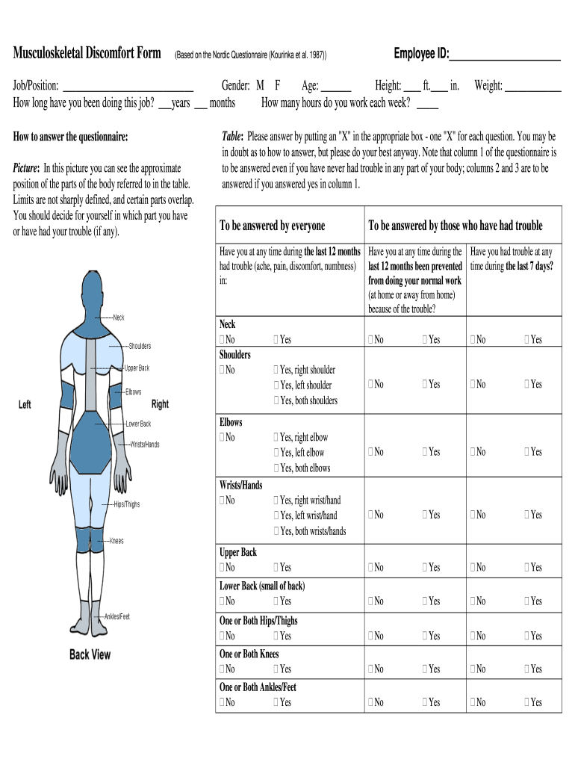

Figure 2 Nordic Questionnaire Survey Sheet

ANALYSIS OF WORKING POSTURE
The Rapid Entire Body Assessment (REBA) technique was used to determine the posture impact of work-related musculoskeletal factors associated. Hi-gnett, and McAtamney developed REBA (Rapid Complete Body Assessment) to give a rapid and easy observational postural evaluation technique for entire body movements (dynamic and static), resulting in musculoskeletal risk action ranges. REBA score and associated risk levels are shown in Table 1 below. REBA's development goal is to separate the body into sections that can be independently defined using motion channels. It determines how much muscle activation is produced by static, dynamic, rapidly changing, or unsteady posture. It demonstrates that connection is critical in load handling, yet it isn't always done with the hands. It also has an amount of activity and an indicator of importance.
REBA score | Risk Level | Action
1 | Negligible | No action
2-3 | Low | May be changes required
4-7 | Medium | Investigation and changes
8-10 | High | Investigate and implement changes
11+ | Very High | Implement changes
Table 1 REBA score and associated risk levels

- STEPS INVOLVED
The hierarchy of controls is a model for identifying the risk reduction effectiveness of control types. It is defined by ANSI Z590.3, Prevention through Design, as A systematic approach to avoiding, eliminating, controlling, and reducing risks, considering steps in a ranked and sequential order, beginning with avoidance, elimination, and substitution. Residual risks are controlled using engineering controls, warning systems, administrative controls, and personal protective equipment is shown in figure 2 below.
The hierarchy of risk control is used when undertaking risk assessment activities, to control hazards and minimize risk. Once you have calculated the level of risk, you should decide on the precautions or controls needed to reduce the risk.
To control risk, you need to do everything reasonably practicable. This means balancing the level of risk against the measures needed to control the real risk in terms of money, time, or trouble. Always aim to reduce the risk as low as is reasonably practicable, also known as ALARP.
The elimination of the risk by getting rid of the hazard completely. If the hazard cannot be eliminated, then how can the risks be controlled so that harm.
Controlling risks means assessing the adequacy of existing controls or introducing new controls to prevent harm. When controlling risks, there is a hierarchy of risk control which should be followed:
● Elimination
● Substitution
● Engineering Controls
● Administrative Controls
● PPE
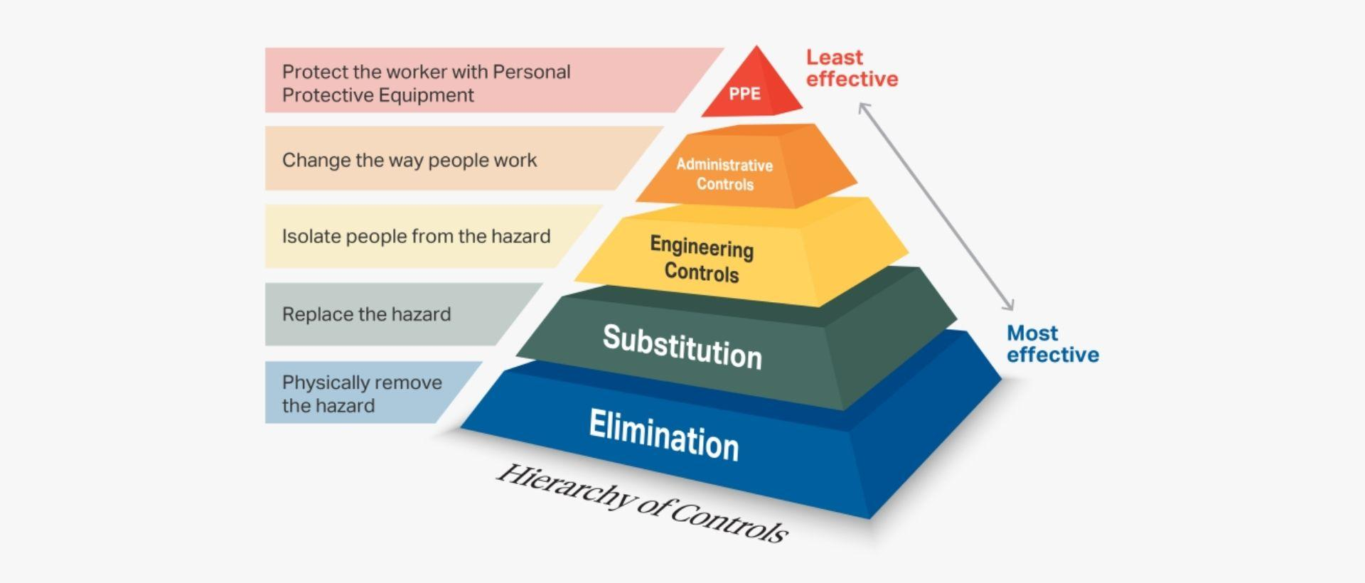
Figure 3 Hierarchy of control

Risk avoidance or elimination should be the first choice when in the design or redesign stage since they have the greatest risk reduction and reliability factors and generally are the most cost-effective. If a hazard is avoided or eliminated in its design, the hazard and its risk will not exist in the system. This should be the safety professional’s goal in all cases possible.
Substitution of a less hazardous component or element for a more hazardous one such as a non-flammable chemical for a highly flammable chemical is considered very effective. By changing the nature of the hazard, risk is reduced.
Engineering controls and design changes to existing systems can be applied to contain or prevent exposure to a hazard. Engineering controls are considered effective and reliable when the application is functioning as intended. These types of controls often require ongoing maintenance and testing to verify their effectiveness. An example might be a well-guarded machine with interlocks that prevent access to moving parts that could cause harm.
Controls below this line are considered less reliable since they rely on human behavior to a large degree. Warning systems require the individual to recognize and obey the warnings. Warnings can be compromised, obstructed, and ignored if false alarms or warnings are given or may fail to operate due to other factors.
Administrative controls such as policies, procedures, and training are only effective if they are known, reinforced, and followed. These measures rely on the individual to understand their intent and the adherence by the individual to these protocols. Communication, training, retraining, supervision, reinforcement, and discipline are required to “manage” employee practices to ensure they are in line with the administrative controls.
PPE is commonly used as a last defense against hazard exposures in the workplace. Their effectiveness is limited and dependent upon the proper selection, use, and care of equipment. Effectiveness of controls are shown in table 2 below

Type of Controls | Effectiveness
1. Eliminate the hazard completely. | 100%
2. Engineering Controls: Create a barrier between the person and the hazard. | 40–99%
3. Administrative Controls: by use & implementation of regulation, law, SOP/WI, safety procedures, etc. | 20–40%
4. Provide personal protective equipment. | 1- 20%

Table 2 Control effectiveness

A combination of risk reduction measures is many times required to achieve acceptable risk levels. Lower levels in the hierarchy of controls should only be selected after practical applications of higher-level controls are considered. For these reasons, controls lower on the hierarchy should not be given much of any credit during the initial or preliminary risk assessment. Risk reduction can be achieved by lowering the severity of harm, improving the likelihood of avoidance, and reducing the need for exposure to the hazard. In selecting the most appropriate risk reduction measures, the hazard control hierarchy principles should be applied in the order as follows.
- RESULTS AND DISCUSSION
The Physical data of workers selected for the assessment is collected is shown in table 3 below for reference. A healthy weight will help to reduce the risk of significant health problems and helps workers get closer to their exercise goals. Based on workers data collected, the physical nature and body mass index (BMI) were calculated for health conditions of the workers to reach the fitness goals.

SI.NO | Name | Age | Height (ft) | Weight (Kg) | BMI  (Kg/m^2) | Working experience (year & month)
1 | kathayamba | 71 | 5.4 | 55 | 20.8 | 32 years
2 | Chelli | 33 | 5.5 | 61 | 22.4 | 8 years
3 | Kathirvel | 69 | 5.6 | 78 | 27.8 | 24 years
4 | madasamy | 49 | 5.4 | 70 | 26.5 | 16 years
5 | Maheshwari | 59 | 5.4 | 62 | 23.5 | 13 years
6 | kaliyammal | 46 | 5.4 | 57 | 21.6 | 12 years
7 | Pappaye | 55 | 5.4 | 60 | 22.7 | 15 years
8 | Umamaheshwari | 36 | 5.5 | 61 | 22.4 | 15 years
9 | Senthilganesh | 42 | 5.4 | 67 | 25.4 | 14 years
10 | Sridhar | 35 | 5.6 | 70 | 24.9 | 4 years
11 | Mayilsammy | 71 | 5.5 | 50 | 18.3 | 30 years
12 | Thelegaraju | 40 | 5.4 | 70 | 26.5 | 3 years
13 | Sangaiyan | 38 | 5.5 | 76 | 27.9 | 3 months
14 | Veeriya | 18 | 5.5 | 66 | 24.2 | 1 year
15 | Kaalimuthu | 67 | 5.3 | 47 | 18.4 | 30 years
16 | Mathiyazhalgan | 38 | 5.7 | 75 | 25.9 | 1 year
17 | Sivanandi | 48 | 5.4 | 65 | 24.6 | 20 years
18 | Maruthu | 51 | 5.3 | 62 | 24.2 | 20 years
19 | Mahasivam | 50 | 5.6 | 80 | 28.5 | 3 years
20 | Mangamma thayi | 60 | 5.2 | 51 | 20.6 | 10 years
21 | Velusamy | 58 | 5.6 | 70 | 24.9 | 5 years
22 | Duraisamy | 68 | 5.5 | 77 | 28.2 | 9 years
23 | Subramani | 62 | 5.8 | 78 | 26.1 | 3 years
Table 3 Physical data of workers
POSTURE ANALYSIS
Workers has performed different job for the past 12 months repetitively. The continuous worse working condition causes musculoskeletal disorder problems to the workers. The workers job carried out in the field is tabulated in table 5.2. Based on the questionnaire survey conducted for the workers it is found that they have problems in the shoulders, trunk, leg and neck. Workers doing pest control activity has to carry heavy weight up to 25 kgs in their shoulders, so they are experiencing heavy shoulder pain. Worker climbing coconut tree is suffering from trunk and leg pain. Workers who are performing manual irrigation, pruning and land preparation activities are having trunk, neck and leg pain.
SAMPLE | Name | Job carried by worker’s
1 | kathayamba | Planting
2 | chelli | Planting
3 | Kathirvel | Pest control
4 | madasamy | Pest control
5 | Maheshwari | Weeding
6 | kaliyammal | Weeding
7 | Pappaye | Weeding
8 | Umamaheshwari | Weeding
9 | Senthilganesh | Irrigation
10 | Sridhar | Irrigation
11 | Mayilsammy | Irrigation
12 | Thelegaraju | Irrigation
13 | Sangaiyan | Irrigation
14 | Veeriya | Irrigation
15 | Kaalimuthu | Irrigation
16 | Mathiazhalgan | Harvesting
17 | Sivanandi | Harvesting
18 | Maruthu | Harvesting
19 | Mahasivam | Harvesting
20 | Mangammathayi | Harvesting
21 | Velusamy | Land preparation
22 | Duraisamy | Land preparation
23 | Subramani | Land preparation

Table 4 Task carried out by workers
Planting
Sample 1 & 2 were planting mulberry for horticulture. Planting of mulberry sticks needs precise knowledge. Planting it upside down will result in reduction of the crops growth, so using planting machines is not the wiser way. It is manually carried out by the worker. Worker’s posture while performing this work is shown in Figure 5.1 below and. With the help of angle measured the REBA score and risk level is calculated.
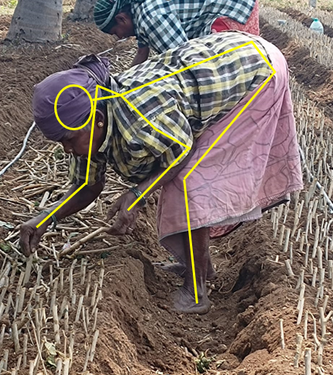
Figure 4 Sample 1,

REBA risk score for sample 1 is calculated as shown in figure 5.2 below. This worker is working in a more awkward posture than sample 2. The risk level for this worker is Very high (11). This worker is suggested to perform the work in a better working posture and take frequent breaks. Sample 1 is advised to adapt the posture of sample 2.
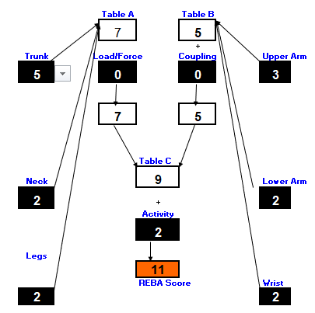
Figure 5 REBA score for sample 1,
Sample 2 is performing the same planting activity. Work posture for doing the job is shown in figure 5.3 below and the respective REBA score calculated is shown in Figure 5.4 below.
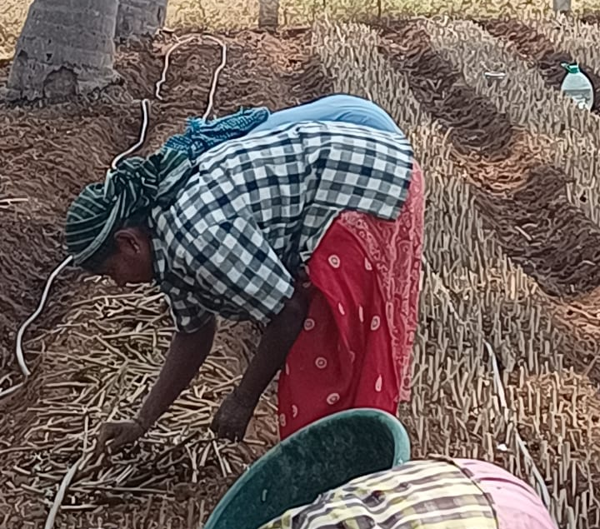
Figure 6 Sample 2

This Worker’s height is apt for performing this work and she is performing the work in a better posture than sample 1 even though the risk level is high (8) . Sample 2 is suggested to perform the work with proper breaks.
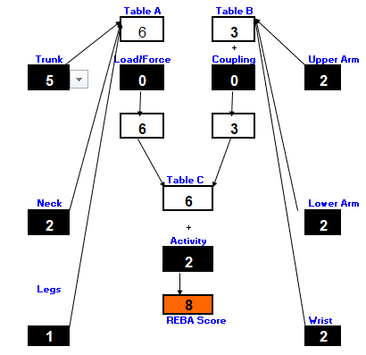
Figure 7 REBA Score for sample 2
Pest control
Sample 3 and 4 are spraying pesticides to the half-grown crops using an electrical sprayer. They were carrying nearly 25 kgs in their shoulders like a back bag. He mostly uses his right arm for performing the job, during the questionnaire survey he informed that he has severe pain in shoulders. His work posture while doing the job is shown in figure 5.5 below for reference. This worker refills the sprayer by keeping it the ground. So he has to pick it up from the ground, it has to be done in a very awkward posture. So the worker is suggested to refill the sprayer by keeping it in a hip level high table.
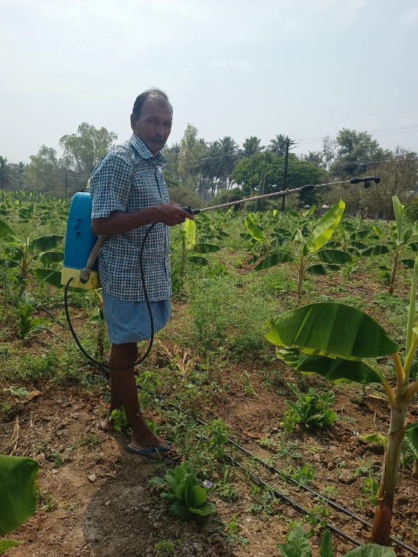
Figure 8 Sample 3

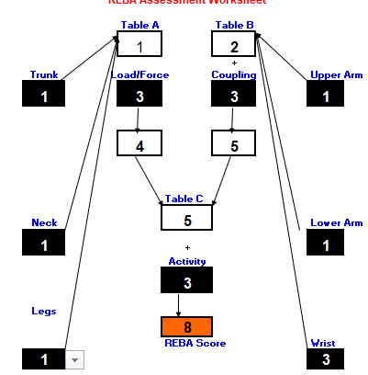
Figure 9 REBA score for sample 3
Weeding
Sample 5,6,7 and 8 were doing weeding activity. Weeding is the process of removing unwanted plants from the cultivated area. It is essential for crop growth and yield. This work can not be performed in a better posture. Every worker is performing this work in a trunk bent position for a long period. Also, the trunk involves side bending. They have to extend one of their hands for removing the plants. In the personal questionnaire sample 6 and 7 said that they were experiencing trunk and right shoulder pain. Whatever the posture may be, the risk level for the workers seems to be high. So, it is suggested not to perform this work manually.
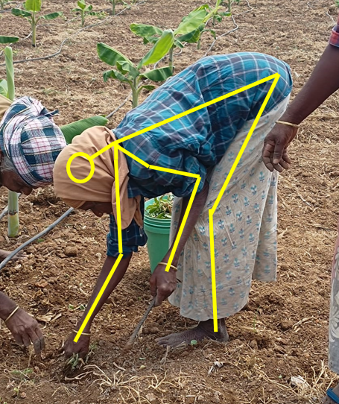
Figure 10 Sample 6
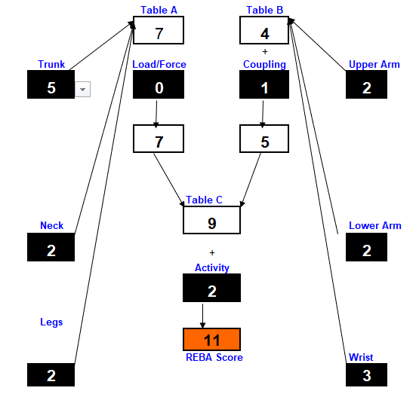
Figure 11 REBA score for sample
The REBA scores for the workers performing weeding activity is shown in table 5.7 below. Average REBA score for 4 workers is found to be 10 so the risk level for doing this work is high. Also sample 8 is having the lowest score so the other workers are suggested to perform the work alike sample 8.
Sample | REBA Score
5 | 10
6 | 11
7 | 11
8 | 8
Average | 10

Table 5 REBA scores for weeding activity workers
Irrigation
Sample 9, 10, 11, 12, 13, 14 and 15 were performing watering activity for crops manually using shovel. It is clear from the REBA scores for the workers that they are performing this work in an awkward posture. Performing this work in this posture for a long period can cause serious problems. Also the workers has to apply constant force for digging the sand. It is advised to carry out this job using machines. Sample 13’s posture for inspection is shown in figure 5.9 below.
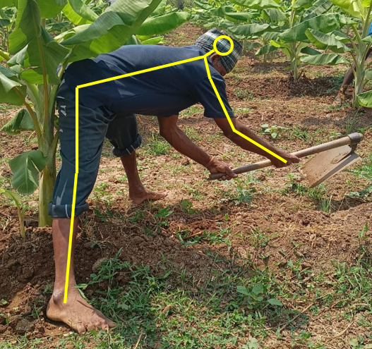
Figure 12 Sample 13
Sample 13 was suffering from back pain for the past 2 weeks. He bends his trunk in standing posture and legs are bent while standing, so the REBA assessment risk level is calculated to be high (9). Calculated REBA score is shown in the figure 5.10 below. For a case where the work has to be performed manually, it is suggested to use a shovel with a long handle so that the worker need not bend more than 60 degrees. It suggested to avoid doing this work manually and use drip irrigation system.
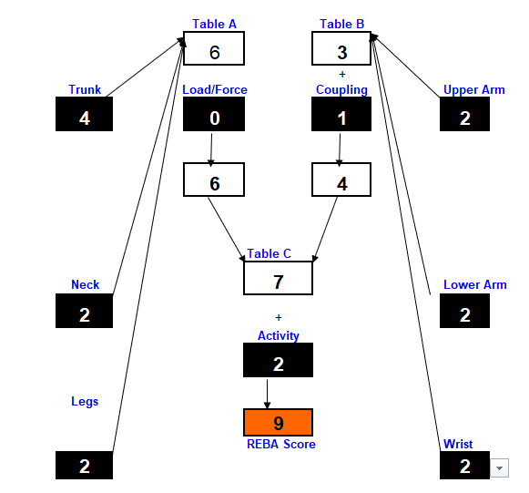
Figure 13 REBA score for sample 13

Harvesting
Coconut harvesting was selected for assessment as it seems to be the most hazardous work. Workers climbing coconut tree are subjected heavy tension in trunk and tows. These workers use a rope made covered by plastic pipe or other rubber material in their leg and back to lock themselves in a height. This method of climbing is too risky not only it will cause accident, it also affects the worker ergonomically. Sample 17 and 18 are suffering from severe back pain and leg pain. It is suggested to use coconut tree climbing machine instead of rope. Sample 16 and 19 loads the harvested coconuts inside the vehicle. They were also performing the job in a very awkward posture. Sample 16 picks the coconut from ground and throws it into the vehicle. This involves standing in a trunk bent posture and there is a repetitive twisting of trunk. This led to severe pain in the back.
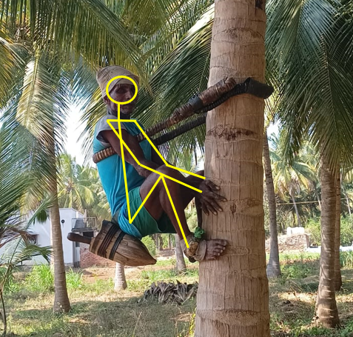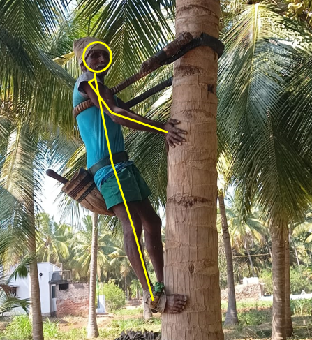
Figure 14 Sample 17 posture 1, 2

REBA risk score for the sample 17 is shown in the figure 5.12 below.
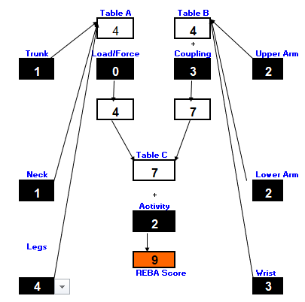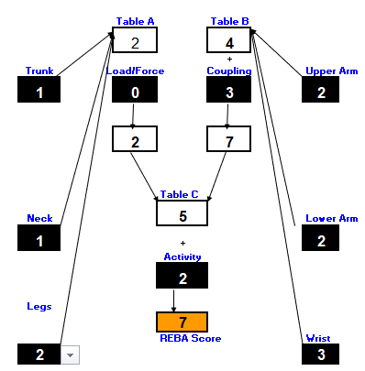
Figure 15 REBA score for sample 17’s posture 1, 2 respectively
Sample 16 and 19 loads the harvested coconuts inside the vehicle. They were also performing the job in a very awkward posture. Sample 16 picks the coconut from ground and throws it into the vehicle. This involves standing in a trunk bent posture and there is a repetitive twisting of trunk. This led to severe pain in the back.
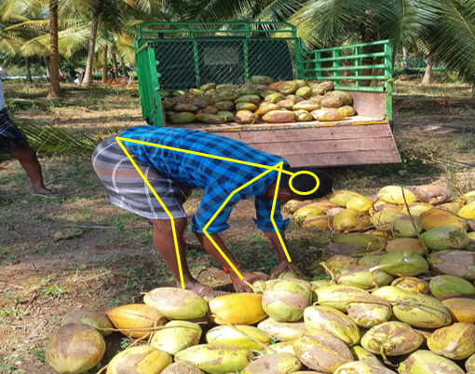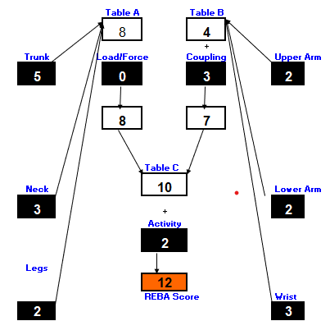
Figure 16 Sample 16
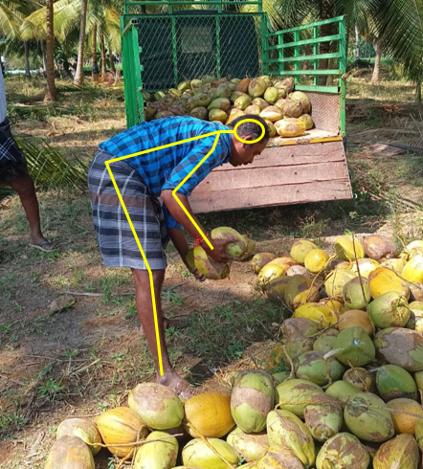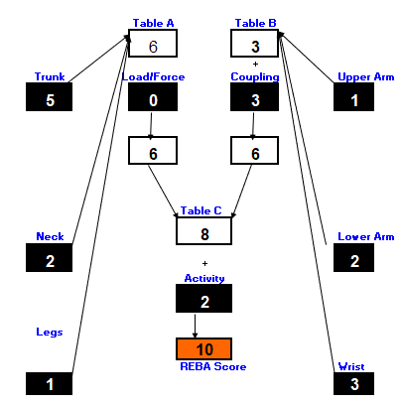
Figure 17 Sample 16
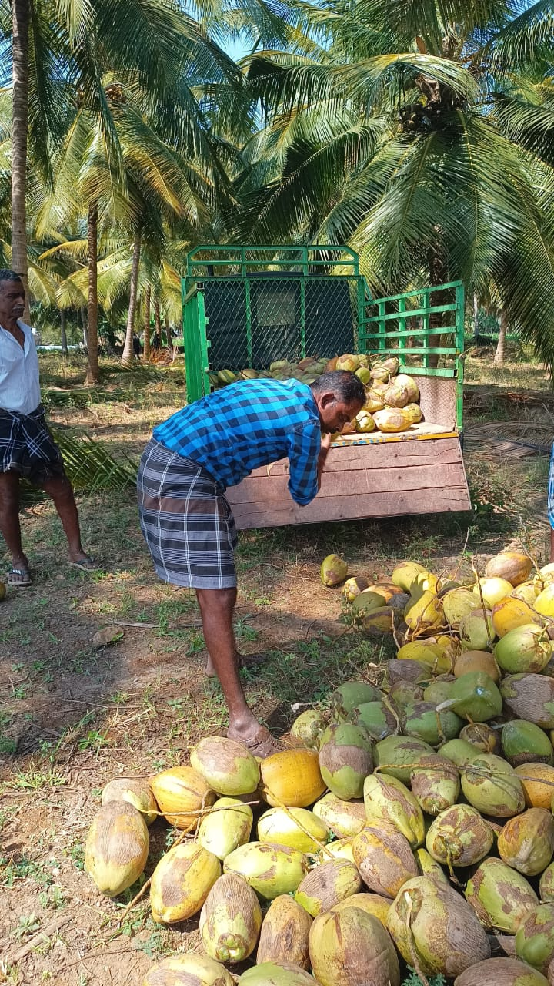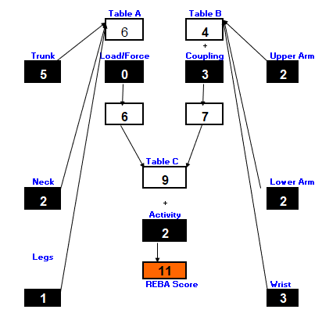
Figure 18 Sample 16
Land preparation
Sample 21, 22 and 23 were doing land preparation activity using shovel. This work is very similar to manual irrigation and weeding. There are machine to perform this work. Although those machines produce a lot of vibrations which will cause whole body vibration or hand arm vibration. It is suggested to use those machines since they reduce the number of workers and as well as the working time. The posture of sample 23 is shown in the figure 19 and angle measured during the operation is tabulated in the table 5.9 for risk score calculation.
The REBA risk score value for the worker is calculated with the angle measured is shown in figure 5.14 below. For workers using shovel, a shovel with longer handle can be provided to carry out the job in a less bent posture.

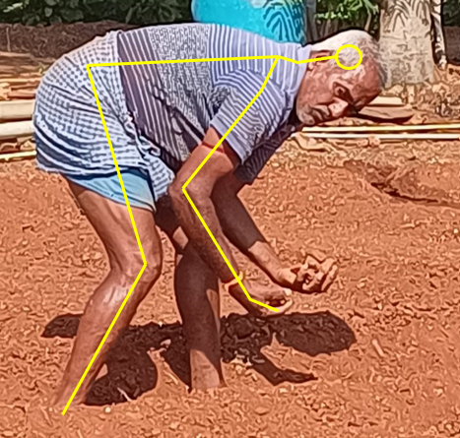
Figure 19 Sample 23

Figure 20 REBA score for sample 23

- CONCLUSION
In this paper, the ergonomics hazards and risk levels has been discussed for agricultural workers. It revealed that major cause for the MSDs problems is cause due to the lack of ergonomics awareness. Another reason is that the employee is working in awkward posture. The average REBA score is 9.1, it is indicates that the risk level is high. As a result, it is essential to redesign the working method as soon as possible. We also identified certain risk factors for musculoskeletal problems in this investigation. As a result, for the ergonomic risk assessment of stress produced by working, workers should work to eliminate or reduce these problems. To reduce the ergonomic hazards for the farmers who are engaged in manual agricultural works, they can utilize mechanical related machineries which can be implemented in agricultural fields. And also certain postural changes can be followed to reduce the ergonomic hazard. Frequent break intervals, shift time can be given as an additional control measures which could improve their efficiency.

- REFERENCES
- Boulila, A., Ayadi, M., & Mrabet, K. (2018). Ergonomics study and analysis of workstations in Tunisian mechanical manufacturing. Human Factors and Ergonomics in Manufacturing & Service Industries, 28(4), 166-185.
- Grepo, L., Yabis, D. J., & Aaron, R. (2013). An Evaluation of Manual Meterial Handling Tasks in a Manufacturing Company. In Diversity, Technology, and Innovation for Operational Competitiveness: Proceedings of the 2013 International Conference on Technology Innovation and Industrial Management (pp. 4-24).
- Hafiz, M. Z., Isa, H., & Mohamed, M. S. S. (2013). An overview of ergonomics problems related to CNC machining operations. In Advanced Engineering Forum (Vol. 10, pp. 137-142). Trans Tech Publications Ltd.
- Hairani, I. H. M., Jalil, S. Z. A., & Yusoff, N. M.(2018) “Reduce Musculoskeletal Disorders Injury during Manual Handling in Tooling Parts Manufacturing Industry”.
- Hignett, S., & McAtamney, L. (2000). Rapid entire body assessment (REBA). Applied ergonomics, 31(2), 201-205.
- Isa, H., Rahman, M. A., Hazmilah, H., Sihombing, H., Saptari, A., Baharudin, A. B., & Syaheera, A. (2014). Ergonomic design of CNC milling machine for safe working posture. In Applied Mechanics and Materials (Vol. 465, pp. 60-64). Trans Tech Publications Ltd.
- Kale, M. P. N., & Vyavahare, M. R. T. (2016). Ergonomic assessment of press machine using RULA method.
- Maldonado-Macias, A., Ramírez, M. G., García, J. L., Díaz, J. J., & Noriega, S. (2009). Ergonomic evaluation of work stations related with the operation of advanced manufacturing technology equipment: Two cases of study. In XV Congreso Internacional de ergonomia SEMAC.
- Muthukumar, K., Sankaranarayanasamy, K., & Ganguli, A. K. (2014). Analysis of frequency, intensity, and interference of discomfort in computerized numeric control machine operations. Human Factors and Ergonomics in Manufacturing & Service Industries, 24(2), 131-138.
- Muthukumar, K., Sankaranarayanasamy, K., & Ganguli, A. K. (2012). Discomfort analysis in computerized numeric control machine operations. Safety and Health at Work, 3(2), 146-153.
- Muslim, K., & Nussbaum, M. A. (2015). Musculoskeletal symptoms associated with posterior load carriage: An assessment of manual material handling workers in Indonesia. Work, 51(2), 205-213.
- Ramaganesh, M., Jayasuriyan, R., Rajpradeesh, T., Bathrinath, S., & Manikandan, R. (2021). Ergonomics hazard analysis techniques-A technical review. Materials Today: Proceedings, 46, 7789-7797.
- Senthilkumar, S (2022) "A Study on Efficacy of an Ergonomic Intervention Programme among Standing Workers by using Rapid Upperlimb Analysis and Rapid Entire Body Assessment."
- Sultan, M., Amin, A., Nuradilah, Z., Isa, H., Nor Akramin, M., & Febrian, I. (2013). A review on ergonomics risk factors and health effects associated with manual materials handling. In Advanced Engineering Forum (Vol. 10, pp. 251-256). Trans Tech Publications Ltd.
- Triyanti, V. (2017, December). Risk assessment of manual material handling activities (case study: PT BRS Standard Industry). In IOP Conference Series: Materials Science and Engineering (Vol. 277, No. 1, p. 012043). IOP Publishing.
- Wanave, S. B., & Bhadke, M. K. (2013). An Ergonomic Evaluation & Assessment of the Workstation to Improve the Productivity for an Enterprise:-A Review. Int. J. Engineering Research & Applications, 3(6), 1598-1602.
- 17. Kirkhorn, S.R.; Schenker, M.B. Current Health Effects of Agricultural Work: Respiratory Disease, Cancer, Reproductive Effects, Musculoskeletal Injuries, and Pesticide–Related Illnesses. J. Agric. Saf. Health 2002, 8, 199–214. [CrossRef] [PubMed]
- 18. Rautiainen, R.H.; Reynolds, S.J. Mortality and Morbidity in Agriculture in the United States. J. Agric. Saf. Health 2002, 8, 259–276. [CrossRef]
- 19. Lee, W.J.; Colt, J.S.; Heineman, E.F.; McComb, R.; Weisenburger, D.D.; Lijinsky, W.; Ward, M.H. Agricultural pesticide use and risk of glioma in Nebraska, United States. Occup. Env. Med. 2005, 62, 786–792. [CrossRef] [PubMed]
- 20. Meyers, J.M.; Miles, J.A.; Faucett, J.; Janowitz, I.; Tejeda, D.G.; Kabashima, J.N. Ergonomics in agriculture: Workplace priority setting in the nursery industry. Am. Ind. Hyg. Assoc. J. 1997, 58, 121–126. [CrossRef]
- 21. Fathallah, F.A. Musculoskeletal disorders in labor-intensive agriculture. Appl. Erg. 2010, 41, 738–743. [CrossRef] [PubMed]
- 22. Miller, B.J.; Fathallah, F.A. The Effects of a Stooped Work Task on the Muscle Activity and Kinematics of the Lower Back. Proc. Hum. Factors Erg. Soc. Annu. Meet. 2006, 50, 1284–1288. [CrossRef]
- 23. Benos, L.; Tsaopoulos, D.; Bochtis, D. A Review on Ergonomics in Agriculture. Part I: Manual Operations. Appl. Sci. 2020, 10, 1905. [CrossRef]
- 24. Bochtis, D.D.; Sørensen, C.G.C.; Busato, P. Advances in agricultural machinery management: A review. Biosyst. Eng. 2014, 126, 69–81. [CrossRef]
- 25. European Parliament. Directive 2002/44/EC of the European Parliament and of the Council of 25 June 2002 on the Minimum Health and Safety Requirements Regarding the Exposure of Workers to the Risks Arising from Physical Agents (Vibration); European Agency. Available online: https://eur-lex.europa.eu/legal-content/EN/ALL/?uri=CELEX%3A32002L0044 (accessed on 29 January 2020).
- 26. Cecchini, M.; Colantoni, A.; Monarca, D.; Longo, L.; Riccioni, S. Reducing the Risk From Manual Handling of Loads in Agriculture: Proposal and Assessment of Easily Achievable Preventive Measures. Proc. Chem. Eng. Trans. 2017, 58. [CrossRef]
- 27. Fathallah, F.A.; Miller, B.J.; Miles, J.A. Low Back Disorders in Agriculture and the Role of Stooped Work: Scope, Potential Interventions, and Reearch Needs. J. Agric. Saf. Health 2008, 14, 221–245. [CrossRef]
- 28. Milosavljevic, S.; McBride, D.I.; Bagheri, N.; Vasiljev, R.M.; Carman, A.B.; Rehn, B.; Moore, D.Factors associated with quad bike loss of control events in agriculture. Int. J. Ind. Erg. 2011, 41,317–321. [CrossRef]
- 29. Azmir, N.A.; Ghazali, M.I.; Yahya, M.N.; Ali, M.H. Hand-arm vibration disorder among grass-cutter workers in Malaysia. Int. J. Occup. Saf. Erg. 2016, 22, 433–438. [CrossRef] [PubMed]
- 30. Chaturvedi, V.; Kumar, A.; Singh, J.K. Power tiller: Vibration magnitudes and intervention development for vibration reduction. Appl. Erg. 2012, 43, 891–901. [CrossRef] [PubMed]
- 31. Hao, K.Y.; Ripin, Z.M. Nodal control of grass trimmer handle vibration. Int. J. Ind. Erg. 2013, 43, 18–30.[CrossRef]
- 32. Bovenzi, M. Health effects of mechanical vibration. Proceedings of the Giornale Italiano di Medicina del Lavoro ed Ergonomia 2005, 27, 58–64.
- 33. Bovenzi, M. The hand-arm vibration syndrome: (I) the clinical picture, exposure-response relationship and exposure limits. Med. Lav. 1999, 90, 547–555.
- 34. Langer, T.H.; Ebbesen, M.K.; Kordestani, A. Experimental analysis of occupational whole-body vibration exposure of agricultural tractor with large square baler. Int. J. Ind. Erg. 2015, 47, 79–83. [CrossRef]
- 35. Kim, J.H.; Dennerlein, J.T.; Johnson, P.W. The effect of a multi-axis suspension on whole body vibration exposures and physical stress in the neck and low back in agricultural tractor applications. Appl. Erg. 2018,68, 80–89. [CrossRef]
- 36. Servadio, P.; Marsili, A.; Belfiore, N.P. Analysis of driving seat vibrations in high forward speed tractors. Biosyst. Eng. 2007, 97, 171–180. [CrossRef]
- 37. Thomsen, G.F.; Johnson, P.W.; Svendsen, S.W.; Kryger, A.I.; Bonde, J.P.E. Muscle fatigue in relation to forearm pain and tenderness among professional computer users. J. Occup. Med. Toxicol. 2007, 2. [CrossRef]
- 38. Cecchini, M.; Bedini, R.; Mosetti, D.; Marino, S.; Stasi, S. Safety Knowledge and Changing Behavior in Agricultural Workers: An Assessment Model Applied in Central Italy. Saf. Health Work 2018, 9, 164–171.[CrossRef] [PubMed]

