SMART DEVICE FOR VISUALLY CHALLENGED
Prathap M R  Assistant Professor /BME  Bannari Amman Institute of Technology, Tamilnadu, India prathap@bitsathy.ac.in | Bibin Sooraj R  UG Scholar/BME  Bannari Amman Institute of Technology, Tamilnadu, India  bibinsooraj.bm19@bitsathy.ac.in | Arish S  UG Scholar/CSE  Bannari Amman Institute of Technology, Tamilnadu, India  arish.cs19@bitsathy.ac.in
Ajaypravin S S
UG Scholar/BME
Bannari Amman Institute of Technology, Tamilnadu, India
ajaypravin.bm19@bitsath y.ac.in

ABSTRACT
Being independent is the top objective for practically everyone in the technological age, when everyone aspires to be self-sufficient in order to live in this hostile environment. Our research aims to grant this independence to persons who are visually impaired. They receive assistance from this programme in order to commute safely and securely. These work as a Third Eye for the vision challenged persons and make their challenging life little bit easier and safe. The project includes of Ultrasonic sensors and IR sensor used for identification of barriers like stairs, wall and other items. When an obstruction is detected, it informs the user with a buzzer beep. The motor driver, which uses the signal received to trigger it, the vibration will be more at the minimum level and less at the maximum level. A PIR sensor is also used to detect item motion, which is indicated by a beeping sound. It also comprises of an emergency location tracking module which sends messages in events of any mishaps to the family of the blind user along with the current position of the user using GSM and GPS module.
Keywords: Smart Goggles, Stick, Speaker, GPS, GSM, and Vibration Motor.

INTRODUCTION
In the life of a person, vision is crucial. Around 83% of the environmental information that humans take in is visual. According to WHO figures from 2011, there are 285 billion individuals worldwide who have some form of visual impairment, of whom 39% are blind and the remainder have impaired vision. White walking canes and guide dogs are the customary aids for those who are visually impaired. The main disadvantage of using these old methods is that they require special knowledge and training, which makes them difficult to apply. Several clever methods to aid the blind person in autonomously navigating have been devised thanks to recent advancements in hardware and software. While these already-existing systems are useful for outdoor navigation, they still need to be improved with additional components to enable precise obstacle detection. This is because accurate results and effective system performance are essential. Consequently, the purpose of this project is to offer freedom to the visually challenged persons by delivering a smart electronic walking assistance solution which is simple to use and easy to understand. There are several canes on the market now designed to promote independence among the visually impaired.
In the contemporary world, electronics is widely used in all sectors. Some of the areas include science, medicine, and space exploration. This endeavour continues the study of medicine. Everything about this is powered by an electrical gadget. The initiative primarily addresses the difficulties faced by blind individuals. It offers the blind folks a decent chance of living a regular life. It's a straightforward project, but it uses more efficient methods. This device's construction method is simple enough for any engineer to understand. As compared to other gadgets, the device's manufacturing costs are extremely cheap. As a result, it is more accessible to persons who meet all criteria. The visually challenged is caused due to the damage caused in the eye system. There are different types of damages, such as. SCOTOMA: There would be a gradual enlargement of blind spot in the eye. PERIPHERAL: It causes damage to the centre of the eye lid, or the centre nerve of the eye. HEMIANOPIA: It is a kind of binocular defect in the eyes hemi field. It is a loss of sight occurs in the inferior contra lateral nerve. This is only a little step in the right direction for the blind, but when new designs and technology are included, it will become more effective.

LITREATURE SURVEY
K.S.Manikanta et.al., explains that For those who are blind, a smart stick has been created that uses water, ultrasonic, and infrared sensors to assist find obstructions. These sensors may be used to detect obstacles that are up to 3 metres away. Also, we employ a GPS module to locate and guide the stick. The use of a GPS unit helps the blind individual get to his destination. The GPS receiver updates the blind person's location as they move around, and the coordinates of that location can be used to keep track of them for safety reasons. [1]
W. Motwakil et.al., says that as consequence, the smart stick is suggested as a stick that may let a person walk securely without worrying about running into another person or hitting something solid. It is an improvement over the conventional blind stick since it allows the blind to request for assistance over the phone while walking by providing audio notifications to them through a headset attached to the phone when they encounter obstacles like water, walls, stairs, or muddy terrain.[3]
A. NADA et.al., verifies that The vibration motor, embedded microprocessor 18F46K80, and flash memory ISD1932 are used in this suggested system. The stick can identify any barrier within a 4 metre range in 39 milliseconds and send a relevant respect message, enabling the blind person to walk twice as quickly as usual since they feel secure. The smart stick is inexpensive, quick to react, power-efficient, lightweight, and foldable. [5]
P. K. D. Vipul et.al., explains that the Similar to a white cane, this method helps the blind monitor their environment for obstructions or direction markers. To monitor environmental changes, this device will be placed on a white cane and equipped with a water sensor and an ultrasonic sensor. Water detection sensors determine if there is a puddle, whereas ultrasonic sensors use the reflection of ultrasonic waves to identify obstructions in front of them.[7]

METHODOLOGY
As each of the systems mentioned above has a separate set of features, not all of the useful functionalities can be found in a single model. In order to improve upon the previous models, this was done by combining their beneficial features into a single model. The goal of this project is to replace the current model with a better one via improvement. The smart Device holds two controllers (Master & Slave), The master controller is with the visually challenged person fixed in the goggles with the Master NodeMCU esp8266 controller connected to the two ultrasonic sensors we can determine the distance of obstacles in its surroundings. Based on the distance the alert conditions will be determined in 3 different states as max level, mid-level and min level.
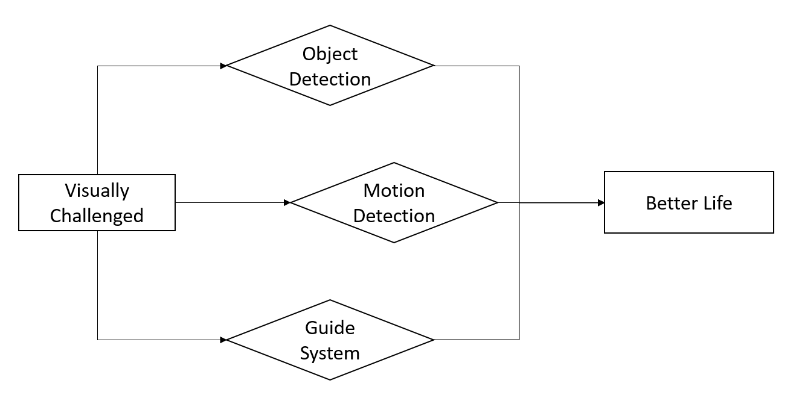
Fig.no.2 Method
This will send the signal to the stick which has the slave NodeMCU controller. The received signal will trigger the motor using motor driver where the vibration of the motor is controlled based on the three levels. The vibration will be more in min level and less vibration at max level. The two components that make up the operation of this project model are obstacle detection and identification. The obstacle identification module recognises the barrier once it has been identified by the obstacle detection module, and with the aid of a buzzer, alerts the user with aural feedback. In the event of an emergency, such as an accident, the message passing and tracking module will monitor the location and send a message to the blind user's relative.
Three components make up the block diagram: message passing and position tracking, obstacle detection, and obstacle identification.
1. The obstacle detection module uses IR and ultrasonic sensors to identify obstructions at a distance of one and two metres, respectively. With a maximum range of 25 metres, the ultrasonic sensor can detect obstructions that are far away.
2. The obstacle recognition module has two ultrasonic sensors and a motion sensor to recognise stairs and obstacles. The 110°x70° detection range has a maximum range of up to 6 metres for motion detection. The direction of obstacles is shown via the use of goggles that include an IR sensor and vibrators on the left and right sides. These can only be used in a crowd and are optional.
3. The location tracking and message-passing module is made up of the GPS and GSM modules. Using Google Maps, we may locate the blind user by utilising the GPS module to monitor the latitude and longitude coordinates of a physical place.
In the event of an emergency, the relatives of a blind user must be notified of the whereabouts of the blind user. This is accomplished by sending a message with a location to the particular contact using the GSM module.

Motion detection flowchart
1. The two slots on a PIR sensor allow it to measure the amount of infrared light.
2. If the sensor is idle, 3. both pick the same quantity of IR light, the amount of light radiated from the room, wall or outside.
4. Alternatively, if a warm body—such as a human or animal—passes by, it first intercepts one half of the PIR sensor, causing a positive change between the two halves. The buzzer then begins to ring, signalling the presence of motion, and when the body moves away from the sensing area, the buzzer stops ringing, indicating the motion has stopped.
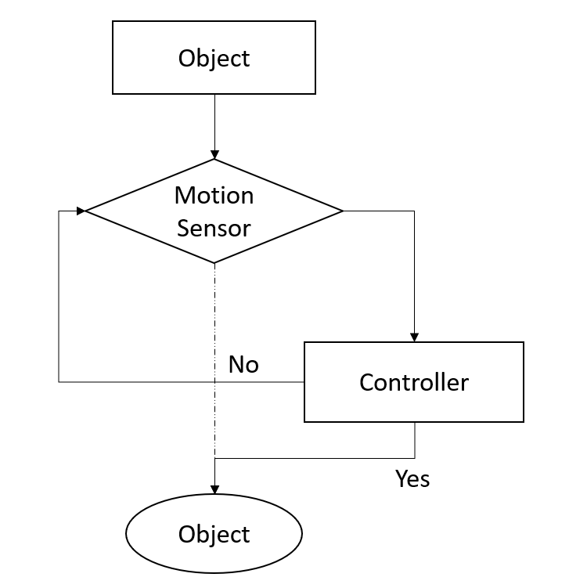
Fig.no.4 MD Flow Chart

Item recognition and detection flowchart
1. Vertically stacked ultrasonic sensors are linked in serial fashion.
2. Sensors are started, and the first one begins detecting the obstruction.
3. If the first sensor detects the obstruction, figure out the separation and save it as r1.
4. The second sensor begins to detect an obstruction and If the second sensor also perceive the impediment
Calculate the distance and save it as r2, then: a. Compare r1 and r2
5. The object is a staircase if r2 > r1.
6. else If r1 = r2, the item is a wall; otherwise, it is a typical obstruction that has to be avoided.
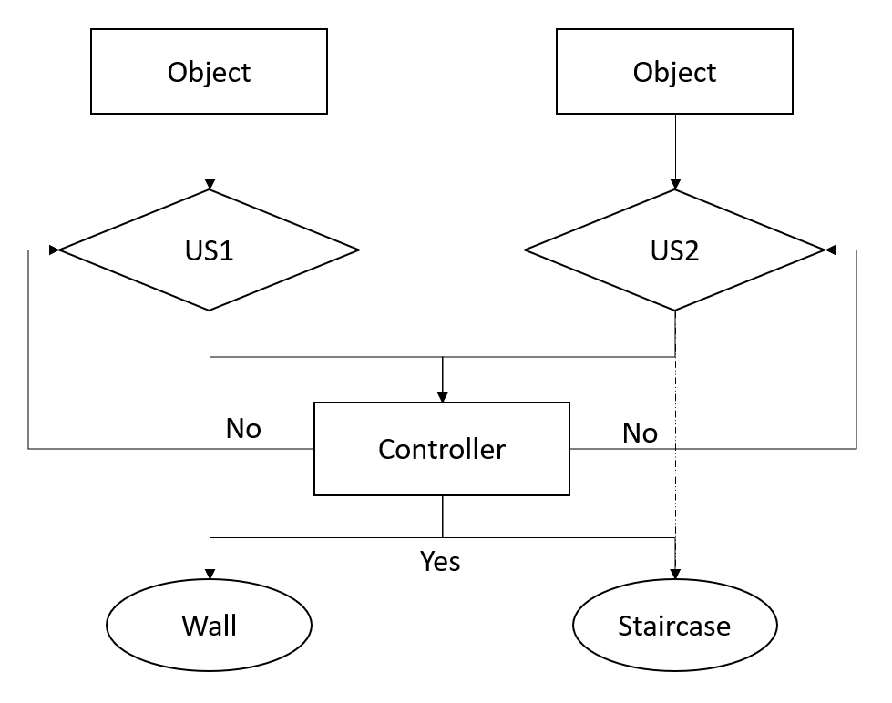
Fig.no.5 IRD Flow Chart

NodeMCU esp8266
A cheap open source IoT platform is NodeMCU. It originally contained hardware based on the ESP-12 module and firmware that runs on Espressif Systems' ESP8266 Wi-Fi SoC. Support for the 32-bit ESP32 Microcontroller was later added. NodeMCU V3 is mostly utilised in WiFi applications because most other embedded modules cannot handle them without the addition of an external WiFi protocol.
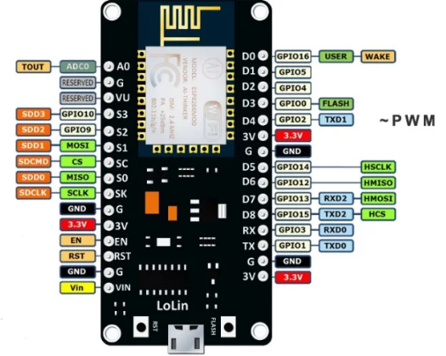
Fig.no.4 NodeMCU ESP8266
Ultrasonic Sensor
Devices that produce or sense ultrasound energy include ultrasonic transducers and ultrasonic sensors. Transceivers, receivers, and transmitters are the three major categories into which they may be separated. Transceivers can transmit and receive ultrasound, whereas transmitters transform electrical signals into ultrasound and receivers into electrical signals.
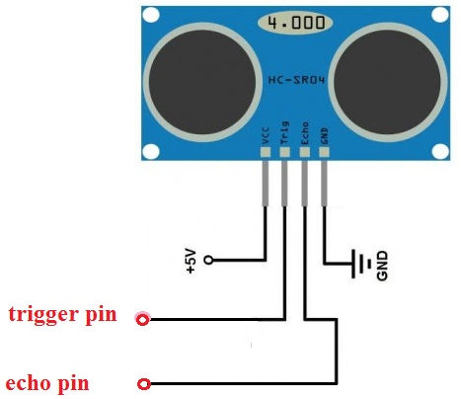
Fig.no.5 Ultrasonic Sensor

Speaker Module
The speaker amplifier IC serves as the basis for this speaker module. It can play high-quality audio and be used as a buzzer. The potentiometer is used to adjust the volume output. The module offers a number of benefits (e.g. a compact footprint, simple interface, wide voltage input range, long service life). An electronic musical instrument without a keyboard or other human-playable interface, such as a piano, is referred to as a sound module. Sound modules must be controlled by an outside connected device, which is frequently a MIDI controller. The musical keyboard is the most popular kind of MIDI controller.
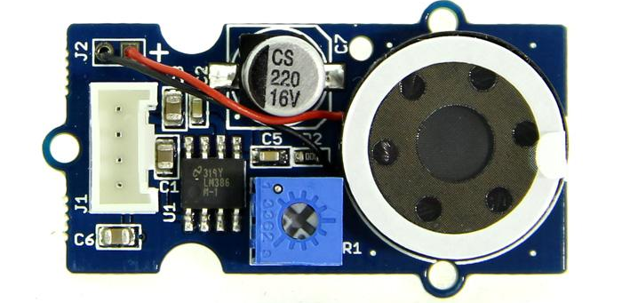
Fig.no.5 Speaker Module
Voice Recognition Module
A small, simple-to-use speech recognition board is the Voice Recognition Module. Up to 80 voice commands are supported by this speaker-dependent module. Every sound may be taught to serve as a command. Before the module can recognise any voice command, users must train it. Voice Recognition Engine does not need any additional hardware, software, or internet access and is compatible with a variety of Esp8266 boards and the Esp8266 IDE. Regardless of the speaker's real voice, tone, or accent, its AI/ML engine can grasp commands expressed through text input in more than 40 languages.
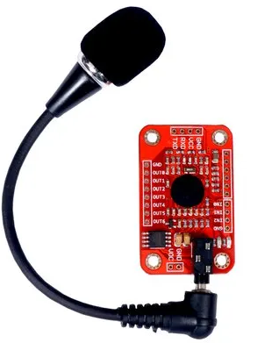
Fig.no.5 Voice Recognition Module

GPS Module
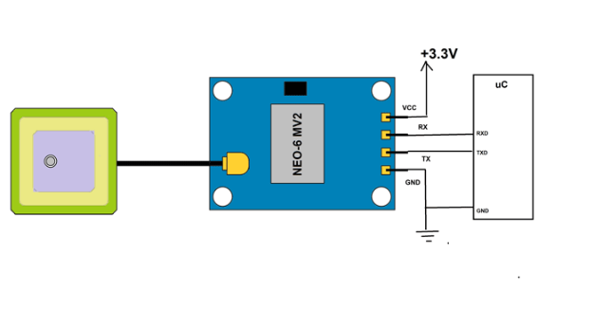
Fig.no.5 GPS Module
A satellite provides a specific position to the GPS module. While you're outside, GPS is a useful tool for locating a location. The GPS module may make use of a number of GPS satellites. In this part, we'll try to use a GPS module to obtain a position. Little processors and antennas found in GPS modules are used to directly receive data from satellites using specific RF frequencies. From there, it will get data from various sources, including timestamps from all visible satellites.

Motor driver
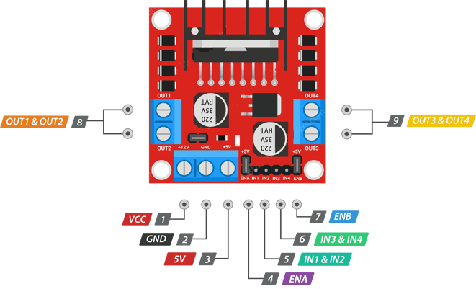
Fig.no.6 Motor driver
An electrical circuit known as an H-bridge changes the polarity of a voltage applied to a load. These circuits enable DC motors to move forward or backward in robotics and other applications. The name is derived from its typical schematic diagram depiction, in which the load is linked as the crossbar and the four switching components are arranged as the branches of the letter "H".

Vibration Motor
A motor that is out of balance is what causes it to vibrate. Or, to put it another way, the motor wobbles because of a weight that is attached to its rotational shaft off-centre. Depending on the amount of weight that can be added, how far it is from the shaft, and how quickly the motor spins, the degree of wobbling may be altered.

Battery
An electric battery that provides a nominal voltage of 9 volts is known as a nine-volt battery or 9-volt battery. Depending on the battery chemistry, the actual voltage ranges from 7.2 to 9.6 volts. Batteries of all shapes and sizes are produced; one popular size is PP3, which was first used in early transistor radios. The PP3 features two polarised snap connectors on the top and is shaped like a rectangular prism with rounded sides. This kind is frequently employed in a wide range of applications, including toys, clocks, and domestic items like smoke and gas detectors.

Jumper wires
An electrical wire, or group of them in a cable, with a connector or pin at each end (or sometimes without them - simply "tinned") is known as a jump wire (also known as a jumper, jumper wire, or DuPont wire), and it is typically used to connect the parts of a breadboard or other prototype or test circuit internally or with other pieces of machinery or components without soldering.

SCHEMATIC
The circuit is made up of a microcontroller and many sensors, including IR, PIR, and ultrasonic. In order to detect various impediments, a pair of ultrasonic sensors is vertically positioned linked in series with one sensor above the other. The first device's Vcc is linked to the Esp8266's 5V supply, its GND to its GND, and its Echo and Trig pins to its respective digital pins 3 and 2. The Echo and Trig pins of the second sensor are linked to the digital pins 4 and 5 of the Esp8266, and the Vcc and GND of the second sensor are connected to the Vcc and GND of the first sensor. PIR's Vcc is coupled with Esp8266's 5V, GND with its GND, and OUT with its digital pin 2. The IR sensor's Vcc and GND are connected to the Esp8266's digital pin 7 while the OUT pin is connected to the board's 5 V and GND. Connected to digital pin 13 is the buzzer. Although Rx and Tx are linked to the analogue A0 and A1 pins of the Esp8266, the Vcc and GND of the GPS are connected to the 5 V and GND of the Esp8266. The 5V and GND of the Esp8266 are linked to the Vcc and GND of the GSM. Rx and Tx are linked to Esp8266's digital pins 9 and 10, while the antenna is connected to the NET pin.
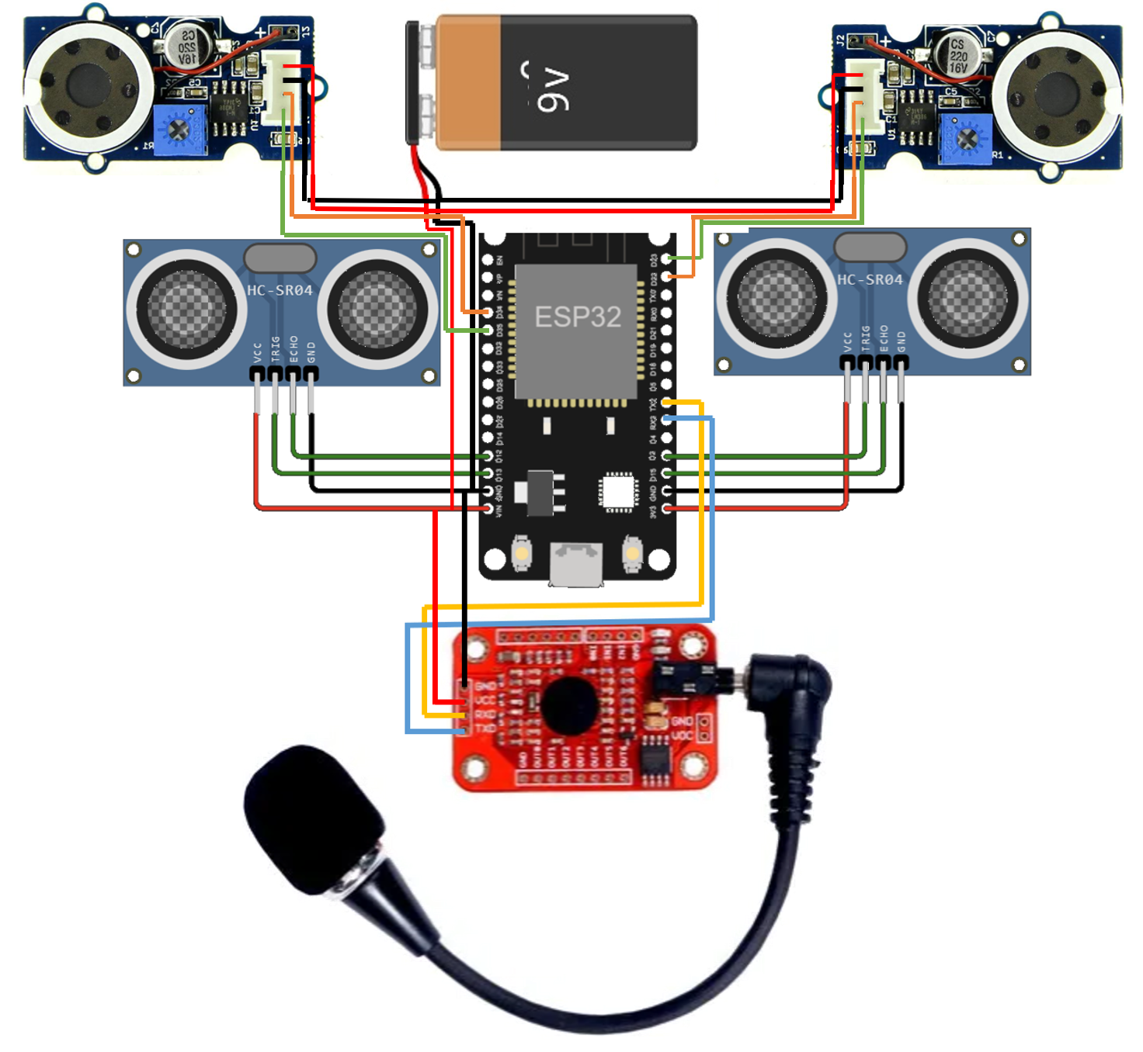
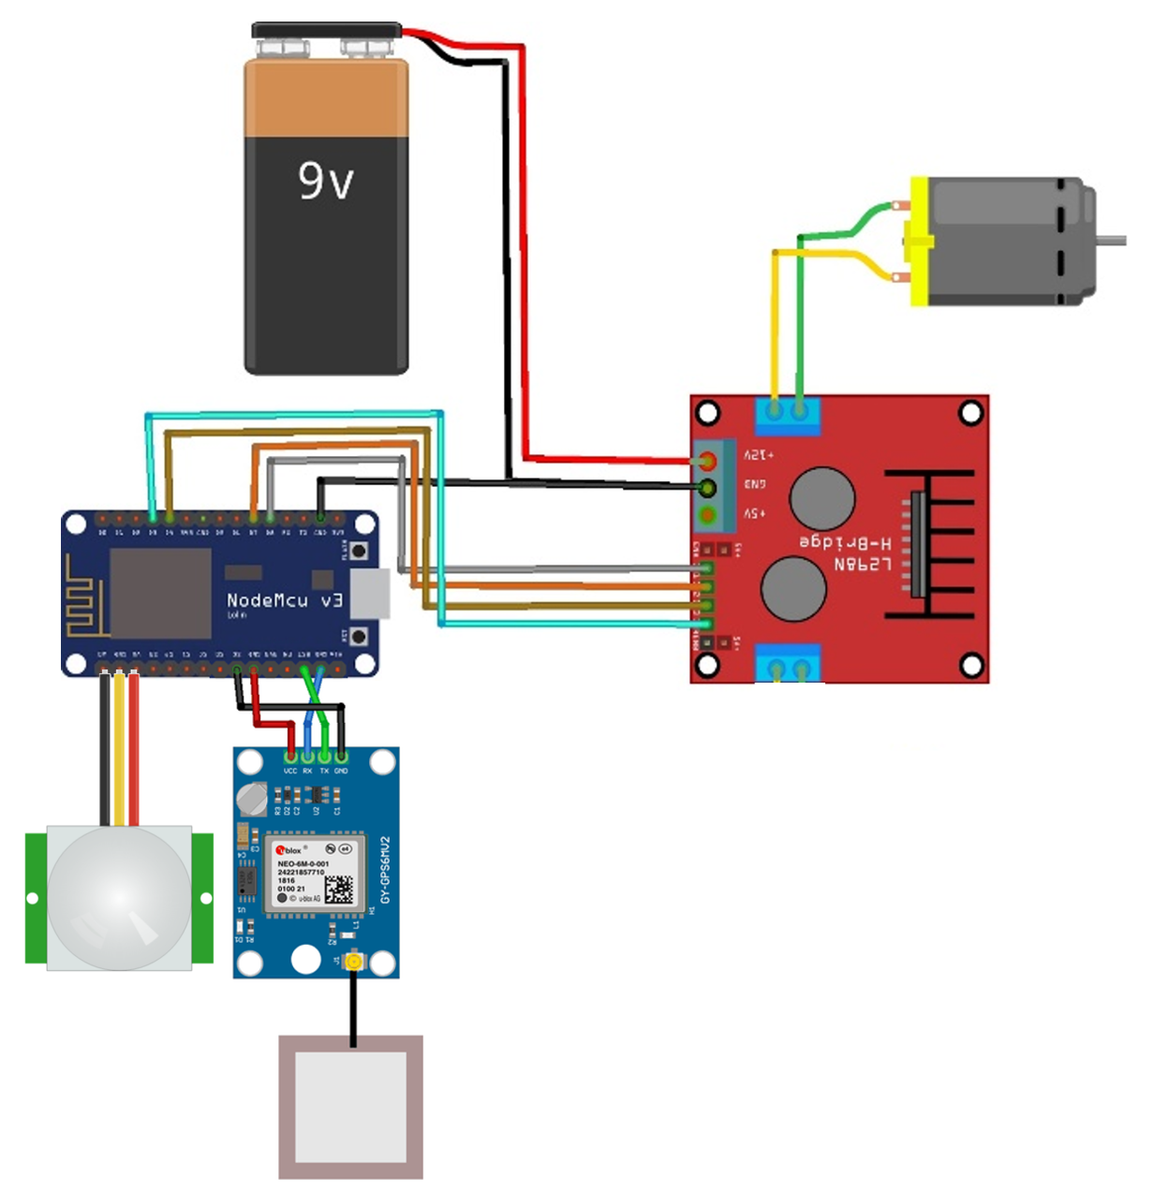
Fig.no.6 Schematic

CONCLUSION
As a result, we draw the conclusion that, despite its numerous shortcomings, the project does have some valuable functions that may be enhanced or further developed to make it more beneficial to blind users. To enhance the functions and add new features that will better serve the needs of the blind user, several further adjustments, such as pothole detection and water detection, may be made.
Future Scope
The price is now one of the biggest obstacles to getting these smart glasses that improve vision. The price of eSight's product was recently dropped after it was previously offered at approximately. The cheapest service bundle from Aira costs about one month's worth of service fees. Vision-improving technologies are frequently not covered by insurance, in contrast to other kinds of medical equipment. Because of the cost burden this place on the user, smart glasses are probably not now used widely.

REFERENCE
[1] A.P. K.S.Manikanta, T.S.S. Phani, “Implementation of Smart Stick for Obstacle Detection and Navigation,” vol. 02, no. 05, pp. 45–50, 2016.
[2] S. A. N. Kudva, Shreedhar, Pratik N K, Poornesh V, “Smart Blind Stick,” Int. J. Latest Trends Eng. Technol., vol. 9, no. 3, pp. 273–275, 2018.
[3] W. Motwakil, I. Ahmed, and E. M. Hussein, “Design and Implementation of Eye Stick for Blind People,” vol. 45, no. 01, pp. 83–87, 2017.
[4] M. H. A. Wahab et al., “Smart Cane: Assistive Cane for Visually-impaired People,” vol. 8, no. 4, pp. 21–27, 2011.
[5] A. F, A. NADA, M. A, and S. MASHALI, “Effective Fast Response Smart Stick for Blind People,” no. April, pp. 5–11, 2018.
[6] A. Anwar, “A Smart Stick for Assisting Blind People,” IOSR J. Comput. Eng., vol. 19, no. 3, pp. 86–90, 2017.
[7] P. K. D. Vipul V. Nahar1, Jaya L. Nikam2, “Smart Blind Walking Stick”, Int. J. Mod. Trends Engineering Research, vol. 2, no. 4, pp. 226–232, 2015.
[8] S. Vinay, N. N. Shaikh, and S. Aithal, “Design of a Smart Stick Prototype Using Goal Oriented Requirements Engineering Methodology,” Int. J. Comput. Appl., vol. 1, no. 29, pp. 31–35, 2010.
[9] M. Shanmugam, J. Victor, M. Gupta, K. Saravanakumar, and I. Mca, “Smart Stick for Blind People 1,” Spec. Issue Publ. Int. J. Trend Res. Dev., pp. 2394–9333, 2017.
[10] D. E. Gbenga, A. I. Shani, and A. L. Adekunle, “Smart Walking Stick for Visually Impaired People Using Ultrasonic Sensors and Esp8266,” Int. J. Eng. Technol., vol. 9, no. 5, pp. 3435–3447, 2017
[11] Mohamed, S. A. E., Hassanin, A. S, & Othman, M. T. Ben. (2014). Educational System for the Holy Quran and Its Sciences for Blind and Handicapped People Based on Google Speech API. Journal of Software Engineering and Applications, 07(03), 150–161.
[12] Sabab, S. A., & Ashmafee, M. H. (2016). Blind Reader: An intelligent assistant for blind. 2016 19th International Conference on Computer and Information Technology (ICCIT), 229–234.
[13] Sarkar, R., Das, S., & Roy, S. (2013). SPARSHA: A Low-Cost Refreshable Braille for Deaf-Blind People for Communication with Deaf-Blind and Non-disabled Persons (pp. 465–475). https://doi.org/10.1007/ 978-3-642-36071-8_37
[14] Sharma, A., Devi, S., & Verma, J. K. (2020). Braille Book Reader using Raspberry Pi. 2020 International Conference on Computational Performance Evaluation (ComPE), 841–843.
[15] K, S. G., & T, S. (2017). Real Time Implementation of Optical Character Recognition Based TTS System using Raspberry pi. International Journal of Advanced Research in Computer Science and Software Engineering, 7(7), 149.
[16] Niel Andre Cloete, Reza Malekian, Lakshmi Nair, “Design of Smart Sensors for Real-Time Water Quality Monitoring”, Journal of latex class files, vol. 13, no. 9, September 2014.
[17] Monika Sethi, “Information System and System Development Life Cycle”, DOI: 10.4018/978-1-4666-3679-8.ch007, January 2013.
[18] V. Jeevana, R. K. Sundar, K. Pravin S. Preethi and R. Karthik, “Design of Intelligent Stick - Guide for the Blind”, in IJSRD - International Journal for Scientific Research, Vol. 6, Issue 01, 2018.
[19] Su, B., & Wang, L.“Application of Proteus virtual system modelling (VSM) in teaching of microcontroller”. In E-Health Networking, Digital Ecosystems and Technologies (EDT), 2010 International Conference on Vol. 2, pp. 375-378, 2010.
[20] Amjed S. Al-Fahoum, Heba B. Al-Hmoud, and Ausaila A. Al-Fraihat, “A Smart Infrared Microcontroller-Based Blind Guidance System”. Active and Passive Electronic Components, 2013.
[21] Bhatlawande, Shripad S., Jayant Mukhopadhyay, and Manjunatha Mahadevappa. "Ultrasonic spectacles and waist-belt for visually impaired and blind person." Communications (NCC), National Conference on. IEEE, 2012.

