Software as a service attack detection and prevention using QR

codes
Mugdha Thakare¹, Samiksha Patil², Hrutuja Pawar³, Anisha Sawant⁴, Prof. Kajal Vatekar⁵

¹Department of Computer Engineering, Smt. Kashibai Navale College of Engineering, Pune, India
²Department of Computer Engineering, Smt. Kashibai Navale College of Engineering, Pune, India
³Department of Computer Engineering, Smt. Kashibai Navale College of Engineering, Pune, India
⁴Department of Computer Engineering, Smt. Kashibai Navale College of Engineering, Pune, India
⁵Assistant Professor, Department Of Computer Science And Engineering, Smt. Kashibai
Navale College Of Engineering, Pune, Maharashtra, India.

ABSTRACT
As the Internet era is increasing now a day results in developing of information and communication technology. As the result of this users are using online facilities for the different purpose like banking transaction. Due to this, protecting sensitive information from malwares or web phishing is becoming difficult from attackers. Using only the username and password for authentication and security is not sufficient to protect our data. Attackers can collect personal information from computer infection or web phishing. Therefore, this requires more advanced version of security mechanism. In this system, we propose the prevention from web phishing by using secure QR code as Anti-Phishing mechanism.
Keywords: QR Code, Attack , Malwares, Machine Learning and Support Vector Machine (SVM)

- INTRODUCTION
QR (Quick Response) codes are two-dimensional standardized tags with the capacity to encode various kinds of data. In light of their high data thickness and heartiness, QR codes have acquired prominence in different fields of utilization. Despite the fact that they offer a wide reach of benefits, QR codes present critical security hazards. Aggressors can encode pernicious connections that lead for example to phishing destinations. Such malignant QR codes can be imprinted on little stickers and sup- plant harmless ones on bulletin commercials. Albeit numerous genuine instances of QR code based assaults have been accounted for in the media, just little exploration has been directed in this field and practically no consideration has been paid on the transaction of safety and human-PC connection. At last we propose plan necessities with regard to the QR code itself, the per user application and ease of use angles to help further examination into to making QR code handling both secure and usable.
In Existing most of the application scan QR code and open link without checking URL authenticity Attackers can encode malicious links that lead e.g. to phishing sites. Such malicious QR codes can be printed on small stickers and replace benign ones on billboard advertisements. Although many real world examples of QR code based attacks have been reported in the media, only little research has been con- ducted in this field and almost no attention has been paid on the interplay of security and human-computer interaction. In this work, we describe the manifold use cases of QR codes. Furthermore, we analyze the most significant attack scenarios with respect to the specific use cases. Additionally, we systemize the research that has already been conducted and identified usable security and security awareness as the main research challenges. Finally, we propose design requirements with respect to the QR code itself, the reader application and usability aspects in order to support further research into to making QR code processing both secure and usable.

- METHODOLOGY
Data collection: The first step in predictive maintenance is to collect data from various sources available. Collecting various QR code links for testing and training of data.

Data pre-processing: The collected data often contains noise, outliers, and missing values that need to be pre-processed before analysis. Pre-processing techniques such as data cleaning, data transformation, and feature engineering are used to prepare the data for analysis.

Data analysis: After pre-processing, the data is analyzed using various machine learning algorithms such as regression, decision tree, random forest, and neural network. The analysis can be used to predict when maintenance is required, identify potential faults, and determine the remaining useful life of components.

Model evaluation: The predictive models developed using machine learning algorithms are evaluated using metrics such as accuracy, precision, recall, and F1-score. The evaluation helps to determine the effectiveness of the models and identify areas for improvement.

Implementation: Once the predictive models are evaluated, they can be implemented in the system. The implementation can involve scanning of QR codes and checking if they are malicious.

Continuous improvement: Predictive maintenance is an iterative process, and the models need to be continuously improved to adapt to changing conditions. This involves monitoring the performance of the models, collecting feedback from the maintenance team, and updating the models based on new data.

- MODELING AND ANALYSIS

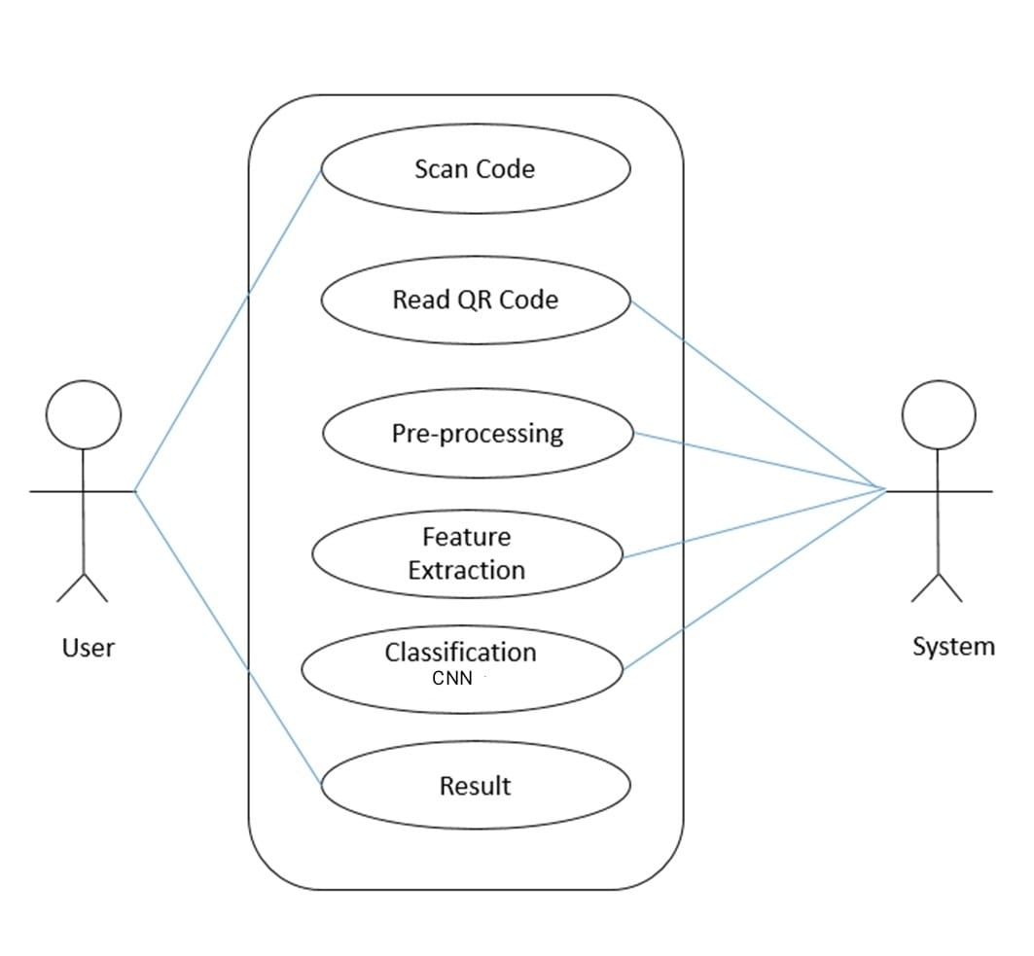
Figure 1: Model Building diagram
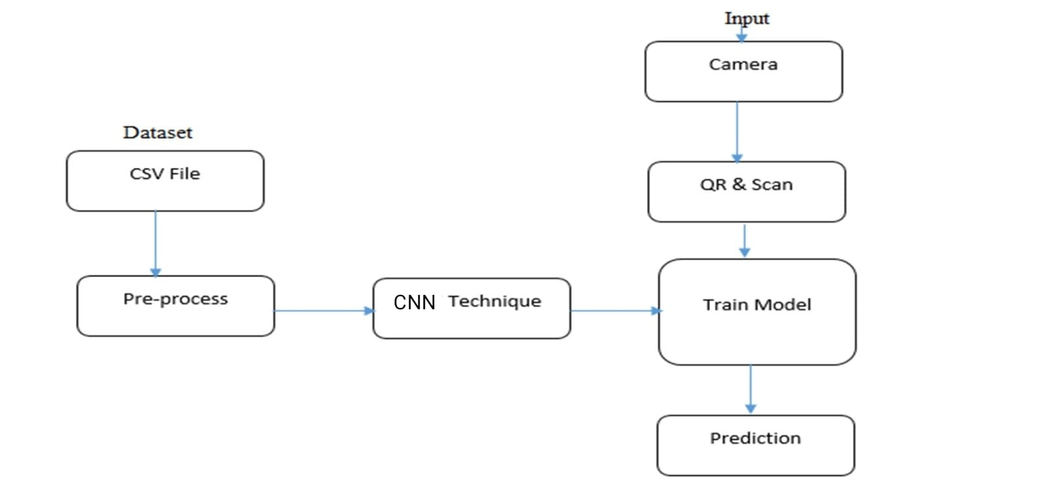
Figure 2: System Architecture

- PROPOSED ALGORITHM
In Deep Learning, a convolutional neural network (CNN/ConvNet) is a class of deep neural network, most commonly applied to analyze visual imagery. Now when we think of a neural network we think about matrix multiplications but that is not the case with ConvNet. It uses a special technique called Convolution. Now in mathematics convolution is a mathematical operation on two functions that produces a third function that expresses how the shape of one is modified by the other.
A Convolutional Neural Network (CNN) is a type of neural network commonly used for image recognition and classification tasks. It is inspired by the biological visual cortex, where neurons respond to different features of the visual stimuli.
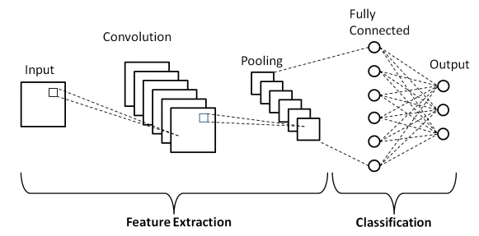
Figure 3: CNN Architecture Diagram

The CNN architecture consists of several layers, including convolutional layers, pooling layers, and fully connected layers.
1. Convolutional layers: These layers perform convolutions on the input image, extracting features such as edges and corners. Each convolutional layer has multiple filters, each filter detecting a specific feature.
2. Pooling layers: These layers reduce the size of the feature maps by downsampling them. The most common type of pooling laver is the max pooling layer, which takes the maximum value of a rectangular patch of the feature map.
3. Fully connected layers: These layers perform classification based on the extracted features. They are similar to the layers in a regular neural network and connect all the neurons in one layer to all the neurons in the next layer.

- CONCLUSION
In the proposed framework we presented an approach to preventing QR Code- Based phishing and malware attacks. Specifically, we first studied the current status of existing QR Code scanners in terms of their detection rate for malicious url’s. Then we proposed our solution to detect malicious url’s . More effectively by using Support Vector Machine techniques. Our main aim of developing technology is to provide scalability, flexibility for secure communication and security.

- REFERENCES
- M. Rajeswari, M. Revathi, Mr. J. Marimuthu, ”IRIS Recognition using QR Code for Finding Duplicate Certificate” ,IJERT 2020
- S.Hariswetha, S.Indira, S.Latha, T.Sivabharathi,”QR based Automatic Penalty Charging for Violation of Traffic Rules” (IJERT)2020
- Saroj Goyal, Dr. Vinod Kumar, Dr. Surendra Yadav, Manish Mathuria,” Quick Response Code Implementation in Society”, IJERT,2019
- Abhishek Mehta, Dr. Kamini Solanki,”Design and Development of QR Code Recognition from Digital Image”,(IJERT)2019
- K. Balasubramanian, P. Suhashini, V. Priyanga, K. Kavinila, ”Using QR Code Detection and Recognition Total Variations and LDA Approach”,(IJERT) 2018
- N Rodimawati , I G P A Budijahjanto, R E Putra and AY Wicaksono , “A Responsive Web-Based QR Code for Inventory in The Laboratory of Informatics, UNESA”, The 2nd Annual Applied Science and Engineering Conference (AASEC),U NESA I0P Conf. Series: Materials Science and Engineering 288, (IJERT) 2018
- Milind Amrurkar Dr.Anup Palsokar Asst.Prof. Pankaj Raibagkar , “QR Code based Stock Management System ”, The Journal: International Research journal of Engineering and Technology (IRJET) e-ISSN: 23951056 p4SSN: 23910375, (IJERT) 2017
- G. M. Agusta, K. Hulliyah, R. B. Bahaweres, et al. Qr code augmented reality tracking with merging on conventional marker based backpropagation neural network. In Advanced Computer Science and Information Systems (ICACSIS), 2012 International Conference on, pages 245–248. IEEE, 2012.

