STUDY ON PERCEPTION OF INVESTORS TOWARDS VARIOUS INVESTMENT AVENUES
G. Portiah Tony Mary
PGDM Finance And Marketing
Loyola Institute Of Business Administration (LIBA)
Loyola college campus, No:1 sterling road, Nungambakkam, Chennai, Tamil Nadu 600034
---------------------------------------------------------------------***---------------------------------------------------------------------

ABSTRACT
This study examines how investors view various investment opportunities. The study's primary goals are to quantify how demographic characteristics affect an investor's decision to invest and to determine the variations among objectives, influence sources, and investor behaviour in relation to investment patterns. 100 participants made up the study's sample size, which was used in Chennai. The study used a descriptive research methodology, and the primary data was gathered using a structured questionnaire approach. Convenience sampling was used for the study's sample strategy. Chi-square test, one of the statistical method and percentage analysis was used to analyse and interpret the data. The study's findings indicate that the preference of different investment avenues have an impact on the purpose of investments that investors make, but that there is no conclusive evidence linking the frequency of investment and the profit or loss that they make. The report goes on to say that the investors' behaviour, goals, and influential people fluctuate significantly depending on their investment pattern and routes.

Key words: Investment, Investor behaviour, avenues, perception

INTRODUCTION

The growth of an economy depends heavily on capital. The rate of capital formation is one factor that influences how quickly the economy develops. Additionally, the mobilization and rerouting of investible money are prerequisites for capital development. The financial system's job is to transfer money from surplus to deficit sectors. Increasing investment and effective demand by facilitating such flows at the national level speeds up economic growth.
An economy's overall growth has been closely correlated with the development of the capital markets. Commercial banks often rule the financial system in less developed nations. The efficiency of indirect lending from savers to investors tends to increase as an economy matures. Securities markets and specialized financial intermediaries emerge as the economy expands. Investors, particularly lone investors, can direct their money into financial assets issued by companies as the securities markets develop.

In India, there are numerous financial resources and investment opportunities. Each investing option has advantages and disadvantages of its own. Some options aim to generate better profits but at a larger risk. Others offer protection, but at the sacrifice of growth and liquidity. FDs and other alternatives provide safety and liquidity, albeit at the expense of return. Mutual funds aim to eliminate the drawbacks of these options while combining the benefits of investing in them.
Due to its semi-efficient structure and reputation as one of the most reputable stock markets, the Indian stock market enables each security's price to swiftly and fairly respond to new information so that it represents the most recent information related to investment value.
Any country's economy depends heavily on savings. Savings serve as a catalyst for the progress of the nation by being invested in a variety of possibilities accessible to the populace. To create a precise amount of money for a certain life goal and to save aside money for an uncertain future, one must invest and earn a return on their idle resources.
To cover the expense of inflation is one of the key reasons why one must make prudent investments. The rate at which the expense of living rises is known as inflation.
Simply put, the cost of living is the amount you pay to purchase the commodities and services you require to survive. Money loses value as a result of inflation since it will no longer be able to purchase the same quantity of goods or services in the future as it can today or in the past. It is best to start investing as soon as possible.
The notion of compounding, which raises your income by accumulating the capital and the interest or dividend received on it year after year, works by giving your assets more time to grow when you invest early. Due to the fact that they can influence the decision-making process and observe the outcomes of their decisions, many people find investing to be exciting. Due to the fact that investors do not always choose the best investments over a long period of time, not all investments will be lucrative.
Investment is a serious topic that may have a significant influence on a person's future well-being, not a game. Most people invest their money. Even if a person does not choose certain assets, such as stocks, they can still invest by taking part in pension plans, employee savings plans, or by buying life insurance, a house, gold, silver, bonds, post office savings, or real estate. The potential return and risk are two features that any investment has in common.
Since the future is unpredictable, one must decide how much risk they are ready to take on because taking on greater risk is correlated with better returns. Based on the foregoing context, this research makes an empirical attempt to investigate investors' perceptions about various investment avenues.

REVIEW OF LITERATURE
“In the study ‘An Empirical Analysis On Perception of Investors’ Towards Various Investment Avenues’, G. Velmurugan, Vishwanth Selvam, Nigahe Nazar studied that the empirical study was an attempt to examine the investors’ perception towards various investment avenues in Vellore city, Tamil Nadu, India. Secondary data from a broad variety of literature from different journal publications as well as primary data employing a suitable sampling technique through questionnaire and interview methods have been used. According to the study's results on investors' perceptions of various investment outlets, high-income and older investors exclusively invest in post office and bank deposits for reasons of safety.”
“In the study ‘A Study of Investor’s Perception towards Various Investment Avenues with Special Reference to Mumbai City’, Nishmita Ahuja, examined the behaviour of people towards different investment avenues available. It focuses mostly on its awareness and its investors' investment practices. It takes into account a number of variables that affect and motivate people to make investments, with risk being one of the most crucial variables. Mumbai city served as the site of this study. Understanding a person's investment style is also useful.”
“In ‘Investors Perception towards Investment Avenues’, U M Gopal Krishna, Aliya Sultana, T Naraya Reddy, studied the investors perception in primary and popular investment avenues in Kurnool District of Andhra Pradesh. All demographic information was gathered from the respondents, along with the investors' goals, and the correlation between these two factors was calculated. Additionally, the study uncovers the ways in which investors choose their investing routes.”
“In’ A Study on Investors Perception towards Investment Avenues’, K. Sowmya, J. Mounika Reddy, examined the perceptions towards various investment avenues in Hyderabad city of Telangana. 200 people made up the study's sample, which included both primary and secondary data. According to the study's findings, investors who choose to make bank deposits are more likely to choose lower-risk investment opportunities.”

ANALYSIS AND INTERPRETATION

Data analysis is the act of examining each element of the supplied data and assessing it using logical and analytical reasoning. One of the various procedures that must be carried out while performing a research experiment is this kind of analysis.

To draw a judgement or conclusion, information from many sources is acquired, evaluated, and then examined.

Experimental scientists mostly rely on objective data and statistical computations for their interpretations. Social scientists analyze the findings of written reports that may lack quantitative computations but are replete with descriptive information. Percentage analysis is the statistical method used in this investigation.

PERCENTAGE ANALYSIS
A specific sort of analysis known as percentage analysis is used to compare two or more data sets. On a descriptive connection, the percentage is based. The relative items are compared. Since the % simplifies everything to a single base, it enables comparison of meaning. It is used to calculate the proportion of responders out of all respondents.
PERCENTAGE = NO. OF RESPONDENTS / TOTAL NO. OF SAMPLES X 100
The following tables will help to indicate the percentage based on the various factors provided in the questionnaire.
Table 4.1
Table showing percentage based on the sources of information
Source | Frequency | Percentage
Print/Electronic Media | 22 | 22%
Friends/Relative advice | 53 | 53%
Expert’s opinion | 25 | 25%
Total | 100 | 100%
Chart 4.1
Chart showing sources of information of the respondents

Interpretation
Table 4.1 and Chart 4.1 shows that 22% of the respondents’ source of information was ‘Print/Electronic Media’, while for 53% were ‘Friends/Relative advice’ and for the remaining 2 5 % of the respondents were ‘Expert’s opinion’.
Table 4.2
Table showing preference of investment avenues
Preference of Avenues | Frequency | Percentage
Stock Market | 15 | 15%
Gold | 20 | 20%
Real Estate | 14 | 14%
Insurance | 16 | 16%
Savings Deposit | 12 | 12%
Post Office | 12 | 12%
Mutual Funds | 6 | 6%
Fixed Deposits | 5 | 5%
Total | 100 | 100%
Chart 4.2
Chart showing the preference of investment avenues

Interpretation
Table 4.2 and Chart 4.2 shows that 15% prefer to invest in ‘Stock markets’, 20% in ‘Gold’, 14% in ‘Real Estate’, 16% in ‘Insurance’, 12% in ‘Savings deposit’, 12% in ‘Post Office’, 6% in ‘Mutual Funds’ and the remaining 5% in ‘Fixed deposit
Table 4.3
Table showing percentage of money that is invested
Percentage invested | Frequency | Percentage
Below 20% | 56 | 56%
20-40% | 39 | 39%
40-60% | 3 | 3%
Above 60% | 2 | 2%
Total | 100 | 100%
Chart 4.3
Chart showing percentage of money that is invested

Interpretation
Table 4.3 and Chart 4.3 shows that 56% of the respondents invest ‘Below 20%’ from their savings, 39% of them invest ’20-40%’, 3% of them invest ’40-60%’ and the remaining 2% of them invest ‘Above 60%’ respectively.
CHI-SQUARE ANALYSIS
The importance of disparity between observed frequencies and expected frequencies produced under some theory was investigated by Karl Pearson in 1900 using a non-parametric test.
Chi-Square Test which is also known as the X2-test, goodness of fit is used to determine whether the difference between expected and observed values can be attributed to chance (fluctuations of sampling) or whether it is actually the result of the theory's failure to adequately explain the observed data.
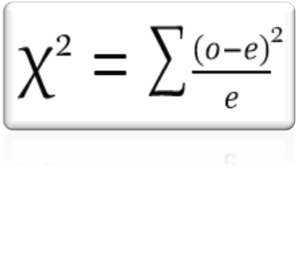
Frequency of investment vs Impact of investment:
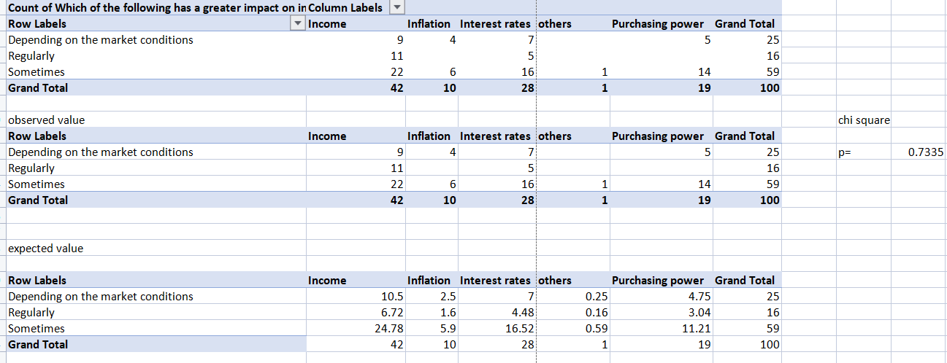

H_{0 :} Rejected : There is a relationship
H₁: Accepted : There is no relationship

Since the p (p=0.733) value is above the significance level 0.5, there is no relationship between frequency of investment and impact of investment. Hence, H₁ is accepted.
Preference of avenues vs purpose of investment
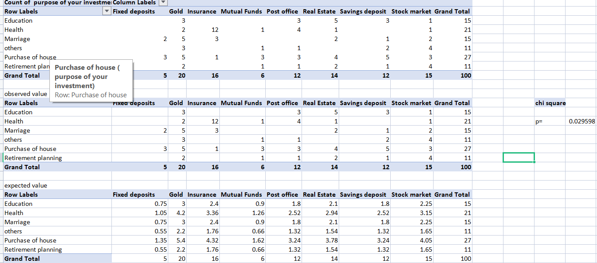
H_{0 :} Rejected : There is a relationship
H₁: Accepted : There is no relationship
Since the p (p=0.029) value is below the significance level 0.05, there is a relationship between preference of investment avenues and purpose of investment. Hence, H₀ is rejected.

Percentage of investment vs its satisfaction
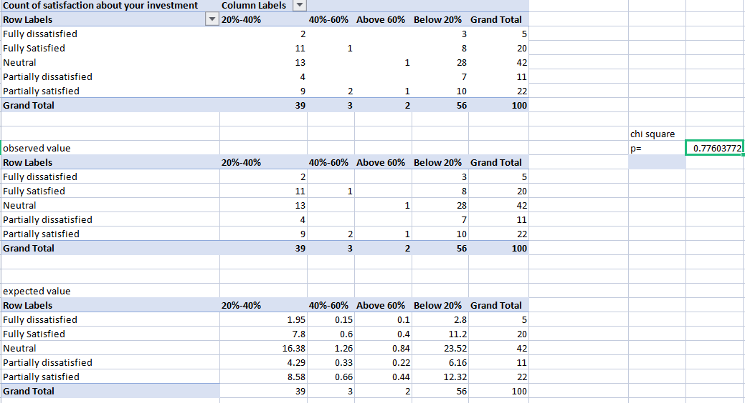H_{0 :} Rejected : There is a relationship
H₁: Accepted : There is no relationship
Since the p (p=0.029) value is below the significance level 0.05, there is a relationship between preference of investment avenues and purpose of investment. Hence, H₀ is rejected
Percentage of investment vs its satisfaction
. H_{0 :} Rejected : There is a relationship
H₁: Accepted : There is no relationship
Since the p (p=0.776) value is above the significance level 0.05, there is no relationship between percentage of investment and the satisfaction of investment. Hence, H₁ is accepted.
FINDINGS, SUGESSTIONS AND CONCLUSION
SUMMARY OF FINDINGS
In this chapter investors preference towards various investment avenues were analyzed. Occupation, Education, Age, Annual Income, investment period, source of information, preference of investment, percentage of money from savings, purpose of investment, period of investment, awareness of investment avenues, impact of investments and satisfaction level of investment etc., were taken into account for this study.
SUGGESSTION
✓ So as to manage one’s personal threat on their own, humans should be made aware about the investments and the way it works so they must be extra relaxed and feel safe to invest their cash.
✓ Also, they should be supplied with correct records and proper steerage so that they're capable of make their very own decisions related to investments.
✓ Many human beings invest their money blindly by considering most effective better returns. in preference to aiming for higher returns, one ought to make investments in the aim of surviving from their economic risk.
✓ They forget about or aren't made known approximately the dangers related to it. consequently, such human beings have to be alert earlier than investing their cash in any unproductive road to avoid future risk.
✓ Marketplace conditions hold on changing and charges maintains fluctuating. consequently, buyers are required to speculate and act at the changing marketplace situations.
✓ Also, investors have to put money into one of a kind avenues in place of making an investment in one, in an effort to mitigate the hazard related to one road.
CONCLUSION
The study comes to the conclusion that investments were made in a variety of investment channels in the hope of increase in growth of capital and both short and long-term profits. The fundamental principle underpinning every participant's investment in this study—public, private, self-employed, and retired—is to use the surplus funds in advantageous schemes that will both roll back the money and yield significant returns. When the average man considers investing, he will never choose a riskier strategy. The share and gold markets are incredibly volatile and unclear at the moment, therefore an investor should carefully research the market before investing. Risky activities are avoided by most individuals, but this is only true with information and persistence.
Few responders, on the other hand, were those who had previously made significant investments in stocks, mutual funds and received larger returns, but those who hadn't yet invested in any platform should at least give it a try. Investments have a major role in determining wealth. In every aspect of life, it needs to be turned on. Income must be used in part for investments. The stock market has many ups and downs, but when invested correctly and sensibly, it also offers maximum profits.

References

- https://www.slideshare.net/abhinaya19/new-project-63405457
- http://www.iosrjournals.org/iosr-jef/papers/Vol11-Issue1/Series-5/G1101055763.pdf
- https://www.researchgate.net/publication/281943764_An_Empirical_Analysis_On_Pe rception_of_Investors'_Towards_Various_Investment_Avenues
- https://www.ijrte.org/wp-content/uploads/papers/v8i2/B2054078219.pdf
- http://euroasiapub.org/wp-content/uploads/2016/10/14FMApril-3496-1.pdf
- https://www.icommercecentral.com/open-access/perception-of-investors-towards-the-investment-pattern-on-different-investment-avenues--a-review.php?aid=85529
- https://core.ac.uk/download/pdf/82598235.pdf

ANNEXURE
QUESTIONNAIRE
- Gender
- Female
- Male
- Education
- Students
- Professionals
- Sector employment
- Government
- Private
- Self-employed
- Retired
- Annual Income
- Upto 2 lakhs
- 2 to 4 lakhs
- 4 to 6 lakhs
- Above 6 lakhs
- Do you prefer investing in various investment avenues?
- Yes
- No
- Source of information
- Print/electronic media
- Friends/relative advice
- Experts opinion
- Which among the following investment avenues you prefer to invest?
- Stock market
- Gold
- Real Estate
- Insurance
- Savings deposit
- Post office
- Mutual Funds
- Fixed deposits
- What is the percentage of money you invest from your savings?
- Below 20%
- 20%-40%
- 40%-60%
- Above 60%
- What is the purpose of your investment?
- Education
- Marriage
- Purchase of house
- Health
- Retirement planning
- Other
- Period of investment
- Short term
- Long term
- Both
- Are you aware of the various investment avenues?
- Yes
- No
- According to you which of the following investments are necessary to achieve quick and higher returns?
- Stocks
- Mutual Funds
- Savings
- Gold
- Real estate
- Insurance
- Fixed deposits
- Other
- How often do you invest?
- Regularly
- Sometimes
- Depending on the market conditions
- Which of the following has a greater impact on investments?
- Income
- Purchasing power
- Inflation
- Interest rates
- Other
- Are you satisfied about your investment?
- Fully Satisfied
- Partially satisfied
- Neutral
- Partially dissatisfied
- Fully dissatisfied

