Uncovering Patterns and Relationships: A Multivariate Data Analysis Case Study
Sudakshina Singha Roy¹
¹Department of Statistics, University of Kalyani, West Bengal, India

---------------------------------------------------------------------***---------------------------------------------------------------------
Abstract - To distinguish between different cheese varieties, a total of 24 commercial cheeses were examined using three distinct methods to assess both general and thermophysical parameters. Rheological properties of different temperatures, stretch ability, melt ability and the formation of free oil were already present in the data. Box plots helped classifying textures of different cheese types on the basis of the general and thermophysical properties. Cluster analysis and multidimensional scaling helped classify the cheese types based on a variety of properties. Principal component analysis was applied, too, to the data set to receive a mapping of the cheese. A reduction of the analyzed parameters to three principal components accounting for 76.3% of the total variation was achieved, indicating that the methods are well suited to characterize the cheese samples. Mapping aids cheese producers to design new products with defined characteristics by affecting the manufacturing protocol. Also it helps cheese dealers to decide whether to buy a new variety of cheese produced in the market.

Key Words: Multivariate data, Andrew’s curves, cluster analysis, mantel test, multidimensional scaling, principal component analysis, general properties, thermophysical properties of cheese, R programming.

- INTRODUCTION

The dataset contains 24 varieties of cheese with 18 variables. There are 8 variables on general properties and 9 variables on thermophysical properties.
Now, let us discuss the questions under study.

  - Research Questions:

- How are the cheese textures different from each other?
- Can the different types of cheese be characterized into groups with respect to their similarities and dissimilarities?
- If yes, how are the groups related to each other?
- Do cheese types that are similar in terms of their general properties also tend to be similar in terms of thermophysical properties?
- Are the variables of general properties and thermophysical properties anyways correlated?

- If yes, what is the new dimension of variables which would be uncorrelated to each other, and will be helpful in further studies?

2. DATA VISUALIZATION

We use three multivariate plots to understand the data.
  - Correlation Plot:
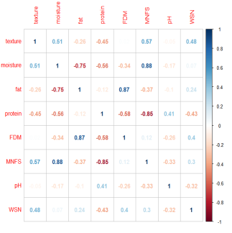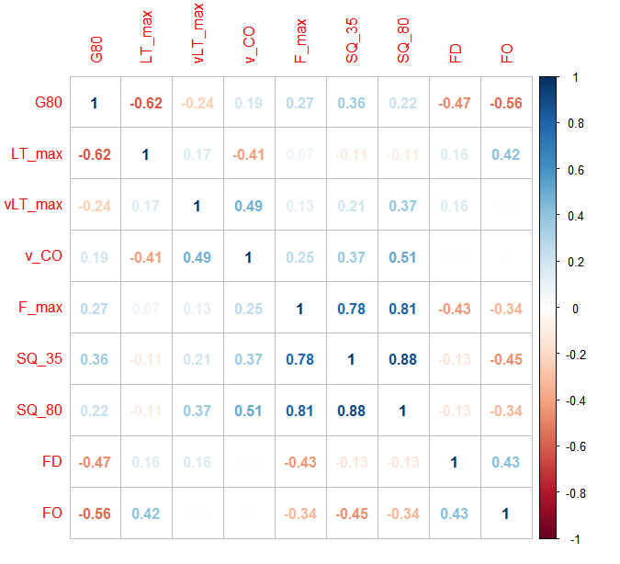
Fig -1: Plot1- on the left is a correlogram for general properties. Plot2- on the right is a correlogram for thermophysical properties.

Observations: Plot1 shows fat and fat in dry matter & moisture and moisture in non fat substance are highly correlated. Also, a high negative correlation is observed between protein and moisture in non fat substances & moisture and fat. For instance, as moisture level rises in cheese, it is seen level of fat content fall.
Similarly, for Plot2, (F_max, SQ_35), (F_max, SQ_80) and (SQ_35, SQ_80) are highly correlated.

  - Andrew’s Curves:
Andrew’s curves [7] are a method of data visualization of multidimensional data by mapping each observation on a function. It is known that the Andrew’s curves are able to preserve means, distance and variances which mean that the curves that are represented by functions close together imply that the corresponding data points will also be close.

R Code:
library(andrews)
imp=andrews(data_1, main= "Andrews Plot")

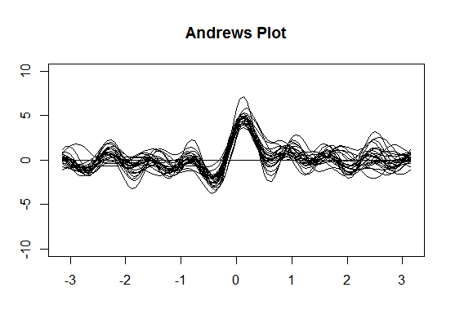
Fig -2: Andrew’ Plot showing different curves for different variables

Observation: On careful scrutiny we find at least 4 curves differ from the others, but it is difficult to tell which curve belongs to which group. Moreover, the number of observations being more than 20, there are too many curves in one graph. This results in an over-plotting of curves or a bad “signal-to-ink-ratio”.
  - Boxplots:

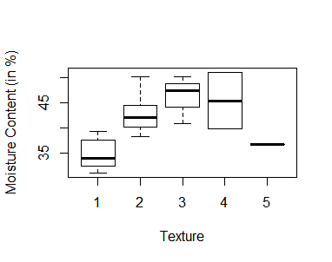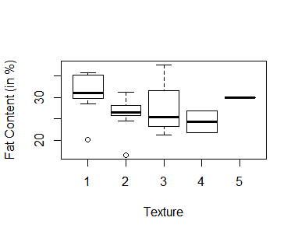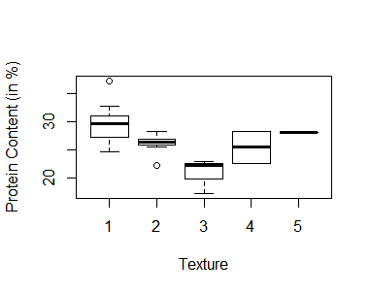
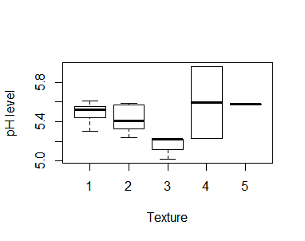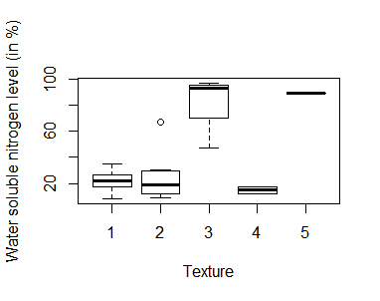
Fig- 3(I): Differentiating texture with respect to group 1 variables (general properties)
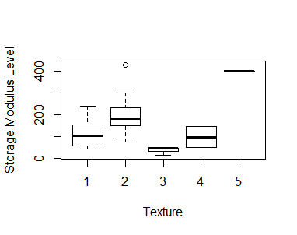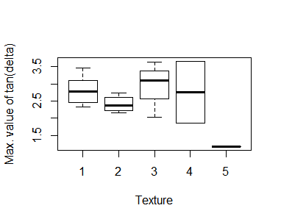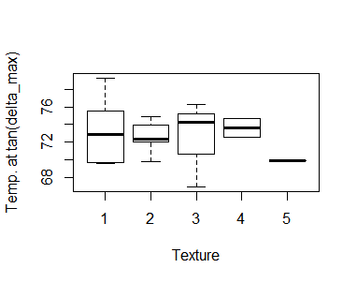
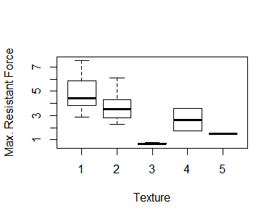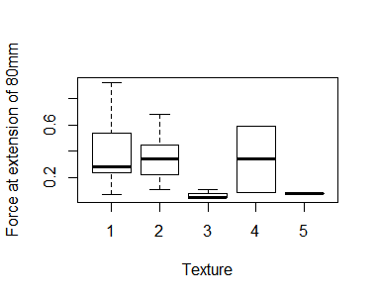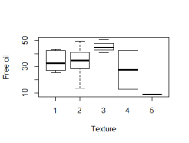
Fig- 3(II): Differentiating texture with respect to group 2 variables (thermophysical properties)

Table-1: Conclusions from boxplots shown above, i.e., differentiating cheese types based on their texture with respect to group 1 and 2 variables

Interpretation of Box plots
Texture | On the basis of general properties (Group 1 variables) | On the basis of thermophysical properties (Group 2 variables)
1 | On an average contains Highest: Fat content, Protein content  Lowest: Moisture content | On an average contains Highest: Maximum Resistance power
2 | _____________ | ______________
3 | On an average contains Highest: Moisture content, Water soluble nitrogen level  Lowest: Protein content, pH level. | On an average contains Highest: Maximum value of tan(delta), Temperature at tan(delta_max), Free oil. Lowest: Storage modulus, Maximum resistance force, Force at extension of 80mm
4 | On an average contains Highest: pH level Lowest: Fat content, Water soluble nitrogen level | On an average contains Highest: Force at extension of 80mm
5 | On an average contains Relatively high water soluble nitrogen level (not highest though) | On an average contains Highest: Storage modulus Lowest: Maximum value of tan(delta), Temperature at ten(delta_max), Free oil

3. DATA ANALYSIS:

3.1. CLUSTERING ANALYSIS:

To analyze the data and find any clusters which are similar to each other we use agglomerative hierarchical clustering method;

- Clustering different cheese types by normal properties
R Code:
normal.clust= hclust(data_dist.normal, method = "average")
plot(normal.clust,lab=cheeseType ,main = "Fig: Clustering of variety of cheese by normal properties", xlab = "", ylab = "Euclidean Distance", sub = "")
text(5.5,30,labels = "1", cex = 2)
text(20,30,labels = "2", cex = 2)
text(23.1,30,labels = "3", cex = 2)
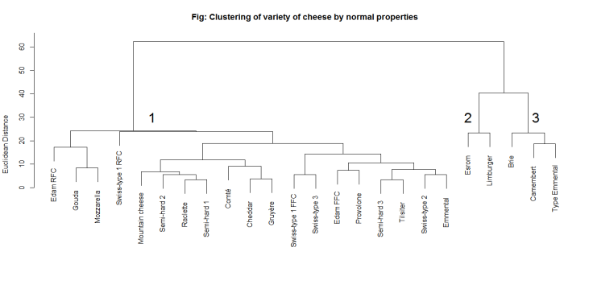
Fig -4: Clustering of variety of cheese on the basis of general properties.

Observation: At level 30 (distance), 3 clusters are formed which are similar on the basis of general properties.
Interpreting the dendogram:
R Code:
cluster <- cutree(normal.clust, h=30)
vars <- c('texture','moisture','fat','protein','FDM',
'MNFS','pH','WSN')
normal.groups <- cbind(cluster,data_1[vars])
table1 <- aggregate(normal.groups[vars],
list(normal.groups$cluster), mean)
colnames(table1)[1] <- 'Cluster'
print(signif(table1, 2), row.names=FALSE)

Output:
Cluster texture moisture fat protein FDM MNFS pH WSN
1 1.7 39 28 28 46 54 5.5 20
2 2.5 46 24 25 44 60 5.4 57
3 3.7 42 31 22 53 60 5.3 93

DISTINGUISHING CHARACTERISTICS:
- Cluster 1 contains the types of cheese that have a lot of protein, high pH level and low amount of moisture as well as moisture in dry state and least water soluble nitrogen.
- Cluster 2 contains the types of cheese that have high amount of moisture, moisture in dry state and low fat content, fat in dry matter.
- Cluster 3 contains the types of cheese that have maximum amount of water-soluble nitrogen, fat, fat in dry matter, and moisture in non-fat substance.
From the above interpretation of clustering based on group 1 variables, we obtain that Cluster 1 cheese are more edible to eat compared to other cluster cheeses but it will be most difficult to preserve them for a long time due to low water-soluble nitrogen level.

- Clustering different cheese types by thermophysical properties:
R Code
thermal.clust = hclust(data_dist.thermal, method = "average")
plot(thermal.clust,lab=cheeseType ,main = "Fig: Clustering of variety of cheese by thermophysical properties", xlab = "", ylab = "Euclidean Distance", sub = "")
text(0.60,139,labels ="1", cex = 2)
text(3.5,100, labels = "4", cex=2)
text(6.5,60, labels = "3", cex=2)
text(20,100, labels = "2", cex=2)
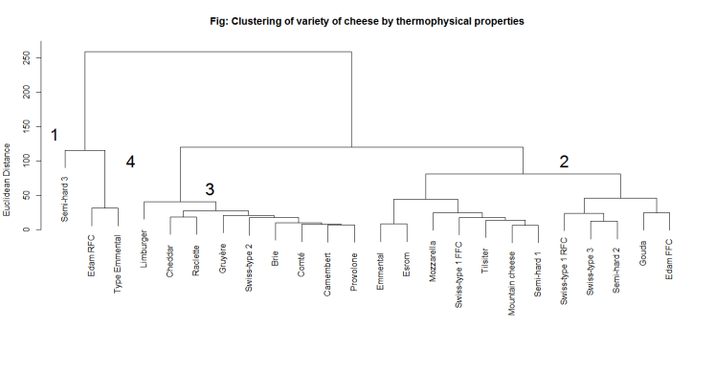
Fig -5: Clustering of variety of cheese on the basis of thermophysical properties.

Observation: At level 100 (distance), 4 clusters are formed which are similar on the basis of thermophysical properties.

Interpreting the dendogram:
R Code:
cluster <- cutree(thermal.clust, h=100)
vars<-c('G80','LT_max','vLT_max','v_CO','F_max','SQ_35','SQ_80','FD','FO')
thermal.groups <- cbind(cluster,data_1[vars])
table1<-aggregate(thermal.groups[vars], list(thermal.groups$cluster), mean)
colnames(table1)[1] <- 'Cluster'
print(signif(table1, 2), row.names=FALSE)

Output:
Cluster G80 LT_max vLT_max v_CO F_max SQ_35 SQ_80 FD FO
1 51 3.0 74 55 2.9 0.9 0.24 3.1 40
2 170 2.5 72 55 3.9 1.4 0.35 2.6 33
3 420 1.7 72 57 3.8 1.9 0.38 2.5 11
4 300 2.2 75 60 4.3 1.0 0.37 2.0 35

DISTINGUISHING CHARACTERISTICS:
- Cluster 1 contains only one cheese type, i.e., Semi-hard type 3, which differentiates itself from other types as it has relatively lowest G80, i.e., the storage modulus or the ability of the cheese to withstand stress at 80C temperature is really low. Next, low v_CO (temperature at cross-over) value, least F_max value, SQ_35 and SQ_80. It also has the highest LT_max value, FD and FO
- Cluster 2 contains the type of cheese who has lowest vLT_max, v_CO values.
- Cluster 3 contains the cheese type which has the highest G80 value, SQ_35, SQ_80 values and the least FO.
- Cluster 4 contains that type of cheese who have high vLT_max, v_CO, F_max values

3.1.1. MANTEL TEST:
This test uses repeated random sampling to obtain a result. As described by Manly[5]: “With a Monte Carlo test the significance of an observed test statistic [here, the Pearson correlation between two distance matrices] is assessed by comparing it with a sample of test statistics obtained by generating random samples using some assumed model.”
We will test for matrix correlations between Group 1 and Group 2 variables. The question addressed with this test is:
Do cheese types that are similar in terms of their Group 1 (normal properties) variables also tend to be similar in terms of Group 2 (thermophysical properties) variables?
R Code:
library(ade4)
mt1=mantel.rtest(data_dist.thermal,
data_dist.normal,nrepet = 10000)
mt1

From the output, we find the value for Observation, 0.1899814, is the observed Pearson correlation between the elements of the thermophysical properties distance matrix and the matrix of Group 1 variable distances. The simulated p-value of 0.09289071 indicates that our observed matrix correlation is indistinguishable from that produced by the random process of scrambling the rows and columns of the two matrices and then calculating the Pearson correlation between the two random matrices (which we did 10,000 times).

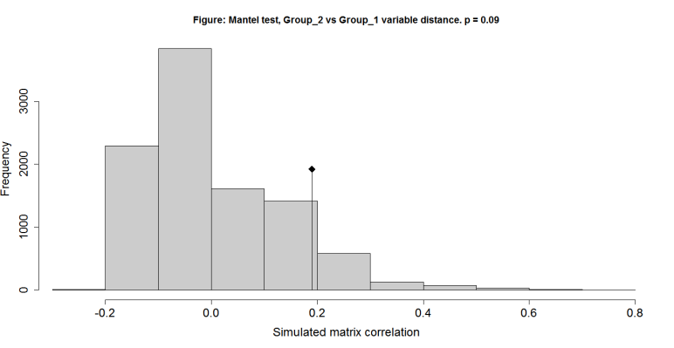
Fig -6: Clustering of variety of cheese on the basis of thermophysical properties.

The histogram shows the sampling distribution of our 10,000 randomly-produced Pearson correlations. The diamond symbol shows the location of our observed correlation (0.1899), clearly indistinguishable from the random distribution.
Answer: The cheese types that are similar in terms of group1 variables do not tend to be similar in group 2 (thermophysical) variables.

3.2. MULTIDIMENSIONAL SCALING:

Another approach to analysis of multivariate-distances is multidimensional scaling (MDS). Whereas cluster analysis uses a distance matrix to group similar objects together, MDS transforms a distance matrix into a set of coordinates in two or three dimensions, thereby reducing the dimensionality (number of variables) of the data. The coordinates are chosen such that the distance between objects in the coordinate space matches the dissimilarities contained in the original distance matrix as closely as possible. This is accomplished through an iterative procedure.
Objective: To classify types of cheese on the basis of
- Normal properties &
- Thermophysical properties

R Code:
library("MASS")
mds <- isoMDS(data_dist.normal, k=3)
mds

Here stress is 0.09858926 which is really good because the lower the value of stress the better the scaling.
The MDS axes can be viewed as synthetic variables: the analysis has reduced the dimensionality of the data from the original 16 variables to three synthetic axes.
PLOT:
R Code:
s3d55=scatterplot3d(mds$points[,1:3], main = "Multidimensional Scaling Plot, Cheese general properties data", xlab = "MDS1", ylab= "MDS2", zlab = "MDS3", angle =250)
text(s3d55$xyz.convert(mds$points[, 1:3]), labels = data_1$cheeseType,cex= 0.7, col = "steelblue", pos=3)

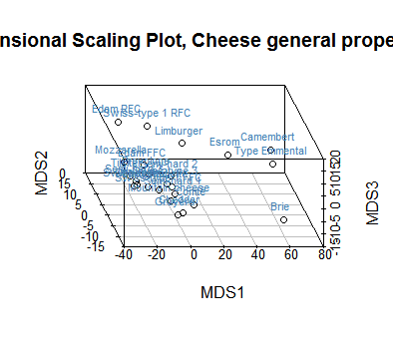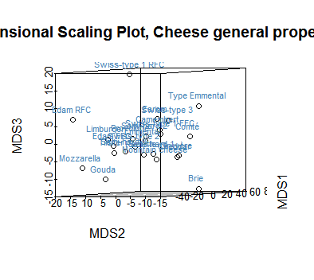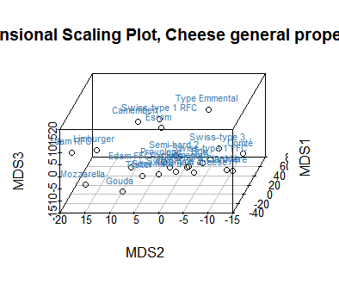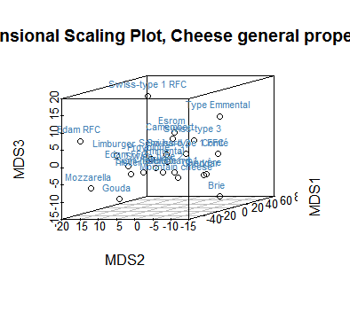

Fig- 7: Different angles of Multidimensional scale plot
After looking at different angles of the same 3D-plot, we finally conclude with the following plot, which clearly shows the differentiation between varieties of cheese.
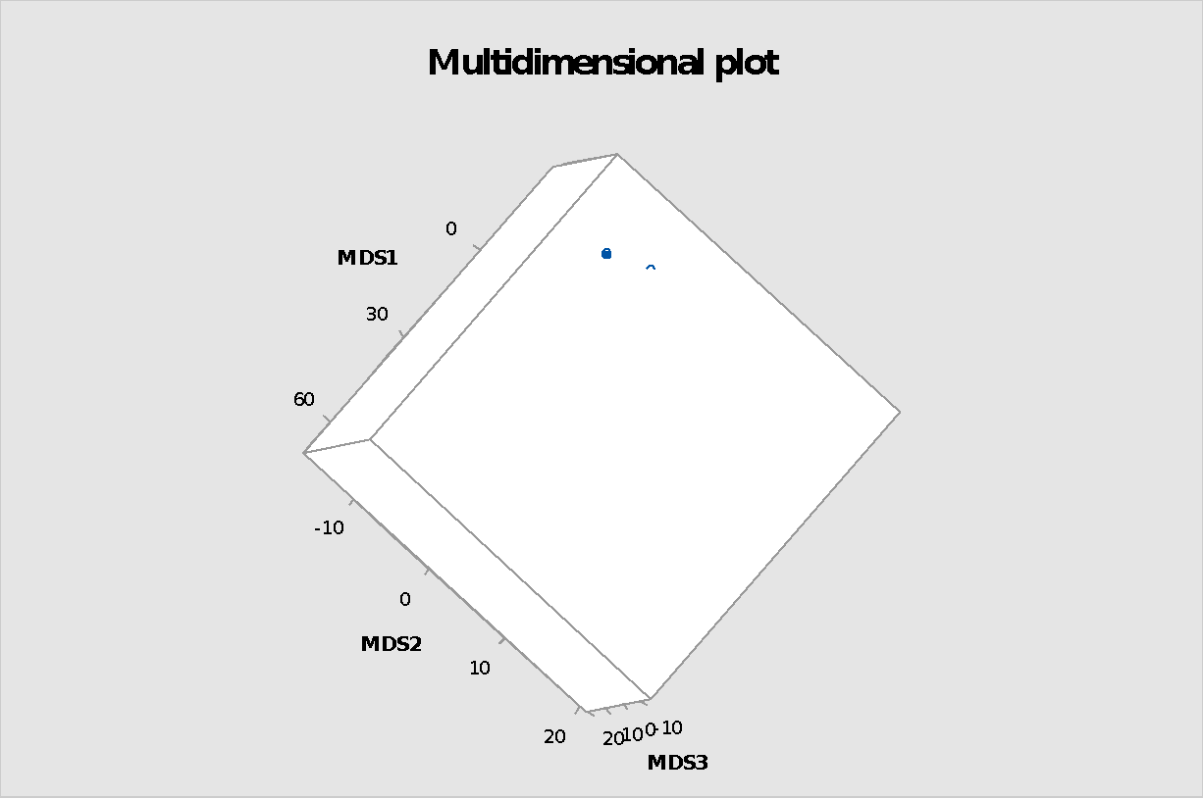
Fig- 8: The only angle of 3D-Multidimensional scale plot which clearly differentiates the cheese types
Observation: Bottom 5 points which clearly separates from the other clusters are:
- Row 24- Type Emmental
- Row 13- Esrom
- Row 21- Limburger
- Row 19- Brie
- Row 20- Camembert
NOTE: On comparing MDS analysis with Cluster analysis, which uses a different approach to classify the data, but obtain similar results.
Compare Figure of Clustering with Figure in MDS Plot, because they represent different ways of looking at the same data. Cluster analysis is a type of classification technique, in which the objective is to arrange objects into groups. MDS is a form of ordination, in which objects are arranged along continuous axes. A combination of both methods, when applied to the same dataset, proves to be a powerful visualization tool.

3.3. PRINCIPAL COMPONENT ANALYSIS:
R Code:
pcadata= data_1[,-2]
pca= princomp(pcadata, cor= TRUE)
summary(pca)

In the output we get ‘Importance of components’ table, in which the Cumulative Proportion row, we see that by the time we have reached Component 3 we have accounted for over 67% of the original variation in the data. This is good, as we have reduced our original 17 variables to three that account for much of the variation. But as with our multidimensional scaling analysis, we now have to interpret these synthetic variables. As before, we do this by computing correlations between the principal components and the original variables. The principal components are “scores” of each individual object (cheese type) computed as linear combinations of the original variables to produce component 1, component 2, etc.

R Code:
pca1 <- pca$scores[,1]
pca2 <- pca$scores[,2]
pca3 <- pca$scores[,3]
cheesepca=cbind(pca1,pca2,pca3,pcadata)
round(cor(cheesepca), digits=3)
plot(pca1, pca2, main="Figure: Principal +components plot, Types of Cheese data.", +cex.axis=1.5, cex.lab=1.5)
text(pca1, pca2, labels=cheeseType, pos=3)

Observing first 24 rows and 3 columns from the output, we find, as pca2 and pca3 increases, values of the properties decreases gradually. Moreover pca1 have a mixture of positive and negative correlations with the original data, usually interpreted as differing aspects of an underlying “shape” factor. The axes are ranked according to importance so plotting PCA1 vs PCA2.
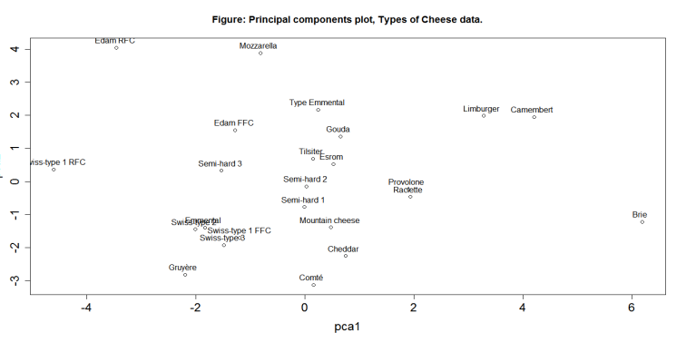
Fig- 9: Principal Component plot for types of cheese data.
Interpretation: Clearly we see Edam RFC, Swiss type 1 RFC to be one kind, then Limburger, Camembert is one, Brie is totally different from others. In particular, Swiss type-1 RFC cheeses are very different from Brie cheeses and (Gruyere, Comte) that from (Edam RFC, Mozzarella)

4. CONCLUSIONS/FINAL REPORT:

- Three multivariate methods, namely cluster analysis, multidimensional scaling and principal component analysis, were used to classify and analyze the data containing 24 varieties of cheese.
- No missing data was found.
- Now answering the questions raised in section 1.1., based on our analysis;
Answer(A): Boxplots were obtained, differentiating cheese types based on their texture with respect to group 1 and 2 variables. (For further details refer to Section 4.c., page numbers 10-11 containing plots and consequent interpretations)
Answer(B): The different types of cheese have been characterized into groups using 3 methods; cluster analysis, multidimensional scaling and principal component analysis. We mainly found the following groups:
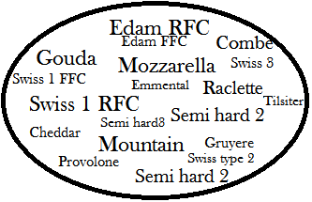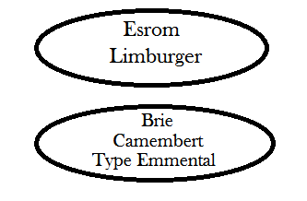
Fig- 10: These are the three classification of cheeses where the leftmost cluster contains edible cheeses but at the same time most difficult to preserve.

- Cluster 1 contains the types of cheese that have a lot of protein, high pH level and low amount of moisture as well as moisture in dry state and least water soluble nitrogen.
- Cluster 2 contains the types of cheese that have high amount of moisture, moisture in dry state and low fat content, fat in dry matter.
- Cluster 3 contains the types of cheese that have maximum amount of water-soluble nitrogen, fat, fat in dry matter, and moisture in non-fat substance.
From the above interpretation of clustering based on group 1 variables, we obtain Cluster 1 cheese are more edible to eat compared to other cluster of cheeses but it will be most difficult to preserve them for long time due to low water-soluble nitrogen level.
Next, to know if the cheese types that are similar in terms of their general properties also tend to be similar in terms of thermophysical properties, the answer is negative. We used mantel test, section 3.1.1., found the cheese types that are similar in terms of group_1 variables do not tend to be similar in group_2 (thermophysical) variables.
Answer(C): Yes, variables of general properties and thermophysical properties were found to be correlated using principal component analysis. Moreover, a reduction of the analyzed parameters to three principal components was found, accounting for 76.3% of the total variation, indicating that the methods are well suited to characterize the cheese samples.
- This study will support cheese producers to design new products with specified characteristics by influencing the manufacturing protocol. Also it will help cheese dealers to decide whether to buy a new variety of cheese produced in the market.

- In the future, one can use this study to build prediction models based on the clusters mentioned above.
REFERENCES

- Schenkel, P., Hartmann, K. I, Samudrala, R., & Hinrichs, J. (2014). Characterization of Commercial Cheese Regarding Thermophysical Properties and Application of Multivariate Statistical Analysis to Elaborate Product Mapping. Journal of texture studies, 45, 440-451.
- JoHNSoN, R. W. DW (1992). Applied Multivariate Statistical Analysis. Editorial Prentice Hall. New Jersey.
- Sanders, G. P., Farrar, R. R., Hardell, R. E., Feutz, F., & Burkey, L. A. (1940).The relationship of moisture in Swiss cheese to quality and yield. Journal of Dairy Science, 23(9), 905-918.
- Manly, B. F., & Alberto, J. A. N. (2016). Multivariate statistical methods: a primer.CRC press.
- Gunasekaran, S., & Ak, M. M. (2002). Cheese rheology and texture. CRC press.
- Fife, R. L., McMahon, D. J., & Oberg, C. J. (2002). Test for measuring the stretchability of melted cheese. Journal of dairy science, 85(12), 3539-3545.
- https://dzone.com/articles/andrews-curves
- http://sfb649.wiwi.huberlin.de/fedc_homepage/xplore/tutorials/mvahtmlnode9.html
- http://www.sthda.com/english/wiki/scatterplot3d-3d-graphics-r-software-and-data-visualization
- https://richardlent.github.io/post/multivariate-analysis-with-r/
- https://www.datamentor.io/r-programming/box-plot/
- https://www.decisionanalyst.com/whitepapers/multivariate/
- https://en.wikipedia.org/wiki/Dynamic_modulus#Storage_and_loss_modulus
- https://www.researchgate.net/figure/Effect-of-temperature-on-the-storage-modulus-a-and-loss-tangent-b-of-Cheddar-cheese_fig1_9082726

