Real-Time Virtual Mouse System using Hand Tracking Module based on Artificial Intelligence

Akash Singh Galgotias University Greater Noida, India
akash_singh.bcamscse@galgotiasuniversity.edu.in
Trapti Upadhyay Galgotias University Greater Noida, India
trapti_upadhyay.bcamscse@galgotiasuniversity.edu.in
Shreya Bhatt Galgotias University, Greater Noida, India
shreya_bhatt.bcamscse@galogiasuniversity.edu.in

Abstract–
The PC mouse is one of the wondrous developments of people in the field of Human-Computer Interaction (HCI) innovation. In this study, we will use a brand-new technique for replacing current mouse technology using a live camera to control mouse movement virtually. Two typical methods include increasing the number of buttons or moving the tracking ball on the mouse. Instead, we advise redesigning the hardware. To virtualize mouse tasks, we propose using a camera and computer vision technologies, and we show how it can do all the functions offered by current mouse devices. The creation of a mouse control system is demonstrated in this project.
In the proposed AI virtual mouse system, this limitation can be overcome by using a webcam or a built-in camera for capturing hand gestures and hand tip recognition using computer vision. The algorithm used in the system uses the machine learning algorithm. Based on hand gestures, the computer can be virtually controlled and perform left-click, right-click, scrolling, and computer cursor functions without using the physical mouse. The algorithm is based on deep learning to recognize hands.

Keywords-Hand-Tracking, Virtual Mouse, Image Capture, Masking, Virtualization, Enhancement, Normalization.

- INTRODUCTION
Hand gestures, which are a universally accepted language, are the most efficient and expressive mode of human communication. It is sufficiently expressive that the deaf and dumb can understand it. A hand gesture system is proposed in this paper. The experimental setup of the system employs a fixed position low-cost web camera high-definition recording feature mounted on the top of a computer monitor or a fixed camera on a laptop, which captures snapshots from a fixed distance using Red Green Blue [RGB] colour space. Image preprocessing, region extraction, feature extraction, and feature matching are the four stages of this work. One of the most difficult issues in communicating with dump and deaf people is the recognition and interpretation of sign language. Based on preprocessing, background subtraction, and edge detection techniques, an effective hand gesture segmentation technique has been proposed in this project. Pre-processing is the process of preparing data for another process. The primary goal of the preprocessing process is to convert the data into a format that can be processed more effectively and easily. The proposed work develops pre-processing techniques based on various types of combinations from subsequent hand gesture image processing operations such as image capture, noise removal, background subtraction, and edge detection, and these image processing methods are discussed below.
Initially, the vision-based camera captures images of hand gestures. Hand gestures can be observed using various interfaces such as "data gloves," which accurately record every abduction angle and digit, as well as position sensors for wrists and optical orientation or electromagnetic, which require the user to wear trackers or gloves. Typically, glove-based interfaces require the user to be attached to the computer, all of which reduces time to user comfort and interface, whereas vision-based interfaces provide unencumbered human interaction.
The goal of this paper is to develop a free hand recognition software for laptops and PCs with webcam support. The project includes a hand recognition tool that can be used to move the mouse pointer, perform simple operations such as clicking, and other hand gesture operations such as moving files from computer to computer via delicate socket programming and performing simple but fascinating operations that can be covered by hand recognition.
- RELATED WORK

The existing system consists of a generic mouse and trackpad system for controlling monitors and the absence of a hand gesture system. Remote access to the monitor screen via hand gesture is not possible. Despite the fact that it is largely attempting to implement the scope is simply limited in the field of virtual mouse. The existing virtual mouse control system consists of basic mouse operations performed using a hand recognition system, such as mouse pointer control, left click, right click, drag, and so on. The hand recognition system has not been used further. Although there are several systems for hand recognition, the system they used is static hand recognition, which is simply a recognition of the shape made by hand and by defining an action for each shape made, which is limited to a few defined actions and causes a lot of confusion.

Even though there are a number of quick access methods for the hand and mouse gesture for laptops, using our project we could use the laptop or web-cam and by identifying the hand gesture we could control the mouse and perform basic operations like mouse pointer controlling, select and deselect using left click, and a direct access feature for transferring files between systems connected via network LAN cable. The completed project is a "Zero Cost" hand
recognition system for laptops that uses simple algorithms to determine the hand, hand movements, and assign an action to each movement. However, we have primarily focused on mouse pointing and clicking actions, as well as a hand action and movement action for file transfer between connected systems. The system we are implementing, which is written in Python code, is much more responsive and easier to implement because Python is a simple language that is platform independent, flexible, and portable, which is desirable in creating a program that is focused on creating a Virtual Mouse and Hand Recognition system. By defining actions for the hand movement for performing a specific action, the system becomes much more extendable. It could be further tailored to any extent by implementing such actions for the set of hand gestures, the only limit is your imagination.

This Virtual Mouse Hand Tracking application uses a simple colour cap on the finger to control the cursor using simple gestures and hand control without the need for additional hardware. This is accomplished through the use of vision-based hand gesture recognition with input from a webcam.
- METHODOLOGY
The method used in each component of the system will be explained separately in the Methodology. They are organized as follows:

- Camera Settings:
The webcam on the connected laptop or desktop controls the runtime operations. To record a video, we must first create a Video Capture object. It accepts either the device index or the name of a video file as an argument. A device index is simply a number that indicates which camera is being used. We pass it as '0' because we only use one camera. We can add more cameras to the system and pass them as 1, 2, and so on.
After that, you can capture frames one by one. But don't forget to release the capture at the end. We could also apply color detection techniques to any image by making minor changes to the code.
- Masking Technique:
The mask basically creates a specific region of the image according to certain rules. In this example, we're making a mask out of a red object. Following that, we perform a bitwise AND operation on the Input and Threshold images, highlighting only the red-colored objects. The outcome of the AND operation is saved in res. We then use the imshow() function to display the frame, res, and mask on three separate windows.

- Capturing Frames:
The infinite loop is used to ensure that the web camera captures frames in every instance and remains open throughout the program. Frame by frame, we record the live feed stream as shown in figure-1.
Then, for each captured frame that is in RGB (default) color space, we convert it to HSV color space. OpenCV includes more than 150 color-space conversion methods. However, we will only look at two of the most commonly used ones, BGR to Gray and BGR to HSV.

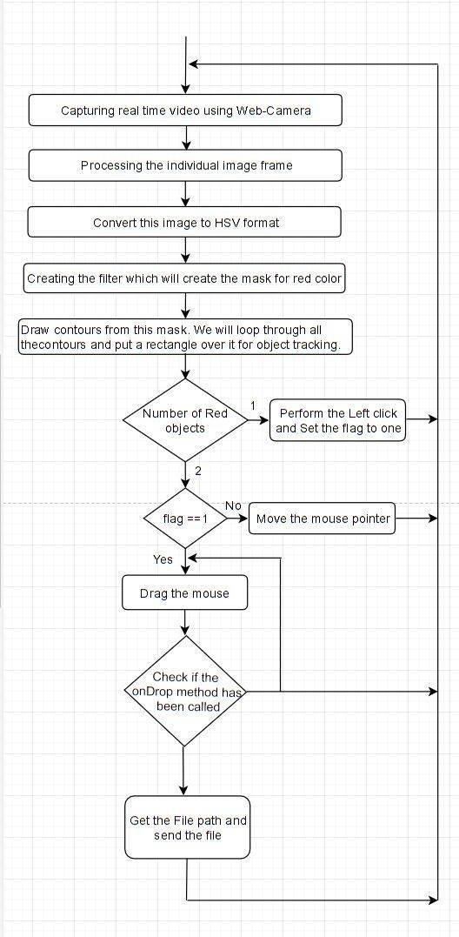
Fig-1: Hand Tracking Process Flowchart
- Display the Frame:
The imShow() function of HighGui is required to call the waitKey on a regular basis. The imshow() function's event loop is processed by calling waitKey. The function waitKey() waits for a key event for a "delay" (here, 5 milliseconds). High Gui handles Windows events such as redrawing, resizing, and input events, among others. Even with a 1ms delay, we call the waitKey function.
- Mouse Movement:
We must first calculate the center of both detected red objects, which we can easily do by averaging the maximum and minimum points of the bounding boxes. We now have two coordinates from the centers of the two objects, which we will average to get the red point shown in the image. The detected coordinate from the camera resolution is converted to the actual screen resolution. The location was then set as the mouse position. However, moving the mouse pointer will take some time. As a result, we must wait until the
mouse pointer reaches that point. So, we started a loop and are just waiting to see if the current mouse location is the same as the assigned mouse location. That's an open gesture.
- Clicking:
The next step is to put the close gesture into action. The operation is carried out by clicking and dragging the object. It is similar to the open gesture, but the difference is that we only use it once. We only have one object here, so we only need to compute its center. And that will be placed in the area where we will be placing our mouse pointer rather than mouse release, we will be carrying out a mouse press operation.
- Drag:
To implement the dragging, we introduce a variable called 'pinchflag.' If it was previously clicked, it will be set to 1. So, whenever we find the open gesture, we check to see if the pinchflag is set to 1. If it is set to one, the drag operation is carried out; otherwise, the mouse move operation is carried out.
- DISCUSSION / RESULT ANALYSIS
In this paper, we attempted to focus on assisting patients who lack control of their limbs while also improving the interaction between the machine and humans. Our goal was to develop this technology as cheaply as possible while also using a standardized operating system.
The proposed system detects red to control mouse pointer functions and performs mouse functions such as left click, dragging, cursor movement, and file transfer between two systems on the same network. This method finds red-colored objects for mouse control. For improved performance, the user employs red-colored objects on their finger tip. When the number of contours is two, the simple mouse movement action is performed. Otherwise, if the number of contours is one, the left click is performed.
This system is mainly aimed to reduce the use of hardware components attached with the computer. Although the application can be run in a ordinary computer having a web camera. but ideally it requires having at least 2MP frontal camera with at least Pentium processor and at least 256 MB RAM. We can see these all operations on the following images:

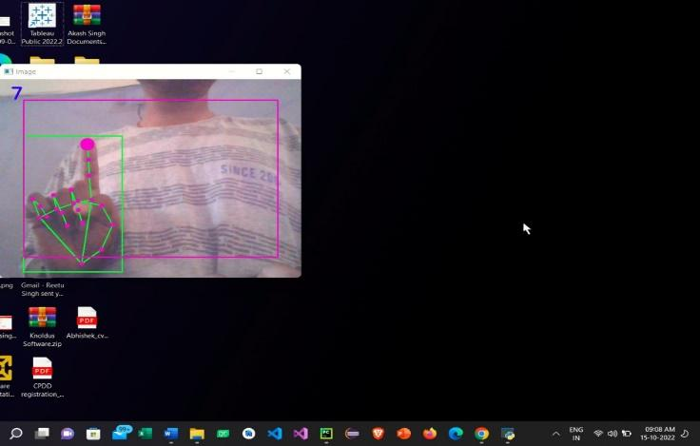

Fig-2: Moving the mouse pointer

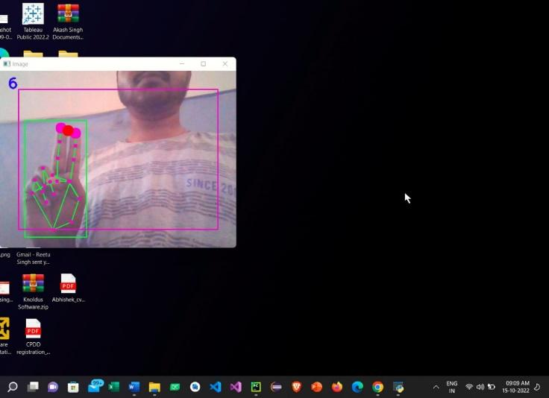

Fig-3: Performing left click

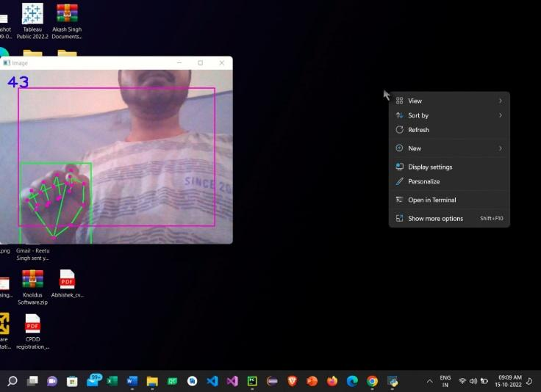

Fig-4: Performing right click
- CONCLUSION
Gesture recognition provides the best human-machine interaction. Gesture recognition is also important for creating new human-computer interaction modes. It allows humans to interact with machines in a more natural manner. Gesture recognition has many applications, including sign language recognition for deaf and dumb people, robot control, and so on.
This technology has a wide range of applications, including augmented reality, computer graphics, computer gaming, prosthetics, and biomedical instrumentation. Digital Canvas is an extension of our system that is gaining popularity among artists, in which the artist can create 2D or 3D images using the Virtual Mouse technology and a Virtual Reality kit or a monitor as a display set.
This technology can be used to assist patients who are unable to control their limbs. In computer graphics and gaming, this technology is used in modern gaming consoles to create interactive games in which a person's motions are tracked and interpreted as commands.
This work can be greatly expanded to make the system work in more complex environments and under different lighting conditions. It can be designed as an effective user interface that includes all mouse functions. Furthermore, it would be ideal to conduct research on advanced mathematical materials for image processing as well as investigate various hardware solutions that would result in more accurate hand detections. This project not only demonstrated the various gesture operations that users could perform, but it also demonstrated the potential for simplifying user interactions with personal computers and hardware systems.
- REFERENCE
- Q. Y. Zhang, F. Chen, and X. W. Liu, "Hand Gesture Tracking and Fragmentation Based on Difference Background Image with Intricate Background," Deliberations of the 2008 International Conference on Embedded Technology and Systems, Sichuan, 29-31 July 2008, pp. 338-343.
- Neethu, angel. P.S., "Real-Time Static and Dynamic Hand Gesture Control," International Journal of Scientific and Engineering Research, Volume 4, Issue 3, March 2013.
- Figure - 1, “Hand Tracking Process Flowchart”, https://www.section.io/engineering-education/creating-a-hand-tracking-module/
- “Real time hand tracking module” - shorturl.at/pxHOX

