A Portable Self-Sustaining Sun-Free Plant Habitat
R. Tharun¹, K.G. Padmasine²
^{1,2}Department of Electronics and Instrumentation, Bharathiar University, Coimbatore-641046, Tamil Nadu, India
---------------------------------------------------------------------***---------------------------------------------------------------------
Abstract - This system involves designing and building a self-sustaining plant habitat that can sustain plant growth indoors without relying on sunlight. The system is designed to be portable and self-contained, providing the necessary environmental conditions for plant growth, including temperature, humidity, soil moisture, and lighting. The lighting system uses LED lights to provide the necessary spectrum of light for photosynthesis, with the specific spectrum and intensity adjusted based on the plant species and growth stage. The aim is to create a self-contained and portable solution for indoor plant growth that does not require natural sunlight. Such a system could be useful for people who want to grow plants indoors but do not have access to a suitable window or outdoor space or for growing plants in environments where natural light is limited.

Key Words: portable plant habitat, self-sustaining, sun-free,
Indoor plant growth, autonomous agriculture, portable, spectrum LED.

1. INTRODUCTION

In recent years, there has been a growing interest in indoor and urban gardening. However, traditional gardening methods can be limited by factors such as space, sunlight, and access to water. A portable self-sustaining sun-free plant habitat offers a solution to these challenges, providing a compact and versatile way to grow plants indoors or outdoors without relying on sunlight or external energy sources.
This project aims to design and build a self-sustaining plant habitat that can provide the necessary resources for plant growth, including water and nutrients, in a compact and portable design (Chang,2017). The habitat will be designed to support a variety of plant species and optimized to ensure maximum plant health and yield. The project will also include the development of educational materials to help users understand how to use and maintain the habitat for long-term use.

2. DESIGN

The habitat is designed to be portable, self-contained, and easy to set up (Bubenheim,2018). The system consists of a control unit, temperature, humidity, and soil moisture sensors, an adaptative LED spectrum light, a water recirculation system, a thermoelectric cooler and a power source. The control unit manages the environmental conditions of the habitat and ensures that the temperature, humidity, and soil moisture levels remain within optimal ranges for plant growth (Smith, A. ,2018). The adaptative LED spectrum light provides light that is tailored to different types of plants, maximizing their growth potential. The water recirculation system includes a water reservoir, a pump, and a nutrient solution. The pump circulates the water and nutrient solution through the plant roots, providing a continuous supply of water and nutrients. The power source consists of a combination of solar panels and a battery backup, which allows the system to operate in areas with limited sunlight.

3. BLOCK DIAGRAM

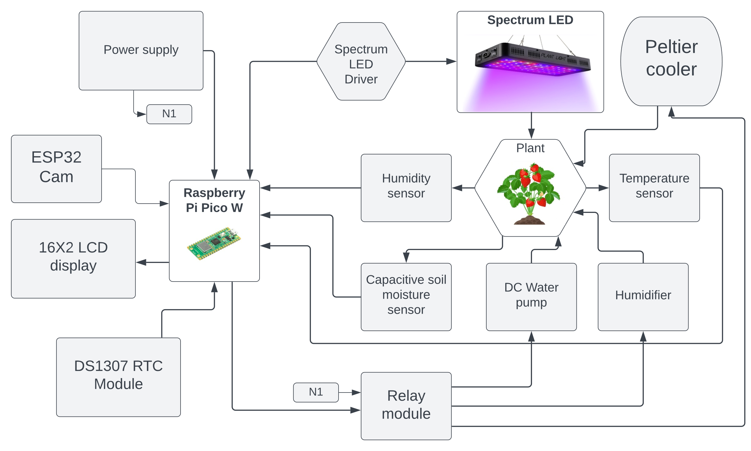
Fig -1: Block-Diagram of the chamber

4. SYSTEM CONTENT
4.0-Raspberry Pi Pico W
The Raspberry Pi Pico is a microcontroller board based on the RP2040 chip, designed by Raspberry Pi Foundation. It features a dual-core ARM Cortex-M0+ processor, 264KB of RAM, and various I/O options such as SPI, I2C, and UART. The Pico can be programmed using Micro Python or C/C++ and can be used for a wide range of applications, including robotics, automation, and Internet of Things (IoT) devices. The "W" variant of the Pico includes built-in Wi-Fi connectivity, making it even more versatile and suitable for wireless applications.
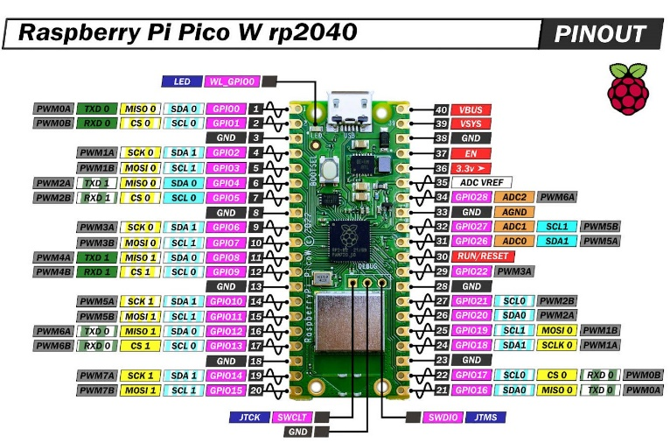
Fig -2: Raspberry pi Pico W pinout
4.1-Spectrum LED
Spectrum LED lighting can be used to enhance plant growth in indoor environments where natural sunlight may be limited or not available. Different colors or wavelengths of light emitted by spectrum LEDs have varying effects on plant growth, depending on the type of plant and stage of growth. For example, blue light can promote vegetative growth and help plants produce more leaves, while red light can encourage flowering and fruiting. Far-red light can promote stem elongation and control the timing of flowering. Spectrum LED lighting allows indoor growers to customize the light spectrum to optimize plant growth, improve crop yields, and control plant quality. It is energy-efficient, long-lasting, and easily controllable, making it a popular choice for indoor horticulture.
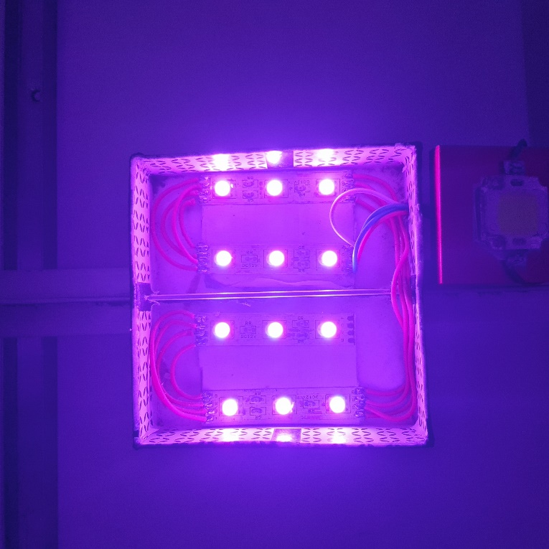
Fig -3: Spectrum-LED
4.2-WAVELENGTH
- Blue (400-500 nm): Blue light is important for promoting vegetative growth and can help plants produce more leaves. It is also essential for regulating plant growth and development, including the opening and closing of stomata.
(Van Iersel, M. W. 2019)

- Green (500-600 nm): Green light is not as effective in promoting plant growth, as it is primarily reflected by plant leaves rather than absorbed. However, it can still play a role in photosynthesis and contribute to overall plant health.

- Red (600-700 nm): Red light is essential for promoting flowering and fruiting, as well as stem elongation. It can also increase the production of plant pigments and antioxidants, improving overall plant health.

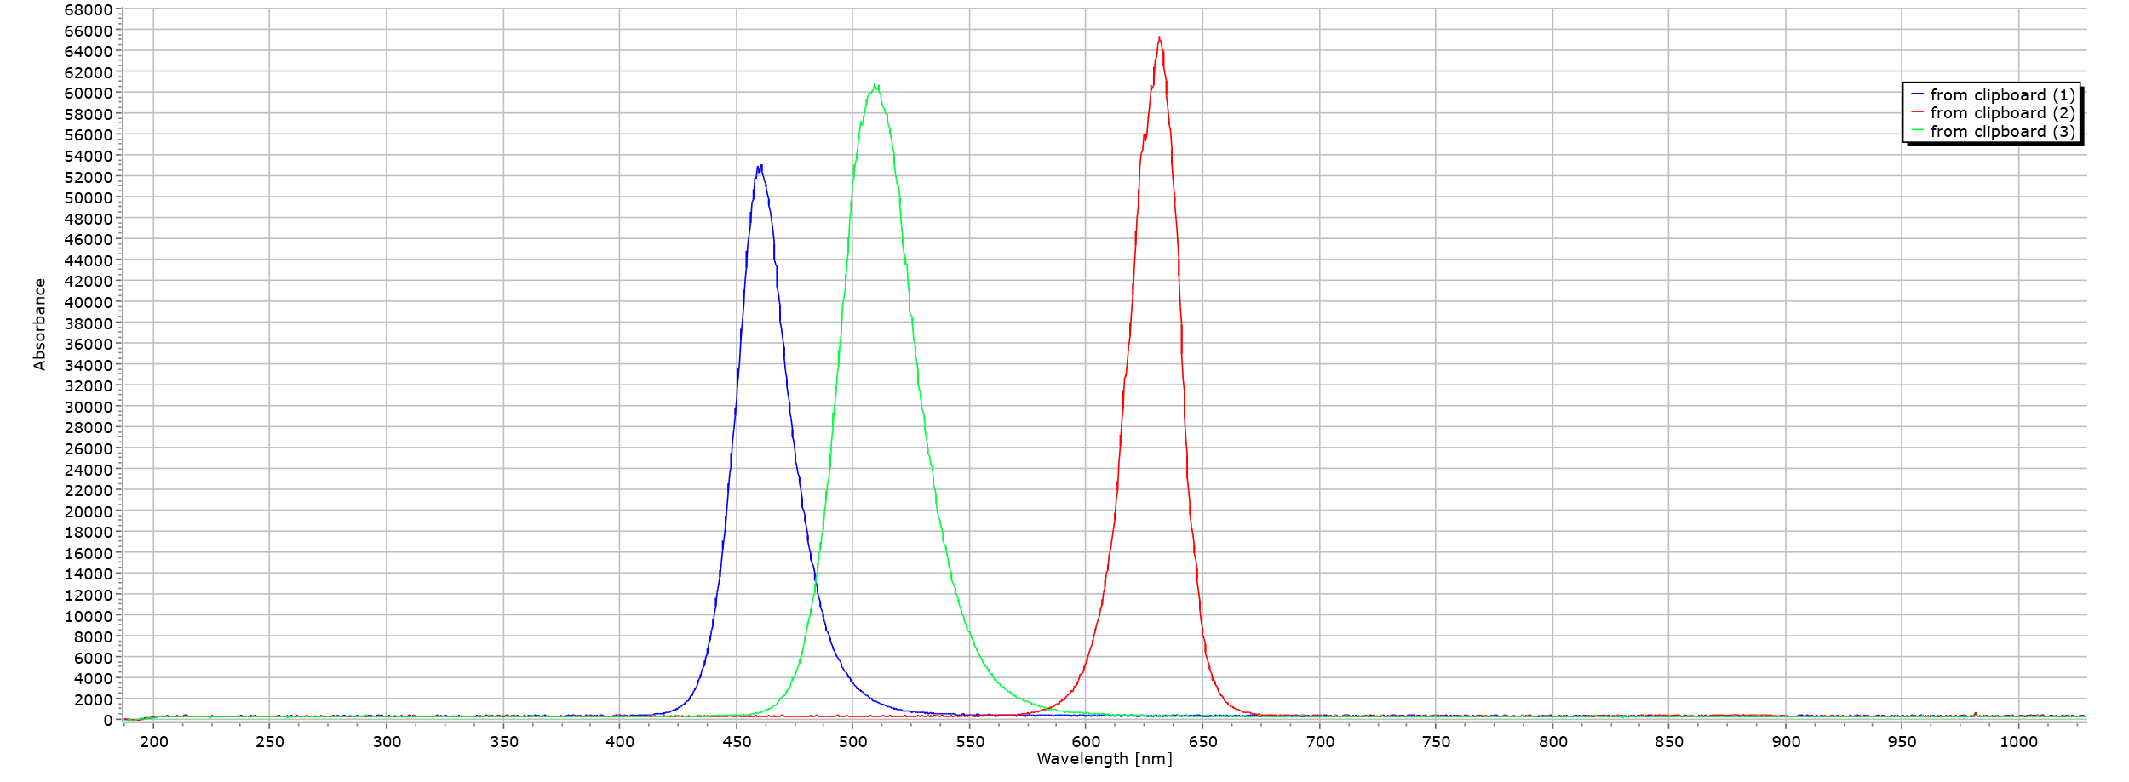
Fig -4: Spectrum-LED Wavelength
4.3-DHT11 MODULE
DHT11 sensor consists of a capacitive humidity sensing element and a thermistor for sensing temperature. The humidity sensing capacitor has two electrodes with a moisture holding substrate as a dielectric between them. Change in the capacitance value occurs with the change in humidity levels. The IC measure, process this changed resistance values and change them into digital form.
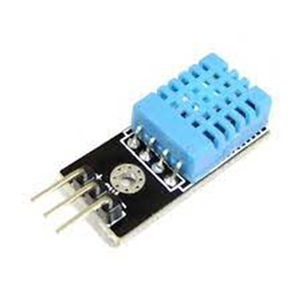
Fig -5: Humidity Sensor
The temperature range of DHT11 is from 0 to 50 degree Celsius with a 2-degree accuracy. Humidity range of this sensor is from 20 to 80% with 5% accuracy. The sampling rate of this sensor is 1Hz.i.e., it gives one reading for every second. DHT11 is small in size with operating voltage from 3 to 5 volts. The maximum current used while measuring is 2.5mA.

5. METHODOLOGY
- Alpine strawberry variety is selected to grow inside the self-sustaining chamber. This is one of the popular varieties for indoor cultivation.
- A suitable growing medium has prepared, such as red soil mix. The medium should be well-draining and nutrient-rich.
- Strawberry runners are planted in the prepared growing medium.
- Adequate lighting has Provided for the plant. Strawberry plants require at least 8-10 hours of
sunlight per day.
- Proper temperature and humidity levels are maintained. Strawberry plants prefer a cool, moist environment, with temperatures around 60-75°F (15-23°C) and humidity levels around 60-70%.
- The plant is watered regularly with the help of soil moisture sensor whenever the moisture level decreases the required amount of water will be poured. The growing medium should be moist but not waterlogged, as this can cause root rot.
- Plants are fertilized with a balanced level, water-soluble fertilizer every 2-4 weeks, or as needed.
- Plants are monitored for pests and diseases, and took appropriate measures to control them if necessary. Common pests that can affect strawberry plants include aphids, spider mites, and whiteflies, while common diseases include powdery mildew and gray mold.
- By following these basic steps, strawberry plant has been successfully grown inside the self-sustaining plant habitat. Remember to be patient and attentive to the needs of your plants, and don't hesitate to seek out additional resources or advice if needed.

6. RESULT
The "Portable Self-Sustaining Sun-Free Plant Habitat" was successfully designed and constructed to provide an indoor growing environment for plants, including strawberries, without the need for sunlight. The habitat consisted of a chamber made of aluminum channels, a spectrum LED lighting system, a Raspberry Pi Pico microcontroller, and sensors for monitoring temperature, humidity, and soil moisture.
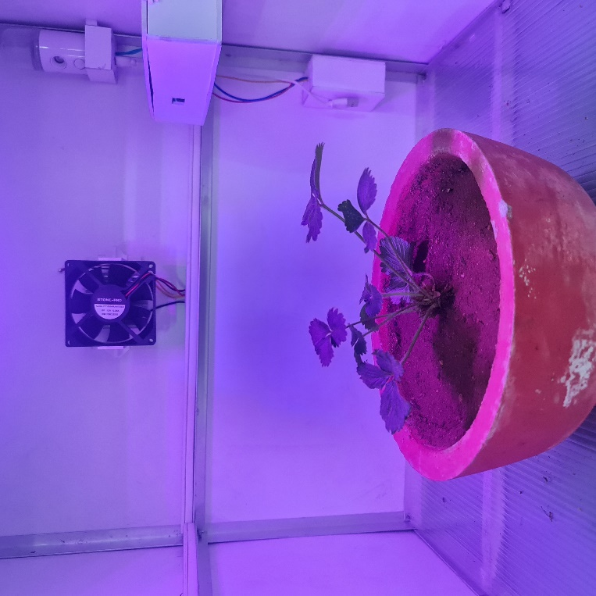
Fig -6: Alpine strawberry inside the chamber
Using the Raspberry Pi Pico microcontroller, we were able to automate the monitoring and control of the environmental parameters needed for growing strawberries, including temperature, humidity, and soil moisture. By doing so, we were able to maintain optimal growing conditions for the plants without the need for human maintenance.
7. DISCUSSION
The "Portable Self-Sustaining Sun-Free Plant Habitat" presents an innovative solution for indoor agriculture by providing an environment for growing plants, including strawberries, without the need for sunlight. This type of system has the potential to address the challenges of growing crops in areas with limited access to sunlight, such as urban areas, and could help to increase access to fresh produce in these areas.
One of the key advantages of this system is the use of the Raspberry Pi Pico microcontroller to automate the monitoring and control of the environmental parameters needed for plant growth. This eliminates the need for human maintenance and allows for remote monitoring and control of the system. The system is also portable, making it ideal for indoor gardening in small spaces such as apartments or homes with limited outdoor space.
However, it is important to note that there are limitations to this type of system. For example, the LED lighting system used in the "Portable Self-Sustaining Sun-Free Plant Habitat" may not provide the full spectrum of light that plants require for optimal growth. Additionally, some plants may have specific environmental requirements that cannot be met by this system.
Overall, the "Portable Self-Sustaining Sun-Free Plant Habitat" presents an exciting and innovative solution for indoor agriculture, and further research and development of this type of system could help to increase access to fresh produce in areas with limited access to sunlight.
8. CONCLUSION
In conclusion, the "Portable Self-Sustaining Sun-Free Plant Habitat" represents an exciting and innovative approach to indoor agriculture. By providing a controlled growing environment for plants without the need for sunlight, this system offers a sustainable and efficient solution for growing crops indoors.
The Raspberry Pi Pico microcontroller plays a crucial role in automating the monitoring and control of environmental parameters required for optimal plant growth. Its ability to maintain optimal growing conditions without the need for human intervention makes the system ideal for indoor gardening in small spaces.
While there are limitations to this type of system, such as the lack of full-spectrum light provided by the LED lighting system, the successful growth of strawberries using the "Portable Self-Sustaining Sun-Free Plant Habitat" demonstrates its potential for growing a variety of crops indoors without sunlight.
Overall, the "Portable Self-Sustaining Sun-Free Plant Habitat" has the potential to contribute to sustainable and efficient indoor agriculture practices, and further research and development in this area could have significant implications for addressing food security challenges in the future.
9. REFERENCE
- "Design and Development of Fully Automated Indoor Farming" by M. Ashraful Islam, Andrew G. Alleyne, and Bruce Y. L. Chang. Journal of Aerospace Engineering, vol. 30, no. 1, 2017.
- "An Artificial Ecosystem for a Mars Greenhouse: Design and Modelling" by Giovanni Minuto, et al. Life, vol. 7, no. 2, 2017."Design and Testing of a Portable Plant Growth System for Use in Microgravity" by David Bubenheim, et al. Life Sciences in Space Research, vol. 16, 2018, pp. 15-23.
- Van Iersel, M. W. (2019). Optimizing plant growth with LED lighting: spectra, intensity, and photoperiod. Scientia Horticulturae, 257, 108735.
- Smith, A. (2018). Using sensors to monitor plant growth. Canadian Journal of Plant Science, 98(4), 763-769.

