WAREHOUSE MANAGEMENT AND INVENTORY CONTROL

Divya Sri L¹, Mohamed Fareeth F², Mohamuda Rila M A³, Murali Kumar R⁴

^{1,2,3,4}UG Student, Department of Computer Science and Engineering
Nandha Engineering College, Erode-52.
Email id: divyasri0401@gmail.com¹, fareethfare@gmail.com², mohamudarila18@gmail.com³ ,
rmuralikumar136@gmail.com⁴

Abstract— In today’s competitive world, it is important for vendors to have a website where the goods can be maintained online. A warehouse management system is designed and developed to permit a purchaser to deliver online orders for items and services from a store that work for both in-person customers and online shoppers. The warehouse management system is an organization that maintains our raw materials. Raw materials include wood, fabric, leather, glass, cane, plastic, stainless steel, metals, and mica. The raw material section is broadly classified into two categories: type of material (raw) and type of section. This type of section is further divided into delivery and packing sections. This unit also comprises the Stock Maintenance Section, Staff Management, Labor Scheduling, Recycle Section, and Return Section. Staff management involves employee details (attendance, salary). Scheduling labor encompasses cutting, laminating, stitching, finishing, bending, designing, packing, and checking. Stock Maintenance Section is built in with two varieties, such as Interior Furniture Varieties and Exterior Furniture Varieties.

Keywords : Warehouse management, Stock maintenance,
Furniture.

- INTRODUCTION

In contemporary world, it is important for vendors to have a website where the goods can be maintained online. A warehouse management system is designed and developed to permit a purchaser to deliver online orders for items and services from a store that work for both in-person customers and online shoppers. The warehouse management system is an organization that maintains our raw materials. Raw materials include wood, fabric, leather, glass, cane, plastic, stainless steel, metals, and mica. The raw material section is broadly classified into two categories: type of material (raw) and type of section. This type of section is further divided into delivery and packing sections. This unit also comprises the Stock Maintenance Section, Staff Management, Labor Scheduling, Recycle Section, and Return Section. Staff management involves employee details (attendance, salary). Scheduling labor encompasses cutting, laminating, stitching, finishing, bending, designing, packing, and checking. Stock Maintenance Section is built in with two varieties, such as Interior Furniture Varieties and Exterior Furniture Varieties.
II. LITERATURE SURVEY
Furniture manufacturing is a complex process that involves various stages, from designing to production and distribution. A warehouse management system (WMS) is a software solution that enables organizations to manage their warehouse operations, including inventory control, receiving of raw materials, and other related tasks. Over the years, several studies have been conducted to understand the benefits of WMS and its impact on overall supply chain management.
This literature survey summarizes some of the key findings from various studies on warehouse management systems.

- Optimizing Inventory Levels in Furniture Retail Supply Chains

This study aimed to optimize inventory levels in furniture retail supply chains using simulation-based methods. The authors developed a simulation model of a furniture retailer's supply chain and used it to test different inventory control policies. They found that a combination of demand forecasting and inventory control policies could significantly reduce inventory holding costs and improve service levels.

- Warehouse Management

This book provides a strategic approach to warehouse management, covering topics such as the role of warehouses in the supply chain, facility design and layout, inventory management, and order fulfillment. It also includes case studies and examples from leading companies.

- A review of Industry 4.0 technologies for furniture manufacturing

This review by Cano et al. (2019) discusses the potential of Industry technologies[4.0] , such as the Artificial Intelligence , and Robotics and the Internet Of Things in these furniture manufacturing industry.

The authors highlight the importance of a well-designed furniture manufacture unit system that integrates these technologies to improve efficiency and reduce costs.

- Modest Warehouse Management

This book provides a comprehensive overview of warehouse management, covering topics such as facility design, inventory management, order processing, and performance measurement. It also includes case studies and best practices from leading companies.

- Warehouse Management and Inventory Control

This book provides a detailed analysis of warehouse management and inventory control, including planning and forecasting, receiving and put away, picking and shipping, and cycle counting. It also covers the role of information technology in warehouse management.

- Modern Warehouse Management

This comprehensive guide provides a detailed overview of warehouse management, including layout design, inventory management, order picking, and shipping. It also covers various technologies and tools that can be used to optimize warehouse operations.

- Warehouse Management Handbook

This handbook provides an in-depth examination of warehouse management, including facility design, automation, labor management, and performance measurement. It also includes case studies and best practices from leading warehouse operators.

- Lean manufacturing in furniture production

The paper by the Kaminski et al. (2015) discusses the application of lean manufacturing principles in the furniture industry. The authors highlight the importance of a well-designed furniture manufacture unit system that is based on lean manufacturing principles to improve efficiency and reduce waste.

- Warehouse Management with SAP ERP

This book provides a detailed overview of warehouse management using SAP ERP, covering topics such as warehouse organization, master data, inbound and outbound processes, and inventory management. It also includes practical examples and case studies.

- The Warehouse Management using the Microsoft Dynamics AX 2012 R3"

This book provides a practical guide for the warehouse management with making use of the Microsoft Dynamics AX 2012 R3. It covers topics such as warehouse configuration, inventory management, order processing, and reporting.

- Challenges in Implementing WMS

A study by Shih and Lin (2008) identified several challenges that organizations face when implementing WMS, including high implementation costs, resistance from employees, and difficulties in integrating WMS with existing systems. The study suggested that organizations need to carefully plan the implementation process and provide adequate training to employees to overcome these challenges.

- Impact of WMS on Inventory Management

A study conducted by Tan and Kannan (2002) found that WMS can significantly improve inventory accuracy, reduce stockouts, and increase customer satisfaction. The study also highlighted that implementing WMS can lead to a reduction in inventory holding costs.

- A study on furniture manufacturing process with the application of Lean principles

This study by Sabra et al. (2016) inspects the impact of lean principles on furniture manufacturing processes. The authors conducted a case study on a furniture manufacturing company and found that the application of lean principles, including the use of a well-designed furniture manufacture unit system, improved productivity and reduced costs.

In conclusion, the literature suggests that Warehouse Management System can have a significant impact on warehouse operations and overall supply chain management. While there are challenges associated with implementing Warehouse Management System, the benefits of the system are widely recognized, and organizations that implement Warehouse Management System can expect to see improvements in inventory management, order fulfillment, and other related tasks.

III. SYSTEM DESIGN

The System Design is the process of defining and developing the architecture, components, modules, interfaces, and data for a system to satisfy specified requirements. It involves the identification of the system's functional and non-functional requirements, the development of a high-level system architecture, and the detailed design of the system components and interfaces.

- FLOW CHART

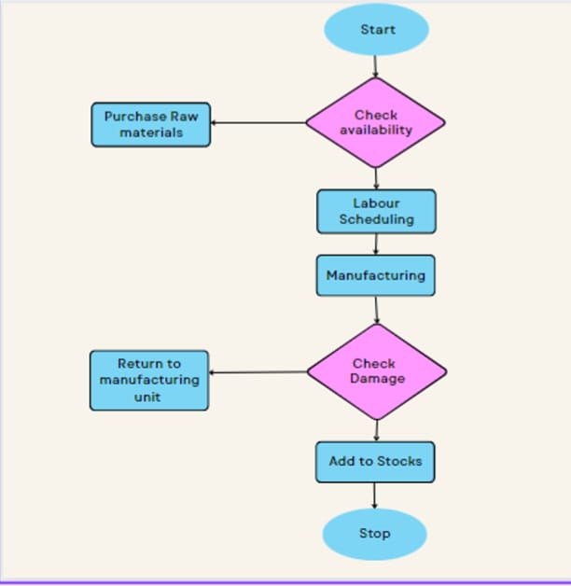

- USECASE DIAGRAM

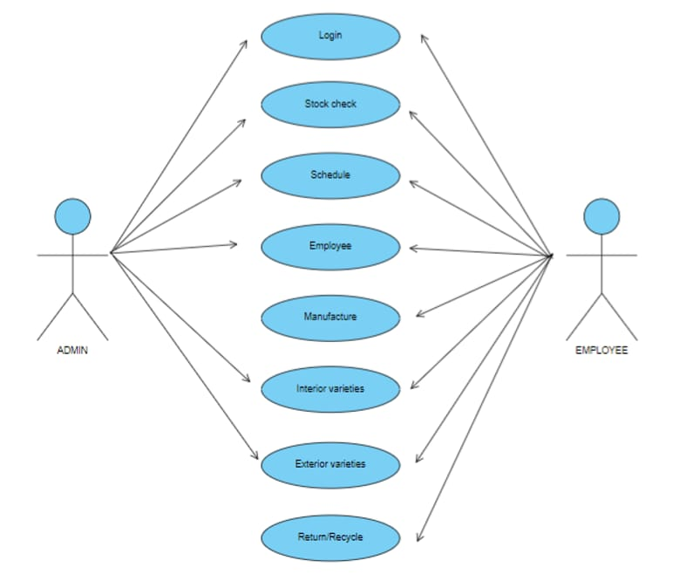

C .DATAFLOW DIAGRAM
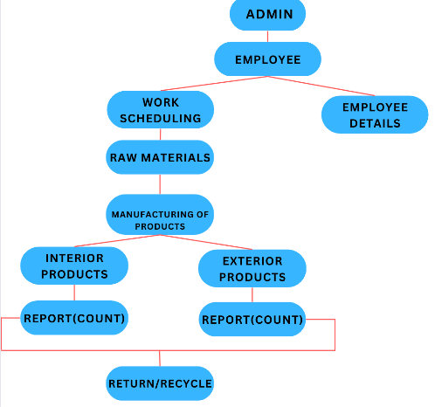

IV. METHODOLOGY

The project’s goal is to convert the manual maintenance and allocation into an automated process.
- This system contains four main sections. And those sections are used to analyze the raw material, manufactured products, and employee details in an easy way.
- Admin can check the interior and exterior furniture goods and can assign work to the employees.
- The above sections are categorized as
- Raw materials section
- Stock maintenance section
- Scheduling labour
- Return section
- Recycle section
- Firstly we bought the raw materials section. In this section the admin can check the availability of the stock and can check the availability of the type of woods. By doing so, the admin of the furniture shop can easily purchase the unavailable raw materials like different types of wood, glass, cane, metal, plastics, leather or stockless raw materials. Admin can check the products finished by the employee and can add it to the Stock maintenance section.

- Second is the stock maintenance section. Here, the admin can glimpse the finished products. The finished products are furtherly divided into two categories. They are,
- Interior varieties
- Exterior varieties

- In the interior varieties we have living, kitchen, and bedroom furniture.
- In the exterior varieties we have sit-out and balcony furniture.
- Admin can understand all interior and exterior products with the raw material details and quantities.
- This will be very useful for the admin to check all the details in a single dashboard.
- Third is the scheduling labour section. In this section the admin will assign the work to the employee. The admin can additionally check the status of the work that the employee did.
- By this the employee can know the type of the work that he wants to do.
- The next section is the Return section. The admin can easily return the damaged or unwanted materials. The return section in a furniture shop typically refers to the area or policy in which we can return or exchange the raw materials they have purchased. It is important to understand the return policy of a furniture shop before making a purchase to ensure they are aware of any potential limitations or requirements for returning or exchanging their furniture.
- Recycle section represents shop collects and recycles used or unwanted furniture. This section may involve in accepting donations of used furniture, which they then refurbish or repair and resell. Some furniture shops may also offer customers the option to recycle their old furniture when they purchase new items. This can be a convenient way for customers to dispose of their old furniture while also supporting sustainable practices. Furniture recycling programs can help reduce waste and extend the life of furniture, which ultimately helps to conserve natural resources and reduce environmental impact.

- CONCLUSION
.Our project is a modest way to satisfy the needs of the client. In addition to satisfying the client’s needs, our project also fulfills all the requirements of the college. Maintaining the warehouse and managing the staff, as well as the employees in the furniture shop, is a tedious task. Hence, we developed this website to serve that purpose. This website serves as a way to understand the availability of stock, stock processing, and managing employees and staffs. It helps businesses save costs, increases efficiency, ensures adequate staffing, and coordinates communication between the owner and the labor force. The software has been made maximum user-friendly so that even a person with minimal knowledge on computer also could easily trace out its contents without any frustration. Testing of the whole system has been done with sample data and output obtained is according to the requirements. The stocks and employees are maintained accurately which reduces the losses that can be made due to various environmental features. All the requirements regard to this problem are solved and needs are specified in the problem definition are fulfilled

VI. RESULT AND DISCUSSIONS

1.Improved inventory accuracy: With a WMS in place, the inventory accuracy can improve significantly. The system will help to identify inventory discrepancies and ensure that the inventory levels are always up-to-date.
2.Increased efficiency: A WMS will help optimize the warehouse processes and increase the efficiency of operations. This can lead to faster turnaround times, reduced labor costs, and improved customer satisfaction.
3.Better visibility: The WMS provides real-time visibility of the warehouse operations, including inventory levels, order status, and location tracking. This allows for better decision-making and helps to prevent stockouts and overstock situations.
4.Enhanced safety: A WMS can help improve safety in the warehouse by reducing the risk of accidents and injuries.

The system can identify potential hazards and provide warnings to the workers.

Discussion: When discussing a warehouse management system project, it is important to consider the benefits of implementing a WMS, the challenges that may arise, and the best practices for successful implementation.
Benefits: A WMS can bring numerous benefits to a warehouse operation. It can help optimize inventory management, increase efficiency, provide real-time visibility, and improve safety. By implementing a WMS, companies can improve their bottom line, increase customer satisfaction, and gain a competitive advantage.
Challenges: Implementing a WMS can also come with its own set of challenges. Some of these challenges may include resistance to change, lack of training, and difficulty in integrating with other systems. To prevail these challenges, it is necessary to comprise all the stakeholders in the project and ensure that proper training is provided.

VII. OUTPUT

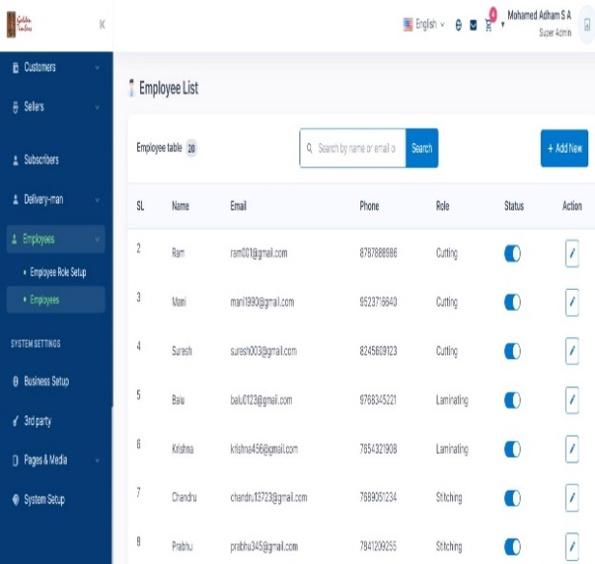

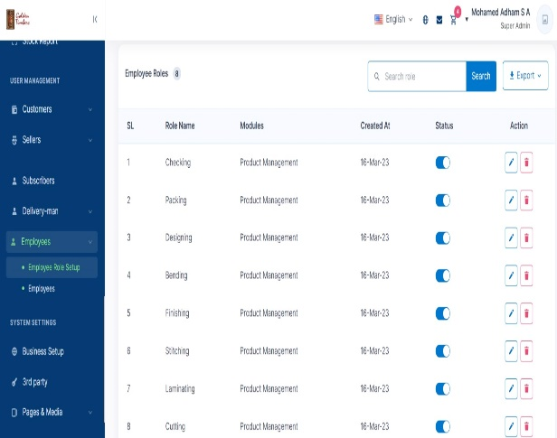

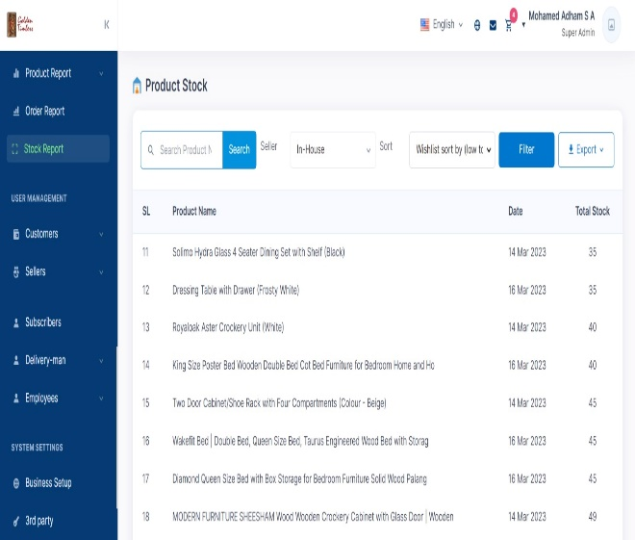

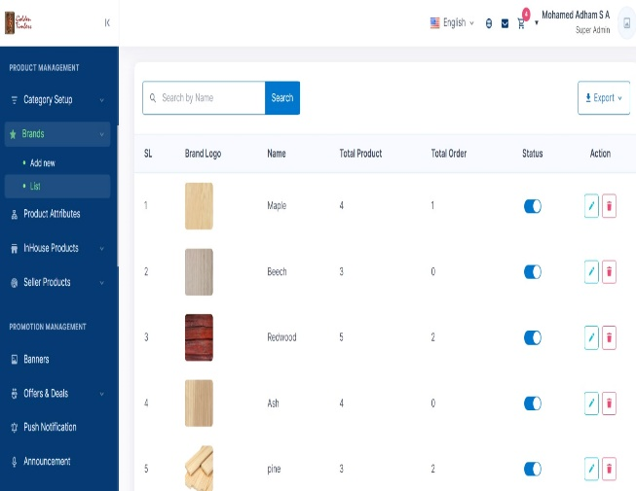

VIII. FUTURE SCOPE

Warehouse management systems are becoming increasingly popular as they offer businesses an efficient and effective way to manage their inventory and optimize their supply chain operations. As technology continues to evolve, the future scope for warehouse management systems is promising. Here are some potential future trends and advancements for warehouse management systems:
1. Increased Use of Automation: Automation is already a critical component of warehouse management systems, but in the future, we can expect to see even more automation in the form of robots, drones, and autonomous vehicles that can pick, pack, and transport goods within a warehouse.
2. Integration with Artificial Intelligence (AI) and Machine Learning (ML): As AI and ML continue to advance, warehouse management systems will likely integrate with these technologies to provide more accurate demand forecasting, predictive analytics, and real-time decision-making capabilities.
3. Integration with Internet of Things (IoT) and Blockchain: IoT and blockchain technologies can provide enhanced visibility and transparency throughout the supply chain, from warehouse to the end customer. Warehouse management systems will likely integrate with these technologies to improve traceability, reduce fraud, and improve overall supply chain efficiency.
4. Increased Focus on Sustainability: As environmental concerns continue to rise, there will be an increased focus on sustainability in warehouse management systems. This will include optimizing energy usage, reducing waste, and finding ways to minimize the environmental impact of supply chain operations.
5. Enhanced User Experience: As technology continues to evolve, warehouse management systems will likely become more user-friendly and intuitive, with more advanced dashboards, mobile applications, and voice recognition capabilities.
Overall, the future scope for warehouse management and inventory control systems is promising, with exciting advancements on the horizon that will help businesses optimize their supply chain operations and improve their bottom line.

IX. REFERENCES

- A. Iscan and B. Karakasoglu “Optimizing Inventory Levels in Furniture Retail Supply Chains: A Simulation-Based Study" Published by Kogan page, 2016.
- Brian J. Gibson “Warehouse Management : A Strategic and Operational Approach” published by Wiley, May 2011.
- Cano et al. “A review of Industry 4.0 technologies for furniture manufacturing” Published by Journal of Intelligent Manufacturing , 2019.
- DavidH.Lodwig “Warehouse Management: A complete Guide for Improving the Efficiency and Minimizing the costs in warehouse management “ Published by Kogan page, 2013.
- Donald Waters “Warehouse Management and Inventory Control” , Published by Wiley, December 2007.
- Gwynne Richards “Warehouse Management: A Complete Guide to Improving the Efficiency and Minimizing Costs in the Modern Warehouse”, Published by Kogan Page, 2014.
- James A. Tompkins “Warehouse Management Handbook” published by Tompkins Associates; 2nd edition, October 1998.
- Kaminski et al. “Lean manufacturing in furniture production” Published by European Journal of Wood and Wood Products, May 2021.
- Martin Murray “Warehouse Management with SAP ERP: Functionality and Technical Configuration” Published by Rheinwerk Publishing, 2016.
- Scott Hamilton “Warehouse Management implemented by using Microsoft Dynamics AX 2012 R3 “ Published by Scott Hamilton, April 2015.
- Shin and Lin “Challenges and implementing Warehouse Management System” Published by Journal of Studies in International Education , 2008.
- Tan and Kannan “Impact of Warehouse Management System on Inventory Management” Published by International Journal of Computer Applications , September 2012.
- Yan et al. “Effectiveness of Warehouse Management System on order fulfillment” Published by Science Direct , 2016.

