A Review On Weather Forecasting using Linear Regression
G. H. Raisoni College of Engineering, Nagpur
Department of Information Technology
Pratiksha Tidke Sakshi Sarode Prof.Sonali Guhe
Department of IT Department of IT Department of IT
GHRCE GHRCE GHRCE
Nagpur Nagpur Nagpur
pratiksha.tidke.it@ghrce.raisoni.net sakshi.sarode.it@ghrce.raisoni.net sonali.guhe@ghrce.raisoni.net

Abstract –Linear regression is a type of supervised MLA (Machine Learning Algorithm), which is a statistical method. It is used to predict the dependent variable (Y) from the independent variable (X). Linear regression evaluates the collaboration between two variables. It is a modeling technique which scales the coefficient of linear equation. The prediction of dependent variable depends on one or more than one independent variable. Of all statistical methods, linear regression analysis is the one that is most frequently utilized.

Keywords: linear regression, statistical, independent, dependent, machine learning, supervised
Introduction

The idea of linear regression was first proposed by Sir Francis Galton in 1984. A statistical test called linear regression is put on the dataset to describe and measure the relation between the considered variables.
Linear regression is the simplest regression analysis mechanism in predictive analysis. The key to linear regression is finding a line which fits the scatter plots as efficiently as possible. In linear regression analysis we plot many lines and then find out which line most effectively fits the scatter plots. The simplest form of linear regression is: y= mx+c
Where,
y=dependent variable
x=independent variable
m & c are constants which are called the coefficients.
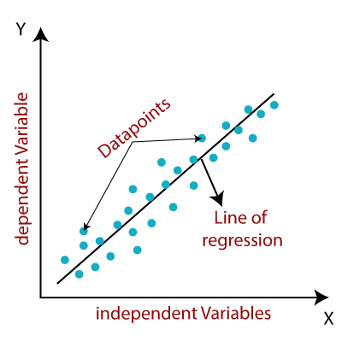

- LITERATURE SURVEY

Weather forecasting has been one of the most challenging problems worldwide because of its practical importance both in scientific study and in the popular sphere of meteorology. Weather is a continuous, dynamic, multidimensional chaotic process, and the data and features make weather forecasting a challenging challenge. It is one of the most pressing and essential operational responsibilities that must be performed by many meteorological services around the world.

Mark Holmstrom, Dylan Liu, Christopher Wu published an article in 2017 called “Machine Learning Applied to Weather Forecasting”. They modeled weather forecasting using 'linear regression' and 'functional regression' algorithms to predict various factors affecting weather. Later they used '4-fold forward chaining time series cross-variation' to assess the accuracy of the model. After completing the model, they compared their model with 'professional weather forecasting services' and the result showed that 'professional weather forecasting services outperformed the both linear regression and functional regression. However, after a period of time, the rate of inconsistencies or errors in their model decreased drastically.

The research paper, titled ‘Issues with weather forecasting’, examined the main issues with weather forecasting. Initially we will use 15-20% of the data for training. We will use the naïve Bayesian classification algorithm and the linear regression algorithm for this prediction. We will be using Python, NumPy, Jupyter Notebook, Spyder, Pandas. Temperature, dew, pressure, and humidity are the only variables used in the project for training data. Here linear regression is used to train the data for prediction.

According to Shubham Madan's "Analysis of Weather Forecasting using Machine Learning and Big Data", weather forecasting was done using Big Data Processing and Machine Learning. The feature used for prediction are maximum temperature, minimum temperature, average humidity, average atmospheric pressure. Algorithms used were linear regression and support vector machines. The author has mentioned the 'root mean square' method to check the accuracy for a given project.

II.PROPOSED METHODOLOGY

The methodology used in this project for weather forecasting is Machine Learning Algorithm- Linear Regression. A block diagram shows the machine learning methodology for project implementation.

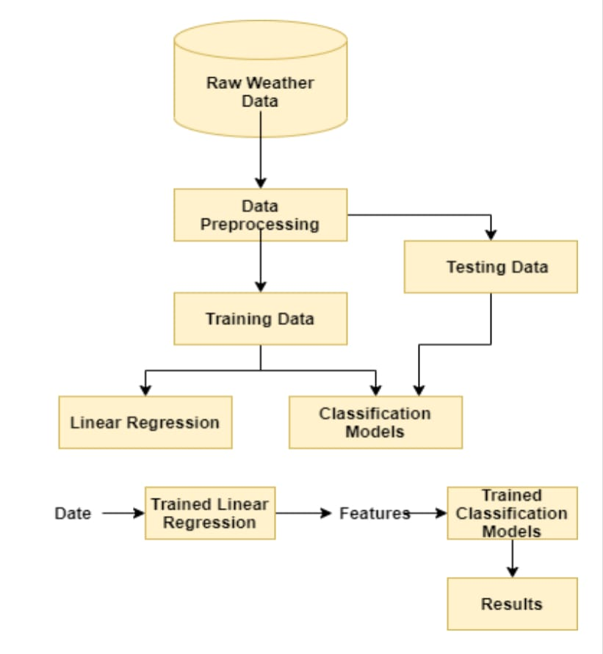
This presents the methods used for pre-processing raw data attributes and the algorithms used for predicting rainfall data and forecasting future rainfall for the next few days. In this methodology we use linear regression algorithm.

Weather forecasting using linear regression is a statistical approach used to predict weather patterns based on ancient weather record. The general methodology for weather forecasting using linear regression includes the following stages:

Data collection: The first stage is the collection of historical weather information for a particular location. This data should include information such as temperature, humidity, wind speed, precipitation, and atmospheric pressure.

Data pre-processing: The data collected must be cleaned and pre-processed to eliminate outliers, missing values, or inconsistencies. This is an important step in ensuring model accuracy.

Feature selection: The further step is to select the relevant characteristics or variables that are most likely to affect the weather pattern. For example, temperature, humidity, and wind speed are important variables that can affect the weather.

Data partitioning: The data is then divided in training and test datasets. The training dataset is used for the formation of the linear regression model, whereas the test dataset is used to evaluate the precision of the model.

Model training: In this stage, a linear regression model is formed with the help of training dataset. The model teaches the relation between the input characteristics (temperature, humidity, wind speed, etc.) and the output (weather patterns).

Model evaluation: The accuracy of the training template is evaluated with the help of test dataset. The evaluation metrics that are used can involves: the mean squared fault, root mean square value error, or average absolute error (MAE).

Model prediction: When the model is formed and assessed, they can be utilized to predict future weather patterns based on the input features.

It is important to note that weather forecasting using linear regression has limitations and may not always provide accurate predictions. This is because weather patterns are complex and can be affected by a variety of factors that may not be captured by the selected features or variables. Therefore, it is important to use this method in conjunction with other weather forecasting techniques and to continually update and improve the model based on new data.

III.SYSTEM FRAMEWORK

A system framework for weather forecasting using linear regression can be developed in the following steps:

1.Data Collection: Collect data on various meteorological parameters such as temperature, humidity, wind speed, precipitation, etc., over a period of time. This data can be obtained from weather stations or other sources.

2.Data Preprocessing: Clean the data by removing any missing values or inconsistencies.
To ensure that the parameters are on the same scale, the data should be normalized.

3.Feature Selection: Identify which weather parameters are the most important for forecasting. This can be done using techniques such as correlation analysis or feature ranking.

4.Model Training: Using linear regression, develop a model that can predict weather conditions based on the selected features. Separate the records in training and trial packages, and modeling based on education data.

5.Model Evaluation: Estimate the execution of the template using the test data. Metrics like mean squared error or R-squared can be used to evaluate the precision of the model.

6.Deployment: Deploy model as a web application or an API that can be used to make weather predictions in real-time.

7.Monitoring and Maintenance: Monitor the performance of the model over time and update it as necessary to ensure that it continues to provide accurate weather forecasts.

IV.CONCLUSION

Linear regression is very powerful tool which can be used to predict weather conditions. By analyzing historical data, linear regression models can identify patterns and trends that can help predict future weather conditions. However, it's important to observe that weather forecasting is a critical task and there are many elements that may impact the accuracy of linear regression models, such as changes in weather patterns, unexpected events, and the quality of the data being used. Therefore, while linear regression can be a useful tool for weather forecasting, it should be used in conjunction with other techniques and always with caution.

V.REFERENCES

[1]https://towardsdatascience.com/introduction-to-machine-learning-algorithms-

[2] International Research Journal of Engineering and Technology (IRJET) www.https://www.irjet.net/

[3]https://www.researchgate.net/publication/336797575_Weather_Forecasting

[4] Yash Mali, Aarya Kurlekar, Shambhavi Lalsinge,”Prediction and Classification of Weather Using Machine Learning” Vishwakarma Institute of Technology,Pune,India, Dec 2022

[5] Shubham Madan; Praveen Kumar; Seema Rawat; Tanupriya Choudhury, 2018 “Analysis of Weather Prediction using Machine Learning & Big Data”

[6] Matthew C., Christensen H., Dueben P. and Palmer T., (2021): Opportunities and challenges for machine learning in weather and climate modeling: hard, medium and soft A Phil. Trans. R. Soc.A.3792020008320200083http://doi.org/10.1098/rst a.2020.0083

[7] Coppola E., Stocchi P., Pitchell E., Alavez J. A. T., Glazer R., Giuliani G., Sante F. D., Nogherotto R., and Giorgi F., (2021) Non Hydrostatic Reg CM4 1 (RegCM4 NH): Model description and case studies over multiple domains, 14, Geoscientific Model Development 14, 7705-7723.

[8] Dutta U., Hazra A.,Chaudhari H. S., Saha S. K., Pokhrel S., Shiu C. J. and Chen J. P., (2021): Role of Microphysics and Convective Autoconversion for the Better Simulation of Tropical Intraseasonal Oscillations (MISO and MJO). J. Advance Model Earth Sys. http.//doi.org10.1029/2021MS002540

[9] Sen P. N., (2021): Numerical Weather Prediction Guidance for Weather Forecasting, IMD Blog https://imdweather1875.wordpress.com/2021/ 10/24/numerical-weather-prediction-guidance-for- weather-forecasting/

[10] Lin. J.N.K., Lee, R.S.T. "Rainfall Forecasting from Multiple Point Source Using Neural Networks". IEEE Int'l. Conf. Systems 2019

