“CRIME MAPPING AND FORECASTING USING GEOSPATIAL TECHNIQUES: A CASE OF AJMER CITY”

Major Project Dissertation

Submitted by

Kajal Yadav

MASTER OF SCIENCE
in
REMOTE SENSING AND GEO-INFORMATICS

MAHARSHI DAYANAND SARASWATI UNIVERSITY

Under the Supervision of:
Mr. AKASH GOYAL (Scientist ‘SE’)


Regional Remote Sensing Centre- North
National Remote Sensing Centre
Indian Space Research Organization

ACKNOWLEDGEMENT
It is with great pleasure that I am bringing out this paper entitled

“CRIME MAPPING USING GEOSPATIAL TECHNIQUES: A CASE OF AJMER CITY”

First, I would like to thank DGM, RC-N: Dr. Bidyut Kumar Bhadra (Scientist SG), Dy. General Manager of Regional Remote sensing center (RRSC) Delhi for giving me an opportunity to do internship with the organization.
I would like to express my Gratitude to my Supervisors: Mr. Akash Goyal (Scientist E) for his Patience, motivation and valuable suggestion at every stage enabled me to complete my work. his supervision at each and every part of work inspired me in countless ways. I want to show my gratitude to Dr. Subroto Dutta Prof. & Head Department of Remote Sensing & Geo-Informatics, MDS University (Ajmer).
A special thanks to IPC department Ajmer for their cooperation and providing crime data.
I would like to thank my friends and parents for helping me and sharing their knowledge and experiences.

KAJAL YADAV
M.SC, GEO-INFOMATICS
MDS UNIVERSITY

TABLE OF CONTENTS
Acknowledgment 2
Lists of Graphs… 4
Lists of Maps… 4
Abstract 6
CHAPTER 1 INTRODUCTION 7

  - Introduction
  - Limitation of study
  - Study Region
  - Objectives

CHAPTER 2 REVIEW OF LITERATURE 10

  - Introduction
  - Research Review

CHAPTER 3 METHODOLOGY 13

  - Introduction
  - Data Used

CHAPTER 4 RESULTS AND DATA ANALYSIS 17

CHAPTER 5 CONCLUSION 45

LIST OF GRAPHS

Graph1-Calculate the crime rate with population……………………………………………………………………………..19

Graph2-Murder crime rate year wise…………………………………………………………………………………………………21

Graph3-Rape crime rate year wise……………………………………………………………………………………………………..24

Graph4-Robbery crime rate year wise……………………………………………………………………………………………….27

Graph5-Kidnapping crime rate year wise……………………………………………………………………………………………30

Graph6-Theft crime rate year wise…………………………………………………………………………………………………….33

Graph7-Gambling crime rate year wise……………………………………………………………………………………………….36

Graph8-Engraving crime rate year wise………………………………………………………………………………………………39

Graph9-All crime occurs in seven years in seven police station…………………………………………………………...42

Graph10-Crime in year 2015………………………………………………………………………………………………………………43

Graph11- Crime in the year 2019………………………………………………………………………………………………………...43
LIST OF MAPS
Map1- AJMER ZONE: Study area……………………………………………………………………………………………..........8
Map2-Map shown location of police station in Ajmer city………………………………………………………………14
Map3- ADA, Ajmer Master plan of Land use 2033 development plan……………………………………………..15
Map4-Zone wise murder cases are registered in seven-year crime…………………………………………………20
Map5-Hotspot area of murder cases………………………………………………………………………………………………22
Map6- Zone wise Rape cases are registered in seven-year crime…………………………………………………….23
Map7-Hotspot area of rape cases……………………………………………………………………………………………………25
Map8-Zone wise Robbery cases are registered in seven-year crime ………………………………………………26
Map9-Hotspot area of robbery cases………………………………………………………………………………………………28
Map10-Zone wise Kidnapping cases are registered in seven-year crime………………………………………….29
Map11-Hotspot area of Kidnapping cases………………………………………………………………………………………..31
Map12-Zone wise Theft cases are registered in seven-year crime…………………………………………………..32
Map13-Hotspot area of Theft area………………………………………………………………………………………………….34
Map14-Zone wise Gambling cases are registered in seven-year crime…………………………………………….35
Map15-Hotspot area of Gambling cases…………………………………………………………………………………………..37
Map16-Zone wise Engraving cases are registered in seven-year crime…………………………………………….38
Map17-Hotspot area of Engraving cases………………………………………………………………………………………….40
Map18-Zone wise all crime cases are registered in seven-year crime………………………………………………….41

ABSTRACT

Advances in computer technology and the development of GIS application software and the ability to access various geographic data through open-source data sources have allowed police and law enforcement agencies to use it effectively. Crime mapping and spatial analysis using GIS tools such as hotspot generation, zoning, crime navigation and profiling, mobile location recognition and various web applications are clearly recognized and can be scientifically applied to improve citizenship while they can be effectively used to predict and control crime.
In the present study crime data is collected from police department and spatial information is extracted from it. Spatial database of different crime is prepared for the year 2015-2022. The present study analyzed the trends and pattern of crime data (Murder, Rape, Robbery, Theft, Kidnapping, Engraving, Gambling) of Ajmer zone from the year 2015-2022(till October) to understand the trends of crime data (IPC crime registered). Also used the demographic data of Ajmer to understand crime trends towards various crime types.
The study focused on the most common crimes reported, which were theft and gambling, as opposed to murder, rape, kidnapping, and robbery. All crimes were reported in 1,009 incidents in 2015. In 2016, 1,064 cases were recorded. In 2017, 1081 cases were reported. In 2018, 1034 cases were reported. In 2019, 1415 cases were reported. In 2020, 829 cases were reported. In 2011, 1120 cases were reported. In 2022, 1268 cases were reported. The highest number of cases occurred in 2017, 2019 and 2022, and the lowest number of cases occurred in 2015 and 2016.
Crime hot spots are identified in the study by analyzing the spatial crime data for 2015–2022 (till October)

INTRODUCTION
Crimes committed and crimes resolved in a given time frame may not be particularly effective in India. In the majority of the Indian states, crime mapping is done physically to aid in locating suspects and determining their method of operation. It aids in Police identify locations where a specific suspect or suspects are active. Crime is an action carried out by a person or group of people that is immoral, damaging, and unsocial to the community. Illiteracy, poverty, and vengeance can all lead to crime (Ansari & Kale, 2014). Household income, educational attainment, employment status, and poverty status are just a few of the many socioeconomic factors that are categorized. Other demographic factors include age, religion, and race. Crime results in a situation of law and order. This social evil exists. It is produced by society, and society also suffers greatly as a result of the crime that its members commit. The public is alarmed by the current wave of escalating crime.
Today, nobody is safe. There are many criminals in the world, and criminal activity is increasing globally nowadays. Due to advances in science and technology, criminals are now adopting scientific methods to carry out their crimes, which has left the police perplexed. Digital maps are used by GIS and RS as an interface for integrating and gaining access to vast volumes experiencing crime and can depict crime-prone areas. The analysis of quantitative and qualitative data and methodologies is more important. The requirement for using a methodical and analytical approach of location-based crime data. These systems also forecast locations that have a high likelihood of to criminal investigations is now more important than ever, according to a huge number of police department-related data. Crime analysts' main area of interest is the analysis of criminal acts including robberies, murders, rapes, thefts, etc. Hotspots naturally appear on crime maps due to the spatial concentration of crime there. It aids the police in identifying criminal trends and locating additional incidents.
I took into consideration a variety of crimes in this study, including robbery, theft, kidnapping, rape, murder, and other crimes. The crime incidences are record based on coordinates using GPS system and fed using a tool so as to generate maps with color coding for crime analysis. The basic idea of this does not only curb the crime but can provide a quick response by police patrolling units which are nearby. The system which is used for capturing, storing, converting data format, exploring and displaying geospatial data is known as Geographic Information System (GIS). Crime patterns change over space and time in an area and hence it is of immense help to police by using GIS maps and spatial crime patterns to capture and study the patterns for better crime control (Pramod Kumar, Ravikumar, & Soma, 2012) The present study focuses on to identifying crime prone zones through crime mapping with probability of occurrence based on past incidence of various crimes

LIMITATIONS OF THE STUDY
Field survey data has been collected for seven year (2015-2022till October) with respect to certain crimes. Many other aspects like suicide, juvenile delinquency, molestation have not been covered in this study. The socio-economic data was available only for one-year 2011, thus it has been taken as a base year due to paucity of data for other years.

STUDY AREA
Ajmer is one of the oldest cities in the Indian states of Rajasthan. Ajmer is surrounded by Aravalli mountains. Ajmer city is head quarter of Ajmer district and is a popular religious and tourist place. The city was founded by Raja Ajay Pal Chauhan in the 7th century A.D. and continued to be a major center of Chauhan power till 1193A.D. When Prithvi raj Chauhan lost it to Mohmmed Gauri. Since then, Ajmer is a popular pilgrimage center for the Hindus as well as Muslims. Especially famous is the Dargah Sharif-tomb of the Sufi saint Khwaja Moinuddin Chishti. It is center culture and education: the British chose Ajmer for its prestigious Mayo College a school exclusively for Indian nobility.
Ajmer is the ideal location to represent Indian culture, ethics, and a perfect blending of numerous different religions, communities, cultures, linguistics, etc., all thriving and prospering in peace and harmony. Several communities, including Gujarati, Marathi, Malayali and other south Indian Communities, Sikh, Catholics, Parsis, etc., exist alongside the local Hindus and Muslims. Ajmer was historically a state that was governed centrally.
Ajmer is a town and tehsil in Rajasthan's Ajmer District. A tehsil in India is a subdivision of a district that is in charge of overseeing and collecting taxes for a specific region within the district. It is a significant component of local governance and is essential to the growth and management of the neighborhood. The district is plain in the east while hilly in the west due to its proximity to the Aravalli Mountain ranges.
The Ajmer city is divided into 80 wards for which elections are held every 5 years. Ajmer has a population of 542,321 peoples (census2011)

GEOGRAPHICAL FEATURES OF AJMER CITY
Ajmer geographically lies nearly in the center of Rajasthan (India) between 25⁰ 38’ to 26⁰58’ North latitudes and 75⁰54’ to 75⁰22’ East longitudes. Ajmer is blessed with a green oasis wrapped in the barren hills which has Tonk and Jaipur districts in the east, Nagaur in the north, Pali to the west and Rajsamand and Bhilwara districts to the south.
Ajmer is a Tehsil in Ajmer District of Rajasthan. In India. A tehsil is a sub-division of a district that is responsible for the administration and revenue collection of a particular area within the district. It is an important part of the local governance structure and plays a crucial role in the development and administration of its local community. Total area Ajmer tehsil is897 km²

including 630.87 km² rural area and 266.19 km² urban area. Ajmer tehsil has a population 7,98,454 peoples, out of which urban population is 5,77,838 while rural population is 2,20,616. Ajmer has a population density of 890 inhabitants per square kilometer.
The geographical understanding of the region along with demographic pattern helps in buildings better understanding of the crime arousal, crime trends and pattern in the region.
The city nine police stations (PS) and one all-female police station (Mahila). It has four major National highways namely NH-8, NH-58, NH-79 AND NH-89 passing through the city region.

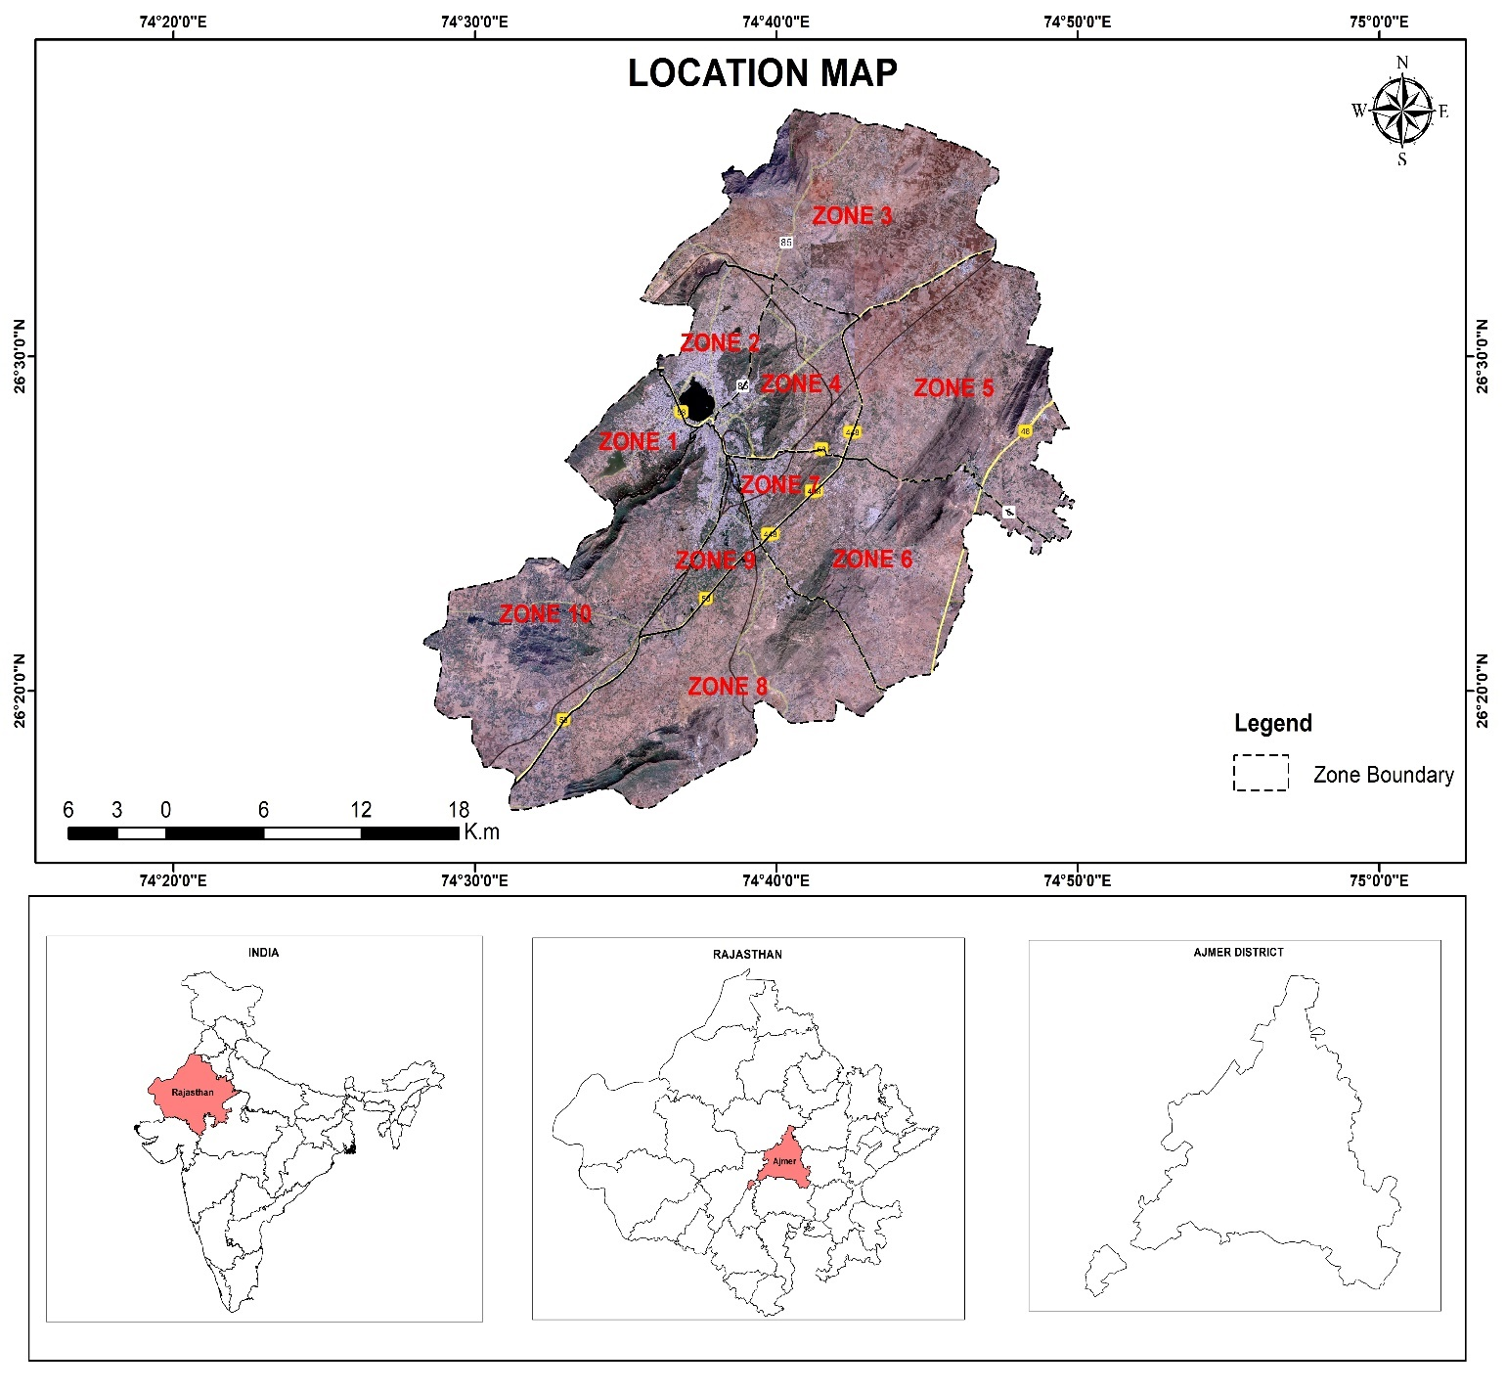
Map 1- AJMER ZONE: Study area

OBJECTIVES
Crime and Geography are interrelated to each other in every possible way, as per Mayhew (2009). The main aim of the present work is to spatial analysis of crime and crime mapping for Ajmer city police force for better management.
- To understand socio-economic factors behind crime.
- To analysis crime trends and pattern that occurred in 2015 to 2022(till October)
- To hotspot analysis and graphs of crime in the study area.
- To forecast future rate of crime based on time series analysis.

REVIEW OF LITERATURE

INTRODUCTION

Literature related to scholarly articles, books and other sources relevant to a particular area of research were summarized a number of attempts in writings has been done in the Field of crime and its related aspects in the society within a particular time and space. Hence, following paragraphs gathers some important researches and works about the crimes in India and other Nations.

RESEARCH REVIEW

S.Sivaranjani and S.Sivakumari, “Crime Hot Spot Analysis and Prediction Using Spatial Data Mining Approaches Crime analysis can be broadly divided into three categories as follows:
Tactical: This type of analysis can aid the police personnel in providing information that helps to assist operations personnel in identifying the crime trends and patterns, series of crimes, sprees and hotspots. This method generally associates the criminal activity with the information like date of crime, exact location of it along with the time of occurrence. Strategic: This type of analysis is essentially used for the preparation of crime reports statistically. Hence this method is concerned with the crimes that are being handled for long time of investigation. Administrative: This type of analysis which consider economic, geographic, or social information to administration.

Zhou et al. - (Zhou, G., Lin, J. And &amp; Zheng,” A Web-Based Geographical Information System for
Crime Mapping”, International Journal Modern Engineering Research,2012 Vol 2 Issue 3) proposed
a web-based crime analysis and mapping using geographical information system. The main objective
of this work was to design and implement a Web based crime mapping using four hotspots mapping
techniques i.e., choropleth mapping, grid mapping, spatial ellipse mapping and kernel density mapping, were implemented in the system.
Howard Jones in his paper “Crime and Penal Systems” (1956) stated that crime is costly and has
reached such dimensions as to constitute a real threat to our way of life. According to one post war
estimates, one person in every nine becomes delinquent at some time in his life. It’s natural that we
should be perturbed by figures such as these, but perturbation alone will not help us. For any improvement in the situation, we must ultimately rely upon advances in our understanding of the
problem. This is the function of criminology, as the science that studies the social phenomenon of
crime, its causes and the measures which society directs against it.

According to Prof. Manuel Lopez –Rey (1971), “As a rule crime is still regarded as casual entity,
the causes of which will eventually be unfolded by persistence criminological research and eventually
suppressed or considerably reduced. My contention is that crime is conceptual and not a casual or natural entity, i.e., it is what, at a historical juncture, is defined as such by the legitimate order in accordance with a changeable but always fundamental system of values and the structure and aims of given society. Legitimate order means here the established and accepted by the majority according to a factual democratic process. By defining what crime is, criminal law performs a socio-political function that of protecting the historical continuum of a particular society in which the individual is not the only element to be considered. His coexistence with other elements makes imperative the protection of human rights …, since crime is a socio-political concept of crime but as criminal law is primarily interested in protecting the changing continuum of particular society the socio-political character of crime, as legally defined is paramount.

Jack Katz brilliantly demonstrated in Seductions of Crime (1988), is that the facts demand it.Whether increases in crime during periods of economic growth, epidemics of violence in wealthy countries such as the United States, the weak correlation of social class with delinquency, or crime in the suites, materialist theory is clearly insufficient. But it is not just deprivation-based theory that has failed. Most criminological theory is static in logic and handicapped by a focus on (allegedly) fixed explanatory categories, thereby failing to address the processes and dynamics leading to criminal events. The most important thing about crime that we do not know, in other words,concerns its causal social processes.

(Sampson &amp; Laub 1993)-There is marked variability in adult outcomes even among serious and
persistent juvenile delinquents. In my research with John Laub, for example, we found that none of
the static variables measuring family background—such as poverty, parental criminality, and child
supervision—predicted trajectories of adult offending among formerly incarcerated delinquents.
According to Brown, Esbensen &amp; Geis (1996) provide a typology for crime in three classes: violent, economic, and victimless. The fear of death or serious injury often causes one to view violent crimes as the most serious of the three classes. Violent crimes of a “serious” nature include murder, assault, rape, and robbery.

According to Brown et al. (1996), “what constitutes a ‘serious’ violent crime is a function of traditional and ideological and not necessarily the result of close attention to the implications of different behaviours.” Economic crimes are committed by those “unable or unwilling to obtain these tokens of self-value-money and goods-in a legitimate manner.

Francis Fajemirokun et al. - made use of Geographic Information System (GIS), an effective tool
for crime mapping and management of crimes in Nigeria. GIS can be a very useful tool to display
and apply spatial analysis to data, which reside in large databases, in order to obtain a strong visual
appreciation of the patterns of crimes.

Kallum Dhillon, [developed several innovative methods and used them to geo-reference archival
sources, in the quest to create a spatial picture of crime/criminality in Edwardian. The result
illustrate that the historical GIS can be used to analyses crime/criminal interactions and provide
researchers with an improved understanding of this social phenomena.

M.Vijayakumar and C. Charasekar, (“GIS Technologies in Crime Analysis and Mapping: A Case Study”, International Journal of Soft Computing and Engineering, 2011, vol.1, issue 5, pp.115-121.) Crime Mapping Maps offer crime analysts graphic representations of crime-related issues. An overview perspective of where and why the crimes takes place and what type of crimes occurred can improve the process of tracking the crime hotspots. Mapping crime can help police personnel to protect people more effectively. Crime maps that display the high concentration of crimes can help in directing patrols to places they are most wanted. Policy makers in police departments might use more complex maps to monitor trends in criminal activity. Display spatial patterns of events: Digital maps are the quickest means of visualizing the entire crime scenario. The locations of crime events can be routinely displayed on maps. This provides an easy method of viewing activities in an area rather than searching through a listing of events. Maps can also be used to convey more than one type of information at a time. Crime locations can be symbolized according to the day of week, type of crime, modus operandi (a particular suspect’s method of operation when committing a crime) or frequency. Integrate community characteristics: Community characteristics (for e.g., slums, markets, colleges, parks, alcohol permit locations, red light area, etc.) can be routinely displayed on maps while analyzing crime patterns to interpret relationship between these characteristics and the crime. For example, the locations of aggravated assaults, robberies and alcohol permits can be displayed to see if crime is clustering around
locations that sell alcohol. Other mapping data such as bus routes and public housing can also be displayed at the same time to analyses relationships between neighborhood characteristics and crime.

METHODOLOGY

The crime data falling under all 9 police stations are collected under the categories such as – kidnapping, murder, rape, theft, robbery, gambling and other crimes. The data was collected on police station basis for all police station basis for all police station for seven-year from2015-2022(till October).
I go to the SSP (senior superintendent police officer) to get authorization to collect crime data from each police station in the city of Ajmer for my research. I also go to the Ajmer crime branch, where I submit an RTI to know regarding crime cases in the city's municipal area.
After that, I spent four months manually compiling all crime data by visiting each police station. After analyzing all the data, I prepared my project about crime.
Today, everyone is aware that crime is steadily rising in the city of Ajmer. I have observed the number and type of crimes as well as the way that crime has grown in various parts of the city. The objectives of this study on crime in Ajmer are to identify the causes of crime as well as the rate at which it has increased over the past seven years with the aid of the crimes reported to the local police station.
Limited socio-economic data of Ajmer city was available for the census year 2011 data such sex ratio, non-working and illiterate population was only available freely.
- Non-spatial data was collected with all attribute information of crime from all police stations, especially location of occurrence of crime.
- Crime location converted into GPS coordinates.
- Thematic layers were generating with the help of this geocoded data.
- These thematic layers are basically generated using data from year 2015-2022 till October.

The research methodology adopted in the study as flow chart is provided

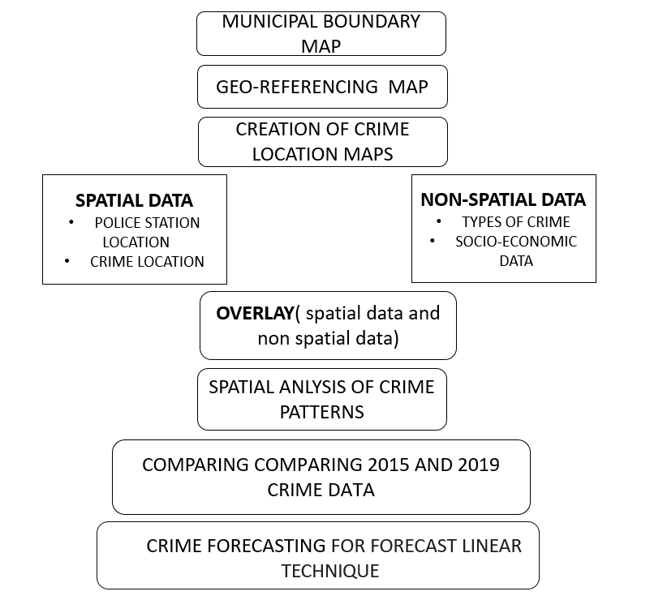

DATA USED
- The IPC crime incidents data is collected from the SP Office, Crime Branch & each Police station of Ajmer city from 2015 to 2022 (till October 2022).
- Crime data About Murder, Rape, Kidnapping, Robbery, Theft, Engraving and Gambling.
- Census data were collected from Statistical department & Nagar Nigam of Ajmer.

SHOW ALL POLICE STATION LOCATION OF AJMER CITY
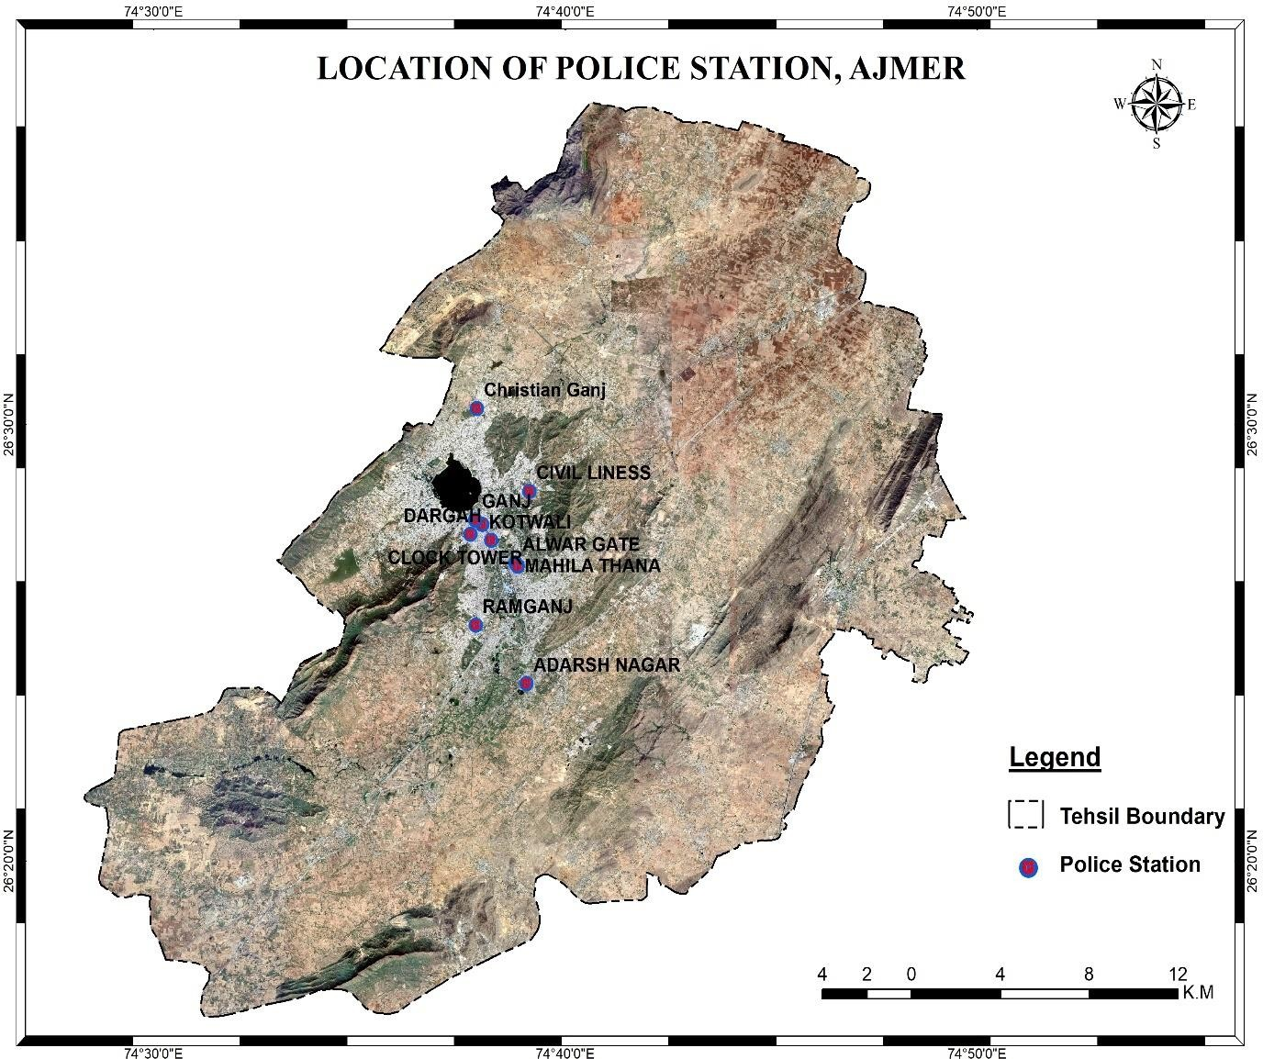
Map 2- Map shown location of police station in Ajmer city
Nine police stations (PS) and one all-female police station are located in the city (Mahila). The city region is traversed by four important national highways: NH-8, NH-58, NH-79, and NH-89. Open street maps were used to create the road network, and crime statistics were displayed to look for any patterns. The standard deviational ellipse was used to study the potential distributional trend for a set of crimes and identify its relationship to criminal arousal.
Using zone boundary maps from the Ajmer Development Authority, Town Planning Department, and Survey Department, the study focuses on examining the urban profile of the city and its trend of growth while keeping in mind the idea of geographical space. The

locations of crimes were placed as points on the shape file of the city map of Ajmer that was recently digitalized.
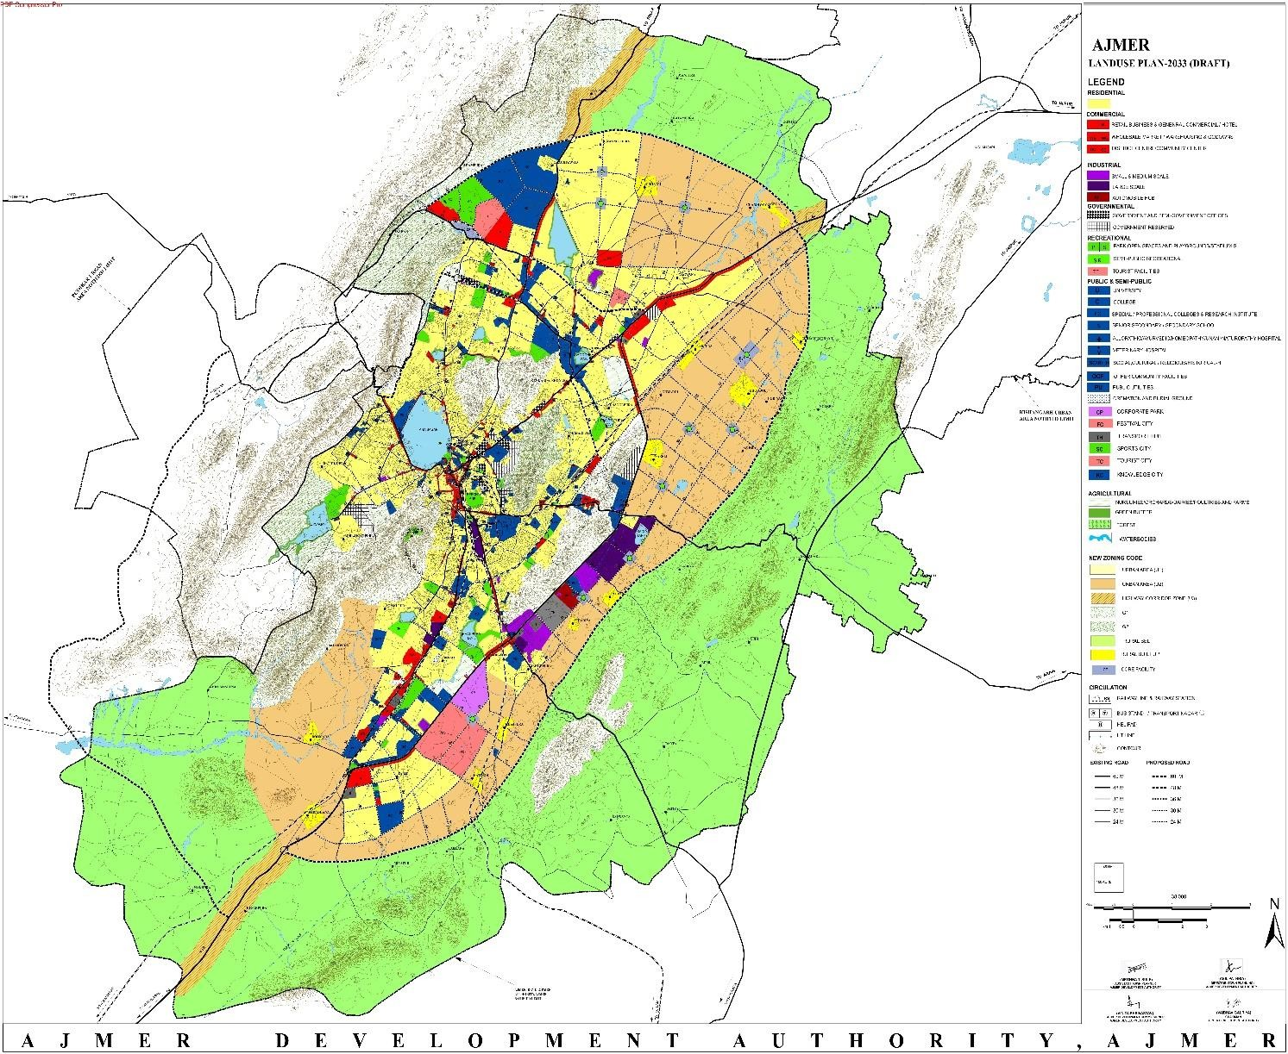
The majority of Ajmer City is underdeveloped or used for residential purposes, according to the city's master plan (Ajmer Development Authority). The nature and pattern of criminal incidents in the area have been significantly impacted by these changes. With the emphasis now being on tertiary and quaternary services rather than agriculture, the city has gone through a complex process of urban transformation. Urban development that has led to high- rise apartment buildings, complicated road systems, and congestion in the ancient city centre area have all contributed to the emergence of a number of social and economic problems in the area.

Map 3- ADA, Ajmer Master plan of Land use 2033 development plan.
Population related data from census of India, statistical information from statistical handbook.
This old city region is densely populated, has very narrow lanes and is the overcrowded commercial zone of the area. It can be referred to as the CBD (Central Business District) of Ajmer City in the urban terminology. Though police stations are located in the vicinity, still

the crime occurrence is frequently observed here because of narrow, dim light lanes with numerous pathways and market regions.

RESULTS
Demographic analysis of Ajmer city
In 2011, Ajmer had population of 2,583,052 of which male and female were 1,324,085 and 1,258,967 respectively. In 2001 census, Ajmer had a population of 2,181,670 of which males were 1,129,920 and remaining 1,051,750 were females. Ajmer District population constituted
3.77 percent of total Maharashtra population. In 2001 census, this figure for Ajmer District was at 3.86 percent of Maharashtra population.
There was change of 18.40 percent in the population compared to population as per 2001. In the previous census of India 2001, Ajmer District recorded increase of 20.9percent to its population compared to 1991.
Socioeconomic factors are often considered to be an important contributing factor to crime. Research in this area has found that people from lower socioeconomic backgrounds are more likely to be involved in criminal activity, both as offenders and victims.

Population | 542321
Male Population | 278545 (51.36%)
Female Population | 263776 (48.64%)
Children Population | 60922
Sex-ratio | 947
Literacy | 76.8%
Male Literacy | 81.41%
Female Literacy | 71.94%

Table1 -Demographic details of Ajmer city (2011)

Some of the specific socioeconomic factors that have been found to be associated with crime include:
Poverty: Individuals and families living in poverty are more likely to be involved in criminal activity than those with higher incomes. This may be due to a lack of economic resources and opportunities, as well as other factors such as poor education, lack of stable housing, and exposure to crime and violence.
Unemployment: High levels of unemployment can lead to poverty and financial strain, and have been linked to increased rates of criminal activity.

Education: Individuals with lower levels of education are more likely to be involved in criminal activity than those with higher levels of education. Poor education can limit job opportunities and economic mobility, which may contribute to criminal behaviour.
Housing: Poor or overcrowded housing conditions can contribute to increased stress and crime. Communities with higher rates of concentrated poverty, tend to have higher rates of criminal activity.
Family Structure: Children from broken homes, or those who grow up in households with a history of criminal behaviour are more likely to engage in criminal activity themselves.
It's important to note that socioeconomic factors do not fully explain criminal behaviour, and there are many other factors that contribute to criminal activity, including individual characteristics such as impulsivity, aggression, and mental health issues. Additionally, the relationship between socioeconomic factors and crime is complex, and further research is needed to fully understand the mechanisms by which these factors contribute to criminal activity.
Social injustice shows itself in crime. It is an unlawful act that violates state law and is strongly criticized by the general public. Any behaviour that violates the law and is punished by imprisonment or monetary fines is referred to as a crime. Crimes include murder, robbery, burglary, rape, drunk driving, abuse of children, and failing to pay taxes.

CRIME ANALYSIS IN AJMER CITY

TYPES OF CRIME | 2015 | 2016 | 2017 | 2018 | 2019 | 2020 | 2021 | 2022
MURDER | 11 | 12 | 16 | 10 | 16 | 8 | 16 | 9
RAPE | 33 | 36 | 30 | 41 | 80 | 49 | 61 | 68
KIDNAPPING | 76 | 52 | 58 | 62 | 105 | 70 | 92 | 93
ROBBERY | 17 | 21 | 14 | 12 | 19 | 15 | 17 | 54
THEFT | 439 | 397 | 342 | 297 | 520 | 260 | 477 | 621
ENGRAVING | 113 | 85 | 88 | 91 | 136 | 105 | 104 | 113
GLAMBLING | 320 | 464 | 523 | 522 | 539 | 322 | 353 | 310
TOTAL | 1009 | 1067 | 1071 | 1035 | 1415 | 829 | 1120 | 1268
Table2- Crime statistics in Ajmer city during the year 2015- 2022(till October)

By looking at and evaluating crime statistics from Ajmer's nine police stations and the crime map from 2015 to 2022 (till October)









MURDER
THEFT
2022
RAPE
ENGRAVING
2015
700
600
500
400
300
200
100
0
KIDNAPPING
GAMBLING
ROBBERY
2016
2021
2017
2020
2018
2019

Here, the pie chart shows the frequency of crimes for the seven years (from 2015 to 2022 through October), with 2019 and 2022 having a disproportionately higher number of crimes than the previous years.
Many socioeconomic factors are associated with crime such as literacy rate, sex ratio, etc. development is a multi-dimensional process involving the restructuring, redirection and reorientation of socio-economic systems in a comprehensive manner in which the products will lead to the improvement of the general welfare of the people.
Calculate the crime rate with population and literacy rate of Ajmer city.

YEARS | NUMBER OF CRIME IN AJMER/ TOTAL POPULATION OF AJMER IN YEAR 2011 | CRIME RATE
2015 | 3190/542321*10000 | 58.82%
2016 | 3221/542321*10000 | 59.39%
2017 | 3208/542321*10000 | 59.15%
2018 | 3241/542321*10000 | 59.76%
2019 | 4243/542321*10000 | 78.23%
2020 | 3024/542321*10000 | 55.76%
2021 | 3617/542321*10000 | 66.69%

Graph1- Calculate the crime rate with population
According to 2011 population crime rate of 2015 to 2021 increase and decrease manner, mostly decrease crime rate in 2016 and highest crime rate in 2019

MURDER
Murder is the unlawful killing of another person without a justifiable reason or justifiable reason, especially the premeditated unlawful killing of another person. Depending on the jurisdiction, this mental state can distinguish murder from other forms of unlawful killing, such as manslaughter.
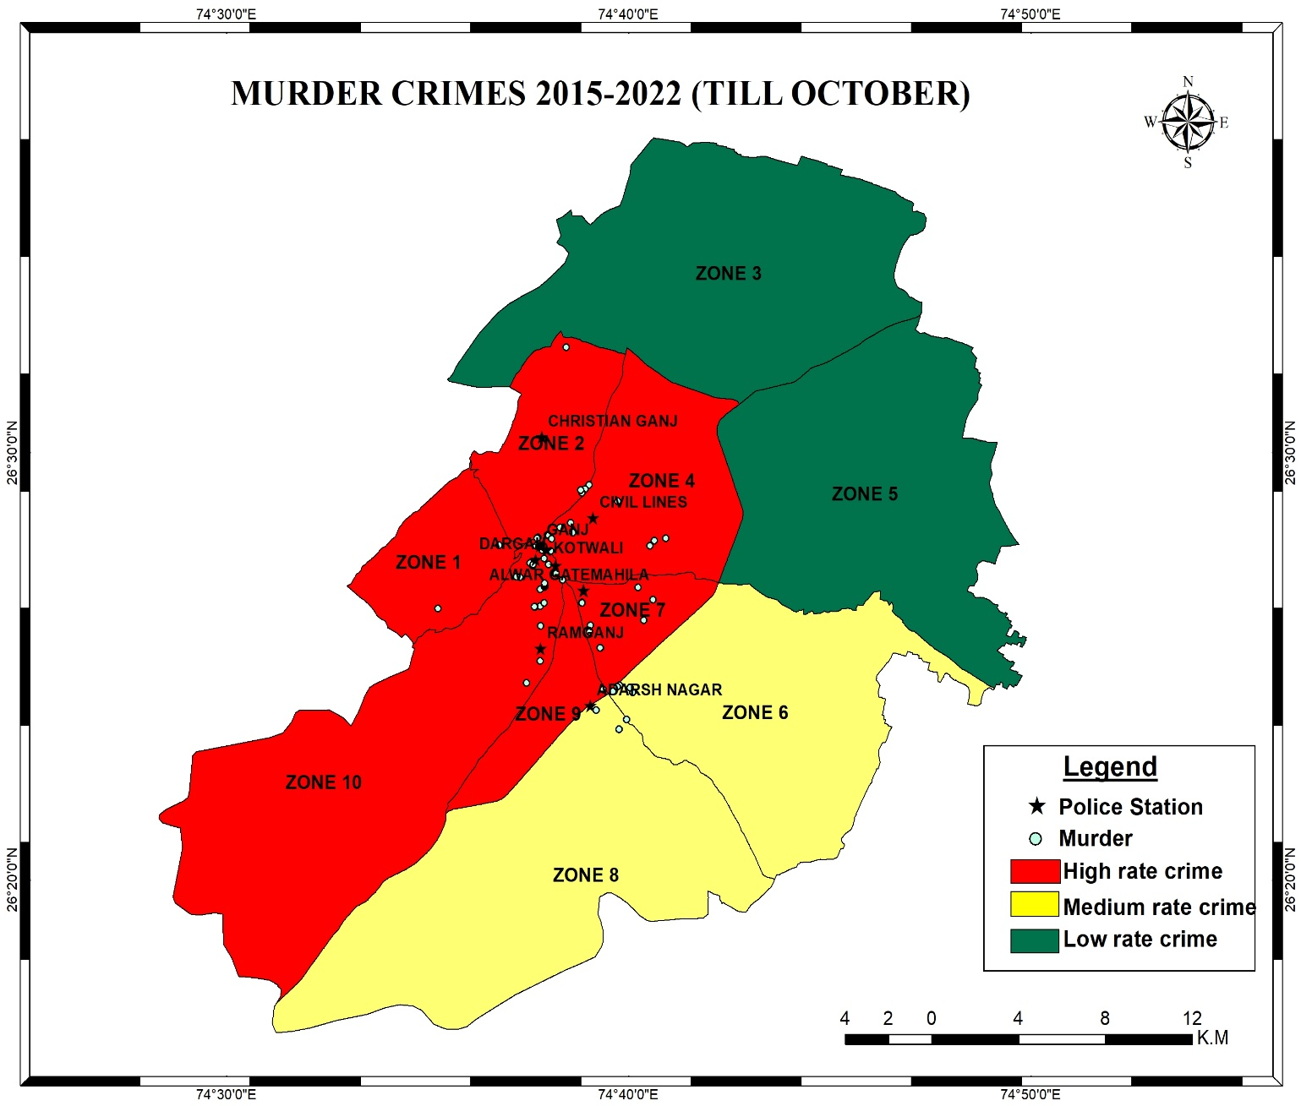
Map 4-Zone wise murder cases are registered in seven-year crime.
According to this map more cases were shown in zone 7, zone 4 and zone 10, comparatively other zone area. At comparison to the other nine police stations where murder cases have been registered, more cases of murder have been detected in Ramganj, Ganj, and Christian Ganj police stations on the murder crime map for the years 2015–2022 (till October). More murders occur in 2017,2019 and 2021 than to other years.

Graph 2- Murder crime rate year wise
Crime forecasting refers to the basic process of predicting crimes before they occur. In excel Microsoft office use forecast linear technique.
The forecast linear function is one of the statistical functions. It is used to calculate, or predict, a future value by using existing values; the predicted value is a y-value for a given x-value. The known values are existing x-values and y-values, and the new value is predicted by using linear regression.

Forecast value

2023 | 11.60714286
2024 | 11.46428571
2025 | 11.32142857

After studying, for 2015 -2022 (till October) crime map of murder, found that murder attempt in the major in three police station area. Hotspot area found near Ganj and Alwar gate zone area.
In Ramganj area- near Shashi basti and pahadganj In Alwar gate area- bhajanganj
In Ganj area- regar mohalla , Lakhan kothri

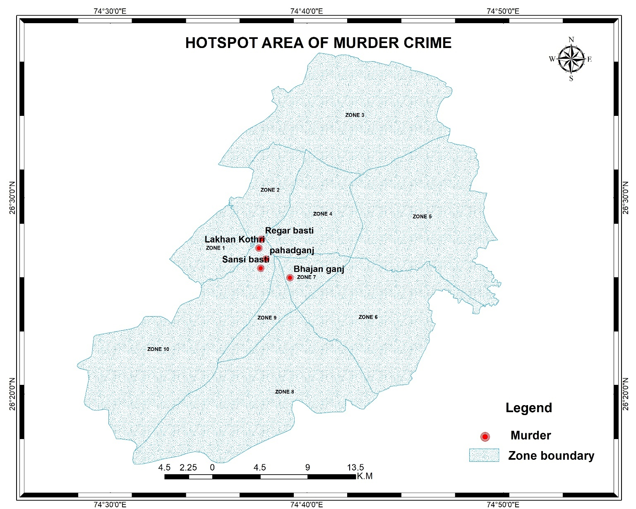

Map5- Hotspot area of murder crime

RAPE
Rape is a type of sexual assault that usually involves sexual intercourse or other forms of sexual penetration against a person without their consent. Action that may be taken by force, coercion, abuse of power, or against a person incapable of giving valid consent, such as an unconscious, incompetent, incapacitated person intellectual or not of legal age to consent. The term rape is sometimes used interchangeably with the term sexual assault.
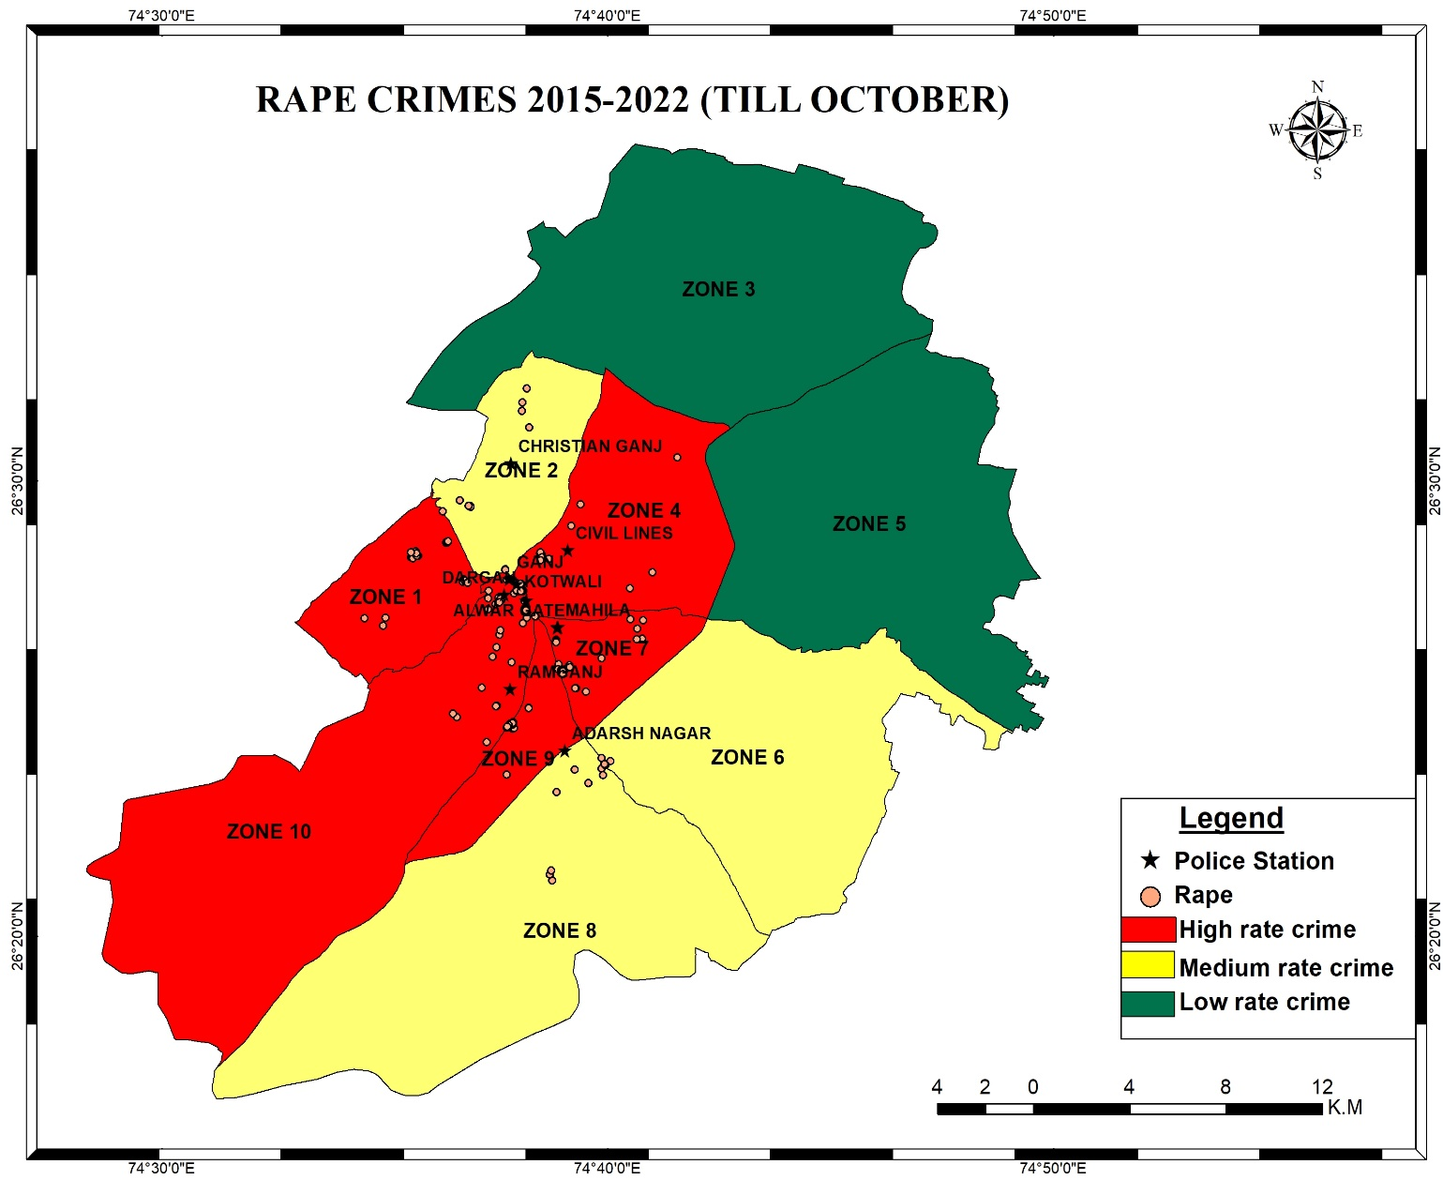
Map 6- zone wise Rape cases are registered in seven-year crime
After studying, more rape cases were found in zone 4, zone 7, zone 1, comparatively other zones. At comparison to the other nine police stations where rape cases have been registered, more cases of rape have been detected in Ganj and Dargah police stations on the rape crime map for the years 2015–2022 (till October).

Graph 3- Rape crime rate year wise
According to this graph more cases were occurred in 2019 and 2022, comparatively other years.
Crime forecasting refers to the basic process of predicting crimes before they occur. In excel Microsoft office use forecast linear technique.
Forecast value

2023 | 74.71428571
2024 | 80.26190476
2025 | 85.80952381

After studying, for 2015 -2022 (till October) crime map of rape, found that rape occurred in the major in two police station area. Hotspot area found near Ramganj and Alwar gate zone area.
In Ramganj area- shashibasti, somalpura
In Alwar gate area- bihariganj , madarpura road, near nagara

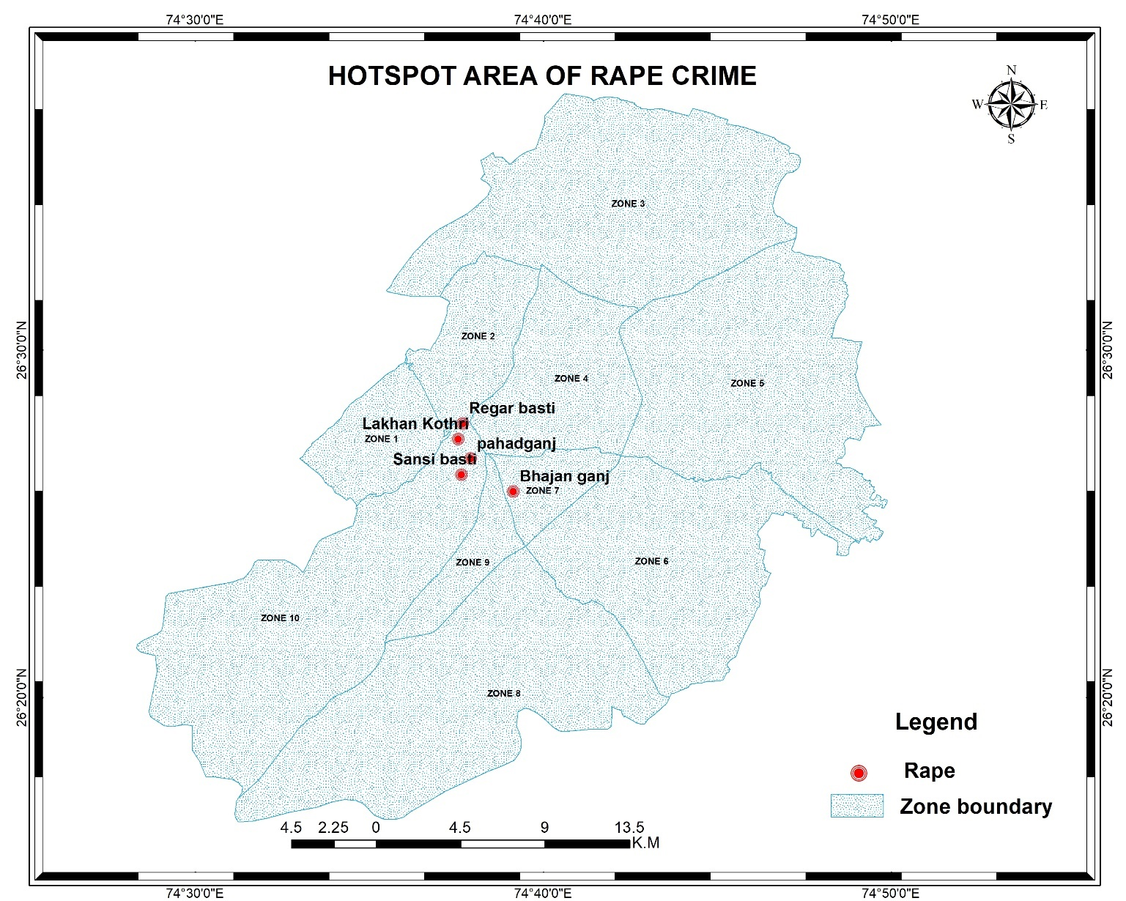

Map7- Hotspot area of rape cases

ROBBERY
Robbery is the act of taking anything of worth or attempting to steal it when using force, the threat of force, or terror. Robbery is crime against person. A person who knowingly or intention ally takes property from another person or from the presence of another person.

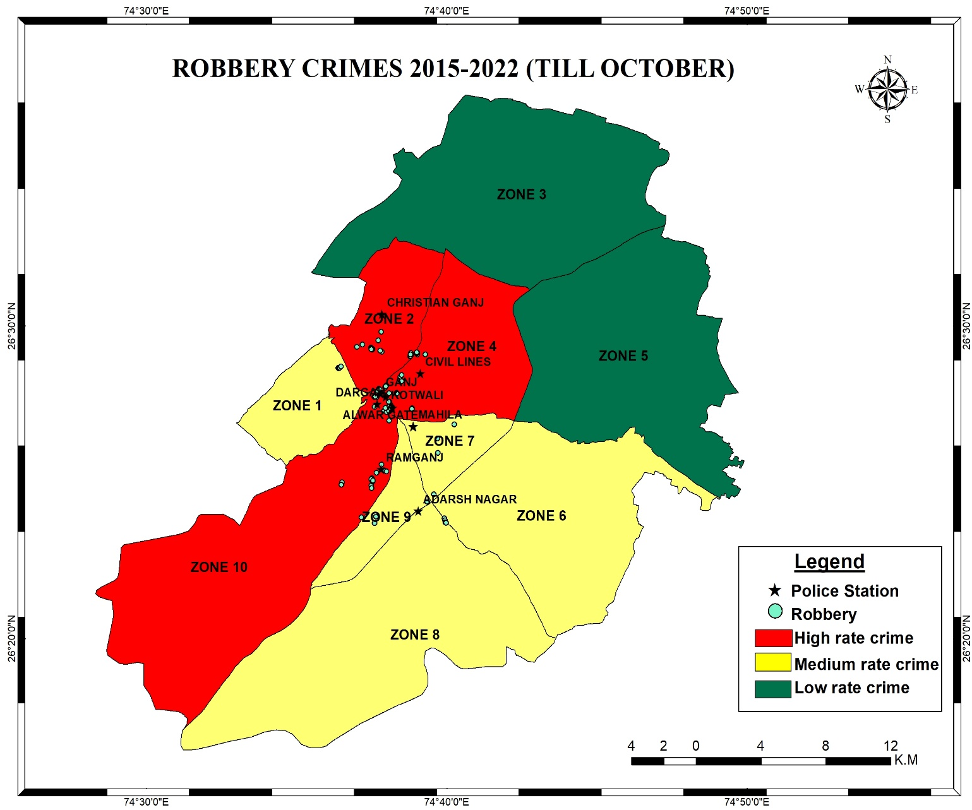
Map 8- zone wise Robbery cases are registered in seven-year crime
After studying, more robbery cases were found in zone 4, zone 2 and zone 10, comparatively other zones. At comparison to the other nine police stations where robbery cases have been registered, more cases of rape have been detected in Christian Ganj, Adarsh Nagar and Ramganj police stations on the robbery crime map for the years 2015–2022 (till October).

Graph 4- Robbery crime rate year wise
According to this graph more cases were occurred in 2016 and 2022, comparatively other years.
Crime forecasting refers to the basic process of predicting crimes before they occur. In excel Microsoft office use forecast linear technique.
Forecast value

2023 | 34.46428571
2024 | 37.42857143
2025 | 40.39285714

After studying, for 2015 -2022 (till October) crime map of robbery, found that robbery occurred in the major in three police station area. Hotspot area found near Ramganj, Adarsh Nagar and Christian Ganj zone area.
In Ramganj area- shashibasti
In Adarsh Nagar area- makupura, pravatpura
In Christian Ganj area- shastri nagar, veer garden, rati dang
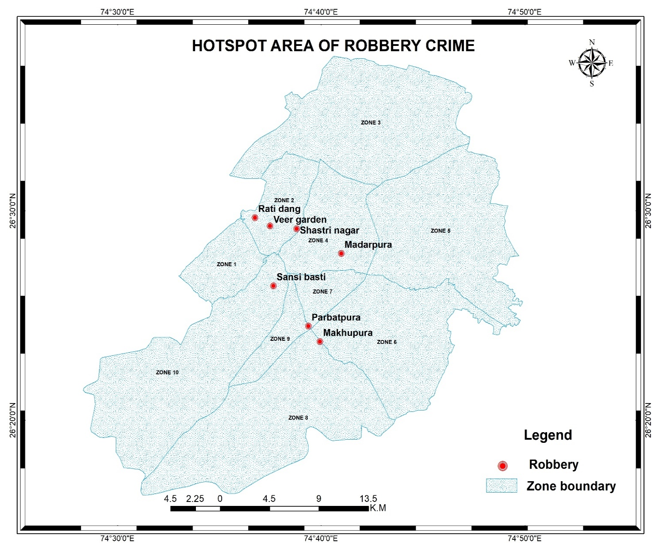

Map9- Hotspot area of robbery cases

KIDNAPPING
kidnapping, also spelled kidnaping, criminal offense consisting of the unlawful taking and carrying away of a person by force or fraud or the unlawful seizure and detention of a person against his will.

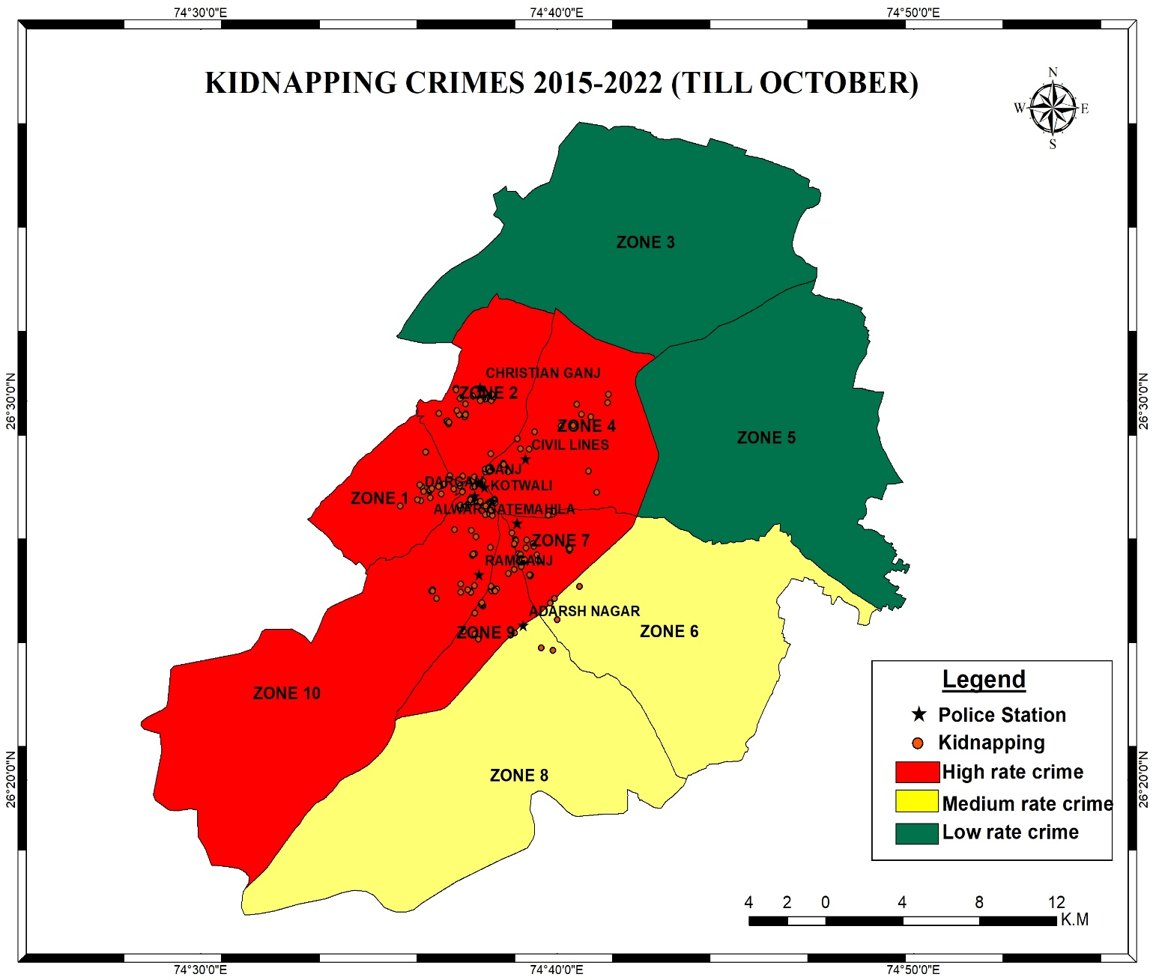
Map 10- zone wise Kidnapping cases are registered in seven-year crime
Map of Kidnapping crime for the years 2015 to 2022 (through October), after study. More rape cases were found in the police station at the Ganj and Dargah. Rape cases increased in 2019, 2021 and 2022 compared to previous year.

Graph 5- Kidnapping crime rate year wise
According to this graph more cases were occurred in 2019, 2021 and 2022, comparatively other years.
Crime forecasting refers to the basic process of predicting crimes before they occur. In excel Microsoft office use forecast linear technique.

Forecast value

2023 | 97.32142857
2024 | 102.0595238
2025 | 106.797619

After studying, for 2015 -2022 (till October) crime map of kidnapping, found that kidnapping occurred in the major in four police station area. Hotspot area found near Ramganj, Alwar gate, Ganj and Christian Ganj zone area.
In Ramganj area- shashibasti
In Alwar Gate area- makupura, pravatpura
In Christian Ganj area- shastri nagar, veer garden, rati dang

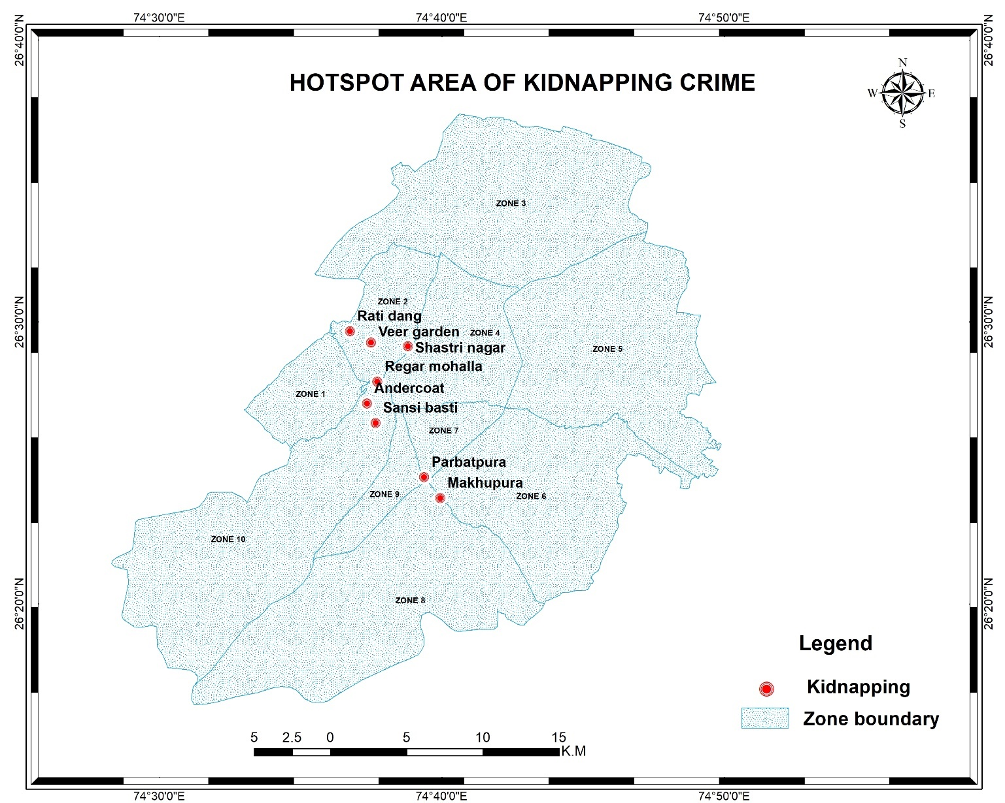

Map11- Hotspot area of Kidnapping cases

THEFT
Theft crimes are crimes that involve the unauthorized taking of the property of another with the intent to deprive them of it permanently.
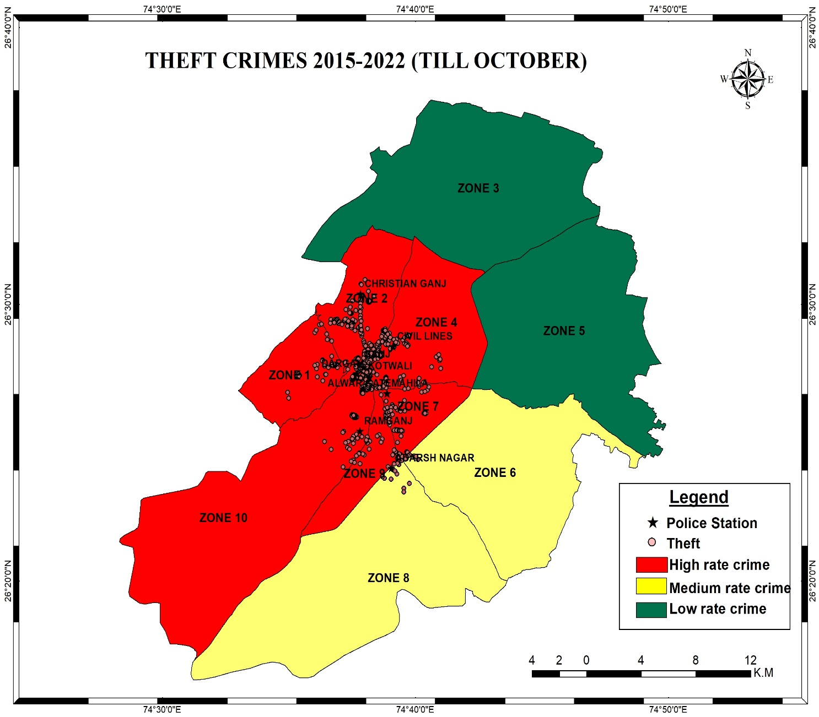

Map 12- zone wise Theft cases are registered in seven-year crime
Map of Theft crime for the years 2015 to 2022 (through October), after study. More theft cases were found in the police station at the Ganj and Dargah. Theft cases increased in 2019 and 2022 compared to previous year.

Graph 6- Theft crime rate year wise
According to this graph more cases were occurred in 2019, 2021 and 2022, comparatively other years.
Crime forecasting refers to the basic process of predicting crimes before they occur. In excel Microsoft office use forecast linear technique.

Forecast value

2023 | 508.3214286
2024 | 528.2261905
2025 | 548.1309524

After studying, for 2015 -2022 (till October) crime map of theft, found that theft occurred in the major in four police station area. Hotspot area found near Kotwali, Adarsh Nagar, Ramganj and Christian Ganj zone area.
In Christian Ganj area- chupati, Hari bhau uphaday, Pancheel block2
In Kotwali area- K.C. complex, Swami complex, Amar Plaza, Prabhat cinema, near P.N.B. Kachahri road, near Jag amba bar
In Adarsh Nagar area- Parvatpura circle, khanpura In Ramganj area- Rambag circle, Dorai, Pahad Ganj

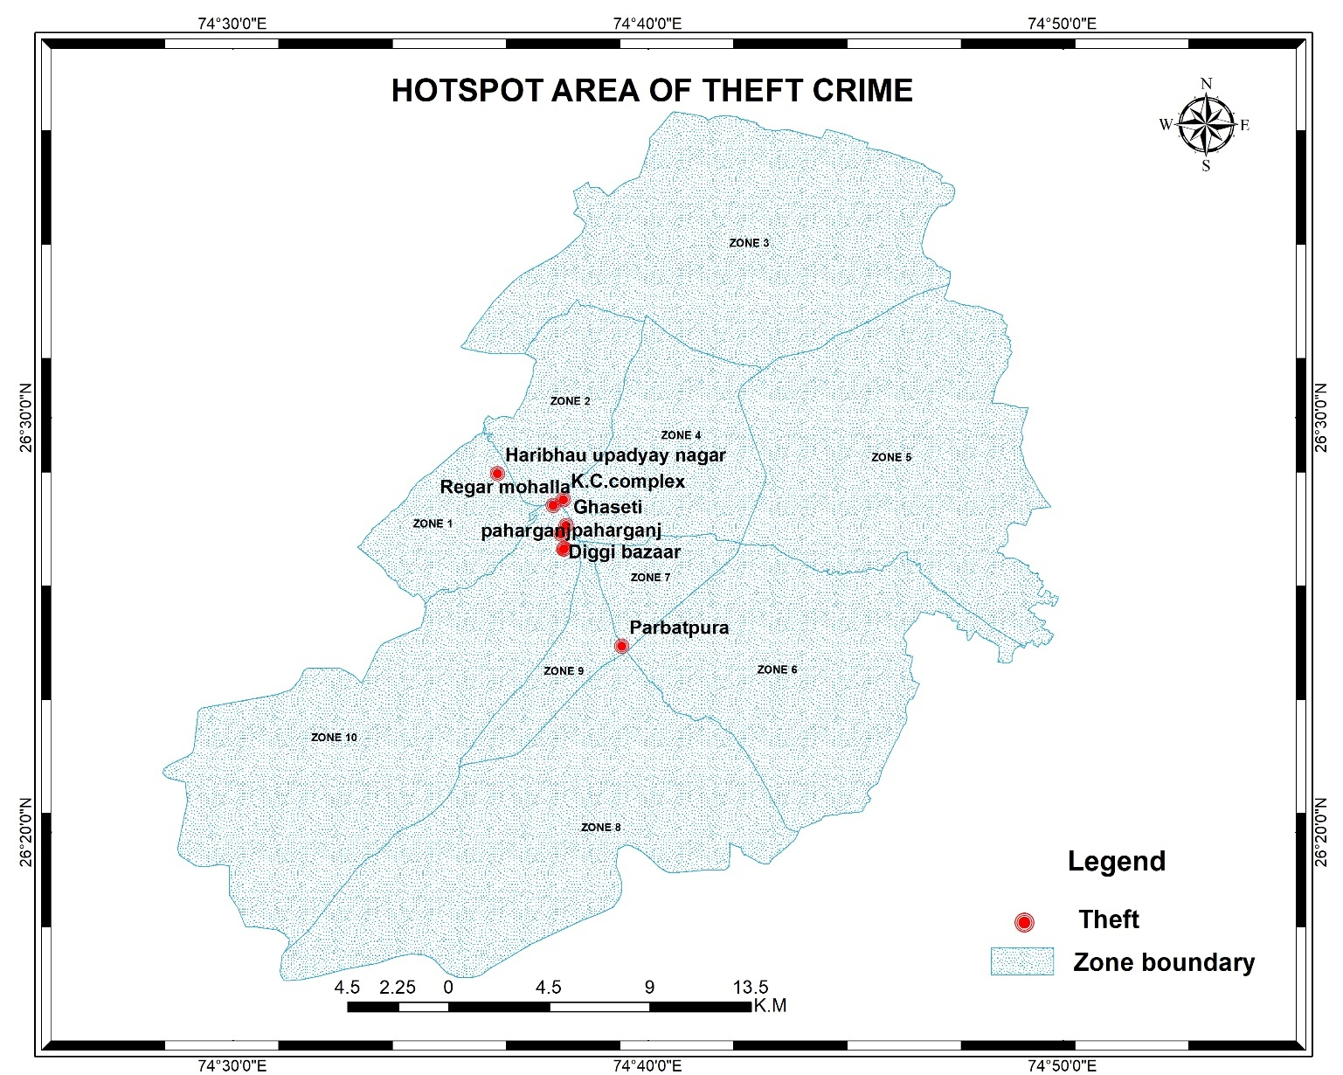
Map13- Hotspot area of Theft cases

GAMBLING
Gambling is the act of placing a bet or gamble on an event with an unknown conclusion with the hope of winning more money or valuables than the original sum. Whenever people gamble, you put something valuable, like money, at risk with the hope of winning more than you lost. To unlawfully stake money or something else of value on the happening of an uncertain event or on the ascertainment of a fact in dispute.
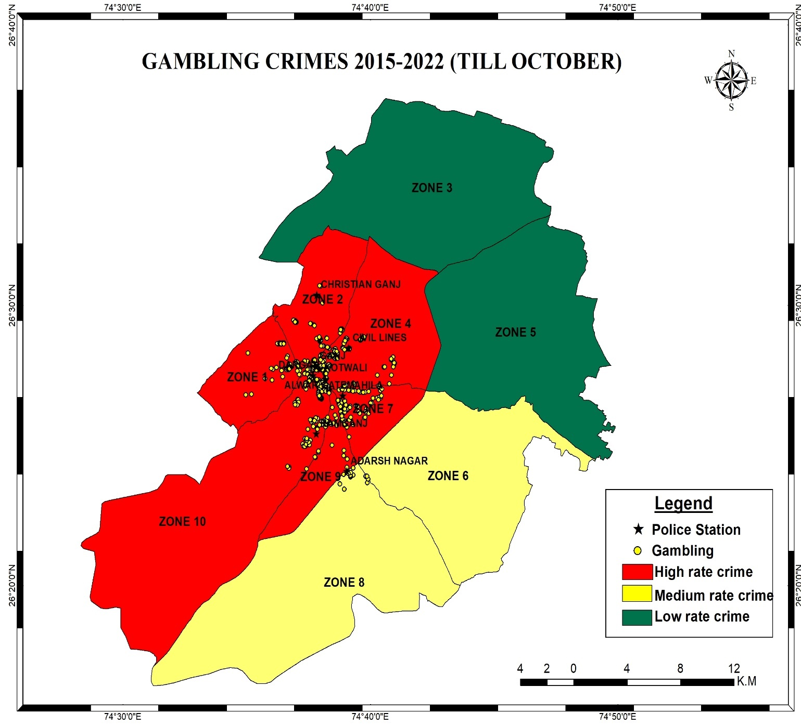
Map 14- zone wise Gambling cases are registered in seven-year crime
Map of Gambling crime for the years 2015 to 2022 (through October), after study. More gambling cases were found in the police station at the Ganj, Clock Tower, Ramganj and Alwar Gate. Gambling cases increased in 2019 and 2022 compared to previous year.

Graph 7- Gambling crime rate year wise
According to this graph more cases were occurred in 2017, 2018 and 2019 comparatively other years.
Crime forecasting refers to the basic process of predicting crimes before they occur. In excel Microsoft office use forecast linear technique.

Forecast value

2023 | 354.25
2024 | 339.83
2025 | 325.41

After studying, for 2015 -2022 (till October) crime map of gambling, found that theft occurred in the major in four police station area. Hotspot area found near Kotwali, Adarsh Nagar, Ramganj and Christian Ganj zone area.
In Christian Ganj area- near veer garden, Panscheel nagar,gouravpath, haribhau updhay colony
In Kotwali area- kc complex, naya bazaar, chuddi bazzar, purani mandi In Adarsh Nagar area- subhash nagar, chisti , pahad ganj, paravatpura In Ramganj area- chandravradai, khanpura

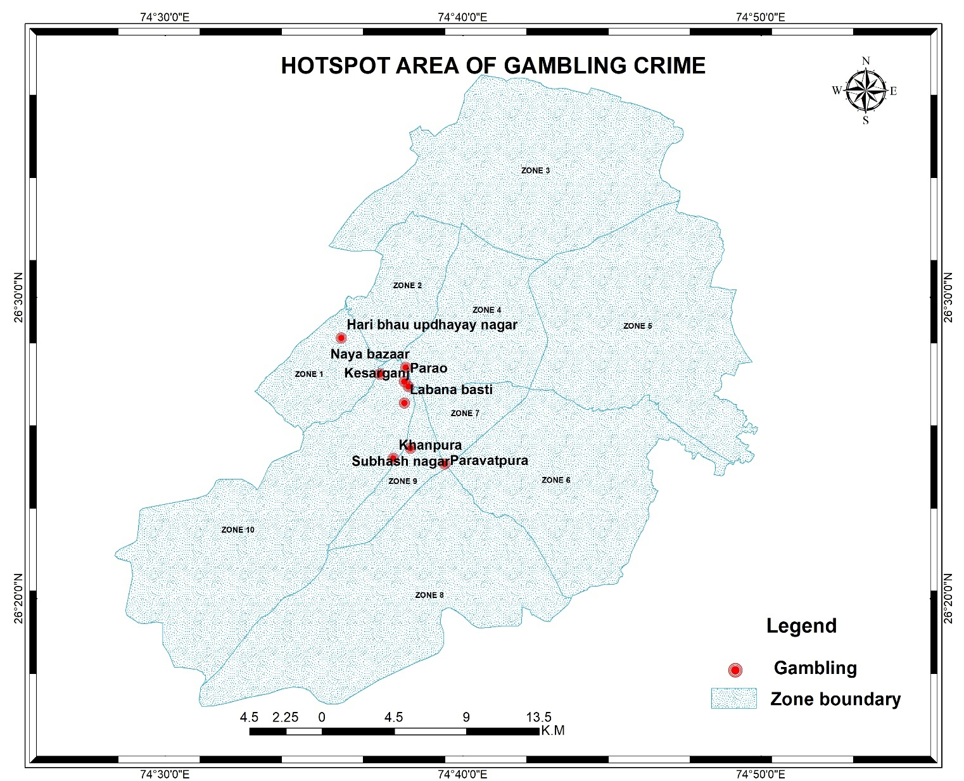

Map15-Hotspot area of Gambling cases

ENGRAVING
Naqbajni is an Arabic/Persian word. “Naqb” means a hole made in the wall, jani means one who does or does work, burglary or breaking the wall and stealing the goods of the house. Also called Engraving. This type of theft was very prevalent in the old times, because most of the houses were made of mud of bricks. In today’s era of cement-concrete, this method has reduced a lot.
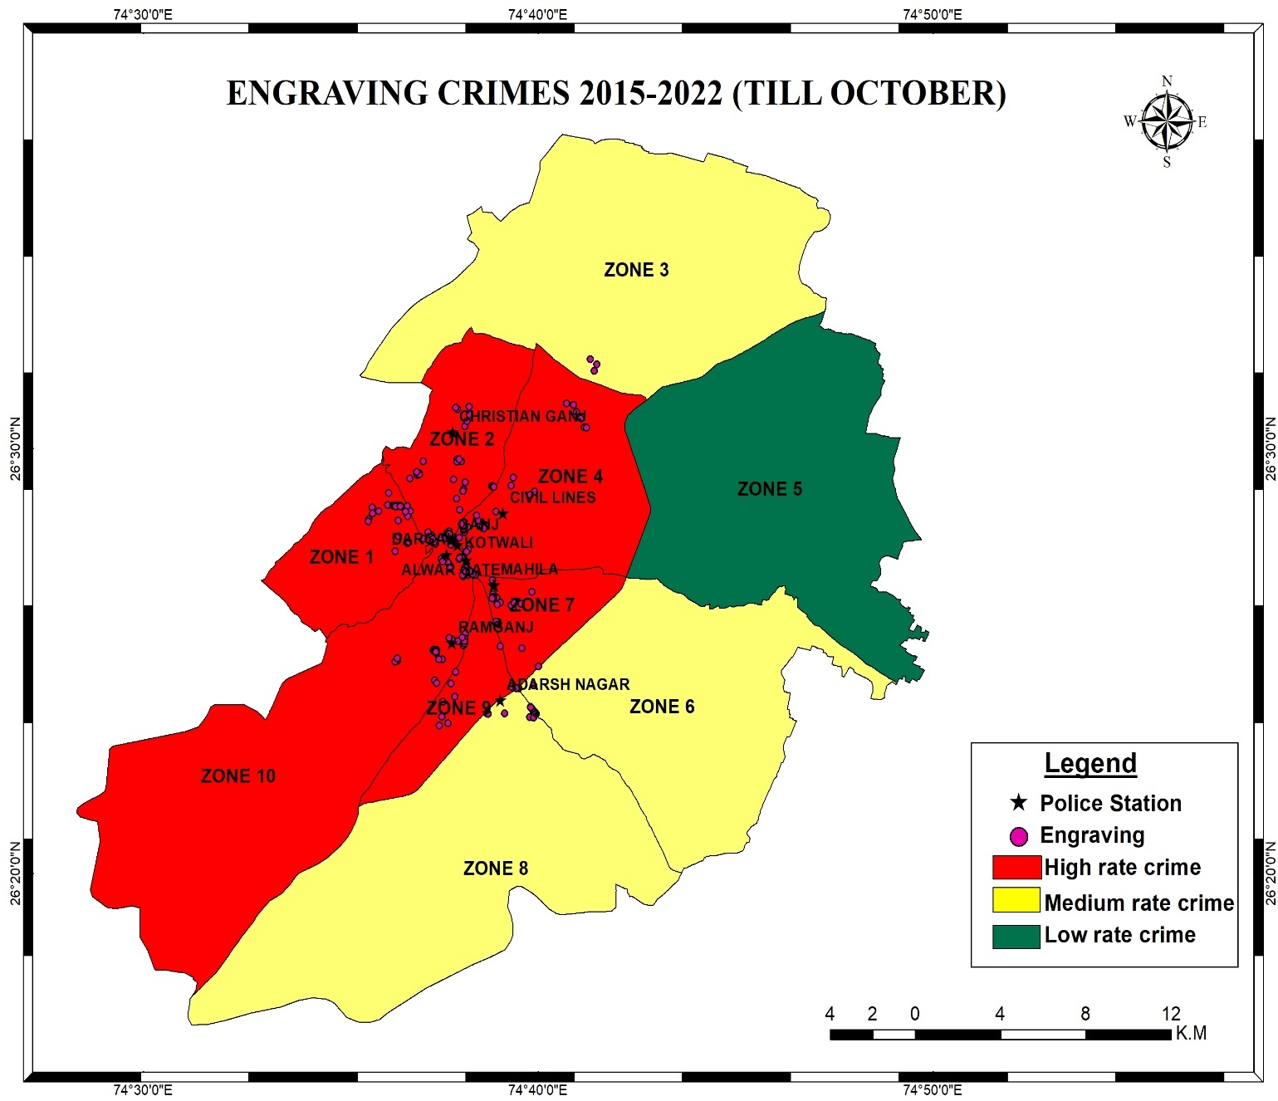
Map 16- zone wise Engraving cases are registered in seven-year crime
Map of Engraving crime for the years 2015 to 2022 (through October), after study. More Engraving cases were found in the police station at the Ganj, Clock Tower, Ramganj and Alwar Gate. Engraving cases increased in 2019 and 2022 compared to previous year.

Graph 8- Engraving crime rate year wise
According to this graph more cases were occurred in 2015, 2019 and 2022 comparatively other years.
Crime forecasting refers to the basic process of predicting crimes before they occur. In excel Microsoft office use forecast linear technique.

Forecast value

2023 | 114.60
2024 | 131.02
2025 | 134.66

After studying, for 2015 -2022 (till October) crime map of theft, found that theft occurred in the major in four police station area. Hotspot area found near and Christian Ganj zone area.
In Clock Tower area- Parau, Dayanand chouhraya In Kotwali area- Kachari road, Bapunagar
In Adarsh Nagar area- Bhihari ganj,near highway, paravatsar In Ramganj area-Solampur, sashi basti

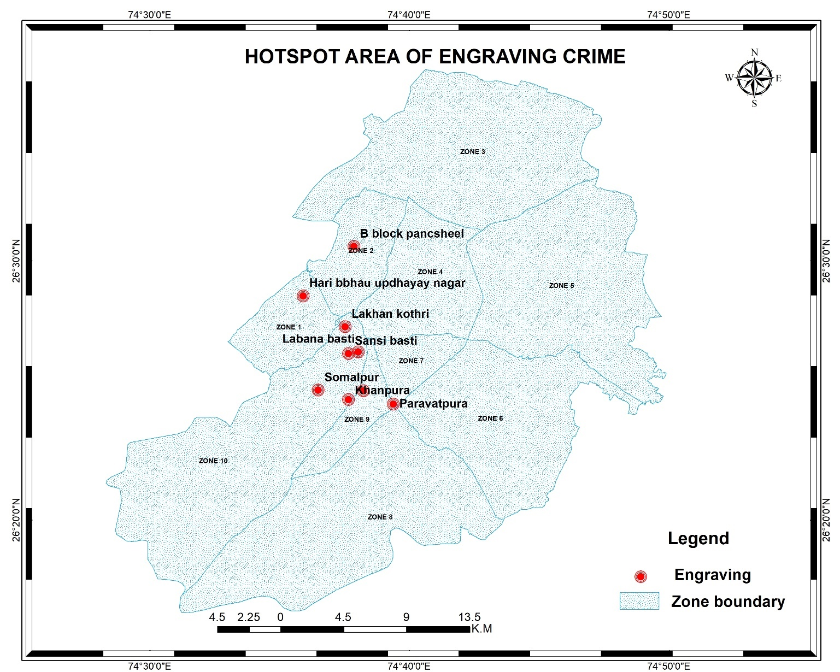
Map17- Hotspot area of Engraving cases

All types of crimes 2015- 2022 (till October)
Crime is a human phenomenon, and generating data for it requires the integration of the people and the existing security outfits (police) within the geographical location where the study is carried out. Crime mapping and analysis are recognised as powerful tools for the study and control of crime, because crime maps help police identify problems in a neighbourhood. The most powerful weapon in law enforcement is information technology. In the present study, we have done crime mapping and analysis for Ajmer seven years crimes.

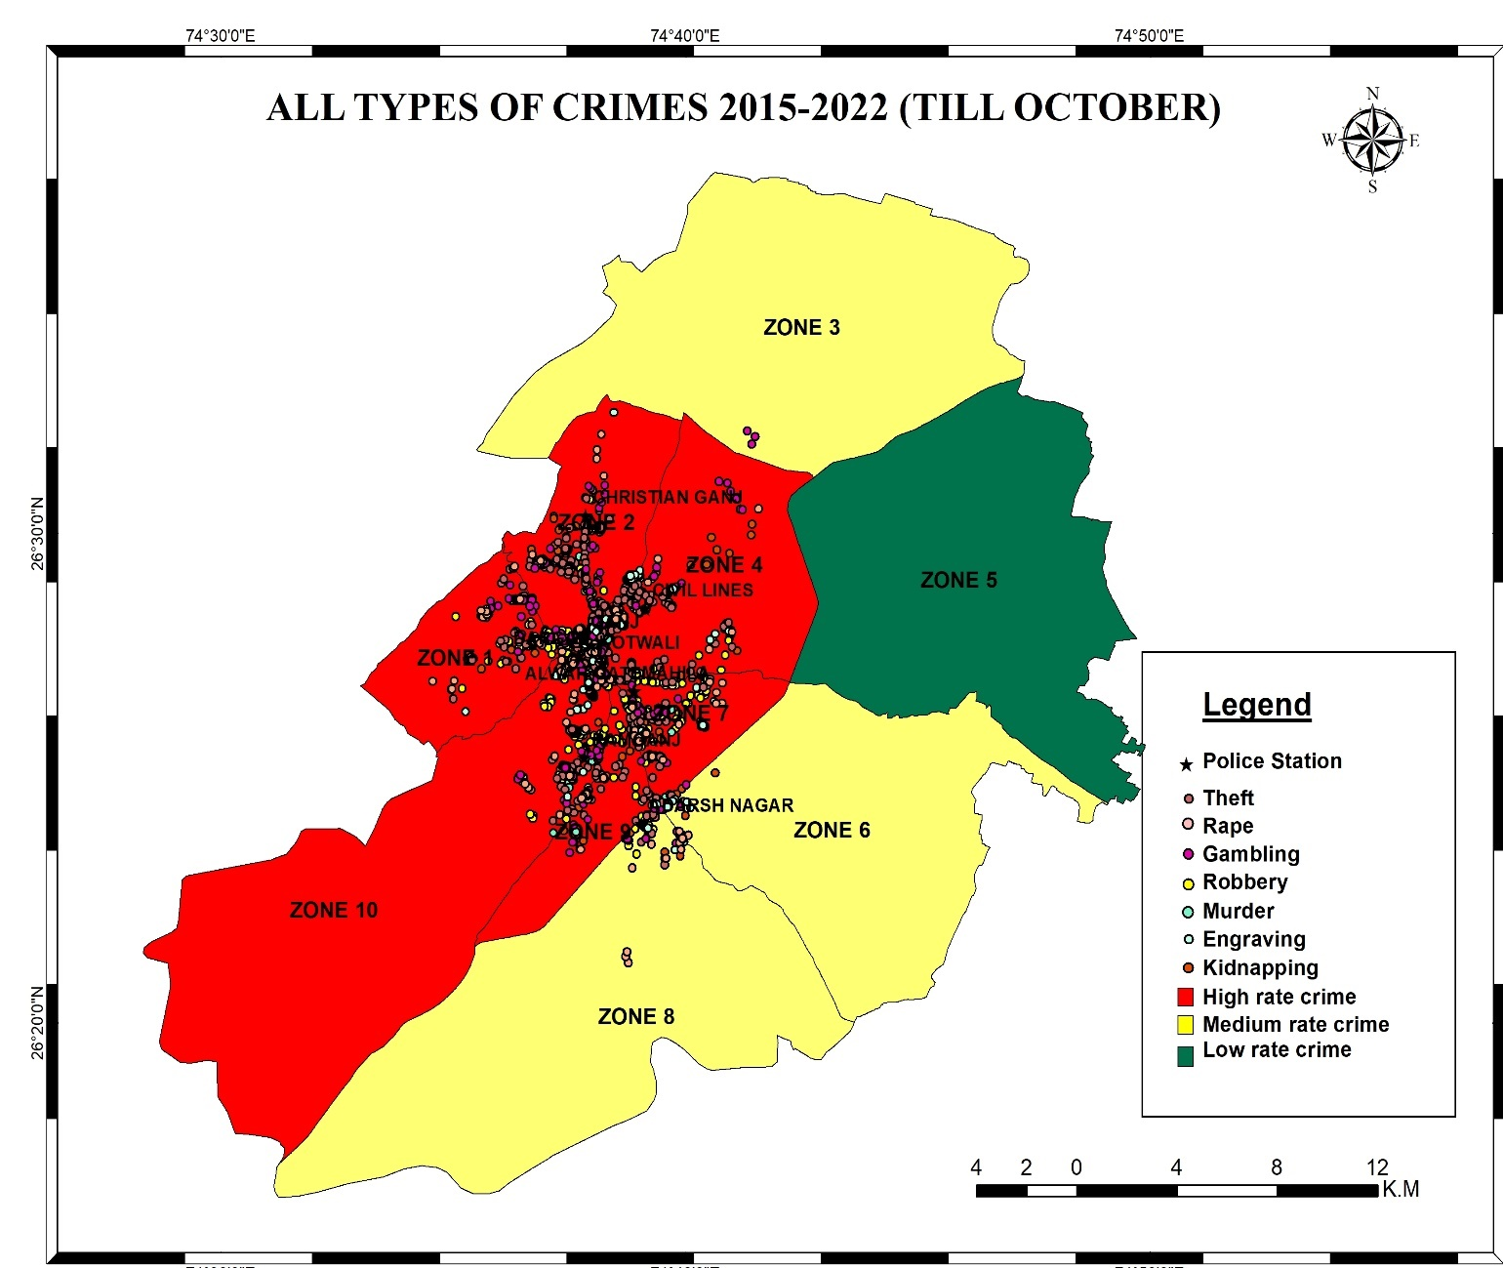

Map 18- zone wise all crime cases are registered in seven-year crime

According to crime data from the Ajmer police station, there are seven types of crimes recorded from 2015 to 2022 (till October). The central city region is congested, with sections along busy roads, congested alleys, and market complexes said to have higher population densities than the city's periphery.

Law enforcement agencies employ crime analysis as a strategy to reduce, prevent, and address crime issues by using criteria to identify prospective crime hotspots. Land use only has a significant impact on their immediate surroundings. Alcohol stores, cultural venues, businesses, bars, and low- income housing colonies are crime hotspots that are heavily attracted to crime, while depots, transports, gardens, and grandstands are also strongly attracted to crime.

Graph 9- All crime occurs in seven years in nine police station
The outcomes of the hot spot analysis were also verified by conducting ground truthing surveys, which indicated the details of the crowded areas of Dargah, Ganj, Kotwali, Christian Ganj, and Purani Mandi. Crime is highly common in the areas near Madar Gate, Nala Bazar, Kaiser Ganj, and Kutchery Road. The key causes of these criminal occurrences that were examined included the high percentage of unemployed people, the high rate of ignorance, people who work largely for day pay, and the low per-capita number of street and footpath sellers. Another supporting field observation related to local drug and alcohol consumption Venues, businesses, bars, and low-income housing colonies are crime hotspots that are heavily attracted to crime, while depots, transports, gardens, and grandstands are also strongly attracted to crime.

COMPARING 2015 AND 2019 CRIME DATA
When I compared the crime rates in 2015 at 1009 and in 2019 at 1415, I found that the major crime rate increases were gambling, kidnapping, and theft crimes. Comparatively, the crime rate in 2015 increased in 2019.

Graph 10- Crime in year 2015
In 2015, 1009 crime cases were reported to nine police stations. Major crimes are theft and gambling (439 cases of theft and 320 cases of gambling).
In this region, the major hotspots are Ganj, Christian Ganj, and the Clock Tower Area.

Graph11- Crime in the year2019
In 2019, 1415 crime cases were reported to nine police stations. Major crimes are theft, engraving and gambling (520 cases of theft, 136 cases of engraving and 539 cases of gambling).
In this region, the major hotspots are Ganj, Christian Ganj, and the Clock Tower Area.

CONCLUSION

In this study, we utilized crime mapping and analysis to investigate crime trends and patterns in Ajmer Tehsil from 2015 to 2022. By analyzing data collected from all police stations, the control room, and the IPC Department, we were able to identify crime hotspots and types of crime prevalent in the region.
Our findings suggest that there has been an increase in the number of reported crimes over the seven-year period, with theft and gambling being the most commonly reported crimes. Moreover, we identified four police stations, namely Alwar gate, Ramganj, Civil line, and Christian ganj, with higher numbers of reported cases compared to other police stations.
While crime mapping and GIS are effective tools for identifying crime hotspots, we acknowledge that addressing the root causes of crime is essential to prevent and control crime in the long term. Poverty and lack of educational opportunities were identified as key factors contributing to crime in the region. Therefore, it is imperative to implement measures that address these issues to prevent the occurrence of crimes in the future.
The growing population and development in Ajmer have contributed to the rise in crime, particularly in densely populated areas. This emphasizes the importance of law enforcement agencies working closely with the local population to ensure the safety and security of the region.
In conclusion, our study highlights the significance of utilizing data-driven approaches to understand crime patterns and trends. By implementing effective strategies to prevent and control crime, we can ensure the safety and security of the local population. However, addressing the root causes of crime, such as poverty and lack of educational opportunities, is essential for long-term crime prevention. As such, it is crucial for law enforcement agencies to collaborate with relevant stakeholders to implement sustainable solutions that address the underlying issues leading to crime in the region.
Overall, our study emphasizes the importance of utilizing data-driven approaches to understand crime patterns and trends to implement effective strategies to prevent and control crime in the long run.

REFRENCES

- Dritsakis, Nikolaos & Gkanas, Alexandros. (2009). The Effect of Socio-Economic Determinants on Crime Rates: An Empirical Research in the Case of Greece with Cointegration Analysis. International Journal of Economic Sciences and Applied Research.
- Jalil, Hafiz & Iqbal, Muhammad. (2010). Urbanisation and Crime: A Case Study of Pakistan. The Pakistan Development Review.
- Kenny's Outlines of Criminal Law, J.W. Cecil Turner, Cambridge University Press, UK, 2013.
- Machin, Stephen, and Costas Meghir (2004) “Crime and Economic Incentives.”
- Maftei, Jana & Varvara, Coman. (2010). Considerations on the Legal Status of the Individual in Public International Law. Acta Universitatis Danubius :Juridica
- Mukherjee, Chandan &Rustagi, Preet &Krishnaji, N.. (2001). Crimes against Women in India: Analysis of Official Statistics. Economic and Political Weekly. 36. 4070-4080. 10.2307/4411293.
- Daniel F. Higgins, “A Crime Analyst’s Guide to Mapping”, A journal of Illinois criminal justice information authority,2003
- K. Jaishankar et. al., “Assessment of Spatial Distribution of Rural Crime Mapping in India: A GIS Perspective” A International Journal of Advanced Remote Sensing and GIS, Volume 2w, issue 1, pp.70-80, 2013.
- http://police.rajasthan.gov.in

