House Price Prediction Using Machine Learning

Chandan Kumar Pandey Diwanshu Kumar Raj
SCSE, Galgotias University SCSE, Galgotias University
Noida (U.P),India Noida (U.P),India
ckpandey8630@gmail.com dipuraj97098@gmail.com

Dr. Kirti Shukla
Galgotias University, Noida (U.P.), India

ABSTRACT

Since housing costs are closely tied to other elements like location, region, and population, predicting individual housing costs requires data other than HPI. There have been a lot of publications that use typical machine learning techniques to successfully estimate house prices, but they rarely analyse the performance of different models and ignore the less well-known but more sophisticated models. As a result, this study will utilise both conventional and advanced machine learning methodologies to investigate the differences between a number of advanced models in order to explore diverse influences of features on prediction methods. This study will deliver a positive outcome for housing price prediction and thoroughly validate a variety of model implementation strategies.
Keywords - Random forest regression, machine
learning

I. INTRODUCTION
The cost of any property was long ago determined manually. But the issue is that when done manually, 25% of errors happen, which results in financial loss. But modern technology has made a significant change. Machine learning is a popular form of technology today. The centre of machine learning is data. The industry for AI and machine learning is now expanding. Automation is a trend across all industries. However, we cannot train a model without data. Machine learning basically entails creating these models from prior data and utilising them to forecast future data. Because of the increasing population growth, there is a daily increase in the market need for homes. Because there aren't enough jobs in rural areas, people are moving there for economic reasons. As a result, housing in cities is in higher demand. People lose money because they are unaware of the true cost of that particular residence. Various Machine Learning techniques, including Leaner Regression, Decision Tree Regression, K-Means Regression, and Random Forest Regression, are used in this research to forecast the house's price. 20% of the data from the Kwon dataset is utilised for testing, and the remaining 80% is used for training. The strategies used in this work include features, labels, reduction approaches, transformation techniques, attribute combinations, setting missing attributes, and searching. for new correlations.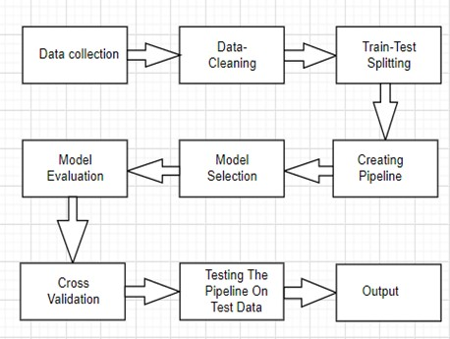
Fig 1. Research Flow Diagram

II. LITERATURE SURVEY

In order to effectively train a machine learning model, we must analyse several machine learning techniques in this conference paper. The current state of the economy can be seen in home cost trends, which also directly affect buyers and sellers. The actual cost of a property depends on numerous factors. They include things like the amount of bedrooms, bathrooms, and location. Costs are lower in rural areas than in cities. The price of a home increases with factors like proximity to a highway, a mall, a super market, employment opportunities, top-notch educational facilities, etc. A few years ago, real estate businesses tried manually predicting property prices. A unique management team is present in the organisation to forecast the cost of any real estate property. They manually determine prices by analysing historical data. However, that prognosis has a 25% inaccuracy rate. Consequently, both vendors and purchasers lose out. As a result, numerous algorithms for predicting home prices have been created. The advance house prediction system was proposed by Sifei Lu and Rick Siow. The major goal of this system was to create a model that could accurately estimate property prices based on other features.
P. Durganjali suggested utilising classification algorithms to anticipate the price of resale homes. In this study, multiple classification algorithms like Leaner regression, Decision Tree, K-Means, and Random Forest are employed to predict the selling price of a house. The physical characteristics of a home, its location, and even the economy all have an impact on its price. Here, we use RMSE as the performance matrix for various datasets, apply these methods, and identify the most accurate model that accurately forecasts better outcomes.

Sofie Lu suggested a hybrid regression method for forecasting home prices. This research examines the creative feature engineering method using a small dataset and data features. Recently, the proposed method was implemented as the crucial kernel for "House Price: Advanced Regression Techniques" Kaggle challenge. The purpose of the paper is to forecast realistic prices for clients taking into account their objectives and budgets.

By analysing the provided features, this paper attempted to estimate the price of a house. To create a prediction model, many machine learning techniques such as linear regression, decision trees, and random forests are used. Data collection, pre-processing, data analysis, and model building were done in a step-by-step manner. The results of every model evaluation are then stored in a ".txt" file. After considering training data, Random forests provide the best outcome out of these. Random Forest was determined to have the highest accuracy, at about 87%.

III. PRAPOSED SYSTEM

We use machine learning methods including Leaner Regression, Decision Tree, k-Means, and Random Forest to forecast the price of homes in this suggested system. We developed the "House Price Prediction Using Machine Learning" algorithm and used several features to forecast the price of houses. We may train a model in this suggested system using a variety of features, including ZN, INDUS, CHAS, RAD, and others. the previously collected data, of which 80% is used for training purposes and the remaining 20% for testing purposes. Hare, a ".csv" file contains the raw data. To address these issues, we primarily utilised two machine learning libraries. Pandas was the first, and "numpy" is the second. The ".csv" file was loaded into the Jupiter notebook using pandas, which was also used to clean and alter the data. Another was sklearner, which was used for actual analysis and offers a number of built-in functions that aid with issue solving. Numpy, another library, was additionally utilised. Numpy was utilised for the train-test splitting process..

IV. SYSTEM DESIGN AND ARCHITECTURE

Stage 1: collection of data

We have gathered information about real estate from a variety of online real estate databases. Such data include attributes like "ZN," "INDUS," "RAD," "CHAS," "LSTAT," "CRIM," "AGE," and "NOX," among others, and one label is "MEDV." We must gather information that is properly organised and classified. Data is always required at the outset of any machine learning problem. Without dataset validity, there would be no sense in analysing the data.
Stage 2: Pre-processing of the data

Our data is cleaned up at this step. Our dataset may contain missing values. Our missing values can be filled in one of three ways: 1) Remove the data points that are missing. 2) Remove the entire attribute.

Stage 3: preparing the model
Data is divided into two parts during this phase: training and testing. 80% of the data is used for training, and the remaining 20% is used for testing. Target variable is included in the training set. Different machine learning techniques are used to train the model while obtaining the outcome. The results of these Random Forest regressions are more accurate.

Stage 4: Model testing
The trained model is then used to estimate house prices on a test dataset. '.joblib' is used to save the learned model.
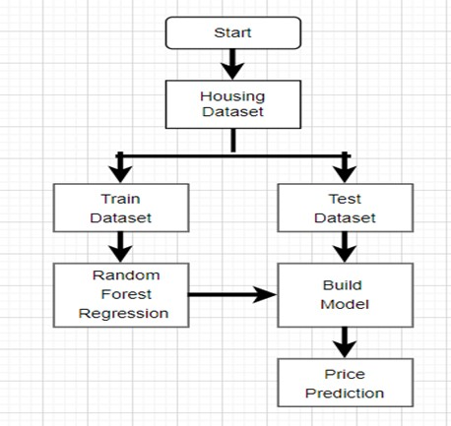
Fig 2. The generic flow of development

V. METHODOLOGY

I. Algorithms: Several machine learning algorithms were researched throughout the development of this model. Leaner regression, Decision tree, K-mean, and Random forest techniques are used to train the model. Out of this, Random Forest provides the most accurate housing price prediction. The size and type of data being used determine the algorithm to be employed. The best fit for our model is Random Forest.

II. Random Forest Regressor: The random forest regressor analyses provided features to train the model while observing features of an attribute. Data is analysed using a Random Forest regressor from the graph, attribute combinations, labels with features, and the system.

VI. IMPLEMENTATION

Phase I: Data Processing
The missing attribute is handled in this phase using the mean value. Drop out is the desired feature. The procedure is carried out using the Pandas library. Use the Matplotlib Python tool to see the dataset graph. Next, try to identify some attribute combinations and fill in the blanks with appropriate values. We divided the data so that 80% was used for training and the remaining 20% was used for testing. After data processing is complete, construct a suitable pipeline for model execution.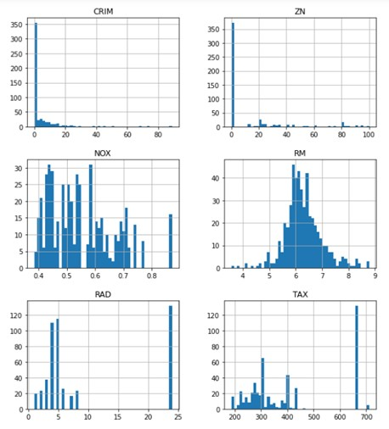

Fig 3. Visualization of data graph

Phase II: Correlation-seeking
We are looking for a fresh association between different attributes. Strong positive correlation or strong negative correlation with our label are provided by this correlation.
Utilize scatter matrix from the pandas library when combining attributes.
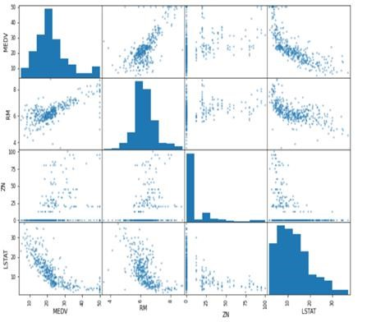

Fig 4. Visualization of attribute correlations

Discover some fresh relationships.
Try to identify a new characteristic from a collision with an existing one. For ex. Using the terms "TAX" and "RM," the new attribute "TAXRM" is discovered. Our MEDV=1.00000 and TAXRM=-0.558626, indicating a strongly negative correlation between "TAXRM" and "MEDV."
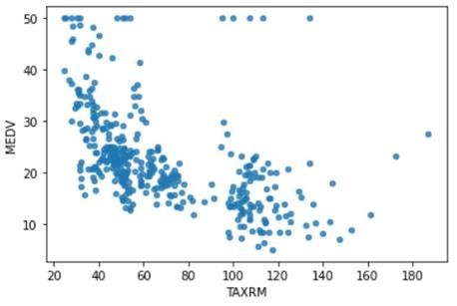

Figure 5: A novel attribute combination

Show the data point for the new attribute "TAXRM" in relation to "MEDV," Hare. We can conclude from the analysis of such data that the relationship is excellent for our model. Similarly, look for novel combinations of previously used attributes..
Phase III: To add any lacking characteristics
Three different values can be set for missing values in data: 1) Remove the problematic data point. 2) Remove the entire attribute. 3) Set the value to a certain amount (0, mean or median). Hare, we are unable to remove the data point from the data, therefore we cannot use the first option. The second choice is unworkable. In order to set missing attributes, we must select option number three.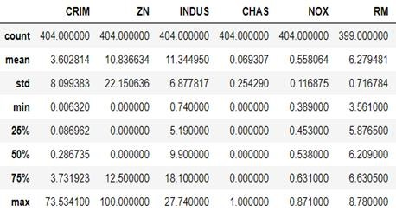

Fig 6. Before setting missing attributes

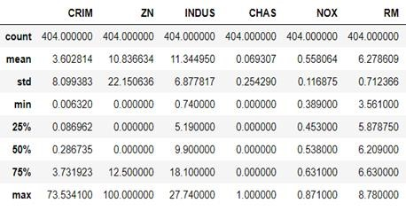

Fig 6.1. After setting missing attributes

The "RM" column in the data above has a total of 399 data points out of 404. Missing data points exist. to fill in the missing points using the median value. After being set, all 404 of the data points in the "RM" column are complete. Creating a pipeline for the execution comes next. From the Sklearn import pipeline for this purpose.
Phase IV: Model fitting
A Random forest regressor from the Sklearn package is used to train a model. The predict function used to forecast outcomes and the model is saved with the extension ".joblib".
VII. OUTCOMES

to solve this challenge using a variety of machine learning approaches. That said, Random Forest predicts outcomes more accurately than other models..

Final RMSE =  2.9131988953 | Mean | Standard Deviation
Leaner  Regression | 4.221894675 | 0.752030492
Decision Tree | 4.189504504 | 0.848096620
K-Means | 21.91834139 | 2.115566025
Random Forest | 3.494650261 | 0.762041223

Fig 7. Model outputs

CONCLUSION

The goal of the paper, "House Price Prediction Using Machine Learning," is to forecast house prices using a variety of attributes on the data. Based on our investigation, we determined the RMSE to be 2.9131689 To make this model distinct from other prediction systems, we must include more parameters like tax and air quality. People can purchase homes on a budget and minimise financial loss.

UPCOMING WORK

In this article, deployment using Flask and automated result file generation are currently being worked on. For forecast, use a different country housing data set. This paper also covers other industries and nations, but those aren't yet fully investigated..

REFERENCES

- Ayush Varma, Abhijit Sarma, Sagar Doshi,
Rohini Nair - “Housing Price Prediction Using Machine Learning and Neural Networks” 2018, IEEE.
- G.Naga Satish, Ch.V.Raghavendran, M.D.Sugnana Rao, Ch.Srinivasulu “House Price
Prediction Using Machine Learning”.IJITEE, 2019.
- CH. Raga Madhuri, G. Anuradha, M. Vani Pujitha -” House Price Prediction Using Regression Techniques: A Comparative Study” 2019 in (ICSSS),IEEE.
- Sifei Lu, Zengxiang Li, Zheng Qin , Xulei Yang , Rick Siow Mong Goh - “A hybrid regression technique for house prices prediction” 2017,IEEE
- Bharatiya, Dinesh, et al. “Stock market prediction using linear regression.” Electronics,
Communication, and Aerospace Technology (ICECA), 2017 International conference of. Vol. 2. IEEE, 2017.
- Vincy Joseph, Anuradha Srinivasaraghavan-
“Machine Learning”.
- Trevor Hastie, Robert Tibshirani, Jerome
Friedman- “The Elements of Statistical
Learning”.
- Tom M Mitchell- “Machine Learning”
- Saleh Hyatt- “Machine Learning Fundamentals”.

