BIOMETRIC AUTHENTICATION IN ATM USING RFID
Ms. Shobha Shanmugam ¹, Bhavana. B ², B. Koushik ³, Hemanth. K ⁴, B. Sahiti ⁵
¹ Sr. Asst. Professor, ^{2,3,4,5} Students
^{1,2,3,4,5} Department of Information of Science and Engineering,
^{1,2,3,4,5} New Horizon of College of Engineering, Bangalore, India.
¹nhceshobha@gmail.com, ²bhav2509ana@gmail.com, ³koushikboggarapu4228@gmail.com, ⁴hemanthkarumudi@gmail.com,
⁵sahithibhavanam08@gmail.com

Abstract:
Automated teller machines are being used widely to carry out everyday transactions. This has created a need to improve and strengthen the security of these machines. Biometric authentication has proven to be reliable, cost effective and secure. Fingerprint authentication of the ATM card will ensure high level of safety for the user. The system must only allow an authenticated user to access the card and if the authentication fails an OTP must be sent to the user to validate. The data can be collected and stored using RFID technology.
Keywords: fingerprint, RFID, Biometric.

Introduction:
Fingerprint recognition and its applications are being widely studied owing to their large scope of usability in the field of computer security. ATM surveillance system needs to increase security by introducing a smart system based on embedded technology. The increased number of thefts and frauds in the ATM has increased demand for a

system that is secure compared to the existing system. Each person has a unique fingerprint structure. So, with the help of fingerprint recognition technology we can enable automatic identification of the ATM user. RFID technology is widely implemented to enable fingerprint authentication. This makes the transactions secure.

Existing system:
The existing ATM systems that are used work based on the personal identification number(pin) that is known only to the user. The ATM works like- the user inserts their card in the ATM and then the machine asks for a Personal Identification Number (PIN), if the pin is entered correctly the user can carry on with his transaction. But if the number is entered incorrectly thrice, most ATMs will retain the card or deny access.

System architecture:
The proposed system contains a fingerprint sensor, RFID tags, LCD screen and NODE MCU.

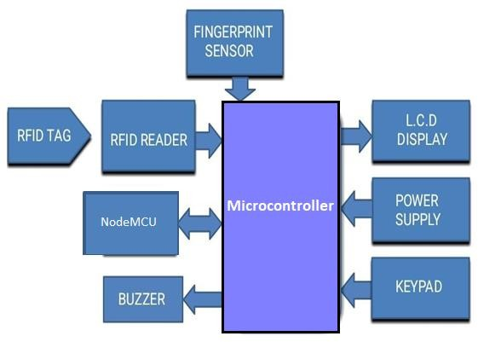
COMPONENTS DESCRIPTION
HARDWARE REQUIREMENTS:
- Arduino Uno:
An open-source electronic platform called Arduino is simple to use and put into practice. It is built on connecting hardware and software. The ATmega328 serves as the foundation for the Arduino Uno microcontroller board. It has 20 digital input/output pins, a 16 MHz resonator, a USB connector, a power jack, an ICSP header, and a reset button, of which 6 can be used as analogue inputs and the remaining 16 as PWM outputs.
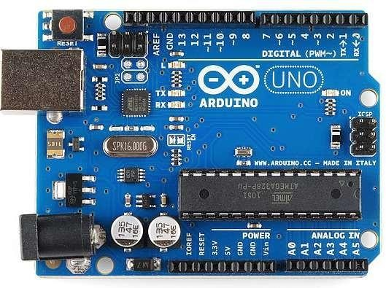

FIGURE: ARDUINO UNO
- LCD Display:
Utilizing liquid crystals' polarising and light-modulating properties, a liquid- crystal display is any flat-panel display. There are LCDs that can exhibit random figures (as on a general-purpose computer display) or fixed pictures with minimal visible or occlusive information, such text, numbers, and seven-segment displays like those used in digital clocks.
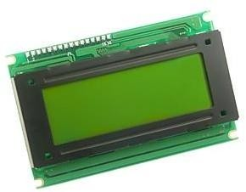

FIGURE: LCD DISPLAY

- BIOMETRIC SENSOR:
A biometric sensor, or transducer, is a gadget that transforms an individual's biometric characteristic into electrical impulses. Biometric sensors are typically semiconductor devices that use sophisticated algorithms to process images derived from a person's physical attributes. Every human being has some distinctive qualities that set them apart from other people in terms of their physiology and behavior.

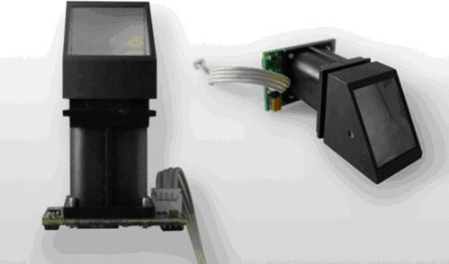

FIGURE: BIOMETRIC SENSOR

D . RFID READER:
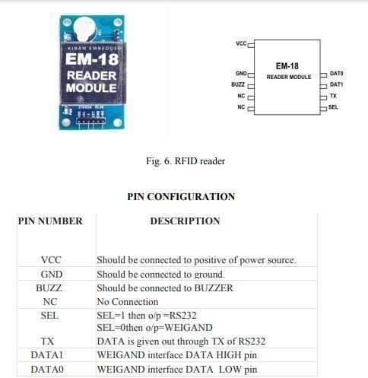
Sensor Electromagnetic fields are used by radio-frequency identification (RFID) to haphazardly spot and locate tags attached to objects. An RFID system is made up of a small radio transponder, a radio receiver, and a radio transmitter. When the tag get an electromagnetic interrogation pulse from an RFID reader device close-by, the tag transmits digital data, constantly an inventory number used to point out the item, back to the reader. An RFID consists of an integrated circuit and an antenna.
FIGURE: RFID READER

E. ESP8266 WIFI MODULE:

The ESP8266 WIFI Module is a self- collected SOC with an integrated TCP/IP protocol stack that setup any microcontroller to attach to your WiFi network. An application can be receive on the ESP8266.

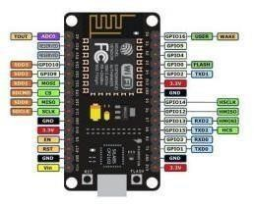

FIGURE: ESP8266 WIFI MODULE

F. PSU

For the inner components of a computer or PSU, transform mains AC power into low-voltage, managed DC power. All modern personal computers use switched mode power supply. The voltage in the UK is 240V 50Hz, while it is 120V 60Hz in the USA and 230V 50Hz in Australia.

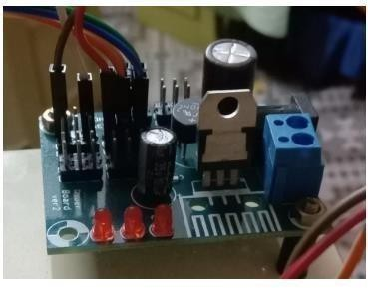

FIGURE: POWER SUPPLY UNIT

SOFTWARE REQUIREMENTS:
- Arduino IDE:
The Arduino IDE is also called as Arduino Software , it contains a text editor for writing code, a message box, a text terminal, a toolbar with buttons, and a different type of menus. It will connects to the Arduino hardware to upload programmes and manipulate with them.


FIGURE: ARDUINO IDE

- Embedded C:
The most popular programming language for creating electronic devices is embedded C. Every electronic system's processor is linked to embedded software. The performance of given tasks by the
CPU is greatly influenced by embedded C programming.

WORKING:
The primary objective of this project is to develop a security system by using fingerprint authentication. An embedded system is generally a combination of software and hardware components used to perform dedicated tasks. Few devices used in embedded systems are microprocessors and microcontrollers. A fingerprint authorization will run to match the prints, if match fails an alert will be raised else will proceed with the transaction. The required commands are loaded into Arduino, then it is programmed using Arduino programming language. This system consists of Arduino Microcontroller Unit, Fingerprint module, RFID tags, LED indicators and a buzzer alarm system and microcontroller that collect data from the fingerprint module. As it is based with the fingerprint authentication there is no point in disclosing of password or pin to the third parties. In this system, we mainly concentrate on customer security and ease of usage. By introducing fingerprint-based ATM system the entire process becomes hassle free. The usage of Arduino Uno board plays a very important role. The RFID tag contains information about the user and store it into database. The RFID reader reads customers tag, the tag is then matched as a first step of authentication and then proceeds to fingerprint verification using Fingerprint Module as a final step for authorization. With the combination of hardware devices and sophisticated software algorithms the whole system will be hack proof.

FLOW CHART:
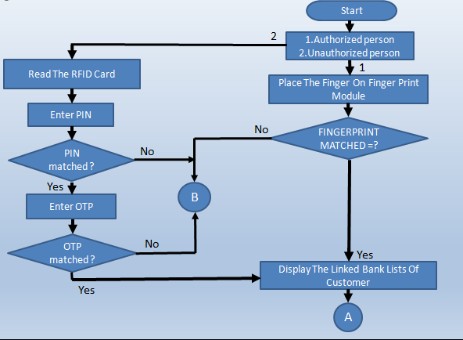

STEPS INVOLED:
- Authentication is done by using fingerprint.
- If a fingerprint matches transaction is processed.
- If the match fails, system requests for RFID card or to cancel the request.
- If there is a cancelation request raised or if the timeout occurs then transaction will be cancelled.
- If RFID card is inserted and if it matches with the database of the respective bank records, a request for pin verification will be raised.
- If pin is entered and authentication is successful system will proceed with the transaction.
  - As a final step an acknowledgement will be sent to user with the transaction status.

APPLICATIONS OF PROJECT:
Security purpose: Biometric data such as fingerprint or facial recognition, is unique to each individual and cannot be easily replicated, which makes it more authentication method than password or PINs that can be guessed or stolen.
Voter verification at polling booth: This can prevent voter fraud and ensure that only eligible voters are able to make their vote.
At airport: It can enhance security by ensuring that only authorized individuals are able to access secure areas of the airport and it can streamline the check in and boarding process.
Defence: It can enhance security by ensuring that only authorized person are able to access sensitive areas of equipment like weapons and it will help to prevent unauthorized access.

CONCLUSION:
The new system for handling multiple accounts using a single smart ATM card with enhanced security features such as OTP and face recognition is more efficient and cost-effective than the existing system. With this new system, users can easily manage their multiple accounts across various banks, eliminating the need to carry multiple ATM cards and remember multiple passwords. Additionally, the reduction in transaction costs will benefit customers, and decreased production of smart cards will benefit banks. Furthermore, implementing this system can prevent ATM fraud such as skimming, thus improving overall security of the banking system.

- REFRENCES :
- “IOT-Based ATM maintenance and security system” – V.prasana, R.sandeep kumar, C.deepak Kummar, s.Navin kumar – Department of ECE velammal Engineering college, Chennai, Tamil Nadu, India – international journal of applied Engineering research ISSN 0973-4562 volume 14,Number 6,2019.
- “Smart ATM Security Using Iot” - PNB Swamy, A. Sathi Babu, S. Sravanthi, P. Sasidhar, MD.Mobin ul haq , P.Narendra - Dept. of ECE, NRIIT, Vijayawada, Andhra Pradesh - e-ISSN: 2278-1676,p-ISSN: 2320- 3331, Volume 15, Issue 3 Ser. I (May
– June 2020
- “A multifactor secure authentication system for wireless payment” – Sugata sanyal , ayu Tiwari
, sudip sanyal - Indian Institute of Information Technology (IIIT), Allahabad (UP), India - DOI:10.1007/978-1-84996-074-8_13
- “Smart ATM security system using FRM, GSM, GPS” – Bharati M Nellagani, dr. N V Uma Reddy, Mr.Nithin Awasti – AMC engineering college.
- “Hard ware architecture of a HAAR classifier – bases Face detection system using a skip scheme”
- Jongkil Hyun, Junghwan Kim, Cheol-Ho Choi , and Byungin Moon - 1Graduate School of Electronic and Electrical Engineering, Kyungpook National University - 2021 IEEE International Symposium on Circuits and Systems (ISCAS) | 978 1-7281- 9201-7/20/$31.00 ©2021 IEEE
- “ATM security using Arduino” – B.Saranraj , N . Sri Priya Dharshini ,
R. Suvetha, K. Uma Bharathi , Department of electronics and communication engineering , 2020 6th international conference advanced computing and communication system.
- “secure online banking with biometrics” – Anum Tanvir kiyani , aboubaker lasebae , kamran ali - School of Science and Technology, Middlesex University, London, United Kingdom - 978-1-7281-4452- 8/20/$31.00 ©2020 IEEE
- “Security for ATM networks” - Vijay Varadharajan and Rajan Shankaran - Dept of Computing, University of W.Sydney, Nepean P.O.Box 10, Kingswood, NSW 2747, Australia - 0-7803-4198-8/97/$10.00 0 1997 IEEE.
- “Finger print authentication” - Aguilar, Gualberto; Sanchez, Gabriel; Toscano, Karina; Salinas, Moises; Nakano, Mariko; Perez, Hector (2007). [IEEE Second International Conference on Internet Monitoring and Protection (ICIMP 2007) - San Jose, CA, USA (2007.07.1- 2007.07.5)] Second International Conference on Internet Monitoring and protection (ICIMP 2007) – fingerprint recognition.,(),32- 32.doi:10.1109/ICIMP.2007.18
- “Secure electronic banking authentication” - Alsaaid Hajjisaaid , Yasser A. Ahmed - Department of Computer Engineering College of Computer University of Qassim Qassim - 2020 International Conference on Computing and Information Technology, University of Tabuk, Kingdom of Saudi Arabia.

Volume: 02, Issue: ICCIT- 1441, Page
No.: 89 - 92, 9 h & 1 0 Sep. 2020.
- “Design and Implementation of Anti - theft ATM Machine using Embedded Systems”,Raj and Anitha Julian, (ICCPCT 2015 IEEE)
- “Multi biometric systems” – Anil K.jain and Arun Ross January 2004/vol.47,No.1,pp.34-40
- “ATM security using fingerprint biometric identifier” - Moses okechukwu onyesolu , Ignatius majesty Ezeani - international journal of advanced computer science and applications , vol.3 , vol.4,2012 , pp.68-72
- “Designing a Biometric Strategy (Fingerprint) Measure for Enhancing ATM Security in Indian e-banking System” - S.S, Das and J. Debbarma, International Journal of Information and Communication Technology Research, vol.1, no. 5, pp.197-203, 2011.
- “Implementation of ATM Security by Using Fingerprint recognition” - GSM
P.K. Amurthy and M.S. Reddy, International Journal of Electronics Communication and Computer Engineering vol.3, no. 1, pp. 83-86, 2012
- “Design and Implementation of Security Based ATM theft monitoring system” - Sivakumar T., Gajjala Ashok,
K. Sai Venuprathap - (IJEI Aug 2013)
- “ATM robbery prevention using advanced security” - Sudipta Maiti, Mayur Vaishnav, Lajari Ingale - (IRJET Feb 2016)
- “A Safe guard against atm card ” - Shweta Sankhwar and Dhirendra Pandey - (ICAC 2016 IEEE)
- “A new business model for ATM transactions security using fingerprint recognition” – Sowmya Ravikumar , sandhya vaidyanatham , B.Thamotharan – International journal of engineering and technology (ISSN : 0975-4024), vol 5 No 3 jun-jul 2023
- “Enhancing ATM security using fingerprint and gsm technology” – V.padmapriya, s.prakasam – volume 80 – No 16,October 2013

