PERFORMANCE ANALYSIS OF A FOUR STROKE SINGLE CYLINDER DIESEL ENGINE BY USING TURBO CHARGER.
¹T.Mahesh, ¹P.Ganesh, ¹SK.Azaruddin, ¹T.Dharmendra Chari, ¹M.Tanoj, ²G. Gopi chandu babu
¹UG Students, Department of Mechanical Engineering, NRI Institute of Technology, Pothavarapadu, Elluru (district),
Andhra Pradesh -521212
²Associate professor, Department of Mechanical Engineering, NRI Institute of Technology, Pothavarapadu, Elluru (district),
Andhra Pradesh -521212
Abstract: Nowadays, turbo chargers and super chargers are employed in I.C engines. It is known that power output of engine increases with the increase in amount of air fuel mixture in the cylinder. This study has been undertaken to show the enhancement of performance of an engine using turbo charger may multiply output of an i.c engine without need to increase the size of cylinder. The turbo charger plays an important role to increase the amount of air. The turbo chargers are now becoming more and more popular in automobile applications. The aim of the turbo charger is to increase the engine volumetric efficiency by increasing density of intake gas (air) allowing more power per engine cycle. The purpose of the turbo chargers is increasing power output of the engine by supplying compressed air.

Key words: Turbo charger, 4-Stroke Single Cylinder Diesel Engine, Volumetric efficiency.

1. Introduction
This chapter introduces Turbo charger, types of Turbo chargers and usage of Turbochargers in Automobiles. The introduction of the turbo charger and it’s working is described as follows:
1.1. Introduction:
A turbocharger is a device that increases the air pressure fed to an internal combustion engine. It consists of a turbine and a compressor, which are connected by a common shaft. Exhaust gases from the engine drive the turbine, which in turn drives the compressor to compress the incoming air. This compressed air is then mixed with fuel and burned in the engine, resulting in a higher mass of air entering the cylinders and a corresponding increase in engine power. Turbochargers are commonly used in gasoline and diesel engines, particularly in high-performance or racing applications where increased power is needed. They can also be used to improve the efficiency of diesel engines by increasing the air pressure at low engine speeds, which can help to reduce emissions.
1.2 HISTORY OF A TURBO CHARGER:
Prior to the invention of the turbocharger, forced induction was only possible using mechanically powered superchargers. Use of superchargers began in 1878, when several supercharged two-stroke gas engines were built using a design by Scottish engineer Dugald Clerk. Then in 1885, Gottlieb Daimler patented the technique of using a gear-driven pump to force air into an internal combustion engine. The 1905 patent by Alfred Büchi, a Swiss engineer working at Sulzer is often considered the birth of the turbocharger. This patent was for a compound radial engine with an exhaust-driven axial flow turbine and compressor mounted on a common shaft. The first prototype was finished in 1915 with the aim of overcoming the power loss experienced by aircraft engines due to the decreased density of air at high altitudes. However, the prototype was not reliable and did not reach production. Another early patent for turbochargers was applied for in 1916 by French 1steam turbine inventor Auguste Rateau, for their intended use on the Renault engines used by French fighter planes. Separately, testing in 1917 by the National Advisory Committee for Aeronautics (NACA) and Sanford Alexander Moss showed that a turbocharger could enable an engine to avoid any power loss (compared with the power produced at sea level) at an altitude of up to 4,250 m (13,944 ft) above sea level. The testing was conducted at Pikes Peak in the United States using the Liberty L-12 aircraft engine. The first commercial application of a turbocharger was in 1925, when Alfred Bucchi successfully installed turbochargers on ten-cylinder diesel engines, increasing the power output from 1,300 to 1,860 kilowatts (1,750 to 2,500 hp). This engine was used by the German Ministry of Transport for two large passenger ships called the Preussen and Hanse Stadt Danzig. The design was licensed to several manufacturers and turbochargers began to be used in marine, railcar and large stationary applications. Turbochargers were used on several aircraft engines during World War II, beginning with the Boeing B-17 Flying Fortress in 1938, which used turbochargers produced by General Electric. Other early turbocharged airplanes included the Consolidated B-24 Liberator, Lockheed P-38 Lightning, Republic P-47 Thunderbolt and experimental variants of the Focke-Wulf Fw 190.
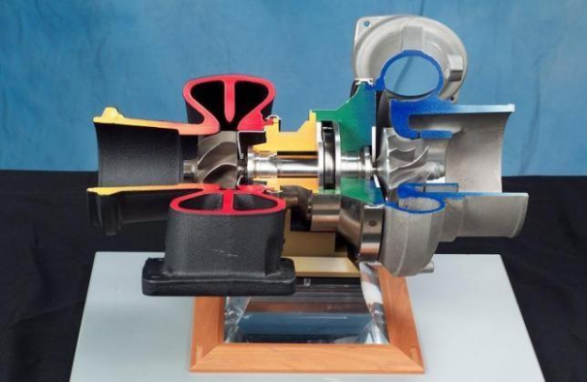
Fig1.1: Cut Section of Turbo Charger

1.3 Design:
Like other forced induction devices, a compressor in the turbocharger pressurizes the intake air before it enters the inlet manifold. In the case of a 23 turbocharger, the compressor, is powered by the kinetic energy of the engine's exhaust gases, which is extracted by the turbocharger's turbine.
The main components of the turbocharger are:
- Turbine – usually a radial turbine design
- Compressor – usually a centrifugal compressor
- Center housing hub rotating assembly
1.4 CLASSIFICATION OF TURBO CHARGERS:
- Single-Turbo.
- Twin-Turbo.
- Twin-Scroll Turbo.
- Variable Geometry Turbo.
- Variable Twin Scroll Turbo.
- Electric turbo.
1.Single-Turbo:

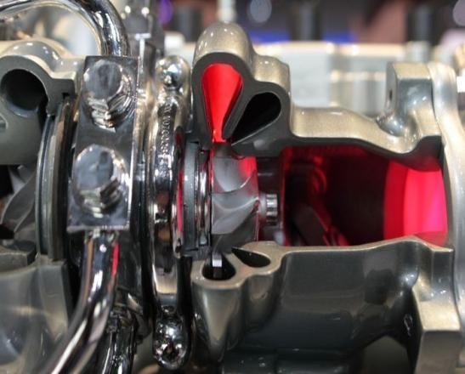
Fig1.2: Single Turbo Charger
Single turbochargers alone have limitless variability. Differing the compressor wheel size and turbine will lead to completely different torque characteristics. Large turbos will bring on high top end power, but smaller turbos will provide better low-end grunt as they spool faster. There are also ball bearing and journal bearing single turbos. Ball bearings provide less friction for the compressor and turbine to spin on, thus are faster to spool (while adding cost).
2. Twin-Turbo:
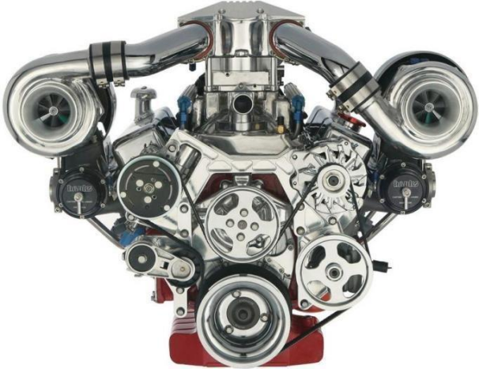
Fig1.3: Twin Turbo Charger

Twin-turbo (not to be confused with a twin Charger setup, which is a combination of a supercharger and a turbocharger) refers to an engine in which two turbochargers work in tandem to compress the intake fuel/air mixture (or intake air, in the case of a direct-injection engine). The most common layout features two identical or mirrored turbochargers in parallel, each processing half of a V engine's produced exhaust through independent piping. The two turbochargers can either be matching or different sizes.
3. Twin-Scroll Turbo:
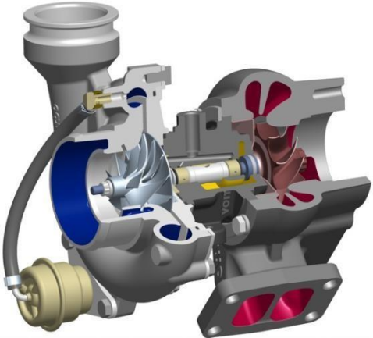
Fig1.4: Twin scroll turbo charger
Twin scroll turbocharger is a type of turbocharger that is commonly used in internal combustion engines. It's called a "twin scroll" turbocharger because it has two separate exhaust gas inlets, each leading to its own scroll or spiral-shaped housing that compresses the incoming air. The purpose of the twin scroll design is to reduce the turbulence and pressure losses that can occur in a single scroll turbocharger. By separating the exhaust gases into two streams, the twin scroll turbocharger can improve engine efficiency and responsiveness, particularly at low engine speeds. This is because the twin scroll design allows for a more precise control of the exhaust pressure pulses, which can improve the efficiency of the turbocharger and produce more power. Twin scroll turbochargers are often used in high-performance engines and racing applications, but they can also be found in some production cars. They are a popular choice for engine tuning because they offer improved throttle response, increased torque output, and a wider power band compared to single scroll turbochargers.
4. Variable Geometry Turbo:
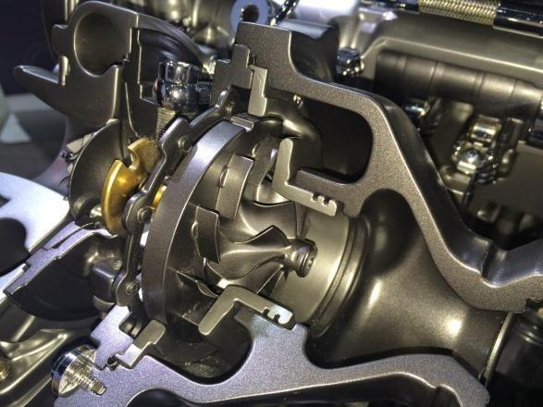
Fig1.5: Variable Twin Scroll Turbo Charger

Variable Geometry Turbo (VGT) is a type of turbocharger system that is used to improve the efficiency and performance of internal combustion engines. Unlike a traditional turbocharger, which has a fixed geometry, a VGT system allows for the adjustment of the turbine and compressor wheel size based on engine load and RPM. This results in a more responsive and efficient turbocharger system, as the turbo can be optimized for different operating conditions systems work by using an actuator to control the angle of vanes within the turbocharger. The vanes direct the flow of exhaust gases, which drives the turbine wheel. By adjusting the angle of the vanes, the amount of exhaust gas flow can be increased or decreased, which changes the size of the turbocharger's output. This allows the engine to produce more power and torque at low RPM, while also reducing turbo lag. The use of a VGT system can lead to improved engine efficiency, reduced emissions, and improved drivability. Additionally, VGT systems can be used to help engines meet emissions regulations by reducing the levels of nitrogen oxides (NOx) produced
5.Variable Twin Scroll Turbo:
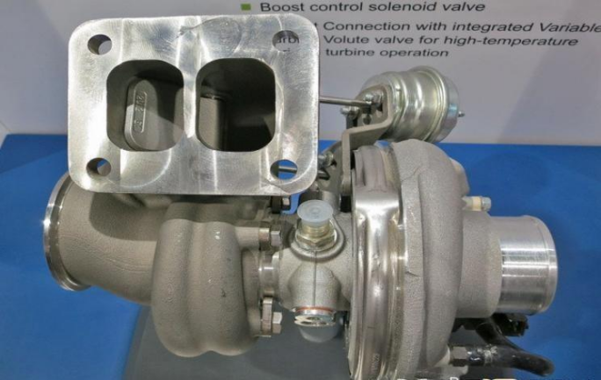
Fig1.6: Variable Twin Scroll Turbo Charger
A variable twin scroll turbocharger is a type of turbocharger used in internal combustion engines. The twin scroll design separates the exhaust gas into two separate streams before they enter the turbocharger. This helps to improve the turbocharger's response time and efficiency by reducing the mixing of hot and cold exhaust gases and minimizing pressure losses in the exhaust system. The "variable" aspect of the turbocharger refers to its ability to adjust the airflow it receives from the engine, which allows for more precise control over the turbocharger's output. This can improve the engine's performance and efficiency, particularly in high-performance applications.
6. Electric turbo:
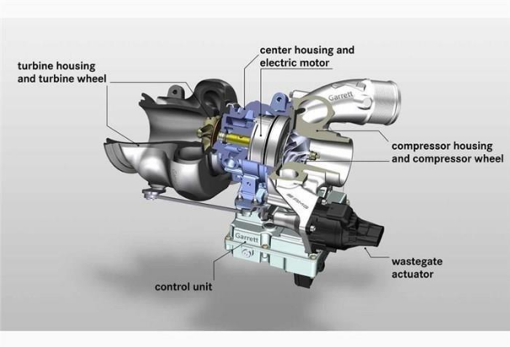
Fig1.7: Electric Turbo Charger
An electric turbocharger, also known as an electric turbo or an e-turbo, is a type of turbocharger that uses an electric motor to drive the compressor rather than relying on exhaust gases to spin the turbine. The electric motor can respond quickly to changes in the engine's load, allowing the electric turbo to provide a more immediate and consistent boost in air pressure compared to a conventional turbocharger. This can result in improved engine response time, increased power output, and reduced turbo lag. Electric turbos can also be designed to operate in parallel with a conventional turbocharger, providing an extra boost of air pressure when needed. This hybrid turbocharger system can improve the engine's overall performance and efficiency, particularly in high-performance applications. It is important to note that while electric turbos have some advantages over conventional turbochargers, they also have some disadvantages, such as increased complexity, the need for additional electrical components and the need for an electrical power source. The suitability of an electric turbo for a specific engine application depends on many factors, including the engine design, performance requirements, and the overall vehicle design.

1.5 Functions of a Turbo Charger:
A turbocharger serves the following functions in an internal combustion engine:
Increasing engine power: By compressing the incoming air, a turbocharger allows more air to be drawn into the engine, which can be mixed with more fuel to create a more powerful combustion.
This results in increased engine power and torque output.
Improving engine efficiency: By compressing the air, the turbocharger increases the engine's volumetric efficiency, which can result in improved fuel efficiency and reduced emissions.
Reducing turbo lag: A turbocharger's quick response time and ability to provide a consistent boost in air pressure can help to reduce the delay or "turbo lag" that can be experienced with some conventional turbochargers.
Supporting engine performance at high altitudes: A turbocharger can help to compensate for the reduced air pressure and density at high altitudes, which can help to maintain the engine's performance.
Overall, the use of a turbocharger can help to increase the power and efficiency of an internal combustion engine, making it a popular choice in high-performance and racing applications, as well as in diesel engines.
2.1 WORKING OF FOUR STROKE CYCLE DIESEL ENGINE:
The working cycle of the engine is completed in four- strokes and diesel is used as fuel, therefore, it is known as four stroke diesel engines. The working of the engine is described as follows.
1. Suction stroke: During the suction stroke of a Diesel engine only air is taken into the cylinder while the piston moves from top dead centre to bottom dead centre as shown in fig 3.1.1
2. Compression stroke: During the compression stroke the air is compressed and near the end of compression, pressure and temperature of the air is about 60 bars and 600⁰ c respectively. The fuel is injected into the cylinder with the help of an injector into this compressed air which initiates combustion as shown in fig 3.1.2
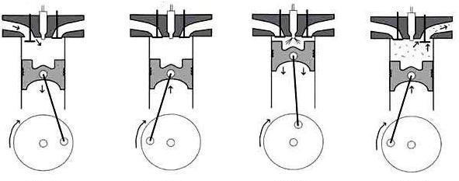
Fig :2.1.1 Induction Fig:2.1.2 Compression Fig:2.1.3 Expansion Fig:2.1.4 Exhaust
Fig :2.1 Working of a Four Stroke Single Cylinder Engine
3. Expansion stroke: During this stroke, the inlet and exhaust valves are closed and the high pressure gases resulting from combustion, pushes the piston in downward direction which is called as Expansion/power stroke. The supply of fuel is continued during a small part of the expansion stroke. The temperature of the air at the end of compression stroke is sufficient to ignite the fuel. The combustion of fuel is continued at constant pressure as long as the fuel injection continues.
4. Exhaust stroke: During this stroke, the inlet valve remains closed and exhaust valve opens. The17 piston moves up in the cylinder and pushes out the burnt gases. The piston reaches the TDC completing the exhaust and is ready for the next cycle.

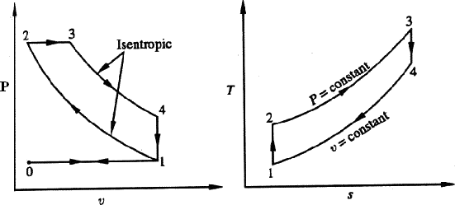
Fig :2.2: Representation of Diesel cycle on P-v and T-s diagrams
2.2 INSTRUMENTATION:
- Digital RPM Indicator to measure the speed of the engine.
- Digital temperature indicator to measure various temperatures.
- U tube manometer to measure quantity of air sucked into cylinder.
- Burette with stop cock to measure the rate of fuel consumed during test.
Table2.1 SPECIFICATIONS OF A SINGLE CYLINDER DIESEL ENGINE:
ENGINE | FOUR STROKE SINGLE CYLINDER
MAKE | KIRLOSKAR
BHP | 5 HP
RPM | 1500
FUEL | DIESEL
BORE | 80 mm
STROKE LENGTH | 110 mm
STARTING | CRANKING
WORKING CYCLE | FOUR STROKE
METHOD OF COOLING | WATER COOLED
METHOD OF IGNITION | COMPRESSION IGNITION

LOADING SYSTEM:
The brake drum is directly coupled to the engine flywheel. It consists of several turns of rope wound around the rotating drum attached to the output shaft. The rope is connected to spring balances on either side. The power is absorbed in friction between the rope and the drum. The drum, therefore, requires cooling.
FUEL MEASUREMENT:
The fuel is supplied to the engine from the main fuel tank through a graduated measuring fuel gauge (Burette). To measure the fuel, close the stop cock and start the stop clock, measure the time taken for the consumption of X cc of fuel.

AIR INTAKE MEASUREMENT:
The suction side of the engine is connected to an Air box. The atmospheric air is drawn into the engine cylinder through the air box. The manometer is provided to measure the pressure drop across an orifice provided in the intake pipe of the Air box. This pressure drop is used to calculate the volume of air drawn into the cylinder. (Orifice diameter is 20 mm).

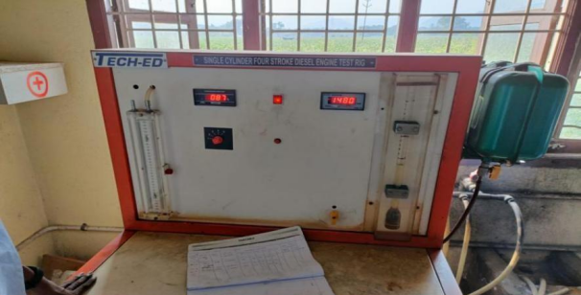
Fig : 2.3 Single Cylinder Four Stroke Diesel Engine Test Rig (without Turbo charger)
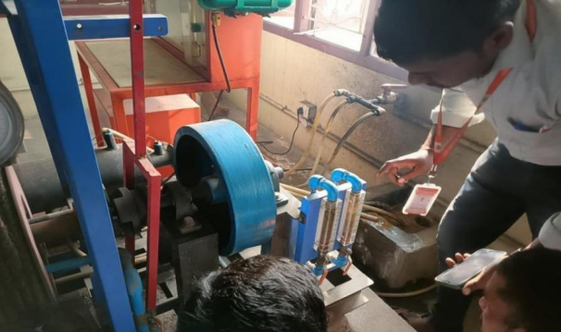
Fig : 2.4 Manometer readings (Without Turbo charger)

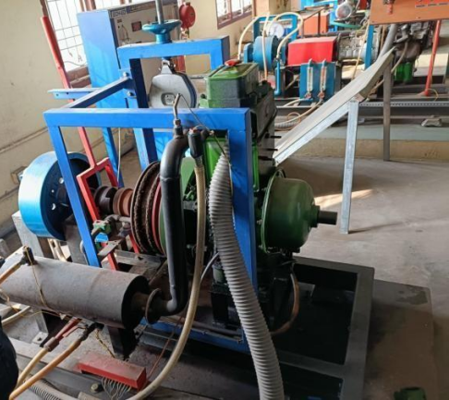
Fig :2.5 Single Cylinder Diesel Engine

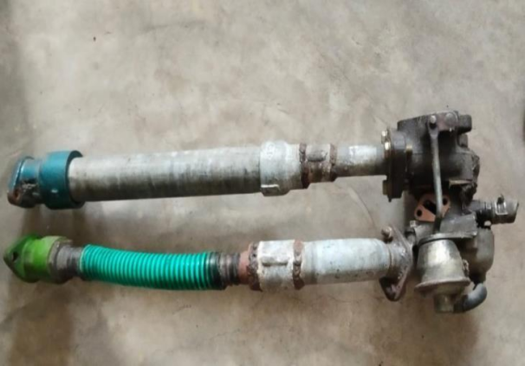
Fig :3.6 Turbo Charger for 4-Stroke Single Cylinder Diesel Engine
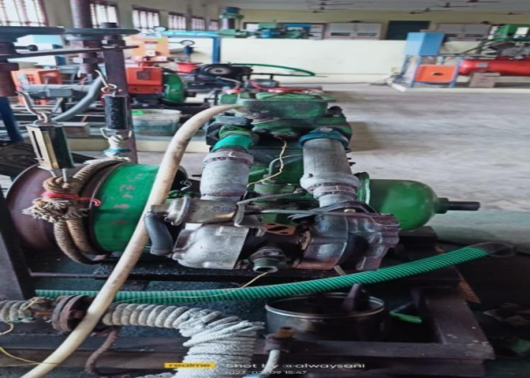
Fig :3.7 Single Cylinder Diesel Engine with Turbo Charger
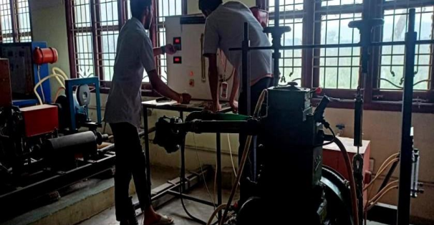
Fig :3.8 Experimentation with Turbo Charger
3.3 Experimental set up for fixing turbo charger
An experimental setup for fixing a turbocharger to an internal combustion engine typically involves
the following steps:
Engine selection: Choose an internal combustion engine that is compatible with the turbocharger to be used in the experiment as shown in fig 3.5
Turbocharger selection: Select a turbocharger that is suitable for the engine selected in step 1. This may include considering the turbocharger's size, wastegate size, and maximum boost pressure.

Preparation of engine and turbocharger: Clean and inspect both the engine and turbocharger to ensure that they are in good working condition.
Mounting the turbocharger: Attach the turbocharger to the engine using flanges and bolts. Make sure, that the turbocharger is mounted in the correct orientation, with the exhaust inlet facing the engine's exhaust manifold and the air inlet facing the air intake as fig 3.7
Connecting the oil supply and drain lines: Connect the oil supply line from the engine to the turbocharger to provide lubrication. Connect the oil drain line from the turbocharger to the engine to return the used oil.
Connecting the coolant lines: Connect the coolant lines from the engine to the turbocharger to provide cooling.

Connecting the wastegate: Attach the wastegate to the turbocharger's exhaust housing. The wastegate controls the amount of exhaust that flows through the turbocharger and helps to regulate the boost pressure.
Testing the setup: Start the engine and perform a series of tests to ensure that the turbocharger is functioning properly. This may include monitoring the boost pressure, exhaust gas temperature, and oil pressure.
Table 3.1: Observation table for 4-Stroke Single Cylinder Diesel engine without Turbo Charger
Sl. No. | Load (S1-S2)  Kg | Speed (N)  Rpm | Time for 10cc fuel  consumption. | manometer reading(h)  =(h1-h2) | Fuel  Consumption kg/hr | Specific Fuel  Consumption kg/kW | B.P  kW
1. | 0-0 | 1530 | 0 | 8.76 | 24.8 | 34.5 | 0
2. | 4-0.2 | 1514 | 1.03 | 10.61 | 25.8 | 40.4 | 14.8
3. | 8-0.8 | 1500 | 1.94 | 9.60 | 25.3 | 39.3 | 20.6
4. | 12-1.2 | 1488 | 2.91 | 9.88 | 26.6 | 37.8 | 20.7
5. | 16-2.6 | 1472 | 3.5 | 10.87 | 24.5 | 44.8 | 26

3.1 CALCULATION

1.Load at 0 kg

- Brake power(BP)=2πN(S1−S2) (D+d/2) *9.81/ 60000
=2πN (0−0) (0.33+0.02/2) *9.81/ 60000
BP=0KW
2. Mass of fuel consumption(mfc) = (X∗ S∗ 3600)/ (t∗ 1000)
= (10∗ 0,82∗ 3600)/ (57∗ 1000)
=0.5178kg/hr
3. .Actual volume (Va)= Cd∗ a√2gH∗ 3600
= ( H = h ∗ ρ w /1000∗ ρa *12.57)
=0.62∗ 0.0254∗ √ (2∗ 9.81∗ 12.57) ∗ 3600
(Va) =8.7m^3/hr
4.Swept volume (Vs)=π/4∗ D^2∗ L∗ N/2∗ 60
=π/4∗ 0.08^2∗ 0.11∗ 1530/2∗ 60
=25.11m^3/hr
5.Volumetric efficiency(ηvol)=Va/Vs∗ 100
=8.76/25.37∗ 100
=34.55%
6.Brake thermal efficiency = BP∗ 3600/mfc∗ cv
=0∗ 3600/0.5178∗ 42500
=0%
7.Indicated power (Ip)=BP+FP
= 0+2.7
=2.7KW
8.Mechanical efficiency(ηmech)= BP/IP
=0/2.7
ηmecℎ=0%

2. Load at 4kg
- Brake power (BP) =1.034kw
- Mass off fuel consumption (MFC) =0.5904kg/hr
- Actual volume (VA) =10.61m^3/ℎr
- Swept volume (VS) =25.37m^3/ℎr
- Volumetric efficiency (ηvol) =40.46%
- Brake thermal efficiency(ηbtℎ) =18.83%
- Indicated power (Ip) =3.734kw
- Mechanical efficiency(ηmecℎ) =27.72%
3. Load at 8kg
- Brake power (BP) =1.9415kw
- Mass off fuel consumption (MFC) =0.7978kg/hr
- Actual volume (VA) =9.60m^3/ℎr
- Swept volume (VS) =24.68m^3/ℎr
- Volumetric efficiency(ηvol) =39.37%
- Brake thermal efficiency(ηbtℎ) =20.61%
- Indicated power(ip) =4.64915kw
- Mechanical efficiency(ηmecℎ) =41.56%

4.Load at 12kg
- Brake power (BP) =2.91kw
- Mass off fuel consumption (MFC) =0.9225kg/hr
- Actual volume (VA) =9.33m^3/hr.
- Swept volume (Vs) =24.41m^3/hr.
- Volumetric efficiency(ηvol) =37.80%
- Brake thermal efficiency(ηbtℎ) =26.74%
- Indicated power(ip) =5.61kw
- Mechanical efficiency(ηmecℎ) =51.92%

5.Load at 16kg
- Brake power (BP) =3.5kw
- Mass off fuel consumption(mfc) =01.1358kg/hr
- Actual volume (VA) =10.87m^3/hr.
- Swept volume (Vs) =24.88m^3/hr.
- Volumetric efficiency(ηvol) =44.53%
- Brake thermal efficiency(ηbtℎ) =96.11%
- Indicated power (Ip) =6.2kw
- Mechanical efficiency(ηmecℎ) =56.45%
Table 3.2: Caluculation table for 4-Stroke Single Cylinder Diessel engine without Turbo Charger
Sl. No. | Load  (S1-S2)  Kg | Speed  (N)  Rpm | B.P  (kw) | VA  (m^3/hr) | Vs  (m^3/hr) | ηvol  (%) | ηbth  (%) | F.P(K.W) | ηmec  % | IP(KW)  (%) | Time taken for fuel  consumption fo 10 cc fuel
1. | 0-0 | 1530 | 0 | 8.76 | 24.8 | 34.5 | 0 | 2.7 | 0 | 2.7 | 57
2. | 4-0.2 | 1514 | 1.03 | 10.61 | 25.8 | 40.4 | 14.8 | 2.7 | 27.7 | 3.7 | 50.
3. | 8-0.8 | 1500 | 1.94 | 9.60 | 25.3 | 39.3 | 20.6 | 2.7 | 41.5 | 4.6 | 37
4. | 12-1.2 | 1488 | 2.91 | 9.88 | 26.6 | 37.8 | 20.7 | 2.7 | 51.9 | 5.6 | 32
5. | 16-2.6 | 1472 | 3.5 | 10.87 | 24.5 | 44.8 | 26 | 2.7 | 56.6 | 6 | 26

Table 3.3: Calculation table for 4 Stroke Single Cylinder Diesel Engine with Turbo charger
Sl. No. |  | Load (S1-S2) | Speed (N)  Rpm | B.P  (kW) | Va  (m^3/hr) | Vs  (m^3/hr) | ηvol  (%) | ηbth  (%) | F.P(K.W) | ηmec  % | IP(KW) | Time taken for fuel  consumption for 10 cc fuel
1. |  | 0 | 1530 | 0 | 8.73 | 24.9 | 38.62 | 0 | 2 | 0 | 2.7 | 58
2. |  | 4 | 1514 | 1.93 | 10.62 | 25.11 | 45.62 | 17.8 | 2 | 30.2 | 3.7 | 49.
3. |  | 8 | 1500 | 1.91 | 9.80 | 25.32 | 43.5 | 22.3 | 2 | 43.2 | 4.6 | 38
4. |  | 12 | 1488 | 3.2 | 10.2 | 27.32 | 42.5 | 23.5 | 2 | 52.5 | 5.6 | 34
5. |  | 16 | 1472 | 3.34 | 12.04 | 24.41 | 49 | 48.11 | 2 | 59 | 6 | 25

Table3.4: Comparison Table (16 kg load)

Parameters | With out Turbo Charger | With Turbo Charger
Volumetric efficiency | 44.8% | 49%
Brake thermal efficiency | 26% | 48.11%
Mechanical efficiency | 56.6% | 59%

4.1 RESULTS:

Increased power and performance: Turbochargers increase the amount of air that is compressed and delivered to the engine, which can result in increased horsepower and torque. This can make the engine more responsive and provide improved acceleration.
Improved fuel efficiency: By compressing more air into the engine, turbochargers can improve the engine's fuel efficiency. This can result in lower fuel consumption and reduced emissions.
Enhanced reliability: Turbochargers are designed to be durable and reliable, and they can help to extend the life of the engine by reducing its load.
Improved engine response: Turbochargers can provide near-instant boost, resulting in improved throttle response and reduced lag.
Increased versatility: Turbochargers can be used in a wide range of internal combustion engines, from small passenger cars to large commercial vehicles.
It's important to note that while fixing a turbocharger to an engine can result in these benefits, it can also introduce some challenges. For example, turbochargers can be more complex and require more maintenance than naturally aspirated engines. In addition, turbochargers can generate more heat and increase the engine's stress, which can result in increased wear and tear. Therefore, it's important to choose the right turbocharger for the engine and to maintain it properly to ensure optimal performance and reliability.

4.1 CONCLUSION
In conclusion, turbochargers are a popular and effective way of increasing the power and performance of internal combustion engines. They work by compressing air and delivering it to the engine, which results in increased horsepower and torque. Turbochargers can also improve fuel efficiency, enhance reliability, improve engine response, and increase versatility.
However, it's important to consider the potential challenges associated with turbochargers, including increased complexity and maintenance requirements. It's also essential to choose the right turbocharger for the engine and to maintain it properly to ensure optimal performance and reliability. Overall, turbochargers can provide significant benefits for internal combustion engines, making them a popular choice for automotive enthusiasts and vehicle manufacturers alike.
REFERENCES

[1] Mukhtar Ahmad, Mohd Muqeem, Mohd Muqeem, “Turbocharging of Diesel Engine for Improving Performance and Exhaust Emissions", International Organisation of Scientific Research journal, Volume 12, Issue 4 e- ISSN: 2278-1684, PP 22-29 Jul - Aug 2015.
[2]SK.Abdul Azeez, Raffi Mohammad, Y.Venkatesh, B. Narendra Kumar, A.Rahul Kumar “Effects of Supercharger and Turbocharger on I.C Engine Performance” International Journal Creative Research Thoughts, Volume 6, Issue 1, IJCRT |ISSN:2320-2882, PP:313-320, February 2018.
[3]M .Herzwan, A. Azri, M.Rizalman are proposed “Turbocharging small size engine to increase engine output: An assessment of turbocharger study field”, 1st International Postgraduate Conference on Mechanical Engineering, volume 1, Issue 3, PP:1-11, January 2019.
[4] Fatima M Elaf, Abdur Rauf Mohamed Naas, Salem Farhat “Improving the Performance of CI Engine by Using Turbo-charger with an Inter-cooler, the International Journal of Engineering and Information Technology, volume 6, issue 4, PP:188-192, 20 November 2020.
[5] K.M. Arunraja, R.V. Naveen Kumar “Turbo Charger in Two Wheelers”, International Journal of Engineering Research & Technology, VOL 5, Issue 7, ISSN: 2278-0181, PP:1-4 20 August 2017.
[6]Daryoush Mirza-Hekmati, William -Heath, Judith M Apsley. “Down-speeding diesel engines with two stage turbochargers” Analysis and control consideration International of Engine Research, Vol. 23 issue 15, PP: 78–89, October 2020.
[7] P. S. Ranjit Mukesh Saxena Mukesh Saxena “Studies on influence of Turbocharger on Performance Enhancement and Reduction in Emissions of an IDI CI engine GJRA - Global Journal for Research Analysis, Volume 3 Issue 5 ISSN No 2277 - 8160, PP:25- 28, May 2014.
[8]Hualei Li, Lei Shi, and Kangyao Deng” Research on the power recovery of Diesel Engines with regulated two-stage Turbocharging system at different altitude”. Hindawi Publishing Corporation International Journal of Rotating Machinery, Volume15, issue 3, Doi: 209084, PP:1-10, March 2014.
[9]Rares,Lucian Chiriac, Anghel Chiru. “Advanced Engine Technologies for Turbochargers Solution". Applied sciences, volume 11, issue 7, doi.101155/2014, pp:1-20,27, oct 2021.
[10] Vijaykumar. B. Chan Shetty “Study of Turbo Charging in Six Stroke Diesel Engine” International Journal on Emerging Technologies, international conference on recent innovation in engineering and technology, volume 7, issue 2, ISSN 09758364, PP: 366-370, October 2016.
[11]Albert Boretti, “Super Turbocharging the Direct Injection Diesel engine” Nonlinear Engineering volume 7, issue 1 doi 10.1515/nleng-2017-0067 PP:17-27 August 2017.
[12] Nag-Jung Choi․Seong-Mo Oh “An Experimental Study on the Improvement of Turbocharger Lag by Means of Air Injection in a Turbocharged Diesel Engine” Journal of the Korean Society of Marine Engineering, Vol. 34, issue 7, ISSN 1226-9549, PP;951-961, November 2010.
[13] Ali Assi, Bassel Choker, Mohamad Hammoud, Ali Hallal, Ali AL Shaer, and Bakri Abdulhay “Reducing the Turbo Lag of a Fixed Geometry Turbocharger” International Journal of Innovative Science, Engineering & Technology, Vol 4 Issue 1, ISSN 2348-7968, PP:235-243, January 2017.

[14] Suresh A, Gokula Varman V, Abishek A, ArutJothi S “Effect and Flow Analysis of Turbine Blades in the Engine Turbocharger "International Research Journal of Engineering and Technology) Volume 07 Issue10 ISSN: 2395-0056, PP:586-594, Oct 2020
[15] R. Gordon Kirk, Alan A. Kornhauser, John Sterling, Ali Alsaeed “High Speed Turbocharger Instability”Dyrobes Rotordynamics SoftwareISCORMA-4, Calgary, Alberta, Canada 27-30 August 2007.
[16] Professor. A.J. Gite1, Professor. V.R. Lawande2 “Significance of Turbocharger on Performance of IC Engine” International Advanced Research Journal in Science, Engineering and Technology International, VOL 3, Issue 1, PP:352-356, March2016.
[17] Dimitar Popov Nikola Vaptsarov “Study of the effects on engine fuel consumption generated by turbocharger performance” International Scientific Journal "Trans & Motauto World, Vol 7, Issue 3, ISSN 2534-8493, P.P. 132-135 March 2022.
[18] Ali Assi, Bassel Chokor, Mohamad Hammoud, Ali Hallal, Ali AL ShaZer, and Bakri Abdulhay “Reducing the Turbo Lag of a Fixed Geometry Turbocharger” International Journal of Innovative Science, Engineering & Technology,ISSN 2348 – 7968 Vol. 4 Issue 1, ISSN 2348 – 7968 PP:235-243, January 2017.
[19]Gregory David Uhlenhake, B.S. “Characterization of Turbo charger performance and surge in a new experimental facility "Presented in Partial Fulfilment of the Requirements for the Degree Master of Science in the Graduate School of The Ohio State University. PP:1-203, January 2017.

