BRAIN-COMPUTER INTERFACE FOR CONVERTING THOUGHTS TO SPEECH

G. Gnancy Subha¹
Assistant Professor- Department of Biomedical Engineering
faculty of Biomedical Engineering, SPIHER.
Avadi, Tamil Nādu
gancysubha95@gmail.com
M.Iyappan
Department of Biomedical Engineering
Biomedical Engineering, SPIHER.line Avadi, Tamilnadu
miyappan006@gmail.com
Hema Priya.R
Department of Biomedical Engineering
Biomedical Engineering, SPIHER.line Avadi, Tamilnadu
hppriya17@gmail.com
Alam Warshi
Department of Biomedical Engineering
Biomedical Engineering, SPIHER.line Avadi, Tamilnadu
alamwarsi8240@gmail.com

ABSTRACT: A brain-computer interface (BCI) is a form of technology that develops a communication channel between a user and certain environmental objects using the user's brain impulses and to develop a non-invasive brain-computer interface that can "translate ideas into voice" (that converts brain signals into speech). The technique is primarily intended for individuals who can no longer interact via conventional channels (lock-in-syndrome patients). The brain signal produced for each word is recorded using EEG electrodes, and the ADC is used to convert the recorded brain signal to a voltage value. When the system produces the requisite voltage, the voice is delivered.
Keywords: Brain, EEG electrodes, Thoughts, Speech, Non-Invasive, Signal processing, Word, ADC.

Introduction
A brain-computer interface (BCI), also known as a
mind-machine interface (MMI), direct neural
interface (DNI), or brain-machine interface (BMI), is a
direct communication link between an upgraded or
connected brain and an external device. Bidirectional information flow is a feature of BCI that distinguishes
it from neuromodulation. BCIs are frequently used to investigate, map, assist, augment, or restore human
cognitive and sensory-motor abilities.
HARDWARE REQUIREMENTS are EEG sensor,
ARDUINO ATmega328, LCD, USB PORT,
OSCILLATOR CLOCk, APR, MIC, SPEAKER
SOFTWARE REQUIREMENTS
EMBEDDED C: The C standards committee created Embedded C as a set of language extensions for
C programming to address issues of similarity
between C extensions for different embedded systems. Embedded C programming has always required non-standard additions to the C language to enable exotic possibilities like fixed-point arithmetic, several different memory banks, and fundamental I/O operations.
Define in advance the predefined sentence, the voltage is gathered and saved in the software. As the patient believes, the brain's impulse is transformed into a voltage.

1.2 THE BRAIN
The fact that a BCI function at all is due to the way our brains work. Small electric signals go from neuron to neuron at speeds of up to 250 miles per hour [source: Walker]. Differences in electric potential conveyed by ions on the membrane of each neuron generate the signals.
Some of the electric signals escape even though the paths the signals traverse are protected by something called myelin. Researchers may, for example, find out what signals the optic nerve sends to the brain when someone sees the color red.
1.3 Dumb or mutism
Muteness, also known as mutism (from the Latinmucuss, which means "silent"), is the inability to speak frequently caused by a speech disorder or surgery. Someone who is deafeningly silent may be so because they refuse to speak in certain social situations.
CAUSES
Physically deaf people may have difficulties with the areas of the
body that require human speech (the esophagus, vocal cords, lungs, mouth, tongue, etc.).
Muteness can be caused by trauma or injury to Broca's region, which is located in the left inferior frontal cortex of the brain.
VARIATIONS
Selective mutism, also known as selective mutism," is an anxiety
disease that affects children of all ages and is defined by the inability
to speak in particular situations. It should not be mistaken for someone who is mute and unable to speak due
to physical impairments. Some people may become motionless and freeze in certain social situations, with no communication.
QQ2A`Q21`
Alalia is a condition characterized by a delay in the development of a child's speaking ability. Some children never learn how to speak in severe circumstances. It is caused by the child's or parents' illness, general muscle abnormalities, the child's timidity, or the fact that the parents are close relatives.
Anarthria is one of the most common types of dysarthria
In other situations, the patient loses his or her ability to
speak.
Symptoms of selective mutism
The inability to sustain eye contact in a noisy, crowded environment, leads to social isolation and
Disengagement.Stubbornness, anger, shyness, and
discomfort is an example of clinging symptoms upon
returning home from a stressful event. After a tense
the situation, acting awkwardly (mostly due to another
a person performing neglected action) Hearing
mutism was a blanket term for a specific language
disabilities in the late nineteenth and early twentieth
centuries. Akinetic mutism is a condition in which a
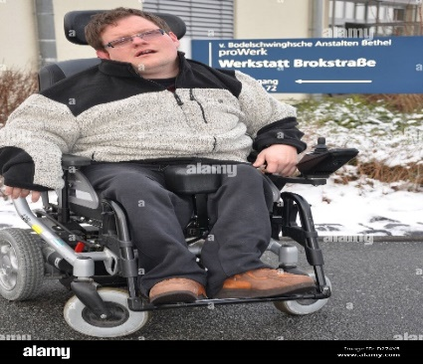
a person can neither speak nor move.

Fig 1.1 (a) DUMB AND PARALYZED PATIENT
1.4 PARALYZED CONDITION
The lack of muscle function in one or more muscles is
referred to as paralysis. If there is sensory as well as
motor injury, paralysis can be followed by a loss of
feeling (sensory loss) in the affected area. In the United
States, about one in every 50 persons has been
diagnosed with a sort of paralysis, whether temporary
or permanent. Palsy is paralysis followed by involuntary
tremors.
CAUSES
The neurological system, particularly the spinal
cord.A most common source of paralysis. Stroke,
nerve injury from trauma, poliomyelitis, cerebral
palsy, peripheral neuropathy, and Parkinson's disease
are some of the other common causes. REM sleep
causes temporary paralysis, and instability of this
system can cause waking paralysis episodes. Paralysis
can also be caused by drugs that interfere with nerve
function, such as curare.
Pseudoparalysis (pseudo-meaning "false, not genuine")
is a voluntary restriction or inhibition of motion caused
by discomfort, incoordination, organs, or other factors,
rather than actual muscular paralysis.
VARIATIONS
Paralysis can be localized or worldwide, and it can also
follow a pattern. Most paralysis is brought on by nerve
damage (such as spinal cord injuries) is permanent, but
some types of periodic paralysis, like sleep paralysis,
are brought on by other sources.
Spina bifida is a congenital disorder that can leave
newborns paralyzed. Spina bifida is a condition where
the spinal cord protrudes from the rest of the spine
because one or more vertebrae are unable to form
vertebral arches. In extreme cases, this could lead to
the spinal cord losing its ability to function below the
level of the missing vertebral arches.
Lower extremities paralysis could develop from spinal cord loss. Untreated spina bifida increases the risk of paralysis of the limbs.
1.5 LOCK-IN SYNDROME
A syndrome called LIS, or faux coma, occurs when a
Due to complete paralysis of all voluntary muscles in the body, `the patient is awake but unable to move or speak audibly with the exception of blinking and vertical eye motions. The person can communicate with their eyes because they are awake and conscious.
The EEG is normal during the locked-in syndrome. CLIS, or total locked-in syndrome, is a kind of locked-in syndrome
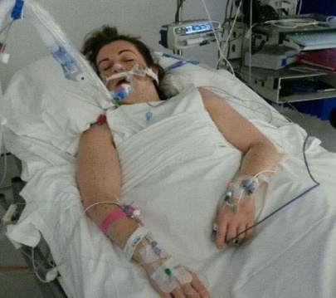
in which the eyes are also immobilized.
Fig 1.1 (b) LOCK IN SYNDROME
1.6 EXISTING SYSTEM
A speech-based BCI would allow communication without the requirement for voice production while retaining the same benefits as traditional speech interfaces. The goal of the focused review is to look into the possibilities of neural signals recorded by various brain imaging techniques for silent speech interfaces. There are several types of brain imaging procedures. The amount of oxygenated and/or deoxygenated blood in specific parts of the brain is measured using imaging methods based on metabolic processes. To produce voice output, functional magnetic resonance imaging (fMRI) and functional near-infrared spectroscopy (fNIRS) are used in this category of imaging techniques (since they are the most commonly used in neuroimaging).
1.7 PROPOSED SYSTEM
Our technique suggests that neural data can be used to collect signals for speech recognition, with a focus on non-invasively collected brain waves (electrocorticography). Unlike previous systems, ours does not require the measurement of magnetic fields created by brain activity (magnet encephalography) or electrical activity from the cerebral cortex. Cortex(electrocorticography) produces output without the need for face recognition, allowing the process to be completed quickly. Another option is to create voice recognition using neural data gathered from brain waves. This would allow users to generate normal acoustic speech from imagined speech, which would be the most natural approach for dump, paralyzed, and locked-in people to regain communication.

RELATED WORK
Speech interfaces have achieved great adoption and can now be used in a wide range of real-world applications and gadgets. The use of an interface based on imagined speech would allow for speedy and natural communication without the use of audible speech, providing a voice to persons who would otherwise be voiceless. Through a detailed review, Tish investigates the capacity of several brain imaging techniques to distinguish speech from neural signals. We contend that because they have a limited temporal resolution, metabolic-based imaging techniques like functional near-infrared spectroscopy and functional magnetic resonance imaging are better suited to studying the neural mechanisms underlying speech production than automatic speech recognition from neural signals. The potential of these signals for speech is demonstrated by our experimental findings with a focus on invasively observed brain activity, and recognition from neural data (electrocorticography).
Without the need for acoustic voice synthesis, communication might be established via a speech-based BCI, which would nonetheless have the same advantages as conventional speech interfaces. But only brain activity-based silent speech interfaces would be able to let those with severe disabilities (such as those with locked-in syndrome) connect with the outside world.
Functional Magnetic Resonance Imaging:
When oxygenated or deoxygenated, hemoglobin, the oxygen-carrying component of the blood, has variable magnetic characteristics. The remarkable spatial resolution of hemoglobin across the entire brain allows for thorough studies of neural processes during various cognitive activities. Because metabolic processes are intrinsically slow, FMRI cannot be employed for continuous speech recognition because phone changes are far too fast for the slow hemodynamic responses.
fMRI, on the other hand, can be employed in neurological investigations to learn more about speech perception, speech production, and reading. FMRI recordings can be used to classify isolated phones or attended speakers, in addition to neuroscientific advancements. The phone is a distinct speech sound that can be distinguished from other speech sounds perceptual. (100% unique
FNIRS: -
Near-infrared light (700-900 nm) passes through skin, bones, and tissue, but is absorbed by hemoglobin. By beaming light through the skull and measuring how much of the re-emerging light is attenuated, it can be used to assess brain activity indirectly. The lighter absorbed, the more oxygenated hemoglobin is produced, and the more active the given brain region becomes. fNIRS is far less expensive equipment that may be installed on the head and does not require the individual to lie immobile to measure identical physiological signals as fMRI. It generates signals on the same time scale as fMRI. measurements, but with a much coarser spatial resolution.
Furthermore, fNIRS can only detect hemodynamic responses in the cortex's periphery and cannot provide signals from the entire brain. While fNIRS can be utilized for both direct and passive user status monitoring in BCIs, it is not well suited for ASR since recorded processes are considered too slow to capture the quick dynamics of speech. fNIRS was used to look at speech processes.
Microarrays: -
few square millimeters in size. Down to single action potentials, the spatial and temporal resolution is unrivaled. Microarrays in the speech-motor cortex have been utilized to successfully decode intended phone production for several isolated phones as well as synthesize vowels. Because microarrays only cover a limited portion of the cortex, they lose important information from other portions of the brain that are involved in speech production Microarrays give high-resolution data on very small brain locations as little as a.
Electroencephalography (EEG): -
Electroencephalography (EEG) uses electrodes on the scalp to measure the electric potentials of large groups of neurons firing at the same time. Experiments using these scalp electrodes are simple to set up and do not require a clinical atmosphere. Because EEG is non-invasive and simple to set up while producing high-quality data with the adequate temporal resolution, it has become the de-facto standard for BCIs. However, because of its location on the scalp, EEG is extremely sensitive to motion aberrations, particularly from head movements. Large electromyography and gloss kinetic artifacts in the EEG are caused by muscle movements in the face, which are not produced by brain activity. EMG activity in the face muscles can be used alone to accurately decipher speech (Schu2011)
Furthermore, due to volume conduction effects, each EEG electrode measures signals from multiple superimposed sources, making brain activity localization extremely challenging. While EEG is the de-facto standard for modern BCIs, it cannot be used for ASR from brain signals as the initial step in speech interfaces, because speech decoding from audible speech is impossible owing to artifact contamination. However, EEG has been successfully employed in studies to analyze perceived speech (Dilbert et al., 2015) or to classify a small number of imagined isolated phones (Yoset al., 2016).
Magnet encephalography (MEG): -
A lot of magnetic shielding is required for magnet encephalography, which uses magnetometers positioned around the head to track the coordinated activity of enormous groups of neurons. MEG is less impacted by the scalp
COMPUTER
than EEG and has a higher temporal and
spatial resolution. However, it is challenging to analyze overt speech production with MEG
because movement, particularly of the face
muscles create considerable aberrations in MEG signals.
MEG's superior spatial and temporal resolution enables in-depth research of speech processes, including comparisons of speech production and perception and phonetic and
musical sound processing (Hotel et al., 2002). (Terumi et., 1999). Although it is challenging to
use with overt voice output, Guims et al.
(2007) achieved signals trial categorization
between two aurally delivered words Heiet al. (2006) provided evidence for a forward model in speech
processing, which would be necessary for ASR.
Due to the huge chambers needed for MEG devices, they are not suitable for upcoming prosthetic systems.
Electrocorticography (ECOG): -
These features make ECOG appropriate for studying speech as natural artifacts. During speech production, there is evidence of neural representation of phonetic characteristics.
It has proven possible to decode isolated aspects of speech. Phonetic abilities can be decoded from ECOG data, Loe et al. (2012) demonstrated that ECOG recordings might be used to recreate perceived speech.
We discuss why just a few brain imaging modalities can be employed for ASR to provide textual to aggregate huge cohorts in this targeted review.
The use of generative models, in
particular, yields simply interpretable models that can provide crucial insights into complex brain activity without the usual statistical issues
associated with huge numbers of variables (Ekluet al., 2016). One of the most common fears linked
with BCI in general, and speech decoding in
brain-to-text in particular, is that private thoughts could be read, and therefore thought freedom
would be compromised. Brain-to-text activities are decoded from the processing of heard sounds and are related to the generation of speech. Thought processes or internal voices do not utilize areas connected with articulatory muscle activity, even though they are also expressed in words. Even if neural prostheses based on imagined speech processes become a reality, there will still be a significant difference between mental processes and the process of imagining oneself to speak.
BLOCK DIAGRAM

LCD DISPLAY
USD

ARDUINOATmega328
EEG
SENSOR

SENSOR
ADC
ECG-100C

SPEAKER
VOICE BOARD

OCSILLATOR CIRCUIT 16HZ
MIC
DIP
SWITCH

TRIMPOT

Fig.3.1(a) BLOCK DIAGRAM 1

3.1 DESCRIPTION 1:
- An EEG sensor is placed on the skull of a normal person.
- Ask the person to think about the word or sentence.
- The EEG sensor collects the impulse from the brain and sends it to EEG-100c AMP.
- The ADC converts analog signals into digital ones.
- The voltage produced is noted down and the sentence is recorded on the voice board.
- In software, the collected voltage is stored.

LCD DISPLAY
USB
EEG SENSOR
ARDUINO
ATmeg328
ADC
AMPLIFIER

VOICE BOARD
SPEAKER
DIP SWITCH
MIC
OCSILATOR
CIRCUIT 16HZ

TRIMPOT

Fig.3.1(b) BLOCK DIAGRAM 2

3.2 DESCRIPTION 2:
- An EEG sensor was placed on the patient skull.
- As the patient thinks the impulse from the patient brain is collected by the EEG sensor
- The impulse collected by the sensor is converted into a voltage value by ADC
- They convert voltage is sent to a microcontroller and compare the output from the sensor with the predefined voltage and a voice is produced

CIRCUIT DIAGRAM

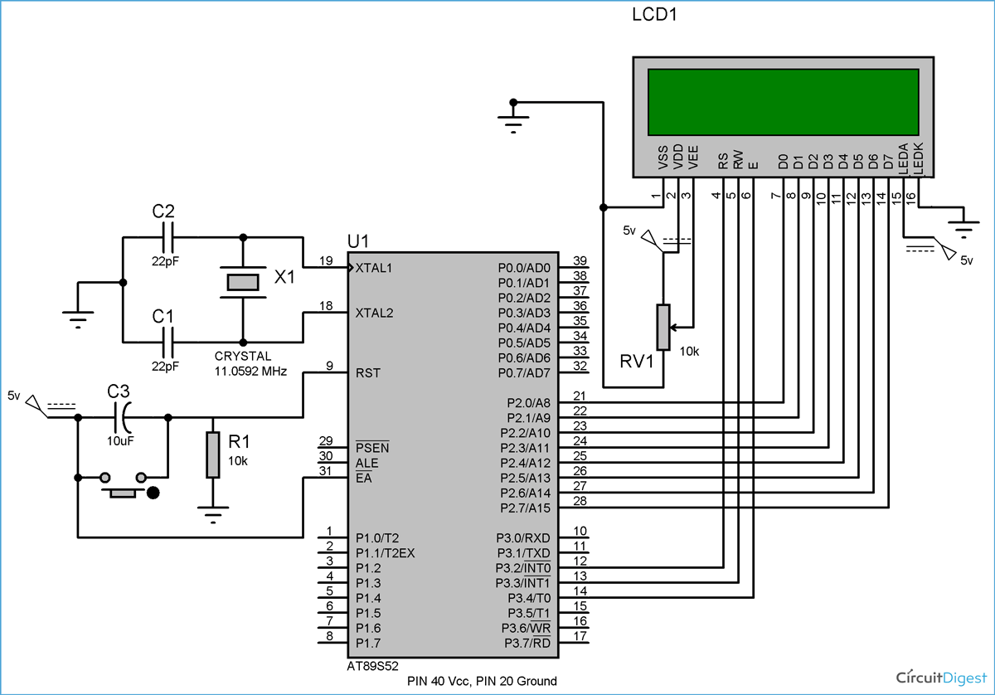

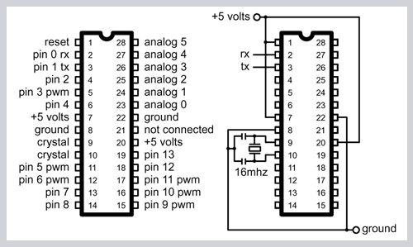

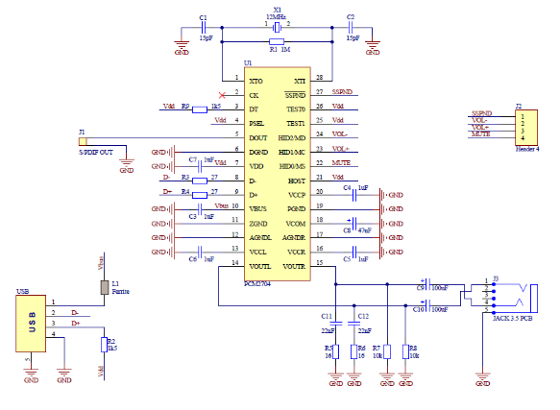

DESCRIPTION:
- Mounted on the board are the power jack and the IC socket.
- Include circuits for the 5V and 3.3V regulators that combine regulators and capacitors; • Include the correct power connections for the microcontroller pins.
- Attach a 10K resistor to the IC socket's reset pin.
- Join pins 9 and 10 with the crystal oscillators.
- Attach the female headers to the board and link them to the appropriate chip pins.
- Mount the six male headers in a row, which can be utilized instead of uploading programs.
- Upload the program to the Arduino-ready microcontroller, remove it, then reattach it to the user kit.
- ISD1012, ISD1016, and ISD1020, all of which are created by ISD and allow for sound voice recording time in seconds, were used in the construction of this voice or sound recorder.
- The final two digits represent the maximum recording time in seconds.
- The circuit contains a microphone amplifier and a speaker amplifier (digital voice recorder) (digital voice recorder)
- S1 switch turns on recording; S2 switch turns on playback; S3 switch turns on voice 1, and S4 switch turns on voice 2.

WORKING DESCRIPTION
The sensor is placed on the regular person's skull, and the individual is asked to think of the statement that will be spoken. The voltage is compared to a set of parameters.
The voice is produced when the voltage equals the predetermined voltage

RESULT AND CONCLUSION
The current device's mechanism is inconvenient and time-consuming. The magnetic field created by brain activity (magnetencephalography), electrical activity from the cerebral cortex (electrocorticography), and face recognition are all required to make a speech. As a result, the patient must sit in front of the computer. The suggested model is non-invasive and time-saving because it does not involve the monitoring of magnetic fields or electrical activity. It is not necessary to recognize your face. As a result, patients can make vocal output without having to sit in front of the computer.
8.1 FUTURE ENHANCEMENT
It is possible to create a portable thinking-to-voice converter that will be useful for dumping individuals who must move from one location to another. Many research councils may benefit from such a system for the well-being of affected populations all over the world. In the future, we want to develop a technology that can convert a person's entire thought process into speech.

APPENDIX
HARDWARE MODELS
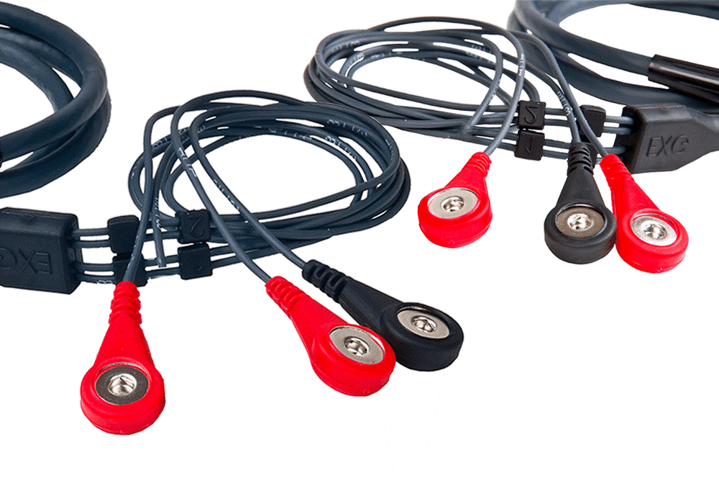

EEG sensor
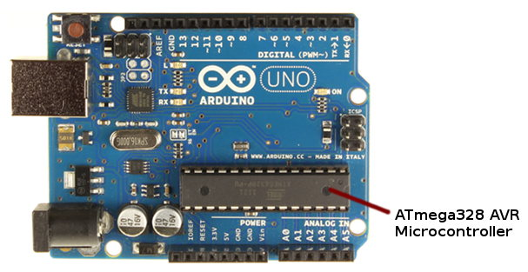

ARDUINO ATmega328

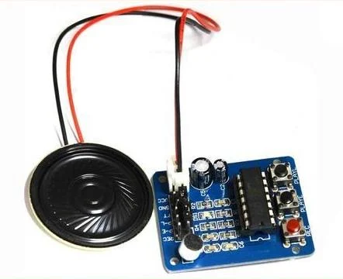

VOICE BOARD

References
- Allison B.Z.; Wolpaw E.W.; Wolpaw J.R. (2007). “Brain-computer interface systems: Progress and prospects”. A British review of medical devices. 4(4): 463-474. doi:10.1586/17434440.4.4.463.
- Baum, Michele (6 September 2008). “Monkey Uses Brain Power to feed Itself With Robotic Arm”. Pitt Chronicle. Archived from the original on 10 September 2009. Retrieved 6 July 2009.
- Fetz, E. E. (1969). “Operant Conditioning of Cortical Unit Activity”. Science. 163 (3870): 955-8. Bibcode:1969Sci…163..955F.doi:10.1126/science.163.3870.955. PMID 4974291.
- Georgopoulos, A.; Laurito, J.; Petrides, M; Schwartz, A.; Massey, J. (1989). “Mental rotation of the neuronal population vector”. Science. 243 (4888): 234-6. Bibcode:1989Sci…243..234G. doi:10.1126/science.2911737. PMID 2911737.
- J. Vidal (1977). “Real-Time Detection of Brain Events in EEG” (PDF). IEEE Proceedings. 65 (5): 633-641. doi:10.1109/PROC.1977.10542.
- Krucoff, Max O.; Rahimpour, Shervin; Slutzky, Marc W.; Edgerton, V. Reggie; Turner, Dennis A. (2016-01-01). “Enhancing Nervous System Recovery through Neurobiologics, Neural Interface Training, and Neurorehabilitation”. Neuroprosthetics. 10: 584.doi:10.3389/fnins.2016.00584. PMC 5186786 Freely accessible. PMID 28282858.
- L. Boozinovska, G. Stojanopv, M Sestakov, S. Bozinovski: CNV pattern recognition: a step toward a cognitive wave observation, In L. Torres, E. Masgrau, E. Lagunas (eds.) Signal Processing V: Theories and Applications, Proc. EUSIPCO-90: Fifth European Signal Processing Conference, Elsevier, p. 1659-1662, Barcelona, 1990
- L. Bozinovska, S. Bozinovski, G. Stojanov, Electroexpectogram: experimental design and algorithms, In Proc IEEE International Biomedical Engineering Days, p. 55-60, Istanbul, 1992
- Lebedev, MA; Nicolelis MA (2006). “Brain-machine interfaces: past, present and future” (PDF). Trends in Neurosciences. 29 (9): 536-46. doi:10.1016/j.tins.2006.07.004. PMID 16859758.[permanent dead link]
- Levine, SP; Huggins, JE; Bement, SL; Kushwaha, RK; Schuh, LA; Rohde, MM; Passaro, EA; Ross, DA; Elisevich, VK; et al. (2000). “A direct brain interface based on event-related potentials”. IEEE transactions on rehabilitation engineering: a publication of the IEEE Engineering in Medicine and Biology Society. 8 (2): 180-5. doi:10.1109/86.847809. PMID 10896180.
- Miguel Nicolelis et al. (2001) Duke neurobiologist has developed a system that allows monkeys to control robot arms via brain signals Archived 19 December 2008 at the Wayback Machine.
- NIH PublicationNo. 11-4798 (1 March 2011). “Cochlear Implants”. National Institute on Deafness and Other Communication Disorders.
- S. Bozinovski: M. Sestakov, L. Bozinovska: Using EEG alpha rhytham to control a mobile robot, In G. Harris, C. Walker (eds.) Proc. IEEE Annual Conference of Medical and Biological Society, p. 1515-1516, New Orleans, 1988
- S. Bozinovski: Mobile robot trajectory control: From fixed rails to direct bioelectric control, In O. Kaynak (ed.) Proc. IEEE Workshop on Intelligent Motion Control, p. 63-67, Istanbul, 1990
- Schmidt, EM; Mclntosh, JS; Durelli, L; Bak, MJ (1978). “Fine control of operantly conditioned firing patterns of cortical neurons”. Experimental neurology. 61 (2): 349-69. doi:10.1016/0014-4886(78)90252-2. PMID 101388.
- Stanley, GB; Li, FF; Dan, Y (1999). Reconstruction of natural scenes from ensemble responses in the lateral geniculate nucleus” (PDF). Journal of Neuroscience. 19 (18): 8063-42. PMID 10479703.
- Vidal, JJ (1973). “Toward direct brain-computer communication”. Annual Review of Biophysics and Bioengineering. 2 (1): 157-80. doi:10.1146/annual.bb.02.060173.001105. PMID 4583653.
- Wolpaw J.R.; Birbaumer N.; McFarland D.J.; Pfurtscheller G.” Vaughan T. M. (2002). “Brain-computer interfaces for communication and control”. Clinical Neurophysiology. 113 (6): 767-791. doi:10.1016/s1388-2457(02)00057-3.
- Wolpaw, J.R. and Wolpaw, E.W. (2012). “Brain-Computer Interfaces: Something New Under the Sun”. In: Brain-Computer Interfaces: Principles and Practice, Wolpaw, J.R. and Wolpaw (eds.), E.W. Oxford University Press.

