Design and Fabrication of Stair climbing trolley

Dr. S.K. Choudhary¹, Amar Gajbhiye², Eptish Khobragade³, Aadarsh Dudhankar⁴, Swikrut Chindhalore⁵, Abhishek Phule⁶
¹Head of Department of Mech Engg., K.D.K. College of Engineering, Nagpur.
^{2,3,4,5,6}Student, Dept. Of Mech Engg., K.D.K. College of Engineering, Nagpur.

Abstract:
This research presents the design and performance test of a stair-climbing trolley. The aim of this project is to develop a mechanism for easy transportation of heavy loads over stairs. The need for such a system arises from day-to-day requirements in our society. In this research, the shaft diameter is calculated by using the bending strength of the beam. A mild steel shaft is selected for design to obtain high strength. Several designs were conceived that would allow a non-industrial hand trolley to travel over stairs, curbs, or uneven terrain while reducing the strain on the user. In our project, the trolley is equipped with Tri-Star wheels, enabling us to carry a load up and down the stairs. It also eases the movement of the trolley on irregular surfaces like holes, bumps, etc.

INTRODUCTION
A hand trolley is a small transport device used to move heavy loads from one place to another. It is a very common tool used by a large number of industries that transport physical products. Also a hand truck or a Dolly, the hand trolley is often used by a stock person who arranges and restocks merchandise in a retail store. when used properly, the trolley can protect people from back injuries and other health problems that can result from lifting heavy loads.

A typical hand trolley consists of two small wheels located beneath a load-bearing platform, the hand trolley usually has two handles on its support frame. these handles are used to push-pull and maneuver the device well my offer install the handles may that extend from the top layer of the frame, or one handle may curve play from the back. An empty hand trolley usually stands up in an L shape and products are usually stacked on top of the platform. When the goods are in place, it is tilted backward there you go so that the load is balanced between the platform and the support frame. Especially if heavy or fragile materials are moved, the person operating the trolley should eat and eat to an upright position carefully Google, to ensure nothing falls off the platform. The front of the fame may be squared off 4 boxes or curved for drums and 2barrels. Sometimes a hand truck also has a strap for securing loose flight during transport.

Professional material handlers prefer to use a hand truck when moving stackable items such as boxes, crates, or packages. The heavier items are usually stacked on the bottom of the hand truck, with lighter objects saved for the top. hand choke user must be careful not to stack it so high that the vision is blocked or the load become unstable. Generally, it is safe to load a hand chug to the level of its handle or the top of the flame the load is then shifted on the wheel with a backward lifting motion. The user can manually the cargo by sharing it left right or forward.

The stair-climbing hand trolley is designed to reduce liability rather than increase it. Conventional hand trolleys work well on flat ground, but their usefulness decreases when it becomes necessary to move an object over an irregular surface. Package deliverymen, for example often find it necessary to drag loaded hand trucks up short flights of stairs just to reach the front door of a building. The purpose of using a conventional hand trolley is to avoid lifting and carrying heavy objects around. Lifting a hand trolley down the stairs defeats the purpose of the device since the user must provide enough upward force to lift the entire weight of the cart and its contents. Furthermore, the geometry of a hand truck makes it nearly impossible to lift with one’s legs, as is the proper form. Considerable strain is placed on the back muscle and the risk of operator injury sharply increased. Pulling up a standard hand trolley of the stairs results in a bumpy and jarring motion. This motion may damage the item loaded on the hand trolley or cause them to fall off entirely. A hand truck that could climb stairs without requiring the user to lift would improve the safety of moving heavy objects over regular surfaces. In our project, we are designing and fabricating a normal hand trolley with a Tri-Star wheel to enable the trolley to move up or down the stair.

TYPES OF TROLLEY

Different types of these trolleys exist, and the type used is often chosen based on what type of material it will move. Hand trolleys are made of various types of hard materials, including steel, aluminum, and high-impact plastic. Most hand trolleys come in standard sizes and are used for general loads, but there are some that are specifically designed for very small or large products.
1. Wheeled trolley
Wheeled trolleys made from stainless steel are the most common type of hand trucks used. These are used in places with heavy loads to move, like retail stores and factories, and typically have wheels made out of stainless steel as well. Welded steel and metal wheel trolleys are typically much more lightweight and are often used to carry lighter materials. Those with a frame and wheels made of a metal alloy are heavier and sturdily made. Trolleys of this type usually have a wider platform for oversized loads. Metal alloy hand trucks are typically used to transport heavy products, such as items made of steel.

2. Folding Trolley
A folding trolley is another type of hand tool and is often made of rust-proof aluminum. It is also lightweight but is usually able to carry heavy loads, and can fold to take up less space when not in use. This feature also allows it to be easily transported to places where it is needed.
3. Garden Trolley
The garden trolley is a maneuver with the use of a pull handle. Garden trolleys tend to have narrow profiles so that they will fit easily on paths and walks without damaging plants. These are designed so that they are capable of lifting both dry and marshy loads which are most commonly found in gardens.
4 Kitchen Trolley
A kitchen trolley is a serving cart that can also be used for storage. It is designed that it has more than one section in it which enables people to carry various utensils and for various purposes.
5. Sack Trolley
Sack trolley or Sack barrow is a fairly generic term describing a range of light, single-operator hand trucks or trolleys used to move cartons, feed and grain sacks, and other light, stackable goods. Lots of different materials are used to make sack trucks. This includes high-impact plastics, tube steel, aluminum steel, and aluminum excursion.

APPLICATIONS OF STAIR CLIMBING TROLLEY
- It can be used in the transportation of luggage from one floor to another on stairs in shopping malls.
- It can be used in buildings under construction.
- This mechanism can be used as a stair-climbing mechanism for wheelchair hair.
- It can be used for material handling.
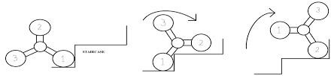

TRI-STAR WHEEL

The Tri-Star wheel was designed in 1967 by Robert and John Forsyth of the Lockheed Aircraft Corporation. They were first developed as a module of the Lockheed Terrastar, a commercially unsuccessful amphibious military vehicle. A Tri-Star wheel functions as an ordinary wheel on flat ground, but can climb automatically when an impediment to rolling is encountered. This wheel design consists of three tires, each mounted to a separate shaft. These shafts are located at the vertices of an equilateral triangle. The three shafts are geared to a fourth, central shaft (to which a motor may be attached).

When geared in this quasi-planetary fashion, these triangular sets of wheels can negotiate many types of terrain, including sand and mud; they can also allow a vehicle to climb over small obstructions such as rocks, holes, and stairs. The wheel assembly may be gear-driven, with two wheels in rolling contact with the ground. The third wheel idles at the top until the lower front wheel hits an obstruction. The obstruction prevents the lower front wheel from moving forward but does not affect the motion of the driving axle. This causes lands on top of the obstruction and allows the rest of the assembly to vault over the obstruction

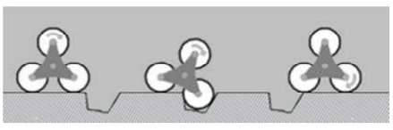

DESIGN ASPECTS

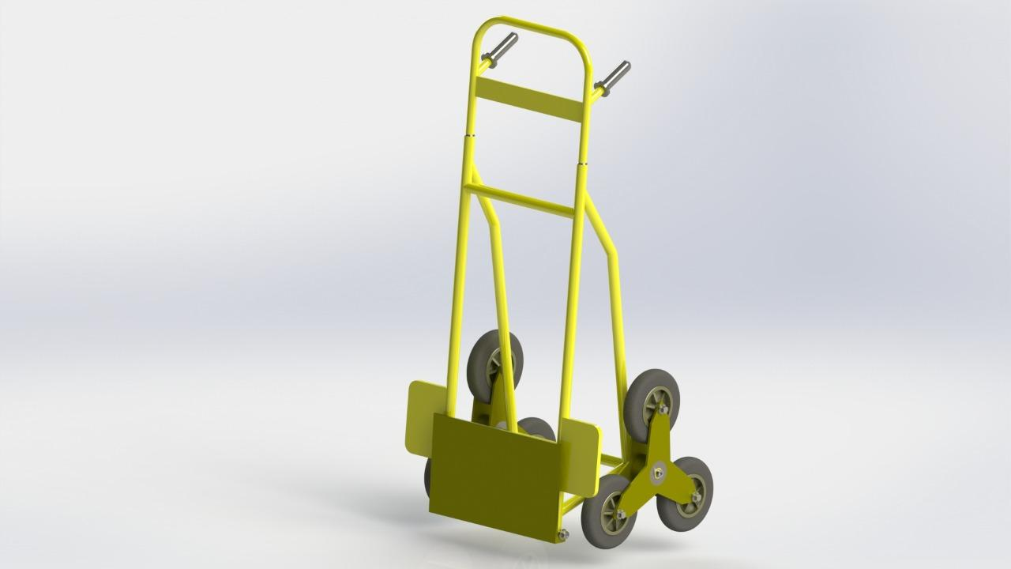

LOAD CALCULATION FOR AXLE
Length of the axle =0.44m Distance between welds = 0.40m

The load applied/ carried = 30 kg (distributed equally by the welds to the axle)
=15 kg through each weld = 147.15N

Weight of the trolley = 20kg (uniformly distributed throughout the axle)
=196.2 N

Neglect the overhang beyond welded points since the wheel provides only negligible reaction

From equilibrium equation ∑ F = 0 And ∑ M = 0

Find reaction at the supports, R1= 190.314N; R2= 190.314N

Calculate the maximum bending moment for the beam,
M(max) =6.7155 N-m Considering FOS =1.5,
M(max) =10.07N -m

Bending equation

: $\frac{M}{L}=\frac{σ}{y}=\frac{E}{R}$

$I=\frac{πR^{4}}{4}σ=3.8\frac{N}{mm^{2}}$:

Bending stress for the given material can be assumed to be 0.66×yeild strength Thus, the
allowable bending stress for the given material is 165 N/mm^2

The calculated bending stress for the material is within the allowable bending stress for the
material,

Thus the design is safe.

CONCLUSION

Though this project had some limitations regarding the strength and build of the structure, it can be considered to be a small step forward, as far as Stair Climbing Vehicles are concerned. During the test run of this project, it was realized that it wouldn’t be a bad idea to consider this design for carrying heavy loads up the stairs. This product will be well acclaimed if it can be commercialized to suit the needs. Though the initial cost of the project seemed to be higher but more accurate manufacturing would shorten this. As for the commercial aspects of this product are concerned, if this product can be fully automated and produced at a lower cost the acceptance will be unimaginable. Presently, there are no competitors for such a kind of product in our

REFERENCES
Journals:

1. Mr. Pratik H. Rathod, Mr. Ravi R. Mishra, Mr. Nitin A. Waghamare, design and fabrication of stair climbing hand truck, International Journal of Emerging Trends in Engineering and Development, Issue 3, Vol.5, September 2013.
2. Md. A.HHussainn. Nafis A. Chowdhury, Rubaiat I. Linda, and Shamiuzzaman Akhtar, Design and Manufacturing of a Stair Climbing Vehicle Proceedings of the 2010 International Conference on IndustrialEngineering and Operations Management, Dhaka, Bangladesh, January 9 – 10, 2010.
3. Ashish Singh, A Thesis On Design, Analysis, And Fabrication Of A Reconfigurable Stair Climbing Robot, Institute Of Technology Rourkela, India, May 2015.
4. Raj Kishor Kumar, Shahbaz Ahmad, Shahid Khan, Shankul Behari, Shubham Rai, A Project Report On Automated Stair Climbing Wheelchair.
5. P.Jey Praveen Raj, P.M.Mohamed Fuge, R.Paul Caleb, G.Natarajan, Design and Fabrication of Stair Climbing Trolley, international journal of advancement in engineering technology, Management &Applied science, Volume 3, Issue 5 May 2016 ISSN No;2349-3224
6. Roshan Alaspure, Chaitali Barmase, Snehal Chambhare, Manish Mandhre, Prof. Yogesh G. Joshi (Guide), Fabrication of Stair Climbing Wheel Mechanism: Alternate for lifting goods, International Research Journal of Engineering and Technology (IRJET) e- ISSN: 2395 -0056 Volume: 03 Issue: 05 | May-2016 www.irjet.net p-ISSN: 2395-0072
7.Prajan Pradip Gondole, Kamlesh Diliprao Thakre, Himanshu Anil Moon, Shubham yengalwar, Mr. S S Marathe ,Stair Climbing Hand Trolley,Journal of Emerging Technologies and Innovative Research (JETIR) www.jetir.org April 2016, Volume 3, Issue 4, JETIR, ISSN-2349-5162.
8. Shubham S.Shiwarkar, International Research Journal of Engineering and Technology (Design and
Fabrication of easy-handling trolley). Volume: 05 Issue: 05, May 2018.
9. Asst. Prof. Vijay Raundal, International Research Journal of Engineering and Technology (Design and Fabrication of easy handling trolley). Volume: 07, Special Issue:

BOOK

1. Dr. R.K. Bansal, A textbook of Strength of Materials, Laxmi Publications (P)
Ltd.
2. R.S. Khurmi, J.K. Gupta, A textbook of Machine Design, S.Chand
Publishing House
(P) Ltd.
3. www.wikipedia.com
4. www.mit.edu

