MVP OF THE NBA SEASON PREDICTION USING MACHINE
LEARNING, DATA ANALYSIS AND WEB SCRAPING

Abhyuday Singh Parihar
Department of Computer Science and Engineering
SRM Institute Science and Technology Kattankulathur, Tamil Nadu
ap7013@srmist.edu.in

Amisha Jaiswal
Department of Computer Science and Engineering
SRM Institute Science and Technology
Kattankulathur, Tamil Nadu aj6109@srmist.edu.in

Abstract— As the NBA (National Basketball Association) is becoming more and more popular, people are trying to predict the best scoring players in each season for many reasons, including for gambling, online tournaments or competitions. There are a lot of factors that can affect the result. The aim of this article is to establish a convincing but simple model to predict the most valuable player of current season using past year results, as well as deriving team ability and separate home advantages based on data from past 30 seasons. By analyzing the games from 1991 to 2022, the model makes reasonable predictions by analyzing some crucial factors, such as team ability and home advantage, even as compared to the bookie's point spread. Although there are still some factors that are not concerned by the data, such as injuries, fouls and trades, the prediction of this model is still convincing. This paper applies the ridge regression and random forest regressor model to predict the results. By comparing the standard error of the results, the best model is created and best player for upcoming year is derived, providing good predictions.
Keywords— Web Scraping, Machine Learning, Python, Selenium, Data Cleaning, Data Science, Ridge Regression, Mean Squared Error, Random Forest

Introduction

Sports statistics have been widely studied and used by the bookmakers to set gambling point spreads. The National Basketball Association (NBA) is the premier professional league for men’s basketball in North America that attracts attentions from the gamblers around the world. This research project aims to construct a model integrating some basic statistical knowledge to evaluate the ability of teams and to predict future most valuable player based on present theories and available data.

Literature Review

In [1], researchers tackle the topic of identifying the teams that will qualify for playoffs. The methodologies involved were logistic regression and data analysis, out of 245 data points, accuracy was 92.5%, though it cannot give a definite set of teams that would make into the playoffs. In [2], researchers tackle the topic to predict the output of a basketball game using machine learning approaches. Methodologies used were Fuzzy Logic, Support Vector Machines.The Hybrid Fuzzy Support Vector Machine model is only capable to predictingthe win and loss outcomes of basketball games. Further extending HFSVM model the scores of win and loss can be investigated. This model can also be further applied to other sports such as soccer.The SVM Model was not much found effective as compared to HFSVM Model. In [3], researchers have tried to predict the playing 11 of the Bangladesh cricket team on the basis of pitch conditions, fitness etc using machine learning algorthms. With Naive Bayes, got 87% accuracy, 94% precision with SVM, 87% accuracy with Random Forest for data collection.Various conditions as Home Team and Foreign Team were not taken care of. Naïve Bayes And Random Forest were less effective than SVM Model.
Limited to domestic team.In [4] researchers have tried to rank the soccer players as ratings just like a FIFA video game. The post-match rating of players is a comprehensive evaluation problem in the soccer field, and it is also applicable to other sports fields with similar scenes, especially various team sports, such as basketball and rugby. Often necessary to examine all aspects of the player's single-game data, such as the number of passes, the number of goals, the success rate of shots

III. Proposed Work

A proposed workflow is shown in the picture below.

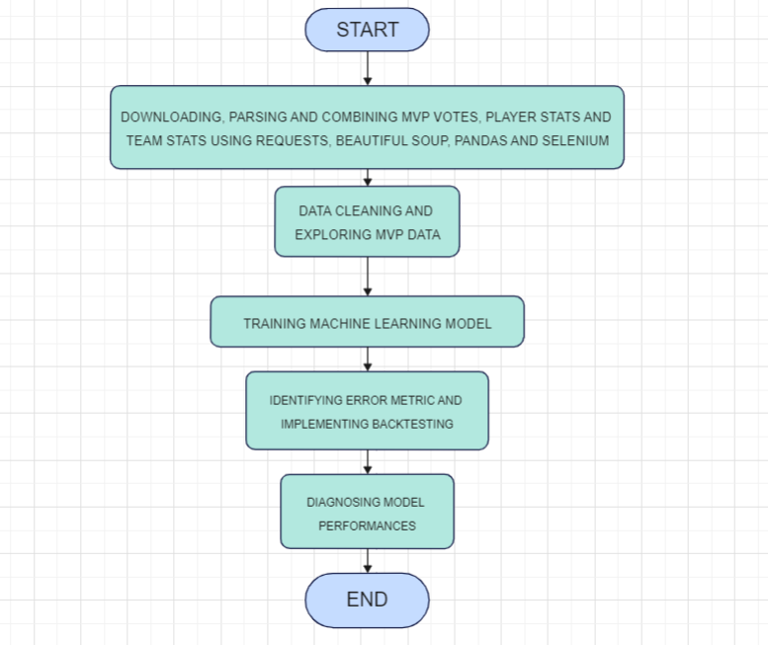

In this project, we are going to predict who is going to be the MVP (Most Valuable Player) in a given NBA (National Basketball Association).The project is divided into Web Scraping, Data Analysis And Machine Learning.For predicting, we need a lot of data on NBA Players and their statistics, regarding who won the MVP in past seasons and what were their rankings.
- But we will test other models, like Ridge Regression, Random Forest Regressor, etc. and compare the results on various algorithms.
Web Scraping refers to the extraction of data from a website.The information is then collected and exported into a format that is more useful to the user.We will be using Python for web scraping in the project. We will extract data from Basketball-reference.com. We will be using Jupyter for coding At first, this exercise can be viewed as a regression problem (predicting numerical variable as target) which in this case the target variable the machine learning model would attempt to predict is the MVP share metric. This would be done for each regular season separately utilizing the list of MVP candidates for that particular season.
Motivation. Currently, the voters are 100 independent media members who are not affiliated with teams nor players. Each member selects players in the weighted voting system: first place vote (10 points), second place vote(7 points), third place vote (5 points), fourth place vote (3 points), and fifth place vote (1 point). The player who receives the most “points” is chosen as the Most Valuable Player for that season.
- To be consistent while evaluating these numbers through time, the MVP vote points for each particular player can be divided by the total MVP vote points for that season. This metric is commonly called MVP shares.

Language: Python
Libraries and Technologies:
- Jupyter Notebook
- Pandas Library(Data Analysis And Manipulation Tool)
- Beautifulsoup(Parsing HTML And XML Documents)
- Selenium(Web Browder Automation Tool)
- SkiKit Learn(Machine Learning Library)
- Machine Learning (Ridge Regression, Mean Squared Error, Random Forest Regressor)

IV.Implementation

MODULE 1 :

DOWNLOADING, PARSING AND COMBINING MVP VOTES, PLAYER STATS AND TEAM STATS USING REQUESTS, BEAUTIFUL SOUP, PANDAS AND SELENIUM

Downloading of MVP Votes, Player And Team Stats is done with the help of requests library.
Separate Files of each year, each being a different web page is downloaded according to year and we store in 3 separate folders of mvp, player stats and team stats.
Beautifulsoup library is used then to parse the data, like for removing extra rows and selecting the table from the whole web page.
Then we create dfs and append all the tables or combine them into separate csv files using pandas library
Sometimes the long tables are not rendered completely and so we use Selenium library of python to render javascript and so tables.

MODULE 2 :

DATA CLEANING AND EXPLORING MVP DATA

At the end of the first module, we have three separate csv files and we need to combine them and create a dataset for training with machine learning model
Then we will clean the csv file datas, like deleting extra columns, removing asterisks, turning the data of player with multiple row who played with different teams into one so that all the three tables can be compared to one another
Using such cleaning techniques, we will finally merge the 3 csv files into one final dataset which we will use for machine learning model
the help of threaded replies and a positive, healthy communication can happen among people under the guidance of the management.

MODULE 3 :
TRAINING A MACHINE LEARNING MODEL
For training a ML model, we need predictors. These predictors will be used in our algorithm for predicting MVP. Wins, Losses, W/L% are some of the predictors.We can then import ridge regression model from scikit learnWe will fit all the predictors into our ridge regression model and then try to predict one particular stat, i.e., Shares of votesNow we will create combination data frame using pandas library and then concat our test file with predictions file to compare them. Then we can apply sort on combination whether to check share and prediction are correct or not and then we will correct errors
MODULE 4 :
IDENTIFYING ERROR METRIC
First you can import mean squared error to calculate error value between prediction and actual share value. But as lots of players have no points in mvp table, so we need to find another error metric instead of shares and predictions.We will use ranking metric and compare the ranking between the predicted and actual rankings and sort it in ascending manner to compare the top players.
MODULE 5 :
DIAGNOSING MODEL PERFORMANCES
We will see the biggest difference in prediction of our estimated ranking and original ranking. Then we can see the most effective predictors in our algorithms which have been used in running algorithm. Further, we can add more predictors and we can test our machine learning model using those stats

V.Results discussion
We used numerical predictors to predict share in mvp votes and then compared both the predicted and actual shares to calculate the accuracy. We relied on mean squared error for calculating accuracy of our model. First we used ridge regression model, and then for all of our dataset comprising more than 500 players error metric was found out to be 0.00266 but its of no importance as most of the players were never selected for mvp and our model predicted the shares for them too. So we made use of our model on top 5 players with most shares and tried to calculate whether our model correctly predicted whether they are in top 5 or not, doing so the error metric was found out to be 0.7636. Backtesting for each year was done and our error metric was then calculated to be 0.71106. Then we used random forest aggressor algorithm and mean error was calculated to be 0.8544. Backtesting for each year was also done and then final mean error was 0.79.
.

Conclusion

The MVP (Most Valuable Player) award has been one of the most popular discussion topics in the NBA. Each year, thousands of sportswriters, media reporters, and basketball fans have huge interests in the final decision and also make some predictions toward the determination of the Most Valuable Player. In this essay, I chose some variables that influence the possibilities of MVP based on previous investigations, developed the relationships between MVP and different variables, created a stepwise logistic regression model of predicting the Most Valuable Player in the NBA based on the players’ data of each regular season, and tested the model based on historical data and MVP results. There are many factors in the criteria of the choice of the Most Valuable Player, including player efficiency ratings, true shooting percentage, win shares, win shares/48 min, assists, rebounds, fouls, turnovers, blocks, adjusted production, free throw percentages, experience, and much more. Among them, the PER (Player Efficiency Ratings), the TS% (True Shooting Percentage), the MP (Minutes Played), the TRB% (Total Rebounds Percentage ), the AST% (Assists Percentage Percentage), USG% (Usage Percentage), the WS (Win Share), the OWS/48 (Offensive Win Shares Per 48 minutes), and the Adjusted Production are positively influencing the possibility of MVP. In contrast, the ORB% (Offensive Rebounds Percentage), the DRB% (Defensive Rebounds Percentage), and the TOV% (Turnover Percentage) have negative relationships with the MVP. The model and its possibility ranking are quite precise, since it provides with accurate data that is suitable with most of the historical data. Limitations including lack of more comparison with other models and shortage of precise testing, require further research. Hopefully additional research will expand on my work to create an even more accurate predictive model that, among other things, will help uncover the most important factors in being awarded NBA MVP.Making predictions in sports is a very difficult task and is clouded in much uncertainty. In this experiment, prediction models to predict the NBA’s MVP award were built and analyzed. While the numbers definitely do not tell the whole story, there were some interesting patterns of metrics and statistics that contributed to the models. In the end, with these models, the forecast of the 2022 MVP was made. In the future, it will be very interesting to see if the models can perform and adjust the predictions to approximate to the opinions of the media and the subject matter experts.

References

- N. Ma, "NBA Playoff Prediction Using Several Machine Learning Methods," 2021 3rd International Conference on Machine Learning, Big Data and Business Intelligence (MLBDBI), 2021, pp. 113-116, doi: 10.1109/MLBDBI54094.2021.00030.
- S. Jain and H. Kaur, "Machine learning approaches to predict basketball game outcome," 2017 3rd International Conference on Advances in Computing,Communication & Automation (ICACCA) (Fall), 2017, pp. 1-7, doi: 10.1109/ICACCAF.2017.8344688.
- M. K. Mahbub, M. A. M. Miah, S. M. S. Islam, S. Sorna, S. Hossain and M. Biswas, "Best Eleven Forecast for Bangladesh Cricket Team with Machine Learning Techniques," 2021 5th International Conference on Electrical Engineering and Information Communication Technology (ICEEICT), 2021, pp. 1-6, doi: 10.1109/ICEEICT53905.2021.9667862.
- W. Yang, "A method of soccer's player rating based on machine learning," 2021 IEEE International Conference on Advances in Electrical Engineering and Computer Applications (AEECA), 2021, pp. 1026-1029, doi: 10.1109/AEECA52519.2021.9574163.
- K. Ishwarya and A. A. Nithya, "Relative Analysis and Performance of Machine Learning Approaches in Sports," 2021 5th International Conference on Electronics, Communication and Aerospace Technology (ICECA), 2021, pp. 1084-1089, doi: 10.1109/ICECA52323.2021.9676147..

