PARKINSON’S DISEASE PREDICTION SYSTEM

Akanksha Dhote
Department of Computer Science and Engineering
G H Raisoni College of Engineering Nagpur, India dhote_akansha.cs@ghrce.raisoni.net
Aditi Barbate
Department of Computer Science and Engineering
G H Raisoni College of Engineering Nagpur, India barbate_aditi.cs@ghrce.raisoni.net
Vedanti Kidile
Department of Computer Science and Engineering
G H Raisoni College of Engineering Nagpur, India kidile_vedanti.cs@ghrce.raisoni.net

Kalash Kesharwani
Department of Computer Science and Engineering G H Raisoni College of Engineering
Nagpur, India
kesharwani_kalash.cs@ghrce.raisoni.net
Anuradha Joshi Assistant professor
Department of Computer Science and Engineering G H Raisoni College of Engineering
Nagpur, India
anuradha.joshi@raisoni.net

Abstract—The adaptation of internet-based technology (specially computers) in the medical industry has caused the collection of digital data. Due to the considerable amount of data, doctors are facing problems to study symptoms precisely and identify diseases at a starting stage. Our project is a healthcare-based project and with the help of this project, we are trying to predict a very silent and less known disease that is Parkinson's disease. People nowadays are having a busy schedule in their life and they usually don’t prioritize their health so our project mainly focuses on taking the symptoms from the user and with the help of those symptoms the user will be able to find whether they are suffering from this silent disease i.e. Parkinson's disease or not. We will be applying machine learning and artificial intelligence in our project which will be helping us to increase the accuracy of our project. We will be trying to make our project more compatible with all devices in future.

Keywords—Health Care, Diseases Prediction, machine learning .

INTRODUCTION
Parkinson’s disease was first brought into the light by an english surgeon Dr. James Parkinson in the year 1817 and he stated this disease as “shaking palsy.” It’s longlasting , growing neurodegenerative disease which can be classified by both motor and nonmotor features.In Parkinson’s disease, several nerve cells in the brain slowly stop functioning or die. Loss of neurons is the main reason for the symptoms that produce a chemical messenger in your brain called dopamine[3]. When hormone levels decrease, it causes a typical activity in the brain that results in impaired movement in the body and other symptoms of Parkinson’s disease.Parkinson's disease (PD) is a common neurodegenerative disease. Early ideas theorizing parkinson's disease as only a motor disorder have made the way to watch it as a more widespread neurological disease with emotive , cognitive, and involuntary manifestation. Mutated genes have been discovered that make parkinson’s disease heritable, Although it is an illness for middle aged, in some rare circumstances people have developed

Parkinson’s Disease in their 40s.[3] There are many causes that can trigger parkinson's disease and some of them are mentioned here Family: here disease can be caused by inherited genes which are considered to be mutant , secondary: can be occured as a result of an hidden factor in body or process toxication or trauma, Atypical: a brain disease that can have matching symptoms to Parkinson's[2].Common Symptoms of Parkinson’s Disease are-Tremors, Rigidity, Loss of balance, Small handwriting, Low voice, Tremors are among the major symptoms[2],[12]

STATISTICS

According to our study from the different research papers and from the internet there are Around 10 lakhs individuals are suffering from Parkinson’s disease in the united states whereas number of individual suffering from Parkinson’s disease in around the globe is around 50 lakhs [3].Hence, it’s necessary to predict Parkinson’s disease in premature stages in order to plan for the treatment of the disease so that the necessary supervision or expertise can be provided to the patients[4].

Parkinson’s disease comes among the top ten neurodegenerative diseases in the world and it position is second in that list. It is a common monogenic disorder in adults over the age of sixty years. According to the study of GBD (Global Burden of Disease) in 2018, the number of individuals suffering from Parkinson's Disease around the world has increased i.e. doubled over the past 20 years from 25 lakhs patients in 1990 to 61 lakhs patients in 2016 so we can see that there is an extreme burst[11] . In India nearly 5.8 lakhs people are living with Parkinson’s Disease. As a rough calculation in 2016, there is bad news that it is expected that there will be a major increase of this disease in the coming years. Other than the large range of people affected with PD, insights
into the fundamental genetic and environmental risk factors specific to the Indian population are restricted[16].
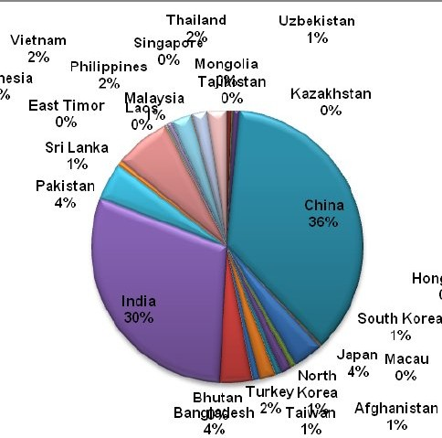

Figure 2.1 Predominance of PD in Asia[11]

If early and sound prediction is possible then a patient can get a proper treatment at the right time.

LITERATURE SURVEY
According to the survey we have done, there is a an app called iprognosis App which it was launched in 2017 but still the app has not reached throughout the world because of its less compatibility. This app is also available in the play store app but as I have mentioned that it has compatibility issues and also this app is working nearly the same like ours but our web application has made some improvements. Since we are working on a website we will be able to tackle the problem of compatibility and it will also be much more feasible than its competitor. The website will be available to the maximum number of people.[12]

One other solution for the detection of Parkinson's Disease is using the convolutional neural network model. The patients were asked to draw a wire

cube and pentagon in spiral form on the top of a image on a pressure sensing tablet and an inking stylus[12].They had to draw four figures, two with each hand. The pressure exerted against the tablet and the angles in which the pads are used were stored in the form of multiple time series dataset.The drawing test is done to check the motor and attentional capabilities of the patient[12]. In this project the dataset was used to train the Convolutional Neural Network deep learning model. The patients suffering the PD generally have less pressure and they hai slowed writing speed and this model is capable of estimating the level of the disease.[13] For image classification, back propagation technique was used to train the CNN model. After training, the model was tested to differentiate between healthy people and affected people[14]. But for this, the suspect of the disease needs to undergo the lengthy and expensive test, which one could not afford at the suspicion level. This model also needs a supervisor so that the patient could operate with the hardware properly
So we have presented the model to clear the doubt about the disease. Patients will be able to test whether they need doctor consultancy or not on the screen of their smartphone.

PROPOSED METHODOLOGY

The methodology is intended for building a model to distinguish Parkinson's Disease at its beginning phases utilizing AI calculation. It comprises the accompanying advances:. In the current work, the dataset was taken by an accessible source. The information incorporates many symptoms that are present in parkinson's disease . It comprises individuals with Parkinson's.
When we have this information some handling is finished.The prediction model is trained according to the people above 60 years as there are the rare chances of having parkinson's disease.. The datasets then are put into the libraries for machine learning to train the datasets. The training of
datasets took place and then the user input is compared to trained datasets.CNN is used in training the datasets which has helped in the prediction purpose
After that the trained model did prediction with the help of the trained data.
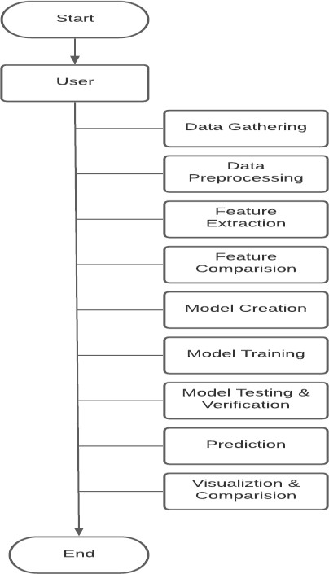

Figure 2.2

FUTURE SCOPE
The future scope of this project is that today there is no such algorithm or any facility that helps

normal people to test whether they have Parkinson disease or not at their home without any doctor’s help. We will be trying to make our website more accessible to the people with which we will be able to reach the maximum number of people. And For security reasons we will be using a login/signup page so that only the patient is able to access his information. Since this is a machine learning model we might get 100% accuracy in future if more work upon algorithms is done. If this model reaches an advanced level, It might bring the revolution in treating Parkinson's disease and this project will be a boon in the field of healthcare industry.In future we will be moving from prediction to detection which will help us to gain 100 % accuracy.

CONCLUSION
The Parkinson’s Prediction System is a unique module where Parkinson’s disease can be predicted just by visiting the website. Parkinson’s disease affects the nervous system. Genetic and environmental factors are might be the reason for producing abnormal protein formation inside selected groups of neurons, leading to cell deterioration and death of cells .The disease is seen in patients of age 40 or above. The symptoms include tremors, rigidity, speech changes, writing changes,slow movements, shaking of hand/leg, blinking of eye, smiling etc. The exact cause of the disease is not known and that’s why there is no way to prevent the risk of the disease, but it is said that the disease is caused due to the hormonal imbalance in the body called dopamine which leads to this disease .Our project helps people to predict Parkinson disease with the assistance of machine learning and CNN (convolutional neural network). This system can help patients to detect the disease at an early stage and get treated as soon as possible. Proper treatment and medications can help to cure the disease. Our prediction system is user friendly where symptoms are written in two languages - English and Hindi for better
understanding. Users will give input in yes/no form and get the result in some minutes. The system gives (%) accuracy with a list of neurologists if the disease is detected. Our system is a portable system where the users can access the site from anywhere and at any time which makes it more flexible and comfortable from a patient's perspective. You can contact your nearby neurologist and get the disease treated correctly.

REFERENCES
- Postuma RB, Montplaisir J. Predicting Parkinson’s disease why, when, and how? Parkinsonism Relat Disord 2009;15: S1059.
- Aarsland D., Kvaloy J. T., Andersen K. et al. (2007) The effect of age of onset of PD on risk of dementia. J. Neurol. 254, 38– 45
- ArmaÃ±anzas R, Bielza C, Chaudhuri KR, Martinez-Martin P, LarraÃ±aga P. Unveiling relevant non-motor Parkinson’s disease severity symptoms using a machine learning approach. Artif Intell Med 2013;58(3):195202.
- Rajput, AH.Frequency and cause of Parkinson’s disease. Can J Neurol Sci 1992; 19: 103–107.Google ScholarPubMed
- https://www.google.com/search?q=wat+is
+parkinsons+disease&oq=wat+is+parkins ons+disease+&aqs=chrome..69i57j0i13i5 12l9.5920j0j7&sourceid=chrome&ie=UT F-8
- H. L. Chen, C. C. Huang, X. G. Yu, X. Xu, X. Sun, G. Wang, and S. J. Wang, “An efﬁcient diagnosis system for detection of Parkinson’s disease using fuzzy k-nearest neighbor approach,” Expert Systems with Applications, vol. 40, no. 1, pp. 263–271, 2013. [Online]. Available:http://dx.doi.org/10.1016/j.eswa
.2012.07.014
- M. Behroozi and A. Sami, “A multiple-classiﬁer framework for Parkin-son’s disease detection based on various vocal tests,” International Journal of Telemedicine and Applications, vol. 2016, 2016.

- ¨O. Eskidere, F. Ertas¸, and C. Hanilc¸ i, “A comparison of regression methods for remote tracking of Parkinson’s disease progression,” Expert Systems with Applications, vol. 39, no. 5, pp. 5523–5528, 2012.
- N. Lavesson, Evaluation and Analysis of Supervised Learning Algo-rithms and Classiﬁers, 2006
- R. Caruana and A. Niculescu-Mizil, “An Empirical Comparison of Supervised Learning Algorithms Using Different Performance Metrics, ” Proceedings of the 23rd international conference on Machine Learning, pp. 161–168, 2006. [Online]. Available:http://citeseerx.ist.psu.edu/view doc/summary?doi=10.1.1.60.3232
- Figure 2.1 is a referred image: https://www.researchgate.net/publication/ 288324436/figure/fig3/AS:311268385804 290@1451223574664/Prevalence-of-Park inson-in-Asia.png
- Drota´r P, Mekyska J, Rektorova´ I, Masarova´ L, Sme´kal Z, Faundez-Zanuy M (2014) Analysis of in-air movement in handwriting: a novel marker for Parkinson’s disease. Comput Methods Programs Biomed 117(3):405–411
- https://www.parkinsonsmovement.com/ipr ognosis/
- . Derkinderen P, Dupont S, Vidal JS, Chedru F, Vidailhet M (2002) Micrographia secondary to lenticular lesions. Mov Disord 17(4):835–837

