ACCURATE MEASUREMENT OF HAEMOGLOBIN AND HAEMOCRIT BY USING 3 - PART HEMATOLOGY ANALYZER -SYSMEX XP-300
Pavithra.S¹, Azha.Periyasamy²
^{1,2}Department of Electronics and Instrumentation, Bharathiar University, Coimbatore-641046, Tamil Nadu, India

---------------------------------------------------------------------***---------------------------------------------------------------------
Abstract - One of the most fundamental laboratory tests in haematology is the evaluation of blood smear because variations in blood cell counts from reference values might signal a number of illness problems. Based on CBC values and blood cell shape, R studio can aid technicians in the analysis and classification of blood cells as well as the identification of certain medical diseases. The objective of this project is to create software that can recognise and categorise haemoglobin and haematocrit in different blood cells from peripheral blood smear samples. Manually locating, recognising, and classifying the Hg and Hct can be tiresome, time-consuming, and erroneous. However, automatic haematology that solely perform quantitative analysis and rely on the flow cytometry categorization concept are expensive. This suggested study seeks to produce a preliminary framework of Automatic analysers Analysis of Human Blood Smear for identification, classification of Hg and HCT of blood cells by employing various data taking into consideration the broad range of data in the field of medicine.

Key Words: Sysmex XP-300 Hematology analyser, blood samples, blood analyser, haematocrit.
1.INTRODUCTION

Blood samples can be swiftly checked for the whole blood count using an automated haematology analyser. Some of the results of a blood test include a leukocyte differential, haemoglobin concentration, haematocrit, platelet count, white blood cell (WBC) count, and red blood cell (RBC) count. Modern haematology analysers can count and gauge the size of several blood cell types, including platelets, WBCs, and RBCs. Haemoglobin, a vital component of blood in the body, aids in the movement of oxygen throughout the body. They are necessary for the movement of oxygen throughout the body. This oxygen-rich protein can rise or fall depending on a variety of factors. It is necessary for life, but it can also fail for a variety of reasons. If you don't get enough water, suffer congestive heart failure, or lose blood, your haemoglobin levels could go up or down. An HCT can determine how much plasma a person's red blood cells contain. Among the fluids that are produced by the blood is plasma. When there are indications of anaemia and dehydration, HCT tests are frequently performed. HCT levels are modifiable, just like haemoglobin levels. When there is not enough blood, anaemia develops. To determine whether there is enough blood, doctors typically analyse red blood cells, haemoglobin, and haematocrit simultaneously. Platelets produce blood.

2. LITERATURE SURVEY:
[1] The state of medical examination equipment has significantly improved as a result of advancements in automation and intelligence. The five-differential hematology analyzer uses a master-slave design, where the master and slaves communicate through a communication interface to exchange commands and interact with data between the management machine and the control machine. The operation management software's system structure and functionalities have been further developed based on PC/Windows, and the control system has been established using DSP controller on the basis of the five-differential blood analyzer model. The modules for communication, data administration, and inspection accuracy have all been enhanced. A systematic maintenance plan has been proposed for the modification and excessive maintenance of the existing software during the development and maintenance process, and software-related functions have been expanded by the system. The system architecture design of the operation management software has been further proposed to expand and manage multiple control machines.
[2] Hematology analyzer equipment is an effective technical gadget that can be used to prevent, diagnose, and treat infections or tumors. The hematology analyzer is the piece of equipment that all hospital laboratories utilize the most frequently. Before using a hematology analyzer, whole blood quality control materials are used in internal quality control to verify the consistency of the instrument's performance and the repeatability and reproducibility of mensurate results. Because the Hemal components used in whole blood quality control have a relatively limited shelf life, changes could happen at any time. As a result, materials for whole blood quality control were created by partially fixing whole blood with aldehydes in various ratios. A hemolytic agent can hemolyze red blood in addition to fixing up red, white, and blood platelet cells. As a result, the outcome may be steady over time. As we evaluate the results of the experiment, we can confirm: When we choose a suitable ratio, even though the temperature is 37°C, the ingredient of whole blood quality control material may stabilize in 76 hours, which can satisfy stability of capability, cost, and safety concerns.
[3] Our lab developed an automated hematology analysis system to replace bulky, expensive equipment in the most popular clinical laboratory test, the total blood cell count (CBC). The technique relies on nucleus shape identification to distinguish between different cell types and categories immature cells based on segmented nucleus pictures. The cells are categorized based on the contour radius and curvature features using a shape recognition technique based on neural networks. Results for the classification have been promising. This outcome is also contrasted with the outcome of another shape recognition method that uses Fourier descriptors, the most used shape descriptor, as the features.
[4] By examining hematological pictures, several red blood cell-related disorders can be identified. The specific location of red blood cells must be determined initially. In this study, a brand-new technique for identifying red blood cells in hematological images is put forth. It is based on polar transformation and run-length matrices. The feature vectors were categorized using a multilayer perceptron. Of the 3092 red blood cells, this approach found that 3022 were present in the photos under investigation. The outcomes demonstrate the suggested method's capacity to find red blood cells in a dermatopathological picture.
3. FLOWCHART
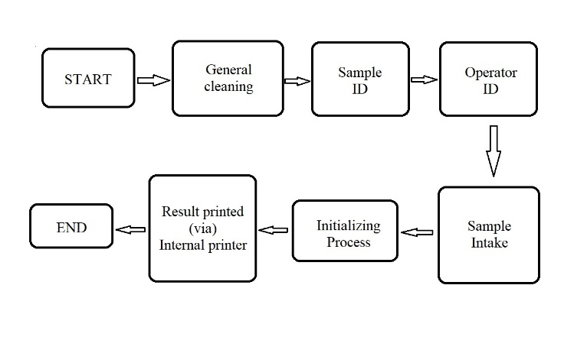
Fig 2

4. BLOCK DIAGRAM 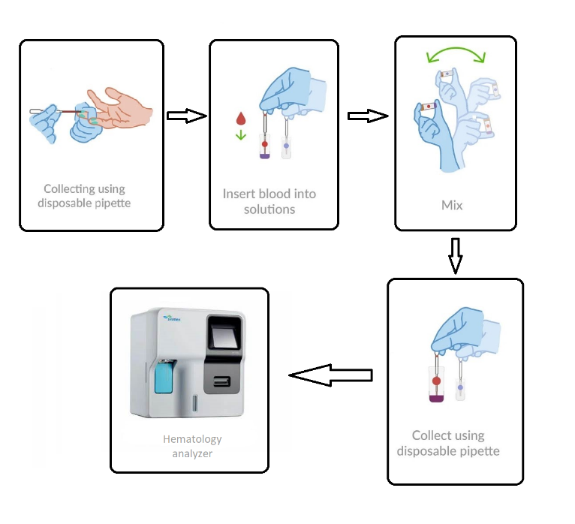
Fig 1

5. HAEMOGLOBIN:
A critical component of the blood in the body called hemoglobin helps oxygen move around the body. Without them, oxygen would not be able to move around the body. Many things can make this oxygen-rich protein rise or fall. It’s essential for life, but it can also fail because of many things. Your hemoglobin levels may rise or fall if you don’t drink enough water, have congestive heart failure, or lose blood.
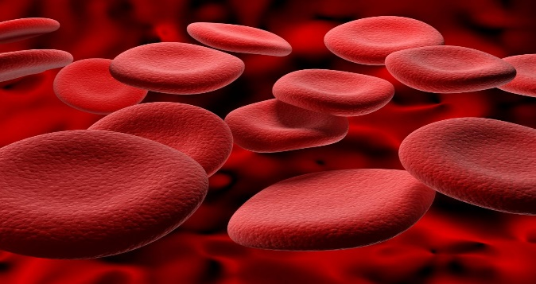
Fig 3

6.HEMATOCRIT:
An HCT tells how much plasma a person has in their red blood cells. Plasma is a kind of fluid that comes from the blood. Often, HCT tests are done when there are signs of dehydration and anemia. Changes can be made to HCT levels, just like hemoglobin levels. Anemia is when there is not enough blood. Doctors usually check red blood cells, hemoglobin, and hematocrit at the same time to see if there is enough blood. Platelets make blood clots.
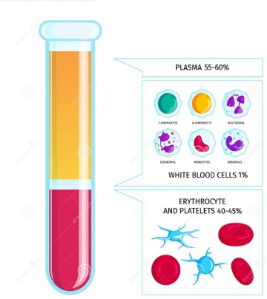

Fig 4

7. 3 PART HEMATOLOGY ANALYZER:
Hematology analyzer are computerized and highly specialized and automated machines that count the number of different kinds of red cells and white cells in a blood sample

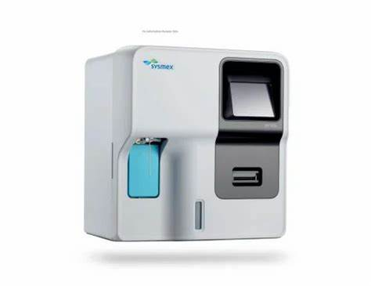
Fig 5
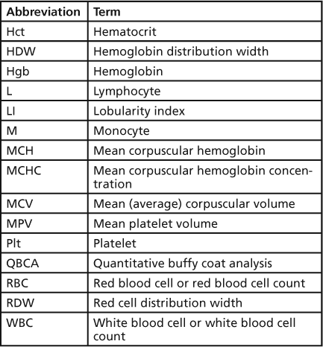

8.METHODOLOGY
- Sample collection: Collect a blood sample from the patient using standard venipuncture techniques. Ensure that the sample is properly labelled with the patient's name and other necessary information.
- Sample preparation: Transfer the blood sample to a suitable tube or container and mix well to ensure that it is well-mixed and homogenous. Allow the sample to stand for a few minutes to allow any clots to form.
- Calibration and quality control: Calibrate the hematology 3-part blood analyzer according to the manufacturer's instructions, using the provided calibration materials. Perform quality control checks using control samples to ensure that the instrument is functioning properly and producing accurate results.
- Sample analysis: Load the sample onto the analyzer according to the manufacturer's instructions. Allow the analyzer to process the sample and generate results. The analyzer will typically provide a complete blood count (CBC), including red blood cell (RBC) count, haemoglobin (Hb) concentration, hematocrit (Hct), platelet count, and white blood cell (WBC) count, along with a differential count of WBCs.
- Interpretation of results: Review the results generated by the analyzer and interpret them in light of the patient's clinical history, physical examination, and other relevant laboratory results. Consult with a hematologist or other expert if necessary.
- Reporting of results: Report the results of the hematology analysis to the patient's medical record and communicate them to the relevant healthcare providers, as appropriate.
- Maintenance and troubleshooting: Regularly maintain and troubleshoot the hematology 3-part blood analyzer according to the manufacturer's instructions to ensure that it continues to function properly and produce accurate results.

9.TESTED VALUE:
TERMS | VALUES
HGB (g/dL) | 12.4
HCT (%) | 38.0

ACCURATE VALUE
TERMS | LL | UL
HGB (g/dL) | 8.0 | 17.0
HCT (%) | 26.0 | 50.0

10. RESULT
The Sysmex xp300 hematology analyzer was used to test different types of blood sample. This analyzer offers several advantages, including its high degree of precision and accuracy, its ability to process large numbers of samples quickly, and its user-friendly interface. The following important values were obtained from the blood sample:

- RBC count: [4.94x10⁶] million cells/mcL
- WBC count: [9.7x10³] cells/mcL
- Hemoglobin (13.8): [insert value] g/dL
- Hematocrit (40.4): [insert value] %
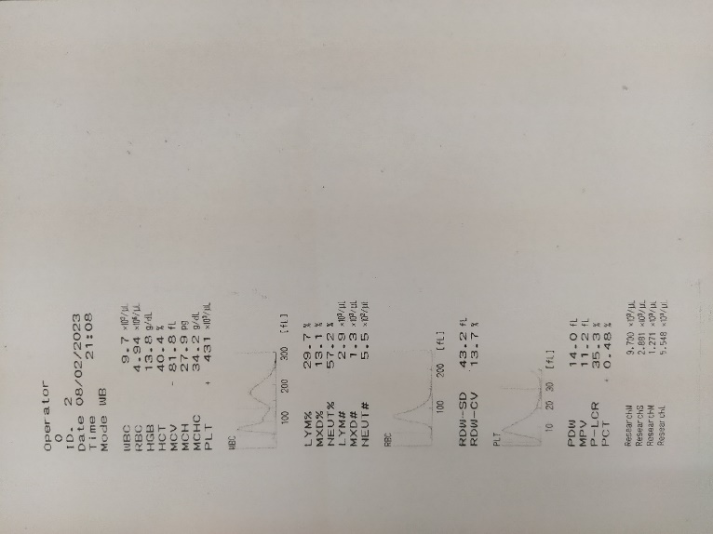
Fig 6

10. CONCLUSION

Based on the available information, it can be concluded that the Sysmex XP-300 3-part hematology analyser is a reliable and accurate tool for measuring haemoglobin and haematocrit levels. The analyser uses advanced technology to provide precise results quickly, which can be helpful in diagnosing and monitoring various medical conditions such as anaemia, dehydration, and polycythaemia.
The Sysmex XP-300 analyser employs advanced technology to measure haemoglobin and haematocrit levels accurately and efficiently. The instrument uses impedance and absorbance measurements to determine the volume and concentration of red blood cells in a blood sample. The analyser also utilizes a unique algorithm to ensure accurate results, which can help healthcare providers make informed decisions about patient care.
Overall, the Sysmex XP-300 3-part hematology analyser is a reliable and accurate tool for measuring haemoglobin and haematocrit levels. It provides quick and precise results, making it an essential tool for clinical laboratories, hospitals, and other healthcare facilities.

11. REFERENCES

- 1. "Reference intervals for complete blood count in adults: a population-based study from Latin America" by R. L. Martinez-Garcia et al. (2022), published in International Journal of Laboratory Haematology.
- "Evaluation of the XN-31 hematology analyser for routine blood cell analysis in patients with hematological malignancies" by H. Zhang et al. (2021), published in Cancer Management and Research.
- "Clinical evaluation of the Sysmex XN-550 hematology analyzer for differential and reticulocyte count" by S. Lippi et al. (2021), published in International Journal of Laboratory Hematology.
- "Hematological changes in patients with COVID-19 treated in ICU: a retrospective study" by M. Pujol et al. (2021), published in Annals of Hematology.
- "Comparison of hematology analyzer-based cellular indices and morphology for prediction of sickle cell disease severity" by L. A. Burgess et al. (2020), published in American Journal of Hematology.
- "Validation of a new hematology analyzer for measurement of complete blood count and white blood cell differential count in peripheral blood" (2014) - Journal of Clinical Laboratory Analysis.
- "Evaluation of the Sysmex pocH-100iV hematology analyzer for use in a resource-limited setting" (2015) - Journal of Clinical Microbiology.
- "Evaluation of the Sysmex XN-series hematology analyzer for detection of malaria and Babesia parasites in human blood samples" (2018) - Malaria Journal.
- "Performance evaluation of the Abbott CELL-DYN Emerald for use in a hematology laboratory" (2019) - Journal of Clinical Laboratory Analysis.
- "Comparison of the performance of the HemoCue Hb 301 and Sysmex XN-10 hematology analyzer for hemoglobin measurement" (2020) - PLOS ONE.
- "Comparative evaluation of the Sysmex XS-1000i and Mindray BC-6800 hematology analyzers in healthy adults" (2021) - Journal of Clinical Laboratory Analysis

