EDUCATIONAL PATTERN PREDICTION USING DATA SCIENCE-SURVEY
Dr. A B Rajendra  Dept. of Information Science and  Engineering  Vidyavardhaka College of Engineering  Mysore rabvvce@gmail.com  Preethi H P  Dept. of Information Science and  Engineering  Vidyavardhaka College of Engineering  Mysore  preethihp1802@gmail.com | kruthi krishnagiri  Dept. of Information Science and  Engineering  Vidyavardhaka College of Engineering  Mysore  kruthikriti1@gmail.com  Veena Bidaralli  Dept. of Information Science and  Engineering  Vidyavardhaka College of Engineering  Mysore  veena.bidaralli20@gmail.com | Pooja V  Dept. of Information Science and  Engineering  Vidyavardhaka College of Engineering  Mysore  poojavhanur@gmail.com

Abstract — Identifying the various factors that influence a student's conduct and academic performance over the course of their academic career. Examining students' poor academic performance and mental health difficulties in the context of the modern educational system is difficult. Monitoring student characteristics and conduct in the current system could be challenging. No automated system or piece of technology can predict a student's academic performance or teach them how to improvise. In the contemporary educational environment, a connection between variables that affect student performance and academic results must be established. Many studies on this subject have employed data science methods like "Association Learning" to identify trends. Although the notion of identifying the determinants for student success prediction in the educational sector has been proposed in several study works, it has not yet been put into practice. The algorithms used have not yet been established despite numerous studies; They instead made use of already available tools and libraries for algorithms. Less training data is used in many research studies. For prediction and to work with static datasets, every extant study employs PYTHON, R, or Ready Data science tools.

Keywords—Correlation, data science, Association Learning, Eclat algorithm, Machine learning, Naïve Bayes

1. INTRODUCTION

The conflict between the limited energy of student counsellors and the diversity of student behaviour, which results in many potentially distressed students missing opportunities for early intervention, is a major problem in student affairs. Because to the rapid advancement of information technology in education and the growth of digital campuses since the early 2000s, student counsellors now have the potential to do quantitative assessments of student behaviour at school, particularly to warn students who may have problems.

Because they are modern students who grew up in the internet era, the internet has a big influence on their daily lives, education, and way of thinking. This presents us with the chance to use big data to understand the behavioural characteristics of their campus network. Today's student instructors have a problem due to the sheer number of data categories and dimensions, but they also have a great opportunity to use cutting-edge methodologies to extract pertinent information from meaningful data.

This study was based on data on B students' internet behaviours and started with actual work-related concerns. It examined the peculiarities of the regulations governing online activity among students and identified those who, because of their frequent use of the campus network, need special attention. Big data science and big data thinking methods were combined. This study could serve as an example of how a student might use data science in the classroom.

2. BACKGROUND

Big data has the potential to revolutionize both academic study and teaching. Big data's ability to inform policy decisions, contribute to the creation of new pedagogical resources, and inspire creative research methodologies is only now being recognized by governments, academics, and private sector organizations. This state-of-the-art overview examines the situation, examining big data and the associated subject of computer code to look at the implications for education and schooling for the present and the foreseeable future.

Key topics include:· The function of educational data science and learning analytics in schools A critical understanding of infrastructures, algorithms, and code. The development of "cognitive classrooms" and the use of computational algorithms in real-world learning settings. Major challenges for researchers using digital research methodologies. Anybody studying or working in the modern educational environment must read this!

Data Science: Building predictive, prescriptive, and prescriptive analytical models employing a vast quantity of data is the focus of the area or domain known as data science. It involves collecting, analyzing, (forming the model), validating, and using the data (deploying the best model). It is the meeting point between computation and data. It combines elements from the fields of business, statistics, and computer science.

3. LITERATURE SURVEY

1. A Data Mining Approach for Forecasting

Students' Performance
"Educational Data Mining" is the study of data mining algorithms and methods with respect to educational data (EDM). One of them is EDM, which might help the model forecast the most unlikely student outcomes at the beginning of the semester and encourage the implementation of educational recovery measures to prevent students from failing. This study presents and discusses the results of three experiments that aimed to estimate student success using actual information from archived student performance levels related to a university course.
METHODOLOGY: classification techniques used
(regression, SVM and Adaboost)
LIMITATIONS
- Algorithmic graphic outputs are not appropriate for usage in real-time.
- Because it employs data mining techniques, a very large amount of data is required.
- Only accepts 2 labels.
- It requires extra time to process the data.

2. Class Result Prediction using Machine Learning.
Primary education increases a nation's literacy rate, while higher education directly affects the industrial workforce, which in turn directly affects the economy. Many colleges were constructed in India. Yet, the ability of the school to retain students and student accomplishment are used to gauge the quality of education. In order to help the student enhance his performance, management may then provide prompt guidance and take the necessary steps. Predicting student performance can help in the process of identifying children who are at danger of failing.
METHODOLOGY: Implementation makes advantage of regression.

LIMITATIONS
1. It is challenging to distinguish between regression methodology outcomes when using the graphical method.
3. Not suitable with real time application.

3. An Intelligent Student Advising System Using Collaborative Filtering
We outline a collaborative filtering-based online intelligent student advising system that assumes users with comparable characteristics and behaviours will have similar preferences. Our method of counselling organises students and gives advice based on how much they resemble the groupings. If a student is found to be similar to a particular group of students, a course that group of students enjoys may be recommended to that student.
LIMITATIONS
- The data collection and the system used to estimate which course would be best for each student are incompatible.
- Not all student actions were influenced by course counselling.
- The method divides the pupils into groups before predicting the best course for each group. Data are insufficient for grouping to forecast.

4. Mining Students’ Data for Performance Prediction
Being able to predict student performance is crucial in educational settings. Academic success is influenced by a number of variables, including environmental, social, psychological, and personal ones. A particularly successful strategy for reaching this goal is data mining. Data mining techniques are used to uncover hidden relationships and patterns in vast amounts of data that are particularly beneficial for decision-making. There is a lot of information in one data point. Data generates some types of information, and these types of information determine how the data is processed. There is a plethora of expertise in the field of education that could provide important insights.
LIMITATIONS
- The method predicts the kids' academic success based on their habits. Dataset incompatible with class result prediction.
- Used more pointless variables to predict student success, such as parents' money, education level, etc.

4. METHODOLOGY
The most well-known, well-known, and simple data science approach is association (or relationship). In order to find patterns, we create a clear connection between two or more elements, typically of the same kind.
We may, for instance, find out from market basket analysis, which analyses customer buying habits, that a client usually buys cream while buying strawberries, and suggest to them to do the same the next time they buy strawberries.
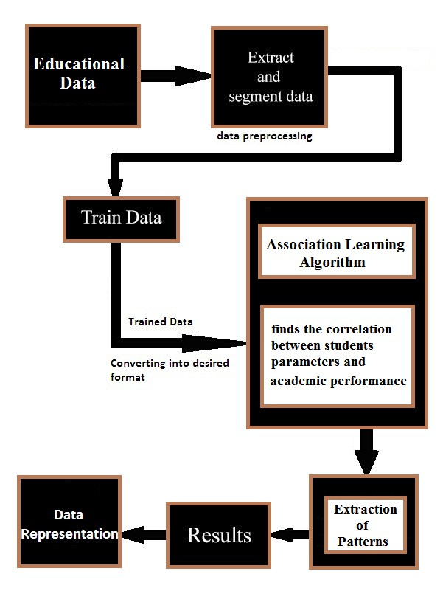
Fig 1 - Methodology

Pattern Prediction Process

Step 1: Data Collection
We are developing a new application with data servers while working on a real-time application (used to store data). Data collection refers to gathering information from various sources. Student parameters and student results are included in the data.

Step 2: Data Preparation
This data was pulled from the servers and examined. extraction, analysis, and deletion of all unnecessary data. According to the project, all that is needed to produce items are the specifications for student input and student output.

Step 3: Specify Constraints
SUPPORT COUNT
The proportion of transactions with that item (A) overall compared to the entire number of transactions in the data collection.
CONFIDENCE
Object set dependability is determined by dividing the number of events with the object set by the number of events with the LHS.

Step 4: Association Rules Mining
A simpler, more widely used, and well-known data mining technique is association (or relationship). In order to find patterns, we create a clear connection between two or more elements, typically of the same kind.
Using market basket analysis, for instance, which analyses consumer shopping habits, we may discover, for instance, that a client always buys cream when buying strawberries, and he recommends doing the same the next time he buys a strawberry.

Step 5: Patterns Prediction
Using a set of educational data, this system makes predictions about the connection between student conduct and performance.

Unsupervised Learning algorithms

Apriori Algorithm Pseudo-code
Apriori (T, minSupport)
Cl = {candidate I-itemsets};
L1 = {cC1|c.count≥ minsup};
FOR (k=2 ; Lk-1ĭ ; k++) DO BEGIN
Ck=apriori-gen(Lk-1);
FOR all transactions tD DO BEGIN
Ct=subset (Ck,t);
FOR all candidates cCt DO
c.count++;
END
Lk={cCk |c.count • minsup}
END
Answer=* Lk;

Eclat Algorithm Pseudo-code
Scanning the data collection will reveal the number of support counts for each item. Include the transaction ids rather than the actual support.
By comparing to the smallest support count, L1 (frequent one item set) is produced.
Use Lk-1 and join Lk-1 to produce the set of candidate kitems.
After scanning the candidate k-item set, generate the support for each candidate k-item set. After we discover the support count of candidate items, there is no need to scan the database once more and compare with the initial data set.
Raise the item set's frequency till C=Null Set is reached. creating every non-empty subset for every frequent item in the collection.
It is necessary to determine the confidence for each nonempty subgroup. if the degree of confidence is greater than or equal to what is indicated. Include Strong Association Rule after that.

SFIT Algorithm Pseudo-code

Examine the data collection to determine the number of supports for each item (both support and transaction ids). Add the support and transaction ids instead of the actual support.
By comparing to the smallest support count, L1 (frequent one item set) is produced.
Use Lk-1 and join Lk-1 to produce the set of candidate kitems.
After scanning the candidate k-item set, generate the support for each candidate k-item set. After we discover the support count of candidate items, there is no need to scan the database once more and compare with the original data set.
Up to C=Null Set, add to the frequent item set.
creating every non-empty subset for every frequent item in the collection.
It is necessary to determine the confidence for each nonempty subgroup. if the degree of confidence is greater than or equal to what is indicated. Include Strong Association Rule after that.

5. CONCLUSION
identifying the various factors that affect a student's academic performance and learning preferences. In the modern educational system, analysing students' mental health difficulties and poor academic performance is difficult. For forecasting, all prior firms used PYTHON, R, or other data science tools, which are effective for static data. However, in the proposed system, we use the idea of dynamic data sets (real-time application). All currently existing efforts are merely model development and cannot be used in real-world contexts. This makes it easier for teachers to identify key factors that influence pupils' success.

REFERENCES
- K. Ganeshan and X. Li, "An intelligent student advising system using collaborative filtering," 2015 IEEE Frontiers in Education Conference (FIE), 2015, pp. 1-8, doi: 10.1109/FIE.2015.7344381.
- T. Mishra, D. Kumar and S. Gupta, "Mining Students' Data for Prediction Performance," 2014 Fourth International Conference on Advanced Computing & Communication Technologies, 2014, pp. 255-262, doi: 10.1109/ACCT.2014.105.
- H. Gull, M. Saqib, S. Z. Iqbal and S. Saeed, "Improving Learning Experience of Students by Early Prediction of Student Performance using Machine Learning," 2020 IEEE International Conference for Innovation in Technology (INOCON), 2020, pp. 1-4, doi: 10.1109/INOCON50539.2020.9298266.
- R. Ghorbani and R. Ghousi, "Comparing Different
Resampling Methods in Predicting Students’ Performance Using Machine Learning Techniques," in IEEE Access, vol.
8, pp. 67899-67911, 2020, doi:
10.1109/ACCESS.2020.2986809.
- C. -Y. Ko and F. -Y. Leu, "Examining Successful Attributes for Undergraduate Students by Applying Machine Learning
Techniques," in IEEE Transactions on Education, vol.
64, no. 1, pp. 50-57, Feb. 2021, doi:
10.1109/TE.2020.3004596.
- Kesheng, N. Yikun, L. Zihan and D. Bin, "Data
Mining and Feature Analysis of College Students’ Campus Network Behavior," 2020 5th IEEE International
Conference on Big Data Analytics (ICBDA), 2020, pp. 231237, doi: 10.1109/ICBDA49040.2020.9101257.
- C. Y. Ko and F. Y. Leu, “Analyzing attributes of successful learners by using machine learning in an undergraduate computer course,” in Proc. 32nd IEEE Int. Conf. Adv. Inf. Netw. Appl. (AINA-2018), Krakow, Poland, 2018, pp. 801–806.
- J.-L. Hung, M. C. Wang, S. Wang, M. Abdelrasoul,
Y. Li, and W. He, “Identifying at-risk students for early interventions—A time-series clustering approach,” IEEE Trans. Emerg. Topics Comput., vol. 5, no. 1, pp. 45–55, Jan.–Mar. 2017.
- R. Asif, A. Merceron, S. A. Ali, and N. G. Haider,
“Analyzing undergraduate students’ performance using educational data mining,” Comput. Educ., vol. 113, pp. 177–194, Oct. 2017.
- S. Zhang, X. Li, M. Zong, X. Zhu, and R. Wang, “Efficient kNN classifi- cation with different numbers of nearest neighbors,” IEEE Trans. Neural Netw. Learn. Syst., vol. 29, no. 5, pp. 1774–1785, May 2018.

