TRACKING SUN PATH and VOLTAGE MONITORING SYSTEM

ABSTRACT
Presently we are invading in a new period of modernisms i.e., Internet of Things (IoT). By using the IoT supervising solar energy can greatly enhance the performance, monitoring of the plant. It is a technique to keep track of the dust assembled on the solar panels to induce the maximum power for active utilization. The amount of output power of the solar panels depends on the radiation hit to the solar cell. All the panels are attached and the sensors are precisely connected to the central controller which supervise the panels and loads. Thus, user can view the current, voltage and sunlight.
INTORDUCTION
With the unavoidable shortage of fossil fuel sources in the future, renewable types of energy have become a topic of interest for researchers, technicians, investors and decision makers all around the world. New types of energy that are getting attention include hydroelectricity, bioenergy, solar, wind and geothermal energy, tidal power and wave power. Because of their renewability, they are considered as favorable replacements for fossil fuel sources. Among those types of energy, solar photovoltaic (PV) energy is one of the most available resources. This technology has been adopted more widely for residential use nowadays, thanks to research and development activities to improve solar cells’ performance and lower the cost. According to International Energy Agency (IEA), worldwide PV capacity has grown at 49% per year on average since early 2000s. Solar PV energy is highly expected to become a major source of power in the future. However, despite the advantages, solar PV energy is still far from replacing traditional sources on the market. It is still a challenge to maximize power output of PV systems in areas that don’t receive a large amount of solar radiation. We still need more advanced technologies from manufacturers to improve the capability of PV materials, but improvement of system design and module construction is a feasible approach to make solar PV power more efficient, thus being a reliable choice for customers. Aiming for that purpose, this project had been carried out to support the development of such promising technology. One of the main methods of increasing efficiency is to maximize the duration of exposure to the Sun. Tracking systems help achieve this by keeping PV solar panels aligned at the appropriate angle with the sun rays at any time. The goal of this project is to build a prototype of light tracking system at smaller scale, but the design can be applied for any solar energy system in practice. It is also expected from this project a quantitative measurement of how well tracking system performs compared to system with fixed mounting method.
LITERATURE REVIEW
Protik Kumar Das1, Mir Ahasan Habib1, Mohammed Mynuddin, “Microcontroller Based Automatic Solar Tracking System with Mirror Booster”, DOI 10.11648/j.ijrse.20150404.11 This paper is designed solar tracking system with mirror booster using microcontroller. Solar energy is rapidly becoming an alternative means of electrical source all over the world. To make effective use of solar energy, its efficiency must be maximized. A feasible approach to maximizing the power output of solar array is by sun tracking. This paper deals with the design and construction of solar tracking system by using a stepper motor, gear motor, photo diode. Mirror is used as booster to maximize the efficiency. The whole frame will travel circularly and the mirror will travel from south to north and vice-versa. The prototype is considered around a programmed microcontroller which controls the system by communicating with sensors and motor driver based on movement of the sun. The performance and characteristics of the solar tracker are experimentally analyzed.
Neenu Sharma, Brijbhushan Sharma, “An Analysis of Automatic Dual Axis Sun Tracking Solar System”, International Journal of Innovative Research in Electrical, Electronics, Instrumentation and Control Engineering ISO 3297:2007 Certified Vol. 4, Issue 12, December 2016 Electricity is the key role in developing progress of industries and modern home society. Coal and oil are non- renewable energy of resources, as the population increases the demand of energy can be increases progressively. Due to the increases of global warming and energy depletion, it is required to control and makes use of natural resources. In modern era, mostly countries focus on the renewable energy of resources. Sun is the supreme sources of renewable energy of resources. Solar energy is the most and unlimited natural resources through which more solar power be generated to use sun power, sun tracking solar system has been designed which can contain photovoltaic modules and act as p-n junction. Sun tracking solar system used mostly to increases the efficiency and power. This paper focus on the study of dual axis solar tracking system which attain more energy from the sun and extends the efficiency or gives more accuracy. The dual axis solar tracker system contain the horizontal position and vertical position in which horizontal position can be vary while vertical position remain fixed. In dual axis solar system they continuously track the sun position in both directions. The paper studied the orientation and tilting of solar panel for which maximum energy can be generated.
EXISTING SYSTEM:
The sun position is one of the main factors that caused instability measurement output voltage. The solar panel will not be able to achieve a maximum illumination from the sun from its standard position. As referring to graph, the output voltages for panel are slightly fluctuated. The comparison between static and moving panels shows that the solar panel with tracker produced higher output voltages as it gets optimum absorption. Due to high and low voltages may lead to the damnage the electronic components and lead to overvoltage sometimes to over come this we implement a new technique that to measure the voltage levels comping from the solar panel. And gives the alert.
PROPOSED SYSTEM
There are various form of energy which we are using in form of themal, chemical, mechanical, electrical and etc. The most popular form of energy is Electrical Energy as it is easy to tranfer with maximum efficiency. The demand of Electrical Energy is increasing day by day. We are mostly generating it through conventional sources like fossil fuels, nuclear fuels etc. But the conventional sources are limited and creates pollution and exhaust one day. So we are shifting to non conventional sources like wind, solar, tidal, geothermal etc. The Solar Energy is the biggest form of energy, all the the other form of energy depends on it only like wind is due to air currents which is due to expansion of air by solar energy only, fossil fuels due to life cycle which also depend on Solar Energy. So instead of taking it indirectly we can directly convert into electrical enrgy by using photovoltaic cell, or Solar cell . But we are not able to harness that much amount of energy. Solar energy can be converted to electrical energy through solar panels. They give maximum output when rays incident on 90 degree. But in current scenario we are using fixed solar panel so it is not able to give maximum output hence the efficiency decreases.
METHODOLOGY:
The main impulsion is to design a high quality solar tracker. This paper consists of two parts; hardware and software. It consists of three main constituent which are the inputs, controller and the output as shown in Fig 1.A Lightdependent resistor (LDR) is a light-controlled variable resistor. They are very useful especially in light/dark sensor circuits. Normally the LDR resistance is very high, up to 1000 000 ohms, but through illumination with light, resistance drops dramatically. LDR’s are inexpensive and has a simple structure. A DC motor relies on the fact that like magnet poles repels and unlike magnetic poles attracts each other. DC motors consist of one set of armature winding, inside another set of coils or a set of permanent magnets, called the stator. Voltage applied to the coils produces a torque in the armature, resulting in motion. DC stepper motor is being used here.L293D IC having two channels is used to drive the DC motors. A DC stepper motor driver is used to achieve the desired speed in moving the solar panel .The Dc motors can turn either clockwise or anticlockwise direction depending upon the sequence of the logic signals. The sequence of the logic signals depends on the difference of light intensity of the LDR sensors. The principle of the solar tracking system is done by Light Dependant Resistor (LDR). Four LDR’s are connected to Arduino analog pin AO to A4 that acts as the input for the system. The built-in Analog-to-Digital Converter will convert the analog value of LDR and convert it into digital. The inputs are from analog value of LDR, Arduino as the controller and the DC motor will be the output. LDR1 and LDR2, LDR3 and LDR4 are taken as pair .If one of the LDR in a pair gets more light intensity than the other, a difference will occur on node voltages sent to the respective Arduino channel to take necessary action. The DC motor will move the solar panel to the position of the high intensity LDR that was in the programming.
BLOCK DIAGRAM:
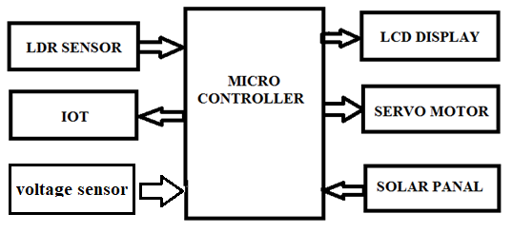
SG90 SERVO MOTOR
There are lots of servo motors available in the market and each one has its own speciality and applications. The following two paragraphs will help you identify the right type of servo motor for your project/system.
Most of the hobby Servo motors operates from 4.8V to 6.5V, the higher the voltage higher the torque we can achieve, but most commonly they are operated at +5V. Almost all hobby servo motors can rotate only from 0° to 180° due to their gear arrangement so make sure you project can live with the half circle if no, you can prefer for a 0° to 360° motor or modify the motor to make a full circle. The gears in the motors are easily subjected to wear and tear, so if your application requires stronger and long running motors you can go with metal gears or just stick with normal plastic gear.
Next comes the most important parameter, which is the torque at which the motor operates. Again there are many choices here but the commonly available one is the 2.5kg/cm torque which comes with the Towerpro SG90 Motor. This 2.5kg/cm torque means that the motor can pull a weight of 2.5kg when it is suspended at a distance of 1cm. So if you suspend the load at 0.5cm then the motor can pull a load of 5kg similarly if you suspend the load at 2cm then can pull only 1.25. Based on the load which you use in the project you can select the motor with proper torque. The below picture will illustrate the same.
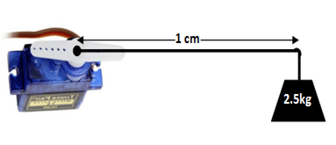

SOLAR PANAL
The amount of sunlight that strikes the earth's surface in an hour and a half is enough to handle the entire world's energy consumption for a full year. Solar technologies convert sunlight into electrical energy either through photovoltaic (PV) panels or through mirrors that concentrate solar radiation. This energy can be used to generate electricity or be stored in batteries or thermal storage.
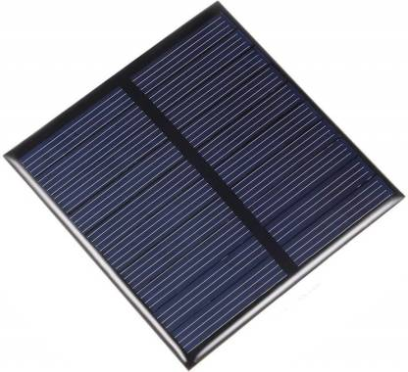
Below, you can find resources and information on the basics of solar radiation, photovoltaic and concentrating solar-thermal power technologies, electrical grid systems integration, and the non-hardware aspects (soft costs) of solar energy. You can also learn more about how to go solar and the solar energy industry. In addition, you can dive deeper into solar energy and learn about how the U.S. Department of Energy Solar Energy Technologies Office is driving innovative research and development in these areas.

LDR – Light Dependent Resistor
An LDR is a component that has a (variable) resistance that changes with the light intensity that falls upon it. This allows them to be used in light sensing circuits. A light-dependent resistor (LDR) is a light-controlled variable resistor. The resistance of this decreases with increasing incident light intensity; in other words, it exhibits photo-conductivity. An LDR can be applied in light-sensitive detector circuits, and light- and dark-activated switching circuits. An LDR is made of a high resistance semiconductor. In the dark, an LDR can have a resistance as high as a few mega ohms (MΩ), while in the light, an LDR can have a resistance as low as a few hundred ohms. If incident light on an LDR exceeds a certain frequency, photons absorbed by the semiconductor give bound electrons enough energy to jump into the conduction band. The resulting free electrons (and their whole partners) conduct electricity, thereby lowering resistance. The resistance range and sensitivity of an LDR can substantially differ among dissimilar devices.
A Light Dependent Resistor (LDR) is also called a photoresistor or a cadmium sulfide (CdS) cell. It is also called a photoconductor. It is basically a photocell that works on the principle of photoconductivity. The passive component is basically a resistor whose resistance value decreases when the intensity of light decreases. This optoelectronic device is mostly used in light varying sensor circuit, and light and dark activated switching circuits. Some of its applications include camera light meters, street lights, clock radios, light beam alarms, reflective smoke alarms, and outdoor clocks.
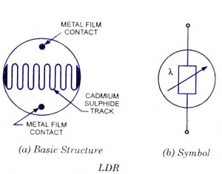
RESULT:
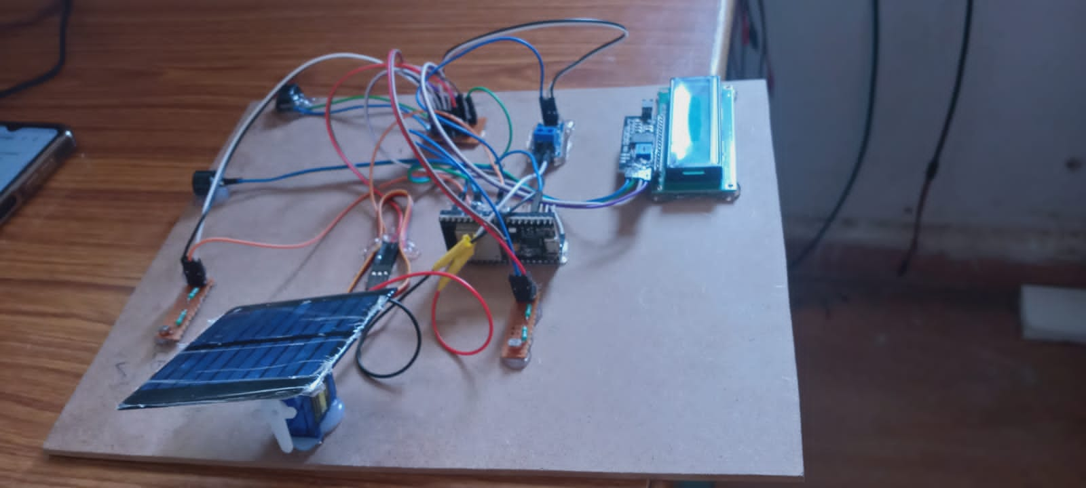
CONCLUSION:
In this 21st century, as we build up our technology, population & growth, the energy consumption per capita increases exponentially, as well as our energy resources (e.g. fossils fuels) decrease rapidly. So, for sustainable development, we have to think alternative methods (utilization of renewable energy sources) in order to fulfil our energy demand. In this project, Dual Axis Solar Tracker, we’ve developed a demo model of solar tracker to track the maximum intensity point of light source so that the voltage given at that point by the solar panel is maximum. After a lot of trial and errors we’ve successfully completed our project and we are proud to invest some effort for our society. Now, like every other experiment, this project has couple of imperfections.
(i) Our panel senses the light in a sensing zone, beyond which it fails to respond.
(ii) If multiple sources of light (i.e. diffused light source) appear on panel, it calculates the vector sum of light sources & moves the panel in that point.
This project was implemented with minimal resources. The circuitry was kept simple, understandable and user friendly.

REFERENCES:
[1] Solar Tracking Hardware and Software by Gerro J Prinsloo
[2] Design and Implementation of a Sun Tracker with a Dual-Axis Single Motor “Jing-Min Wang and Chia-Liang Lu’’
[3] Sensors and Transducers...Second Edition...’’D.Patranabis”
[4] Atmel ATmega48A/PA/88A/PA/168A/PA/328/P-datasheet
[5] Utilisation of Electrical Power. Author, Er. R. K. Rajput.
[6] Arduino Programming Book. Author, Brian W. Evans

