IOT SMART TROLLEY
^{1.}S. JAYAMANGALA,^{2.} MULA SNEHA PRIYANKA, ^{3.} YEDDULA LAKSHMI DEVAMMA, ^{4.} DUDDEKUNTA SUSMITHA,^{5.}JISHITHAPONAMALA,^{6.}KANDUKURISUJATHA,^{1.}Asst.professor,^{2,3,4,5,6}.UG Students,Dept.of ECE SANTHIRAM ENGINEERING COLLEGE,NANDYAL.Mailid:jaya.ece@srecnandyal.edu.in

ABSTRACT:
A shopping trolley is used to transport goods from the store to the customer in supermarkets and shopping centers. It's not easy to get your hands on this goods. Ideally, customers would draw the trolley each time they wanted to receive products, rather than having to pull it each time and risk losing their place in line. Customers prefer to pay their bills after making purchases. A lengthy line forms as customers wait to get their items scanned with an RFID reader and a barcode scanner before being invoiced. The wise shopper may change that by making strategic purchases at the mall. A RFID barcode must be placed on every product for scanning with an RFID reader. The RFID reader and LCD screen will make up the smart cart's other components. Customers use the shopping cart to store the items they want to purchase. After scanning and reading the product, the price and product name will be shown on an LCD screen. Ultimately, the Arduino will operate as a memory, storing the total amount charged for all items bought. All of these processes take place in a special trolly.
INTRODUCTION:
Shopping is going to a shop, looking at the products, buying them, walking through the billing area, waiting in a long line, having the things scanned, the total price calculated, and then paying for everything with either cash or a credit card. But, not everyone finds it rewarding to do so. What we learned is that people become frustrated because they have a hard time making purchases. These three parts make up the whole of this system. In the first place, there's the trolley itself. A primary storage unit, two servo motors, a weight sensor, and a wifi-enabled Nodemcu microcontroller make up the trolley's other main components. The Nodemcu acts as an HTTP server that communicates with the phone and processes the data.
The smartphone is equipped with a QR code scanner and an Android software that allows it to communicate with the trolley and a web server. The whole shopping list is also recorded in the app. The Apache server was created specifically for storing data about items and facilitating their customization. In order to get details on goods, the mobile phone communicates with a web server. Complete your purchase information and send it in. The complete image, therefore, is made up of all these parts doing their jobs. The shopping cart and the web server communicate with one another thanks to the android app. How the system as a whole functions is as follows.
LITERATURE REVIEW:
In his work "Smart Cart with Automatic Billing, Product Information, Product Recommendation," A. Yewatkar [1] describes a system that "automatically" Combining Radio Frequency Identification (RFID) and Zigbee (Zigbee) with Anti-Theft, we created a smart shopping cart system that can record items bought and process payments digitally. With a consolidated database, the system will also recommend items to the user.
In their study, A framework for attribute selection in marketing utilizing rough computing and formal concept analysis, D. P. Acharjya and T. K. Das [2] provide a system for making these decisions. In order to deal with a database where certain numerical attribute values are close but not identical, they used this method. Two procedures, pre- and post-processing, were developed to deal with such a data system. In the pre-process phase, they employed a rough set on intuitionistic fuzzy approximation space with ordering rules to discover information and relationships; in the post-process phase, they used formal concept analysis to pinpoint the most important factors in making judgments.
In his work Enabling RFID in Retail, G. Roussos [3] argues that RFID tagging provides real advantages to both suppliers and retailers. But, public concerns regarding privacy must be addressed before deployment can be made at scale.
According to the authors H. H. Chiang et al. [4] in the article The core components of the AI-powered, cashierless convenience store are the customer application and the smart shelf. Customers may use the Customer's Application as a starting point for their own online checkout processes. The Smart Shelf is a helpful tool for retailers in maintaining order and stock levels. Facial recognition technology is integrated into Smart Shelves to increase safety measures and give valuable data to shop owners.

EXISTING SYSTEM:
Due to the lack of such tools in prior projects, we have had to resort to the time-consuming and inefficient traditional methods of paying, checking materials numerous times before adding or removing them, and waiting our turn to build.
PROPOSED SYSTEM:
Here, users get access to the android app's dashboard, where they may browse various service categories; this, in turn, allows them to quickly and easily finish their purchases. Shopping cart services make it easier for consumers to complete this process and get high-quality goods while minimizing the hassles and impediments that customers often face. When the smart shopping cart has been initialized, customers may log in using the login Authentications we covered before. After that, they'll be brought to the dashboard, which has quick access to their order history, product recommendations, a search bar, and their recently added items. These modules show the whole shopping process workflow, making it simple for clients to buy whatever they need.
METHODOLOGY:
Small, medium, and complex embedded systems are three of the many categories of embedded systems. Small-scale applications often use 8-bit processors and lack operating systems. On a smaller size, 4/8 processors and operating systems are employed, but on a medium-large scale, 8/16 is standard. Co-designs are favored in the high-end market. Under the category of medium-sized embedded systems, this project properly belongs. The design's high-level block diagram is shown. Hardware elements of this prototype model include a Node MCU, RFID tag, RFID reader, and an LCD display.
Node MCU stores RFID libraries. Everything has to have an RFID tag linked to it. When a consumer uses a smart trolley to choose an item from a selection, an RFID reader in the trolley will scan the item and the information will be displayed on an LCD screen. Let's say a consumer completes their shopping trip and sees their total cost displayed on an LCD screen. After then, the client is sent to the billing department, where they will remain until the payment has been processed. Customers shouldn't have to wait in line at the billing counters if their whole amount can be shown on an LCD screen. Instead of a direct connection to the Node MCU, the system utilizes a module to communicate with it.
BLOCK DIAGRAM:
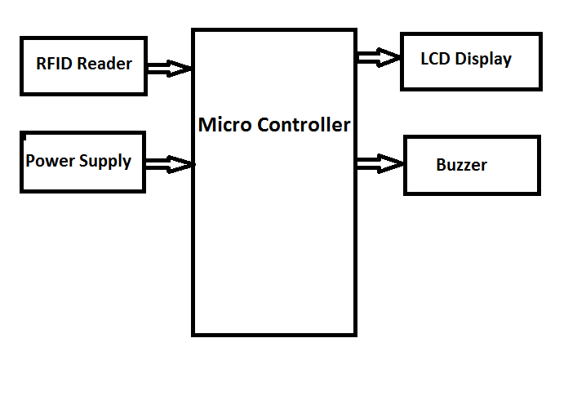
Shopping centers and markets are bustling hubs where people go to stock up on necessities such branded groceries, snacks, clothing, home goods, and electronics. There are now an unprecedented number of malls, both big and small, accessible to consumers everywhere. During weekends and holidays, shoppers often flock to shopping centers. They wanted to spend more time there and that's what retailers gave them. Customers often wait an inordinate amount of time at the register before being able to pay for their purchases. The standard billing system was forced to evolve through time so as to better serve its clients.
In order to address these issues and make necessary adjustments to the current system, we developed an RFID-enabled "Smart trolley" for smart shopping. Putting an RFID reader with an LCD display on the shopping cart and RFID tags on the merchandise is all that's needed to do this. Each item's total price and a short description of the product will be shown on an LCD screen once the buyer scans it with an RFID reader in this system. Both shoppers' and the mall's time will benefit from this system's efficiency. It may also be utilized to ease the burden on mall workers.
Buzzer
A buzzer or beeper is an audible signaling device that may be mechanical, electromechanical, or piezoelectric (piezo for short). Alarm clocks, timers, and anything that requires the user's confirmation of action (such a mouse click or keyboard) often make use of some kind of audible signal, and buzzers and beepers fall.
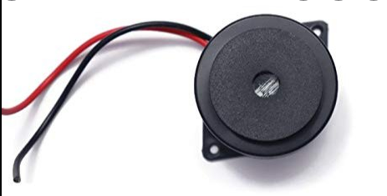
EM18
The RFID reader EM18 can decode 125 kHz tags. After scanning tags, it sends the collected data in serial to a PC or microcontroller through UART connection or Wiegand format on the appropriate pins. The EM18 RFID reader is capable of retrieving information from RFID tags that have a 12-byte ID encoded on them.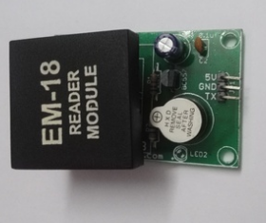

RFID tags
Radio frequency identification (RFID) tags are a sort of tracking device that may be used to locate, identify, follow, and exchange data with objects and people. RFID tags are essentially smart labels with the capacity to hold a wide variety of information, from serial numbers and brief descriptions to pages of data.
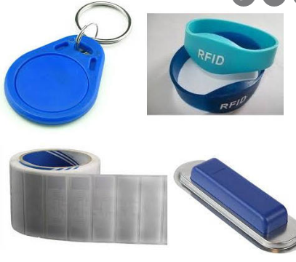
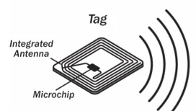

RESULT:
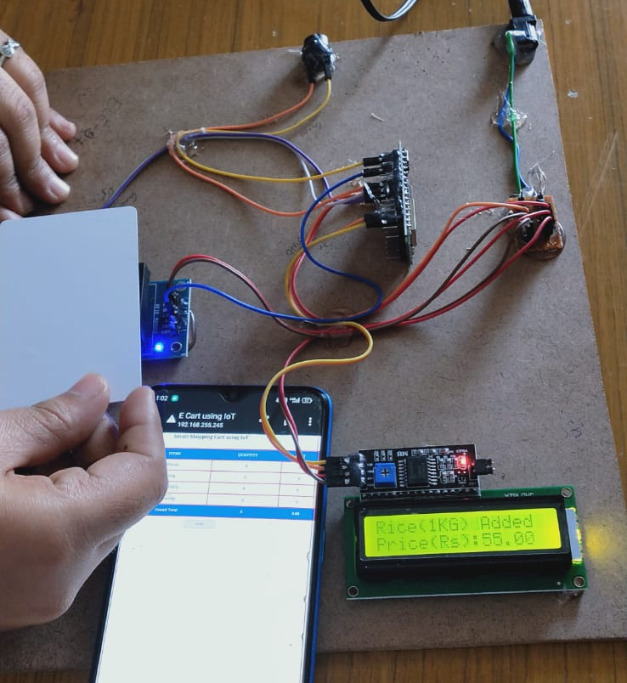
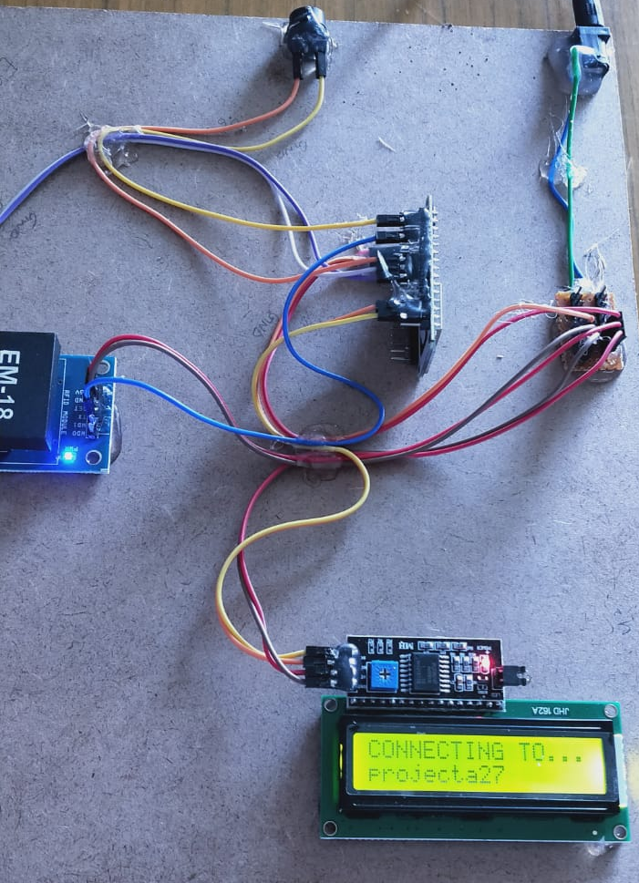
CONCLUSION
A shopping trolley is used to transport goods from the store to the customer in supermarkets and shopping centers. It's not easy to get your hands on this goods. Ideally, customers would draw the trolley each time they wanted to receive products, rather than having to pull it each time and risk losing their place in line. Customers prefer to pay their bills after making purchases. A lengthy line forms as customers wait to get their items scanned with an RFID reader and a barcode scanner before being invoiced. The wise shopper may change that by making strategic purchases at the mall. A RFID barcode must be placed on every product for scanning with an RFID reader. The RFID reader and LCD screen will make up the smart cart's other components. Customers use the shopping cart to store the items they want to purchase. After scanning and reading the product, the price and product name will be shown on an LCD screen. Ultimately, the Arduino will operate as a memory, storing the total amount charged for all items bought. These are all trolly operations.
REFERENCES:
1. Mr. S. Balamurugan and Mr. S. Balaji “Smart Shopping Cart”, 2017.
2. Mr. Manikandan and Mr. Mohan “RFID Based shopping Trolley for Supermarket”, 2017.
3. Mr. Kumar and Mr. Gupta. A “Smart Trolley using Arduino”,2017.
4. Mr. Raj and Mr. Inamdar “Smart Cart with Automatic billing”, 2016.
5. R.O’ Neil (21 June 2005, 21 June 2017) “Smart trolley for shopping malls”.
6. Mr. Inamdar, Mr. Singh “Smart cart using automatic billing, product information, product recommendation using RFID,2015.
7. Mr. P. Chandrasekar and Ms. T. Sangeetha “Smart shopping cart with automatic billing system through RFID and transmitter and receiver”, IEEE, 2014.
8. S. K. Nataraj, F. Al-Turjman, A. H. Adom, R. Sitharthan, M. Rajesh and R. Kumar, "Intelligent Robotic Chair with Thought Control and Communication Aid Using Higher Order Spectra Band Features," in IEEE Sensors Journal, doi: 10.1109/JSEN.2020.3020971.
9. B. Natarajan, M. S. Obaidat, B. Sadoun, R. Manoharan, S. Ramachandran and N. Velusamy, "New Clustering-Based Semantic Service Selection and User Preferential Model," in IEEE Systems Journal, doi: 10.1109/JSYST.2020.3025407.
10. Ganesh Babu, R.; Obaidat, Mohammad S.; Amudha, V.; Manoharan, Rajesh; Sitharthan, R.: 'Comparative analysis of distributive linear and non-linear optimised spectrum sensing clustering techniques in cognitive radio network systems', IET Networks, 2020, DOI: 10.1049/iet-net.2020.0122
11.Rajalingam, B., Al-Turjman, F., Santhoshkumar, R. et al. Intelligent multimodal medical image fusion with deep guided filtering. Multimedia Systems (2020). https://doi.org/10.1007/s00530-020-00706-0.
12.“Design and Simulation of High Performance Hybrid Full Adder UsingCMOS 45 nm Technology”, Advances in Signal Processing and Communication Engineering, Lecture Notes in Electrical Engineering 929,(SPRINGER) ,in 2022 .
13.Vlsi Implementation Of Ternary Adder And Multiplier Using Tanner Tool”, Journal of Pharmaceutical Negative Results , Volume 13 ,Special Issue 5 ,2022
14.“Design and Analysis of Memristor Based 7T SRAM Using Leakage reduction Techniques”, IJIREEICE,ISSN 2321-2004, Feb-2022.

