A Learning Platform for Children with Special Needs in Schools of Kabwe District, Central Province in Zambia.

Mutunda Paul¹
PG Student
Department of Computer Science
DMI-St. Eugen University, Zambia
Email: mutundapaul@gamil.com

Dr. T. Ananth kumar²
Supervisor
Department of Computer Science
DMI-St. Eugene University, Zambia
Mail ID: tananthkumar@ieee.org

Dr. Glorindal Selvam³
Course Coordinator
Department of Computer Science
DMI-St. Eugene University, Zambia
Mail ID: glorygj@yahoo.com

Abstract—Technology has extended to the education sector especially when it comes to eLearning or virtual learning platforms in Zambia. Unfortunately, Children with special needs (SEN) in schools have not enjoyed this privilege. This paper aims to create an eLearning platform for the visually impaired and deaf in Kabwe district of Zambia. This platform or the stand-alone program will help the users to learn using text(deaf) and speech (voice) command (visually impaired). Since the inception or introduction of ICT, the Government of the Republic has put in a lot of effort and money to train human resources in the field of ICT to solve problems using ICT and foster the agenda of the government. The Ministry of Education is the prime target for the training of masses in ICT-related fields. A branch of government called Smart Zambia or eGovernment division has been involved in trying to propel this government agenda by training teachers around the country on ICT issues called eGovernment. A combination of simply available programming technologies such as Java and MYSQL is used in this project. The possible ways of learning via text for the deaf and voice command for the visually impaired learners in Kabwe are analyzed in this project. It reveals that it is possible to use simple technologies to create eLearning or virtual platforms for SEN learners apart from the traditional way, which is face to face type of learning in the classroom. This is in line with the Ministry of Education’s vision for all learners in the district in particular and the country at large that all children whether regular or with a disability should have access to education. Advantages of the eLearning platform that the eLearning platform for SEN is portable, meaning it can be used on any computer, is easy to use, and is inexpensive to develop. Not much computer hardware would be required to deploy this system in stipulated schools in the district.
Keywords—SEN learners, Java, MYSQL, Ministry of Education
- Introduction
The Ministry of Education is mandated to formulate and implement Education and Science policies, set and enforce standards and regulations, license, supervise and provide education skills development, promote science and technology, and promote innovation education. Its mission statement is "To enable and provide an education system that will meet the needs of Zambia and its people" (Brooks, Nolan and Gallergher). There is a department for Special Educational Needs (SEN) among other secondary school departments. However, with the advent of covid – 19 which lasted about three years and is still ongoing threatening and claiming lives in the district, the Ministry introduced eLearning or virtual platforms to aid learners with continuing with learning regardless of the pandemic (Ibid, 2002) Most of the eLearning platforms that were deployed to carry out this mandate of the government of the republic, excluded the department of special educational needs learners. Distance learning is another aspect that cannot be overlooked in the educational sector today (Mwanakatwe). The Ministry has made it clear that all government departments should embrace ICT to enhance government delivery and services (Division). This, therefore, means that SEN learners in schools should not be left out. In addition, traditional lesson delivery is slowly fading away and the educational system around the world is quickly embracing modern ways of learning. The world of learning and teaching is at a watershed; confronted by challenges to previous educational models (Taylor, How to be a Webinar Master). technology has brought a change in nearly all sectors especially, education meaning even learners with special educational needs (SEN) should not at all be left out.
The main function is to allow Special Educational Needs SEN) learners to have their own eLearning platform exclusively. The other Function is to allow the Ministry via the Examinations Council of Zambia (ECZ) be able to assess SEN candidates using wordwall application on the eLearning platform (wordwall.net). The advantage of this system is that it can be used on any operating system currently being used by most users in the district. Online final examinations administered by the Examinations Council of Zambia (ECZ) will dispel certain issues that the Zambia Federation of Disability Organisations (ZAFOD) has been raising. ((ZAFOD)) issued a statement on 15th December 2020 about disadvantaged candidates with special needs in final examinations in terms of scripts not being accompanied by any documentation that clearly states to markers that the papers being marked are from learners with special educational needs (SEN). Another issue raised by ZAFOD is that of losing scripts for candidates with special needs (SEN). Administering online examinations would eliminate this issue appropriately. In this way, SEN candidates would be receiving their results instantly than waiting for the end of the year as per trend to view their results. The Ministry could benefit hugely in terms of saving on costs for administering, the process of marking, and publishing these results.
One advantage of eLearning to take note of is that it has enabled an increasingly student-cantered learning setting (Salmon)
The eLearning platform or system for specifically the visually impaired and deaf is portable, simple to use, user-friendly, and affordable. It is developed using easy programming language techniques such as Java and MYSQL which are readily available. Questions for assessments for School Based Assessments (SBA) and Examinations Council of Zambia will be administered using wordwall which can easily be accessed by Administrators of the system.
- Literature Survey
Over the last decade or two from the inception of the adoption of Information Technology in education in Zambia particularly, so much related work has been developed as well as published in the literature globally. Research to establish how technology can be of help in Schools, Colleges, and Universities around the world, has been done by many scholars. The following are some of the related researches towards the development of eLearning platforms:

Webinar is a platform for video presentation workshops or lecturers hosted online, usually via Webinar software. It is said that webinars are usually interactive where a student and instructor get to interact (Taylor, How to be a Webinar Master). It offers a wide range of training materials or teaching aids such as a whiteboard, breakout rooms, slide show areas, speakers, chat areas, and many more (Taylor, How to be a Webinar Master). Further, the platform offers very unique features such as multimedia content. The platform is globally used by many people. The webinar can be used by schools such as those in Kabwe District easily. However, it is not specifically created for SEN learners.

Teaching with Google Classroom is an eLearning platform that is quite useful and popular. Learners can be invited to their virtual classroom by a teacher, announcements can easily be sent, online discussions, hanging out and taking in assignments, grading typed assignments by a teacher or instructor, customizing to a particular subject and so on are features offered by this particular platform is a free application. (Zhang) It is user-friendly and supports all types of multimedia and therefore, can be used by all schools including those in a rural setup. Unfortunately, it is not specifically meant for SEN learners. Web teaching is a courseware type of learning. (Hat) clearly states that in web teaching, we think of teachers controlling the server meaning teachers decide what will be made available to the server and which content of information will be served for computers or clients (Hat). it is stated that the learner speaks, writes, performs experiments, plans, etc as opposed to reading, listening to lecturers, etc. this eLearning platform is good as it appears to be cheaper and has no need to download an application per se. Learners would just be required to connect to the internet to access learning materials and attempt assessments prepared by teachers or instructors. However, it is not meant specifically for learners with special needs such as the visually impaired and the deaf.

- Proposed Methodology
The implementation of the project is a desktop application using java and MYSQL languages. Below is a design of the system structure of the proposed system.

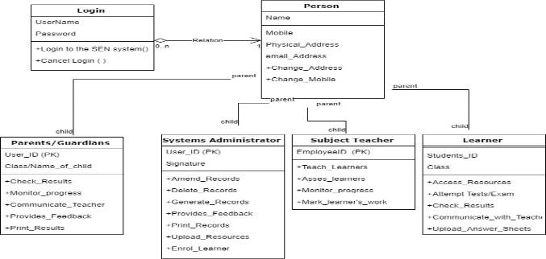
As seen above, it comprises the following modules;
Login module (Access control Interface Module) integrates components which are: the username and password. This would make sure the verification and authentication procedure just like in any other eLearning system is followed. However, privileges to the system for the Admin and the Student (Learner) differ. All users regardless of the module would have the privilege of changing their password in circumstances where the password is forgotten or just changing to strengthen security.

Admin/Teacher Module: This module allows a user (Admin/Teacher) to log in and perform the following tasks:
- Upload content for learners
- Upload school notices by school Administration or otherwise.
- Assess the learners
- Signup a new user
- Generate required reports
- Upload results

Learning Module: this module is divided into two categories which is the module for deaf learners which is text-based and the module for the visually impaired which is a voice (speech) based module and allows learners to learn and attempt assessment using speech or voice commands.

Parent/Guardian Module: This module allows the parents to access the progress made by their children so far. It also allows the user to access the results of their children.

Algorithm (flow chart)
the following is an algorithm using a flow chart to determine the type of login:
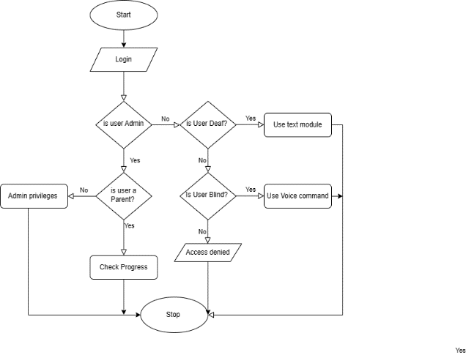
The algorithm checks to see if the user is either an Admin (Teacher), Parent/Guardian or Learner. If a user is a learner, it checks to see if a learner is visually impaired or deaf. If a learner is visually impaired, then the system would allow such a learner to access the system using voice command and if a learner is deaf, then the system would allow such a learner to use text commands or instructions.

Dataflow diagram
Below, is a dataflow diagram to illustrate the flow of data in the system from login by a user and what they are able to do as they interact with the system.
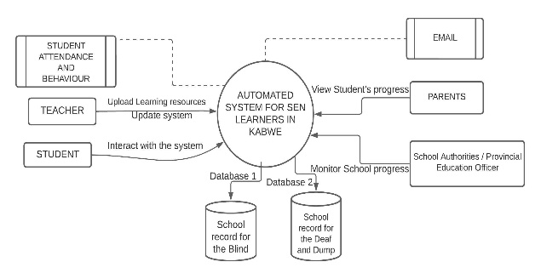
The above context zero diagram illustrates how users will interact with the proposed system. A teacher will be able to login and upload learning materials, update the system, and so on. A student (learner) will be able to interact with the system in so many ways such as attempting the assessments, viewing results, and so on. Parents or Guardians will be able to view results for their child. The system will be able to store information such as the currently enrolled learners, school-based assessment (SBA) results for all practical subjects such as Integrated Science (IS), Computer Studies (CS), Physical Education (PE), and Home Economics (HE), and results from the Examinations Council of Zambia (ECZ). The database would also help the Administrators to generate vital reports.
- Results And Analysis
The following are compiled results and descriptions of each

piece of data collected from the respondents from the three main schools that enrol SEN learners in Kabwe i.e., the visually impaired, deaf, and in some cases, dump;

Three schools were used for this case study namely; Lukanga secondary school, Broadway secondary school, and Neemtree Secondary school within the District of Kabwe, Zambia. The information was strictly given for the purpose of this project exercise.

Analysis or the findings from secondary data collection through the questionnaire are represented in a graphical form (Graphs).

Take note that respondents are mainly from these named schools as they deal with the targeted learners themselves.

A few parents also participated in this exercise successfully. However, some parents were not cooperative enough and others simply did not return the questionnaires on time.
The following are the findings and results from the respondents;
How long have been a teacher of SEN Learners?
Gender of Teachers | Frequency | Percentage (%) | None Respondent
Female | 11 | 58% | 10
Male | 08 | 42% | 10
Total | 19 | 100 | 10

This determines the experience of a teacher in this field of SEN learners. This data helps to develop the required software that will easily solve the current problem. Years in service by a teacher matters as they are the Administrators of the proposed system.

Are you conversant with using a computer as a teacher? (Demographic data)

Options | Frequency | Percentage % | Nonrespondent
Yes | 10 | 53% | 10
No | 09 | 47% | 10
Total | 19 | 100 | 10

This data helps to understand the competence levels of using a computer by end users as the proposed system requires competence in computer use.

Describe the pedagogy used in class by a subject teacher
Collaborative: This type involves learning in groups to find
Learning and teaching aids
Aids | Mics | Computers | Charts | Real objects
Blind | 07 | 03 | 00 | 07
Deaf | 00 | 60 | 60 | 60

This data helps to determine how multimedia would be used in the proposed system. All teaching and learning aids used in the traditional way should have cooperated in the proposed system in a form of multimedia. Multimedia devices (hardware) such as computers, microphones, and speakers will continually be used as teaching and learning aids.
solutions to problems or complete a given task collectively.
Integrative approach allows learners to connect the lesson with what has been taught or learned.
Reflective and Inquiry-based learning: allows learners to demonstrate what has been learned. It is an experimental approach and promotes field study and project work by learners.
Constructivist: this allows these learners to construct their understanding of the environment around them which is based on experience as they learn and grow (12)
This data helps to determine if it is really necessary to incorporate multimedia in the proposed system.

Teachers | Neemtree | Broadway | Lukanga | Totals
Female | 02 | 17 | 02 | 21
Male | 01 | 05 | 02 | 08
Total | 03 | 22 | 04 | 29

This data helps to determine the gender of teachers. The above data indicates that there are many female teachers compared to male teachers.
With the help of the data collected, a proposed system to solve the current problem of leaving out SEN learners using technology was solved.
In line with the objectives, the output is designed to meet the end users (Ministry of Education, Learners with special needs such as the deaf and the visually impaired) requirements. Further, it should serve the intended purpose of aiding learners with special needs, who need to be able to learn at their pace and receive quality education just as other regular or general or regular learners do.

How conversant are learners with computers? Demographic data
Learners | Good | Moderate | Poor | V. Poor
Frequency | 11 | 04 | 13 | 11
Percentage | 28% | 10% | 33% | 28%

The above data shows that there is a need to train learners in the use of ICT devices in order to have them use the proposed system.

However, some data collected may not have coincided with the original hypothesis. Data such as how a teacher communicates with the learners could have been paraphrased.

Previous studies relating to the development of technologies concerning children with special needs in schools have all shown that it is indeed possible to have a system or platform created for learners with special needs in schools.

With respect to teaching and learning aids, multimedia is one very powerful tool to help learners regardless of their learning abilities to assimilate information easily and quickly. Online or eLearning platforms, supports multimedia to the fullest. Consequently, the development of the proposed system comes in handy.

learners with special needs should be able to learn at their pace and receive quality education just as regular or general learners do. This in turn promotes the desired student–centred type of methodology strategy.

The output obtained or produced by the proposed system interface appears as follows in the illustration below:

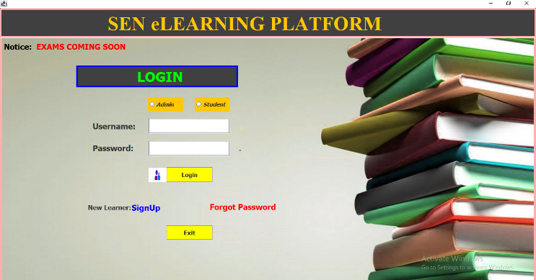
The login output interface looks as above. Unauthorized users would not be able to log in as access would be denied. The Administrator would be able to sign up a new learner or indeed, a new user to the system. If a user happens to forget the password, the system would automatically help such a user to change the password.

Privileges between an Administrator, a learner, and parents or Guardians differ. Therefore, when a user logs in, the system will direct the user to a specific module with consideration of the module logged into. The Administrator would also be able to administer examinations whether School Based Assessments (SBA) or from the Examinations Council of Zambia (ECZ) examining body. The Administrator would also be able to upload results.

A Learner will log in to access the material depending on whether the learner is blind or deaf. A learner who is visually impaired would have access to materials via voice command and a learner with a deaf disability would have access to materials via text form. Learners would be able to check or view results using the system.

The Parent or Guardian would log in to have the privileges of checking the results and progress made by the child this way, a parent/guardian would be fully involved in the learning process of the child at all times.

Below, is an illustration using an actual diagram of the learning module for both the visually impaired and the learners with deaf disability (SEN).

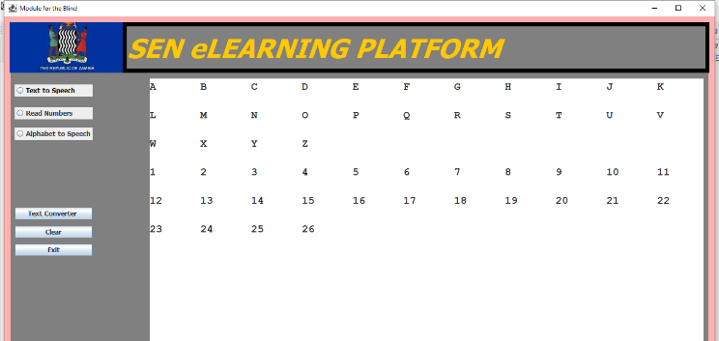

- Conclusion
An Online Learning Platform for learners with special needs specifically the visually impaired and the deaf, is imperative to include in modern learning strategies happening globally. Most available learning platforms leave out learners with special needs for a lot of different reasons one of which is the expense of developing such technologies. I embarked on this very important research to bridge the existing gap in technology between regular or general learners and learners with special needs in schools located in Kabwe district, Central Province, Zambia. The system proposed solved a challenge for learners with special needs in Kabwe schools particularly, the visually impaired and the learners with deaf disabilities. Covid – 19 happened to be an eye-opener in the education fraternity and virtual learning is being embraced by the Ministry of education. eLearning learning is considered to be a modern way of lesson delivery as it is a more student–centered method of learning. Moreover, entries into universities require training or competence in the use of ICTs. This may help give an opportunity to learners with special needs to acquire knowledge in the use of computers before they are enrolled in Colleges and Universities. Therefore, children with special needs should not be left out when it comes to

Reference
- Fazeli, Maryam, et al. ‘Design and Validation of a Persian Knowledge, Attitude, and Practice Questionnaire for Rabies (PKAP-Rabies) in the General Population of Iran’. Journal of Medical Microbiology and Infectious Diseases, vol. 6, no. 2, CMV Verlag, Apr. 2018, pp. 67–71, https://doi.org10.29252/jommid.6.2.3.67.
- ‘Zambia Country Profile’. Commonwealth of Nations, 26 Feb. 2013, https://www.commonwealthofnations.org/country/zambia/document-centre-for-zambia/.
- Brooks, David W., et al. Web - Teaching - A Guide to Designing Interactive Teaching for the World Wide Web. Kluwer Academic Publishers, 2002.
- ‘Supporting Students with Learning Disabilities during School Closures’. Teaching Tolerance, vol. 03.
- Division, Electronic. ‘Public Service Information Communication Technology Standards’. Public Service Information Communication Technology Standards, 2019.
- <i>Education, Ministry of. Ministry of Education -Education</i>. 503.
- Tregear, P. S., and J. M. Mwanakatwe. ‘The Growth of Education in Zambia since Independence’. British Journal of Educational Studies, vol. 19, no. 1, JSTOR, Feb. 1971, p. 103, https://doi.org10.2307/3120671.
- Salmon, Gilly. ‘E-Tivities: The next Key to Active Online Learning’. Salmon, Gilly. e-Tivities: The next Key to Active Online Learning. Oxfordshire: Routledge, 2013.
- Taylor, Donald H. “., and Donald H. Taylor. ‘How to Be a Webinar Master’. How to Be a Webinar Master, Canelo Press, 2020, pp. 5–6.
- Zhang, Michael. Teaching with Google Classroom. 2nd ed., Packt Publishing, 2021.

