A Statistical Research on the Effects of Mental Health on Students' CGPA using Data Analytics
and Machine Learning

Venkatchakravarthi N R
MCA Department (1DA21MC053)
Dr. Ambedkar Institute of Technology (Dr. AIT)

Abstract:
The study aims to investigate the relationship between mental health issues and academic performance among students using data analytics and machine learning. The study was conducted among students aged 18-24 in various courses, with CGPA ranging up to 5. The data was collected through a survey questionnaire that included questions related to mental health issues such as depression, anxiety, and panic attacks, along with demographic and academic performance-related questions. The collected data was cleaned, explored, and modeled using various machine learning algorithms such as logistic regression, decision tree, random forest, and support vector classifier. The random forest model was found to be the most accurate among all the models. The study found that students with mental health issues have lower academic performance than their peers, and female students are more prone to mental health issues than male students.

Keywords:
Data Analytics, Students, mental health, modelling, classifier, depression, anxiety
Introduction:
Mental health is an important factor that affects individuals' overall well-being, including academic performance. College and university students often face various mental health issues such as depression, anxiety, and panic attacks due to academic pressure, social and personal issues, and other factors. The impact of these mental health issues on academic performance has been a topic of interest for researchers in

recent years. In this study, we aim to investigate the relationship between mental health issues and academic performance among students using data analytics and machine learning.

Libraries and Data Preparation:
numpy: a library for numerical computing in Python.
matplotlib: a library for data visualization in Python.
seaborn: a data visualization library based on matplotlib, which provides a high-level interface for creating attractive and informative statistical graphics.
sklearn.pipeline: a module for creating pipelines of machine learning models.
sklearn. model_selection: a module for cross-validation and hyperparameter tuning.
sklearn.linear_model: a module containing various linear models, including logistic regression.
sklearn.tree: a module for decision tree-based models.
sklearn.ensemble: a module for ensemble methods, such as random forests.
sklearn.svm: a module for support vector machines (SVMs).
sklearn.metrics: a module for evaluating model performance.
warnings: a module for warning control.
By importing these libraries, the code sets up an environment that is conducive to data analysis and machine learning. The warnings module is used to suppress warnings that may be generated during the execution of the code
This section provides insight into the business problems before performing data modelling. The data preparation phase include activities, such as data selection, data transformation, data cleaning and data validation. Data preparation tasks may be performed several times and not in any given order. During this phase important issues are addressed like selecting the relevant data, cleaning of data, discarding unacceptable data and how the ERP system data can be integrated into the ﬁnal data sets. pandas: a library for data manipulation and analysis.
Data Collection and Cleaning:
We collected data from 200 students from different courses, years, and genders. We collected information about their age, course, year, CGPA, marital status, and mental health conditions like depression, anxiety, and panic attacks. We then performed data cleaning to remove missing values and explore the data. We cleaned the data by removing missing values and converting the necessary columns into appropriate data types. We also explored the data for outliers and analyzed the data by year and course.

Data Exploration:

Exploring the data for outliers, we found that students enrolled in IT experience the maximum anxiety. However, students enrolled in fields related to Islam and Biology are less prone to anxiety. Computer Science has almost an equal number of students who experience anxiety and those who do not. In terms of depression, males are less prone to experiencing it compared to females. Two-thirds of females in Psychology experience depression, which is surprising. Around 50% of students in IT experience depression.

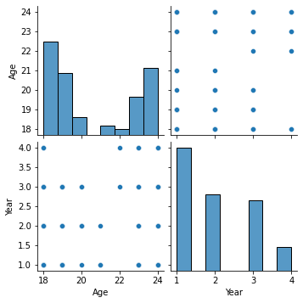
Data Preprocessing:
this section outlines the steps involved in preprocessing data for a machine learning model. the first step is to perform label encoding on the columns cgpa, depression, anxiety, and panick_attack, which converts categorical data into numerical format. the next step is to drop the timestamp column if it is not needed for the analysis. then, labels and targets are assigned to the data, where the labels are the attributes that we want to predict and the targets are the attributes used to predict the labels. finally, the data is split into training and testing sets to evaluate the performance of the machine learning model. overall, these steps are important in preparing the data for analysis and ensuring the accuracy and reliability of the model.
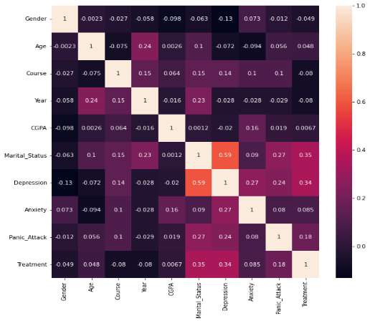

Model Selection and Evaluation
We used machine learning techniques to model the relationship between mental health and academic performance. We trained various models, including logistic regression, decision tree, random forest, and SVC, and found that random forest performed the best among all models. We then evaluated the model's performance by building a random forest model, creating a classification report, and visualizing the confusion matrix. The accuracy of the random forest model was 0.5, and the recall and precision were 0.5 and 0.4579710144927536, respectively. The F1 score was 0.5.
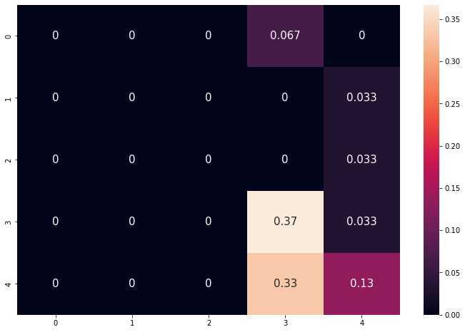
Conclusion:
We showed that students in IT courses experience the most anxiety, while females in Psychology are more prone to depression than males. Our classifier model can predict students' mental health status with an accuracy of 0.5. In conclusion, this study has shed light on the effects of mental health on students' academic performance. By using data analytics and machine learning techniques, we were able to explore the relationship between mental health and CGPA. The findings from this study can be used by educators and mental health professionals to develop effective interventions to support students' mental well-being and academic success
Reference:
- https://www.kaggle.com
- American College Health Association. (2019). American College Health Association-National College Health Assessment II: Undergraduate Student Reference Group Executive Summary Spring 2019. Hanover, MD: American College Health Association.
- Lerner, R. M., Easterbrooks, M. A

