GESTURE LANGUAGE RECOGNITION SYSTEM USING TENSORFLOW

Himanshu Bute G.H.Raisoni College Of  Engineering And Management | Rutuja Deshmukh  G.H.Raisoni College Of Engineering And Management | Rutuja Pagote G.H.Raisoni College Of  Engineering And Management
himanshu.bute.cs@ghrcem.raisoni.net | rutuja.deshmukh.cs@ghrcem.raisoni.net | rutuja.pagote.cs@ghrcem.raisoni.net
 | Mrs. Gayatri Bedre
 | Asst.Prof, G.H.Raisoni College of
 | Engineering And Management
 | gayatri.bedre@raisoni.net

Abstract- The act of sharing or exchanging information, ideas, or emotions is referred to as communication. In order for communication to occur between two individuals, they must possess knowledge and understanding of a common language. However, for individuals who are deaf and mute, communication occurs through a different means. Deafness refers to the inability to hear, while muteness refers to the inability to speak. These individuals use sign language to communicate with each other and with the general population. However, the importance of sign language is often overlooked by those who do not possess knowledge or understanding of it, making communication between individuals who are deaf and mute and those who are not quite challenging. To address this communication barrier, a machine learning- based model can be created. This model can be taught to recognise various sign language motions and convert them into English. This method has the potential to improve communication between deaf and mute people and others. The current Indian Sign Language Recognition systems use machine learning techniques to recognise single and double-handed motions, but they do not work in real time. This work describes a novel method for creating an Indian Sign Language dataset using a webcam and training a TensorFlow model for real-time Sign Language Recognition via transfer learning. Despite its small size, the system achieves a high level of precision.

Keywords- Indian Sign Language, Sign Language Recognition(SLR), Computer Vision, Communication

INTRODUCTION

For individuals who are unable to hear or speak, sign language is their primary mode of communication. Sign language enables people with physical disabilities to express their thoughts and emotions effectively. In this project, computer vision and neural networks are employed to recognize hand gestures and alphabets, which are then translated into text output. Sign language comprises various hand shapes, orientations, movements, and facial expressions, and it is a vital means of communication for individuals with hearing impairments. Building systems
capable of recognizing specific gestures and utilizing them to communicate information or control devices is a key objective of this project. However, gestures must be described in spatial and temporal terms, where a gesture is the dynamic movement of the hand as opposed to a static hand posture. Vision-based and data glove-based methods are the two primary approaches to gesture recognition. In this project, a vision-based system for real-time sign language recognition is developed as it offers a more natural means of dialogue between individuals and machines. Hand gestures are critical communication tools in daily life, and advances in image and video processing have led to the use of gesture recognition technology in a wide range of applications, including touch screens, video games, virtual reality, medical applications, and sign language understanding. However, individuals who are deaf often struggle to communicate with those who can hear. The goal of this project is to develop a real-time vision-based system capable of recognizing Indian sign language represented by the letters in Fig. 1's alphabet. The prototype aims to assess the feasibility of a vision-based system for sign language recognition.The implemented algorithm is based on a set of assumptions, including
- The use of a single camera and the speaker's placement in front of the camera within a designated region.
- Hand gesture is defined with a bare hand and not clotted by other objects.
- The system must be utilised in enclosed spaces because the specified camera performs poorly in direct sunlight. There has been a significant amount of research conducted in the field of gesture translation using various techniques such as data gloves, motion capturing systems, or sensors [16]. Additionally, vision-based SLR systems have also been previously developed [17]. The current Indian Sign Language Recognition system was designed using machine learning algorithms in MATLAB [18], which focused on single-handed and double-handed gestures. The system used two algorithms, the K Nearest Neighbours Algorithm and Back Propagation Algorithm, and achieved a high accuracy of 93-96%. However, this system is not real-time. The main
goal
of this research is to create a real-time SLR system using the TensorFlow object detection API and a dataset that will be generated using a webcam.

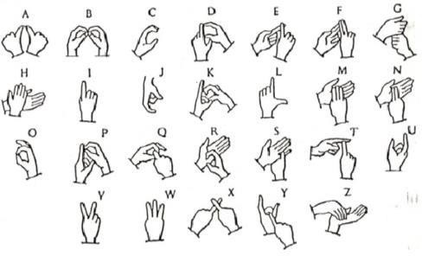

Figure 1: Signs of hand gesture.[5]

The two modules that make up this proposed system design are data collecting, pre-processing and feature extraction, and categorization of sign language gestures.

LITERATURE SURVEY

The majority of the research in this sector is conducted with the aid of a glove-based device. The glove-based system has detectors on each finger, comparable to potentiometers, accelerometers, etc. A representation of the alphabet is made based on their readings. A glove-based gesture recognition system was created by Christopher Lee and Yang Sheng Xu. It could recognise 14 of the hand alphabet's letters, learn new gestures, and update each gesture's model in the system's online mode. Similar to the Sayre Glove, Dexterous Hand Master, and Power Glove, advanced glove technology has evolved over time. The key issue with this glove-based system is that it needs to be calibrated each time a new speaker is placed on the fingertip so that the Image Processing unit can link the fingertips. Using image processing, we are developing our project. Our model's key benefit is that it may be used on any background colour; a black background is not a must. Any background made of planes can be used with it. Additionally, with our approach, colour band wearing is not necessary.
Deaf Mute Communication Interpreter [2]: This paper aims to present a system that can efficiently translate American Sign Language gestures to both text and auditory voice. The interpreter here makes use of a glove based technique comprising of flex sensor, tactile sensors and accelerometer. For each hand gesture made a signal is produced by the sensors corresponding to the hand sign the controller matches the gesture with pre-stored inputs.
Real Time Sign Language Recognition For the Deaf And Dumb [1]: This paper aims to create a vision- based system suitable to do real- time sign language recognition. A system based on vision is preferred because it offers a more straightforward and natural means of communication between a human and a machine. Being one of the most
crucial forms of communication in day-to-day life, and with the constant advances of images and videotape processing.Recently, research on gesture detection for human-machine communication led to the deployment of this type of technology in a large variety of applications, including touch screens, video game consoles, virtual reality, medical applications, and sign language interpretation..
Speech To Indian Sign Language Translator [8]: The goal of this project is to create a translation system made up of many modules that can take in English audio and convert it to English text. The text is then processed to represent the grammar rules of Indian Sign Language, and stop words are deleted from the reordered sentence. Because Indian Sign Language does not permit word conjugation, words are transformed into their root or original form via stemming and lemmatization. The system examines every individual words in a dictionary that has videos of each word, and if a term is not identified, it is substituted with the best appropriate replacement. Unlike current systems that transform words directly into Indian Sign Language, our method intends to turn sentences into Indian Sign Language grammar and properly show it to the user.
Hand Gesture Recognition System for Dumb People using Image Processing [4]: The objective of the hand gesture recognition system is to enable finger spelling, which involves using hand gestures to spell out words in an alphabetical language. To achieve this, the system utilizes a wireless glove that is equipped with flex sensors, which detect the gestures based on the resistance associated with the sensors when they are flexed. This approach offers several benefits, including high accuracy in hand gesture recognition and cost efficiency.
Hand Gesture Recognition for Sign Language Recognition: A Review in [3]: The authors of this study discussed a variety of hand gesture and sign language recognition systems that have been put forth historically by different scholars. Sign language is the only means of communication for the dumb and deaf. These physically challenged persons communicate with one another by using sign language.
American Sign Language Recognition System:An Optimal Approach [13]: This research paper discusses the use of sign language as a visual language for communication by individuals with speech and hearing disabilities. Sign language has its own distinct grammar and is different from oral languages. The paper presents an optimal approach for transliterating 24 static sign language alphabets and numbers of American Sign Language into machine-readable English manuscript. The process involves pre-processing the signed input gesture, computing the various region properties of the pre-processed gesture image, and then transliterating the signed gesture into text based on the properties calculated in the earlier phases. The paper also presents statistical evaluation results, with comparative graphical depictions of

existing and proposed techniques. The advantage of this approach is its ability to improve the accuracy of sign language recognition and translation.

METHODOLOGY
The suggested system's goal is to build a real-time sign language detector using TensorFlow's object identification API and train it using transfer learning on a dataset generated by a webcam. The data acquisition procedure begins with taking photos through a camera using Python and OpenCV, followed by the creation of a labelled map with 26 labels representing each letter. After that, the training and testing data are turned into binary files known as TF records, which are used to train the TensorFlow object detection API. SSD MobileNet v2 320x320 is the pre-trained TensorFlow model utilised in this system, which has been integrated with the FPN-lite feature extractor and shared box predictor. The pre- trained model's setup is changed for transfer learning, and the model has been trained for 10,000 steps. The model suffers losses during training, including classification loss, regularisation loss, and localization loss, which occurs when the predicted bounding box correction differs from the true values. The suggested system intends to produce a real-time sign language detector for the created dataset using TensorFlow object detection API and transfer learning. To collect data, photos from a camera are recorded using Python and OpenCV, and a labelled map is built to represent all of the items in the model. The TensorFlow object detection API is utilised to generate TF records from the training and testing data, and the transfer learning is performed using the pre- trained SSD MobileNet v2 320x320 TensorFlow model. Following training, the model is loaded from the most recent checkpoint, preparing it for real-time sign language identification with OpenCV and a webcam. The algorithm recognises indicators in real time, translates them into English, and assigns a confidence level to each one.

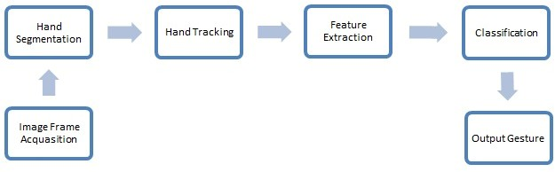

Figure 2: Workflow

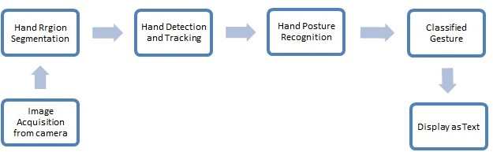

Figure 3: Different phases in the project

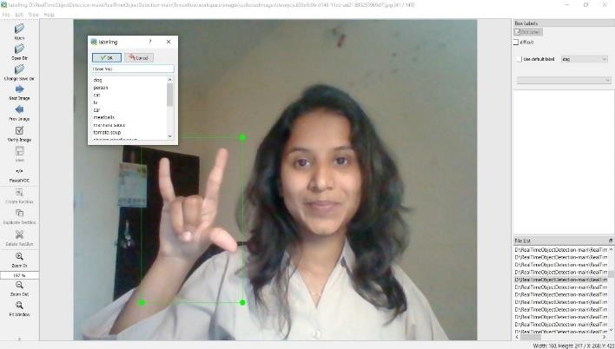

Figure 4: Real-Time Sign Language Detection

RESULT AND DISCUSSION

A system for automatically sign translating sign language gestures into text or voice that can be read by machines or people is known as a sign language recognition system. Many scholars have suggested various methods for recognising static and dynamic movements in Indian Sign Language (ISL). The Indian Sign Language alphabet motions can be recognised by the real-time sign language recognition system established in this work. The system was created with the TensorFlow object detection API and trained on a dataset of 650 photos, 25 for each of the 26 alphabets. The pre-trained SSD MobileNet v2 320x320 model retrieved from the TensorFlow model zoo was trained using transfer learning. The total loss during the final 10,000 steps of training was 0.25, comprising a localisation loss of 0.18, a classification loss of 0.13, and a regularisation loss of 0.10.
The system's performance is determined by the confidence rate, and on average, it has a confidence rate of 85.45%. The confidence rate for each alphabet is noted and presented in Table 1. To improve the system's recognition ability, the dataset size can be increased, which will also increase the system's confidence rate. Therefore, expanding the dataset can enhance the system's result.

- Yogeshwar I. Rokade, Prashant M. Jadav, “Indian Sign Language Recognition System”, Volume:09 Issue:03 July 2017
A | B | C | D | E | F | G | H | I
94% | 98% | 90% | 90% | 70% | 96% | 73% | 97% | 95%
J | K | L | M | N | O | P | Q | R
57% | 87% | 93% | 91% | 55% | 78% | 95% | 95% | 83%
S | T | U | V | W | X | Y | Z
86% | 81% | 87% | 86% | 87% | 88% | 90% | 80%

- Joyeeta Singha, Karen Das, “Recognition Of Indian Sign Language In Live Video”, Volume:70-No.19, May 2013

- Ashok Kumar Sahoo, Gouri Sankar Mishra, Pervez Ahmed, “A Proposed Framework For Indian Sign Language Recognition”, Volume:5 Issue: October 2012

CONCLUSION

Sign languages are visual languages that communicate using hand, body, and face motions. They are vital for persons with impairments to express themselves. However, not everyone understands sign languages, which limits communication. To circumvent this constraint, automated Sign Language Recognition (SLR) systems that translate sign language into spoken language can be utilised. TensorFlow object detection API was utilised in this paper to train an SLR system on the Indian Sign Language alphabet dataset. The device detects sign language in real time using a webcam and OpenCV, saving money. The system earned an 85.45% average confidence rate. However, the training dataset was small and limited in size, and there is room for improvement by increasing the dataset size.

REFERENCES

- Reddygari Sandhya Rani, R Rumana, R. Prema: “A Review Paper on Sign Language Recognition for The Deaf and Dumb”:Volume 10, Issue 10 (October 2021)
,01-11-2021 .

- Anbarasi Rajamohan, Hemavathy R., Dhanalakshmi M,“Deaf-Mute Communication Interpreter”: International Journal of Scientific Engineering and Technology, Volume 2 Issue 5,1 May 2013

- Pratibha Pandey, Vinay Jain, “Hand Gesture Recognition for Sign Language Recognition: A Review”, International Journal Of Science, Engineering and Technology Research(IJSETR), Volume 4, Issue 3, March 2015.

- Swaroop Y P1, Abhishek T G2, Kishor K3, Ravindra Prasad Y K4, Anisha P S5, “Hand Gesture Recognition System for Dumb People using Image Processing”, Volume: 08 Issue: 09 | Sep 2021
- Alisha Kulkarni, Archith Vinod Kariyal, Dhanush V, Paras Nath Singh “Speech To Indian Sign Language Translator”, Volume:4

- Vinayak S. Kunder, Aakash A. Bhardwaj, Vipul D. Tank, “Sign Language Recognition System With Speech Output” Volume:4 Issue: 3, March-2019

- Geetha M, Manjusha C, Unnikrishanan P, Harikrishnan R “Vision Based Dynamic Gesture Recognition Sign Language” May 21, 2013

- SP Goswami, Anita Ravindra GGR, Kanchan Sharma,“Introduction Of Indian Sign Language In Inclusive Education” Volume:30, No. 4,2019

- Shijjat Khan, Gourab Sen Gupta, Donald Bailey “Sign Language Analysis And Recognition: A Preliminary Investigation” , 2009

- Shivashankara S, Srinath S, “American sign Language Recognition System: An Optimal Approach” Issue: August 2018

- Lean Karlo S. Tolentino, Ronnie O. Serfa Juan, August
C. Thio-ac, Mariya Abigail B. Pamahoy, Joni Rose R. Forteza, Xavier Jet O. Garcia “Static Sign Language Recognition Using Deep Learning” Volume: 9 No. 6, December 2019

- R. S. Sabeenian ,S. Sai Bharathwaj M. Mohamed Aadhil “ Sign Language Recognition Using Deep Learning And Computer Vision” Volume:12 , 05-Special, 2020

- Suharjito, Ricky Anderson, Fanny Wiryana, Meita Chandra Ariesta, Geda Putra Kusuma, “Sign Language Recognition Application Systems for Deaf-Mute People:A Review Based On Input-Process-Output” Volume 116, 2017

- Dimitrios Konstantindis, Kosmas Dimitropoulos, Petros Daras, “Sign Langauge Recognition Based On Hand And Body Skeletal Data” 3DTV-conference. 2018-June

- Kuumika Krori Dutta, Sunny Arokia Swamy Bellary, “Machine Learning Techniques for Indian Sign Language Recognition” 3DTV-conference. 2018-June

