Early Forest Fire Detection and Control System
Siddharth Shankar^{1,} Jayanta Mandal², Tanikanti Venkata Sudheer³, Ganesula Mohan Durga Chandra Teja⁴, and Mandeep Singh⁵
Author Affiliations
(Use the Microsoft Word template style: Author Affiliation) or (Use Times New Roman Font: 10 pt, Italic, Centered)(if authors share the same affiliation, list the affiliation one time and number accordingly)
¹Replace this text with an author’s affiliation
(use complete addresses, including country name or code).
²Additional affiliations should be indicated by
superscript numbers 2, 3, etc. as shown above.
³You would list an author’s second affiliation here.
Author Emails
- jayanta.jay998@gmail.com
- sidds4970@gmail.com
- ganesulateja7610@gmail.com
- sudheertanikanti@gmail.com
- mandeep.16853@lpu.co.in

Abstract. Forest fires are a major threat that can destroy the environment, wildlife, and people. One way to lower the risk of forest fires is through utilizing Internet of Things (IoT) technologies. IoT involves using actual physical items to collect and distribute data across an internet-based network.
The main goal of this study is to predict when forest fires will start by monitoring a variety of environmental factors, such as temperature and humidity. A number of sensors can be used to collect this data, which can then be fed into an IoT-based system. Using this technology can improve the dependability and effectiveness of the fire detection procedure.
The mechanism suggested in this paper entails defining threshold values for each sensor in order to validate the data collected. By employing this tactic, the system is guaranteed to take the necessary safeguards to prevent fires from spreading and causing damage. IoT adoption may often greatly improve the effectiveness of measures used to prevent and manage forest fires.

Introduction
The development of the Internet has reshaped how people interact, and as technology develops, it gets simpler to connect gadgets smoothly over numerous networks. These networks include ZigBee, Wi-Fi, RFID, Bluetooth, and WSNs, to name a few. As more devices are linked together, they will cooperate to gather, share, and disseminate data without the aid of a human. These gadgets come in a variety of shapes and sizes, including sensors, automobiles, smartphones, medical equipment, home appliances, and RFID tags, and they all have intelligence and communication capabilities built in. Our lives will be made simpler and more convenient thanks to this network of connected gadgets, which will enable more effective and efficient communication and data sharing.

A change in how we link things has led to the development of the Internet of Things (IoT). In addition to being connected to one another over the internet, gadgets are also connected to one another. The internet of things (IoT) is a recent innovation that developed from the internet we currently use, where gadgets are connected to build networks. A web of interconnected systems that can interact, share information, and work together to complete various tasks has been formed as a result of the interconnection of devices. The Internet of Things (IoT) is a network of connected gadgets that may communicate with one another and cooperate to improve our quality of life.

IoT devices communicate with people by gathering data about their surroundings using common Internet protocols. After that, this data is developed into intelligent data that can be applied to improve our comprehension of the world. According to estimates, there will be billions of gadgets involved in the IoT that can wirelessly broadcast their identification, position, and history. This implies that these gadgets will be able to connect to the internet and share information with other gadgets, allowing them to cooperate and carry out coordinated tasks. With the IoT, a connected
world will be created where gadgets may communicate and work together to build a more intelligent and effective environment.

The Internet of Things (IoT) technology allows for the connecting of things. With the help of this technology, gadgets can connect to the internet and communicate with one another in order to gather information about their surroundings. These gadgets may interact with their environment and gather data that can be utilized to make wise judgements by utilizing internet standards and protocols. IoT essentially enables a network of intelligent devices that can cooperate to improve the quality and efficiency of our lives.
For IoT conceptualization, the flexible method of cloud computing in data gathering and storage may be used. Time and labor costs are reduced when IoT is used to connect devices automatically. Critical information may be exchanged between machines thanks to these gadgets, enabling activities to be carried out smoothly and without the involvement of a human.

Literature Review
The linked study focuses on the early detection of flames using various methodologies and frameworks. The authors investigate the notion of the Internet of Things (IoT) and suggest possible technologies and topics that can speed up IoT research. They emphasize the usage of Aneka, a cloud-based platform that allows the integration of public and private cloud resources, and emphasize the significance of merging wireless sensor networks (WSNs), various computing resources, and the internet to drive technological developments in this field. The study underlines the importance of collaboration and the integration of diverse technologies in order to enhance IoT research and improve early fire detection [1].
The IoT is a cutting-edge commercial strategy that links objects and people online. It enhances procedures and emergency management by offering a prompt and efficient response in real-time. In order to test and assess a quick response to fire dangers, which are a significant source of accidental mortality worldwide, this article suggests an IoT-based model. A costly Wi-Fi module, gas detector, flame detector, awareness alarm, and thermistors are used to construct this application. By gathering data, which is subsequently communicated to pertinent institutions like fire departments, police stations, and hospitals with precise location information, the sensors identify and warn the local emergency services. All linked gadgets will be integrated into the system to create a smart, integrated system that can control risks to safeguard innocent individuals and assets [ 2-3 ].

Design aspects in network-assisted D2D (device-to-device) by G. Fodor, N. Reider, E. Dahlman, G. Miklós, G. Mildh, Z. Turányi, and S. Parkvall In this section, we discuss the 3GPP Development system as a dubious choice for Data transmission, examine a few problems with force projects, and make reference to fixes that permit liquid equipment and Device to device interference to share spectre with the intention of enhancing spirit efficiency and spectre of antiquated loculose cobweb. The test is over. [4].
Wireless Sensor Networks (WSN) play a critical role in predicting and preventing forest fires. In WSN fire-detection systems, sensor nodes are placed in remote forests to collect data and transmit it to a station located nearby. However, installing GPS connectivity in these sensor nodes can be expensive. To address this challenge, the authors of a research paper proposed a distinctive localization method utilizing SVM to extend the life of the network and reduce congestion during data transfer. This approach allows the sensor nodes to transmit audible information to the sub-station without the need for GPS connectivity, thereby reducing the cost of the network. By adopting this method,
forest departments can save the environment from damage caused by forest fires more effectively and efficiently [5-6].
Alarm systems and fire alarms have been developed to include smoke sensors and alarm devices, creating a system for life safety. However, these fire alarms can sometimes produce false alarms, responding to unrealistic fire signals. To address this issue, High-quality, intelligent fire detection systems are required, and they must use various sensor values to identify actual fire occurrences [7].
A proposed system includes sensors that collect crucial data from sensor nodes. This data is then converted using symbolic logic, which takes into account linguistic diversity and is trained at ANFIS to identify leading fire hazards. The system also give alerts and sends a text to the user's mobile. Solution is designed to use smaller, less expensive sensors and is designed to regenerate itself [8].
By deploying an initial warning system that warns nearby firefighters, a proposed method aids in the detection of flames and the prevention of fire spread. The device also captures security footage of the area in front of the center, which aids in determining the fire's origin, such as heat. The technology detects abnormal temperatures in a fireplace and notifies the central station of the location information using rotatable cameras and radiometry thermal sensors. The device alerts nearby pump stations and activates a water cannon system as well as to informing area firemen to the fire. This method is particularly crucial in Greece, which is at high risk for wildfires in the Mediterranean region, especially due to global climate change. In the summer of 2007, approximately 200,000 hectares of cultivated land were burned due to wildfires, highlighting the critical need for advanced fire detection and prevention systems. By using this proposed method, firefighters and local authorities can better protect their communities from the dangers of wildfires [9].
The technology being demonstrated [10] makes use of temperature and smoke sensors to recognize fire emergencies and sends a digital signal to a client machine and server cellphone that would immediately make a call or send an SMS to up to 5 authorized remote users. The system is fully accessible to the authorized user, who can then take the necessary actions, such as turning on or off alert notifications, modifying thresholds, and resetting the system. As the civil defense station lacks specialized technology to receive and decipher the signal, there is no direct automatic contact between the systems. The adjacent buildings cannot communicate with the system.
In this approach [11], the fire is detected using the model, which then immediately alerts the fire brigade via an IoT server. The system makes use of a number of sensors to detect fire and alert the fire service via IoT by activating
the fire buzzer there. The fire department team connects to the IoT server via a Wireless Fidelity (Wi-Fi) connection to relay information about the situation and transfer data over the Internet so that it may use this information to take the proper action. This method is not very useful if there is no Internet access or if there is a slow Internet connection.
The suggested system [12] uses early fire accident detection, communication with the appropriate authorities, and storage of fire accident-related data. The system detects fire using sensors for Down Hill Control (DHC) and smoke. The system alerts the appropriate authorities whenever the temperature surpasses the limit. Then it turns on the fire sprinklers and maintains them in place until the temperature drops below a predetermined level. Data relating to fire accidents are kept on a distant server for later use. The sprinkler may never turn off in this system if a fire damages the heat sensor.

Methodology and Model Specifications
The potential of wireless sensor networks (WSN) as a promising strategy to deal with the problem of early forest fire detection is discussed in the study. The study's suggested device gathers and transmits data using a variety of sensors and wireless connection technology. After that, this data is sent to a tiny satellite, which sends it to a ground station for evaluation. Early detection of potential fire hazards is made possible by the proposed WSN-based method, which aids in preventing and reducing the effects of forest fires. Ultimately, the study emphasizes the significance of utilizing cutting-edge technological solutions to tackle urgent environmental concerns like forest fires. Monitoring ignition-alert temperatures and CO2 levels is made possible by the integration of temperature and smoke sensors throughout the forest area. This device enables a quick response to forest fires, hence lowering the possibility of substantial damage, by transferring real-time data to a microcontroller, which can then react instantaneously in case of crises. Additionally, the sensors' one-time installation avoids the requirement for ongoing expenditures on detection systems. The capability of remotely monitoring the environment also keeps staff members informed and alert to any potential hazards to their safety. In general, using sensor technology to prevent and detect forest fires is a viable strategy that can help protect both the environment and the welfare of human communities.

Model Specifications and Construction
- A. Construction-
- 12V Lithium ion battery
- Smoke Sensor
- Arduino
- Fire Sensor
- Smoke Sensor
- GSM module
- Relay
- LED
- I2C convertor
- Solar Panel

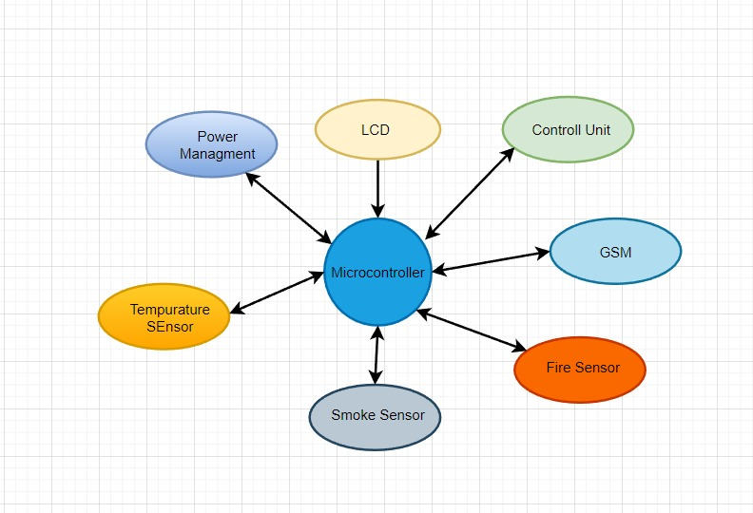
Fig. 1 – Model Construction

- Theory of operation- When the emerging vapor enters the sensory via the rear of the open pia mater to attain the operation electrode, it is subjugated or oxidized. The magnetic passable, which is elapsed through the external rotation, is carried by this electrochemical backlash. The disposal circumlocution suffers the voltage across the sensory between the relation and practical electrodes for a three-electrode vacuole or between the Contrariwise and practical electrodes for a two-electrode sensory in addition to measuring, accomplishing, and enlarging other token projection services.
- Fire Sensor- An electronic gadget called a flame sensor detects fires by detecting the infrared radiation that flames release. As flames emit light between the wavelengths of 760 and 1100 nm, this sensor, which is extremely sensitive to light, can identify them. The sensor's output interface is compact and can be connected directly to an input/output (I/O) port on a microcomputer. During testing, it's crucial to keep the sensor a specific distance from flames to prevent damage from high temperatures. The minimum distance for testing is 80 cm, but the sensor should be tested from a wider distance if larger flames are being produced. The sensor can detect flames from a wide angle of up to 60 degrees and is exceptionally sensitive to the flame spectrum.
- Internet of Things- The Internet of Things (IoT) is a network of actual physical things including equipment, structures, and vehicles that have sensors, software, online connectivity, and other electronics to collect and exchange data. IoT is essentially a framework that uses unique identifiers to allow people, things, or communities to send data to a network without the need for direct human-to-human (H2H) or human-to-computer (H2C) interaction. These items or gadgets can be monitored and operated remotely over the internet, giving us a way to automate and improve numerous procedures and operations. IoT has a wide range of uses, from smart cities and homes to healthcare and industrial automation.
Actuating (prenominal) internet association which is also outfitted with an administrator to systematize all the input UART data into the GPRS-supported data that is online. Data may be updated to a precise place or a convivial Reticulum by which the user can efficiently to accessibility the data.
- Data Management- A crucial component of the Internet of Things is data management (IoT). When taking into account a network of interconnected and continually sharing all types of information, the volume of data generated and the activities involved in processing that data take on substantial importance. IoT now has more options thanks to the development of wireless communication technologies and machine-to-machine (M2M) connections. Many applications that can be utilized for gathering, processing, and transferring data among IoT systems and devices are made possible by this technology. Wireless communication technology has consequently evolved into a crucial tool for administering and improving IoT systems. This technology enables the remote monitoring, control, and management of IoT devices, enabling the automation of several intricate procedures and operations. In general, wireless communication technology is a critical enabler of the IoT, making it feasible to achieve this game-changing technology's full potential.

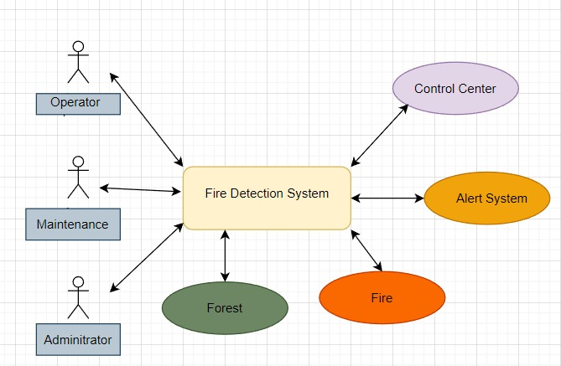
Fig. 2 – Case Diagram
The following are some of the most pertinent ideas that help us comprehend
the potential and difficulties associated with data management:
- Gathering and analyzing data.
- "Big data."
- Networking of Semantic Sensors.
- The virtual sensor.
- Processing of Complicated Events.
- Application Areas- Technology development and application have made great strides in recent years, which has boosted economic potential and expanded social acceptability and support for the foreseeable future. Social advancement can be grouped into categories such as health and wellness, transportation, security and safety, sustainability, and digital communication. These categories offer considerable prospects across a range of sectors, including communication technologies, consumer electronics, automotive electronics, and healthcare. Development of applications in various fields is being facilitated by advancements in semiconductor technology, communication networks, energy, and software development.
- Cities,
- Environments,
- Water,
- Energy Smart Grid & Smart Metering,
- Security & Emergencies,
- Industrial Control,
- Agriculture,
- Domestic and Home Automation,
- eHealth,

CONCLUSION

A project has been created to enhance a system that can algorithmically alter sensory characteristics. By employing an IoT platform, this solution seeks to lessen the perception of errors and alert the expert to inadequacies in real time.

In order for IoT devices to operate, communicate, and maintain a healthy ecosystem, D2D communication protocol is a crucial part of this system. The system is built to use sensors to identify changes in mixtures, hazardous gases, and fire occurrences, and to immediately alert an expert via an IoT platform utilizing the MQTT protocol. Overall, this system is effective and strong at finding anomalies and reporting them, creating a secure environment.

It is possible to employ the enhanced system in both industrial and domestic appliances. The aforementioned approach, however, is solely intended for precise feedback reporting. A decision-making organization is investigating a multifaceted strategy in the future using an IoT platform, and work is being done to achieve this challenging task. It is anticipated that the multidimensional decision-making process would be applied through IoT platforms in real-time scenarios given the technological developments that are already available.

References
- J. Gubbi, R. Buyya, S. Marusic, and M. Palaniswami, “Internet of Things (IoT): A vision, architectural elements, and future directions,” Future Gener. Comput. Syst., vol. 29, no. 7, pp. 1645–1660, Sep. 2013.
- Sathya D 2019 Int. J. Engg. and Technol. 8 6S3 pp 1138-1142.
- Castro J T, Gil P C, Perez N R, Gonzalez I S, Goya C H and Colomo R A 2018 Complexity 2018 pp 1-17.
- G. Fodor, E. Dahlman, G. Mildh, S. Parkvall, N. Reider, G. Miklós, and Z. Turányi, “Design aspects of network assisted device-to-device communications,” IEEE Common. Mag., vol. 50, no. 3, pp. 170–177, Mar.2012.
- Shukla A, Kumar S and Singh H 2019 J. Chin. Inst. of Engg. 42 7 pp 583-592
- Ghosrani S, Jadhav A, Lekhak K and Chheda D 2019 Int. J. Research in Engg. Sc. and Mgmt. 2 4 pp 442-445.
- Mahajan R, Yadav A, Baghel D P, Chauhan N, Sharma K and Sharma A 2019 Int. Research J. Engg. And Technol. 6 8 pp 4623-4625.
- Saikumar T and Sriramaya P 2019 Int. J. Recent Technol. and Engg. 7 6S4 pp 429-433.
- Pico A M, Frau D C, Araujo A, Alejandre J and Rozas A 2016 J. Sensors 2016 pp 1-8.
- Dener M, Ozkok Y and Bostancioglu 2015 Procedia Soc. and Behav. Sc. 195 pp 1846-1850.
- AlKhatib A A A 2014 Int. J. Distr. Sensor Networks 10 3 pp 1-12.
- Sifakis N I, Iossifidis C, Kontoes C and Keramitsoglou 2011 Remote Sens. 3 pp 524-538.

