FABRICATION AND EXPERIMENTAL INVESTIGATION OF COMPRESSED AIR ENGINE

Pittala Sai Radha Krishna¹ |D. Naveen Kumar² |G. Dinesh³ |G. Uday Kiran⁴|K. Sai Sumanth⁵|K. Varun Kumar⁶ |K. Vamsi Krishna⁷|A. Durga Dalinaidu⁸|J. Lakshman⁹| ¹Department of Mechanical Engineering, N.S. Raju Institute of Technology(A), Visakhapatnam, Andhra Pradesh, India
²Department of Mechanical Engineering, N.S. Raju Institute of Technology(A), Visakhapatnam, Andhra Pradesh, India
³Department of Mechanical Engineering, N.S. Raju Institute of Technology(A), Visakhapatnam, Andhra Pradesh, India ⁴Department of Mechanical Engineering, N.S. Raju Institute of Technology(A), Visakhapatnam, Andhra Pradesh, India ⁵Department of Mechanical Engineering, N.S. Raju Institute of Technology(A), Visakhapatnam, Andhra Pradesh, India ⁶Department of Mechanical Engineering, N.S. Raju Institute of Technology(A), Visakhapatnam, Andhra Pradesh, India ⁷Department of Mechanical Engineering, N.S. Raju Institute of Technology(A), Visakhapatnam, Andhra Pradesh, India ⁸Department of Mechanical Engineering, N.S. Raju Institute of Technology(A), Visakhapatnam, Andhra Pradesh, India ⁹Department of Mechanical Engineering, N.S. Raju Institute of Technology(A), Visakhapatnam, Andhra Pradesh, India

Abstract— This study presents an experimental investigation of a piston engine driven by compressed air. The compressed air engine was a modified 100 cm³ internal combustion engine obtained from a motorcycle manufacturer. The experiments in this study used a test bench to examine the power performance and pressure/temperature variations of the compressed air engine at pressures ranging
from 5 to 9 bar (absolute pressure). The engine was modified from a 4-stroke to a 2- stroke engine using a cam system driven by a crankshaft and the intake and exhaust valves have a small lift due to this modification. Similar situations occurred during the exhaust process, restricting the power output of the compressed air engine. The pressure and temperature variation of the air at engine inlet and outlet were recorded during the experiment. The outlet pressure increased from 1.5 bar at 500 rpm to 2.25 bar at 2000 rpm, showing the potential of recycling the compressed air energy by attaching additional cylinders (split-cycle engine). A temperature decrease (from room temperature to 17 °C) inside the cylinder was observed. It should be noted that pressures higher than that currently employed can result in lower temperatures and this can cause poor lubrication and sealing issues. The current design of a compressed air engine, which uses a conventional cam mechanism for intake and exhaust, has limited lift movement during operation, and has a restricted flow rate and power output. Fast valve actuation and a large lift are essential for improving the performance of the current compressed air engine. This study presents a power output examination with the

pressure and temperature measurements of a piston type compressed air engine to be installed in compact vehicles as the main or auxiliary power system.
Keywords: Compressed Air Engine, Power Performance, Indicated Power, Brake Power, Mechanical efficiency.

- INTRODUCTION
In the past few decades, energy conservation and carbon reduction have become very crucial issues worldwide. Scientists have been searching for solutions to reduce the extensive use of conventional internal combustion (IC) engines and/or reduce their carbon dioxide emissions. To find a replacement for conventional IC engines, researchers have studied several types of engines that use green energy to determine the feasibilities of installing these engines in motor vehicles. Examples include electric engines, natural gas engines, and hydrogen engines. Electric vehicles are the most common green energy alternative and have been developed and commercialized for decades. However, slow battery recharging and a heavy battery weight are critical issues for electric vehicles. Hydrogen engines and natural gas engines can be used in motor vehicles; however, the required tank size limits their applications. In recent years, high-pressure compressed air has been considered a green energy source for its advantage of zero carbon emissions and potential applications as a main or auxiliary power system in motor vehicles. The Air Driven Engine is a low-emission engine that runs on compressed air. In Air Driven Engine, the expansion of compressed air drives the pistons of an engine. An Air Driven Engine is a pneumatic actuator that expands compressed air to produce useful work. Because there is no combustion, there is no mixing of fuel and air. Adder,
J. [1] in the past few decades, energy conservation and carbon reduction have become very crucial issues worldwide. Scientists have been searching for solutions to reduce the extensive use of conventional internal combustion (IC) engines and/or reduce their carbon dioxide emissions. To find a replacement for

conventional IC engines, researchers have studied several types of engines that use green energy to determine the feasibilities of installing these engines in motor vehicles. Examples include electric engines, natural gas engines, and hydrogen engines. Papson, A.; Creutzig, F.; Schipper, L. [2] Electric vehicles are the most common green energy alternatives and have been developed and commercialized for decades. However, slow battery recharging and a heavy battery weight are critical issues for electric vehicles. Hydrogen engines and natural gas engines can be used in motor vehicles; however, the required tank size limits their applications. In recent years, high-pressure compressed air has been considered a green energy source for its advantage of zero carbon emissions and potential applications as a main or auxiliary power system in motor vehicles. Schechter, M
[3] describes new thermodynamic cycles and associated vehicle operational strategy that can bring about a substantial improvement in automobile fuel economy. Schechter studied the feasibility of using compressed air in conventional IC engines with two power strokes; one stroke is driven by combustion and the other stroke is driven by compressed air. Schechter, M. [4] Driving the additional power cycle by compressed air instead of combustion reduces fuel consumption by half. Schechter also reported on the concept of producing compressed air during the braking of motor vehicles (i.e., regenerative compression braking).

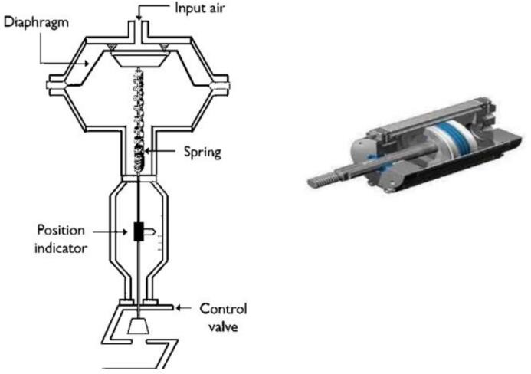

Fig2 : Pneumatic Actuator Construction

- FABRICATION AND METHODOLOGY
A. Components used:
In the present work the components Pneumatic Actuator, Crankshaft, Couplings, Bearings, Pneumatic Pipes, Valve, Wheel, Supporting Frame

C. Methodology:

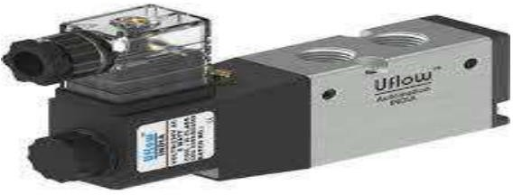
Fig3 : solenoid valve

are used.
B. Experimental Setup and Procedure
The experimental set-up shown in Fig below. The main components of the experimental setup are Pneumatic Actuator, Crankshaft, Couplings, Bearings, Pneumatic Pipes, Valve, Wheel, Supporting Frame.

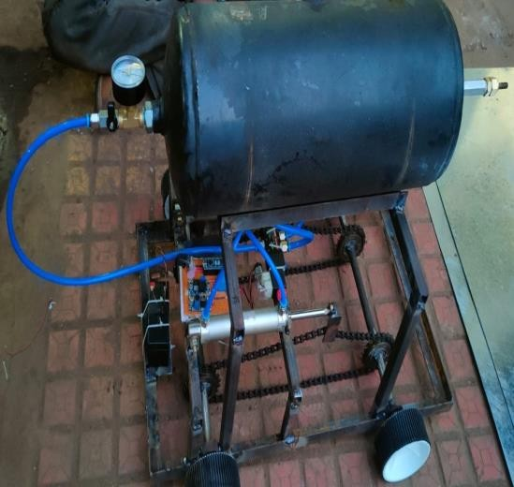

Fig1: Fabricated Air Engine
A pneumatic air engine is a type of engine which does mechanical work by expanding compressed air. Pneumatic engines generally convert compressed air energy to mechanical work either into linear motion or rotary motion. Once compressed air is transferred into the onboard storage tank, it is slowly released to power the pistons. The motor then converts the air power into mechanical power. That power is then transferred to the wheels and becomes the source of power for the Engine.
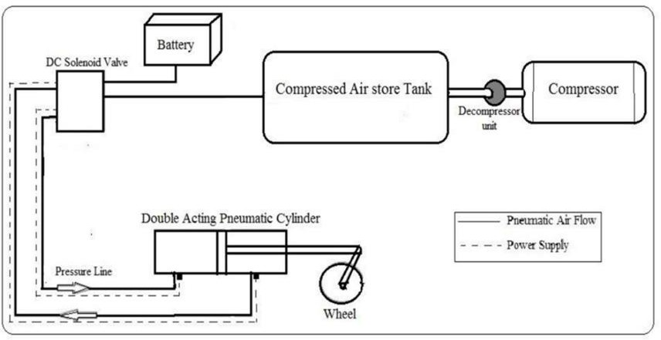

Fig4 : Layout of Pneumatic air engine

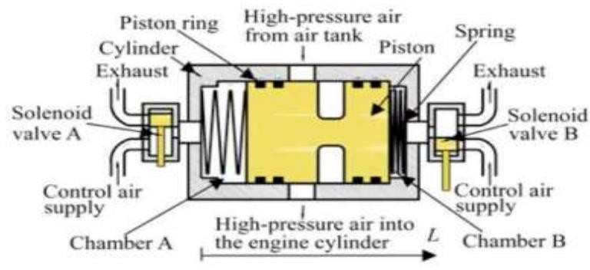
Fig4 : Compressed Air Engine

Connections are done as per the circuit diagram when the accelerator pedal is pressed, air is passed through the solenoid valve from the reservoir to the cylinder. Now the piston inside the cylinder is pushed forward. When it attains maximum position. The reed switch sensor which is connected along the cylinder changes the direction of flow of air hence, the piston is pushed backward. Thus, the forward backward movement of the piston is connected to the crank shaft. Hence linear movement of the piston is converted into a rotary motion by mean of chain sprocket, which is connected to the rear axle. Thus, the Engine attains its motion.

D. Calculations:

Indicated Power is the Theoretical Power Output of an IC Engine.

IP = 1/60 * P*L*A*N*k Watts

where, P: Mean Effective Pressure of Gas exerted on to the Piston during Power Stroke
L: Stroke (From TDC to BDC) A: Area of Cylinder
N: Number of revolutions per minute of the Crankshaft k: Factor, it is 1/2 for Four Stroke Engine whereas 1 for Two Stroke Engine.

The brake power (briefly written as B.P.) of an IC Engine is the power available at the crankshaft.

B. P= 2πNT/60 Watts

where, N- rpm of crankshaft T- Torque.

Mechanical Efficiency is the ratio of the power available at the engine crankshaft (BP) to the power developed in the engine cylinder (IP).

Mechanical Efficiency = (B.P/I. P) x 100%

B.P. = Brake Power
I.P. = Indicated Power.
- RESULTS AND DISCUSSION

The values noted down are used for calculating the mechanical efficiency, indicated power brake power; etc. Since this prototype was designed for low speed, the output power; applied load was also kept low. The prime aim being to test the concept of application of air and the suitability of special connecting rod assembly with its related advantages, hence the obtain result may not be the exact measure of its potential, since it wasn't very professionally designed.

- Indicated power:

The indicated power is increasing for increase of load. As load is increased, the speed falls, to maintain it constant injection pressure must be increased. As the injection pressure must be increased, the indicated mean effective pressure gets increased; hence the indicated power is increased. Indicated power is calculated by plotting the P-V diagram and calculating the area under the curve. Initial suction pressure P1 known as pressure after compression P2 of air in cylinder is also known because the compression ratio is known and the P3 is the injection pressure of air from cylinder which can be recorded from the pressure gauge, and the exhaust pressure p4 is also recorded so the p-v plot can be easily drawn as four pressures are known. Power is defined as the rate of doing work. In the analysis of cycles the network is expressed in kJ/Kg of air. This may be converted to power by multiplying the mass flow rate of air through the engine in kg/ time. Since the network obtained from the p-v diagram is the network produced in the cylinder as measured by an indicator diagram, the power based there on is termed indicated power (I.P).
Indicated power (I.P) = 0.065 kW.

- Brake power:

The brake power was increasing upon the application of the load. Though the applied load is smaller, the developed power was in proportion to the applied load. As load was applied the speed was reduced, to maintain it constant, the inlet air pressure must be increased. As shown injection pressure is increased. In the present case the speed was maintained constant as 600 rpm. As the output speed was less the brake power was significantly lower. In general, only the brake power, bp, has been used here to indicate the power delivered by the engine. The product of the moment arm R & the measured force, F is termed the torque of the engine & is usually expressed in Nm. Torque, T is the uniform or fluctuating turning moment, or twist, exerted by tangential force acting at a distance from the axis of rotation. For an engine operating at a given speed and delivering a given power, the torque must be fixed amount, or the product of F and R must be the constant (T=FR). In case, R is decreased, the F will be increased proportionately and vice-versa.
Brake power, (B.P) = 0.013 kW

- Mechanical Efficiency:

The mechanical efficiency is increasing with the increase of output power. At lower output it was very low. However, the overall mechanical efficiency is low compared to the conventional engine, the reasons being the addition of three extra joints and the rotating pairs which has increased the frictional loss. The slightly oversized links also has contributed significantly to increasing the frictional force and high initial torque required to set the link in the motion. This can however be improved by optimizing the link sizes and reducing the frictional loss in the rotating pairs.
Mechanical Efficiency (η )=25%

- CONCLUSIONS
CAE was introduced, and thermodynamic characteristics and efficiency analysis were studied. To obtain the performances of CAE, a prototype of CAE was designed and adopted in test bench. The output power, torque and efficiency were obtained through experimental study. The conclusion is summarized as follows:

- The performance of the CAE is mainly influenced by the rotation speed and supply pressure.
- In the first instance, the output power ascends sharply with the increasing rotation speed and reaches maximum value. After this peak, the output power drops sharply.
- The prototype of CAE has a good economic performance under low speed.
- When the supply pressure is 2 MPa, the maximum output power is 1.92 kW; the maximum output torque is
56.55 Nm.; and the maximum efficiency is 25%.

REFERENCES

- Adder, J. Assessment of Future Vehicle Transportation Options and Their Impact on the Electric Grid; DOE/NETL-2010/1466; National Energy Technology Laboratory: Morgantown, WV, USA, 2011. [Google Scholar]

- Papson, A.; Creutzig, F.; Schipper, L. Compressed air vehicles: Drive-cycle analysis of vehicle performance, environmental impacts, and economic costs. Transp. Res. Rec. J. Transp. Res. Board 2010, 2191, 67–74. [Google Scholar] [CrossRef] a. Motor Development International (MDI) Home Page. Available online: http://www.mdi.lu/english/index.php (accessed on 8 March 2013)

- Schechter, M. New Cycles for Automobile Engines. In Proceedings of International Congress and Exposition, Detroit, MI, USA, 1 March 1999; SAE International: Warrendale, PA, USA.

- Schechter, M. Regenerative Compression Braking— A Low-Cost Alternative to Electric Hybrids. In Proceedings of SAE 2000 World Congress, Detroit, MI,
USA, 6 March 2000; SAE International: Warrendale, PA, USA.

- Huang, K.D.; Tzeng, S.C. Development of a hybrid pneumatic-power vehicle. Appl. Energy 2005, 80, 47–59. [Google Scholar] [CrossRef] a. Huang, K.D.; Tzeng, S.C.; Ma, W.P.; Chang, W.C. Hybrid pneumatic-power system which recycles exhaust gas of an internal- combustion engine. Appl. Energy 2005, 82, 117–132.

- IDEX_Coporation Gast Airmotor Web Page. Gast Air and Gear Motors. Available online: http://www.gastmfg.com/product_overview_air_motors.a spx (accessed on 8 March 2013).

- Tai, C.; Tsao, T.C. Control of an Electromechanical Actuator for Camless Engines. In Proceedings of the 2003 American Control Conference, Denver, CO, USA, 4–6 June 2003; pp. 3113–3118. a. Mercorelli, P. A Switching Model Predictive Control for Overcoming a Hysteresis Effect in a Hybrid Actuator for Camless Internal Combustion Engines. In Proceedings of 2011 Workshop on Predictirve Control of Electrical Drives and Power Electronics, Munich, Germany, 14–15 October 2011; pp. 10–16.

- Phillips, F.; Gilbert, I.; Pirault, J.-P.; Megel, M. Scuderi split cycle research engine: Overview, architecture, and operation. SAE Int. J. Engines 2011, 4, 450–466. [Google Scholar]

- IDEX_Coporation Jun-Air Home Page. Available online: http://www.jun-air.com/ (accessed on 8 March 2013).

- Fazeli A, Khajepour A, Devaud C. A novel compression strategy for air hybrid engines. Energy 2011:2955e66.

- Bossel U 2005.Thermodynamic Analysis of Compressed Air Vehicle Propulsion European Fuel Cell Forum.

- Gairns J F 1904. Industrial locomotives for mining, factory, and allied uses. Part II. Compressed air and internal combustion locomotives Cassirer's Mag.16 363- 77.

