AIR-BLOWN SEED SPREADER - DRONE
Kailash M
dept. of Agriculture Engineering
SNS College of Technology
Anna University, Chennai
(of Affiliation)
Coimbatore, India
charlottemashiya9150@gmail.com

Abstract—The air-blown seed spreader is a seed spreader, specially designed for drones of a category (drones above 2 kg and below 25). A drone is an unnamed aerial vehicle that is used for various purposes to meet daily needs. The agriculture drones are specialized to perform agriculture activities such as fertilizer and pesticide spraying, seed sowing, Crop data analysis, crop health analysis, and weather data also. We have achieved no seed damage while sown from a drone. The main advantage of this seed spreader is to avoid seed damage while sown from a drone.

Keywords—drones, airflow, agriculture.

INTRODUCTION

As much as India depends upon agriculture, still it is far short of adapting the latest technologies in it to get a good farm. Developed countries have already started to use UAVs in their precision agriculture, photogrammetry, and remote sensing. It is very fast, and it could reduce the workload of a farmer. In general, UAVs are equipped with cameras and sensors for crop monitoring and sprayers for pesticide spraying. In the past, a variety of UAV models ran on military and civilian applications. Technical analysis of UAVs in precision agriculture is to analyze their applicability in agriculture operations like crop monitoring, crop height Estimations, pesticide Spraying, and soil and field analysis. However, their hardware implementations are purely dependent on critical aspects like weight, range of flight, payload, configuration, and costs. Drones have long been thought of as expensive toys. One area that has seen little attention from drones, perhaps to

Its detriment is the agricultural sector. Drones can fly autonomously with dedicated software which allows making a flight plan and deploying the system with GPS and feeding in various parameters such as speed, altitude, ROI (Region of Interest), geo-fence, and fail-safe modes. Drones are preferred over full-size aircraft due to major factors like a combination of high spatial resolution and fast turnaround capabilities together with low operation cost and ease to trigger. These features are required in precision agriculture where large areas are monitored, and analyses are carried out in minimum time. The use of aerial vehicles is possible due to the miniaturization of compact cameras and other sensors like infrared and sonar. The Japanese were the first to successfully apply UAS technology to agricultural chemical spraying applications in the 1980s, and crop dusting in the 1990s. As of 2001 1,220 units of Yamaha unmanned helicopters had been sold and were in use in Japan. Over 2,000 Yamaha RMAX unmanned hellos spray about 2.5 million acres a year, covering about 40% of the country’s rice paddies in Japan. The U.S. is behind Japan in UAV agricultural applications, and advocates must navigate through a minefield of privacy and legal issues to legally implement them into society. Although the use of UAVs in agriculture has been steadily increasing, such growth is hindered by many technical challenges that still need to be overcome.

PROBLEM STATEMENT
Incorporating novel technologies has been identified as a promising solution to address these challenges. Smart farming and precision agriculture have emerged as a result of such debates. The former is a general notion for adopting information communication technologies (ICT) and other cutting-edge innovations in farming activities to increase efficiency and efficacy. The latter focuses on site-specific management in which the land is divided into homogeneous parts, and each part gets the exact amount of agricultural input for crop yield optimization using novel technologies. Prominent technologies that have attracted scholars’ attention in this field include Wireless Sensor Networks (WSNs), the Internet of Things (IoT), artificial intelligence (AI) techniques, including machine learning and deep learning, computing technologies, big data, and blockchain.

In addition to the abovementioned technologies, remote sensing has been considered a technological tool with a high potential to improve smart and precision agriculture. Satellites, human-crewed aircraft, and drones are popular remote-sensing technologies. Drones, popularly known as Unmanned Aerial Vehicles (UAVs), Unmanned Aircraft Systems (UAS), and remotely piloted aircraft, are of great importance as they have multiple advantages in comparison with other remote-sensing technologies. For example, drones can deliver high-quality and high-resolution images on cloudy days. Also, their availability and transfer speed constitute other benefits. Compared with aircraft, drones are highly cost-efficient and easy to set up and maintain. Despite being initially mainly used for military purposes, drones can benefit numerous civilian applications, for example in supply chain management, humanitarian purposes, smart agriculture, surveying and mapping, cultural heritage documentation, disaster management, and forest and wildlife conservation. In agriculture, manifold application areas of drones exist as they can be integrated with novel technologies, computing capabilities, and onboard sensors to support crop management (e.g., mapping, monitoring, irrigation, plant diagnosis), disaster reduction, early warning systems, wildlife and forestry conservation to name a few. Similarly, drones could be leveraged in several agricultural activities, including crop and growth monitoring, yield estimation, water stress assessment, weeds, pests, and disease detection. Not only can drones be used for monitoring, estimation, and detection purposes based on their sensory data, but also for precision irrigation and precision weed, pest, and disease management. In other words, drones can spray water and pesticides in precise amounts.
OBJECTIVE

- To reduce the seed consumption per area
- To avoid seed damage
- To ensure seed spreading in fixed lengths
- To reduce the cost and make the machine easy.

SCOPE OF RESEARCH
- Utilize the thrust of the drown to push the seeds down.
- Using lightweight and strong materials to reduce the payload of the drone.
- Sow the seeds without causing any damage to them.

SIGNIFICANT OF RESEARCH
Drone technology has gotten most of the recognition in the industry because of its diversity and is considered the future of the agrarian community. The military initially used them. However, other sectors quickly embraced unmanned aerial vehicles (UAVs) when they learned about their widespread applications.
How can drones support Indian agriculture? Drones don't merely enhance overall performance but also encourage farmers to solve other assorted barriers and receive plenty of benefits through precision agriculture. With the market for agricultural drones reaching a whopping $1.3 billion, UAVs (unmanned aerial vehicles) fill the gap between human error and inefficiency by traditional farming methods. The purpose of adopting drone technology is to exclude any guesswork or ambiguity and instead focus on accurate and reliable information.

External factors like weather, soil conditions, and temperature play a critical role in farming. Agriculture drones empower the farmer to adapt to specific environments and make mindful choices accordingly. The gained data helps regulate crop health, crop treatment, crop scouting, irrigation, and carry out field soil analysis and crop damage assessments. The drone survey helps boost crop yields and minimize time and expenses. According to experts, the predicted world population will be 9 billion by 2050. Agricultural consumption is also said to increase simultaneously by nearly 70%. Drone technology, equipped with artificial intelligence (AI), machine learning (ML), and remote sensing features, are rising in demand because of its advantages. The central government has acknowledged the importance of unmanned aerial vehicles (UAVs), machine learning, and artificial intelligence with their 'Digital Sky Platform' online. Drone startups in India have used this opportunity to accomplish better technological capacities. Only after complete recognition of drone characteristics can one gain in-depth knowledge about agriculture drones. Typically, drones include a navigation system, GPS, multiple sensors, high-quality cameras, programmable controllers, and tools for autonomous drones. The DJI is one such familiar drone utilized by the industry. Most farmers currently use satellite imagery as an introductory guide for farm management. Furnished with modern technology, unmanned aerial vehicles (UAVs) can get more precise data than satellites for precision agriculture. They then process the data captured into Agri-tech software to produce beneficial knowledge

LITERATURE REVIEW
DRONES

Multi-Rotor Drones:
Multi Rotor drones are the most well-known sorts of automatons that are utilized by experts and specialists alike. They are utilized for most basic applications like aeronautical photography, ethereal video observation, and so on. Multi-rotor automatons can be additionally arranged dependent on the number of rotors on the stage. They are Tri-copter (3 rotors), Quadcopter (4 rotors), Hexa-coper (6 rotors), and Octocopter (8 rotors). Out of these, Quadcopters are the most prominent and generally utilized variation. The Conspicuous ones are its constrained flying time, restricted continuance, and speed. They are not appropriate for vast-scale ventures like long separation flying mapping or reconnaissance.

Fixed Wing Drones:
Fixed Wing drones are altogether extraordinary in structure and work to multi-rotor type drones. They utilize a 'wing' like the typical planes out there. Most fixed-wing drones have a normal flying time of several hours. Gas motor fuelled automatons can fly as long as 16 hours or higher. They can't be utilized for aerial photography where the automaton should be kept still reporting in real time for a timeframe. Alternate drawbacks of fixed-wing rambles are greater expenses and the ability preparation required in flying. It is difficult to put a fixed-wing ramble noticeable all around.
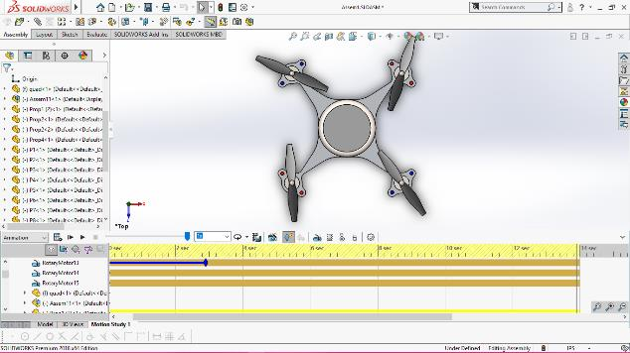

Single Rotor Drone:
A single rotor model has just one big-sized rotor plus a small-sized one on the tail of the drone to control its heading. Single-rotor drones are much more efficient than multi-rotor versions. They have higher flying times and can even be powered by gas.
engines. However, these machines come with much higher complexity and operational risks. Their costs are also on the higher side. The large-sized rotor blades often pose a risk (fatal injuries have been recorded from RC copter accidents) if the drone is mishandled or involved in an accident. 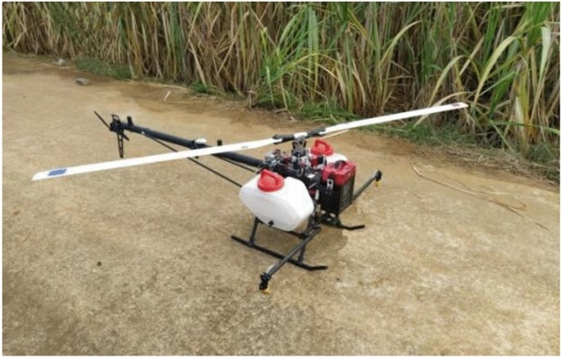

Search and Rescue:
UAVs equipped with infrared or other specialty cameras can be used in search and rescue operations. For example, the European Union is funding ICARUS, a research project to develop unmanned search and rescue tools to assist human teams. In January 2019, 88-year-old Luis Reyna Zuniga was reported missing after leaving his home in Brownsville, Texas at 5:30 p.m. Search and rescue team members pooled their efforts with local police and fire department personnel and deployed a drone with a thermal camera to try and find the missing man.

Mapping:
UAVs can rapidly produce geo-references (GPS accurate) or 3D maps that are often more detailed and faster than satellite imagery. Kathmandu University students along with drone and software experts obtained huge aerial maps using drones. The imagery along with local villagers’ knowledge was used to locate safe sources of drinking water, dangerous debris, displaced people, ruined buildings, and transportation.
networks Nepal Earthquake (2015)
Construction and Infrastructure Inspection:
The net market value of the deployment of UAVs in support of construction and infrastructure inspection applications is about 45% of the total UAV market. So there is a growing interest in UAV uses in large construction projects monitoring and power lines, gas pipelines, and GSM towers infrastructure inspection. In 2016, it was reported that Pacific Gas and Electric Company (PG&E) performed drone tests to inspect its electric and gas services for better safety and reliability with the authorization from Federal Aviation Administration (FAA). The inspections focused on hard-to-reach areas to detect methane leaks across its 70,000-square-mile service area. In the future, PG&E plans to extend the drone tests for storm and disaster response.

Agriculture:
UAVs can be utilized in precision agriculture (PA) for crop management and monitoring, weed detection, irrigation scheduling, disease detection, pesticide spraying, and gathering data from ground sensors (moisture, soil properties, etc.,) A French farming cooperative, OCEALIA Group with 7,200 members and nearly 900 employees have been using drones to gain valuable fertilization data. The drone’s data is used to measure the amount of dry matter in the field and nitrogen absorption at key stages of the crop’s development. For farmers looking solely to increase yield, a flight takes place when the crop is between Z30 and Z33 stage, while for those looking to boost crop quality (i.e., increase the amount of protein in the plant the flight instead takes place at the Z39 stage). The OCEALIA farmers who have used our AIRINOV-supported drone service have recorded an average yield increase of 10%, compared to parcels analyzed using traditional, non-drone methods.
DRONES IN AGRICULTURE

There are several bases for categorizing drones but we the types of drones according to Watts et al. (2012). This study has been classified into seven categories i.e., Micro Air Vehicles (MAV and landing (VTOL), Low Altitude- Short Endurance (LASE), Low Endurance Close, Low Altitude low endurance, Medium Altitude, and High-Altitude Long Endurance (HALE)

Micro Air Vehicles (MAV):
Because of their scale, they are very often called as Nano-Air aircraft which usually allows military variants of these aircraft to be carried in backpacks of soldiers and enables unobtrusive monitoring ability in cramped spaces Such aircraft usually operate at lower altitudes (< 330 m) with battery life constraints contributing to shorter flight times near 5-30 minutes. But their development on a commercial scale is still in the infant stage.

Vertical take-off and landing (VTOL):
These aircraft do not entail a take-off and landing flight and therefore are usually used in instances where terrain constraints demand this advanced ability They fly at different heights, based on the mission profile but mostly at lower altitudes and high battery power demands flight hovering restricts flight time frames VTOLS have a major advantage of remote area network portability, without any need for pathway complexes.
Low Altitude-Short Endurance (LASE):
Mini unmanned aerial systems often eliminate the necessity of aircraft runways designed for fast zone deployment and conveyance. Typically, it weighs 2 to 5 kg and less than a three-meter length of wingspans to launch the aircraft from the catapult configuration. Weight-capacity sacrifices tend to reduce the range of strength and connectivity to 1-2 hours but within a few kilometers of ground stations.

LASE Close:
This group defines tiny, unmanned aircraft which require runways of greater weight and size with enhanced capabilities. They have relatively high flight time and can operate to an altitude of 1500 m and these constraints were addressed through explicitly modified "record-breaker" aircraft substantially.

Low Altitude-Long Endurance (LALE):
United States Federal Aviation Administration gave a designation to these types of drone ones based on their capability to carry input payloads to an extreme upper end with a high weight (kg) at a relatively higher altitude for a prolonged period.

Medium Altitude - Long Endurance (MALE):
Usually, these aircraft are much bigger than low-altitude UAV groups, flying at altitudes up to 9,000 m through hundreds of kilometers of flights from their base stations which last several hours. These have a magnificent role in taking strategic decisions for military defense services and inflated usage is seen in some areas of civil applications.

High Altitude-Long Endurance (HALE):
These are the biggest and most complicated aircraft featuring aircraft bigger than most manned aircraft in commercial aviation. These drones have flight capability and can operate at 20,000 m or more to the extent of several thousand.

ROLE OF DRONES IN FARMING

An ever-increasing global labor force does not match plant growth proportionately; thus there is widespread concern about food production sustainability. In such an effort to address this task, growers all over the world have to acclimate to the advanced and computerized solutions to maintain the world's human population farming needs, which are in a constant state of flux. At present, drones are used in agricultural fields to determine crop biomass growth and production pattern in determining the precision application of input resources, aid in harvesting the produce, and optimization of logistics

Field and soil assessment:
Before the start of the season and after crop planting data collected by drones regarding soil analysis is instrumental in planning the crop species to be sown, the pattern of planting, and determining the amount and time of irrigation and nutrient application. These management decisions taken at the farm level can enhance the overall productivity of the farm. This kind of approach in agriculture fetches scope to adapt site-specific management practices to precision farming.
Precision crop spraying:

Site-specific crop spraying can be real using drones equipped with sensors where it scans the cropped area on a real-time basis and ensures a precise quantity of liquid (like pesticides and nutrients) is sprayed on that target place. Indeed, experts estimated that drones can complete aerial spraying up to five times faster than those conventional spraying. It enhances accuracy in spraying and saves time and input costs for farmers. It indirectly reduces pesticide pollution in groundwater.

Crop monitoring:
Crop production challenges are unpredictable weather extremes that create the biggest obstacle in monitoring crops at the field level. The greatest benefits of using unmanned drones are their simplicity and efficiency in massive-scale surveillance of crops and agricultural land. Well into the earlier days, satellite imagery had been used to get a view of the farm on a large scale, whilst helping to find potential problems in crop monitoring. At present, animations of time series can provide precise development of a crop and reveal production inefficiencies, enabling better crop management.

Irrigation management:
Agricultural drones equipped with thermal sensing cameras can offer phenomenal perspectives into particularly troubled areas of the farm for irrigation applications. Several insights were monitored through these thermal digital cameras from low moisture-stressed conditions to waterlogged conditions, thus allowing farmers to take irrigation management decisions based on water status in the soil. It drives the precision application of water in fields.
Crop health assessment:
Crop health monitoring is essential to detect crop, bacterial and fungal diseases. It is done by drones using green visible light along with near-infrared light to scan the crop for assessing disease incidence in spatial and temporal variation based on crop reflectance. Early detection of disease is possible to make before interventions to safeguard the crop.

Livestock monitoring:
Drones have several potential applications in animal husbandry. Each animal is tagged with sensors or radio frequency identification (FRIDS) tags to monitor feeding activity and their movements using drones. By using this, tracking livestock can be done with much higher frequency, with less time and investment in personnel. Remote sensing-fencing, virtual boundaries, or remote sensing-zoning essentially means creating a virtual obstacle or security fence across the spatial area of interest especially in the free-range practice of livestock grazing.

DRONE REGULATIONS 2.0
1. Certification of drone hardware and software for safe and controlled operations.
2. Air space management by automated operations connected to an overall structure in airspace management.
3. Over and above visual track-of-sight operations.
4. Contribution to building a global set of norms.
5. Suggestions for changing the law on existing CARs and new CARs.
RESEARCH METHODOLOGY
RESEARCH PROCESS
Before embarking on the details of the research methodology and techniques, it seems appropriate to present a brief overview of the research process. The research process consists of a series of actions or steps necessary to effectively carry out research.
The chart indicates that the research process consists of several closely related activities, as shown from I to VII. But such activities overlap continuously rather than following a strictly prescribed sequence. At times, the first step determines the nature of the last step to be undertaken. If subsequent procedures have not been considered in the early stages, serious difficulties may arise which may even prevent the completion of the study. One should remember that neither the various steps involved in a research process are mutually exclusive, nor they are separate and distinct. They do not necessarily follow each other in any specific order and the researcher has to be constantly anticipating at each step in the research process the requirements of the subsequent steps. However, the following order concerning various steps provides a useful procedural guideline regarding the research process:
- formulating the research problem.
- extensive literature survey.
- developing the hypothesis.
- preparing the research design.
- determining sample design.
- collecting the data.
- execution of the project.
- analysis of data.
- hypothesis testing.
- generalizations and interpretation; and
- preparation of the report or presentation of the results
MATERIAL SELECTION
HDPE Material:
High-Density Polyethylene, aka HDPE, is a trendy thermoplastic material made from petroleum. HDPE is known for its excellent tensile strength, high melting point, low cost, and good impact strength. Because of such impressive properties, HDPE can be used in various applications like milk jugs, plastic bottles, beach bottles, cutting boards, and piping. The melting point of HDPE is 130°C thus, making it easy to fabricate and weld using standard thermoplastic welding equipment, mainly available in sheet and rod forms.
Accessible welding properties and versatility make HDPE the right choice for manufacturing more oversized plastic products like water tanks and chemical tanks, which are difficult to manufacture without using high-grade plastic material. HDPE density is also impressive, catering to plastic manufacturers looking to
HDPE is also available in multiple additional grades. It can be utilized to manufacture various products from many categories like FDA-compliant cutting boards, disinfectants for medical facilities, woodgrain texture for the outdoor environment, etc.

HDPE Properties:
- Enhanced Stiffness HDPE.
- UV Stabilized grade HDPE.
- Cutting Board grade HDPE.
- Antimicrobial HDPE.
- Engravable HDPE.
- Wood Grain HDPE.

SEED BROADCASTING
Broadcasting is otherwise called random sowing. This means ‘scattering the seeds. Broadcasting is done for many crops. Broadcasting is mostly followed for small-sized to medium-sized crops. This is the largest method of sowing followed in India, since; it is the easiest and cheapest and requires minimum labor. To have an optimum plant population in the unit area certain rules should be followed. • Only a skilled person should broadcast the seeds for uniform scattering. • The plowed field should be in perfect condition to trigger germination. The seeds are broadcasted in a narrow strip and the sowing is completed strip by strip. It is better to broadcast in either direction to ensure a good and uniform population. This is called crisscross sowing. If the seed is too small, it is mixed with sand to make a bulky one and for easy handling. Ex. Sesame seeds are mixed with sand at a 1:15 or 1:10 ratio and sown. In certain cases, the person sowing will be beating the seeds against the basket for uniform scattering. Ex. Sorghum, pearl millet. After broadcasting, the seeds are covered gently either using a country plow with a very shallow plowing or some wooden planks (boards/levelers) used to cover the surface. In some cases, tree twigs or shrub branches are used. If the seeds are large, levelers collect the seeds and leave them on the other side. Comb Harrow is the best-used one.
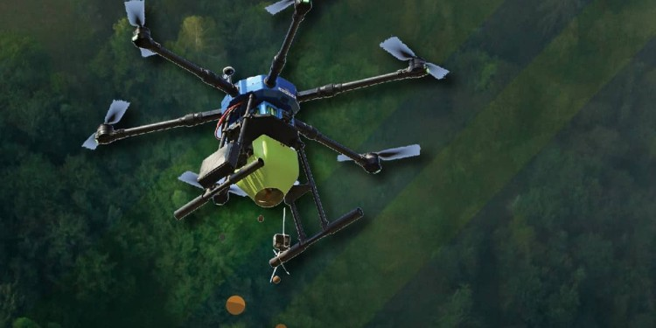
Advantages:
In situations where the number of plants per unit area (per m2) is more important than that of definite spacing from plant to plant, broadcasting is the usual method of sowing. Crop plants not requiring special cultural practices (earthing up or picking) may be sown by broadcasting. Other advantages are as follows:
- It is an easy, quick, and cheap method of sowing seed.
- More land can be covered within a short time.
- No need for sowing implementation.
- Cost of sowing becomes less.
- Broadcasting is the usual method of sowing seed for mixed cropping.
- Broadcasting needs less labor.

Disadvantages:
Though the method is an easy, quick, and cheap method of seeding, there are difficulties in uniform distribution, placing the seed in the optimum and uniform depth of soil, and providing soil cover and compaction. As not all seeds are placed in uniform depth, there is no evenness of germination and uniformity in seedling establishment. Other disadvantages are:
- The requirement of seed per area is more.
- The cost of weeding and thinning in the broadcast crop is more.
- The Intercultural operations such as earthing up, manuring, irrigation, etc., cannot be carried out with ease.
- Broadcasting needs planking for covering the seed with soil. On the other hand, drilling needs no planking.
- Broadcast crops do not grow uniformly, and the desired yield is not possible. Moreover, the prediction of the expected outcome becomes erroneous.

RESULTS
DRONE
The flight controller is the main board in the UAV and is embedded with the most advanced firmware and is responsible for the actual flight. The flight controller controls a lot of things simultaneously during the flight or UAV. It is built with a microcontroller and communicates with the four brushless motors. BLDC motor connects with the rotors in the direction of the UAV configuration model. These BLDC motors are controlled by Electronic Speed controllers (ESC). The UAV is controlled by the Radio channel transmitter and receiver. Every RC transmitter has several channels for an individual activity to control the UAV. Different methodologies, controllers, loads, and speeds of UAVs Startups have created drone-planting systems that achieve an uptake rate of 75 percent and decrease planting costs by 85 percent.
These systems shoot pods with seeds and plant nutrients into the soil, providing the plant with all the nutrients necessary to sustain life. First, a drone scans the topography to create a 3D map. Then, the most efficient planting pattern for that area is calculated using algorithms. A drone loaded with germinated seeds fires pods.
into the ground at a rate of one per second, or about 100,000 a day. Scale this up and 60 drone teams could plant 1 billion trees a year.
Applications:
- Reforestation tool.
- Crop Monitoring.
- Irrigation.
- Crop Spraying (Sprinkler).
- Wildlife & Photograph.

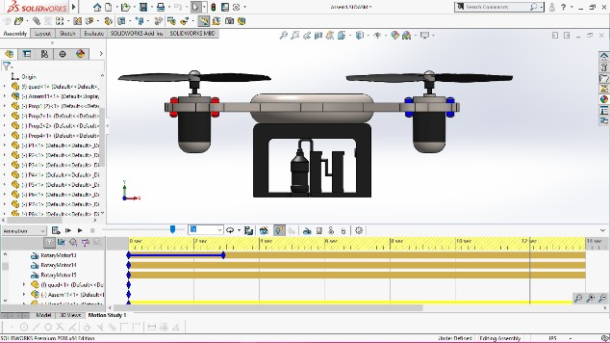

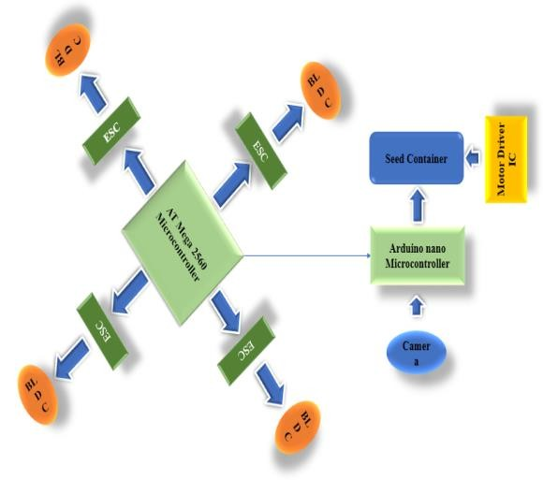
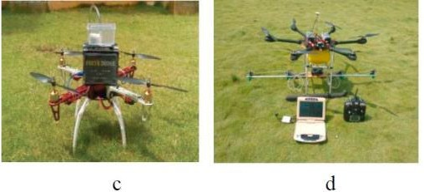

SEED DISPENSER
The seed dispenser mechanism’s main role is to release the seeds on the selected site. The seed-releasing course is controlled by a Lego DC motor, connected to a 5V power supply. Seeds are dropped inside the container and sequentially dropped into a rotational dispensing compartment through the holes in the bottom of that container. At the bottom of the container, there is an infrared sensor that can detect the presence or absence of seeds being dispensed by the motor dispenser. Figure 6 shows the seed dispenser mechanism and the main components. First, the operator should know in advance the exact location that has been targeted by the aircraft using a seed plant drone. This can be done by relying on pictures, videos, or satellite-scanned images as analyzed data. Based on this information, the operator defines the area in which it will be operating. Second, the operator then uses the software to generate the necessary waypoints (mission path) by typing as input the initial waypoint and the final waypoint with the corresponding latitude and longitude and the distance between waypoints as well. The software translates these inputs by generating coordinates as a rectangular area with successive waypoints, and the mission path is defined. Third, the GPS takes the current position of the quadcopter as the waypoint that represents Home. This waypoint will serve as the “TAKEOFF” position before the mission is performed and returned to the launch position after the mission is completed. Last, the coordinates stored in an SD card, inserted in an SD card module, and connected to the Arduino are ready to be uploaded remotely on the Mission Planner software to the Pixfalcon Autopilot by using FPV telemetry radios. The Arduino on the ground station is connected to other Arduinos placed on the quadcopter by using XBee’s radios to communicate with each other; it means that a replica of data-write by one of them will appear on the other and vice-versa. Once properly connected and functional, they transcribe all data using serial communication. The drone is armed in stabilized mode, allowing the operator to have full control over the drone. Missions are executed autonomously in Auto flight mode by using GPS coordinates; however, the operator can have full control by flipping the switch positions on the transmitter and allowing manual control.

FABRICATION
Parts of the seed spreader:
- Tank clamp
- Outlet pipe
- Shutter
- Servo
- Rack and pinion
- Air flow area
- Air blower

The tank clamp:
The tank clamp is made up of HDPE (High-density polyethylene) The tank clamp is designed to the dimensions of the seed tank of the drone. It is because it fits firmly to the tank to avoid any accidents while in use. The tank clamp has holes to tighten the seed spreader to the tank. The M4*10 Allen screws are used to fit the tank clamp.
Outlet pipe:
The outlet pipe is made of the same HDPE (High-density polyethylene). The outlet pipe is a partial part of the tank clamp as it is a full structure. The outlet pipes are the channel that collects the seed from the tank and direct it to the spreading area. It consists of the shutter, servo motor, rack, and pinion gear.
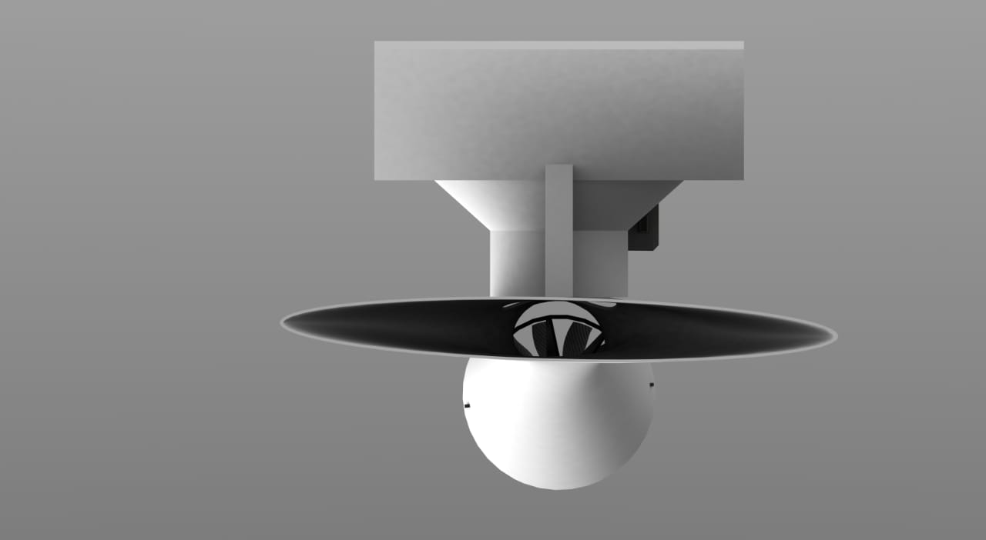
Shutter:
The shutter helps to control the seed flow rate. It is achieved by making an accurate hole in the outlet pipe to help the shutter move back and front in a horizontal direction smoothly. The shutter is shaped by the h dimensions of the outlet pipe’s inner diameter, so we can achieve 0 flow rate by closing the outlet 100%.
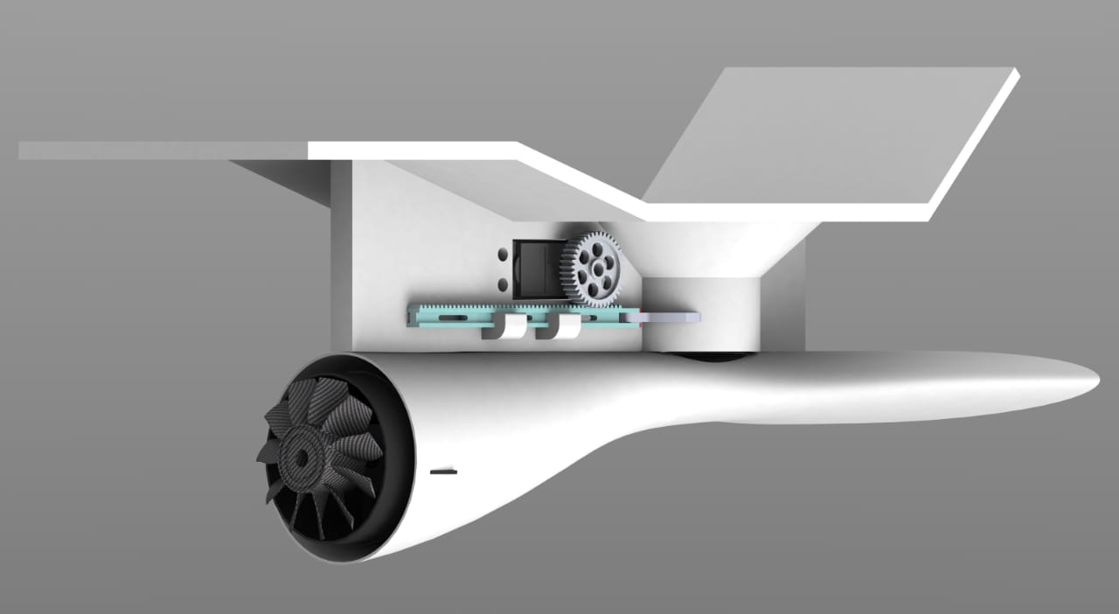
Servo:
The servo motor we have used is a 360° servo motor. Its rotating speed without load: 60°/0.16s @7.2v. The motor uses a 6 to 12V DC. The servo motor is used to regulate the shutter opening. It is mounted on the right side of the side plates parallel to the direction of the rack and pinion setup.
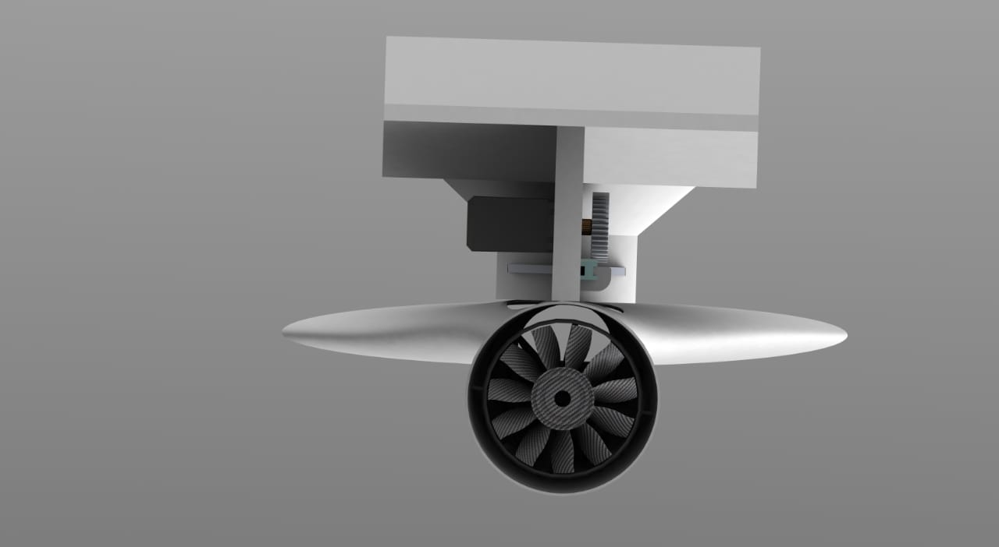
Rack and pinion:
The rack and pinion setup is the mechanism we have chosen to operate the shutter. The rack is the drive, and the pinion (spur gear) is the driver. The pinion is fixed to the servo motor. 40 teeth spur gear is used in this system. The rack is mounted in the side frame with two clamps, which are designed
in the way to help the rack move smoothly.
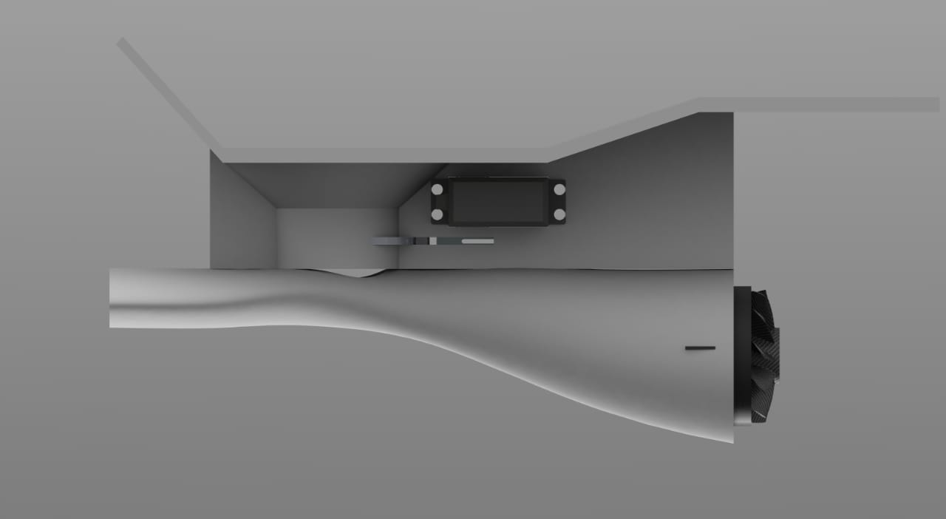
Air blower:
We have used a 12V BLDC motor as the air blower. The motor is clamped to the sides of the air chamber design which is attached to the outlet pipe with screws. The wire circuits of the motor are carried out safely to the FC inside an insulated pipe. The back side of the blower is left open to suck air inside and push it inside.

Construction:
The prefix Quadcopter implies (“quad” =four), is a drone configuration where there are eight arms. The main frame is made of carbon fiber composite material with each arm length of 492 mm. At each free end of the arm, a motor will be fixed. and the propeller will be mechanically coupled to the motor. For all four motors, the output side of an ESC will be connected. and the input side of the Electronic Speed Controller (ESC) will be connected to the flight controller. The other input from the ESC will be connected to the power distribution board. where the power supply is provided by the Li-Po battery. Similarly, all the other ESCs, motors, and propellers are connected. A receiver will be connected to the Flight controller to receive signals from the transmitter. An FPV camera and a suitable transmitter connected are connected to the flight controller. The storage tank of dimensions 200 x 300 x 110 mm is mechanically coupled to the frame with the help tank clamp, the bottom of the tank will have an outlet pipe so that the entire tank gets drained completely. The outlet pipe contains a shutter that helps to control the flow rate. The rack is the drive, and the pinion (spur gear) is the driver. The pinion is fixed to the servo motor. 40 teeth spur gear is used in this system. The rack is mounted in the side frame with two clamps, which are designed in the way to help the rack move smoothly. The air blower is made up of a 12V BLDC motor. The motor is clamped to the sides of the air chamber design which is attached to the outlet pipe with screws. The wire circuits of the motor are carried out safely to the FC inside an insulated pipe. The back side of the blower is left open to suck air inside and push it inside. The servo motor we have used is a 360° servo motor. Its rotating speed without load: 60°/0.16s @7.2v. The motor uses a 6 to 12V DC. The servo motor is used to regulate the shutter opening. It is mounted on the right side of the side plates parallel to the direction of the rack and pinion setup. The landing frame of a height of 300mm is connected to the main frame so that the landing of the drone will be safe, and the storage tank will not touch the ground.
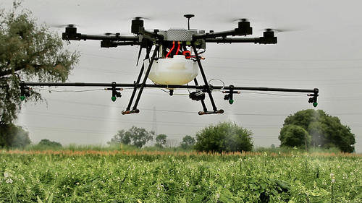

Efficiency and Efficacy:
Efficient fertilizer application ensures equal distribution and full absorption of nutrients by the rice crop. Manual broadcasting is the most common method of applying granular fertilizers in rice fields in the Philippines. Meanwhile, an octa-copter agricultural precision drone that can broadcast dry materials of a diameter between 0.5mm to 5mm such as granular fertilizers, seeds, and feeds is starting to gain access to the local farming market. With a load capacity of 10kg, the system has an automated mission feature wherein users can plot out the area and it automatically creates and follows the flight path. The drone is also capable of resuming its mission path after refilling should it empty its tank load at mid-flight. The potential of this technology in nutrient application in rice has not been explored. Thus, a study under the field condition at PhilRice CES from January to May 2019 was conducted to test and compare the efficiency and effectiveness of the precision drone spreader technology with the manual method of applying granular fertilizer in rice. Cutting the recommended nutrient rate into two splits, granular fertilizers were applied in two plots through the following treatments: manual broadcast and drone spreading. Crop cut and actual yield data as well as the time spent during the application were recorded and analyzed. Results showed that the drone-spread plot has a more equal distribution of nutrients based on crop cut compared to the manually broadcasted. Drone-spread plot harvest data was higher compared to the manually broadcasted plot both in the crop cut and actual yield. In terms of the duration of the fertilizer application, both are relatively equal. The results suggest that a multi-purpose precision drone spreader has the same efficiency and is more effective than manual fertilizer broadcasting. This experiment will be continued in the next seasons under a more rigorous design.

DISCUSSION
I believe that as an Agriculture engineers, we must develop and produce technological results that can significantly improve the life quality of humanity and improve agriculture. I can personally see this project as an ambitious one that can probably bring universal, innovative trends to the world. I’m optimistic that this project will be a valuable contribution to farmers and therefore reduce wastage. Mindful that the process of seed dissemination will be fast and low-cost compared to the overlapped issues we may face along the road. Therefore, I have full confidence that significant gains will be achieved with conventional reforestation. However, changes sooner or later will be unstoppable, only because we cannot afford to lose one of our most supportive lines of survival by keeping only the traditional methods of reforestation. In specific countries with poor agriculture practices, desertification and deforestation are common problems.

CONCLUSION
Though drone spreader reduces manpower it fails in some ways. One of that is seed wastage, the drone spreader spreads seeds in the method of broadcasting. We designed a spreader that minimizes the wastage of seeds that exits from the spreader. The main objective of this project is to help farmers in many aspects. They reduce seed wastage and money spent on the seed wasted. And modern farming industry is at a turning point with the development of more advanced farm management techniques, such as precision agriculture, industry professionals now have more tools than ever to improve the accuracy and efficiency of processes. The use of the different types of agricultural drones for solving specific tasks of plant growing is studied: the creation of electronic maps of fields, operational monitoring of crop conditions, evaluation of germination and predicting crop yields, checking the quality of plowing, maintaining environmental monitoring of agricultural land, etc. Consequently, drones are very important tools in modern agriculture and farming systems.

REFERENCE
[1] M. Reinecke and T. Prinsloo, "The influence of drone monitoring on crop health and harvest size," 2017 1st International Conference on Next Generation Computing Applications (Next Comp), Mauritius, 2017, pp. 5-10.
[2] Salaskar1, Saee Paranjpe2, Jagdish Reddy3, Arish Shah4, “Quadcopter – Obstacle Detection and Collision Avoidance’’, International Journal of Engineering Trends and Technology (IJETT) – Volume 17 Number 2 – Nov 2014 ISSN: 2231-5381 http://www.ijettjournal.org Page 84
[3] Spoorthi S., B. Shadaksharappa, Suraj S. and V. K. Manasa, "Freyr drone: Pesticide/fertilizers spraying drone - an agricultural approach," 2017 2nd International Conference on Computing and Communications Technologies (ICCCT), Chennai, 2017, pp. 252-255.
[4] Y. A. Pederi and H. S. Cheporniuk, "Unmanned Aerial Vehicles and new technological methods of Monitoring and crop protection in precision agriculture," 2015 IEEE International Conference Actual Problems of Unmanned Aerial Vehicles Developments (APUAVD), Kyiv, 2015, pp. 298-301.
[5] A. K. Saha et al., "IOT-based drone for improvement of crop quality in the agricultural field," 2018 IEEE 8th Annual Computing and Communication Workshop and Conference (CCWC), Las Vegas, NV, 2018, pp. 612-615.
[6] Roma, A., 2017. Drones and popularization of space. Space Policy 41, 65–67.
[7] Bell, D., Reinhardt, F., Shelman, M., 2016. The Climate Corporation (Case No. 9-516-060) Harvard Business School Publishing, Brighton, MA.
[8] Bunge, J. 2015. On the farm: Startups put data in farmers’ hands. The Wall Street Journal.

