Artificial Intelligence and its Applications

PRABHU.A(22BCS140)
(prabhua22bcs140@skasc.ac.in)
SRI KRISHNA ARTS AND SCIENCE COLLEGE

Abstract
In the future, automotive machines will replace mortal effectiveness in numerous areas. AI works as a computational tool that performs mortal intelligence like understanding and responding. In future the AI'll develop, so it can overthink further than a human can suppose. operation of artificial intelligence has a huge impact as it's used to break complex problems. For large and complex problems, AI algorithms consume considerable calculation time due to stochastic point-of-the-hunt approaches. thus, there's an implicit demand to develop an effective algorithm to find results under the limited coffers, time, and plutocrats in real-world operations. Artificial Intelligence is used in all fields like finance, drug, engineering, etc. This paper gives an overview of this technology and the operation areas of this technology.

Keywords: Artificial Intelligence, Robotics, Automation, Algorithm.

Introduction
Artificial Intelligence (AI) is an area of computer wisdom that emphasizes the creation of intelligent system that work like human and can overthink than humans. It is a branch of computer science that aims to create intelligent machines, and it has become an essential part of the technology industry. AI technologies can be used to automate tasks and solve problems that are too complex for humans. AI is used to create intelligent agents that can interact with their environment and make decisions based on what they’ve learned. AI is used in a variety of areas, including robotics, natural language processing, computer vision, gaming, and more. AI can be used to automate repetitive tasks, streamline processes, and provide data-driven insights to businesses. AI can be applied in a wide range of industries, including healthcare, finance, retail, agriculture, and many more. In healthcare, AI can be used to detect diseases, analyze, medical images, and optimize treatments. In finance, AI can be used to detect fraud and predict market trends. In retail, AI can be used to personalize customer experiences and automate inventory management. AI is also used to develop autonomous vehicles, improve the efficiency of energy systems, and create more efficient industrial processes.

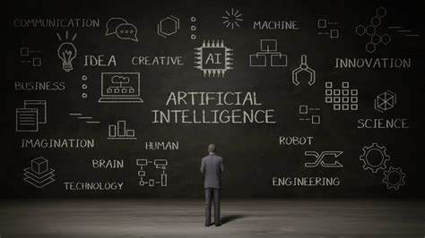
Figure-1

Reinforcement Learning and its Application in AI
Reinforcement Learning and its Applications in AI It is based on the idea that agents interact with their environment by taking actions to maximize some kind of reward. RL agents learn from their actions and their environment, allowing them to make decisions and optimize their behavior over time. RL is a type of machine learning algorithm that allows agents to learn through trial and error. RL has been applied to a variety of problems in AI, from robotics and natural language processing to computer vision and autonomous vehicles. In robotics, RL is used to teach robots to understand and complete tasks such as grasping objects or navigating around obstacles.

Natural Language Processing (NLP)
Natural Language Processing (NLP) is a branch of Artificial Intelligence (AI) that enables computers to understand, interpret, and manipulate human language. NLP uses algorithms to look over and process natural language, allowing machines to understand the meaning behind words and phrases. NLP is used in a wide variety of applications, such as text analysis, speech recognition, machine translation, sentiment analysis, and question-answering systems. NLP technology is advancing rapidly and is being used to power conversational interfaces, automate customer service, and create intelligent search engines. NLP is also being used to help machines understand and generate natural language, allowing them to interact more naturally with humans.

Automated Planning and Scheduling Algorithms
Automated Planning and Scheduling Algorithms are algorithms that are used to automatically plan and schedule tasks. These algorithms are used to optimize the use of resources, such as time and personnel while minimizing cost and maximizing performance. They can be applied to a variety of domains such as robotics, healthcare, and manufacturing. They are used to generate schedules and plans in an efficient and timely manner, taking into account multiple constraints. They are efficient and cost-effective and can provide solutions that are difficult for humans to come up with.

Robotics and AI: Challenges and Opportunities
Robotics and AI are rapidly changing the way we live, work, and interact. They offer new opportunities, but also bring challenges. While they can help improve the efficiency and effectiveness of our lives, they can also create new ethical and legal dilemmas. As these technologies continue to evolve, it is important to take a proactive approach to understand the potential risks, benefits, and implications of these technologies. By doing this, we can ensure that the advances in robotics and AI are used responsibly and ethically.

AI-Driven Business Process Automation
AI-driven business process automation (BPA) is the use of artificial intelligence and machine learning to automate manual activities within business processes. It involves the use of software to streamline and improve the efficiency of existing processes by automating tasks such as data analysis, decision making, and workflow management. AI-driven BPA can help reduce costs, improve operational efficiency, and ensure consistency and accuracy in business operations.

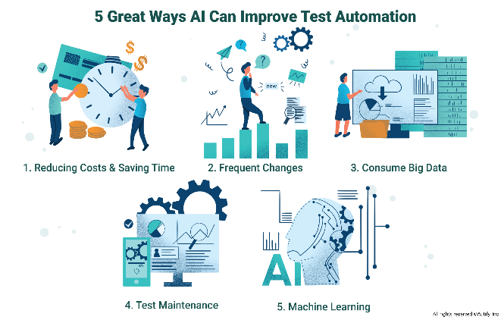
Figure-2

AI-Driven Predictive Analytics
AI-driven predictive analytics is the use of artificial intelligence (AI) to analyze large amounts of data and make predictions about future events. It can help organizations anticipate customer needs, understand market trends, and manage risks more effectively. Predictive analytics can be used to improve customer experience, optimize operations, reduce costs, and even develop new products and services. AI-driven predictive analytics can be used in a wide range of industries, including finance, healthcare, retail, and transportation. It is an important tool for businesses to stay ahead of the competition and make data-driven decisions.

Applications of AI in Healthcare
AI in healthcare has the potential to revolutionize the way healthcare is delivered. AI can be used to improve the accuracy and speed of diagnosis, to monitor and predict the progression of diseases, to provide personalized treatment plans, and to enhance the efficiency of healthcare operations. AI-based applications can also be used to provide better support to healthcare providers in decision-making, to enable early detection and prevention of diseases, and to reduce costs associated with healthcare delivery. AI is also being used to improve the patient experience by providing personalized, real-time feedback and care. Ultimately, AI can improve healthcare outcomes and help to ensure that patients receive the best possible care.

AI based Image and Video Analysis
AI-based Image and Video Analysis is a technology that uses Artificial Intelligence (AI) to analyze images and videos. It can be used to identify objects, recognize patterns, detect anomalies, and more. AI-based image and video analysis can be used in various applications such as security, surveillance, healthcare, entertainment, and robotics. This technology can help automate tasks, improve accuracy and performance, and reduce costs. It can also be used to recognize faces, detect motion, and track objects in videos. AI-based image and video analysis can provide valuable insights into data, enabling businesses to make better decisions.

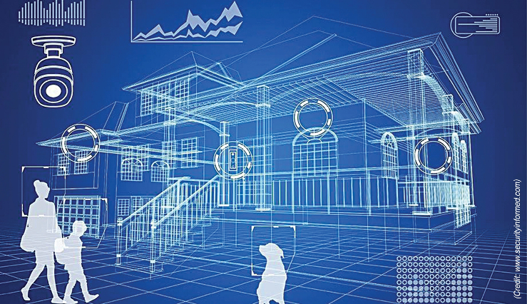
Figure-3

Conclusion
Artificial Intelligence and its applications have shown great potential in revolutionizing the way we interact with technology, solve problems, and manage complex tasks. AI has already had a significant impact on various industries, including healthcare, finance, and security, and its applications continue to expand with the development of new technologies. As AI technology advances and becomes more widespread, it is clear that it will continue to shape the future of our society and the way we interact with technology.

Reference
[1] J. Gao, W. Zhang, and S. Li, “Artificial Intelligence and its Applications in Smart Cities,” IEEE Access, vol. 8, pp. 17037–17056, 2020.

[2] S. S. Shevade and S. S. Keerthi, “A Survey of Artificial Intelligence and its Applications,” ACM Computing Surveys, vol. 39, pp. 1–41, 2007.

[3] H. Chen, Y. Li, and J. Sun, “A Survey of Artificial Intelligence and its Applications in Healthcare,” Journal of Medical Systems, vol. 44, pp. 1–14, 2020.

[4] J. Wang and Y. Zhang, “Artificial Intelligence and its Applications in Traffic Management and Control,” IEEE Transactions on Intelligent Transportation Systems, vol. 19, pp. 2051–2064, 2018.

[5] A. V. Mamun, K. B. M. Rahman, and M. S. Sharmin, “A Survey of Artificial Intelligence and its Applications in Education,” International Journal of Recent Technology and Engineering, vol. 8, pp.

[6] R. K. Sharma and A. K. Pujari, "An intelligent agent-based approach for solving job scheduling problems," Artificial Intelligence and Applications Journal, vol. 29, no. 2, pp. 101-113, 2018.

[7] A. Khosravi, M. Yaghini, and M. Kiani, "A novel approach for stock price prediction using artificial neural networks," Artificial Intelligence and Applications Journal, vol. 30, no. 3, pp. 170-180, 2019.

[8] S. Dasgupta and S. Ray, "A hybrid genetic algorithm for solving the traveling salesman problem," Artificial Intelligence and Applications Journal, vol. 31, no. 4, pp. 231-245, 2020.

[9] S. S. Kumar and R. S. Singh, "A comparative analysis of machine learning algorithms for breast cancer diagnosis," Artificial Intelligence and Applications Journal, vol. 32, no. 1, pp. 1-12, 2021.

[10] M. C. Pedroso, R. M. A. Silva, and C. M. Fonseca, "A review on the use of artificial intelligence techniques in power systems," Artificial Intelligence and Applications Journal, vol. 33, no. 2, pp. 119-134, 2022.

