CLASSIFICATION IN DETECTING AND MAPPING OF SATELLITE IMAGES USING ML
Dr P H S TejoMurthy¹| M Sri Karthik² | K Kiran Kumar³|
K Lokesh⁴| N Jagadeesh⁵| I Guru Babu⁶
¹Professor, Department of Electronics and Communication, Sir C R Reddy College of Engineering, Vatluru, Eluru, Andhra Pradesh – 534007.
^{2,3,4,5,6}Under Graduate Scholars, Department of Electronics and Communication, Sir C R Reddy
College of Engineering, Vatluru, Eluru, Andhra Pradesh – 534007

Abstract— In numerous real-time applications, including the military, geospatial surveys, surveillance, and environmental monitoring, satellite image categorization is frequently employed. Content extraction from satellite images has recently become more dependable and effective with the addition of Machine Learning (ML) based methods. Among the ML based methods, semisupervised adversarial approaches represent an emerging area of application in content extraction from satellite images. The preprocessing procedure is necessary to obtain the correct segmentation and categorization of satellite pictures. The two components of the pre-processing technique are picture enhancement and image restoration. Multiresolution segmentation with the aid of an innovative edge detector was used to build superior segments since segmentation techniques were actually used to identify the items. Segmentation was carried out to classify the feature objects into classes of water, trees, grass, soil, and shadows separately using Normalized Difference Vegetation Index (NDVI) band ratios and Water Vegetation Index (WVI) membership functions. The algorithms for classification were used to categorise these classes. The classifiers Support Vector Machines (SVM) were employed to categorise the objects.By looking at the classified image it can be found that the water, grass and shadows classes were classified well. The extent of soil is not very large so it was ignored. The intensities of trees and grass are near, so the trees are treated as grass.
Accuracy was measured for the output of Machine learning and deep learning algorithms classifiers to assess the quality of the classification.. In this investigation, the SVM classifier was employed, and it attained a remarkable 99% accuracy as well as by using K-NNC classifier it attained a 98% accuracy similarly by using light GBM classifier it attained a 98% accuracy.Ultimately, classification accuracy is evaluated, and the best classifier is identified by contrasting the results. Every object's space occupancy as a percentage can also be seen in the form of histogram representation. histogram consists of space occupancy of various areas.In x-axis its consists of various areas labelled 0-Tress with percent of 19.16%,1-Agricultre lands with 27.52%,2-soil area with 6.96%,3-combination of different colours with 19.51%,4-water area with16.72%,5-forest area with 10.10%. y-axis represents occupation of various areas in form of pixels.
Keywords—Multispectral, satellite image, remotesensing, segmentation, classification, accuracy, Support Vector Machine(SVM), K-NNC,Light GBM etc,
INTRODUCTION
In the past, land surveys were manually carried out to collect data on land use and land cover. Manual land surveys were time-consuming, costly, hazardous, and required more work. Eventually, aerial photographs were utilised to gather data on land use and cover in general, but these images contain noisy data and are challenging to map with geographic coordinates. Several academics have tried to automate the digitization process in an effort to increase speed and decrease resource requirements. Remote sensing enabled all of this to be done. By using remote sensing, one can gather information about an object without physically touching it. The development of remote sensing has made it feasible to precisely and effectively collect data on land use and land cover on a massive scale. This was very helpful in determining the resources that are there on the surface of the earth.
The vegetative features that were present on a significant portion of the earth's surface were known as land cover. Vegetation identifies a set of objects with related characteristics. Usually, land use and land cover were distinct. Land cover was the term used to describe the natural resources that might be found on the surface of the earth, such as mountains, forests, water bodies, deserts, soils, etc. Buildings, farms, roads, and other man-made resources were used as part of the land usage.
Remotely sensed images had relatively low resolution in the beginning, making processing them difficult. Yet, advancements in remote sensor technology now enable us to capture photos with Very High Definition (VHR). These VHR images have been used to find solutions to a wide range of problems, including the tracking of enemy vehicles as a security risk in defence, dynamic environmental changes, finding and managing natural resources, researching crop diseases, identifying crop vegetation, and developing master plans for the construction of large cities. These images may be used to research how people impact the environment.
In reality, visible electromagnetic spectrum photographs are part of remote sensing. Yet, a multispectral image only uses a few of the electromagnetic spectrum's bands, not all of them. More information is extracted from multispectral photos that the human eye cannot see in the various colour bands. Several remote sensing applications increasingly often employed multispectral satellite imagery.
These multispectral satellite photos were classified using object-based image analysis (OBIA) techniques rather than pixel-based techniques. The OBIA techniques include form, texture, or adjacency measurements in addition to spectral features, whereas the pixel-based approaches simply take into account spectral properties.

LITERATURE REVIEW
The review of the literature was highly beneficial to the study process. It details numerous strategies and methods that were required. To determine the likelihood of completing the necessary work, a thorough review of the literature was conducted. For this effort, a variety of publications were analysed, and the concise reports provided by numerous authors on the same background in the past were used.
A method for monitoring in remote sensing on multitemporal pictures using a Maximum Likelihood (ML) classifier was reported by Diego Fernandez Prieto and Lorenzo Bruzzone. Their method enables precise land cover determination for a specific area from a picture without the need for an appropriate training set. They claim that using the new image as unsupervised learning input, the ML classifier parameters were updated. Without using the training data for the new image, high accuracy was attained.
Curt H. Davis and Aaron K. Shackelford want to improve how well urban areas are identified in high resolution multispectral satellite photography. They have examined panchromatic and multispectral IKONOS datasets for this purpose. They examined the classification accuracy of hierarchical fuzzy logic classifiers and maximum likelihood (ML) classifiers.
Support Vector Machines (SVM) were used by R. Muralidharan and Dr. C. Chandrasekar to recognise the object from the provided image using Kernel Principal Component Analysis (KPCA), which increased classification accuracy by 8% to 11% in comparison to ML classifier. The KPCA from the training picture and dimension reduction are used to create the feature vector. The MATLAB implementation of this made use of the COIL-100 database. They trained with a short feature vector and the polynomial kernel function for SVM classification. The Back Propagation Neural Network, which was also used for object recognition, is inferior than SVM in terms of performance.
Satellite photographs of land cover may be classified into predefined groups using a technique described by Eric Bach, Irene Walde, Soren Hese, Christiane Schmullius, and Joachim Denzler.In order to automate segmentation and classification without involving any human intervention, this only needs a little amount of training data. Iterative Context Forest is the name given to this technique (ICF). RDF, which is a collection of Decision Trees, is the foundation of ICF (DT). An experiment was conducted using Quick Bird's high definition satellite photos and the LiDAR data of the city of Rostock. Using the selected training regions, the pixels were split into groups of trees, water, barren soil, buildings, and grassland.. Accuracy can be greatly improved by adding contextual features.
Gustavo Camps-Valls, Valero Laparra, Emma Izquierdo-Verdiguier, and Luis Gomez-Chova published a technique for implementing invariance in Support Vector Machines (SVM) in the characterization of remote sensing pictures.The available labelled examples were used to train the conventional SVM to create new Support Vectors (SVs). The virtual SVM was trained using both the old and new SVs. To enhance contextual classification, they first added picture patch invariance to rotations and reflections. Eventually, they added an object scale invariance to patch-based classification. Lastly, illumination invariances are included to address shadows in the image. The results were efficiently produced with a small number of tagged samples.
Gulsen Taskin Kaya provided a model for categorising remote sensing images by combining the results from Linear Support Vector Machines (LSVM) and Support Vector Selection and Adaptation (SVSA). The SVSA methodology makes advantage of the support vectors that the LSVM method produces. The hybrid model incorporates some LSVM since it can access the LSVM model through the usage of SVSA. The approach that utilises this hybrid model is known as the Hybrid Support Vector Selection and Adaptation method (HSVSA) [13]. The experiment made use of one multispectral dataset and two hyperspectral datasets. For linearly separable data, LSVM outperformed SVSA in terms of classification accuracy, whereas HSVSA the best for classifying multispectral images in order to achieve higher accuracy when compared to other classifiers, according to a careful examination of the literatures of many scholars.
MULTISPECTRALIMAGE CLASSIFICATION APPROACHES
The ability to identify objects in multispectral images has attracted a lot of attention due to its potential remote sensing applications. One of the best uses is the classification of objects in remotely sensed satellite images. For businesses, governments, and people at large, the detection of objects in satellite images is immensely helpful. The features, such as vegetation, water, trees, houses, etc. are objects in the satellite image.
The system's architectural model is shown in Figure 1.
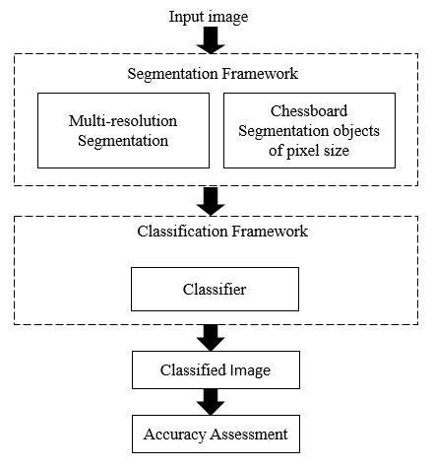
Figure 1: Architectural mode
a)Segmentation:
Segmentation is the process of breaking up a picture into several parts. The segmentation methods used in this methodology were multiresolution segmentation and chessboard segmentation; each has a specific goal to achieve.
1) Multiresolution Segmentation
The multiresolution segmentation makes objects by utilizing an iterative algorithm, whereby objects are gathered until a threshold signifying the better object difference is grasped. The difference threshold is weighted with shape elements to minimize the fractal limitations of the objects. By increasing the difference threshold bigger objects will be generated in spite of the fact that their precise size and measurements is based on the basic information. In multi-resolution segmentation the boundaries are traced at multiple resolutions by using the wavelets functionality. It makes use of edge detector for tracing the boundaries for this canny edge detector was used.
2) Chessboard Segmentation
The chessboard segmentation is the easiest segmentation accessible as it just partition the image into segments pixel size. The segmentation does not consider the underlying data and therefore when large objects are created, the features within the data we are trying to classify will not be delineated. This segmentation tends to be used in more advanced processes where segmentation is undertaken in a number of steps combined with a classification. The chessboard segmentation makes use of Normalized Difference Vegetation Index (NDVI) band ratios and membership functions in creation of the feature object classes.
Band Ratios: The Normalized Difference Vegetation Index (NDVI) is an index of plants that can be used to evaluate the remote sensing measurements and judge whether the object contains live green vegetation or not [14].
1. Normalized Difference Vegetation Index
NDVI =((DNnir-DNr))/((DNnir+DNr))
2. Water Ratio Index
WRI=((DNnir+DNr+DNg))/DNb
3. Blue Red Ratio
BRratio=DNb/DNr
4. NDVI green ratio
NDVIgreen=((DNnir-DNg))/((DNnir+DNg))
5. Blue Near Infrared Ratio
BNirratio=DNb/DNnir
6. Green Red Ratio
GRratio=DNg/DNr
7. Water Vegetation Index
WVI=(DNr+DNg)/DNnir
8. Red Green Ratio
GRratio=DNr/DNg
Intensity2 is used for classifying shadows
Intensity2=(DN r+DNg)/2
Intensit3 is used to prevent road pixels from becoming shadows
Intensity3=(DNnir+DN r+DNg)/3
Where,
DN=digital number
nir=near infrared
r=red
g=green
b=blue
Membership Functions: Water Vegetation Index (WVI) threshold values for identifying water vegetation and various objects based on the intensity threshold values.

Table 1: Membership functions of pixel classification
Classes | Membership functions
Water | WVI > 3
Trees | WVI < 1.05 & green entropy > 2.4
Grass | WVI <= 1.5 & greater entropy <= 34
Soil | WVI > 1.5 and <= 1.8 & red green ratio > 0.91
Shadow | Intensity2 <= 70 & WVI > 1.6
The membership functions are very useful in identifying the feature objects from a multi-spectral image.
B. Classification:
The primary part of image classification is to identify, detect, diagnose and classify features of an object in an image depending on the type of class. The classification techniques used here are Support Vector Machines (SVM) and Multiclass Support Vector Machines (MSVM).
- Support Vector Machines (SVM)
As the SVM is fundamentally a supervised algorithm, training data are needed to classify the feature objects. Just two classes may be classified at once because of its binary character. The items in the SVM were classified by framing a hyperplane in the feature space with all the positive vectors living on one side and all the other vectors lying on the other.
SVM often do classification in a linear fashion. SVMs may effectively conduct nonlinear classification in addition to linear classification. This allows them to use the kernel method to map the inputs to the highdimensional component spaces. SVMs may effectively conduct nonlinear classification in addition to linear classification. This allows them to use the kernel method to map the inputs into high-dimensional component spaces. In addition to linear classification, SVMs are also capable of doing nonlinear classification. This enables them to map the inputs into high-dimensional component spaces using the kernel approach component spaces.
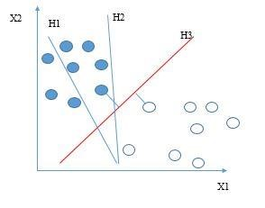

Figure 2: The training samples are accurately separated by hyper planes.
The three linear hyper-planes in Figure 2 that divide the training samples in the feature space are labelled H1, H2, and H3.
Just a small number of classes may be categorised because the SVM was a binary classifier. Yet, most applications must be split into more than two categories. One-Against-One (OAO) and One-Against-All were two ways available to deal with multiclass classification issues using SVM (OAA). In multiclass SVM, the classes are categorised using a voting system.
Using One-Against-One (OAO) techniques, SVM classifiers built for each pair of classes in this method. The result of categorization is the class that appears most frequently among the two classes in pair. One class is chosen at random as the output label if a pair's classes were proportionally represented. The biggest disadvantage is that as there are more classes, there are more classifiers.
One-Against-All (OAA): This requires building an equal number of binary SVM classifiers as there are classes. Each classifier is taught to distinguish between one class and the other classes. The class with the biggest margin using the SVM classifier is the final output. Two or more classes are unclassified or rejected if they are close to one another C. Precision
A pixel-based assessment technique was used to evaluate the object detection accuracy. Doing a mapping of all classes that are unmatched by the total number of classes, every single distinct object in this technique was examined for convergence with externally translated vector layers. The level of information quality is based on accuracy. The accuracy can be calculated as
$Accuracy=1-\frac{Total no:of unmatched classes}{Total no:of classes}$
RESULTS AND OBSERVATIONS
The image used for execution is a LAN file. The LAN file is a multi-spectral satellite imagery of the Landsat satellite. It was provided in the MATLAB image processing toolbox. The Figure 3 shows an image utilized for classification of objects.
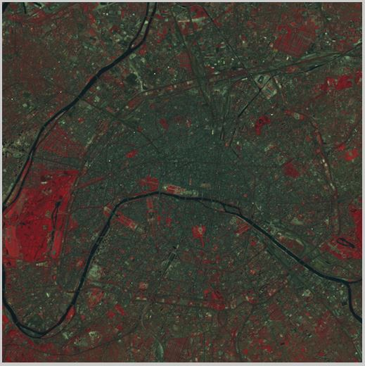
Figure 3: Multispectral image of paris
The LAN file, paris.lan is a Landsat image that contains 7-band colors and image of size 512 by 512. A 128-byte header is followed by the pixel values, which are band interleaved by line (BIL) in order of increasing band number. They are stored as unsigned 8-bit integers, in little-endian byte orderThe image was transformed into gray scale image for removing noise and to increase the visibility level for identifying different objects in the image.
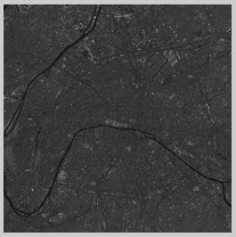
Figure 4: Gray scale image
The classification of sub-objects was done by choosing parameters from the output of band ratios.
The range is 0 to for all other ratios, but the NDVI and NDVI-Green normally range from -1 to 1. The NDVI result illustrates how water and vegetation may be distinguished from other features. The Water Ratio Index could not be used to categorise any feature. Detail between related items is provided by the Blue Red Ratio. The findings of Green NDVI are almost comparable to NDVI, with the exception of how effectively water can be separated from other classes when employing this metric. Air and water are easily distinguished by the blue NIR ratio. Both the Red Green Ratio and the Green Red Ratio yield results that are beneficial for soil refinement. Use the Water Vegetation Index to distinguish between types of vegetation.
To create the feature object classes, utilise the membership functions and NDVI band ratio indices indicated in Table 1. With the exception of trees and dirt, almost all classes were correctly identified when looking at the feature class output. Despite the fact that the green band had a lot of trees, certain pixels and soil objects were not classified as trees or as dirt. All of the streets and structures were viewed as shadows.
Using the results of the multi-resolution segmentation and feature classes, the final classification is carried out. In order to categorise the feature object classes, machine learning and deep learning methods were used.
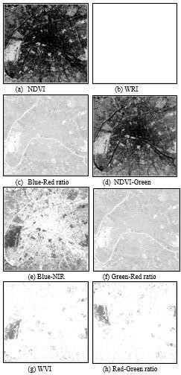
Figure 5: Band ratios
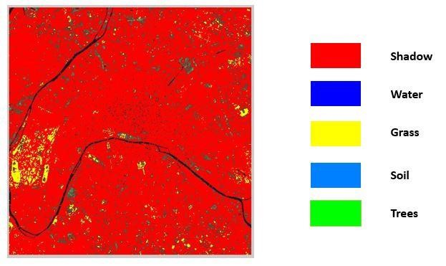

Figure 6: Classified image using SVM classifier
Figure 8 displays the feature item classification using the SVM classifier.
Looking at the classed image reveals that the classes for water, grass, and shadows were correctly identified. Since the soil's area was not particularly large, it was disregarded. Trees are classified as grass since their intensities are similar to that of grass.
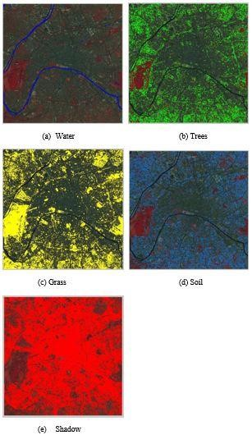
Figure 7: Feature object classes
Figure 8 displays the feature item classification using the SVM classifier.
Looking at the classed image reveals that the classes for water, grass, and shadows were correctly identified. Since the soil's area was not particularly large, it was disregarded. Trees are classified as grass since their intensities are similar to that of grass. To evaluate the classification's quality, accuracy was measured for the results of machine learning and deep learning algorithms.
The accuracy of machine learning and deep learning algorithmsclassifiers is shown in Figure 11. With machine
learning and other techniques, accuracy of 99% and 93%
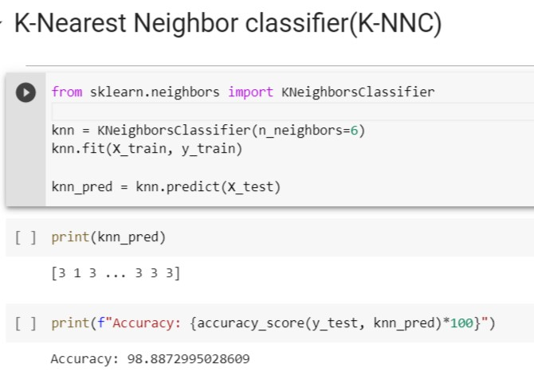
Figure:K-NNC accuracy

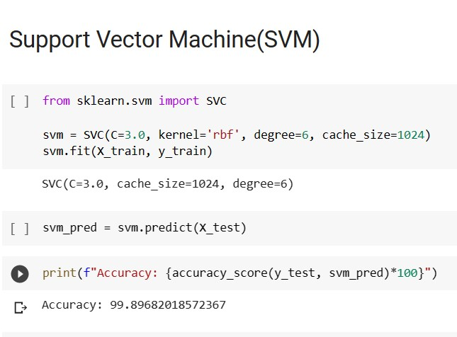

Figure:Accuracy of SVM Algorithm

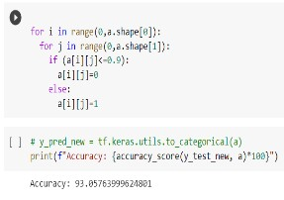
Figure:Testing accuracy
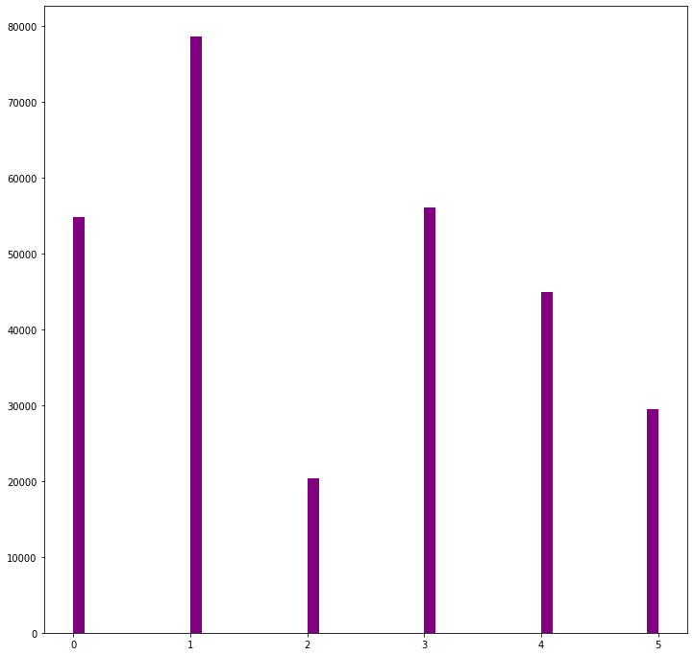
Figure:Representation of are occupied using K-NNC
Above histogram consists of space occupancy of various areas.In x-axis its consists of various areas labelled 0-Tress,1-Agricultre lands,2-soil area,3-combination of different colours,4-water area,5-forest area.y-axis represents occupation of various areas in form of pixels’
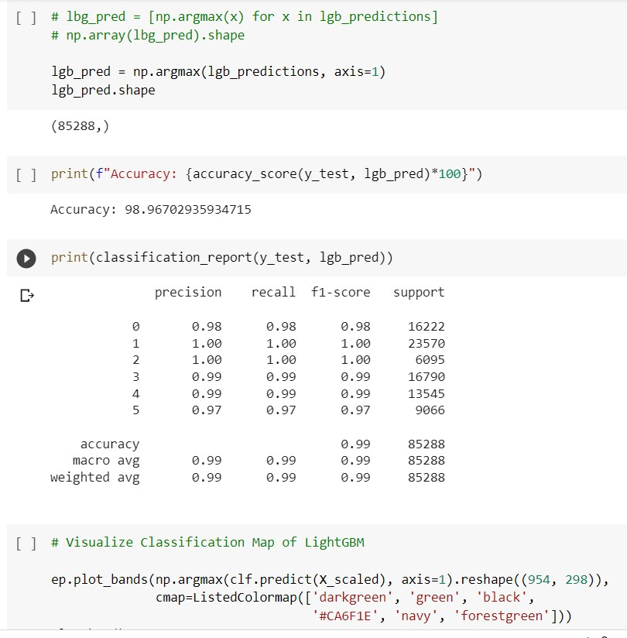
Figure: LightGBM Accuracy
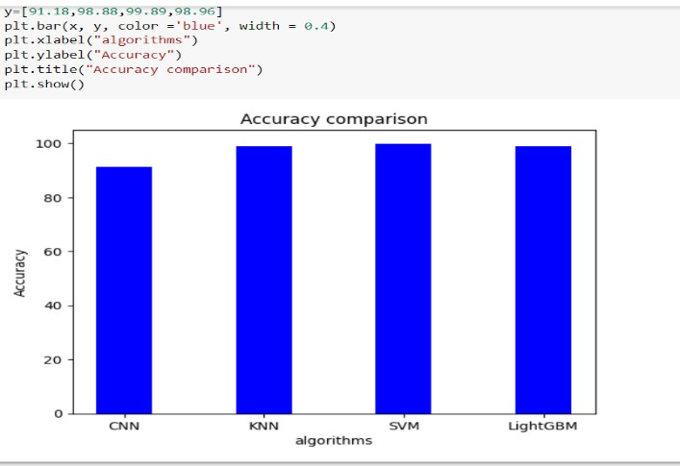
Figure:Accuracies comparison
CONCLUSION
Satellite missions have recently given us a lot of remote sensing data, but utilising this data for precise mapping comes with certain difficulties. Remote sensing photos taken at various times and locations may have distinct data distributions depending on the atmospheric conditions, sensor properties, and acquisition durations. Because of this, it may be challenging for machine learning models to produce precise maps, especially when there is a lack of annotated data.
An effective image classification method was also suggested in addition to this strategy for the classification of multispectral remotely sensed satellite images. The technique divides the image's feature components using checkerboard segmentation and multiresolution segmentation.
The image is segmented into discrete pixels of varying sizes using the checkerboard segmentation technique after employing multiresolution segmentation to track and detect the image's borders and boundaries. The NDVI band ratios and WVI index are used to generate the classes for the relevant feature object types. Then, classifiers based on machine learning and deep learning algorithms are used to categorise the different feature classes. In this investigation, the SVM classifier was employed, and it attained a remarkable 99% accuracy as well as by using K-NNC classifier it attained a 98% accuracy similarly by using light GBM classifier it attained 98% accuracy
In general, these methods are crucial for overcoming the difficulties involved in the analysis of remote sensing data. By creating techniques that can adjust to variations in data distribution and train utilising a little amount of annotated data, researchers can improve the accuracy of maps generated from remote sensing data.
REFERENCES
- Eric Bach, Irene Walde, Soren Hese, Christiane Schmullius and Joachim Denzler,
“Land Cover Classification of Satellite Images using Contextual Information,” ISPRS Annals of the Photogrammetry, Remote Sensing and Spatial Information Sciences, Volume II-3/W1, 2013.
- R.Ablin, C.HelenSulochana, “A Survey of Hyperspectral Image Classification in Remote Sensing,” International Journal of Advanced Research in Computer and Communication Engineering Vol. 2, Issue 8, August 2013.
- R. Muralidharan and Dr. C. Chandrasekar, “Object Recognition Using Support
Vector Machine Augmented by RST Invariants,” IJCSI International Journal of Computer Science Issues, Vol. 8, Issue 5, No 3, September 2011.
- Z.Li, R.Hayward, J.Zhang, H.Jin, R.Walker, “Evaluation of Spectral and Texture Features for Object-Based Vegetation Species Classification Using Support Vector Machines,” Austria, July 5–7, 2010, IAPRS, Vol. XXXVIII, Part 7A.
- Ryuei Nishii and Shojiro Tanaka, “Accuracy and Inaccuracy Assessments in Land-Cover Classification,” IEEE Transactions On Geoscience And Remote Sensing, Vol. 37, No. 1, January 1999.
- D. Koc San, M. Turker, “Building Extraction from High Resolution Satellite Images using Hough Transform,” International Archives of the Photogrammetry, Remote Sensing and Spatial Information Science, Volume XXXVIII, Part 8, Kyoto Japan 2010.
- Curt H. Davis and Aaron K. Shackelford, “A Hierarchical Fuzzy Classification Approach for High-Resolution Multispectral Data over Urban Areas,” IEEE Transactions On Geoscience And Remote Sensing, Vol. 41, No. 9, September 2003.
- Farid Melgani, Lorenzo Bruzzone, “Classification of Hyperspectral Remote
Sensing Images with Support Vector Machines”, IEEE Transactions on Geoscience and Remote Sensing, Vol. 42, No. 8, August 2004.
- Qian Yu, Peng Gong, Nick Clinton, Greg Biging, Maggi Kelly and Dave Schirokauer, “Object-Based Detailed Vegetation Classification with Airborne High Spacial Resolution Remote Sensing Imagery,” Photogrammetric Engineering & Remote Sensing Vol. 72, No. 7, July 2006, pp. 799–811.
- Lorenzo Bruzzone and Diego Fernàndez Prieto, “Unsupervised Retraining of a Maximum Likelihood Classifier for the Analysis of Multi-temporal Remote
Sensing Images,” IEEE Transactions On Geosciences And Remote Sensing, Vol.
39, No. 2, February 2001.
- Curt H. Davis and Aaron K. Shackelford, “A Hierarchical Fuzzy Classification Approach for High-Resolution Multispectral Data over Urban Areas,” IEEE Transactions On Geoscience And Remote Sensing, Vol. 41, No. 9, September 2003.
- Emma Izquierdo-Verdiguier, Valero Laparra, Luis Gomez-Chova and Gustavo Camps-Valls, “Encoding Invariances in Remote Sensing Image Classification With SVM,” IEEE Geoscience and Remote Sensing Letters, Vol. 10, No. 5, September 2013.

