DATA ANALYTICS SYSTEM FOR DIGITAL CURRENCY
PRICE PREDICTION USING REGRESSION ALGORITHM
Alfinbelan P, Jagadeeswaran K, Manojkumar M, Sabarinathan R, Mr.R.Mohanabharathi (AP/CSE)
CSE & Selvam College of Technology

---------------------------------------------------------------------***---------------------------------------------------------------------
Abstract - Cryptocurrency is a type of digital currency similar to dollars, euros, and yen. The difference is that instead of the backing of a nation or federal bank, it uses an online ledger with strong cryptography to secure online transactions. The system aids in cryptocurrency price prediction using deep learning algorithm. Using deep learning, this program helps in forecasting cryptocurrency prices. In an effort to more accurately predict bitcoin prices quantitatively. Experimental results shows that the proposed system provide high level accuracy in cryptocurrency price prediction using machine learning algorithm named as LSTM algorithm.

Key Words: Bayesian regression, Bitcoin, Bitcoin prediction, Blockchain, cryptocurrency, generalized linear model (GLM),machine learning.
1.INTRODUCTION

To make price predictions using machine learning, historical data on cryptocurrency prices and other relevant factors, such as trading volume and market sentiment, are collected and analyzed. This data is then used to train a machine learning model, which can be used to predict future prices based on patterns and trends identified in the historical data. However, it is important to keep in mind that cryptocurrency prices can be influenced by a wide range of factors, including unexpected events and changes in global economic conditions. This can make it difficult for machine learning models to accurately predict future prices.

1.1 Bitcoin
Bitcoin is a crypto currency which is used worldwide for digital payment or simply for investment purposes. Bitcon in is decentralized it is no to owned by anyone. Transactions made by Bitcoins are easy as they are not tied to and country. Investment can be done through various market places known as “bitcoin exchanges”. These allow people to sell/buy Bitcoins using different currencies. The largest Bitcoin exchange is Mt Gox. Bitcoins are stored in a digital wallet which is basically like a virtual bank account. There cordo fall the transactions, the timestamp data is stored in a place called Blockchain. Each record in a blockchain is called a block. Each block contains a pointer to a previous block of data. The data on blockchain is encrypted. During transactions the user’s name is not revealed, but only their wallet ID is made public.

Prediction
The Bitcoin’s value varies just like as total be it differently. There are a number of algorithms used on stock market data for price prediction. However, the parameters affecting Bitcoin are different. Therefore it is necessary to predict the value of Bitcoins to that correct investment decisions can be made. The price of Bitcoin does not depend on the business events or intervening government unlike stock market. Thus, to predict the value we feel it is necessary to leverage machine learning technology to predict the price of Bitcoin.

2.1 LITERATURE REVIEW
[1] In this paper, 3 kinds of algorithms for machine learning are built and used for predicting the costs of 3 kind of cryptocurrency-BTC, ETH, and LTC. Performance measures have been carried out to check the accuracy of various models. Then, we as compared the real and predicted prices. The effects display that GRU out performed the other algorithms with a MAPE of 0.8267%, 0.2454%, and 0.2116% for ETH, BTC, and LTC, respectively. The RMSE for the GRU version became discovered to be 26.59, 174.129, and 0.825 for ETH, BTC, and LTC, respectively. Based on those effects, the GRU model for the focused cryptocurrencies may be considered reliable and efficient. This method is considered the satisfactory model. But, bi-LSTM represents much less accuracy than GRU and LSTM with large variations among the real and the anticipated expenses for both BTC and ETH. The experimental outcomes show that the Artificial Intelligence algorithm is proper and reliable for cryptocurrency prediction. Prediction of cryptocurrency prices of GRU is better than bi-LSTM and LSTM however all the algorithms represent predictive results which are excellent.
[2] The foremost goal is to acquire a line that nice suits the records. A line is stated to be nice suit whilst it possesses a smaller overall prediction error. Distance among factors in regression line is known as an error. To make the version examine we want to cognizance on LSTM & RNN to permit identity of smaller series patterned records and the price of the following day is predicted. The training of the records wishes a big quantity of filtered records sets. When records reach a stabilization factor it doesn’t increase its outcome performance so with the aid of using the feature, we will enhance it with the aid of using loss feature, activation feature, optimizer. Results relay on training records which may be later pass checked with the aid of using the prevailing price of statistical importance test.
[3] This paper noted that although current works of research have made use of Machine Learning for better accuracy of the Bitcoin price prediction, only some seem to have concentrated on the usefulness of making use of a variety of methods to inspect with various data structures, as well as elemental characteristics. The authors of the paper, in order to estimate Bitcoin prices on various recurrences making use of ML approaches, initially classified the Bitcoin value by various parameters, such as daily price, high frequency price. A cluster of multi-dimensional characteristics, that include network and property, market and trading, gold spot price and attention have been made use of for Bitcoin everyday value forecast, whereas, the basic trading characteristics obtained from a cryptocurrency exchange have been used for the value estimation in between a 5-minute intermission value l clusters.
[4] In this paper, some techniques such as ANN (Artificial Neural Network) and RF(Random Forest) seem to have been used, to estimate the closing price of the following day for five companies that belong to various domains of service. Here, the data related to finance relevant to stocks have been made use of to construct newer variables that are used as intake for the system. The systems have been classified making use of benchmark strategic indices, like MAPE and RMSE. The lower rates for the 2 aforementioned indices demonstrate the systems’ capability of estimating the stock closing price.
[5] In the paper “Deep Neural Networks for Cryptocurrencies Price Prediction”, A hybrid model of RNN, MLP and LSTM was used for the prediction. LSTMs have been found to have the highest accuracy in predicting directional movements of cryptocurrencies.

3. Proposed Methodology
The proposed model implements a machine learning algorithm to build the model to predict the price of Bitcoin based on a historical dataset available on an online database. In the proposed model, the Bitcoin price prediction can be done using the LSTM (Long Short Term Memory) which is one of the types of the RNN (Recurrent Neural Networks). The tool used for the project is anaconda-navigator. The procedure to be followed for the proposed system is given as follows:
First, collect the data set using the Rest-API to collect the historic of the Bitcoin prices from the online database. Arrange the data into the data frame according to the problem definition, to get the analysis correct and produce the results which are efficient to meet the goals of the system. Then the rows of the dataset which are outdated for analysis/prediction to build a model and in order to feed the relevant data to the model extra columns are removed and stored in a CSV file. Then data-preprocessing is performed to missing values for the attributes, this is done to reduce the noise and inconsistency in the data. Then we build the model for the data-set using the LSTM (RNN) algorithm to predict the values of bit-coin on daily basis. Test the predictions with different layers of the RNN Model.
2. PRELIMINARIES
In this section, we present the foundation for the next sections. We first present a brief overview of Bitcoin Then we review the DC– net protocol and introduce its challenges.
2.1 Overview of Bitcoin
Bitcoin [27] is the first and most popular digital
currency and payment system. In Bitcoin, payments are conducted by creating transactions that transfer bit coins between users. To do this, users create their transactions and broadcast them into the Bitcoin peer–to–peer network without the need for an intermediary (e.g., a central bank). A published transaction is then picked up by miners for verification to ensure its authenticity, validity, and integrity. A miner can be any resourceful Bitcoin user that performs the following computations: (1) verifying newly issued transactions, (2) creating new block of transactions by embedding the newly verified transactions into a new block, and (3) adding these blocks to the blockchain (the public ledger). These computations require a high level of processing power, therefore, miners are rewarded for their contribution. For example, data center in China, designed specifically for Bitcoin mining, demands up to 135 megawatts of power [31].
In Bitcoin, every block includes a SHA–256cryptographic hash of the previous block. This links every block to its previous block and hence creates the whole blockchain. Thus, the blockchain (the public ledger) is kept consistent and immutable. Inside a Bitcoin transaction, the payer and payee accounts are inserted using their Bitcoin addresses (pseudonyms). The payer’s and payee’s addresses are called input and output addresses of a transaction respectively. These Bitcoin addresses are created using a series of immutable cryptographic hash computations on the public key of users. There is a standard four–step procedure for this:
3. FLOW OF PAPER
The first part of the paper is database collection. We have acquired bitcoin values from two different databases namely Quandland Coin market Cap. After acquiring this time-series data recorded daily for five years at different time instances, it must be normalized and smoothened. For this, we have implemented different normalization techniques like log transformation, z-score normalization, box Cox normalization, and so on. After this, data is smoothened over the complete time period. The next step is to select parameters that will be fed to the predictive network. From an array of available features, some are mentioned below:
Comparison of the related works on cryptocurrency price prediction.
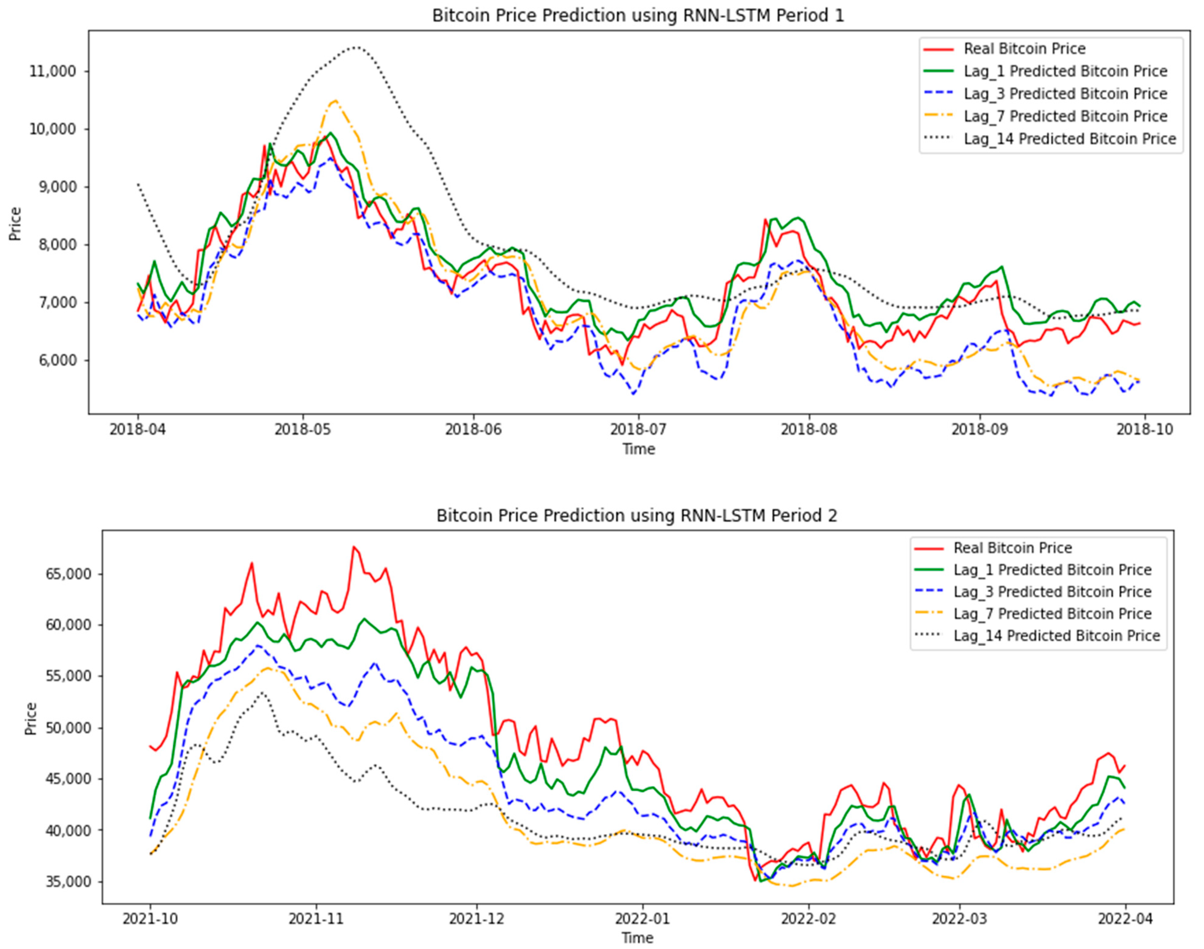
Deep learning is a powerful machine learning algorithm for solving complex and nonlinear issues to exploit the huge number of data and good predictions. The price prediction with accurate results is a complex problem because the variation of values is a lot, but the deep learning approach overcomes this issue. Jietal. [7] Presented the comparison of Long Short Term Memory (LSTM) with Deep Neural Network (DNNs) and combined the results with the bitcoin price prediction. The presented result of their approach shows the acceptable accuracy of LSTM comparing with the other regression models. In this approach they tried to analyze the deep learning models in term of regression analysis which is immature to just for trading of bitcoin Shintateetal. [8] Presents the framework of trend classification and prediction for the non-stationary cryptocurrency time series data based on deep learning. The developed approach results show the LSTM model performance based
On profit ability analysis using the buy and hold strategy. The output results of this system show the LSTM generalized perfectly in the prediction of cryptocurrency prices. [9] Proposed the Generalized Auto-regressive Conditional Heteroskedas- ticity (GARCH) with Support Vector Machine (SVM) for Bitcoin price prediction.
METHODS
Multiple models were assesses on the task of predicting the directionality of change in Bitcoin price. Classification models like Logistic Regression, Support Vector Machine. Other models were based on regression algorithms, such as the Autoregressive integrated moving average (ARIMA). Models based on a Recurrent neural network (RNN) implemented and tested.
All of the models were assessed on how well they performed on the task, and these results are analyzed. The impetus for trying such a large number of models was to analyze how the assumptions underlying each of the respective models could affect the models performance. Then methods underlying these models and their assumptions are brieﬂy summarized below.

- Logistic Regression
It is a statistical method for examine a data set in which there are one or more individualistic variables that determine an outcome. The outcome is measured with a divided variable (only two possible outcomes). It is used to predict a binary outcome (1 /0, Yes / No, True / False) given a set of independent variable. It is a predictive regression model in which the dependent variable is categorical. It uses Maximum Like hood Estimation to formulate the probabilities in which Logistic Regression will take on a particular class.

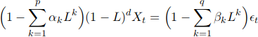

- Support Vector Machine

Like logistic regression, the support vector machine algorithm yields a binary classiﬁcation model while making very few assumptions about the dataset.
The classiﬁer is obtained by optimizing:

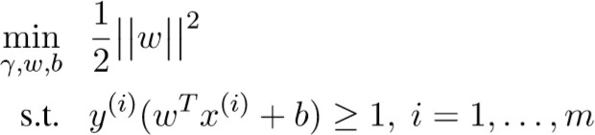

- Auto Regressive Integrated Moving Average(Arima)

ARIMA is a model used for time series analysis and forecasting. The model is used on time series data which will be transformed into a stationary time series; the predictions are an inner regression upon features including time differences and moving averages. The implementation used is from the Stats models package (Seabold and Perktold, 2010). In ARIMA, the data is difference hat is the price features are transformed to the difference between prices.
Let be the lag operator, in the above equation and p, d, q are hyper-parameters over which we optimized. At each time t,
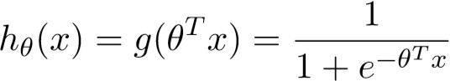

we train a model using the price history to predict the price at time t and use the sign of the change in price as a prediction.

- Recurrent Neural Networks(RNN)
The RNN (Recurrent neural network) was first developed by scientist Elman. The RNN is structured similarly to the MLP (multilayer perceptron), with the exception that signals can flow both forward and backwards in an iterative manner. In order to facilitate both the backward and forward flow an addition layer has been added called the Context Layer In addition to passing input between layers, the output of each layer is fed to the context layer to be fed into the next layer with the next input. In this context, the state is over written at each time step. This offers the benefit of allowing the network to assign particular weights to events that occur in a series rather than the same weights to all input as with the MLP.

CONCLUSIONS
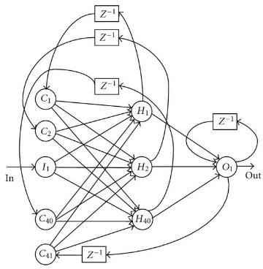
We considered previous Bitcoin transaction in which price and time stamps are the attributes used to predict the bitcoin price for future. We used four methods for price predictions such as Logistic regression, Support vector machine, RNN and ARIMA. Prediction accuracies for the see four methods are listed in the Table 2. Among the four methods, ARIMA performs well for next day’s predictions but performs poor for longer terms like given last few days price predict next 5-7 days prices. RNN perform consistently upto 6days. Logistic regression-based model’s assumptions were not violated, it is only able to classify accurately if a separable hyper plane exists.

BITCOIN PRICE CHANGE PREDICTOR ACCURACIES

Method | Accuracy
Logistic Regression | 47%
SVM | 48%
ARIMA | 53%
RNN | 50%

REFERENCES
- CharlesBovaird.2017. Why the crypto markets the appreciated more than 1,200% this year. Forbes Magazine [Online;posted[17-November-2017]. https://www.forbes.com/sites/cbovaird/2017/11/17/whythe-crypto-market-has-appreciated-more-than1200-this-year.

- MarshallVanAlstyne.2014. Why bitcoin has value .Communications of the ACM 57(5):30–32.https://doi.org/10.1145/2594288.

- KareemHegazy and Samuel Mum ford.2016.Comparitive automated bitcoin trading strategies.http://cs229.stanford.edu/proj2016/report/MumfordHegazyComparitiveAutomatedBitcoinTradingStrategiesreport.pdf.

- Satosh iNakamoto.2008.Bitcoin:Apeer-to-peer electronic cash system.

- LipoWang and EdwinSin School of Physical and Mathematical Sciences Nanyang Technological University Singapore presented― Bitcoin Price Prediction Using Ensembles of Neural Networks‖

- Nehamangla,‖UnstructuredDataAnalysisAndProcessingUsingBigDataTool-HiveAndMachineLearningAlgorithm-Linear Regression‖,International Journal of Computer Engineering & Technology (IJCET)

- NehaMangla, ‖Machine Learning Approach for UnstructuredData Using Hive, ‖International Journal of Engineering Research‖,

